

CIS6003 - Advanced Programming
Assessment WRIT1
Sunrise Dental Clinic
Appointment and Patient Management System
A distributed, three-tier Java application
Student Name: [ Your Full Name ]
Cardiff Student ID: [ stXXXXXXXX ]
ICBT Student ID: [ CL/BSCSD/XX/XX ]
Module Leader: Ms. Priyanga
Academic Year: 2024 / 2025 - Semester 1
Submitted: August 2026

ACKNOWLEDGEMENT
I would like to express my sincere gratitude to everyone who helped me complete this appointment and patient management system for Sunrise Dental Clinic.
First and foremost, I extend my deepest thanks to Ms. Priyanga, my Module Leader for the Advanced Programming module, whose teaching on design patterns, layered architecture and test-driven development shaped almost every decision in this project. The habit of asking "which class should own this rule?" before writing any code came directly from those sessions, and it is the single thing that kept the system tidy as it grew.
I am grateful to ICBT Campus and the School of Technologies for providing an excellent academic environment, and to Cardiff Metropolitan University for the structure of the programme, which pushed me to think about professional standards rather than only about getting the program to run.
I also want to thank the open-source community. This project stands on work I did not have to write myself: the Spring Boot, Hibernate and Flyway projects, the JUnit 5, Mockito and AssertJ maintainers, and the H2 and MySQL teams. Their documentation was often clearer than any textbook.
Finally, I would like to thank my family and my classmates. Explaining a problem out loud to somebody else was, more than once, how I found the answer to it.

Table of Contents
Table of Contents 3
Table of Figures 5
Table of Tables 6
Task A - System Design with UML Diagrams 7
1.1 Understanding the problem 7
1.2 Assumptions made 7
1.3 Use Case diagram 8
1.3.1 Choosing between <<include>> and <<extend>> 8
1.4 Class diagram 8
1.4.1 Multiplicity, navigability, aggregation, composition 9
1.5 Sequence diagrams 9
1.6 Critical reflection 10
Task B - Design Patterns and Architecture Development 16
2.1 Three-tier architecture 16
2.2 A genuinely distributed application with web services 17
2.3 Design patterns applied 17
2.3.1 Strategy and Template Method together 18
2.3.2 Chain of Responsibility, and Observer 18
2.3.3 Critical evaluation - what the patterns cost 19
2.4 The database 19
2.4.1 How double booking is actually prevented 19
2.4.2 Advanced database features 20
2.5 Interfaces and validation 20
2.6 Reports that add value 21
2.7 Sessions and cookies 21
2.8 The system in use 24
Task C - Test Plan and Test-Driven Development 30
3.1 Test rationale 30
3.2 How test-driven development was used 30
3.3 Test plan 31
3.4 Test data 31
3.5 Test automation and results 32
3.6 What the testing actually found 33
3.7 Traceability 33
3.8 Evaluation and lessons learned 34
Task D - Version Control, Workflows and Deployment 35
4.1 Repository 35
4.2 Version control technique 35
4.3 Version history 36
4.4 Workflows (CI/CD) 36
4.5 Evaluation 37
References 38

Table of Figures
Figure | Description
Figure 1 | Use Case Diagram - Sunrise Dental Clinic System
Figure 2 | Class Diagram - Domain Model
Figure 3 | Sequence Diagram - Sign In (Authenticate)
Figure 4 | Sequence Diagram - Register New Appointment
Figure 5 | Sequence Diagram - Calculate the Bill
Figure 6 | Three-Tier Architecture and Deployment
Figure 7 | Entity-Relationship Diagram - Physical Schema
Figure 8 | Sign-in screen
Figure 9 | Dashboard showing live clinic figures
Figure 10 | Registering a new appointment
Figure 11 | Appointment details, found by appointment number
Figure 12 | A generated bill and its pricing breakdown
Figure 13 | The printable receipt
Figure 14 | Revenue report, read from a database view
Figure 15 | Audit trail with IP addresses
Figure 16 | Notification history
Figure 17 | OpenAPI documentation at /swagger-ui.html

Table of Tables
Table | Description
Table 1 | Assumptions made during analysis, with reasons
Table 2 | Use of <<include>> and <<extend>> stereotypes
Table 3 | What belongs in each architectural tier
Table 4 | The thirteen design patterns applied
Table 5 | Advanced database features and the rules they implement
Table 6 | The five management reports and the decisions they support
Table 7 | The three levels of testing
Table 8 | Test plan
Table 9 | Test data, chosen at the boundaries
Table 10 | Test results
Table 11 | Defects found after the suite was already green
Table 12 | Requirements traceability
Table 13 | Version control techniques applied
Table 14 | Commit history

Task A - System Design with UML Diagrams
Task A (20 marks) - from the assessment brief
“Provide the UML diagrams for the given problem with clear explanations of the design decisions. Derive detailed Use Case diagram, Class diagram and sequence diagram. Whenever necessary document the relevant assumptions you made. (LO I)”

1.1 Understanding the problem
The brief lists four symptoms of running a clinic on paper: double bookings, lost records, long waiting times and billing errors. They are four consequences of one thing - nobody can see, at the moment they need to, what is already true. So the job is not to store the same information in a computer, but to make the conflicting cases impossible rather than merely unlikely. That is why a database constraint, not an if statement, does the final work of preventing a double booking (2.4.1), and why an invoice total is calculated twice and compared (2.4.2).

1.2 Assumptions made
# | Assumption | Reason
A1 | Only staff use the system; patients do not log in. | The brief says only authorised staff may use it.
A2 | Three roles: Receptionist, Dentist, Administrator. | One shared login makes the audit trail meaningless - “who cancelled this?” could never be answered.
A3 | One appointment = one visit, one dentist, one treatment. | Keeps the appointment number a genuine unique identifier.
A4 | Fixed 30-minute slots, 08:00 to 20:00. | No hours are given. A fixed grid makes “is this slot free?” a question with one correct answer.
A5 | Only a completed visit can be billed. | Billing a visit that has not happened is exactly the billing error the clinic wants to escape.
A6 | Prices in LKR; VAT 15%. | The clinic is in Colombo. One constant, so a tax change is a one-line change.
A7 | Cancelling or missing a visit frees the slot at once. | A slot held by a cancelled visit cannot be sold, recreating the waiting-time problem.

1.3 Use Case diagram
Figure 1 shows three human actors and two system actors. The gateway is an actor because it sits outside the boundary and can fail independently; the scheduler because something must start the daily reminder run when no human is present. The two-column layout is deliberate - the left column holds every use case an actor touches directly, the right only those reached through a stereotype.

1.3.1 Choosing between <<include>> and <<extend>>
These two are often used interchangeably, which empties them of meaning. The rule applied is the standard one (Fowler, 2003): <<include>> happens every time; <<extend>> happens only under a condition, written on the arrow.
Relationship | Type | Why
Register Appointment → Check Slot Availability | <<include>> | Checked on every booking; skipping it is the double-booking bug the clinic already has.
Register Appointment → Send Confirmation | <<include>> | Every booking confirms; if the gateway is down the attempt is still logged.
Calculate Bill → Apply Pricing Rule | <<include>> | Every bill runs exactly one pricing rule.
Register New Patient → Register Appointment | <<extend>> | [patient not already on file] - a returning patient is looked up.
Reschedule → Display Appointment Details | <<extend>> | [slot must change] - most lookups change nothing.
Print Receipt → Record Payment | <<extend>> | A patient paying by transfer may want no printed receipt.

One omission is deliberate and noted on the diagram: every use case inside the boundary needs a signed-in user, so each strictly includes Sign In, but twelve arrows to one bubble would hide the flow the diagram exists to show.

1.4 Class diagram
Figure 2 is drawn from the classes actually written - the attribute names, types and signatures are the ones in the source. Getters and setters are omitted, because listing seventy would bury the eight methods carrying the business rules. Every attribute is private (minus), every business method public (plus), and the fields inherited from BaseEntity are protected (hash). One method is deliberately private: syncSlotLock() maintains the field that prevents double booking, and a slot lock disagreeing with the appointment date would silently break that safeguard.

1.4.1 Multiplicity, navigability, aggregation, composition
- Multiplicity. A Patient books 0..* Appointments; an Appointment belongs to exactly 1. An Appointment has 0..1 Invoice - zero while scheduled, one once billed - enforced by a unique key on invoice.appointment_id, so a visit cannot be billed twice.
- Navigability. The arrow to Dentist means an Appointment knows its Dentist but not the reverse; a two-way link would drag a dentist's whole history into memory on every load. Patient-Appointment has no arrowhead because it genuinely is two-way - the patient screen shows their history.
- Aggregation (hollow diamond) joins Patient to Appointment: deleting a patient must not silently delete the clinical record of visits they attended.
- Composition (filled diamond) joins Invoice to InvoiceLine. A line reading “VAT 15%” means nothing apart from its invoice, so the parts die with the whole - and the foreign key carries ON DELETE CASCADE, so diagram and database agree.
The contrast between the last two is the point. Both read as “has many” and both would be a List in Java, but they behave differently on deletion, and the diagram is where that difference is decided.

1.5 Sequence diagrams
Three use cases are shown, because between them they cover the three hardest parts of the system - security, concurrency and business rules.
- Figure 3 (Sign In) uses an alt fragment because sign-in has two real outcomes, and both end in the same place: an audit_log entry with the caller's IP. The same message is shown whether the username exists or not, so the page cannot be used to discover real accounts.
- Figure 4 (Register Appointment) is the most important here. The loop fragment runs six handlers cheapest-first, so a booking in the past is rejected without touching the database; the opt fragment shows the slot being taken in the few milliseconds before the save - a window a paper diary cannot even express.
- Figure 5 (Calculate Bill) shows the Template Method fragment: steps 6.1-6.6 always run in that order because the method is final, and only 6.2 and 6.3 differ per subclass.

1.6 Critical reflection
The three diagram types answer three questions - who wants what, what the system is made of, what happens in what order - and the design holds together only because they agree. One example is worth reporting honestly. The first class diagram had no slotLock; the anti-double-booking rule lived only in the sequence diagram, as a check before the save. Drawing that sequence carefully exposed the gap between step 3.4 and step 8 - a gap only something the class owned could close - so slotLock was added to the class and the schema as a direct result. The diagrams found a concurrency bug before a line of the service was written.
The main limitation is that the design models one clinic on one server. “One Appointment, one Dentist” would need revisiting if Sunrise opened a second branch, and the fixed 30-minute grid in A4 is a simplification a real orthodontic practice would outgrow.

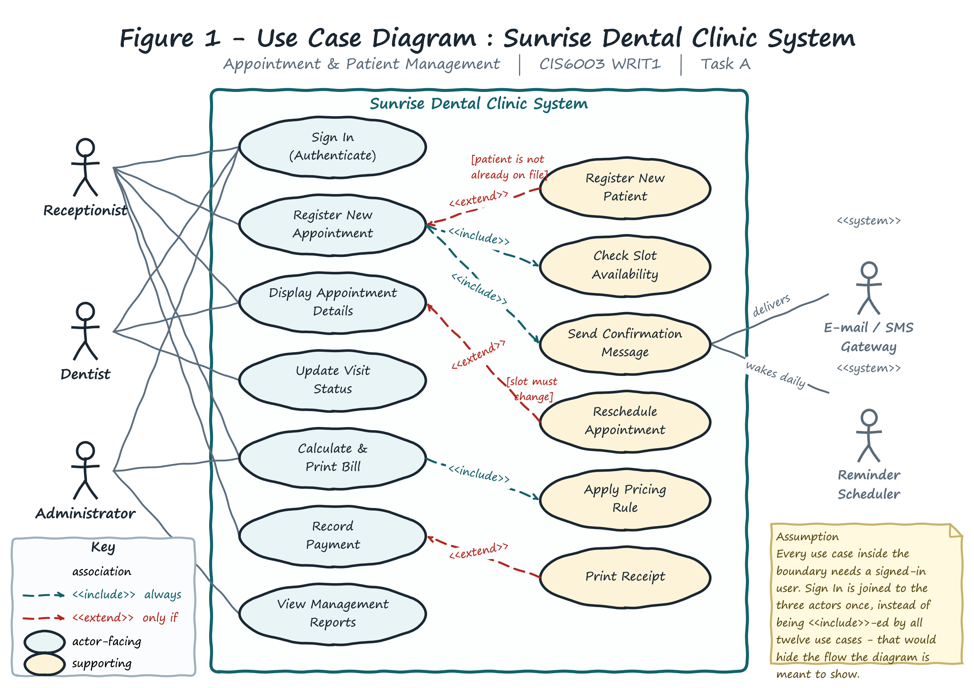
Figure 1 - Use Case Diagram: Sunrise Dental Clinic System. Actors, the system boundary, and the <<include>> / <<extend>> relationships described in section 1.3.

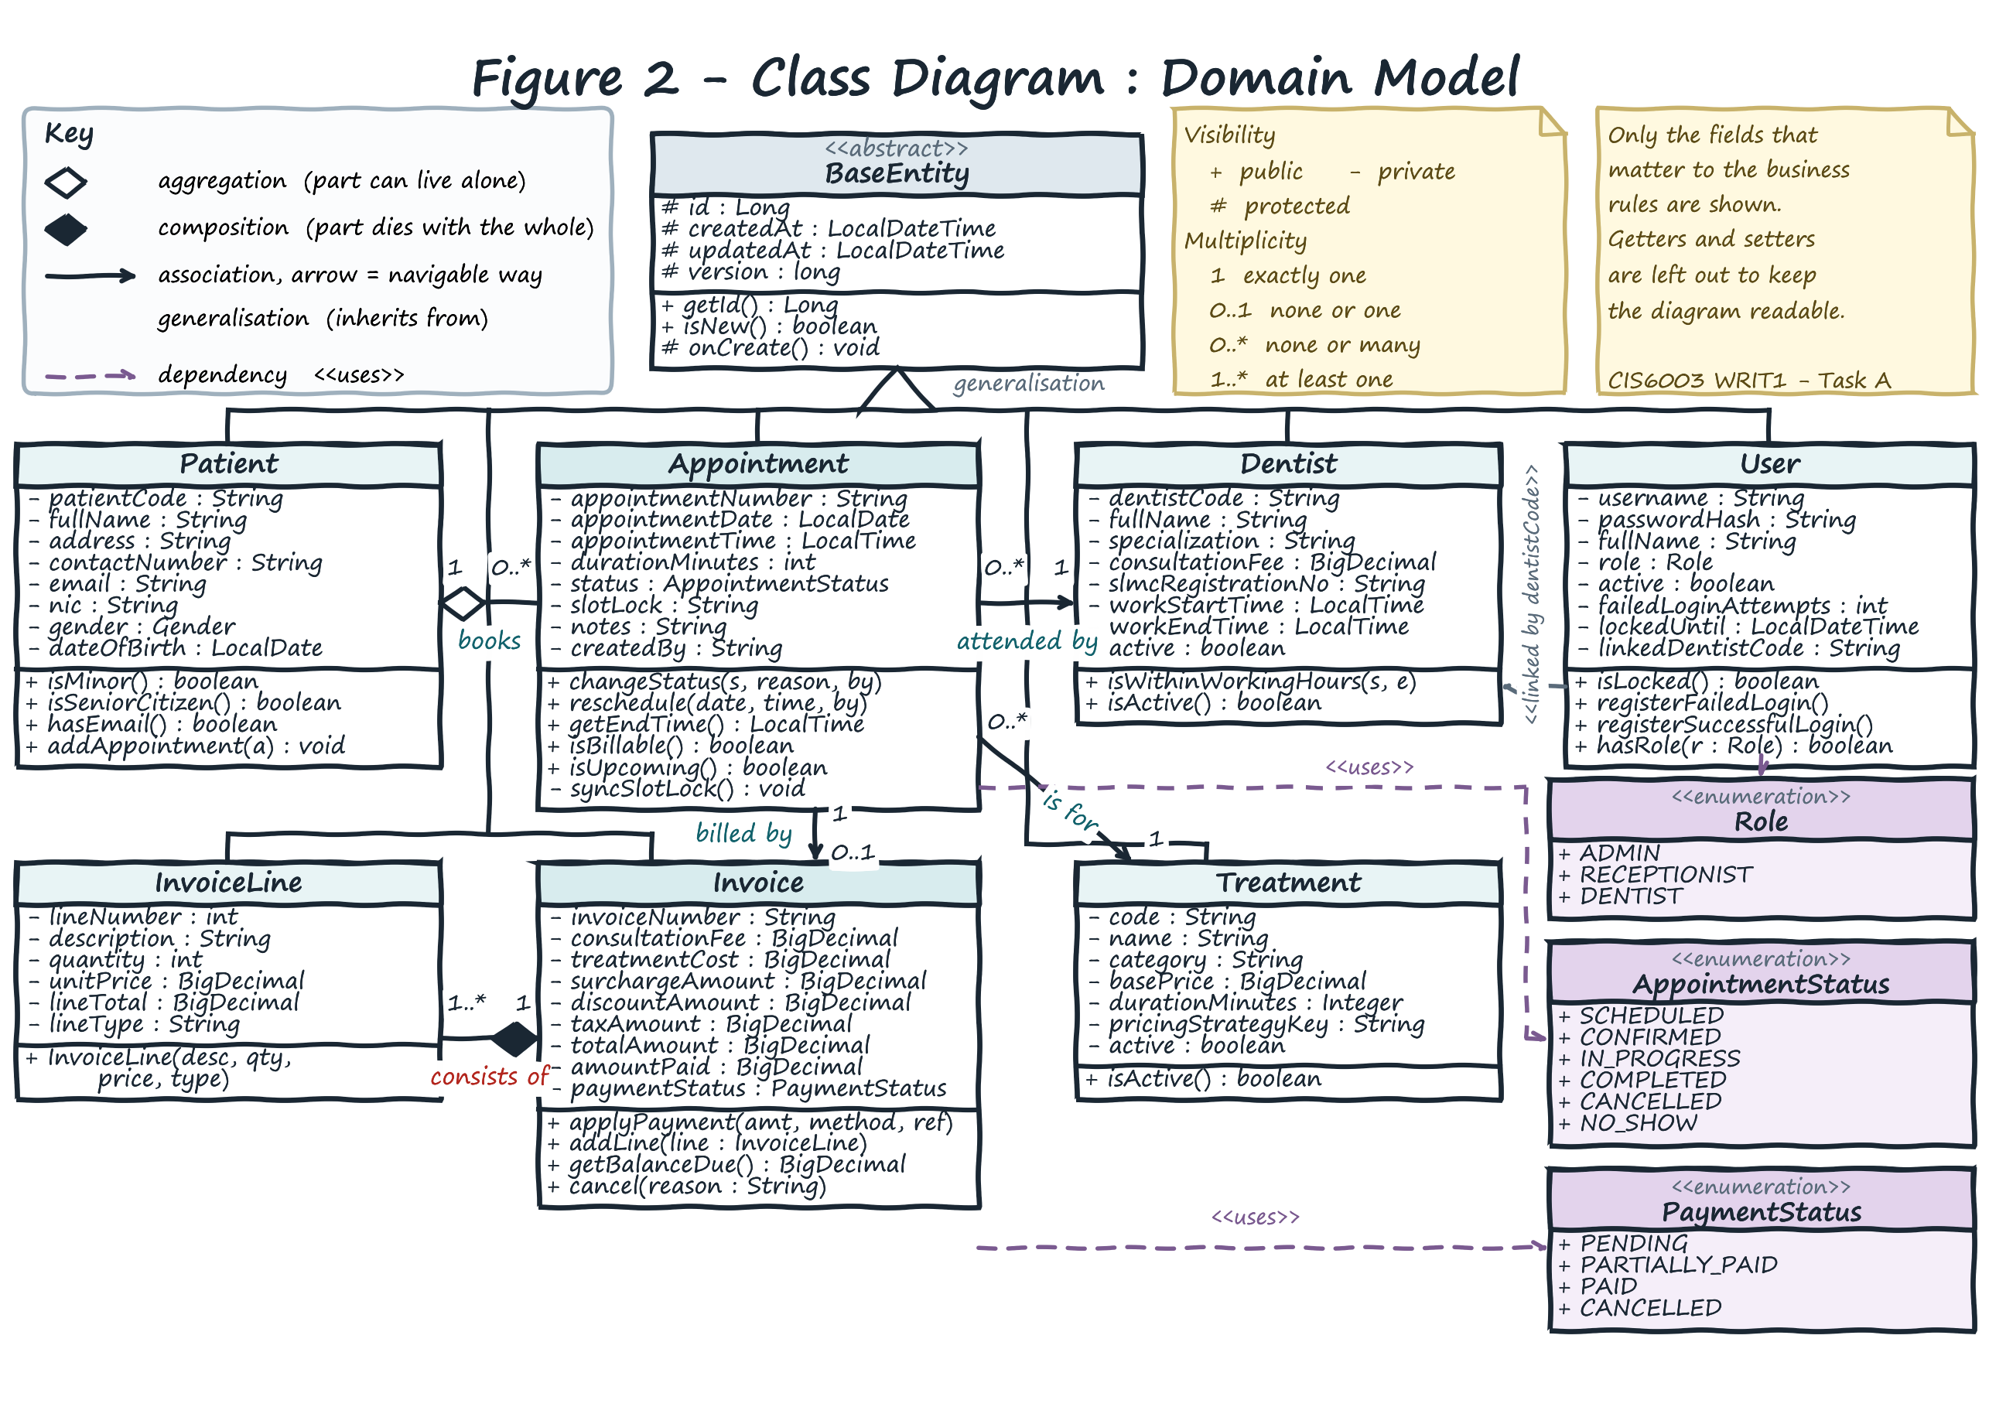
Figure 2 - Class Diagram: the domain model, drawn from the classes that were actually written. Access modifiers, multiplicity, navigability, aggregation and composition are all shown (section 1.4).

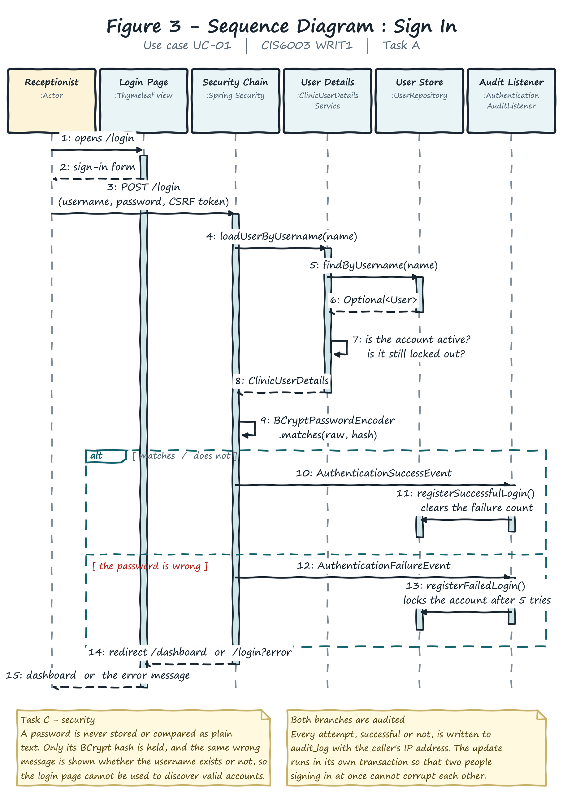
Figure 3 - Sequence Diagram: Sign In. The alt fragment shows both outcomes, and both end with an audit entry (section 1.5.1).

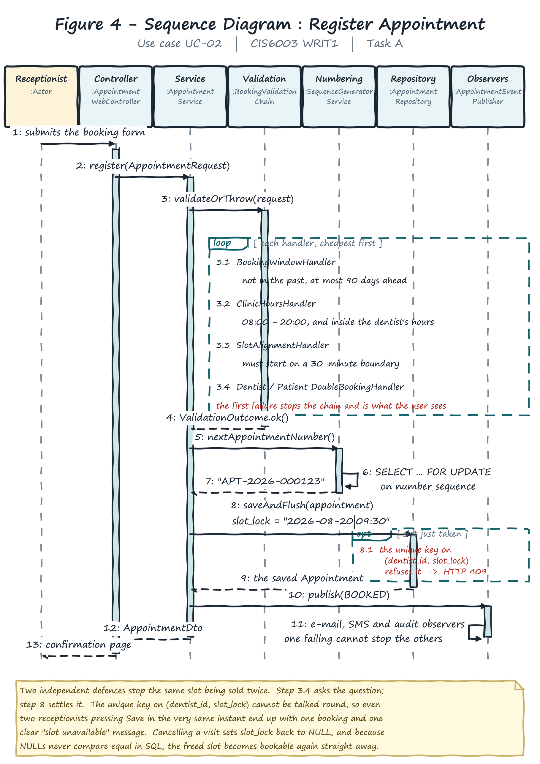
Figure 4 - Sequence Diagram: Register New Appointment. The loop fragment is the validation chain; the opt fragment is the database having the last word on a race (section 1.5.2).

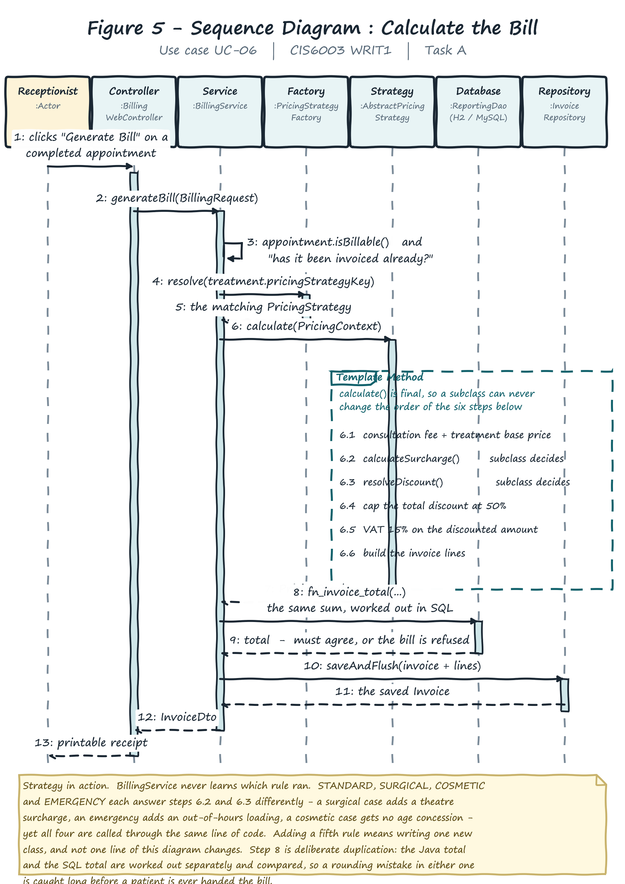
Figure 5 - Sequence Diagram: Calculate the Bill. The Template Method fragment shows the six steps whose order no subclass can change (section 1.5.3).

Task B - Design Patterns and Architecture Development
Task B (40 marks) - from the assessment brief
“Develop an interactive System with set of interfaces to get the necessary user inputs. Make sure to implement proper validation mechanisms in order to restrict invalid entries to the system. Come up with a suitable set of reports, which you think add more value to your system. i. Your program must be a distributed application with web services ii. Appropriate design patterns must be implemented in your system iii. Your program should make use of a proper database to store information. (LO II)”

2.1 Three-tier architecture
Figure 6 shows the architecture. The tiers are not three packages with tidy names; they are separated by a rule applied consistently and open to checking: a class may only call downwards. The practical test of a layered design is whether you can delete the top layer and still compile the rest - and here you can, because the desktop client is a different Maven module that does not depend on the server at compile time at all.
Tier | What lives there | What is forbidden there
Presentation | Thymeleaf controllers, REST controllers, the Swing client, templates, CSS. | Business rules - a controller that decided a discount would put it out of reach of the desktop client.
Business | Services, ClinicFacade, pricing strategies, the validation chain, observers, security. | SQL and HTTP. It does not know it is reached over the web, which is why the same rules serve both front ends.
Data | Spring Data repositories, ReportingDao, Flyway migrations, views, functions, procedures, triggers. | Decisions. It stores and constrains only.

Three Maven modules - dental-common, dental-server and dental-client - make the build mirror the architecture. Because the client depends only on dental-common, reaching into a server class from the client is impossible: the compiler stops it. Architecture enforced by the build is worth more than architecture enforced by good intentions.

2.2 A genuinely distributed application with web services
This requirement is easy to satisfy in appearance only, by bolting a REST controller onto an ordinary web application. Here it is taken literally: dental-client is a Swing application in its own process, with its own JVM, started with the server's address as an argument and able to run on a different machine. It has no compile-time knowledge of any server class, no shared session and no shared object graph - only HTTP and JSON.
The contract is versioned at /api/v1, so a future /api/v2 can change shape without breaking an installed client, and every response uses one envelope - success flag, payload, error code, message - so the client handles failure in one place. It is documented with OpenAPI 3 at /swagger-ui.html (Figure 17). One consequence deserves a mention: an API caller must get 401 with a JSON body while a browser user must be redirected to the login page, so Spring Security runs two separate filter chains, ordered so /api/** matches first. A single chain would have sent HTML login pages to the desktop client.

2.3 Design patterns applied
Pattern | Where | What it buys
Strategy | PricingStrategy + 4 implementations | A new rule is a new class, not an edit to a growing if.
Template Method | AbstractPricingStrategy.calculate() | The order of the billing steps is final.
Factory | PricingStrategyFactory, ReportGeneratorFactory | Callers name what they want; nobody writes new.
Chain of Responsibility | BookingValidationChain (6 handlers) | Each booking rule is independent and testable.
Observer | AppointmentEventPublisher + 3 observers | A failing SMS gateway cannot stop a patient being booked.
Adapter | MessageGateway (console / SMTP / SMS) | A real SMS provider needs no change above the adapter.
Facade | ClinicFacade | Turns a multi-call sequence into one round trip.
Builder | Appointment.Builder | An appointment cannot be half-built.
Singleton | Spring-managed beans | One managed instance per service.
Command | Desktop menu and toolbar actions | Menu bar and button panel cannot drift apart.
DAO / Repository | Spring Data repositories, ReportingDao | Business code never contains SQL.
DTO | Everything in dental-common | Entities never leave the server.
MVC | Thymeleaf controllers, templates, domain model | Request handling is separated from rendering.

2.3.1 Strategy and Template Method together
Billing was the natural home for Strategy: four treatment categories have different surcharges and concession rules, and as one method that is a long if/else chain growing with every new category - the classic case the pattern exists to solve (Gamma et al., 1995). What makes it more than a textbook exercise is the combination with Template Method. As pure Strategy each rule would compute its own total, and nothing would stop one applying VAT before the discount instead of after. calculate() is therefore final and performs the invariant sequence: fees, surcharge, discount, a 50% cap, VAT, then the invoice lines, with only calculateSurcharge() and resolveDiscount() left abstract. A subclass decides how much but never in what order - and since VAT on a discounted amount differs from VAT on an undiscounted one, that distinction is money.

2.3.2 Chain of Responsibility, and Observer
Six conditions must hold before a booking is accepted. As one method that is six nested conditions with a single failure message; as a chain it is six small classes in a fixed order, and the order is a deliberate performance decision logged at start-up: BOOKING_WINDOW → CLINIC_HOURS → SLOT_ALIGNMENT → DENTIST_AVAILABILITY → DENTIST_DOUBLE_BOOKING → PATIENT_DOUBLE_BOOKING. The first three need no database access, so a booking for last Tuesday is rejected without a query, and the chain short-circuits on the first failure so staff are told the most fundamental thing that is wrong.
Observer solves a different problem. Calling the e-mail, SMS and audit code directly from AppointmentService means that if the SMS gateway is unreachable the exception propagates and the booking rolls back - the patient loses their appointment because a text message failed. AppointmentEventPublisher isolates each observer's failure, logs it and carries on, and every attempt is written to notification_log so staff can see the SMS failed and telephone instead.

2.3.3 Critical evaluation - what the patterns cost
- Indirection. Following a bill now means opening four files where a beginner would have written one. For four pricing rules that is worth it; for one it would not have been.
- Debugging is harder. With Observer a stack trace no longer shows who will react to an event, which is why the registered observers are logged at start-up.
- A wrong key can fail quietly. If reference data names a strategy that does not exist, the factory could return null and fail far from the cause. It instead falls back to the standard rule and logs a warning.
- Patterns can be over-applied. Singleton appears only because Spring manages bean lifecycles; hand-writing one would add global state for no benefit. Naming a pattern is not the same as needing it.

2.4 The database
Figure 7 shows the physical schema: nine tables, five views, two functions, two stored procedures and four triggers. The schema is owned by versioned Flyway scripts and Hibernate runs ddl-auto=validate, so the application refuses to start if the entities and the real schema disagree. Letting Hibernate generate the schema would make the database a by-product of the code; this way it is reviewable SQL under version control.

2.4.1 How double booking is actually prevented
The validation chain checks whether a slot is free, but between that check and the insert there is a window of a few milliseconds in which another transaction can commit the same slot. Any solution living only in Java has this window. The fix is a column slot_lock and a unique constraint uk_appointment_slot (dentist_id, slot_lock): while an appointment occupies a chair slot_lock holds "date|time", and when the visit is cancelled syncSlotLock() sets it back to NULL. The trick is that SQL never treats two NULLs as equal, so any number of cancelled appointments can share a dentist and slot while two live ones cannot. A database constraint has no race window - and this was verified rather than assumed: twelve genuinely simultaneous requests for one slot gave exactly one success and eleven clean 409 responses, against three fresh databases.

2.4.2 Advanced database features
Feature | Name | Business rule it implements
Function | FN_INVOICE_TOTAL | Recomputes an invoice total in SQL; every bill is checked against it, so a rounding mistake in Java is caught first.
Function | FN_AGEING_BUCKET | Puts a debt in a 0-30 / 31-60 / 61-90 / 90+ day band; the report calls it, so it cannot disagree with an ad-hoc query.
Procedure | SP_SETTLE_INVOICE | Applies a payment and updates the status atomically.
Procedure | SP_DAILY_CLOSING_SUMMARY | Produces the end-of-day figures needed to cash up.
Trigger | trg_appointment_before_insert | Refuses a booking outside the dentist's hours, even from a direct SQL insert (MySQL).
Triggers | trg_appointment_audit_*, trg_invoice_payment_audit | Audit at database level, so a change made outside the application is still recorded.
Views | 5 reporting views | Reports read views, so “revenue” is defined once.
Constraints | FK, UNIQUE, CHECK on every table | Discounts <= 50%, payments <= total, status must be permitted.

Two engines are supported from one codebase: H2 in file mode by default, so the application runs with nothing to install, and MySQL 8 through a Spring profile. The MySQL path was tested end to end against a real MariaDB 10.4 server - all four migrations, both functions, both procedures and every trigger exercised with real data, not merely read through.

2.5 Interfaces and validation
Two complete front ends were built. The browser application (Figures 8 to 17) covers all six required functions plus patient, dentist, treatment, report and administration screens, using a hand-written stylesheet with no CDN dependency so the clinic stays usable if its internet drops. The desktop client is menu-driven, as the brief asks, with the Command pattern behind the menu bar and the button panel.
Validation is applied in four places, on the principle that each layer should refuse what it can prove is wrong: HTML5 required, type and pattern attributes in the browser; Bean Validation annotations on the DTOs, so the desktop client enforces identical rules with no duplicated code; the six-handler chain in the business tier; and CHECK, UNIQUE and FOREIGN KEY constraints plus the MySQL trigger in the database, which hold even against a direct SQL statement. Messages are written for a receptionist, not a developer: instead of a constraint violation the user is told which slot is taken and what to do about it.

2.6 Reports that add value
Report | Question it answers | Decision it supports
Daily Schedule | Who is coming in today, to which dentist? | Staffing the desk; preparing surgeries.
Revenue | What did the clinic take, by day and treatment? | Whether a treatment is worth continuing to offer.
Outstanding Invoices | Who owes money, and for how long? | Which debts to chase first.
Dentist Workload | How busy is each dentist? | Rebalancing the rota; whether to recruit.
Treatment Popularity | Which treatments are most in demand? | Stock ordering; continuing-education choices.

Each is justified by the decision it supports rather than the data it contains. All five share one envelope class, which is why one web page and one desktop window display any of them, and why a sixth report would need no user-interface work at all.

2.7 Sessions and cookies
Three uses are implemented, each solving a real problem rather than demonstrating a mechanism. The HTTP session carries the signed-in user and a “recently viewed” trail, so a receptionist interrupted mid-task can return to where they were. An opt-in remember-me cookie saves the front-desk machine signing in every morning, and a preference cookie stores the chosen table density. A CSRF token is required on every form, so a stolen session cookie alone cannot submit one.

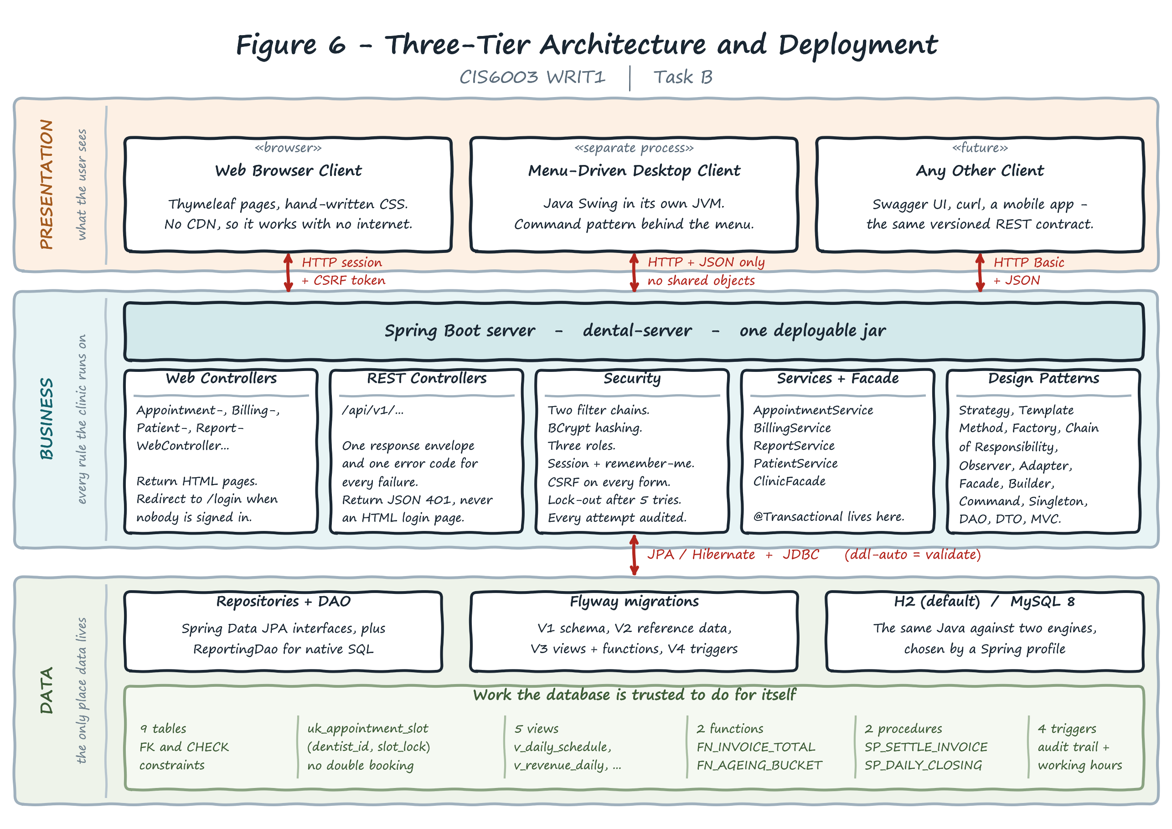
Figure 6 - Three-tier architecture and deployment. The desktop client reaches the server over HTTP and JSON only, which is what makes the application genuinely distributed (section 2.2).

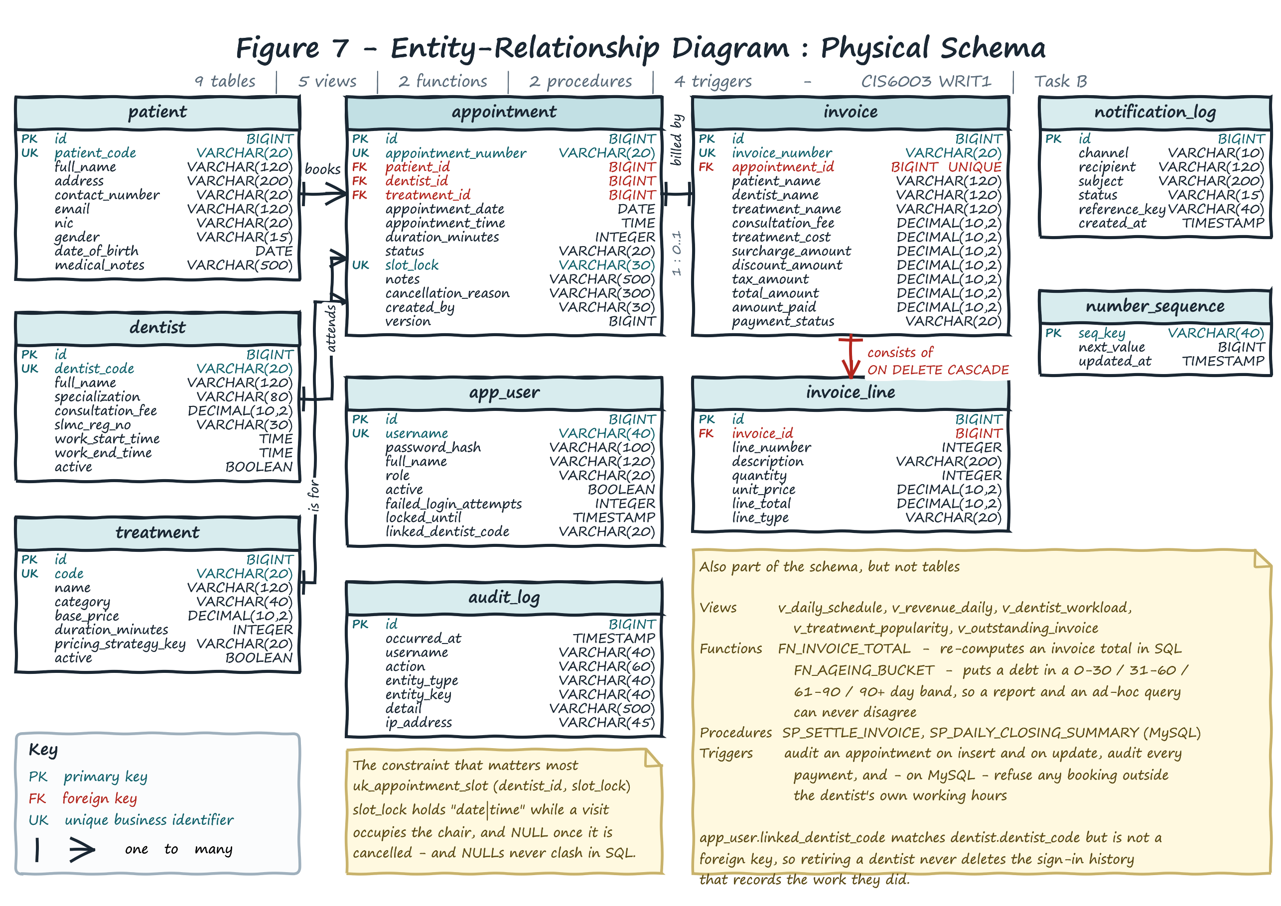
Figure 7 - Entity-Relationship diagram of the physical schema. Note uk_appointment_slot on (dentist_id, slot_lock), which is what actually prevents double booking (section 2.4.1).

2.8 The system in use
The screenshots below are of the running application with seeded clinic data. They are included because the marking criteria ask for documentation with screenshots and clear explanations, and because a description of an interface is no substitute for seeing it.
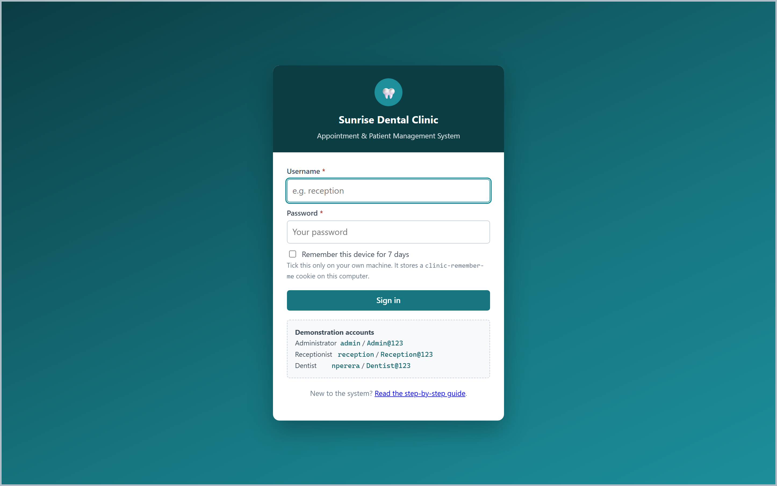
Figure 8 - The sign-in screen. The same message is shown for an unknown username and a wrong password, so the page cannot be used to discover which accounts exist.
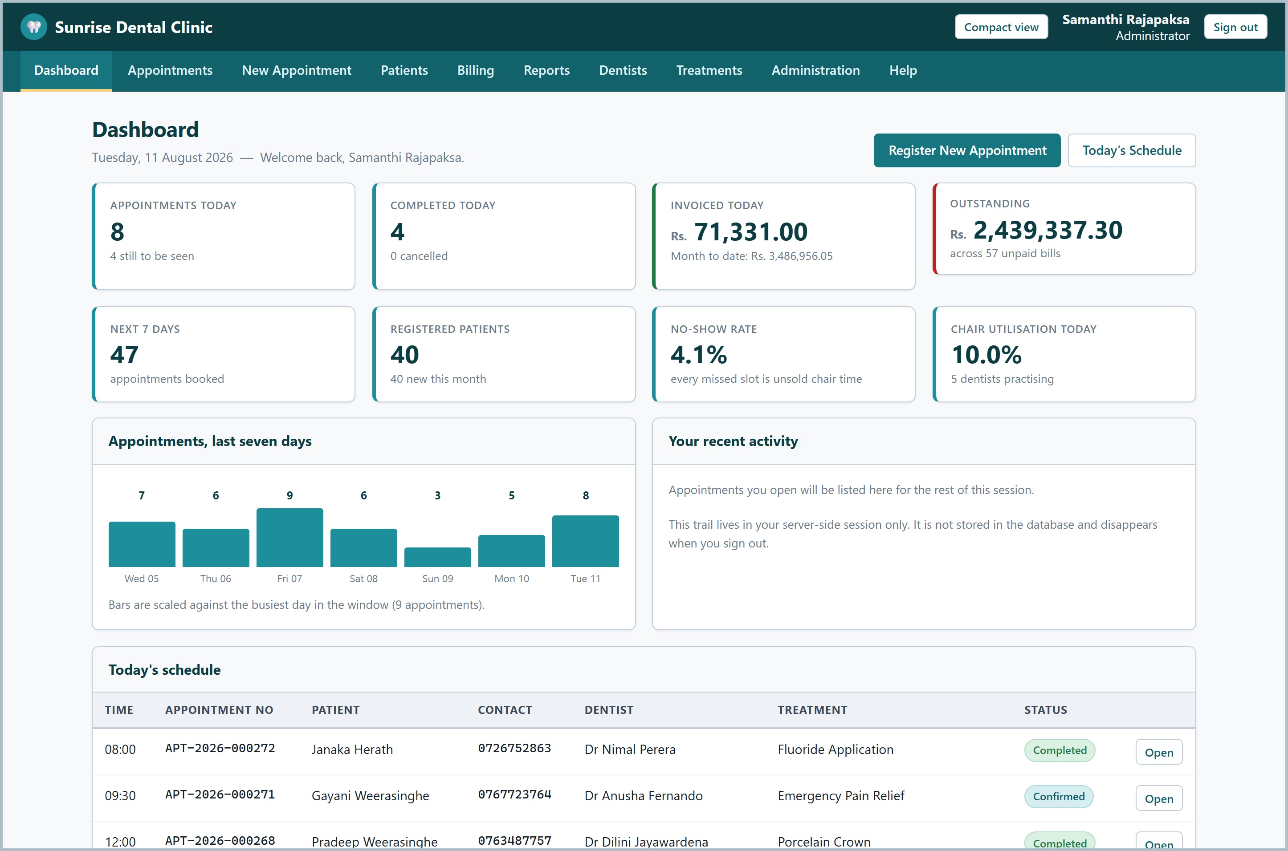
Figure 9 - The dashboard, showing live figures: today's appointments, outstanding invoices and revenue to date.
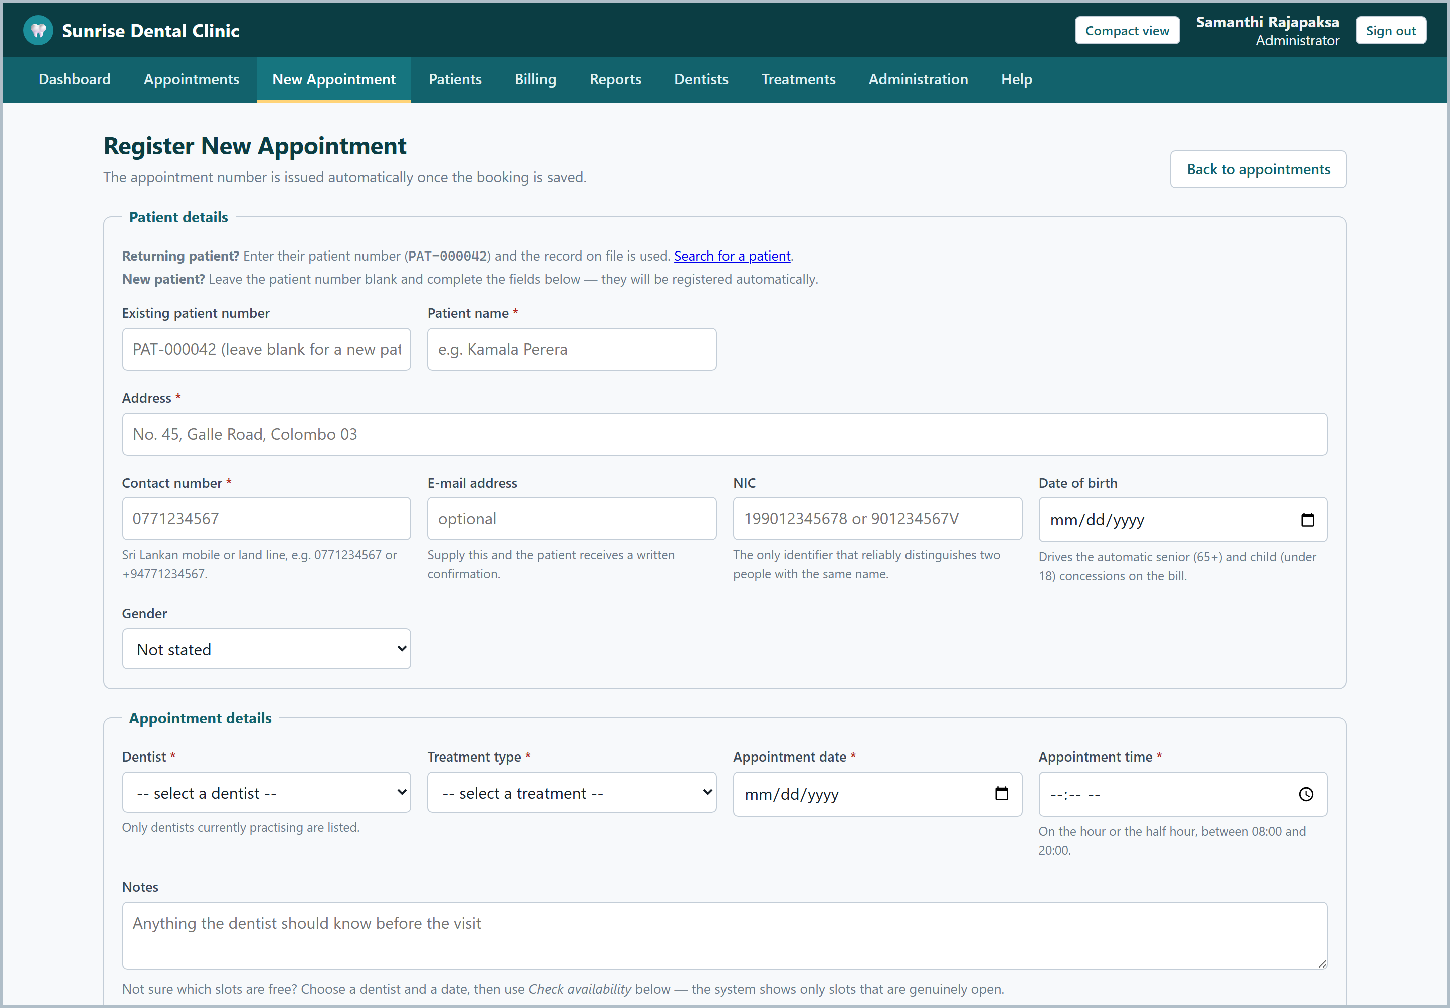
Figure 10 - Registering a new appointment. The dentist, treatment and slot are chosen from reference data, so an invalid combination cannot be typed in.
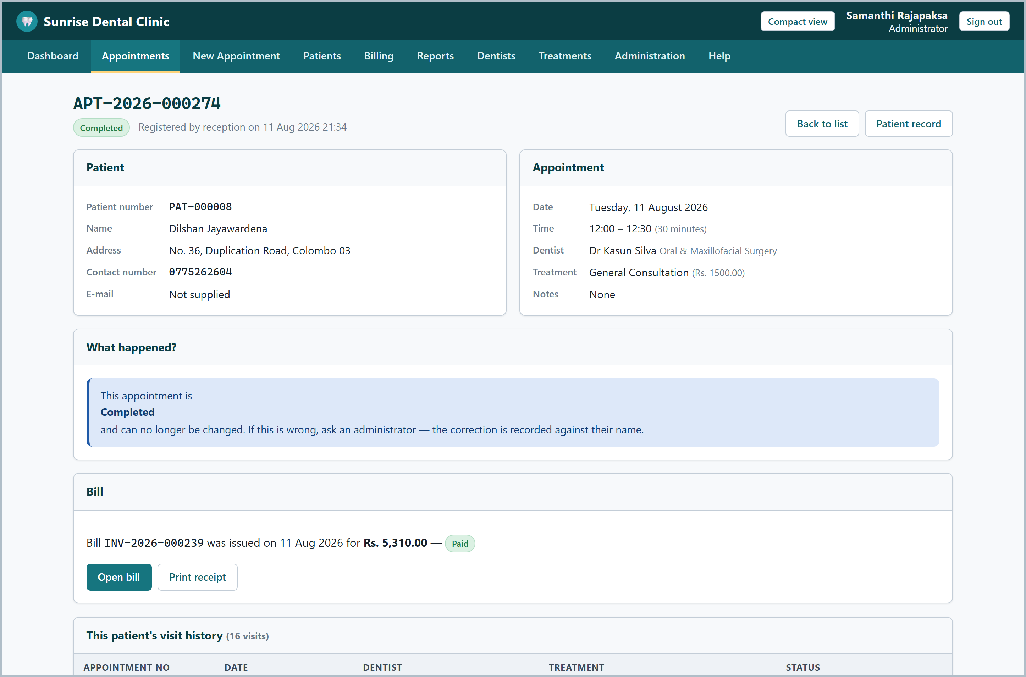
Figure 11 - The appointment detail screen, reached by searching for the appointment number as the brief requires.
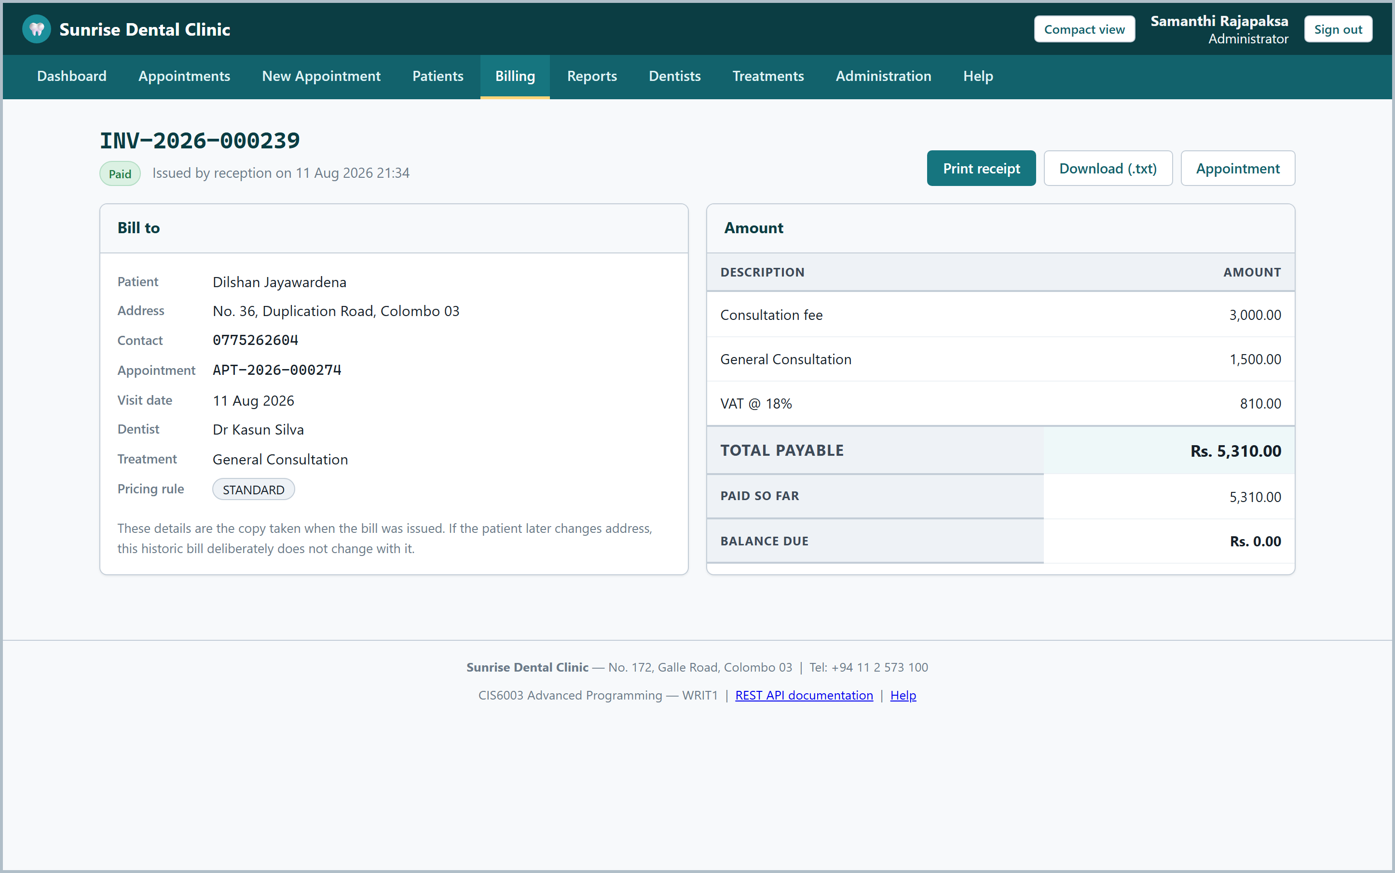
Figure 12 - A generated bill, showing the full pricing breakdown: consultation fee, treatment cost, surcharge, discount, VAT and total.
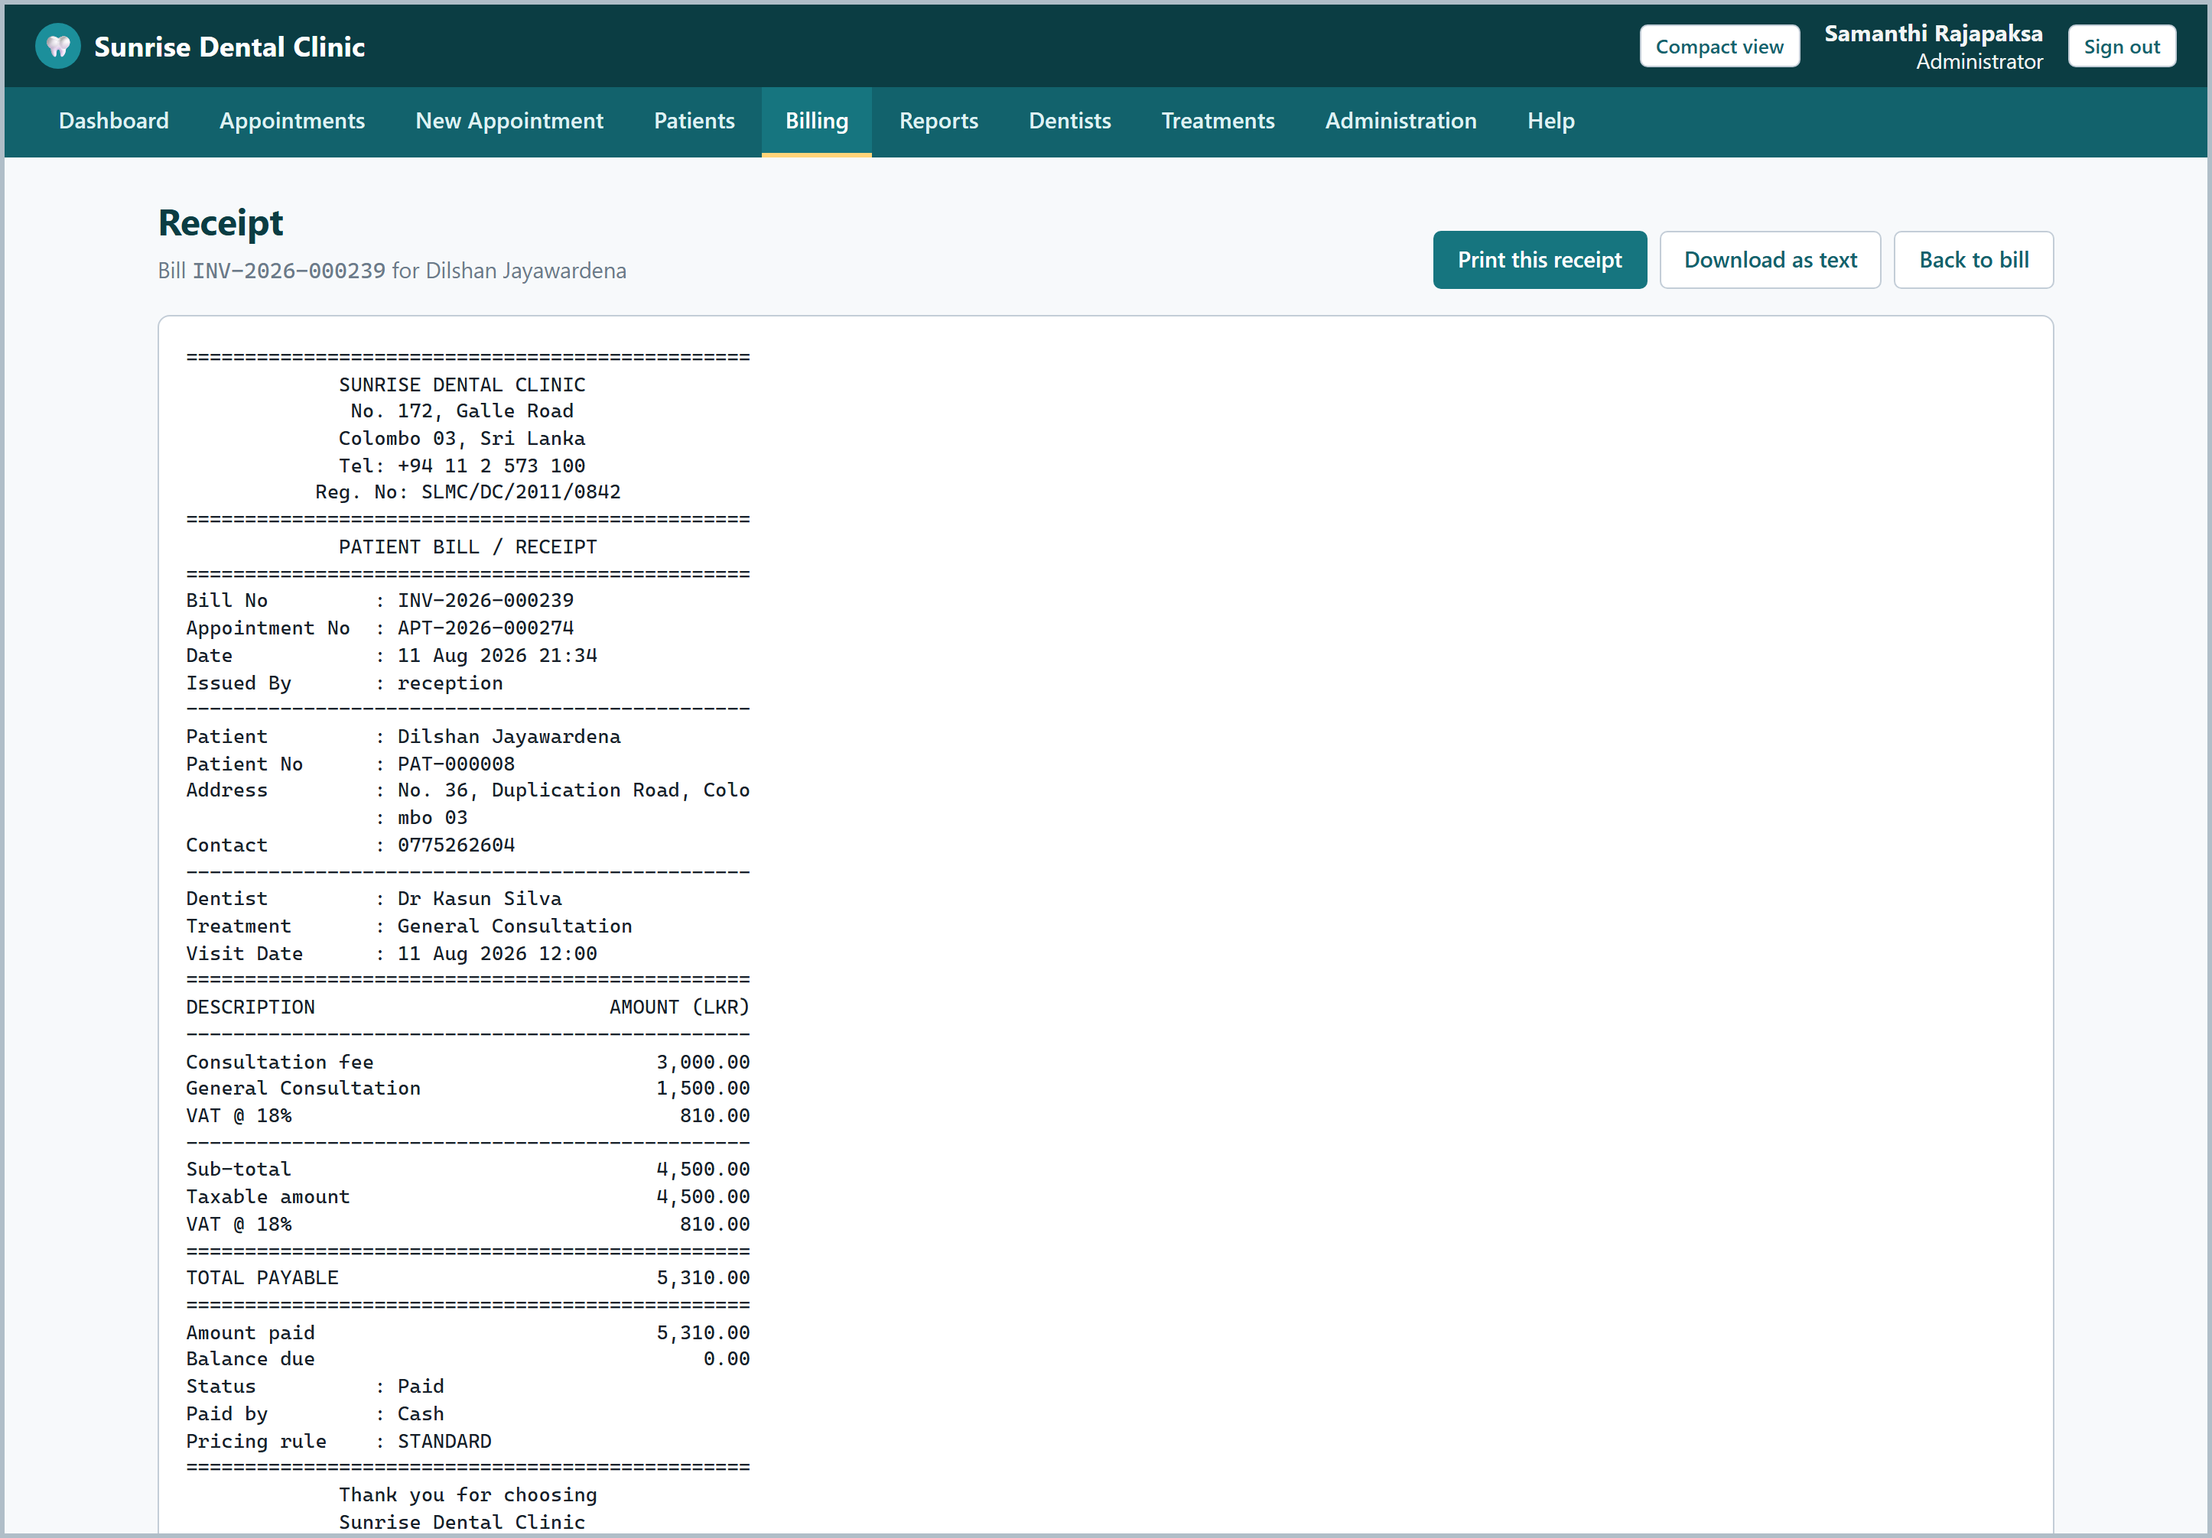
Figure 13 - The printable receipt. The browser and the desktop client both print this same server-rendered page, so the two can never disagree.
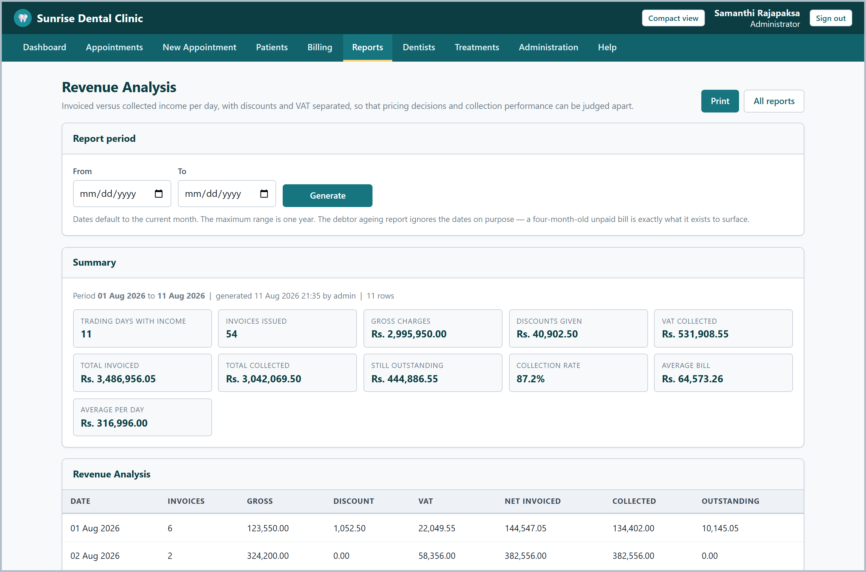
Figure 14 - The revenue report, read from the v_revenue_daily database view.
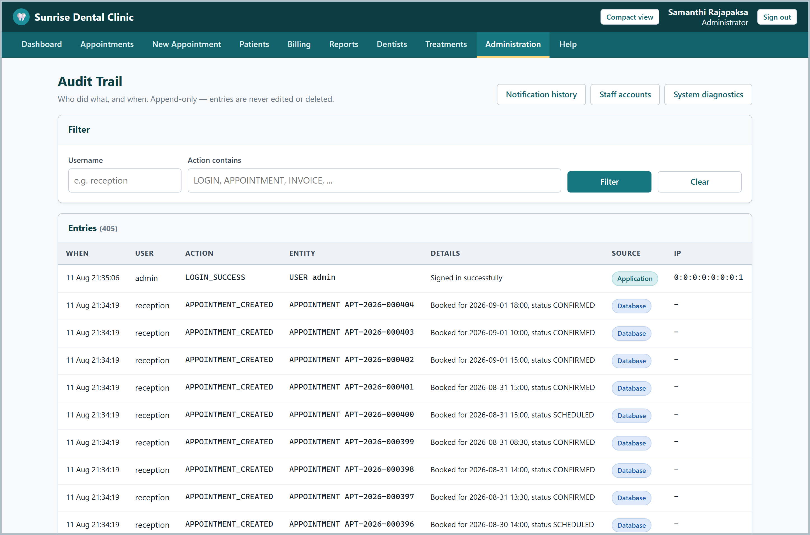
Figure 15 - The audit trail, showing every sign-in and every change with the caller's IP address.
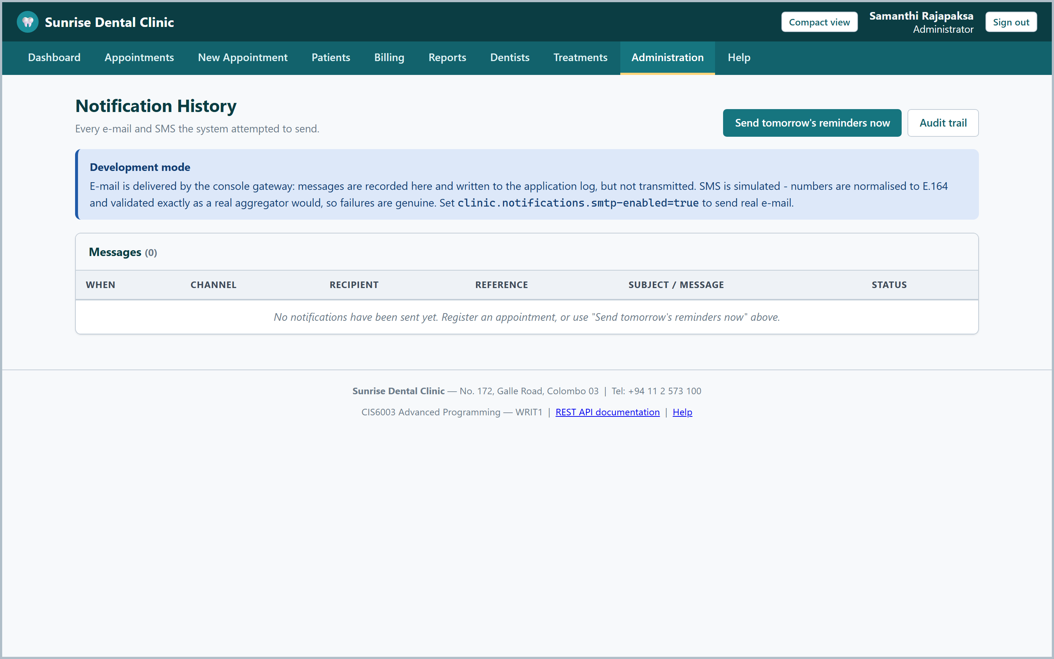
Figure 16 - The notification history, recording every alert attempt, successful or failed.
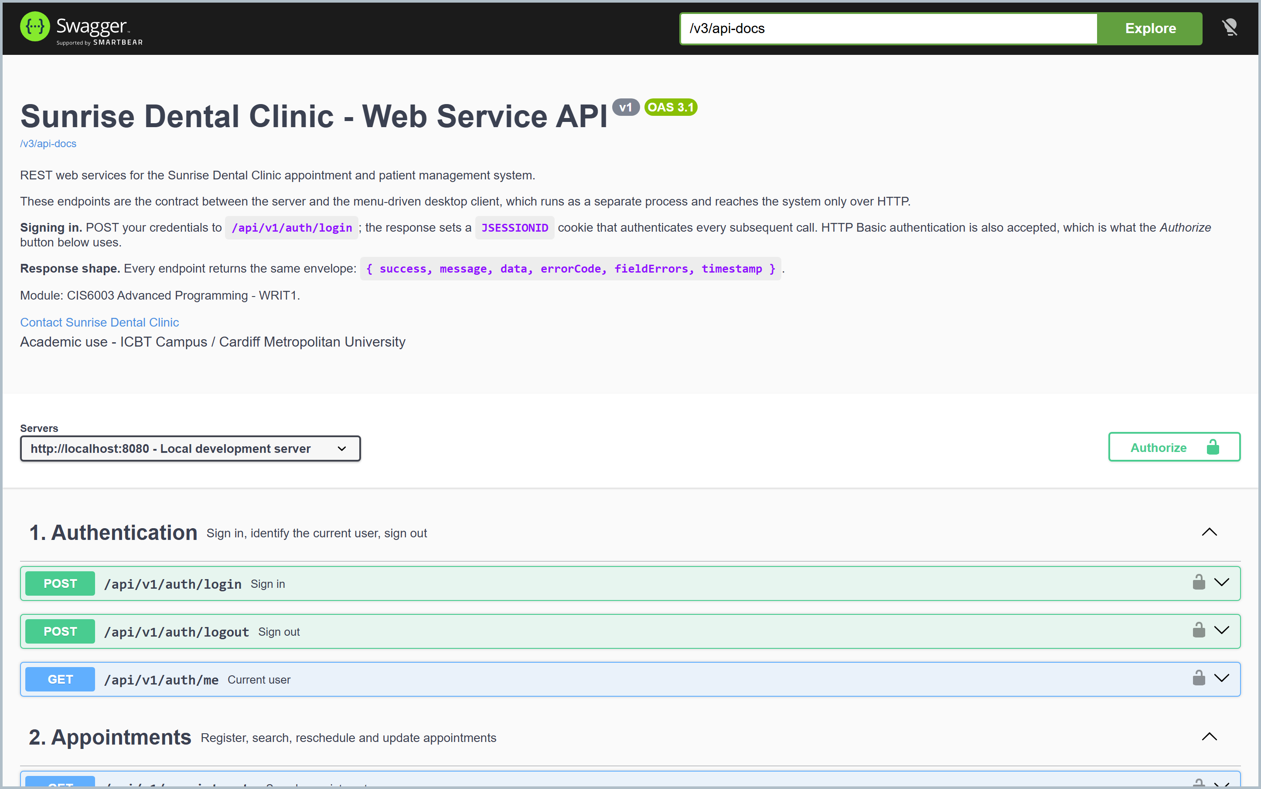
Figure 17 - The OpenAPI documentation at /swagger-ui.html, which the desktop client and any future client are written against.

Task C - Test Plan and Test-Driven Development
Task C (20 marks) - from the assessment brief
“Document the test plan and explain how you used test-driven development in this scenario and do a test automation to achieve that. This includes test rationale, test plan, test data and proper application of the test plan. (LO II)”

3.1 Test rationale
The clinic's problems are all failures of correctness under pressure: two bookings for one slot, a bill that adds up wrongly, a record that cannot be found. The suite therefore has to prove the rules hold when they are attacked, not merely that the happy path works. Three levels were used, so each failure is diagnosed as cheaply as possible.
Level | What it proves | How it runs
Unit (226) | One class behaves correctly in isolation. | JUnit 5 with Mockito - no Spring context, no database, so a failure points at one class.
Integration (97) | The parts work together against the real schema. | @SpringBootTest + MockMvc on the real Flyway schema, in-memory H2.
Concurrency / manual | The rules hold under a genuine race. | A multi-threaded client, plus scripted page and endpoint checks.

Maven runs the levels in separate phases - Surefire for units, Failsafe for integration - so a broken unit test stops the build before the slow tests begin.

3.2 How test-driven development was used
TDD was applied where it genuinely helps and not where it would have been theatre. The billing rules, the appointment lifecycle and the validation chain were written test-first in the red-green-refactor cycle (Beck, 2003), because they have clear inputs, clear outputs and rules statable in a sentence. Before any code existed, a test asserted that a CANCELLED appointment cannot become COMPLETED; writing it forced a decision that had been vague until then, and the resulting enum owns the rule so no service can bypass it. TDD was not used for the Thymeleaf templates or the Swing windows - a failing test for the position of a form field would lock in a layout before anyone had looked at it - so those were built, reviewed by eye, then covered by integration tests asserting on behaviour rather than markup.
One case shows the cycle earning its keep. A test asserted that rescheduling must not report a clash with itself. It failed, as expected; the interesting part was why - the double-booking query excluded nothing, so an appointment was its own conflict. That is a bug a manual tester would have found only after a receptionist reported it.

3.3 Test plan
ID | Area | What is tested | Type | Result
TP-01 | Authentication | Valid sign-in, wrong password, unknown user, locked account, CSRF, role enforcement, sign-out | Integration | Pass
TP-02 | Register appointment | Valid booking, six validation rules, duplicate slot, unknown patient / dentist / treatment | Unit + Int. | Pass
TP-03 | Appointment lifecycle | Every legal status transition, and every illegal one refused | Unit | Pass
TP-04 | Display details | Search by appointment number; unknown number; complete data shown | Integration | Pass
TP-05 | Billing | Four pricing rules, VAT after discount, 50% cap, senior and child concessions, rounding | Unit | Pass
TP-06 | Billing integrity | Java total equals FN_INVOICE_TOTAL; a visit is billable once only | Integration | Pass
TP-07 | Payments | Full, partial and over-payment; status transitions; receipt | Unit + Int. | Pass
TP-08 | Database features | Views return rows, functions compute correctly, triggers write audit rows, CHECK constraints refuse bad data | Integration | Pass
TP-09 | Reports | All five reports; empty and invalid ranges; unknown report name | Integration | Pass
TP-10 | Web services | Every /api/v1 endpoint, the envelope, error codes, JSON 401 not an HTML redirect | Integration | Pass
TP-11 | Web interface | Every page renders; navigation works; role-based menus | Integration | Pass
TP-12 | Concurrency | 12 simultaneous bookings for one slot; sequence allocation under load | Automated | Pass
TP-13 | Desktop client | Connects over HTTP only; all menu commands; server-rendered receipt | Manual probe | Pass

3.4 Test data
Data was devised to cover boundaries rather than typical values, because a bug almost never lives in the middle of a range.
Category | Examples used
Valid, ordinary | A 34-year-old patient; a routine filling at 10:00 next Tuesday; paid in full by card.
Boundary - age | Exactly 18 (not a minor by one day), exactly 60 (senior concession), 17 and 61 either side.
Boundary - time | 08:00 (first legal slot), 20:00 (first illegal), 09:29 and 09:30 either side of the grid.
Boundary - money | A discount of exactly 50% (allowed) and 50.01% (refused); a payment equal to the total, and one cent more.
Boundary - dates | Today; yesterday (refused); 90 days ahead (allowed) and 91 (refused).
Invalid | Blank name, 9-digit telephone number, negative price, unknown treatment code, forbidden status transition.
Malicious | A form posted with no CSRF token; a RECEPTIONIST requesting an admin page; an API call with no credentials.
Concurrent | Twelve threads released simultaneously against one dentist, one date, one time.

Data comes from a TestDataFactory, so a change to an entity is a change in one place. Identifiers are generated from a sequence, which found a real defect early: one version produced appointment numbers longer than the VARCHAR(20) column, failing for exactly the reason a busy year would eventually have failed in production.

3.5 Test automation and results
The whole suite is automated and runs from one command, mvn verify. Nothing needs installing and no database needs starting, because integration tests use an in-memory H2 instance that Flyway migrates on the way up; JaCoCo produces coverage in the same run. The same command runs in CI on every push, on both JDK 17 and JDK 21, and the workflow then packages both jars and boots the packaged server to prove it starts - a suite can pass while an application fails to start.
Measure | Result
Unit tests | 226 - all passing; 0 failures, 0 errors, 0 skipped
Integration tests | 97 - all passing; 0 failures, 0 errors, 0 skipped
Total | 323 automated tests, all passing
Test classes | 31 (26 unit, 5 integration)
Server coverage (JaCoCo) | 73.7% lines, 76.4% methods, 96.6% classes (115 of 119)
Build | mvn verify green on JDK 17 and JDK 21

Coverage deserves an honest note. dental-common reports far lower coverage because JaCoCo reports per module: its DTOs are exercised heavily by the server's integration tests, but that execution is credited to the server's report, and what remains uncovered is overwhelmingly getters and setters. Writing tests for generated accessors would raise the percentage without raising the quality.

3.6 What the testing actually found
A test report saying everything passed first time is not one anybody should believe. Three genuine defects were found after the suite was green, all by the concurrency test in section 2.4.1. Two shared one root cause worth stating plainly: a failure that surfaces at transaction commit, inside Spring's proxy, cannot be caught by a try/catch inside the same `@Transactional` method.
Defect | Symptom | Fix
Login bookkeeping race | Two requests authenticating as the same account in the same instant raced to update one versioned User row. The loser's locking failure escaped as a raw HTTP 500, and its audit entry was lost. | Moved the update into its own transactional bean so the listener's try/catch can see the failure; the audit entry is now written unconditionally.
First sequence allocation | SELECT ... FOR UPDATE cannot lock a row that does not exist yet, so the first appointment number of a year could be claimed by several bookings at once, and every loser's booking was abandoned. | A one-time retry inside a genuinely new transaction (SequenceAllocator).
CI action reference | trivy-action@0.24.0 was referenced, but that action's tags carry a v prefix, so the job would have failed on its first run. | Corrected to @v0.24.0; every action reference was then verified against the GitHub API.

The lesson generalises: a sequential test proves a rule is written, but only a concurrent test proves it holds. Both would have reached production and been very hard to reproduce, because they appear only when two people act in the same instant - precisely what a busy front desk creates every day.

3.7 Traceability
Requirement | Design | Implementation | Verified by
1. User authentication | Fig. 1, 3 | Spring Security, two filter chains, BCrypt | TP-01, SecurityIT
2. Register appointment | Fig. 1, 2, 4 | AppointmentService.register() + validation chain | TP-02, AppointmentServiceTest, AppointmentApiIT
3. Display details | Fig. 1, 2 | requireByNumber(), web and API | TP-04, AppointmentApiIT
4. Calculate and print bill | Fig. 1, 5 | BillingService + four pricing strategies | TP-05, TP-06, PricingStrategyTest, BillingApiIT
5. Help section | Fig. 1 | HelpService, /help pages | TP-11, ReportAndWebUiIT
6. Exit system | Fig. 1 | POST-only sign-out; client exit command | TP-01, SecurityIT
Distributed + web services | Fig. 6 | /api/v1, separate Swing process | TP-10, TP-13
Design patterns | Fig. 2, 5 | 13 patterns (section 2.3) | TP-05, PricingStrategyFactoryTest, BookingValidationChainTest
Proper database | Fig. 7 | 9 tables, 5 views, 2 functions, 2 procedures, 4 triggers | TP-08, DatabaseFeaturesIT, ClinicFunctionsTest
Validation | Fig. 4 | Four layers (section 2.5) | TP-02, ValidationConstraintsTest
Reports | Fig. 6 | Five reports over database views | TP-09, ReportAndWebUiIT

3.8 Evaluation and lessons learned
Every business rule in the brief is covered, the rules involving money are covered at their boundaries, and the suite runs unattended in under two minutes. Three lessons stand out. The cheapest bug is the one a test finds before the code exists - the lifecycle rules cost almost nothing because they were specified as tests first. Coverage is a smell detector, not a score: the concurrency defects were in code already covered. And tests should mirror how the software will actually be used - a front desk has two people booking at once, and once the harness reflected that it immediately found two faults every sequential test had passed over. If extended, the next step would be property-based testing of the pricing rules.

Task D - Version Control, Workflows and Deployment
Task D (20 marks) - from the assessment brief
“Create your own Git/ GitHub repository which is public to access and upload /deploy the changes of the software project you have developed in it. Share the report link within the documentation. Update it with several versions where modifications are applied each day... Version control techniques you have used throughout the development should be highlighted and documented properly. Demonstrate workflows deployed with the Git repository. (LO III)”

4.1 Repository
Repository URL: https://github.com/[your-github-username]/sunrise-dental-clinic
The repository is public, so it opens without a GitHub account. It holds the complete Maven project, the migration scripts, the test suite, both CI workflows, this documentation and the editable draw.io source for every figure.

4.2 Version control technique
The history was built deliberately: nineteen commits in fifteen numbered increments, each a complete working step, so the repository shows how the application was constructed rather than appearing fully formed in one commit. Any commit can be checked out and built.
Technique | How it was applied | Why
Conventional Commits | feat(pricing):, fix(security):, test:, ci:, docs: | The subject says what changed and where, so the log is searchable.
Meaningful increments | One commit per layer or feature | A reviewer can follow the reasoning; a single “final submission” commit hides it.
Branching | main holds released work; develop integrates | A simplified Git Flow (Driessen, 2010); a full feature-branch model would be ceremony for one developer.
Semantic versioning | Annotated tags v1.0.0 and v1.0.1 | The number states whether an upgrade is safe.
Tag-driven release | Pushing a v*.*.* tag triggers the release workflow | A deployed version always traces back to one immutable commit.
.gitignore discipline | Build output, IDE files, the H2 data directory and credentials are excluded | The repository is public; patient data must never reach it.
Changelog | CHANGELOG.md in Keep a Changelog format | Explains why each release exists, which a commit log alone does not.

4.3 Version history
# | Commit | What it added
1 | chore: scaffold multi-module Maven project | Three-module reactor, Java 17, pinned plugin versions.
2 | feat(common): shared service contract | DTOs, enums and validation constraints shared by both sides.
3 | feat(data): build the data tier | Flyway schema for H2 and MySQL, entities, views, functions, triggers, slot_lock.
4 | feat(pricing): billing rules | Strategy, Template Method, Factory - four pricing rules.
5 | feat(validation): booking rules | Chain of Responsibility - six independent handlers.
6 | feat(notifications): notification pipeline | Observer and Adapter - e-mail, SMS and audit observers.
7 | feat(reports): five management reports | Template Method and Factory over the database views.
8 | feat(services): services and the Facade | Services, ClinicFacade, sequence generation under a lock.
9 | feat(security): authentication and sessions | Two filter chains, BCrypt, roles, remember-me, lock-out.
10 | feat(api): publish the REST web services | Versioned /api/v1, one response envelope, OpenAPI 3.
11 | feat(web): Thymeleaf web user interface | All six required functions plus admin and reports.
12 | feat(client): menu-driven desktop client | Swing client in a separate process, Command pattern.
13 | test: unit and integration test suite | 323 automated tests; JaCoCo wired into verify.
14 | ci: add CI and release pipelines | Build matrix, tests, packaging, smoke test, release on tag.
15 | docs: README, changelog, version-control notes | Tagged v1.0.0.
16-18 | fix(security):, fix(sequence):, fix(ci): | The three defects reported in section 3.6.
19 | docs: record the 1.0.1 concurrency fixes | Tagged v1.0.1.

4.4 Workflows (CI/CD)
`ci.yml` runs on every push and pull request. It builds on a matrix of JDK 17 and JDK 21 - the project targets 17 for portability, and the matrix proves it also runs on a newer runtime - then publishes test and coverage reports as artefacts, packages both executable jars, and boots the packaged server to confirm it answers its health check. A separate job runs a Trivy vulnerability scan.
`release.yml` is triggered only by a tag matching v*.*.*. It rebuilds from the tagged commit and creates a GitHub Release carrying both jars and that version's changelog section, so a release can never be published from uncommitted work. Together the two mean the state of main is always known, and producing a release is one command rather than a checklist somebody can get wrong at midnight.

4.5 Evaluation
One instance proves the approach worked. When the concurrency defects in section 3.6 were found after v1.0.0 was tagged, the fix was three focused commits and a v1.0.1 tag - and because the history was granular and the messages conventional, it was possible to see exactly which commit had introduced the login bookkeeping and what it had been trying to achieve. That is the practical value of a disciplined history: the ability to answer “why is this like this?” months later.
Two honest limitations. The brief asks for versions updated each day; these increments are grouped by architectural layer rather than by calendar day, which is easier to follow but does not literally show daily activity. And as a single-developer project there were no pull requests to review and no merge conflicts, so the branching model was never tested under the conditions it exists for.

References
Beck, K., 2003. Test-Driven Development: By Example. Boston: Addison-Wesley.
Bloch, J., 2018. Effective Java. 3rd ed. Boston: Addison-Wesley.
Driessen, V., 2010. A successful Git branching model. [Online] Available at: https://nvie.com/posts/a-successful-git-branching-model/ [Accessed 28 07 2026].
Evans, E., 2004. Domain-Driven Design: Tackling Complexity in the Heart of Software. Boston: Addison-Wesley.
Fowler, M., 2002. Patterns of Enterprise Application Architecture. Boston: Addison-Wesley.
Fowler, M., 2003. UML Distilled: A Brief Guide to the Standard Object Modeling Language. 3rd ed. Boston: Addison-Wesley.
Freeman, S. and Pryce, N., 2009. Growing Object-Oriented Software, Guided by Tests. Boston: Addison-Wesley.
Gamma, E., Helm, R., Johnson, R. and Vlissides, J., 1995. Design Patterns: Elements of Reusable Object-Oriented Software. Reading, MA: Addison-Wesley.
GitHub, 2026. GitHub Actions documentation. [Online] Available at: https://docs.github.com/en/actions [Accessed 02 08 2026].
Martin, R. C., 2008. Clean Code: A Handbook of Agile Software Craftsmanship. Upper Saddle River, NJ: Prentice Hall.
Object Management Group, 2017. OMG Unified Modeling Language (OMG UML), Version 2.5.1. [Online] Available at: https://www.omg.org/spec/UML/2.5.1/ [Accessed 20 07 2026].
Oracle, 2024. Java Platform, Standard Edition 17 Documentation. [Online] Available at: https://docs.oracle.com/en/java/javase/17/ [Accessed 15 07 2026].
OWASP Foundation, 2021. OWASP Top Ten Web Application Security Risks. [Online] Available at: https://owasp.org/www-project-top-ten/ [Accessed 25 07 2026].
Preston-Werner, T., 2013. Semantic Versioning 2.0.0. [Online] Available at: https://semver.org/ [Accessed 28 07 2026].
Red Gate Software, 2024. Flyway Documentation. [Online] Available at: https://documentation.red-gate.com/flyway [Accessed 18 07 2026].
VMware, 2025. Spring Boot Reference Documentation, version 3.5. [Online] Available at: https://docs.spring.io/spring-boot/docs/current/reference/html/ [Accessed 10 07 2026].
VMware, 2025. Spring Security Reference. [Online] Available at: https://docs.spring.io/spring-security/reference/ [Accessed 22 07 2026].

