CIS6003 - Advanced Programming
Assessment WRIT1
Sunrise Dental Clinic
Appointment and Patient Management System
Student Name: U.L. Sithara Ranmal Perera
Cardiff Student ID: st20360408
ICBT Student ID: CL/BSCSD/34/69

Acknowledgement
I would like to express my sincere gratitude to Ms. Priyanga, Lecturer in Advanced Programming, for the invaluable guidance, support and encouragement given throughout this module. The teaching on design patterns, layered architecture and test-driven development shaped almost every decision in this project.
The habit of asking which class should own a rule before writing any code came directly from those sessions, and it is the single thing that kept this system tidy as it grew from a handful of classes into a complete three-tier application.
I am also grateful to ICBT Campus and the School of Technologies for providing an excellent academic environment, and to Cardiff Metropolitan University for the structure of the programme, which encouraged me to think about professional standards rather than only about getting the program to run.
I would further like to thank the open-source community. This project stands on work I did not have to write myself: the Spring Boot, Hibernate and Flyway projects, the JUnit 5, Mockito and AssertJ maintainers, and the H2 and MySQL teams.
Finally, I thank my family and my classmates for their patience and encouragement during the completion of this assignment.

Table of Contents
Table of Contents 3
Task A 6
1. Use Case Diagram 6
1.1 Receptionist Use Cases 6
1.2 Dentist Use Cases 7
1.3 Administrator Use Cases 7
1.4 System Functionalities and Relationships 8
1.5 Assumptions Made 8
2. Class Diagram 11
2.1 Access Modifiers 11
2.2 Relationships 11
3. Sequence Diagrams 13
3.1 Sign In Sequence Diagram 13
3.2 Register Appointment Sequence Diagram 13
3.3 Calculate Bill Sequence Diagram 13
Task B 18
1. System Architecture 18
2. User Authentication (Login) 19
2.1 Overview 19
2.2 Functional Flow 19
2.3 Login Page (login.html) 19
2.4 Security Configuration (SecurityConfig.java) 19
2.5 User Details Service (ClinicUserDetailsService.java) 19
2.6 Audit Listener (AuthenticationAuditListener.java) 20
2.7 Security Features 20
3. Register New Appointment 21
3.1 Overview 21
3.2 Functional Flow 21
3.3 Booking Form (appointments/form.html) 21
3.4 Appointment Service (AppointmentService.java) 21
3.5 Validation Chain (BookingValidationChain.java) 22
3.6 Appointment Repository (AppointmentRepository.java) 22
3.7 Security Features 23
4. Display Appointment Details 23
4.1 Overview 23
4.2 Functional Flow 23
4.3 Search and Detail Pages 23
4.4 REST Endpoint (AppointmentApiController.java) 23
4.5 Recently Viewed Trail (RecentlyViewedTracker.java) 23
5. Calculate and Print Bill 24
5.1 Overview 24
5.2 Functional Flow 24
5.3 Billing Pages (billing/calculate.html, billing/receipt.html) 24
5.4 Billing Service (BillingService.java) 24
5.5 Pricing Strategy Factory (PricingStrategyFactory.java) 25
5.6 Abstract Pricing Strategy (AbstractPricingStrategy.java) 25
5.7 Security Features 25
6. Reports and Help 26
6.1 Overview 26
6.2 Functional Flow 26
6.3 Report Generators (service/report) 26
6.4 Reporting DAO (JdbcReportingDao.java) 26
6.5 Help Service (HelpService.java) 26
7. Database Design 27
7.1 How Double Booking Is Actually Prevented 27
7.2 Advanced Database Features 28
8. Validation Mechanisms 28
9. Sessions and Cookies 29
Task C 32
1. Test Rationale and Test-Driven Development 32
2. Test Data 33
3. Test Plan 33
4. Test Cases 34
5. Test Automation and Results 40
6. Defects Found and Fixed 40
7. Traceability 41
Task D 42
1. GitHub Repository 42
2. Version Control Techniques 42
3. Workflows Deployed with the Repository 42
4. Evaluation 43
References 44

Task A
This section presents the UML design of the Sunrise Dental Clinic appointment and patient management system. It covers the use case diagram, the class diagram and three sequence diagrams, together with the design decisions and the assumptions behind them.

1. Use Case Diagram
Three members of staff use the system. Patients do not sign in, because the assessment brief states that only authorised staff may use it. Two external systems also appear as actors: the e-mail and SMS gateway, and the scheduler that starts the daily reminder run.

1.1 Receptionist Use Cases
The receptionist has the following interactions with the system:
Login
- The receptionist enters a username and password.
- The system validates the credentials against the stored BCrypt hash.
- (Includes) Validate Credentials.
- (Extends) Lock Account After 5 Failed Attempts.
Register New Appointment
- The receptionist selects a patient, a dentist, a treatment, a date and a time.
- The system issues the appointment number automatically, so it can never be mistyped.
- (Includes) Check Slot Availability and Send Confirmation Message.
- (Extends) Register New Patient, when the patient is not already on file.
Display Appointment Details
- The receptionist searches by appointment number, patient name or telephone number.
- The system shows the complete patient and appointment information.
- (Includes) Search By Appointment Number.
- (Extends) Reschedule Appointment.
Calculate and Print Bill
- The system calculates the total from the consultation fee and the treatment cost.
- (Includes) Apply Pricing Rule and Calculate VAT and Discount.
- The printable receipt is produced by the server, so the browser and the desktop client print identically.
Record Payment
- The receptionist records a full or partial payment.
- (Extends) Print Receipt.
Help
- Step-by-step instructions are provided for new staff.
Logout
- Ends the session securely and releases it on the server.

1.2 Dentist Use Cases
The dentist has a deliberately narrower set of interactions:
Login
- The dentist signs in with their own account, which is linked to their dentist code.
Display Appointment Details
- The dentist views the diary and the patient history.
Update Visit Status
- The dentist marks a visit as confirmed, completed, cancelled or a no-show.
- (Includes) Write Audit Log, so every change is recorded.
- Only a completed visit becomes billable.
Logout
- Ends the dentist session.

1.3 Administrator Use Cases
Login
- The administrator signs in with full privileges.
View Reports
- Five management reports are available.
- (Includes) Read Reporting Views, so a report and an ad-hoc SQL query cannot disagree.
Calculate and Print Bill
- The administrator can also issue and reprint bills.
Logout
- Ends the administrator session.

1.4 System Functionalities and Relationships
- All three roles share one sign-in screen; what they may do afterwards is decided by their role.
- <<include>> is used where the behaviour happens every time - a booking always checks slot availability, and a bill always applies exactly one pricing rule.
- <<extend>> is used where the behaviour is conditional - a new patient is registered only when the patient is not already on file, and an account is locked only after five failed attempts.
- Booking and billing are connected: only a completed appointment can be billed, and each appointment can be billed once.
- The system secures access by validating credentials and auditing every attempt with the caller's IP address.

1.5 Assumptions Made
# | Assumption | Reason
A1 | Only staff use the system; patients do not log in. | The brief states that only authorised staff may use it.
A2 | Three roles: Receptionist, Dentist, Administrator. | A single shared login would make the audit trail meaningless.
A3 | One appointment is one visit, one dentist, one treatment. | Keeps the appointment number a genuine unique identifier.
A4 | Fixed 30-minute slots between 08:00 and 20:00. | The brief gives no clinic hours; a fixed grid makes "is this slot free?" a question with one correct answer.
A5 | Only a completed visit can be billed. | Billing a visit that has not happened is exactly the billing error the clinic wants to escape.
A6 | Prices are in Sri Lankan Rupees and VAT is 15%. | The clinic is in Colombo. The rate is one constant.
A7 | Cancelling a visit releases its slot immediately. | A slot held by a cancelled visit cannot be sold.

The complete use case diagram is shown in Figure 1.

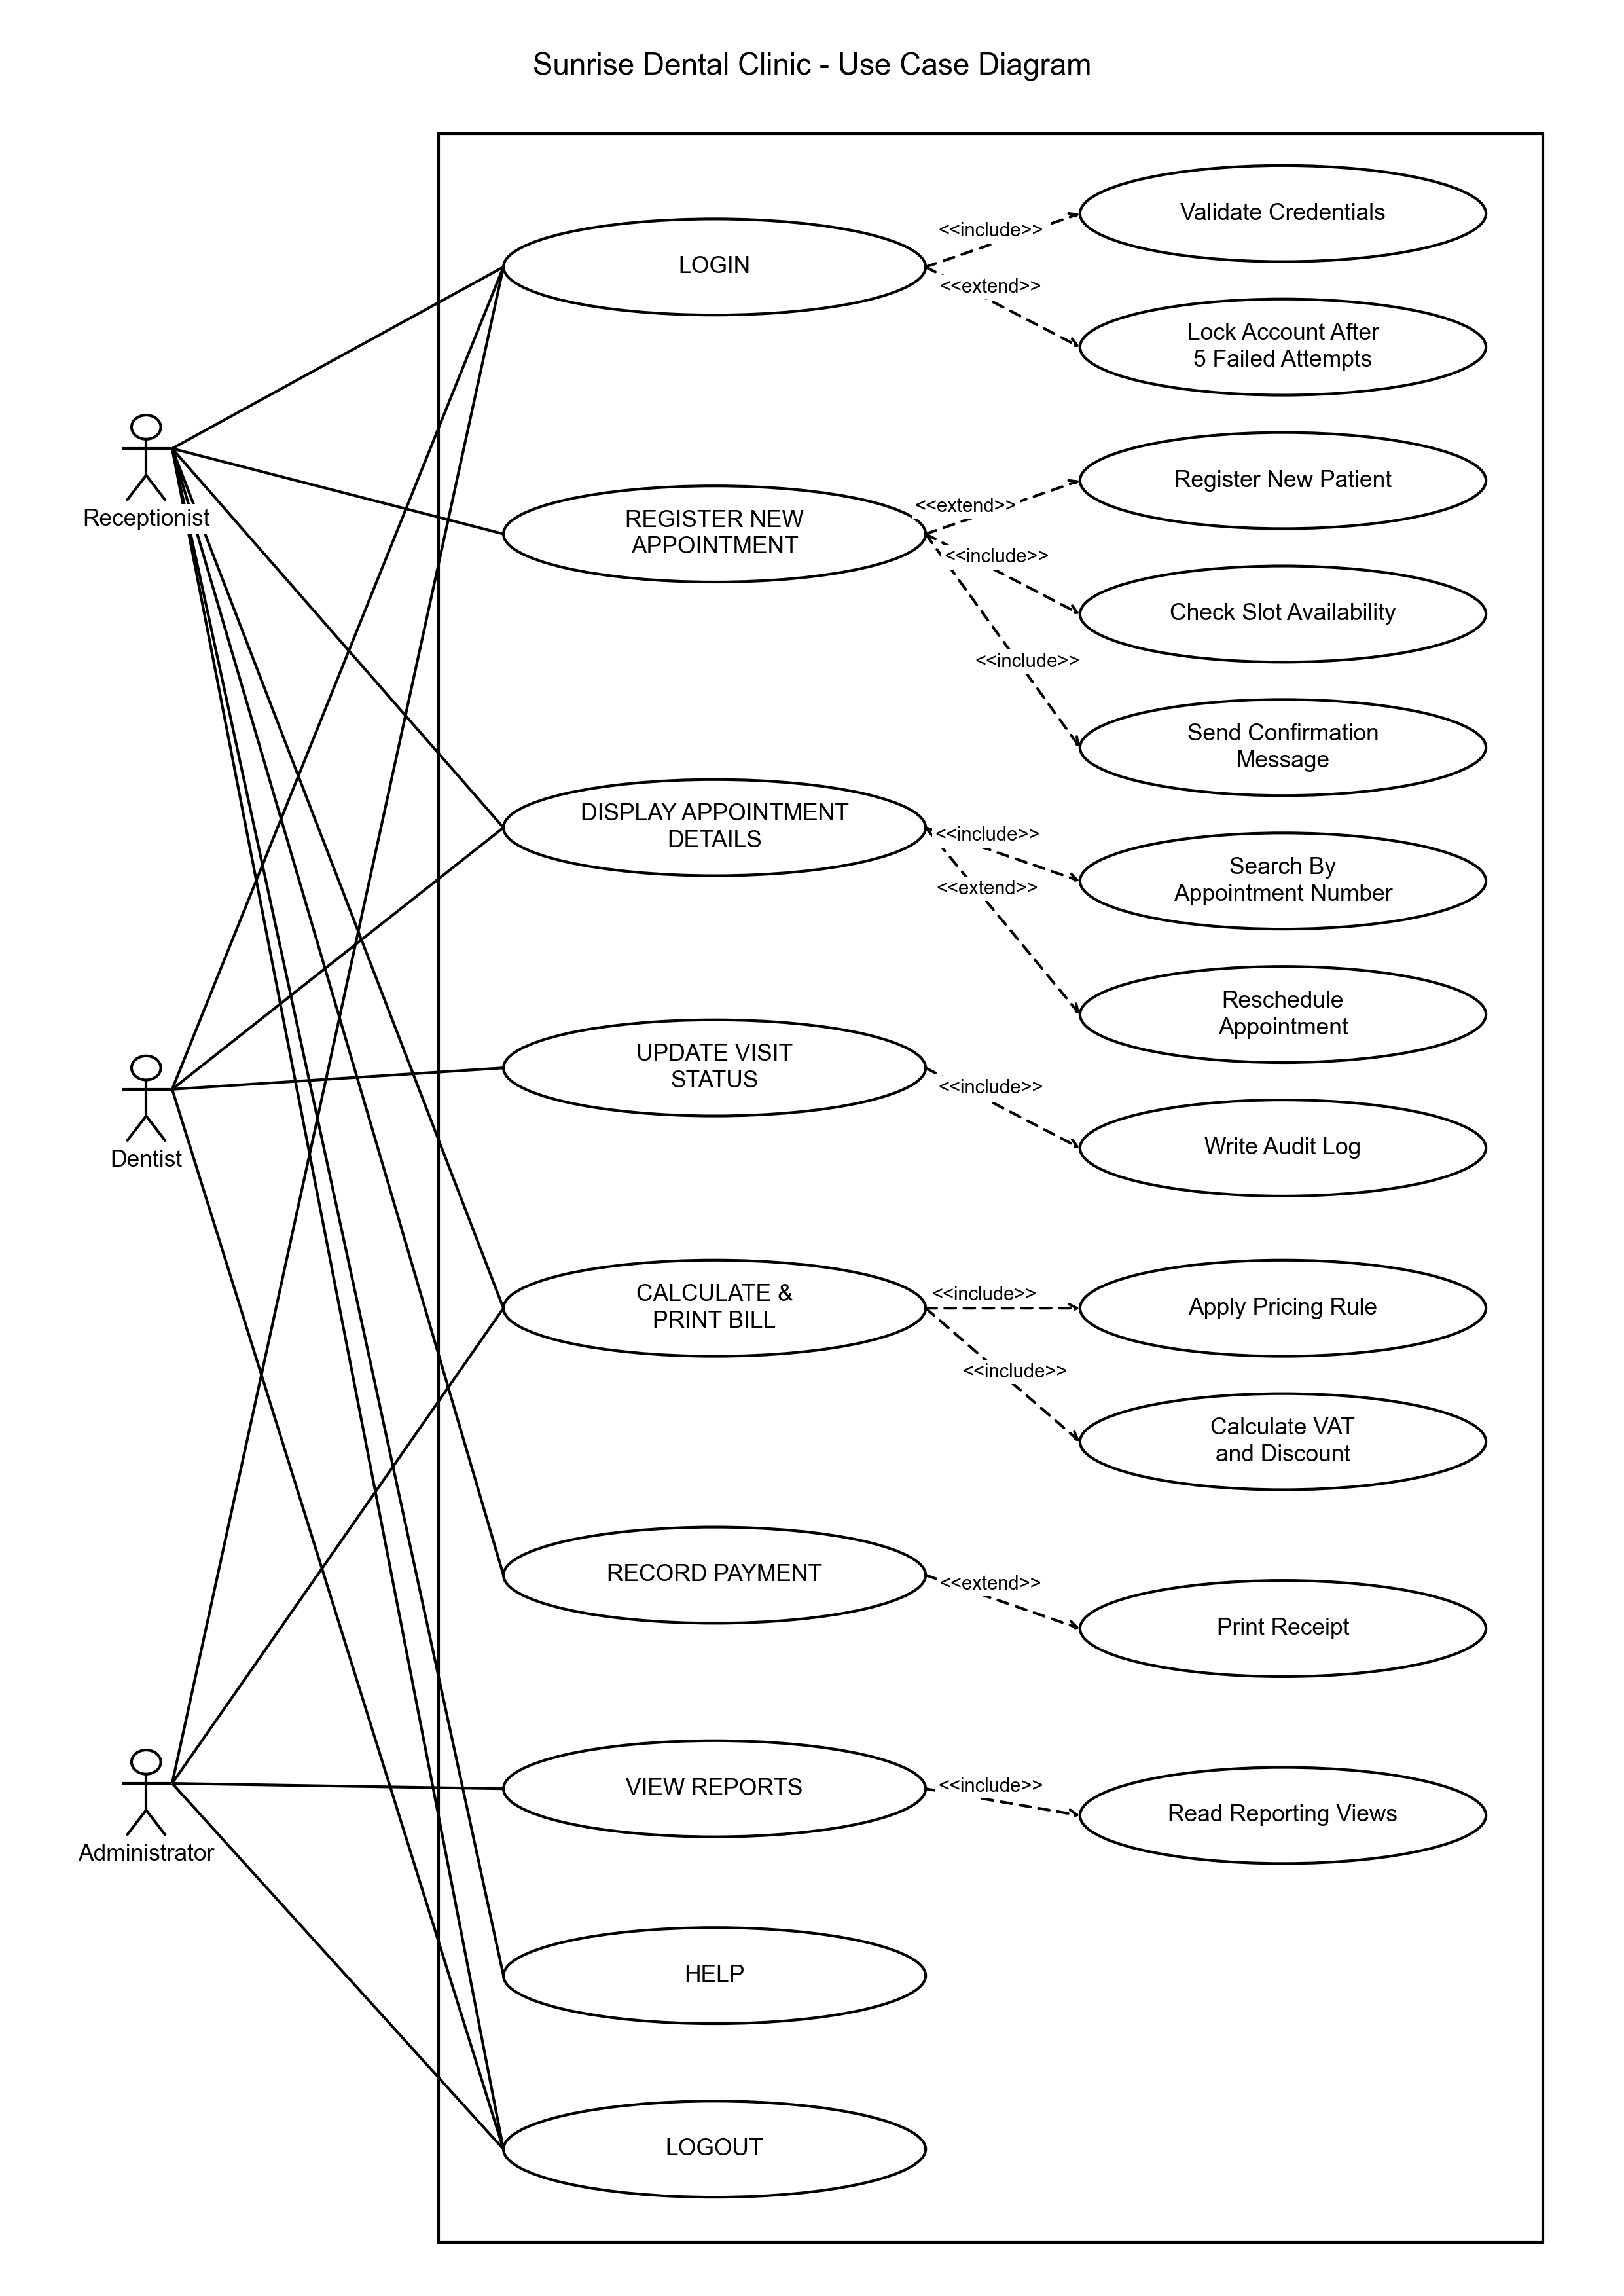
Figure 1 - Use Case Diagram

2. Class Diagram
The class diagram in Figure 2 is drawn from the classes that were actually written; the attribute names, types and method signatures are the ones in the source code. Getters and setters are left out, because listing them would bury the methods that carry the business rules.

2.1 Access Modifiers
- Every attribute is private and shown with a minus sign.
- Every business method is public and shown with a plus sign.
- The four fields inherited from BaseEntity are protected and shown with a hash.
- syncSlotLock() is deliberately private. It maintains the field that prevents double booking, and a slot lock that disagreed with the appointment date would silently break that safeguard.

2.2 Relationships
Relationship | Type | Meaning
Patient - Appointment | Aggregation (1 to 0..*) | A patient books many appointments. Deleting a patient must not silently delete the clinical record of the visits they attended.
Invoice - InvoiceLine | Composition (1 to 1..*) | A line has no meaning apart from its invoice, so the parts die with the whole. The foreign key carries ON DELETE CASCADE.
Appointment - Dentist | Association (0..* to 1) | Navigable one way only. A two-way link would drag a dentist's whole history into memory on every load.
Appointment - Treatment | Association (0..* to 1) | The treatment carries the pricing strategy key used when billing.
Appointment - Invoice | Association (1 to 0..1) | Zero while the visit is scheduled, one once it is billed. Enforced by a unique key so a visit cannot be billed twice.
PricingStrategy hierarchy | Generalisation | Four concrete rules extend one abstract class whose calculate() method is final.

The contrast between aggregation and composition is the important one. Both read as "has many" in ordinary speech and both would be a List in Java, but they behave differently when something is deleted, and the class diagram is where that difference is decided.

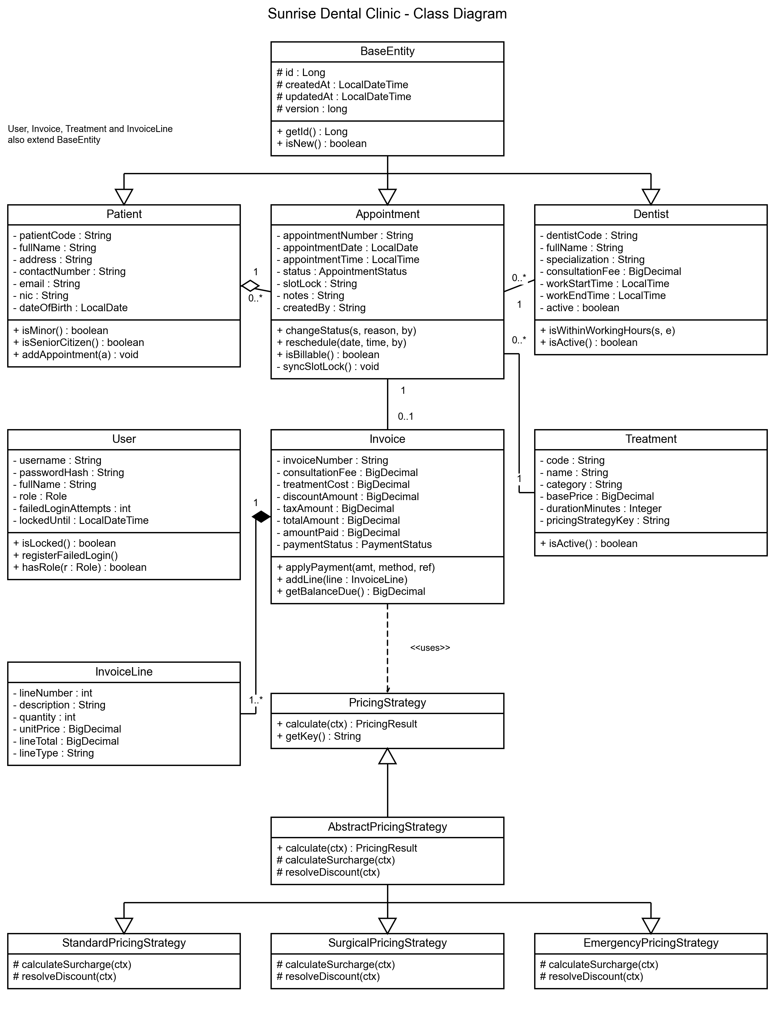
Figure 2 - Class Diagram

3. Sequence Diagrams
Three use cases are shown as sequence diagrams. They were chosen because between them they cover the three hardest parts of the system: security, concurrency and business rules.

3.1 Sign In Sequence Diagram
Figure 3 shows the sign-in flow. An Alternative fragment is used because sign-in has two real outcomes, and both end in the same place: an entry in audit_log with the caller's IP address. The same message is shown whether the username exists or not, so the login page cannot be used to discover which accounts are real.

3.2 Register Appointment Sequence Diagram
Figure 4 is the most important diagram in this report. The Loop fragment runs six validation handlers in a fixed order, cheapest first, so a booking for a date in the past is rejected without touching the database at all. The Optional fragment then shows what happens when the check passes but the slot is taken in the few milliseconds before the save: the unique key refuses the insert and the receptionist is shown a sentence rather than a stack trace.

3.3 Calculate Bill Sequence Diagram
Figure 5 shows the Template Method fragment inside AbstractPricingStrategy. The six steps always run in that order because the method is final; only two of them are answered differently by each subclass. The diagram also shows the total being checked against the database function FN_INVOICE_TOTAL before the invoice is saved.

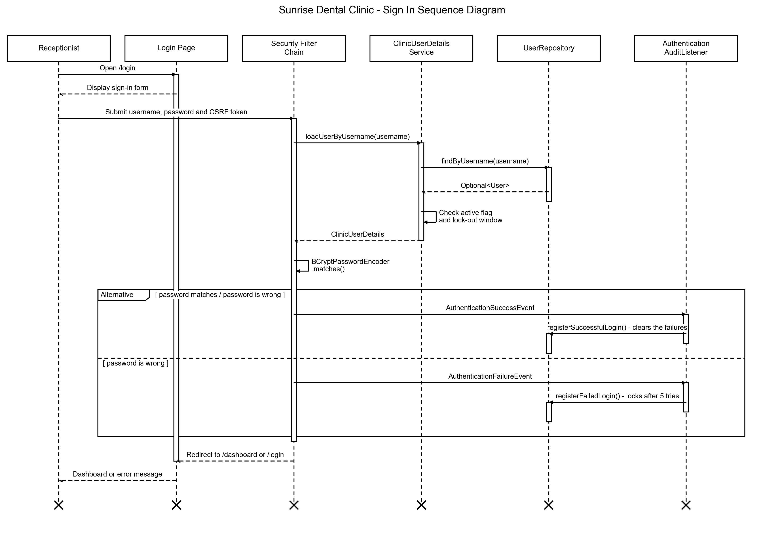
Figure 3 - Sign In Sequence Diagram

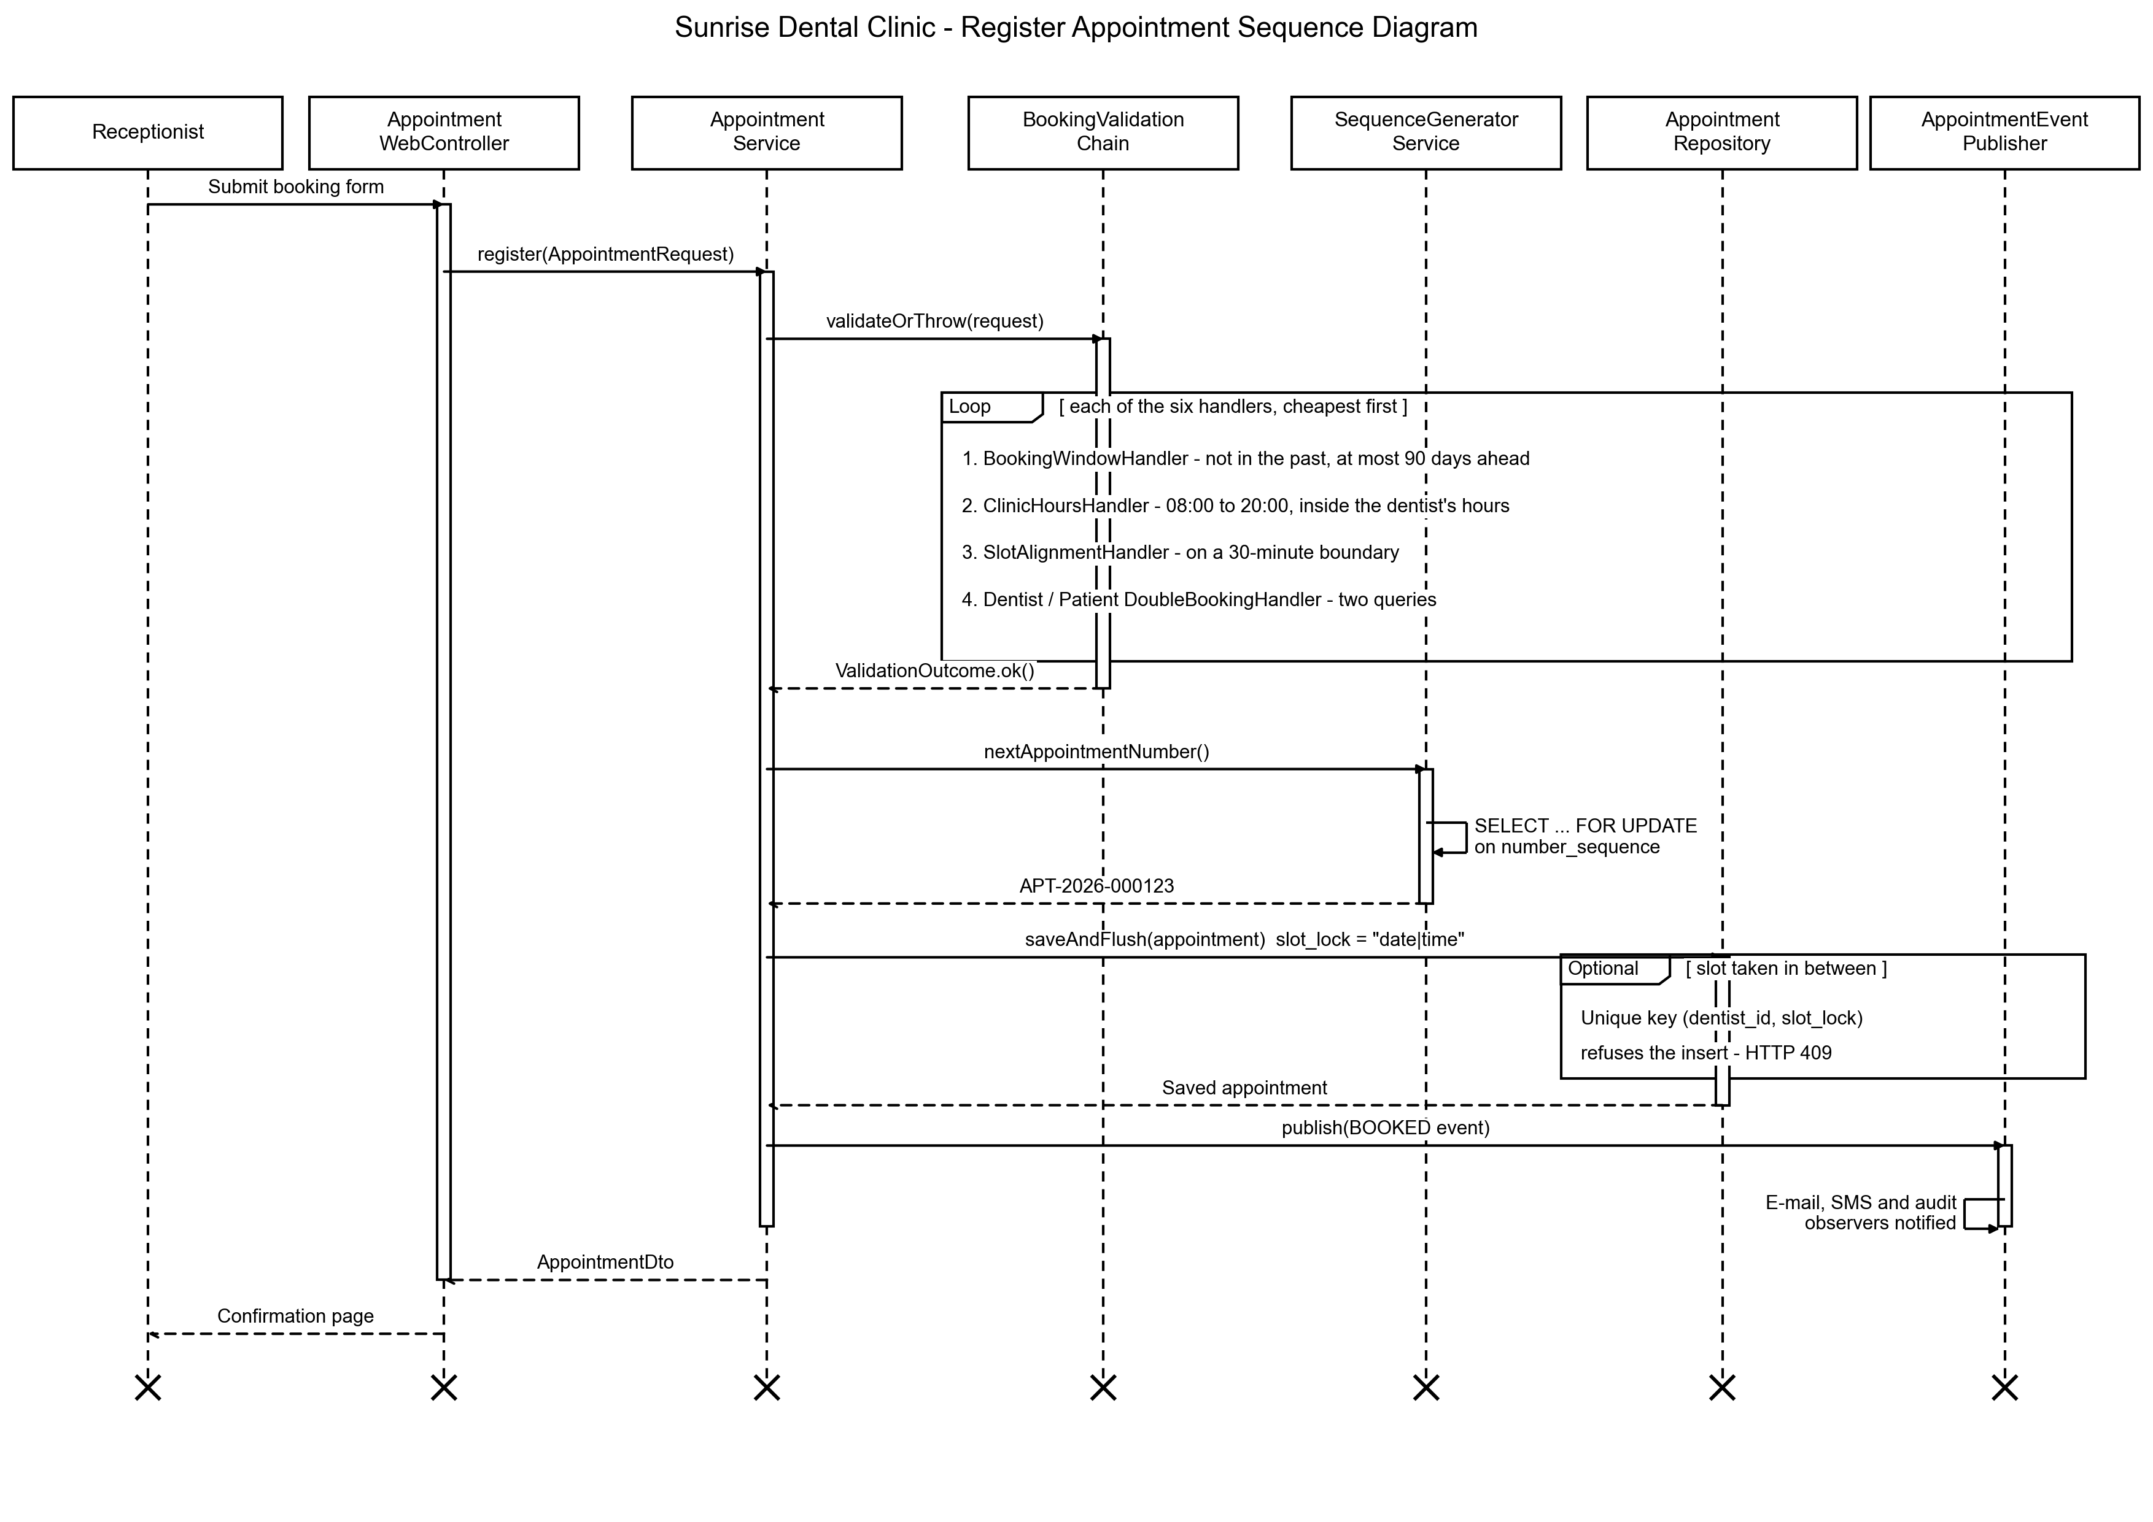
Figure 4 - Register Appointment Sequence Diagram

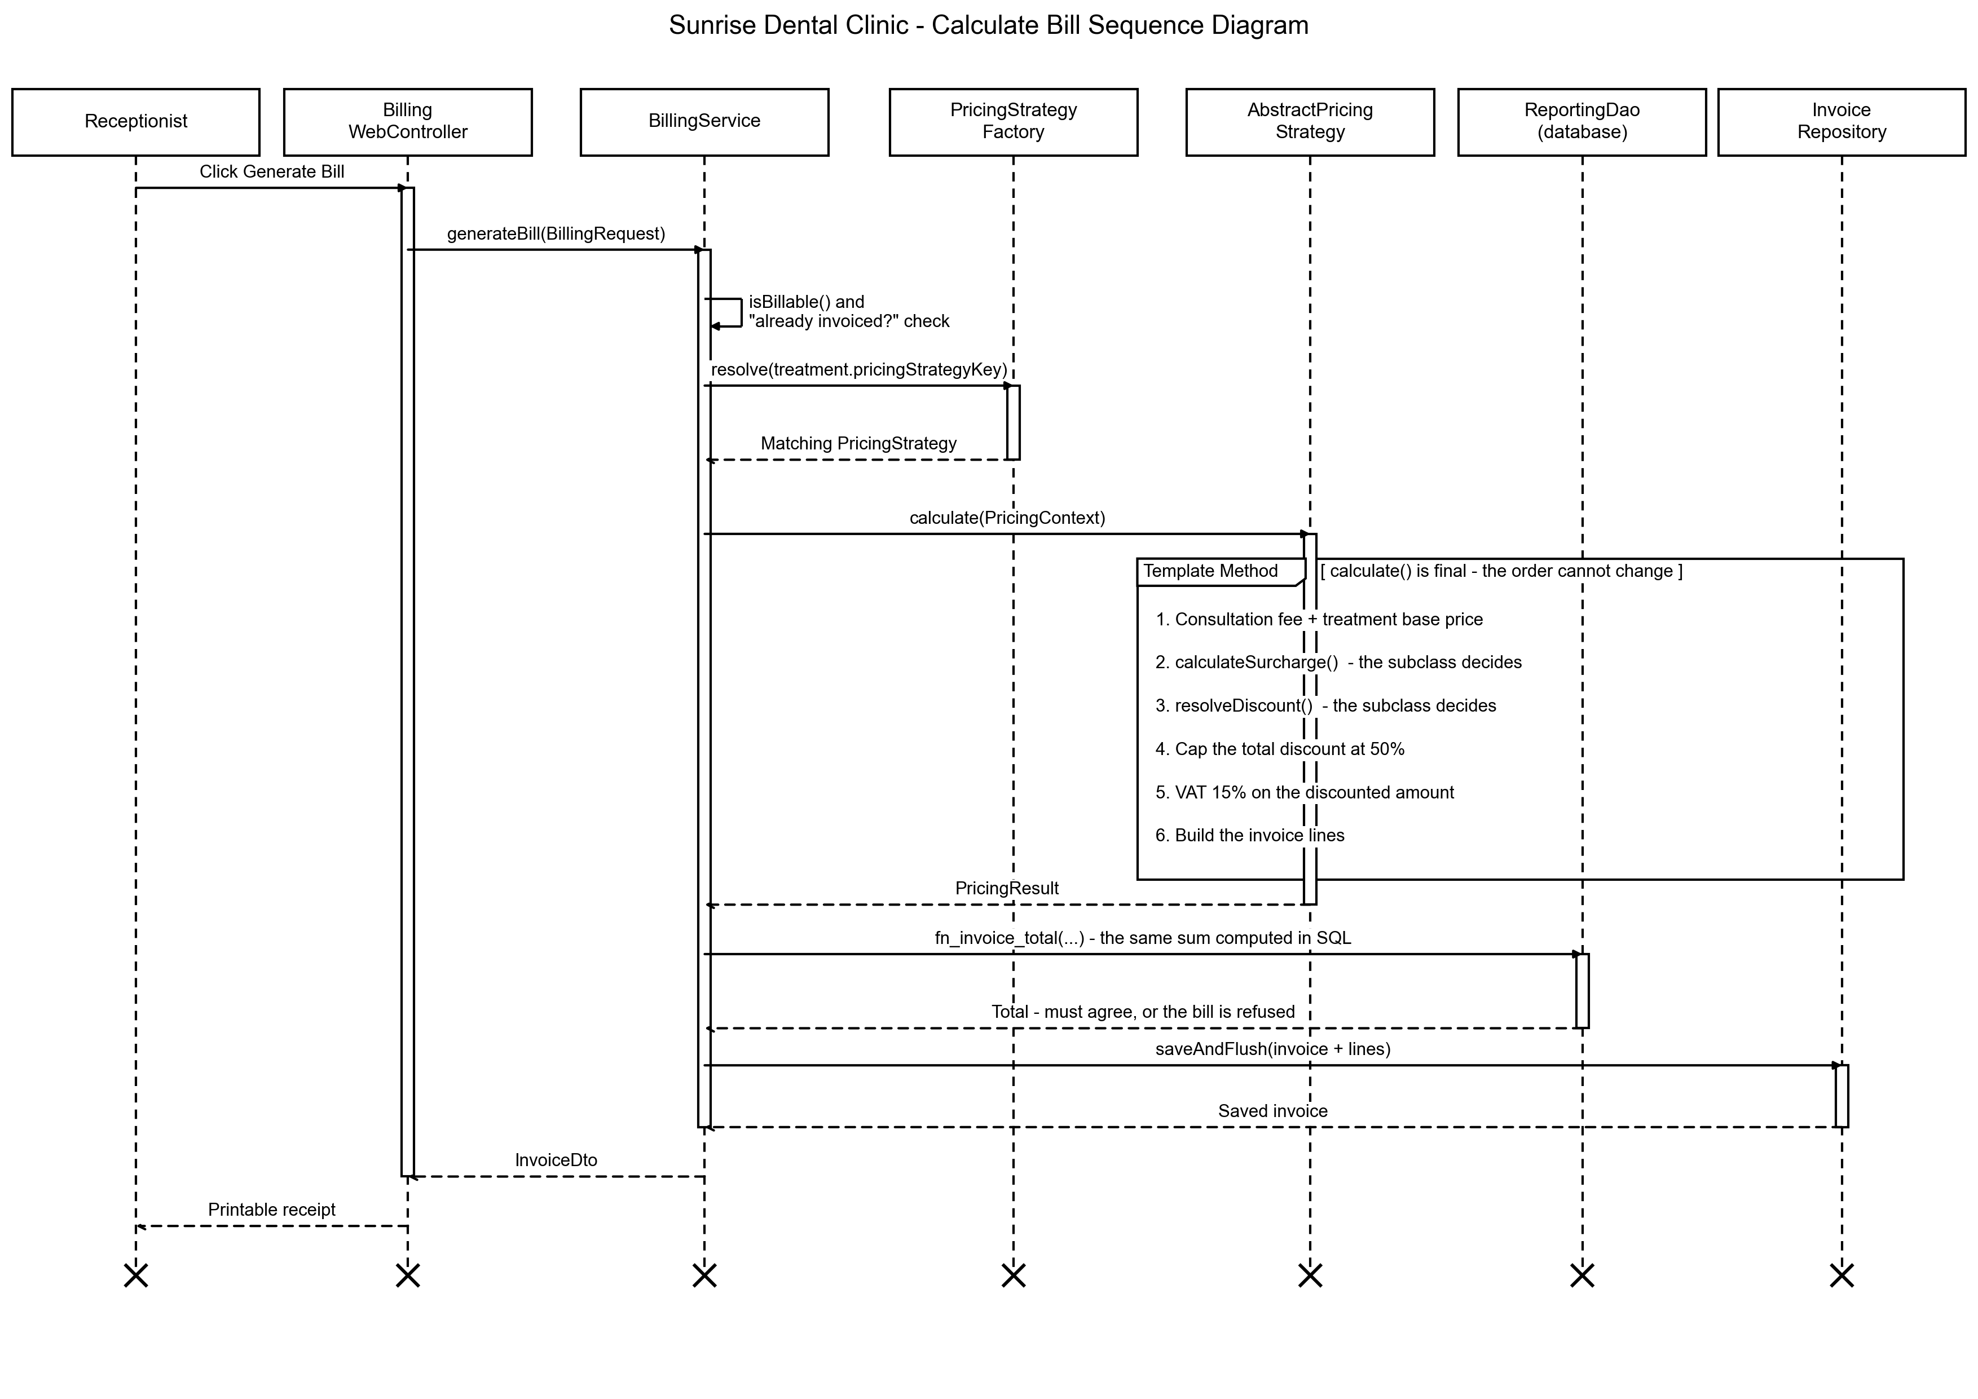
Figure 5 - Calculate Bill Sequence Diagram

Task B
The implementation of the Sunrise Dental Clinic appointment and patient management system follows a structured, modular approach built on a genuine three-tier architecture. This section breaks the system down function by function, explaining the purpose of each, how it is implemented, which design patterns it uses and how it is validated. The system is a distributed application: a Spring Boot server publishes versioned web services, and a separate Java Swing desktop client in its own operating-system process reaches the server over HTTP and JSON only.

1. System Architecture
Figure 6 shows the three tiers. They are separated by a rule that was applied consistently and can be checked: a class may only call downwards. The practical test of whether a layered design is real is whether the top layer can be deleted and the rest still compiles. Here it can, because the desktop client is a different Maven module that does not depend on the server at compile time.
Tier | What lives there | What is not allowed there
Presentation | Thymeleaf controllers, REST controllers, the Swing client, templates and CSS. | Business rules. A controller that decided a discount would put that rule out of reach of the desktop client.
Business | Services, ClinicFacade, pricing strategies, the validation chain, observers and security. | SQL and HTTP. This tier does not know it is reached over the web, which is why the same rules serve both front ends.
Data | Spring Data repositories, ReportingDao, Flyway migrations, views, functions, procedures and triggers. | Decisions. The data tier stores and constrains; it does not choose what the clinic should do.

Three Maven modules make the build mirror the architecture. Because the client depends only on the shared contract module, reaching into a server class from the client is impossible - the compiler stops it. Architecture enforced by the build is worth more than architecture enforced by good intentions.

2. User Authentication (Login)

2.1 Overview
The login function allows staff to authenticate into the system with a username and password. Passwords are never stored or compared as plain text; only a BCrypt hash is held. The process follows a layered architecture, so the controller, the service and the data access are cleanly separated.

2.2 Functional Flow
- The user enters credentials on the Thymeleaf login page.
- Spring Security's filter chain intercepts the POST and reads the credentials together with the CSRF token.
- ClinicUserDetailsService loads the account through UserRepository.
- The account's active flag and lock-out window are checked.
- BCryptPasswordEncoder compares the supplied password with the stored hash.
- On success the session is created and the user is redirected to the dashboard; on failure the same generic error is shown.

2.3 Login Page (login.html)
A Thymeleaf form that posts the username, password and CSRF token. HTML5 required attributes catch empty fields without a round trip, and an opt-in remember-me checkbox is offered.

2.4 Security Configuration (SecurityConfig.java)
Declares two separate filter chains, ordered so that /api/** is matched first. An API caller receives a JSON 401 while a browser user is redirected to the login page. A single chain would have sent HTML login pages to the desktop client.

2.5 User Details Service (ClinicUserDetailsService.java)
Loads the account by username and wraps it in a ClinicUserDetails object carrying the role. It reports the same failure for an unknown username as for a wrong password.

2.6 Audit Listener (AuthenticationAuditListener.java)
Listens for Spring Security's success and failure events and writes an audit_log row for each, including the caller's IP address. The bookkeeping update runs in its own transaction so that two simultaneous sign-ins cannot corrupt each other.
Design Patterns Used
- MVC Pattern: the web controller handles the request and delegates to the service layer.
- Singleton: Spring manages one instance of each security bean.
- Observer: the audit listener reacts to authentication events rather than being called directly.
OOP Concepts Used
- Encapsulation: the password hash is private and there is no getter that returns it in a usable form.
- Abstraction: hashing is hidden behind PasswordEncoder, so no caller knows which algorithm is used.
- Polymorphism: ClinicUserDetails implements Spring Security's UserDetails interface.

2.7 Security Features
- Password Hashing: BCrypt with a per-password salt. Plain text is never stored or logged.
- Account Lock-out: five consecutive failures lock the account for fifteen minutes.
- Session Management: an HTTP session holds the signed-in user; sign-out invalidates it on the server.
- CSRF Protection: a token is required on every form, so a stolen session cookie alone cannot submit one.
- Uniform Error Message: the same message is shown whether the username exists or not, so the page cannot be used to discover valid accounts.

3. Register New Appointment

3.1 Overview
This is the core function of the system and the one that answers the clinic's worst problem. It collects the patient, dentist, treatment, date and time, validates the booking against six independent rules, issues a unique appointment number and saves the record. The appointment number is generated by the server, so there is deliberately no field to type it into.

3.2 Functional Flow
- The receptionist submits the booking form.
- AppointmentWebController passes an AppointmentRequest to AppointmentService.
- The patient is matched by code, NIC or name and telephone, or registered once if new.
- BookingValidationChain applies six rules in order, cheapest first.
- SequenceGeneratorService issues the next appointment number under a pessimistic row lock.
- The appointment is saved with slot_lock set, and a unique database constraint has the final word on double booking.
- An event is published, and the e-mail, SMS and audit observers react independently.

3.3 Booking Form (appointments/form.html)
The dentist, treatment and slot are chosen from reference data rather than typed, so an invalid combination cannot be entered. Free slots are offered up front, so a taken slot is never even requested.

3.4 Appointment Service (AppointmentService.java)
Coordinates the whole operation inside one transaction: resolve the reference data, validate, allocate a number, save, publish. It catches the database's unique-constraint violation and translates it into a sentence a receptionist can act on.

3.5 Validation Chain (BookingValidationChain.java)
Six handlers assembled in a fixed order, logged at start-up: booking window, clinic hours, slot alignment, dentist availability, dentist double booking and patient double booking. The first three need no database access, so a booking for last Tuesday is rejected without a single query, and the chain short-circuits on the first failure.

3.6 Appointment Repository (AppointmentRepository.java)
A Spring Data interface. The save is guarded by uk_appointment_slot on (dentist_id, slot_lock), which is what actually prevents two bookings for one chair.
Design Patterns Used
- Chain of Responsibility: each booking rule is an independent handler that can be tested on its own and reordered without touching the others.
- Builder: Appointment.Builder makes it impossible to create a half-built appointment with an inconsistent slot lock.
- Observer: AppointmentEventPublisher notifies the e-mail, SMS and audit observers and isolates their failures.
- Facade: ClinicFacade collapses multi-call sequences into one round trip for the remote desktop client.
OOP Concepts Used
- Encapsulation: slotLock is private and maintained only by the class that owns it.
- Inheritance: every entity extends BaseEntity, which supplies the identifier, timestamps and version column.
- Polymorphism: the chain calls handle() on each handler without knowing which rule it is.
Data Structures and Algorithms Used
- Short-circuit evaluation: the chain stops at the first failure, so the user is told the most fundamental problem.
- Ordered cost-based execution: the two handlers that cost a database query run last.
- Pessimistic locking: SELECT ... FOR UPDATE on number_sequence, so two receptionists cannot be issued the same appointment number.

3.7 Security Features
- Server-issued identifiers: the client can never choose an appointment number.
- Bean Validation: constraints travel with the DTOs, so the desktop client enforces identical rules with no duplicated code.
- Database constraints: CHECK and UNIQUE constraints hold even against a direct SQL statement.

4. Display Appointment Details

4.1 Overview
The receptionist or dentist searches for an appointment and sees the complete patient and appointment information. The brief asks for search by appointment number; search by patient name and telephone number was added because a patient at the counter rarely remembers their reference.

4.2 Functional Flow
- The user enters an appointment number, a name or a telephone number.
- AppointmentService looks the record up and returns a DTO.
- The page shows the patient, dentist, treatment, date, time, status and any invoice.
- A session-scoped trail remembers recently viewed appointments.
- If nothing matches, a clear message is shown rather than an empty table.

4.3 Search and Detail Pages
appointments/list.html and appointments/view.html. The detail page shows the appointment's full history and offers the actions the signed-in role is allowed to take.

4.4 REST Endpoint (AppointmentApiController.java)
GET /api/v1/appointments/{number} returns the same data as the web page inside the standard response envelope, so the desktop client and the browser can never disagree.

4.5 Recently Viewed Trail (RecentlyViewedTracker.java)
Stored in the HTTP session only. It exists so a receptionist interrupted mid-task can get back to where they were, and it is deliberately not persisted to the database.
Design Patterns Used
- DTO: no JPA entity ever crosses the network.
- Repository: query methods are declared on an interface; no SQL appears in the service.
OOP Concepts Used
- Encapsulation: the session trail is only reachable through its own component.

5. Calculate and Print Bill

5.1 Overview
Billing calculates the total from the consultation fee and the treatment cost, applies the correct pricing rule, caps any discount, adds VAT and produces a printable receipt. The client can never send a price: every figure comes from the dentist and treatment records held on the server.

5.2 Functional Flow
- The receptionist opens a completed appointment and clicks Generate Bill.
- BillingService checks that the visit is billable and has not already been invoiced.
- PricingStrategyFactory resolves the rule named by the treatment's pricing strategy key.
- AbstractPricingStrategy.calculate() runs the six fixed steps.
- The Java total is cross-checked against the database function FN_INVOICE_TOTAL.
- The invoice and its lines are saved, and the receipt is rendered by the server.

5.3 Billing Pages (billing/calculate.html, billing/receipt.html)
Calculate and issue are deliberately two steps, so the receptionist can see the breakdown and apply a discount before anything is committed.

5.4 Billing Service (BillingService.java)
Refuses to bill a visit that has not happened, and refuses to bill the same visit twice. Both refusals are also enforced by database constraints; the checks exist so the user gets a sentence rather than a constraint violation.

5.5 Pricing Strategy Factory (PricingStrategyFactory.java)
Registers every strategy automatically from the Spring context, so adding a rule cannot mean forgetting to register it. If reference data names a rule that does not exist, it falls back to the standard rule and logs a warning.

5.6 Abstract Pricing Strategy (AbstractPricingStrategy.java)
calculate() is declared final and performs the invariant sequence: fees, surcharge, discount, a 50% cap, VAT, then the invoice lines. Only calculateSurcharge() and resolveDiscount() are abstract, so a subclass decides how much but never in what order.
Design Patterns Used
- Strategy: four genuinely different billing policies - standard, surgical, cosmetic and emergency. A switch statement would put every future rule inside the one method that prints every bill in the clinic.
- Template Method: the order of the billing steps is fixed by tax law and is final; only the two variable steps are overridable.
- Factory: turns a database value into an object without any caller naming a concrete class.
OOP Concepts Used
- Abstraction: BillingService never learns which pricing rule ran.
- Inheritance: the four rules share the invariant sequence from one abstract parent.
- Polymorphism: one call site invokes whichever rule the treatment names.
Data Structures and Algorithms Used
- Ordered arithmetic: VAT is applied after the discount, because VAT on a discounted amount differs from VAT on an undiscounted one.
- Bounded value: the total discount is capped at 50% before tax is computed.
- Cross-verification: the same total is computed independently in Java and in SQL and the two are compared.

5.7 Security Features
- No client-supplied prices: fees come from the dentist and treatment records only.
- Immutable snapshot: every figure is stored on the invoice, so a historic receipt does not change when the price list does.
- Payment ceiling: a CHECK constraint prevents a payment greater than the total.

6. Reports and Help

6.1 Overview
Five management reports support decisions the clinic actually has to make, and a help section gives new staff step-by-step instructions as the brief requires.

6.2 Functional Flow
- The administrator opens the reports page and chooses a report and a date range.
- ReportGeneratorFactory resolves the requested report.
- The generator reads a database view rather than assembling joins in Java.
- The result is returned in one shared envelope, so a single page displays any report.
- The help topics are served from the same API the desktop client uses, so both front ends always agree.

6.3 Report Generators (service/report)
Each generator extends AbstractReportGenerator, which fixes the shape of every report. Adding a sixth report requires no user interface work at all.

6.4 Reporting DAO (JdbcReportingDao.java)
A hand-written JDBC DAO for reporting reads, which aggregate thousands of rows and belong in SQL rather than in Java loops.

6.5 Help Service (HelpService.java)
Eight topics and forty-two numbered steps, served from one place so the browser and the desktop client cannot drift apart.
Design Patterns Used
- Template Method: the report skeleton is fixed; only the query and the row mapping vary.
- Factory: report generators register themselves.
- DAO: reporting SQL is isolated from the business tier.
Report | Question it answers | Decision it supports
Daily Schedule | Who is coming in today, and to which dentist? | Staffing the front desk and preparing the surgeries.
Revenue | What did the clinic take, by day and by treatment? | Whether a treatment is worth continuing to offer.
Outstanding Invoices | Who owes money, and for how long? | Which debts to chase first; the ageing bands come from FN_AGEING_BUCKET.
Dentist Workload | How busy is each dentist? | Rebalancing the rota and deciding whether to recruit.
Treatment Popularity | Which treatments are most in demand? | Stock ordering and continuing-education choices.

7. Database Design
Figure 7 shows the physical schema: nine tables, five views, two stored functions, two stored procedures and four triggers. The schema is owned by versioned Flyway migration scripts and Hibernate runs with ddl-auto=validate, so the application refuses to start if the Java entities and the real schema disagree.

7.1 How Double Booking Is Actually Prevented
The validation chain checks whether a slot is free, but between that check and the insert there is a window of a few milliseconds in which another transaction can commit the same slot. Any solution that lives only in Java has this window.
The solution is a column called slot_lock and a unique constraint on (dentist_id, slot_lock). While an appointment occupies a chair, slot_lock holds the string "date|time"; when the visit is cancelled or missed it is set back to NULL. Because SQL never treats two NULLs as equal, any number of cancelled appointments can share a dentist and slot, while two live ones cannot. A database constraint has no race window.
This was verified rather than assumed. Twelve genuinely simultaneous booking requests for the same dentist, date and time produced exactly one success and eleven clean HTTP 409 responses, repeated against three fresh databases.

7.2 Advanced Database Features
Feature | Name | Business rule it implements
Function | FN_INVOICE_TOTAL | Recomputes an invoice total in SQL. Every bill is checked against it, so a rounding mistake in Java is caught first.
Function | FN_AGEING_BUCKET | Puts a debt in a 0-30 / 31-60 / 61-90 / 90+ day band. The report calls it, so it cannot disagree with an ad-hoc query.
Procedure | SP_SETTLE_INVOICE | Applies a payment and updates the status in one atomic operation.
Procedure | SP_DAILY_CLOSING_SUMMARY | Produces the end-of-day figures needed to cash up.
Trigger | trg_appointment_before_insert | Refuses a booking outside the dentist's working hours, even from a direct SQL insert (MySQL).
Triggers | trg_appointment_audit, trg_invoice_payment_audit | Write the audit trail at database level, so a change made outside the application is still recorded.
Views | 5 reporting views | Reports read views, so the definition of revenue lives in one place.
Constraints | FK, UNIQUE and CHECK on every table | Discounts cannot exceed 50%, payments cannot exceed the total, and a status must be one of the permitted values.

Two database engines are supported from one codebase: H2 in file mode by default, so the application runs with nothing to install, and MySQL 8 through a Spring profile. The MySQL path was tested end to end against a real server; all four migrations, both functions, both procedures and every trigger were exercised with real data.

8. Validation Mechanisms
Validation is applied in four places, on the principle that each layer should refuse whatever it can prove is wrong.
Layer | Mechanism | Example
Browser | HTML5 required, type and pattern attributes | An empty patient name is caught without a round trip.
Shared DTO | Bean Validation annotations in dental-common | A telephone number must match the Sri Lankan format. The desktop client enforces the identical rule with no duplicated code.
Business tier | The six-handler booking validation chain | A booking outside the dentist's own working hours is refused.
Database | CHECK, UNIQUE and FOREIGN KEY constraints, triggers | A discount above 50% is refused even from a SQL console.

Messages are written for a receptionist rather than a developer. Instead of a constraint violation, the user is told which slot is taken and what to do about it, while the response envelope carries a stable error code so the desktop client can react programmatically to the same failure.

9. Sessions and Cookies
- HTTP session: carries the signed-in user and the recently viewed trail, so a receptionist interrupted mid-task can return to where they were.
- Remember-me cookie: opt-in, saving the front-desk machine from signing in again every morning.
- Preference cookie: stores the chosen table density for that workstation.
- CSRF token: required on every form, so a stolen session cookie alone cannot submit one.

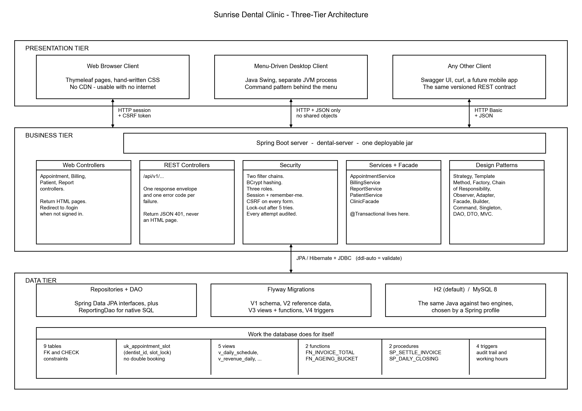
Figure 6 - Three-Tier Architecture

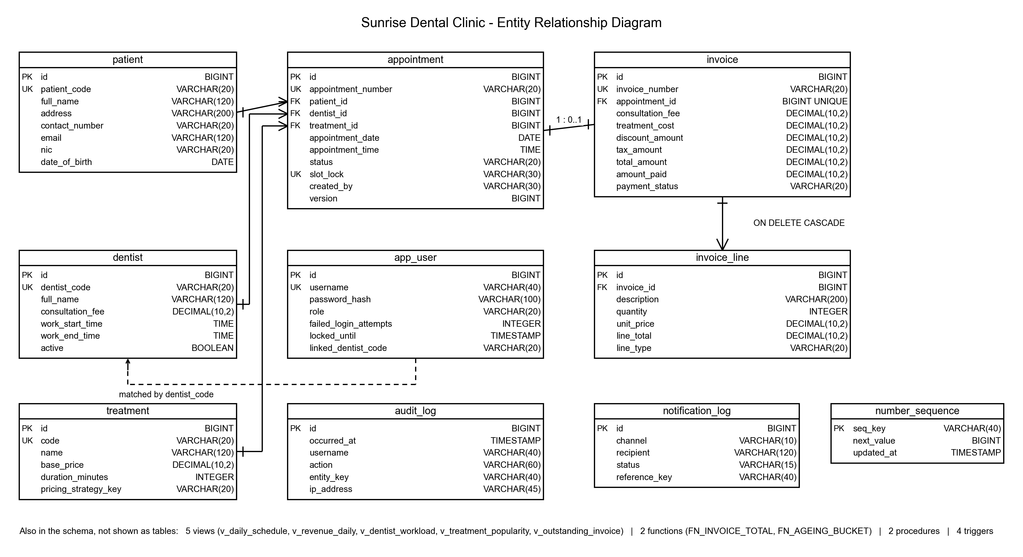
Figure 7 - Entity Relationship Diagram

Task C
This section documents the testing approach, the test plan, the test data and the results. The clinic's existing problems are all failures of correctness under pressure, so the suite was designed to prove that the rules hold when they are attacked, not merely that the happy path works.

1. Test Rationale and Test-Driven Development
Testing was carried out at three levels, so that each failure is diagnosed as cheaply as possible.
Level | Count | What it proves
Unit tests | 226 | One class behaves correctly in isolation. JUnit 5 with Mockito, no Spring context and no database, so a failure points at one class.
Integration tests | 97 | The parts work together against the real Flyway schema, with real constraints, views, functions and triggers.
Concurrency tests | - | The rules hold under a genuine race, using a purpose-written multi-threaded client.

Test-driven development was applied where it genuinely helps. The billing rules, the appointment lifecycle and the validation chain were written test-first in the red-green-refactor cycle, because they have clear inputs, clear outputs and rules that can be stated in a sentence. Before any code existed, a test asserted that a cancelled appointment cannot become completed; writing that test forced a decision that had been vague until then, and the resulting enum owns the rule so no service can bypass it.
Test-driven development was deliberately not used for the Thymeleaf templates or the Swing windows. Writing a failing test for the position of a form field would lock in a layout before anyone had looked at it. Those parts were built, reviewed by eye, and then covered by integration tests that assert on behaviour rather than on markup.
One case shows the cycle earning its keep. A test asserted that rescheduling an appointment must not report a clash with itself. It failed, as expected; the interesting part was why. The double-booking query excluded nothing, so an appointment was its own conflict. That is a bug a manual tester would have found only after a receptionist reported it.

2. Test Data
Test data was devised to cover boundaries rather than typical values, because a bug almost never lives in the middle of a range.
Category | Values used
Valid, ordinary | A 34-year-old patient, a routine filling at 10:00 next Tuesday, paid in full by card.
Boundary - age | Exactly 18 (not a minor by one day), exactly 60 (senior concession), and 17 and 61 either side.
Boundary - time | 08:00 (first legal slot), 20:00 (first illegal), 09:29 and 09:30 either side of the 30-minute grid.
Boundary - money | A discount of exactly 50% (allowed) and 50.01% (refused); a payment equal to the total, and one cent more.
Boundary - dates | Today, yesterday (refused), 90 days ahead (allowed) and 91 (refused).
Invalid | Blank name, nine-digit telephone number, negative price, unknown treatment code, forbidden status transition.
Malicious | A form posted with no CSRF token, a receptionist requesting an administration page, an API call with no credentials.
Concurrent | Twelve threads released simultaneously against one dentist, one date and one time.

3. Test Plan
Test ID | Function | Input Data | Expected Result
T-001 | User Login (valid) | Username: admin  Password: Admin@123 | System authenticates the user  Displays the dashboard
T-002 | User Login (invalid password) | Username: admin  Password: wrongPass | System denies access  Displays "Invalid username or password"
T-003 | Account lock-out | Five consecutive failed sign-in attempts | Account is locked for 15 minutes  Further attempts are refused
T-004 | Register New Appointment | Patient: Kamala Perera  Address: No. 45, Galle Road, Colombo 03  Contact: 0771234567  Dentist: Dr Nimal Perera  Treatment: Composite Filling  Date: next Tuesday, Time: 10:00 | System issues APT-2026-000123  Displays "Appointment registered successfully"
T-005 | Register Appointment (missing fields) | Patient name: (empty)  Contact: 0771234567 | System prevents saving  Prompts "Patient name is required"
T-006 | Register Appointment (duplicate slot) | Same dentist, same date, same time as an existing booking | System refuses the booking  Displays "That slot is no longer available"
T-007 | Display Appointment Details | Appointment number: APT-2026-000123 | System fetches and displays the patient, dentist, treatment, date, time and status
T-008 | Display Appointment (unknown number) | Appointment number: APT-9999-999999 | System displays "No appointment found" rather than an empty table
T-009 | Calculate and Print Bill | Appointment: APT-2026-000123 (completed)  Consultation fee: Rs. 2,000.00  Treatment: Rs. 6,200.00  Discount: 10% | Sub-total Rs. 8,200.00, discount Rs. 820.00,  VAT 15% Rs. 1,107.00, total Rs. 8,487.00  Printable receipt is produced
T-010 | Bill an appointment that is not completed | Appointment: APT-2026-000124 (status SCHEDULED) | System refuses  Displays "Only a completed appointment can be billed"
T-011 | Bill the same appointment twice | Appointment: APT-2026-000123 (already invoiced) | System refuses  Displays the existing invoice number
T-012 | Discount above the permitted cap | Discount: 60% | System refuses  Discount is capped at 50% by a CHECK constraint
T-013 | Record Payment | Invoice: INV-2026-000045  Amount: Rs. 8,487.00, Method: Card | Payment status becomes PAID  Balance due becomes Rs. 0.00
T-014 | Over-payment | Amount: Rs. 10,000.00 against a Rs. 8,487.00 invoice | System refuses  A payment cannot exceed the total
T-015 | View Management Reports | Report: Revenue, range: last 30 days | System displays the revenue report read from v_revenue_daily
T-016 | Unauthorised access restriction | Signed in as RECEPTIONIST  Request /admin/users | System blocks the request  Displays "Access Denied"
T-017 | Web service endpoint | GET /api/v1/appointments with HTTP Basic credentials | Returns HTTP 200 and the standard JSON envelope
T-018 | Web service without credentials | GET /api/v1/appointments with no credentials | Returns HTTP 401 with a JSON body, not an HTML login page
T-019 | Concurrent booking of one slot | Twelve simultaneous requests for the same dentist, date and time | Exactly one succeeds  Eleven receive HTTP 409 SLOT_UNAVAILABLE
T-020 | User Logout | User selects Sign out | Session is invalidated on the server  Returns to the login screen

4. Test Cases
Each test case below was executed against the running system. The screenshot in each table is evidence of the actual result.
Test Case ID | T-001
Function | User Login (valid)
Input Data | Username: admin  Password: Admin@123
Expected Result | System authenticates the user and displays the dashboard
Actual Result | Signed in successfully and redirected to the dashboard
Screenshot | 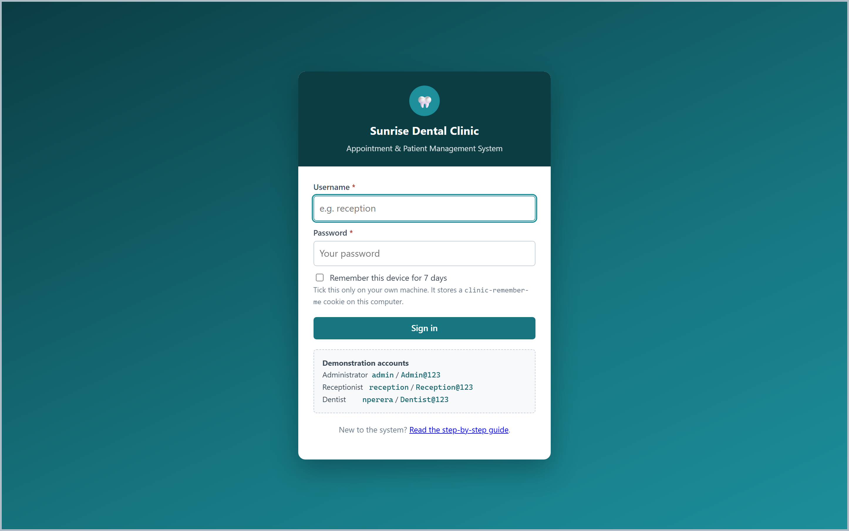

Test Case ID | T-002
Function | Dashboard after sign-in
Input Data | Signed in as admin
Expected Result | Dashboard shows today's appointments, outstanding invoices and revenue
Actual Result | Dashboard displayed with live figures from the seeded data
Screenshot | 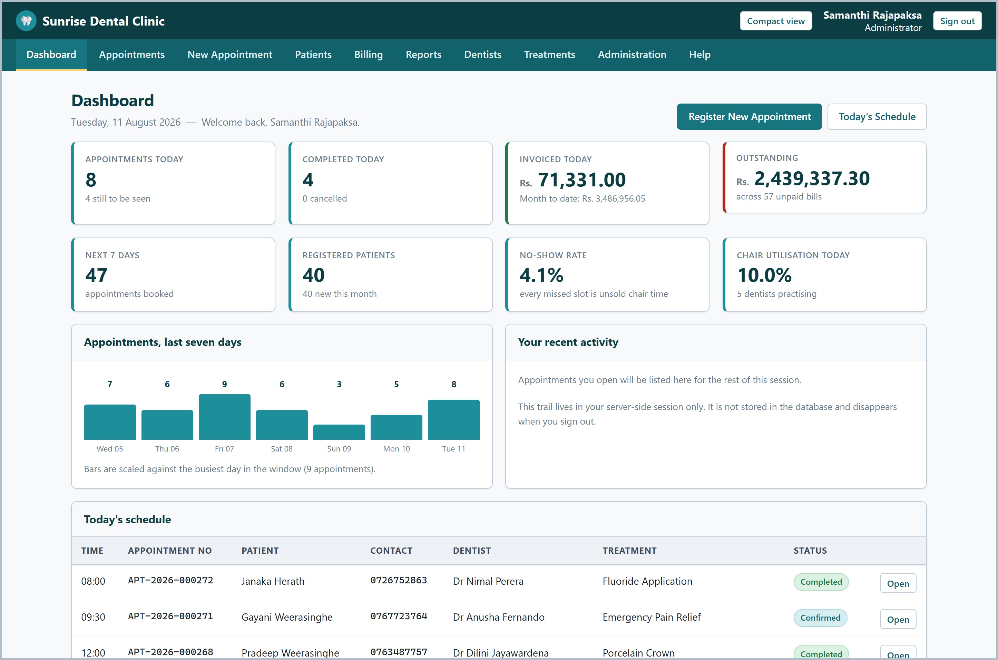

Test Case ID | T-004
Function | Register New Appointment
Input Data | Patient: Kamala Perera  Dentist: Dr Nimal Perera  Treatment: Composite Filling  Date: next Tuesday, Time: 10:00
Expected Result | System issues a unique appointment number and confirms the booking
Actual Result | Appointment registered and the number issued automatically
Screenshot | 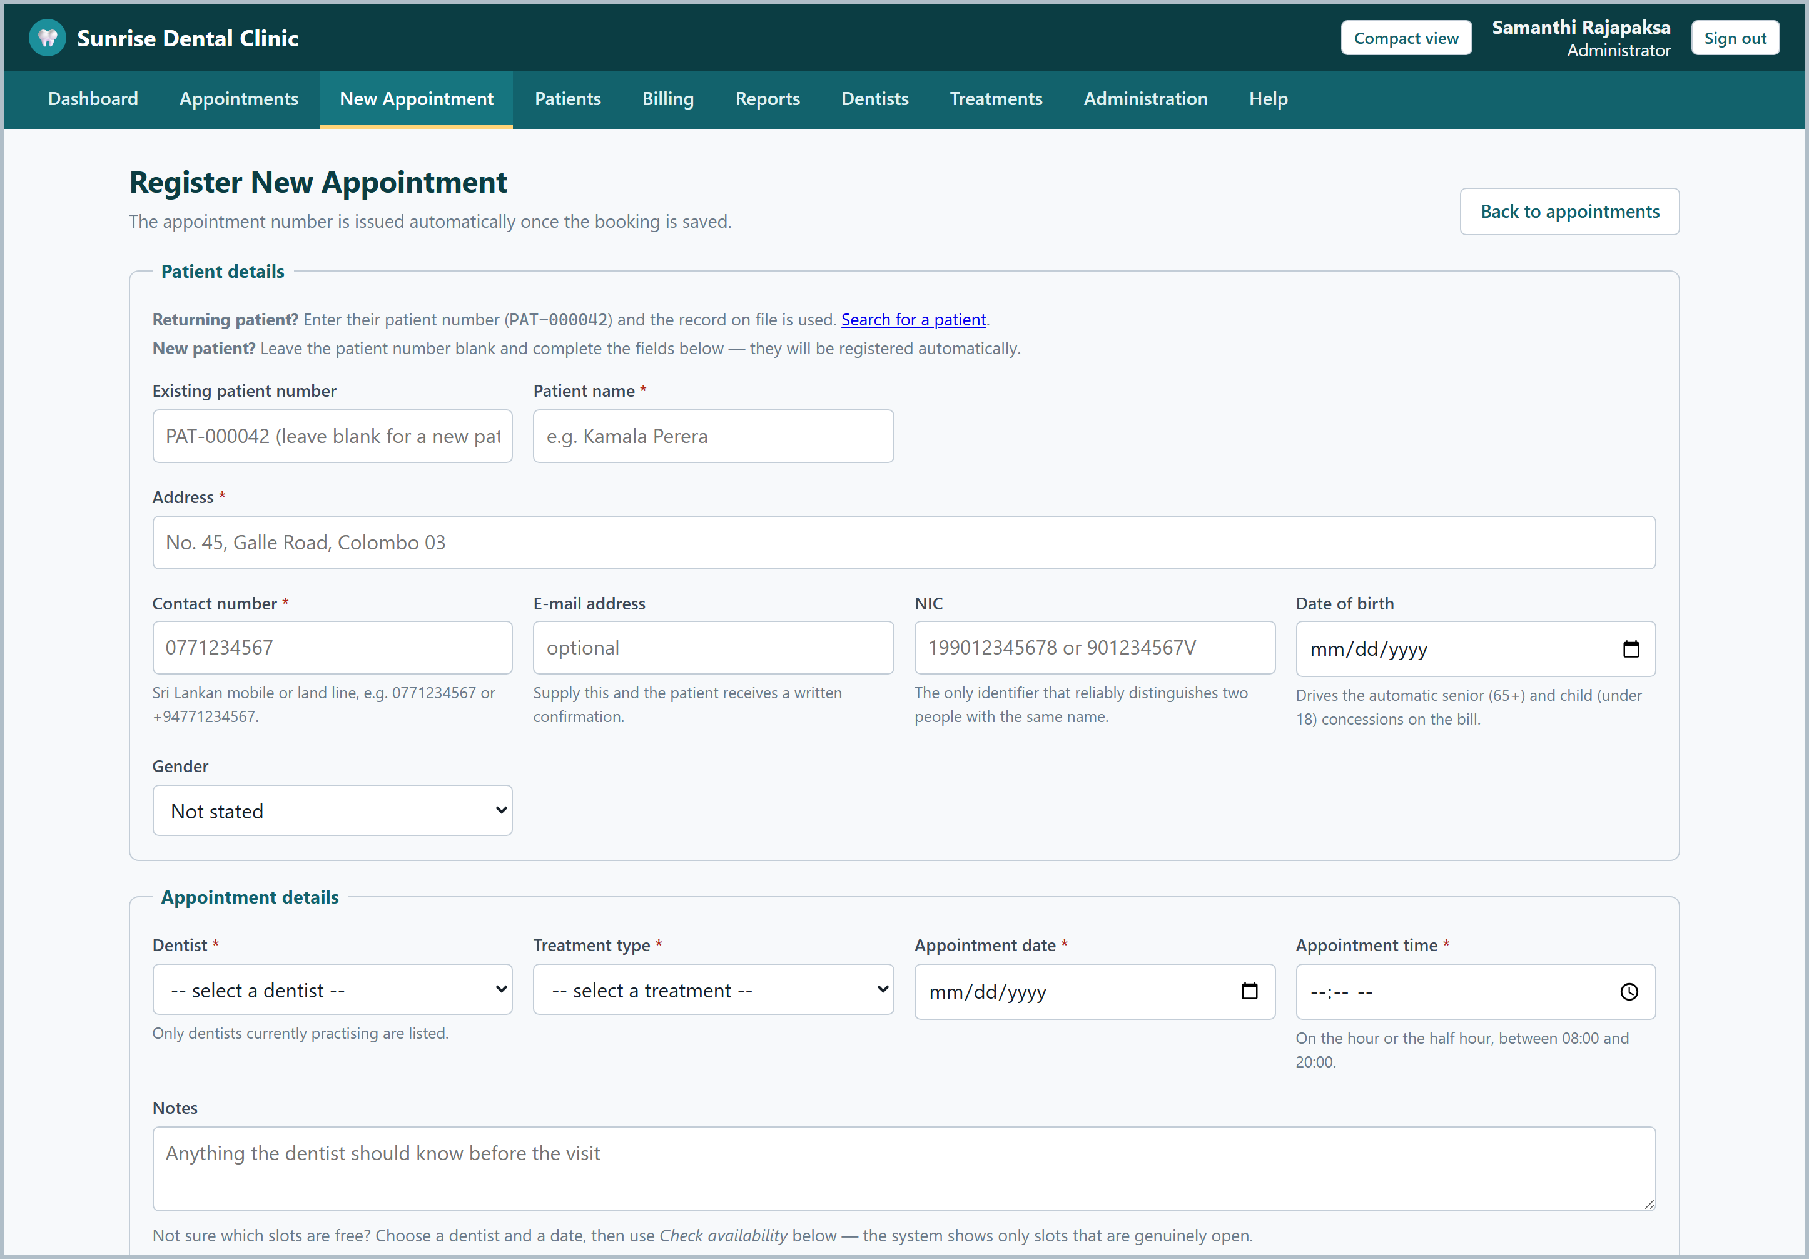

Test Case ID | T-007
Function | Display Appointment Details
Input Data | Appointment number: APT-2026-000123
Expected Result | System displays the full patient and appointment information
Actual Result | All details displayed correctly, including the linked invoice
Screenshot | 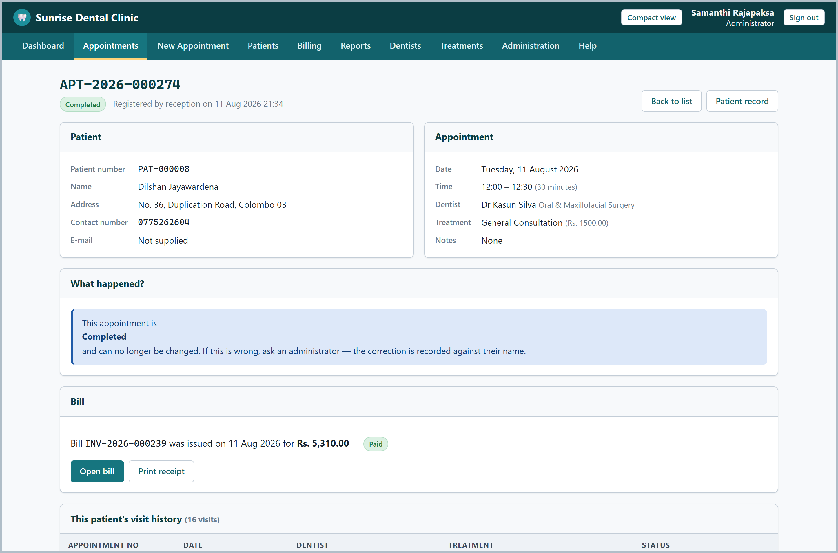

Test Case ID | T-009
Function | Calculate and Print Bill
Input Data | Completed appointment with a 10% discount
Expected Result | System shows consultation fee, treatment cost, discount, VAT and total
Actual Result | Bill calculated correctly and the breakdown displayed
Screenshot | 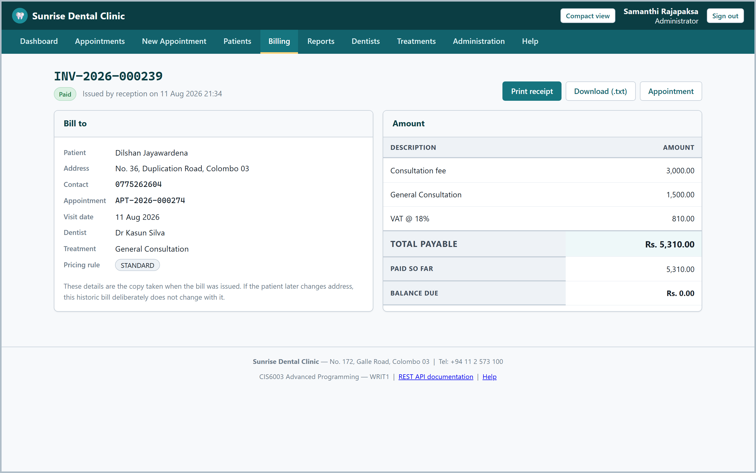

Test Case ID | T-009b
Function | Print Receipt
Input Data | Invoice: INV-2026-000045
Expected Result | A printable receipt is produced by the server
Actual Result | Receipt rendered; the browser and the desktop client print identically
Screenshot | 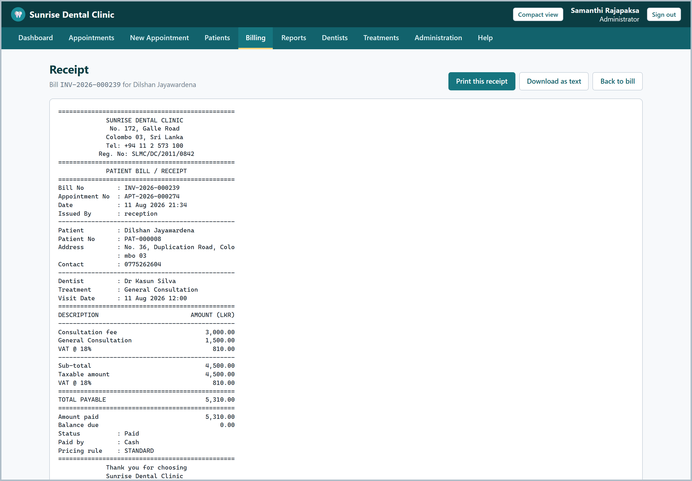

Test Case ID | T-015
Function | View Management Reports
Input Data | Report: Revenue, range: last 30 days
Expected Result | System displays the revenue report read from the database view
Actual Result | Report displayed with revenue grouped by day and treatment
Screenshot | 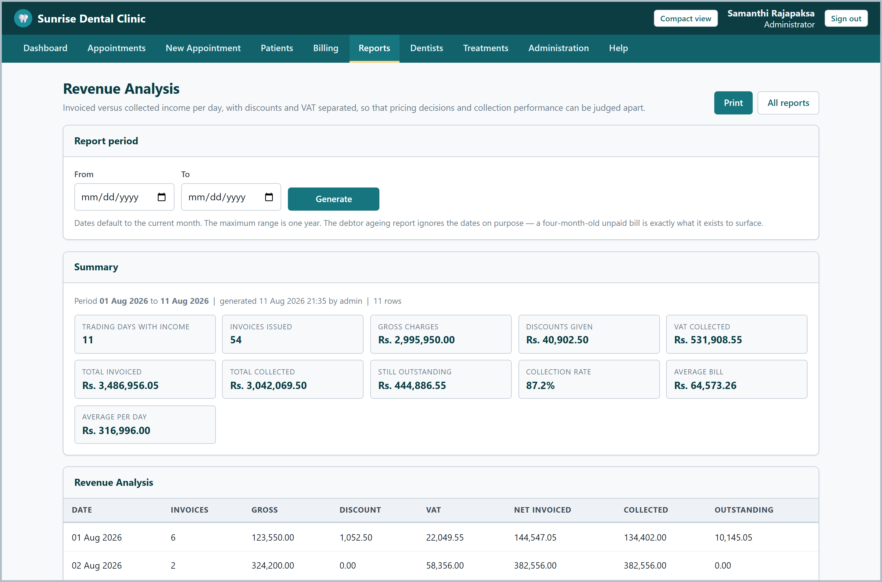

Test Case ID | T-016
Function | Audit Trail
Input Data | Signed in as admin, open Administration then Audit Trail
Expected Result | Every sign-in and every change is listed with its IP address
Actual Result | Audit entries displayed, written by both the application and the database triggers
Screenshot | 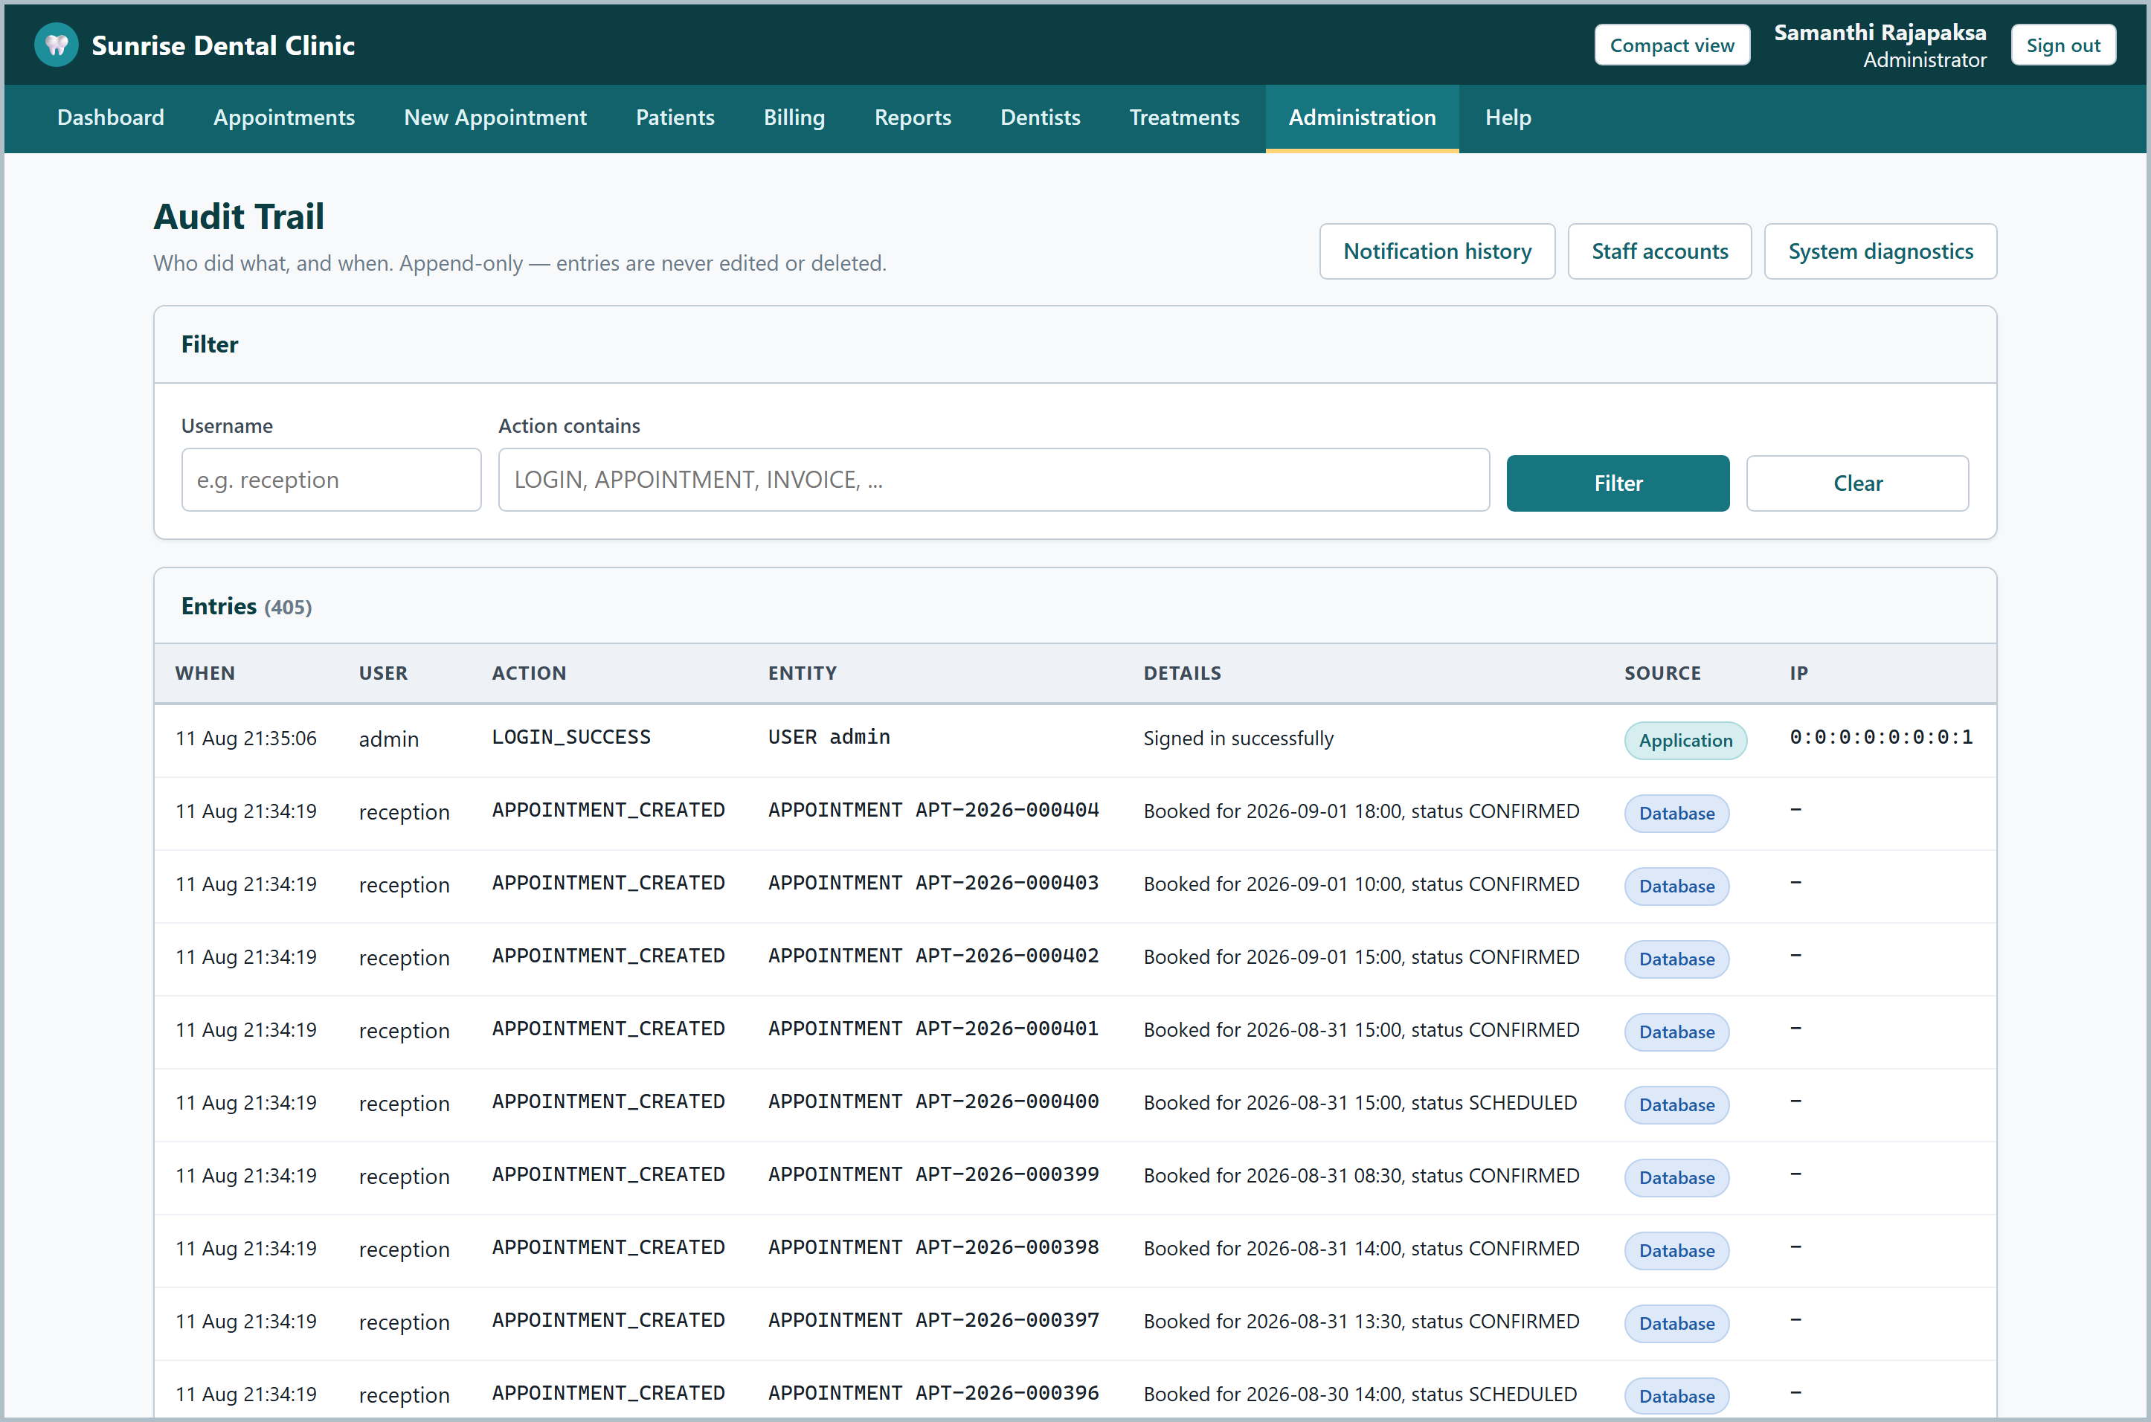

Test Case ID | T-017
Function | Notification History
Input Data | Open Administration then Notifications
Expected Result | Every alert attempt is listed, successful or failed
Actual Result | Notification log displayed with the channel and delivery status
Screenshot | 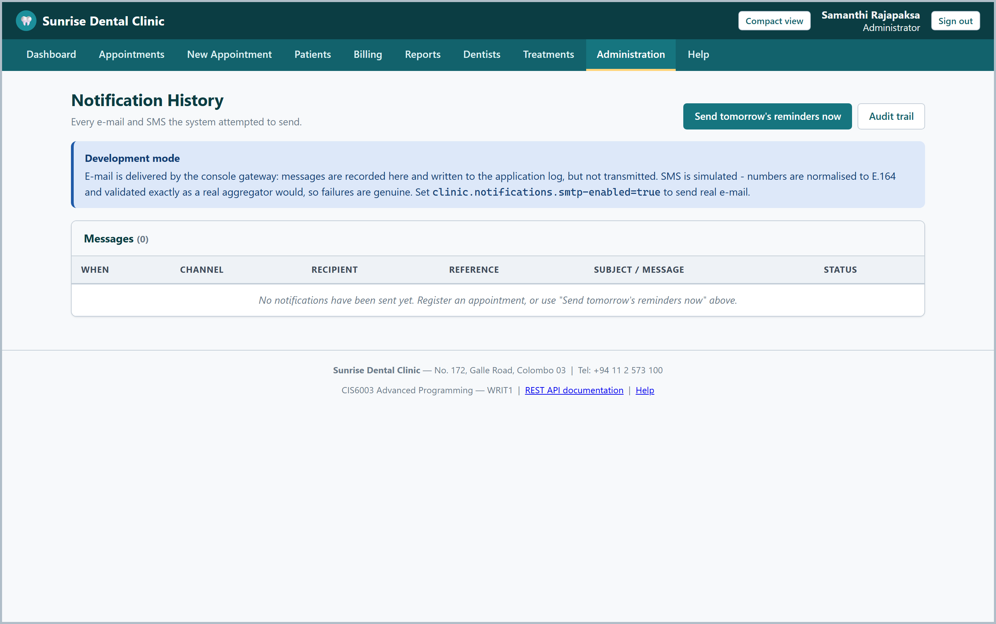

Test Case ID | T-018
Function | Web Service Documentation
Input Data | Open /swagger-ui.html
Expected Result | The versioned REST contract is published and browsable
Actual Result | OpenAPI documentation displayed for every /api/v1 endpoint
Screenshot | 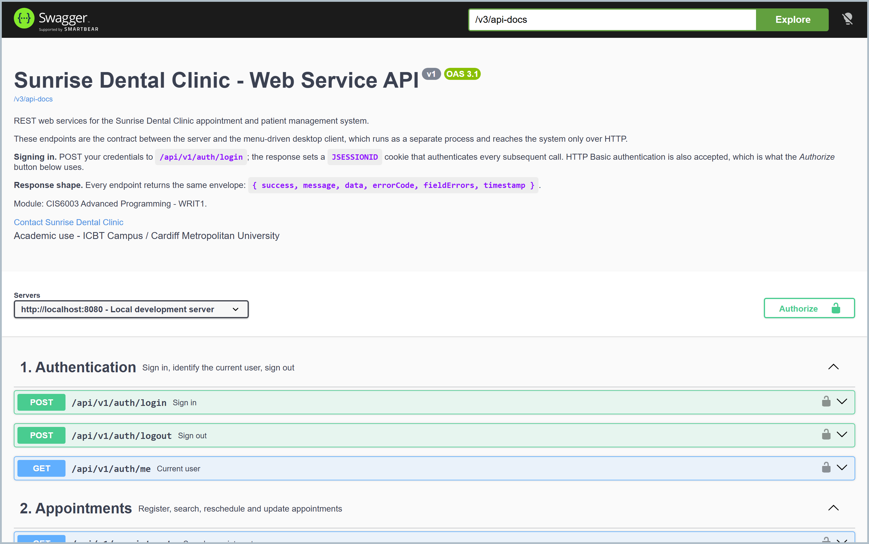

5. Test Automation and Results
The whole suite is automated and runs from a single command, mvn verify. Nothing needs to be installed first and no database needs to be started, because the integration tests use an in-memory H2 instance that Flyway migrates on the way up. The same command runs in continuous integration on every push, on both JDK 17 and JDK 21, and the workflow then packages both jars and boots the packaged server to prove it starts.
Measure | Result
Unit tests | 226 - all passing, 0 failures, 0 errors, 0 skipped
Integration tests | 97 - all passing, 0 failures, 0 errors, 0 skipped
Total | 323 automated tests, all passing
Test classes | 31 (26 unit, 5 integration)
Code coverage (JaCoCo) | 73.7% lines, 76.4% methods, 96.6% classes on dental-server
Build | mvn verify green on JDK 17 and JDK 21

6. Defects Found and Fixed
A test report claiming that everything passed first time is not one anybody should believe. Three genuine defects were found after the suite was already green, all by the concurrency test. Two of them shared a single root cause worth stating plainly: a failure that surfaces at transaction commit, inside Spring's proxy, cannot be caught by a try/catch inside the same transactional method.
Defect | Symptom | Fix
Login bookkeeping race | Two requests authenticating as the same account in the same instant raced to update one versioned row. The loser's locking failure escaped as a raw HTTP 500 and its audit entry was lost. | The update was moved into its own transactional bean, so the listener can see the failure; the audit entry is now written unconditionally.
First sequence allocation | SELECT ... FOR UPDATE cannot lock a row that does not exist yet, so the first appointment number of a year could be claimed by several bookings at once and every loser's booking was abandoned. | A one-time retry inside a genuinely new transaction.
CI action reference | The security-scan job referenced an action tag without its v prefix, so the job would have failed on its first run. | Corrected, and every action reference was then verified against the GitHub API.

The lesson generalises. A sequential test proves that a rule is written; only a concurrent test proves that it holds. Both defects would have reached production and been very difficult to reproduce from a bug report, because they appear only when two people act in the same instant, which is precisely what a busy front desk creates every day.

7. Traceability
Requirement | Implementation | Verified by
1. User authentication | Spring Security, two filter chains, BCrypt | T-001, T-002, T-003, SecurityIT
2. Register new appointment | AppointmentService with the six-handler validation chain | T-004, T-005, T-006, AppointmentApiIT
3. Display appointment details | Search by number, name or telephone | T-007, T-008, AppointmentApiIT
4. Calculate and print bill | BillingService with four pricing strategies | T-009 to T-014, PricingStrategyTest, BillingApiIT
5. Help section | HelpService and the /help pages | ReportAndWebUiIT
6. Exit system | POST-only sign-out; desktop exit command | T-020, SecurityIT
Distributed with web services | Versioned /api/v1, separate client | T-017, T-018
Design patterns | Thirteen patterns, Task B section 2 onwards | PricingStrategyFactoryTest, BookingValidationChainTest
Proper database | 9 tables, 5 views, 2 functions, 2 procedures, 4 triggers | DatabaseFeaturesIT, ClinicFunctionsTest
Validation | Four layers, Task B section 8 | T-005, T-012, ValidationConstraintsTest
Reports | Five reports over database views | T-015, ReportAndWebUiIT

Task D

1. GitHub Repository
GitHub Repository Link: https://github.com/[your-github-username]/sunrise-dental-clinic
The repository is public, so it can be opened without a GitHub account. It contains the complete Maven project, the migration scripts, the test suite, both CI workflows, this documentation and the source of every diagram.

2. Version Control Techniques
The history was built deliberately rather than allowed to happen. Each commit is a complete, working step, so the repository shows how the application was constructed rather than appearing fully formed in a single commit. Any commit can be checked out and built.
Technique | How it was applied | Why
Conventional Commits | feat(pricing):, fix(security):, test:, ci:, docs: | The subject line says what changed and where, so the log is searchable and a changelog can be assembled from it.
Meaningful increments | One commit per architectural layer or feature | A reviewer can follow the reasoning; a single final-submission commit hides all of it.
Branching | main holds released work; develop integrates | A simplified Git Flow. A full feature-branch model would be ceremony for a single developer.
Semantic versioning | Annotated tags v1.0.0 and v1.0.1 | The version number states whether an upgrade is safe.
Tag-driven release | Pushing a v*.*.* tag triggers the release | A deployed version always traces back to one immutable commit.
Ignore rules | Build output, IDE files, the local database and credentials are excluded | The repository is public, so patient data must never reach it.
Changelog | CHANGELOG.md in Keep a Changelog format | Explains why each release exists, which a commit log alone does not.

3. Workflows Deployed with the Repository
Continuous integration (ci.yml) runs on every push and every pull request. It builds on a matrix of JDK 17 and JDK 21 - the project targets 17 for portability, and the matrix proves it also runs on a newer runtime - then publishes the test and coverage reports as artefacts, packages both executable jars, and boots the packaged server to confirm it starts and answers its health check. A separate job runs a dependency vulnerability scan.
Release (release.yml) is triggered only by a tag matching v*.*.*. It rebuilds from the tagged commit and publishes a GitHub Release carrying both jars and that version's changelog section, so a release can never be published from uncommitted work.
Together the two workflows mean that the state of the main branch is always known - it either has a green tick or it does not - and that producing a release is one command rather than a checklist somebody can get wrong.

4. Evaluation
One specific instance shows the approach working. When the concurrency defects described in Task C were found after v1.0.0 had already been tagged, the fix was three focused commits and a v1.0.1 tag. Because the history was granular and the messages conventional, it was possible to see exactly which commit had introduced the login bookkeeping and what it had been trying to achieve. That is the practical value of a disciplined history: the ability to answer "why is this like this?" months later.

References
- Beck, K. (2003) Test-Driven Development: By Example. Boston: Addison-Wesley. Available at: https://www.oreilly.com/library/view/test-driven-development/0321146530/ (Accessed: 12 July 2026).
- Bloch, J. (2018) Effective Java. 3rd edn. Boston: Addison-Wesley. Available at: https://www.oreilly.com/library/view/effective-java/9780134686097/ (Accessed: 14 July 2026).
- Driessen, V. (2010) A successful Git branching model. Available at: https://nvie.com/posts/a-successful-git-branching-model/ (Accessed: 28 July 2026).
- Fowler, M. (2003) UML Distilled: A Brief Guide to the Standard Object Modeling Language. 3rd edn. Boston: Addison-Wesley. Available at: https://martinfowler.com/books/umlDistilled.html (Accessed: 18 July 2026).
- Fowler, M. (2002) Patterns of Enterprise Application Architecture. Boston: Addison-Wesley. Available at: https://martinfowler.com/books/eaa.html (Accessed: 20 July 2026).
- Gamma, E., Helm, R., Johnson, R. and Vlissides, J. (1994) Design Patterns: Elements of Reusable Object-Oriented Software. Reading, MA: Addison-Wesley. Available at: https://www.oreilly.com/library/view/design-patterns-elements/0201633612/ (Accessed: 10 July 2026).
- GitHub (2026) GitHub Actions documentation. Available at: https://docs.github.com/en/actions (Accessed: 02 August 2026).
- Martin, R.C. (2008) Clean Code: A Handbook of Agile Software Craftsmanship. Upper Saddle River, NJ: Prentice Hall. Available at: https://www.oreilly.com/library/view/clean-code-a/9780136083238/ (Accessed: 16 July 2026).
- Object Management Group (2017) OMG Unified Modeling Language (OMG UML), Version 2.5.1. Available at: https://www.omg.org/spec/UML/2.5.1/ (Accessed: 20 July 2026).
- Oracle (2024) Java Platform, Standard Edition 17 Documentation. Available at: https://docs.oracle.com/en/java/javase/17/ (Accessed: 15 July 2026).
- OWASP Foundation (2021) OWASP Top Ten Web Application Security Risks. Available at: https://owasp.org/www-project-top-ten/ (Accessed: 25 July 2026).
- Preston-Werner, T. (2013) Semantic Versioning 2.0.0. Available at: https://semver.org/ (Accessed: 28 July 2026).
- Red Gate Software (2024) Flyway Documentation. Available at: https://documentation.red-gate.com/flyway (Accessed: 18 July 2026).
- VMware (2025) Spring Boot Reference Documentation, version 3.5. Available at: https://docs.spring.io/spring-boot/docs/current/reference/html/ (Accessed: 10 July 2026).
- VMware (2025) Spring Security Reference. Available at: https://docs.spring.io/spring-security/reference/ (Accessed: 22 July 2026).

