**Answer for question 7**

* **Why are there 1783 boxes?**

The model outputs a great number of candidates bounding boxes across the full image, and 1783 is the count before filtering.

* **Maximum Number of Boxes**

Depending on grid size and number of anchors, it is computed as grid size x number of anchors per grid cell.

* **Minimum Number of Boxes**

Minimum number of boxes shall be 0, but obviously for most of the cases at least 1 box will be generated.

**Answer for question 8**

* **Advantage of Using Anchor Boxes**

It allows the model to predict more effectively the variable-shaped and sized bounding boxes. This means that, with predefined anchor boxes, the model could fit the real shapes of objects in an image much better and, hence, detect them better.

* **Method Used for Determining the Sizes of Anchor Boxes**

Normally, these anchor boxes are generated using the k-means clustering algorithm. This algorithm clusters the bounding boxes of objects in the training dataset to find the most representative sizes that are used as anchor boxes.

**Answer for question 10**

**Original images**

Figure : 0116.jpg

Figure : 0117.jpg

**Output images**

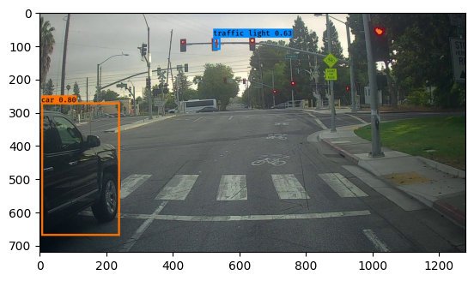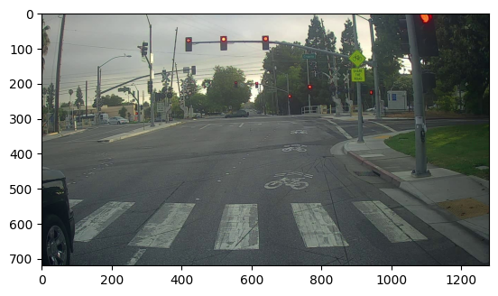

Figure : 0117.jpg Figure : 0116.jpg

**For Image 0116.jpg**

Model 0116.jpg detected two objects correctly: light and car. The former gives a confidence score of 0.63, while the latter is detected with 0.80. The bounding boxes for these objects appear almost correct, thus showing the model's performance on this image to be very high. In this case, there were no incorrectly detected objects; there were also no major problems with undetected objects. Though some minor adjustments might still be needed to perfect the positions of the bounding boxes.

**For Image 0117.jpg**

On the other hand, 0117.jpg shows a different scene wherein no objects were detected by the model. This clearly means failure in detection for this image, hence zero bounding boxes identified. Therefore, there are no incorrect bounding boxes or detections to review for this image. No detection could suggest that the problems in this very image—due to a lot of factors such as visibility, size, or model sensitivity—may mean the failure of the model's object detection.

**Answer for question 11**

**Change max_boxes**

Modified Parameter: max_boxes = 115

**Results:**

Image 0116.jpg:

Found 2 boxes:

Traffic light: 0.63 (522, 76) to (543, 113)

Car: 0.80 (5, 271) to (241, 671)

Image 0117.jpg:

Found 0 boxes

Increasing max_boxes did not result in any additional detections or improvements in the images compared to the original values.

**Change score_threshold**

Modified Parameter: score_threshold = 0.4

**Results:**

Image 0116.jpg:

Found 2 boxes:

Traffic light: 0.63 (522, 76) to (543, 113)

Car: 0.80 (5, 271) to (241, 671)

Image 0117.jpg:

Found 0 boxes

Lowering the score_threshold did not change the detection results for either image.

**Change iou_threshold**

Modified Parameter: iou_threshold = 0.8

**Results:**

Image 0116.jpg:

Found 2 boxes:

Traffic light: 0.63 (522, 76) to (543, 113)

Car: 0.80 (5, 271) to (241, 671)

Image 0117.jpg:

Found 0 boxes

Increasing the iou_threshold did not affect the detection results.

**Conclusion:**

Adjusting the parameters max_boxes, score_threshold, and iou_threshold did not result in any noticeable improvements in object detection for the images 0116.jpg and 0117.jpg. The original values seem to be appropriate for this dataset, as the modified parameters did not enhance the detection results.