**Cursors**

**1.Calculate Interest for Fixed Deposit Amount Using Cursors.**

**set intrest as 0 and then update it using the program.**

**set 10% intrest for amount less than or equal to 1000.**

**20% for more then 1000 to 5000.**

**30% for above 5000.**

create table fd (accno number(20),years number(20),amount number(20),interest number(20));

insert into fd values(&accno,&years,&amount,&interest);

Enter value for accno: 101

Enter value for years: 2

Enter value for amount: 1000

Enter value for interest: 9

old 1: insert into fd values(&accno,&years,&amount,&interest)

new 1: insert into fd values(101,2,1000,9)

declare

cursor c1 is select * from fd;

begin

for i in c1

loop

if i.amount<=1000 then

update fd set interest=i.amount*.01 where accno=i.accno;

elsif i.amount>1000 and i.amount<=6000 then

update fd set interest=i.amount*.02 where accno=i.accno;

else

update fd set interest=i.amount*03 where accno=i.accno;

end if;

end loop;

end;

/

**OUTPUT**

**Initial Table**

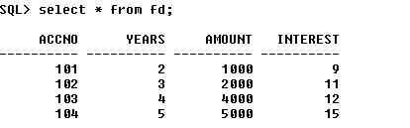

**Result**

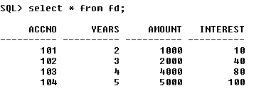

**2. Calculate Electricity Bill Using Cursors.**

**set charges if units<=100 AS 10%**

**unit>100 and less than=200 as 20%**

**else 30%**

create table ebill(ebno number(20) primary key,name varchar(20),eunit number(20),echarge float);

insert into ebill values(&eb,'&name',&eunit,&echarge);

EBNO NAME EUNIT ECHARGE

-------- -------------------- ---------- ----------

100 Nishan 150 6.6

101 sreerag 220 6.6

103 Abhiram 3 .03

declare

cursor cbill is select * from ebill;

begin

for i in cbill

loop

if i.eunit<=100 then

update ebill set echarge =i.eunit*.01 where ebno=i.ebno;

elsif i.eunit>=100 and i.eunit<=200 then

update ebill set echarge=i.eunit*.02 ;

else

update ebill set echarge=i.eunit*.03 ;

end if;

end loop;

end;

/

**OUTPUT**

EBNO NAME EUNIT ECHARGE

-------- -------------------- ---------- ----------

100 Nishan 150 6.6

101 sreerag 220 6.6

103 Abhiram 3 .03

**3.**

create table dhemp(id number primary key,ename varchar(20),esalary float);

Table created.

insert into dhemp values(&id,'&name',&esalary);

Enter value for id: 101

Enter value for name: gopika

Enter value for esalary: 20000

old 1: insert into dhemp values(&id,'&name',&esalary)

new 1: insert into dhemp values(101,'gopika',20000)

1 row created.

select * from dhemp;

ID ENAME ESALARY

---------- -------------------- ----------

101 gopika 20000

102 sisra 10000

103 sreerag 25000

104 girish 7000

declare

rowno number(20);

begin

update dhemp set esalary=esalary+200;

if sql%notfound then

dbms_output.put_line('no salary updated');

elsif sql%found then

rowno:=sql%rowcount;

dbms_output.put_line('salary for'||rowno||'employees updated');

end if;

end;

/

set serveroutput on;

/

**OUTPUT**

salary for4employees updated

procedure successfully completed.