**COURSE OUTCOME 3(CO3):**

1. Work with built-in packages

**Statistics.py**

import statistics

# Calculate average values

print("Mean : ",statistics.mean([1, 3, 5, 7, 9, 11, 13]))

print("Mean : ",statistics.mean([1, 3, 5, 7, 9, 11]))

print("Mean : ",statistics.mean([-11, 5.5, -3.4, 7.1, -9, 22]))

print("===============================")

# Calculate middle values

print("Median : ",statistics.median([1, 3, 5, 7, 9, 11, 13]))

print("Median : ",statistics.median([1, 3, 5, 7, 9, 11]))

print("Median : ",statistics.median([-11, 5.5, -3.4, 7.1, -9, 22]))

print("===============================")

# Calculate the mode

print("Mode :",statistics.mode([1, 3, 3, 3, 5, 7, 9, 11]))

print("Mode :",statistics.mode([1, 1, 3, -5, 7, -9, 11]))

print("Mode :",statistics.mode(['red', 'green', 'blue', 'red']))

print("===============================")

# Calculate the variance from a sample of data

print("Varience :",([1, 3, 5, 7, 9, 11]))

print("Varience :",statistics.variance([2, 2.5, 1.25, 3.1, 1.75, 2.8]))

print("Varience :",statistics.variance([-11, 5.5, -3.4, 7.1]))

print("Varience :",statistics.variance([1, 30, 50, 100]))

print("===============================")

# Calculate harmonic mean

print("Hermonic mean",statistics.harmonic_mean([40, 60, 80]))

print("Hermonic mean",statistics.harmonic_mean([10, 30, 50, 70, 90]))

print("-=-=-=-=-=-=-=-=-=-=-=-=-=-=-=-")

**OUTPUT**

Mean : 7

Mean : 6

Mean : 1.8666666666666667

===============================

Median : 7

Median : 6.0

Median : 1.05

===============================

Mode : 3

Mode : 1

Mode : red

===============================

Varience : [1, 3, 5, 7, 9, 11]

Varience : 0.4796666666666667

Varience : 70.80333333333334

Varience : 1736.9166666666667

===============================

Hermonic mean 55.38461538461538

Hermonic mean 27.97513321492007

-=-=-=-=-=-=-=-=-=-=-=-=-=-=-=-

**random.py**

import random

print(random.random())

print("===============================")

mylist = ["apple", "banana", "cherry"]

random.shuffle(mylist)

print(mylist)

print("===============================")

random.seed(10)

print(random.random())

print("===============================")

mylist = ["apple", "banana", "cherry"]

print(random.choice(mylist))

print("===============================")

print(random.randrange(3, 9))

**OUTPUT**

0.25174248185744386

===============================

['apple', 'cherry', 'banana']

===============================

0.5714025946899135

===============================

banana

===============================

6

**Datetime.py**

import datetime

t=datetime.time(22,56,44)

print(t)

print("hour",t.hour)

print("minute",t.minute)

print("second",t.second)

print(".....................")

d=datetime.data.today()

print(d)

**OUTPUT**

**Math.py**

import math

print("value of pi is",math.pi)

import math as m

print("value of pi from m",m.pi)

from math import pi,sqrt

print("value of pi",pi)

print("square root of 4 is:",sqrt(4))

print(math.cos(90))

print(math.sin(60))

print(math.tan(60))

print(math.tan(45))

**OUTPUT**

value of pi is 3.141592653589793

value of pi from m 3.141592653589793

value of pi 3.141592653589793

square root of 4 is: 2.0

-0.4480736161291701

-0.3048106211022167

0.320040389379563

1.6197751905438615

**Datetime.py**

import datetime

t=datetime.time(22,56,44)

print(t)

print("Hour : ", t.hour)

print("Minute : ", t.minute)

print("Second : ", t.second)

print("==============================")

d = datetime.date.today()

print(d)

td = datetime.timedelta(days=2)

print(td)

d2 = d+td

print("After adding two days :",d2)

print("d2-d",d2-d)

print("d2>d",d2>d)

d1 = datetime.date.today()

t1 = datetime.time(12,44,56)

print("Date and Time : ",d1, t1)

**OUTPUT**

22:56:44

Hour : 22

Minute : 56

Second : 44

==============================

2021-12-22

2 days, 0:00:00

After adding two days : 2021-12-24

d2-d 2 days, 0:00:00

d2>d True

Date and Time : 2021-12-22 12:44:56

**calendar.py**

import calendar

mm = int(input("enter month:"))

yy = int(input("enter year:"))

print(calendar.month(yy,mm))

print(calendar.calendar(2021))

**OUTPUT**

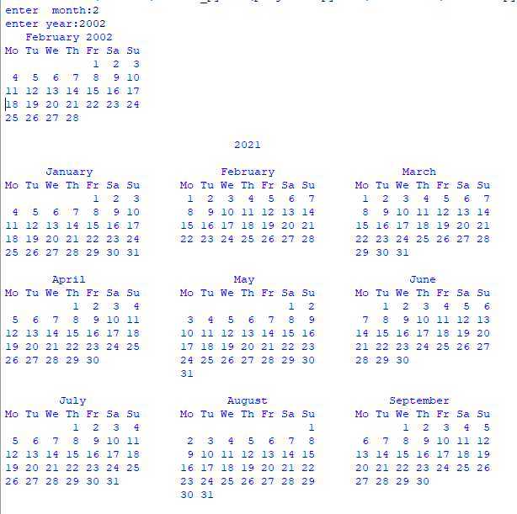

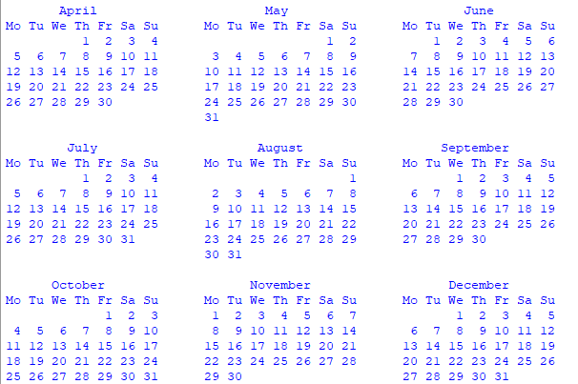

**Time.py**

import time

print("current time in sec:",time.time())

print("current time:",time.ctime())

print ("current time after 30 se:",time.ctime(time.time()+30))

t=time.localtime()

print("time",t)

print("current year:",t.tm_year)

print("current month:",t.tm_mon)

print("current day:",t.tm_mday)

print("current hour:",t.tm_hour)

print("current weekend day no:",t.tm_wday)

print("day of year:",t.tm_yday)

**OUTPUT**

current time in sec: 1640165761.415304

current time: Wed Dec 22 15:06:01 2021

current time after 30 se: Wed Dec 22 15:06:31 2021

time time.struct_time(tm_year=2021, tm_mon=12, tm_mday=22, tm_hour=15, tm_min=6, tm_sec=1, tm_wday=2, tm_yday=356, tm_isdst=0)

current year: 2021

current month: 12

current day: 22

current hour: 15

current weekend day no: 2

day of year: 356

2. Create a package graphics with modules rectangle, circle and sub-package 3D-graphics with modules cuboid and sphere. Include methods to find area and perimeter of respective figures in each module. Write programs that finds area and perimeter of figures by different importing statements. (Include selective import of modules and import * statements)

**rectangle.py**

def rectangle(l,b):

print("Area of rectangle :",l*b)

print("Perimeter of rectangle :",2*(l+b))

**circle.py**

def circle(r):

def circle(r):

print("Area of Circle :",3.14*r*r)

print("Perimeter of rectangle :",2*3.14*r)

**cuboid.py**

def cuboid(l,b,h):

print("Area of Cuboid: ",(2*l*b)+(2*l*h)+(2*h*b))

print("Perimeter of Cuboid: ", 4*(l+b+h))

**sphere.py**

def sphere(r):

print("area of sphere=",4*3.14*r*r)

print("perimeter of sphere =",2*3.14*r)

**appackage.py**

from graphics import circle

from graphics import rectangle

from graphics import sphere

from graphics import cuboid

r=int(input("enter the radius:"))

circle.circles(r)

l=int(input("enter the lenght:"))

b=int(input("enter the bredth:"))

rectangle.rectangles(l,b)

r=int(input("enter the radius:"))

sphere.sphere(r)

l=int(input("enter the lenght:"))

b=int(input("enter the bredth:"))

h=int(input("enter the height:"))

cuboid.cuboid(l,b,h)

P from graphics import circle

**OUTPUT**

enter the radius:3

area of circle= 28.259999999999998

perimeter of circle= 18.84

enter the lenght:2

enter the bredth:8

area of rec= 16

perimeter of rec= 20

enter the radius:9

area of sphere= 1017.36

perimeter of sphere = 56.52

enter the lenght:1

enter the bredth:2

enter the height:3

Area of Cuboid: 22

Perimeter of Cuboid: 24