

PawMart
PawMart is a full-stack, multi-vendor e-commerce marketplace built to bring Cambodia's independent pet-product sellers onto one mobile-first platform. It solves the everyday inconvenience of hunting across several physical shops for pet food, accessories, and healthcare items by giving customers one trusted account, cart, and KHQR/Bakong-native checkout across every store, while giving sellers a ready-made storefront and dashboard of their own.

A comprehensive project submitted in partial satisfaction of the requirements for the degree of Bachelor of Science (Hons) in Software Engineering

By:
Mr. Bunthay CHEA
Limkokwing University of Creative Technology
Faculty of Digital Innovation and Technology
ACADEMIC YEAR: 2026

PawMart
PawMart is a full-stack, multi-vendor e-commerce marketplace built to bring Cambodia's independent pet-product sellers onto one mobile-first platform. It solves the everyday inconvenience of hunting across several physical shops for pet food, accessories, and healthcare items by giving customers one trusted account, cart, and KHQR/Bakong-native checkout across every store, while giving sellers a ready-made storefront and dashboard of their own.

A comprehensive project submitted in partial satisfaction of the requirements for the degree of Bachelor of Science (Hons) in Software Engineering

By:
Mr. Bunthay CHEA
Limkokwing University of Creative Technology
Faculty of Digital Innovation and Technology
ACADEMIC YEAR: 2026
PawMart
PawMart is a full-stack, multi-vendor e-commerce marketplace connecting Cambodian pet owners with independent pet-product sellers on a single platform. It combines pet-profile-driven, rule-based recommendations, real-time order tracking, and a native KHQR/Bakong and checkout to make finding and buying trustworthy pet products convenient, while giving each independent seller a self-service storefront and dashboard without building their own e-commerce infrastructure.

The comprehensive project of
Mr. Bunthay CHEA
is approved.

Signatures:
Ms. Ratha NIT
Main Advisor

Signatures:
Mr. Wathana VINH
Main Advisor

- Copyright Reserved -

Project Title | PawMart
Project Credit | 6
Candidate | Mr. Bunthay CHEA
Project Advisor | Ms. Ratha NIT & Mr. Wathana VINH
Program | Bachelor of (Hons) Software Engineering with Multimedia
Field of Study | Major Project 2
Faculty | Faculty of Digital Innovation and Technology
Year | 2026

ABSTRACT
Cambodia's pet-care economy has grown steadily alongside its urban middle class, yet the retail side of that market has not modernised at the same pace: pet food, accessories, grooming supplies, and healthcare items are still sold almost entirely through independent, brick-and-mortar shops with fixed hours, uneven stock, and no shared way for a buyer to compare or trust one seller against another. A 34-respondent validation survey conducted ahead of this project confirmed the resulting friction directly; the most commonly cited problems were products being out of stock or in limited variety, having to visit multiple stores to complete a single shopping trip, and difficulty finding trustworthy product information, and only 79% of respondents currently own a pet at all, suggesting the addressable market is still growing. PawMart was built to remove that friction by bringing independent Cambodian pet-product sellers onto one mobile-first marketplace. The platform gives every customer a single account, cart, and checkout experience regardless of which of its several independent stores they are buying from, matches products to each customer's registered pets through a transparent, explicitly rule-based (not machine-learning) recommendation engine, and tracks every order from confirmation through delivery. Payment is handled natively for the local market through a real, client-generated KHQR/Bakong QR code; a choice the same validation survey supports directly, with 81% of respondents naming KHQR (Bakong) as their preferred payment method. A Paws Rewards loyalty program converts spend into real checkout discounts rather than a simple points ledger, and independent sellers are given a full self-service storefront and management dashboard, product listings, order fulfilment, stock alerts, and a public store page; without needing to build or pay for any e-commerce infrastructure of their own. For the platform owner, the result is a single point of oversight (seller approval, store monitoring, and a platform-wide dashboard) and a single payment-collection point across a growing multi-vendor catalogue. Together, these pieces give Cambodian pet owners the convenience, trust, and one-stop access that the survey shows they currently lack, while giving independent sellers a low-friction route to an online storefront and giving the platform owner a scalable foundation to grow the marketplace further.

DEDICATION
To my parents, whose patience and steady support carried me through every late night of this build; your belief in what I was working toward, even when it was hard to explain in words, meant more than I can put on this page.
To my lecturers at Limkokwing University, thank you for the guidance, the critical questions, and the standards you held me to, which are the reason this project grew from a single-shop concept note into a real, tested, multi-vendor platform.
To my classmates and friends who tested early builds, argued over feature scope with me, and kept me company through the marketplace pivot and the security audit alike; your feedback shaped PawMart as much as any single design decision did.
And to myself: for staying with this project through a scope correction, a full architectural pivot, and a late-stage security review that could easily have been skipped; proof that steady, methodical work is what actually ships a product.

Mr. Bunthay CHEA
9/October /2026

TABLE OF FIGURES
Figure 1.1 Survey chart 1
Figure 1.2 Project Planning 4
Figure 2.1 Which single feature matters most to you? 7
Figure 2.2 Preferred payment method 7
Figure 3.1 Moodboard 12
Figure 4.1 Logo & Wordmark Logo 16
Figure 4.2 Color Palette 17
Figure 4.3 Typography Type Families 17
Figure 4.4 EB Garamond 18
Figure 4.5 Inter 19
Figure 4.6 Icon set 20
Figure 4.7 Login Page 21
Figure 4.8 Profile Page 21
Figure 4.9 Personalized Recommendation 22
Figure 4.10 Shipping Info 22
Figure 4.11 Payment 23
Figure 4.12 Review order before payment confirmation 23
Figure 4.13 Tracking Order 24
Figure 7.1 ERD Diagram 30
Figure 9.1 Survey Data 0.1 34
Figure 9.2 Survey Data 0.2 35
Figure 9.3 Survey Data 0.3 36
Figure 9.4 Survey Data 0.4 37
Figure 9.5 Survey Data 0.5 38

Table of Contents
CHAPTER 1: PROBLEM CONTEXT & METHODOLOGY 1
1.1 Project Background 1
1.2 Current Problems 1
1.3 Goal and Objectives 2
1.4 Methodology & Project Plan 3
CHAPTER 2: RESEARCH AND OPPORTUNITY 5
2.1 Primary Research 5
2.2 Competitor Research 7
2.3 User Typology 8
2.4 User Persona & Journey Map 9
2.5 Design Criteria 10
CHAPTER 3: DESIGN PROPOSAL 10
3.1 Design Statement 10
3.2 Mood Board 11
3.3 Design Direction & Core Features 11
3.4 Business Model Canvas 13
3.5 Design Development & Interface Evolution 14
CHAPTER 4: FINAL DESIGN 15
4.1 Concept Posters 15
4.2 Brand Identity Guide 15
4.3 Functional Platform Demonstration 19
CHAPTER 5: PRODUCTION TECHNOLOGY STACK SPECIFICATIONS 23
5.1 Technology Stack Layer Summary 23
5.2 Technology Interaction Overview 24
CHAPTER 6: FUNCTIONAL & NON-FUNCTIONAL REQUIREMENTS 24
6.1 Functional Requirements (FR) Matrix 24
6.2 Non-Functional Requirements (NFR) Constraints 27
CHAPTER 7: SYSTEM ARCHITECTURE & DATABASE DESIGN 27
7.1 Hardware and Infrastructure Map 28
7.2 Database Table Design & Schema Definitions 28
7.3 System Security and Data Integrity Controls 29
7.4 End-to-End Technical Flow Walkthrough 30
CHAPTER 8: CONCLUSION & FUTURE WORK 31
8.1 Summary 31
8.2 Lessons Learned 31
8.3 Future Development Plans 32
CHAPTER 9: APPENDIX & REFERENCES 32
9.1 Initial Research Findings 32
9.2 User Testing Feedback Matrices 37
9.3 Academic References 39

PROBLEM CONTEXT & METHODOLOGY

1.1 Project Background
Pet ownership in Cambodia has grown alongside the country's expanding urban middle class, and with it, steady household spending on food, accessories, grooming, and healthcare for cats, dogs, fish, and other pets. A 34-respondent validation survey run ahead of this project found that 27 respondents (79%) currently own a pet, with dogs the most common (52%), followed by cats and fish (22% each), see Figure 1.1. Alongside that growth, Cambodia's e-commerce and mobile-payment infrastructure has matured quickly, most visibly through the National Bank of Cambodia's Bakong system and its KHQR standard, which is now accepted across most major local banking apps (ABA, ACLEDA, Wing, and others).
The pet-retail sector itself has not kept pace with either trend. It remains dominated by independent, single-location shops that operate on fixed hours, carry limited and inconsistent stock, and offer no shared way for a buyer to browse, compare, or trust one seller against another. A pet owner who needs food for one pet, a grooming product for another, and a healthcare item that a nearby shop does not stock is left visiting several physical stores in turn, with no unified purchase history, loyalty program, or delivery tracking across any of them. PawMart was built to close that gap: a single, mobile-first, multi-vendor marketplace where independent Cambodian pet-product sellers each run their own storefront, while customers get one account, one cart, and one trusted checkout experience across all of them.
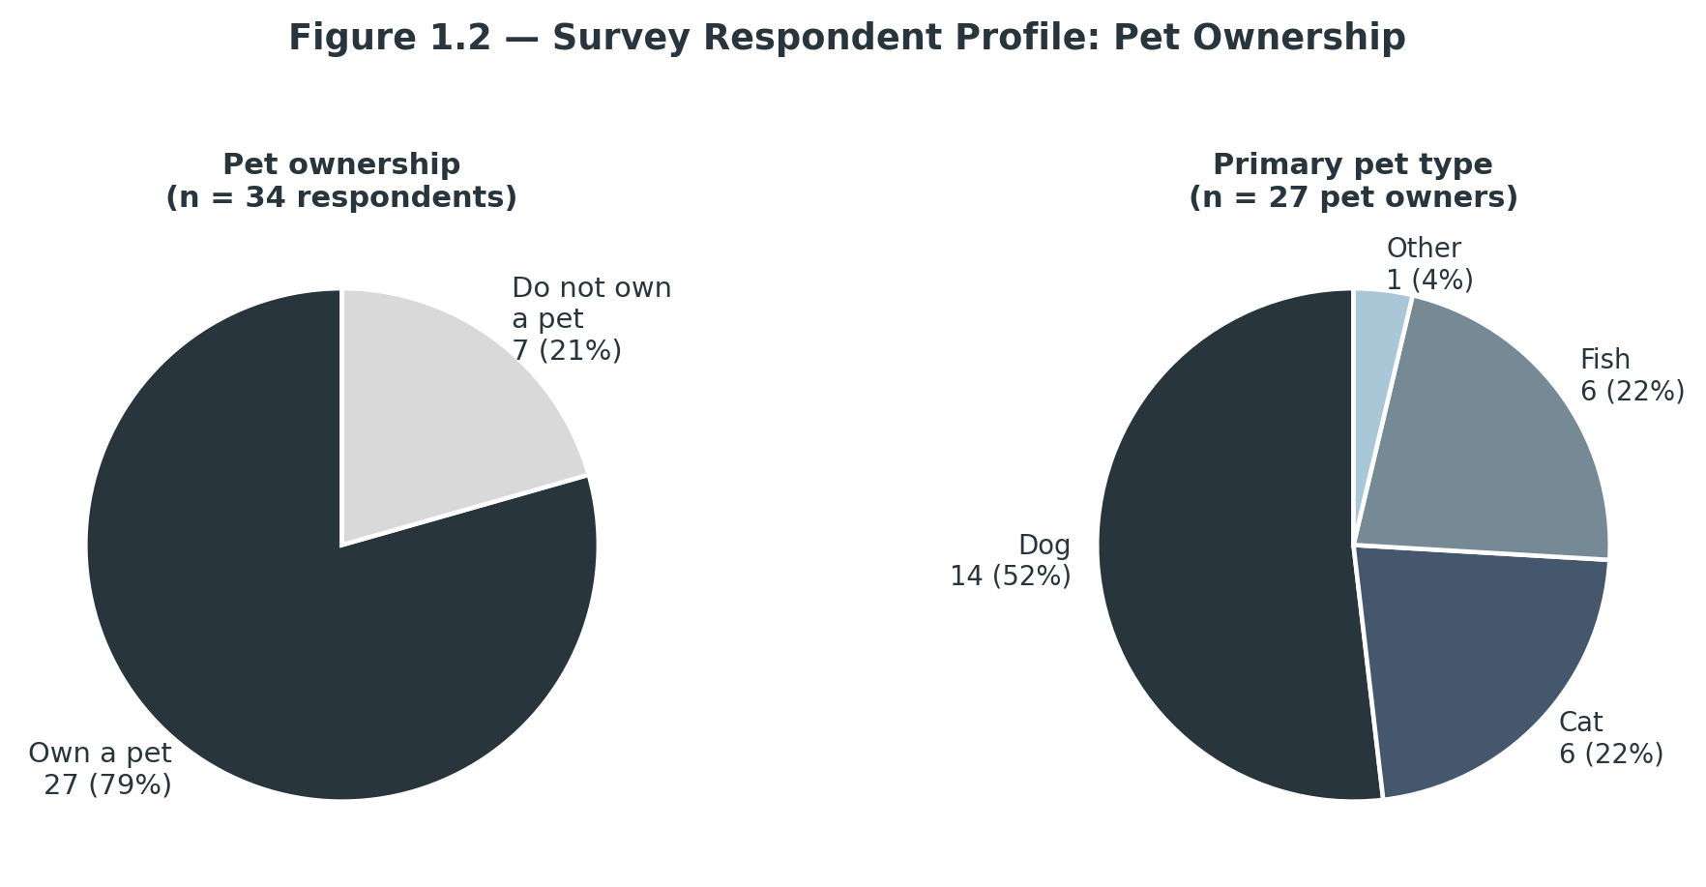
Figure 1.1 Survey chart

1.2 Current Problems
- Fragmented Access and Limited Product Visibility
Because no shared catalogue exists across Cambodia's independent pet shops, buyers cannot see what is in stock, at what price, or with what level of detail before travelling to a store. This shows directly in the validation survey: when asked how easy it is to find the specific pet products they need, "Neutral" was the single most common answer, meaning products are findable, but not conveniently so. The most frequently cited shopping challenges were products being out of stock or in limited variety and having to visit multiple stores to complete a single shopping trip, with a meaningful share of respondents reporting their preferred product is out of stock "often" or "very often".
- No Shared Trust, Loyalty or Order History
Each pet shop today is an isolated relationship: a buyer who shops at three different sellers in a month has three separate, untracked interactions, no consolidated order history, no way to compare seller reliability through reviews, and no loyalty program that rewards them across the market as a whole rather than at a single counter. Hard-to-find trustworthy product information and inconsistent pricing were both cited as recurring pain points in the survey, and when asked what they look for when deciding whether to trust an online pet seller, respondents most frequently named secure payment and product authenticity/quality, followed by a visible return/refund policy and reviews from other customers, all signals a single, fragmented shop-by-shop retail model cannot easily provide.
- Payment and Access Friction Specific to the Local Market
Cambodia's retail payment landscape is shifting quickly toward Bakong/KHQR, but most independent pet shops have not adopted digital payment tools that match it, leaving many transactions cash-only and undocumented. The validation survey shows how strong the local preference for KHQR already is: 81% of respondents named KHQR (Bakong) as their preferred payment method, well ahead of credit/debit cards and cash on delivery (Figure 2.2). A platform serving this market has to treat KHQR as a first-class, native payment path rather than an afterthought, alongside standard card processing for the segment of buyers who prefer it.

1.3 Goal and Objectives
PawMart's long-term goal is to become the trusted, mobile-first home for buying and selling pet products in Cambodia, a single marketplace that independent sellers can join without building their own e-commerce infrastructure and that buyers can rely on for consistent stock visibility, transparent trust signals, and a checkout experience built around how Cambodian consumers actually pay. Three objectives guided the build:
- Baseline Quality Optimization: A seller application-and-approval workflow, product options and customer reviews, and explicit promotion/discount tagging give buyers verifiable, comparable information at the point of decision, directly answering the trust gap identified in the validation survey.
- Value Generation for Independent Sellers: A full self-service storefront and management dashboard, covering product CRUD, order fulfilment, stock alerts, and a public store page, lets an independent seller reach online buyers without paying for or maintaining their own website, while a Paws Rewards loyalty program converts customer spend into real, redeemable checkout discounts that keep buyers returning to the marketplace as a whole.
- Technological Workflow Efficiency: A rule-based (explicitly not machine-learning) product recommendation engine, pet-profile personalisation, and a real-time order status timeline reduce the manual effort buyers currently spend comparing sellers and chasing order updates by phone or in person.

1.4 Methodology & Project Plan
The project followed an empirical, iterative software-development methodology grounded in two sources of data. Primary data came from a 34-respondent validation survey of 30 multiple-choice questions covering current pet ownership and purchasing habits, shopping pain points, trust factors, feature-usefulness ratings for each proposed differentiator, and payment, device, and spending preferences, distributed before implementation began to validate demand and prioritise features ahead of the build (see Chapter 2). Secondary data came from a review of Cambodia's digital-payment infrastructure, in particular the National Bank of Cambodia's Bakong/KHQR standard, and from general e-commerce and multi-vendor marketplace UX conventions used to structure the catalogue, cart, and checkout flow.

1.4.1 Methodology Methods and Tools
The project followed an empirical, iterative software-development methodology grounded in two sources of data. Primary data came from a 34-respondent validation survey of 30 multiple-choice questions covering current pet ownership and purchasing habits, shopping pain points, trust factors, feature-usefulness ratings for each proposed differentiator, and payment, device, and spending preferences, distributed before implementation began to validate demand and prioritise features ahead of the build (see Chapter 2). Secondary data came from a review of Cambodia's digital-payment infrastructure, in particular the National Bank of Cambodia's Bakong/KHQR standard, and from general e-commerce and multi-vendor marketplace UX conventions used to structure the catalogue, cart, and checkout flow.
Frontend Client | Vue 3 (Composition API, TypeScript), Vite
Backend | Python 3.11, FastAPI, uv for dependency management, deployed CPU-only on Render
UI / State | Element Plus + Phosphor icons, Pinia (auth, cart, pets, wishlist stores)
Backend runtime | Python 3.11, FastAPI, managed with uv
Database / Auth / Storage | Supabase (managed PostgreSQL) with Row-Level Security
Payments | Manual mock Visa card-entry flow; KHQR/Bakong QR generated client-side
Containers / Hosting | Docker Compose (local dev); Vercel (frontend, SPA rewrites)

1.4.2 Project Planning Timeline
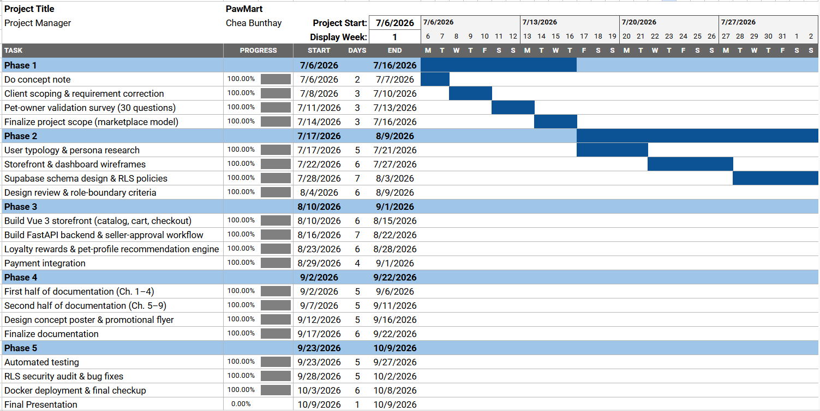
Figure 1.2 Project Planning
The build ran from 7 August to 20 September 2026 across 50 commits, well inside the four-month allowance set in the original concept note, and is tracked task-by-task in a repository-root checkpoint file, with every planned task checked off by close.
- Phase 1: Frontend scaffold (16 tasks). Static, mock-data views for the shop shell, home, catalogue, product detail, cart, the checkout wizard, order confirmation and tracking, authentication pages, account and pet management, and the admin shell, products, orders, and collections views.
- Phase 2: Backend foundation (4 tasks). FastAPI project structure, the Supabase schema with Row-Level Security, authentication wiring with route guards, and Storage configuration.
- Phase 3: Wiring (9 tasks), then 3.10 the marketplace pivot (10 tasks, from 12 August). Live catalogue, cart/checkout, tracking, pets, recommendations, and loyalty wiring, followed by a substantial rework once the client confirmed the real intent was a multi-vendor marketplace rather than a single shop, covering a new stores schema, backend role gates, store-owner frontend, public storefronts, a single-store cart rule, seller intake, admin review, and store bans.
- Phase 4: Payments (27 August to 13 September). A manual mock Visa card-entry flow for cards, and a real, client-generated KHQR/Bakong QR code, replacing an earlier static placeholder and a manual admin-confirmation step that added friction without adding real verification.
- Phase 5: Testing, through 16 September, and post-testing polish through 20 September. 170 frontend tests across 17 spec files and 69 backend tests across 5 files, a dedicated Row-Level Security audit, and later additions including wishlist, product options and reviews, promotion/discount tags, and full Cambodia address data for checkout shipping.

RESEARCH AND OPPORTUNITY

2.1 Primary Research
Primary research took the form of a 30-question, multiple-choice validation survey distributed online ahead of implementation and completed by 34 respondents. The survey was built to test three things at once: whether the underlying problem was real, which of the proposed differentiating features respondents actually valued, and whether there was genuine willingness to try and to pay for the resulting platform. The findings below are drawn directly from that response set and were used to prioritise the feature set described in Chapter 3.
- Ownership and category. 27 of 34 respondents (79%) currently own a pet; dogs are the most common pet type (52%), with cats and fish tied at 22% each and a small "other" segment (Figure 1.1).
- A real, if moderate, access problem. "Neutral" was the modal answer to how easy respondents find the specific pet products they need, not a crisis, but not effortless either. The most cited shopping challenges were products being out of stock or in limited variety and having to visit multiple stores, followed by difficulty finding trustworthy product information and inconsistent pricing across sellers.
- Strong appetite for a reliable online alternative. Among pet-owning respondents, the large majority said they would "definitely" or "probably" prefer buying pet products online over in-store if a reliable platform existed, and 21 of 27 (78%) said they were "very likely" or "likely" to try PawMart if it launched today, with only one respondent unlikely (Figure 2.3).
- Order Tracking as the clearest single priority. When asked which one feature mattered most, 12 of 27 respondents (44%) chose Order Tracking, ahead of Pet Profile Management (30%), Personalized Recommendations (22%), and Loyalty & Rewards (4%), shown in Figure 2.1. The same pattern holds in the individual usefulness ratings: 22 of 27 respondents (81%) rated Order Tracking as "very useful" or "extremely useful", making it the strongest, most consistently validated feature in the survey.
- Trust is built on payment security and authenticity, not marketing. Asked what matters most when trusting an online pet seller, respondents overwhelmingly cited secure payment and product authenticity/quality, followed by a visible return/refund policy and reviews from other customers, directly informing the Design Criteria in section 2.5 and the seller-approval and review features described in Chapter 3.
- KHQR (Bakong) is the payment method to build around. 22 of 27 respondents (81%) named KHQR (Bakong) as their preferred payment method, against 3 for credit/debit card and 2 for cash on delivery (Figure 2.2), the clearest single validation finding in the survey and the reason KHQR is a native, first-class checkout path in PawMart rather than a secondary option.
- A mobile-first, modest-spend audience. 21 of 27 respondents (78%) said they would shop on PawMart primarily via smartphone, and most respondents' monthly pet-product spend is modest: 74% spend $30 or less per month, with a smaller segment (19%) spending over $60, pointing to a broad, price-sensitive base rather than a narrow high-spend niche.
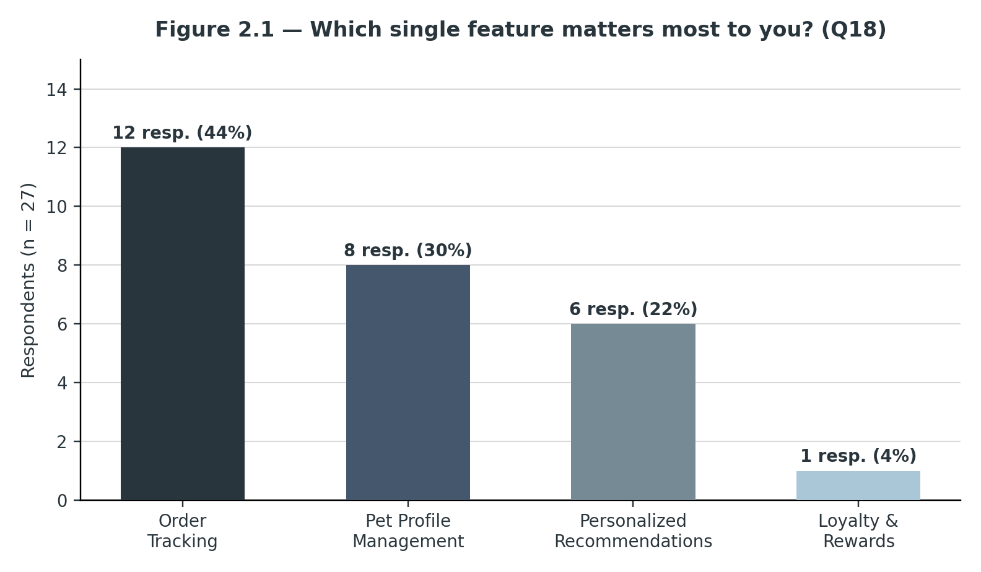
Figure 2.1 Which single feature matters most to you?
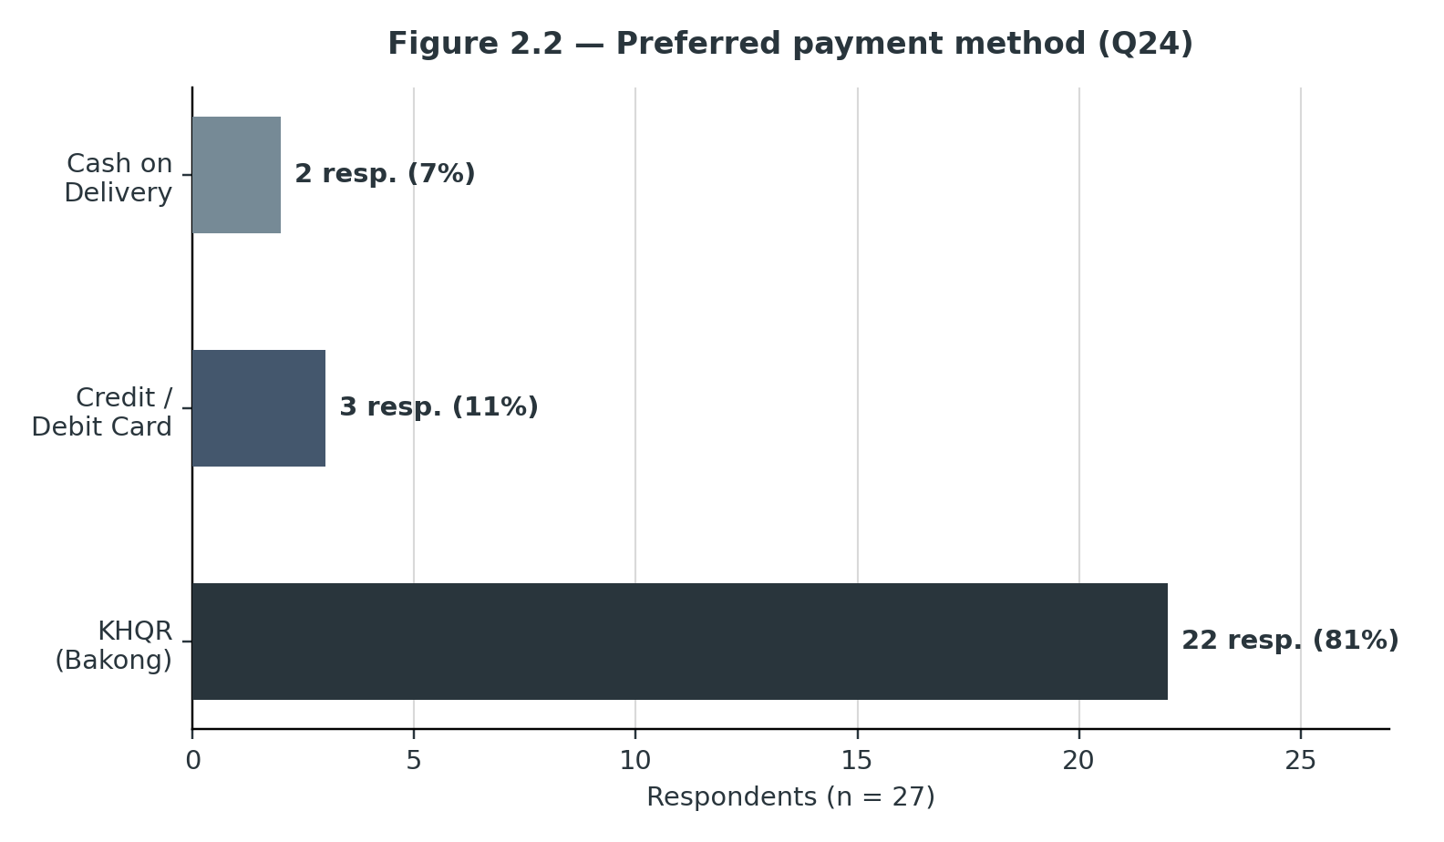
Figure 2.2 Preferred payment method

2.2 Competitor Research
Benchmarked against what exists today, regional marketplaces such as Shopee and Lazada carry pet products but do not run a local marketplace in Cambodia, so Cambodian buyers can only reach them through slow cross-border shipping, and even there pet products are one category among thousands, with no pet-profile matching, no order tracking built for a physical-delivery pet-care context, and no loyalty program specific to pet owners. Independent local pet shops, in turn, offer trust through in-person relationships but no online presence, no shared catalogue, and no digital payment path beyond cash. PawMart sits between the two: a pet-specific, multi-vendor marketplace with the trust and tracking tools respondents said they were missing, built on the payment rail they already prefer.
Before PawMart, the researcher reviewed who else serves Cambodian pet owners today, spanning regional e-commerce marketplaces, Cambodia's one direct online pet retailer, and the established physical pet shops the survey respondents already use. No existing option combines a multi-vendor catalogue, pet-profile-based recommendations, order tracking, and a native KHQR checkout in one place.
- Petzo (petzo.net), Cambodia's closest direct comparison, sells dog food, cat food, treats, supplies, toys, and healthcare items with free delivery above $49 in Phnom Penh and $89 in the provinces, and lets customers browse by pet type and brand, proof that Cambodian pet owners will already shop for pet products online given a working site. Its limits are exactly where PawMart differs: it is a single retailer's own storefront, not a marketplace, so there is no path for other independent sellers to list alongside it, no loyalty program, no pet-profile-driven recommendations, and no order-status tracking beyond a delivery confirmation.
- Established physical shops such as Happy Dog Pet Shop and K9 Cambodia carry the trust an established, in-person shop earns, in some cases bundled with grooming or veterinary services on site. Neither extends that trust online in any structured way: ordering outside store hours, where it happens at all, runs through an informal Facebook message or phone call, with no shared catalogue, no cart, no checkout, and no way for a buyer to check stock or compare price before travelling there, the same gap the validation survey's respondents described directly.
Competitor | Model | Strength | Gap PawMart Fills
Petzo (petzo.net) | Single-retailer online pet store | Real catalogue, delivery pricing, and proof of online demand | No marketplace model, no loyalty program, no pet-profile recommendations
Shopee / Lazada (cross-border) | Regional marketplace, not operating locally in Cambodia | Huge catalogue and low prices for buyers willing to wait 1 to 3 weeks | Pet products are one category among thousands; no pet-specific features
Happy Dog Pet Shop, K9 Cambodia | Physical shop (some with grooming/vet services) | In-person trust and expertise | No online catalogue, cart, checkout, or order tracking
Informal Facebook sellers | Message-based ordering on a Facebook page | Low barrier to start selling | No cart, no persistent order history, no payment verification
Positioned against all four, PawMart is the only option built specifically around Cambodian pet owners and independent sellers together: a multi-vendor marketplace with the pet-profile recommendations, order tracking, and loyalty program respondents said they were missing, checked out through the payment rail, KHQR, they already prefer.
The table above covers the four groups PawMart is most often compared with. The real market a Cambodian pet owner uses when buying pet products is wider than that. Each competitor group is described below with its business model, how it make money, where it is strong, and where PawMart is positioned against it.
Petzo (petzo.net). Petzo is the closest direct competitor. It is a single retailer that buys stock itself and sells it through its own website, with categories for dog food, cat food, treats, supplies, toys and healthcare. Delivery is free above $49 in Phnom Penh and $89 in the provinces, under that the customer pays a delivery fee. Petzo make money from the retail margin on every product it sells, so it controls price and quality well, but it also carry all the inventory risk itself and the catalogue can only grow as fast as its own warehouse and cash allow. There is no way for another shop to sell on Petzo. Customers browse by pet type and brand, but there is no saved pet profile, no recommendation based on the pet and no loyalty points. For PawMart, Petzo is proof that Cambodian pet owners will buy pet products online, and its free delivery threshold is the benchmark that PawMart shipping prices are compared against (section 3.8).
Physical pet shops (Happy Dog Pet Shop, K9 Cambodia and similar). Physical shops have the strongest trust in the market. Customers can see and touch the product, ask the owner for advice, and in some shops get grooming or a vet check in the same visit. Their online presence is usually a Facebook page and sometimes a Telegram account. Orders come in by chat, payment is by ABA transfer or cash, and delivery is arranged by the shop calling J&T or a moto driver. These shops make money from retail margin and services. They are not only competitors, they are the main target sellers for PawMart. Every feature on the store owner side (product listing, stock alert, order status, public store page) is built so one of these shops can move its chat orders onto PawMart without hiring extra staff.
Facebook and Telegram sellers. A big share of pet product selling in Cambodia happens through Facebook pages, Facebook Marketplace and Telegram channels, many of them small resellers importing from Thailand, Vietnam or China. Starting cost is close to zero, which is why there are so many of them. The weak points repeat across almost all of them: the price is often "PM for price", there is no cart, stock is not visible, payment proof is a screenshot of a bank transfer, and there is no record when something goes wrong. PawMart competes with this group by being as easy to start as a Facebook page (apply, get approved, list products) while giving the buyer a real checkout, a receipt and order tracking.
Delivery and super apps (Grab, foodpanda, WOWNOW, E-GetS, Nham24). Delivery apps in Phnom Penh sell some pet food next to groceries and deliver within about an hour. Grab and foodpanda (through its pandamart grocery service) are the biggest, with local apps such as WOWNOW, E-GetS and Nham24 also active. Their strength is speed and a customer base that already have the app on their phone. Their pet range is usually small, mostly a few cat and dog food brands and cat litter, and there is no pet specific feature. They make money from a high commission on partner shops, often around 25% to 30%, because the commission include the delivery rider. PawMart does not try to beat them on speed. It offers a much wider pet range, a lower commission for shops (section 3.6) and Grab Express as a same day option for customers in Phnom Penh who need it fast.
Cross-border marketplaces (Shopee, Lazada, Taobao, AliExpress). Shopee and Lazada do not run local marketplaces in Cambodia. Cambodian buyers who use them, or who order from Taobao and 1688 through a local buying agent, wait one to three weeks for delivery and pay extra for cross-border shipping and agent fees. This channel is cheap for light accessories like collars, beds and toys, but it is not practical for heavy items like food bags, for anything a pet needs this week, or for healthcare products where authenticity matter. Returns are close to impossible. PawMart competes here on speed, local after-sales support and trust, not on price.
Veterinary clinics. Vet clinics in Phnom Penh sell prescription diets, flea and tick treatment and supplements at the counter, and customers trust them most for anything health related. Clinics are treated as possible partners more than competitors. A clinic can open a PawMart store for its non-prescription products, and PawMart does not allow prescription medicine to be listed at all (section 3.12), so there is no conflict with the clinic own counter sales.
The feature comparison below summarises how each group covers what the validation survey said buyers care about most (order tracking, trust, payment and range).
Feature | PawMart | Petzo | Physical shops | FB / Telegram sellers | Delivery apps | Cross-border
Many sellers in one place | Yes | No | No | No | Partly | Yes
Pet specific range | Yes | Yes | Yes | Yes | No | No
Online cart and checkout | Yes | Yes | No | No | Yes | Yes
Order status tracking | Yes, 5 steps | Partly | No | No | Yes | Yes, slow
Pet profile and recommendations | Yes | No | In person | No | No | No
Loyalty points for pet purchases | Yes | No | Some shops | No | App wide | Platform wide
Same day delivery option | Phnom Penh | Not stated | Some shops | Some sellers | Yes | No
Delivery to provinces | Yes | Yes | By courier | By courier | No | Yes, 1 to 3 weeks
KHQR payment | Yes | Not stated | Bank transfer | Bank transfer | Yes | Cards mostly
Local returns | 7 days | Not stated | In store | Rarely | Limited | Very hard
From the seller side, a small pet shop that wants to sell online has four realistic options. The table compares them on what the shop pays and what work it still has to do itself.
Option | Upfront cost | Ongoing cost | What the shop gets | What the shop still does
Own website | Around $300 to $1,500 to build | Hosting, domain, payment gateway fees, maintenance | Full control of brand and data | Marketing to bring every single visitor, all customer service, all tech problems
Facebook page / Telegram | $0 | $0 unless paying for ads | Reach to existing followers | Chat every order by hand, check transfer screenshots, no stock or order records
Delivery app (Grab, foodpanda) | Usually $0 | Commission around 25% to 30% | Big app audience, rider delivery included | Keep a small fast moving range only, accept thin or no margin on food
PawMart | $0 | 7% or 10% commission, 5% in first 3 months | Storefront, checkout, KHQR, order tracking, buyer base, dashboard | Pack and hand parcels to J&T, Virak Buntham or Grab
Positioning. When the competitors are placed on two axes, how pet specific the range is (low to high) and how many sellers are on one platform (one to many), the gap is clear. Petzo and physical shops are pet specific but single seller. Delivery apps and cross-border marketplaces have many sellers but no pet focus. Facebook sellers are pet specific but every seller is an island. The high specialisation and many seller corner is empty, and that is the position PawMart takes.
Advantages that are hard to copy:
- Seller network effect. Every new store adds products that make the platform more useful for buyers, and every new buyer makes it more attractive for the next store. A single retailer like Petzo cannot get this without changing its whole business model.
- Pet profile data. Pet profiles (species, breed, age, weight, diet) together with order history let PawMart recommend the right product and, later, remind the owner when a food bag should be running out. General delivery apps do not collect this.
- Local payment and delivery fit. KHQR as the default payment and a delivery setup built around J&T, Virak Buntham and Grab match how Cambodians already pay and ship, which cross-border platforms cannot offer.
- Low commission. At 7% to 10% PawMart is far cheaper for a shop than a delivery app, because PawMart does not pay riders.
Where competitors are stronger, and how PawMart responds:
- Petzo: controls its own stock and offers free delivery over $49. PawMart responds with a wider range from many shops and plans an optional store funded free shipping threshold (section 3.8).
- Delivery apps: faster and already installed on most phones. PawMart responds with Grab Express inside Phnom Penh and by not competing on one hour delivery.
- Cross-border: cheaper for accessories. PawMart responds with speed, local returns and authentic products.
- Physical shops: personal advice and trust. PawMart responds by bringing those same shops online instead of fighting them, plus customer reviews on every product.

2.3 User Typology
PawMart is a two-sided marketplace, so its users fall into three typologies, two on the buying side and one on the selling side, each with distinct needs the platform had to satisfy.
- Typology A: First-Time / Casual Pet Owners
Challenge: limited product knowledge and uncertainty about what a specific pet actually needs, combined with the survey's finding that product discovery is only "neutral" in ease today. System requirement: pet-profile-driven, rule-based recommendations and clear, comparable listings that reduce the guesswork of a first purchase.
- Typology B: Experienced / Multi-Pet Owners
Challenge: recurring, often bulk purchases across several pets or species, since the survey included respondents managing as many as six dogs or four to five fish at once, where speed and reliability matter more than discovery. System requirement: fast repeat ordering from order history, dependable order tracking, and a loyalty program (Paws Rewards) that rewards volume spend with real checkout discounts.
- Typology C: Independent Pet-Product Sellers
Challenge: no affordable way to reach buyers online or manage stock and orders without building and maintaining their own e-commerce website. System requirement: a self-service seller dashboard, including product listings with image upload, forward-only order status management, low-stock alerts, and an editable store profile, that requires no technical infrastructure of the seller's own.

2.4 User Persona & Journey Map
Three personas map back to the typologies above, each illustrating how PawMart's core features address a distinct set of goals and friction points.
- Persona 1 (Primary User) Dara, the Casual Pet Owner
Dara is a first-time cat owner in Phnom Penh who is not yet confident about what brand of food or which accessories actually suit her pet. She wants a simple, trustworthy way to find suitable products without visiting several shops to compare, and she values seeing reviews and clear product detail before she buys.
- Persona 2 (Secondary User) Sophea, the Multi-Pet Household
Sophea keeps several dogs and manages recurring purchases of food, healthcare items, and grooming supplies every few weeks. She wants fast reordering, dependable delivery tracking across multiple parcels, and a loyalty program that rewards her consistent spend.
- Persona 3 (Tertiary User) Ratana, the Independent Seller
Ratana runs a small independent pet-supply shop and wants to reach buyers online without the cost or technical burden of building her own website. She needs a simple way to apply to sell, list her products, and manage incoming orders and stock from a single dashboard.
Together, these three personas confirm that PawMart's value has to work on both sides of the marketplace at once, for the survey's overwhelmingly buyer-side respondents, and for the independent sellers whose participation is what actually gives buyers something to browse.

2.5 Design Criteria
The following criteria translate the research above into concrete architectural rules that shaped the platform's engineering, matching the template's structure of Personal Guidance, Industry Focus, Information Sensitivity, and Compliance with the local commercial ecosystem.
- Personal Guidance: Pet-Profile-Driven Personalisation. The platform gathers each customer's registered pets (species, breed, age, weight, diet) and uses them to drive an explicit, rule-based recommendation engine that weights pet-species match highest, then purchase-category affinity, then new arrivals, rather than an opaque or overstated "AI" system.
- Industry Focus: Category and Multi-Vendor Structure. Dedicated categories (food, accessories, toys, grooming, healthcare) and a catalogue spanning many independent sellers are unified under one browsing, cart, and checkout experience, directly matching the fragmentation respondents described in the survey.
- Information Sensitivity: Trust and Data Isolation. A seller application-and-approval workflow, product reviews and options, and explicit discount/promotion tagging give buyers the authenticity and transparency signals they said they rely on, while Row-Level Security keeps every store owner's data strictly isolated from every other store.
- Compliance with the Local Commercial Ecosystem. Checkout is built around Cambodia's actual payment habits, combining a native, client-generated KHQR/Bakong QR code with a manual mock Visa card-entry flow, rather than assuming international card payment is the default, and order status can only ever move forward, protecting the integrity of the fulfilment record.

2.6 Market Size and Opportunity
PawMart sizes its market from the top down using public population figures and the validation survey, and checks it from the bottom up against the number of stores and orders in the financial plan (section 3.14). All figures here are planning estimates, not measured market data, and they only cover Phnom Penh because that is where PawMart launches.
Step | Figure | Basis
Phnom Penh population | About 2.3 million | 2019 General Population Census, rounded
Households | About 500,000 | Population divided by an average household size of around 4.5
Households with a dog or cat | About 150,000 (30%) | The survey found 79% pet ownership, but the sample was young and online, so a much lower 30% is used for the whole city
Households buying commercial pet products regularly | About 75,000 (50%) | Many households still feed leftovers, so only half are counted as regular buyers
Average spend per buying household | About $25 a month, $300 a year | 74% of survey respondents spend $30 or less a month, 19% spend over $60
Total pet product spend (TAM) | About $22.5 million a year | 75,000 x $300
Share open to buying online (SAM) | About $9 million a year (40%) | 78% said they would shop mainly by smartphone, reduced to 40% to be careful
PawMart target share (SOM), Year 3 | About $739,000 a year (around 8% of SAM) | Year 3 order value from section 3.14
Year 1 order value in the plan ($67,500) is under 1% of the serviceable market, so growth is limited by how fast PawMart can sign stores and reach buyers, not by the size of the market. Siem Reap, Battambang and Sihanoukville are not counted here. They are added from Year 2 when province sellers join.
Things pushing the market up:
- Urban middle class. More households in Phnom Penh keep pets as family members and buy imported food, treats and accessories instead of feeding leftovers.
- KHQR everywhere. Bakong KHQR is accepted by almost all local banking apps, so paying online is already normal for the target buyers and needs no card.
- Smartphone first. Most buyers shop from their phone, which is why PawMart was built mobile first and as an installable web app.
- More delivery options. J&T, Virak Buntham and Grab together now reach the whole country, so a shop in Phnom Penh can sell to a buyer in Ratanakiri.
Things holding it back:
- Price sensitivity. Most buyers spend under $30 a month, so shipping fees and small price differences matter a lot.
- Trust in online sellers. Buyers worry about fake or expired products, which is why seller approval, reviews and a clear return policy are core features.
- Heavy items. Food bags of 10 to 20 kg are expensive to ship to provinces with flat price couriers, which is handled with Virak Buntham and weight based pricing (section 3.8).
- Cash habits in provinces. Cash on delivery is still common outside Phnom Penh, and PawMart does not offer it (section 3.8).

2.7 SWOT Analysis
The SWOT below sums up PawMart position at launch, based on the research in this chapter and the current state of the build.
Strengths | Weaknesses
Only pet specific multi-vendor marketplace in Cambodia. KHQR native checkout. Five step order tracking, the most wanted feature in the survey. Pet profiles and rule based recommendations. No inventory risk. Low cost stack ($67 a month in production, section 5.3). Low 7% to 10% commission. | Run by one person, so support and development share the same time. No commission or payout splitting built yet. Flat shipping that ignores weight. No automatic Bakong payment check. No cancel or refund flow in the app. Small starting seller base.
Opportunities | Threats
Thousands of pet shops and Facebook sellers with no real online checkout. Vet clinics and groomers as partners and referral points. Repeat food purchases make reorder reminders valuable. Province buyers with few local pet shops. Featured placement and later subscription boxes as extra revenue. | Delivery apps adding a bigger pet range. Petzo lowering prices or opening to other sellers. Sellers moving buyers to Facebook chat after the first order to avoid commission. Fake or expired products damaging trust. Changes in e-commerce or payment rules. Courier delays during Khmer New Year and Pchum Ben.
Strategies that come from the SWOT:
- Strength with opportunity: use the low commission and free first 3 month rate (5%) to sign Facebook sellers and physical shops quickly, and use pet profiles for reorder reminders that keep buyers coming back.
- Weakness with opportunity: build commission, payouts and weight based shipping before scaling marketing, so growth does not multiply losses on heavy orders.
- Strength with threat: keep order tracking, reviews and the 7 day return policy on PawMart only, so buyers have a reason to stay on the platform instead of moving to Facebook chat.
- Weakness with threat: set clear seller rules with penalties (section 3.12) and plan delivery cut-off dates around public holidays, so one bad seller or one holiday week does not hurt the brand.

DESIGN PROPOSAL

3.1 Design Statement
PawMart is designed as a mobile-first, multi-vendor pet-product marketplace that unifies independent Cambodian sellers under one browsing, cart, and checkout experience. It matches buyers to relevant products through transparent, pet-profile-based recommendations; keeps every party informed through a real-time order-status timeline; and settles payment through the channel Cambodian buyers already trust, KHQR/Bakong, alongside standard card processing. Each independent seller is given a self-service storefront and dashboard requiring no infrastructure of their own, while the platform owner retains a single point of oversight, covering seller approval, store monitoring, and platform-wide reporting, across the whole marketplace.

3.2 Mood Board

Figure 3.1 Moodboard
The intended visual direction is warm and approachable rather than clinical, with friendly, rounded iconography; clear, high-contrast product photography of pets and pet products; and a palette built around a trustworthy, calm base tone with a warm accent, echoing the reassurance (secure payment, authenticity, clear return policy) respondents said they look for when deciding whether to trust an online pet seller. The final mood board, typography pairing, and colour swatches should be inserted here from the project's design files once confirmed.

3.3 Design Direction & Core Features
The platform's functional capabilities are organised around the customer shopping journey, the seller's day-to-day operations, and the platform owner's oversight needs.
- Product Catalogue and Search. Browse by category (food, accessories, toys, grooming, healthcare); filter by pet type, brand, price range, and store; sort, paginate, and use slug-based product URLs.
- Product Detail. Images, description, live stock, product options (size/variant), customer reviews, promotion and discount badges, related products, and a "Sold by {store}" link back to the seller's public storefront.
- Shopping Cart and Checkout. A server-persisted cart with quantity adjustment and a live loyalty-reward discount, a three-step wizard (Shipping → Payment → Review) with a persistent order-summary sidebar, and a "Buy Now" path that skips the cart for a single item.
- Zoned Shipping. Standard delivery by J&T Express or Virak Buntham at $1.50 inside Phnom Penh and $2.50 to other provinces (1 to 3 business days), and same day Grab Express for $3.00 only inside Phnom Penh. The zone is read from the province in the address, so customer cant pick a cheaper zone than where the parcel actually go. Section 3.8 describes the carriers and the planned weight based pricing.
- Secure Payment. A manual mock Visa card-entry form for card payments, with card details entered into a dedicated, non-persisted form so they never touch application state; a real, client-generated KHQR/Bakong QR code scannable by any major Cambodian banking app.
- Order Tracking. A post-purchase status timeline moving from Confirmed to Processing to Shipping to Out for Delivery to Delivered, plus a full order history with item images, the single most-valued feature in the validation survey.
- Pet Profile Management. Customers register their pets (name, species, breed, age, weight, diet), loaded app-wide so every recommendation, listing, and future order can be matched against them.
- Personalized Recommendations. Explicitly rule-based, not machine-learning: a weighted score favouring pet-species match, then purchase-category affinity, then new arrivals, with a newest-arrivals fallback for guests and a UI indicator of whether a given list is genuinely personalised.
- Paws Rewards Loyalty. Five points per dollar of post-discount subtotal, earned automatically on paid orders and redeemable for a real checkout discount, whether a dollar amount, free shipping, or both, rather than a ledger balance with no direct use.
- Multi-Vendor Marketplace Tools. A public storefront per store, a seller application-and-approval workflow, a store-owner dashboard for product and order management, a platform-admin oversight dashboard, and a single-store-per-cart rule that keeps checkout simple.
- Wishlist. Server-side saved products that survive a refresh and follow the customer across devices.

3.4 Business Model Canvas
Key Partner  Independent pet-product sellers (stores); the National Bank of Cambodia's Bakong/KHQR rail as a payment partner; Supabase and Vercel as managed cloud infrastructure; J&T Express, Virak Buntham Express and Grab Express as delivery partners that the stores hand parcels to. | Value Proposition  For customers: one trusted account, cart, and KHQR-native checkout across many independent sellers, with pet-profile recommendations and live order tracking. For sellers: a ready-made storefront and dashboard with no infrastructure of their own to build or maintain. For the platform owner: a single oversight and payment-collection point across the whole marketplace. |  |  | Key Resources  The Vue 3 / FastAPI / Supabase technology stack; the product, order, and loyalty data model; the PawMart brand; and, at this stage, a single solo-developer engineering and support capacity.
Customer Relationship  Self-service for both buyers (account, wishlist, order history) and sellers (dashboard, store profile), backed by admin-mediated seller approval and dispute oversight rather than one-to-one account management. |  | Channel  The PawMart web application itself (mobile-first), plus each seller's own word-of-mouth and existing customer base migrating onto their new storefront. |  | Customer Segments  Casual and first-time pet owners; experienced multi-pet households; independent pet-product sellers currently without an online storefront.
Revenue Streams  Commission on every delivered order: 7% on Pet Food and Pet Healthcare, 10% on all other categories, and 5% on all categories in a new store first three months (section 3.6). Featured placement at $7.50 per store per week from Year 2. Shipping fees are passed to the store at cost. In the current build no commission is collected yet and all payments land in one shared platform account (section 6.2, NFR-5). |  |  | Key Activities  Platform development and maintenance; seller onboarding and approval; catalogue and review moderation; customer support; marketing to grow both the buyer and seller sides of the marketplace. | Cost Structure  Hosting and software (about $67 a month at launch, section 5.3), development and maintenance, customer support, Paws Rewards discounts and free shipping rewards (paid by PawMart, not the store), card payment fees, refunds where the store is not at fault, outsourced accounting, and yearly tax and licence costs such as patent tax and the e-commerce permit (section 3.9).
The canvas above is a one page summary. Each block is explained in more detail below, with the numbers PawMart plans with and how the block connect to the rest of the business.
Customer Segments. PawMart is a two-sided platform, so it has two kinds of customers and both have to be won at the same time. On the buyer side there are three groups from the user typology in section 2.3: casual and first time pet owners who need guidance, experienced and multi-pet households who buy food often and in bulk, and gift buyers who buy occasionally. The main buyer target in Year 1 is pet owners in Phnom Penh aged around 20 to 40 who already pay with KHQR on their phone, which match the survey respondents. On the seller side the target is independent pet shops, Facebook and Telegram pet sellers, groomers and vet clinics selling non-prescription products. Year 1 aims for about 15 active stores, Year 2 about 40 and Year 3 about 80 (section 3.14).
Value Propositions. For buyers, PawMart is one place to compare and buy from many local pet shops with one account, one cart and one KHQR checkout, products matched to their own pets, a five step order timeline and points that turn into real discounts. For sellers, PawMart is an online shop that costs nothing to open, takes no monthly fee and only charges commission when a delivered sale happens, with stock alerts and an order dashboard included. For the platform owner, every sale on the marketplace go through one checkout, which makes the commission model possible and gives one view of the whole market.
Channels. The product itself is the PawMart web app, built mobile first and installable on the phone home screen like an app, so there is no app store fee or approval wait. Buyers are reached through Facebook and TikTok content, pet groups on Facebook and Telegram, partner vet clinics and groomers, and most importantly each store own followers, because every store gets a public page link it can share (section 3.13). Sellers are reached by visiting shops in person and through the public "Sell on PawMart" application form.
Customer Relationships. Buyer relationship is self service: account, pet profiles, wishlist, order history and Paws Rewards all work without contacting anyone. Support is available through Telegram and email for problems, with a reply target of 24 hours on business days. Seller relationship is more personal in Year 1, every store is onboarded by the founder, then moves to self service with the application form, the store dashboard and written seller terms (section 3.12). Trust is kept through admin approval of every store, product reviews, the ban function, and a clear return policy.
Revenue Streams. The main revenue is commission on delivered orders: 7% on Pet Food and Pet Healthcare, 10% on all other categories, and 5% on everything for a store first three months. From Year 2 stores can also pay $7.50 per week for a featured slot. With a 60/40 mix between food and other categories the blended commission is 8.2% of order value. Revenue is about $5,000 in Year 1, $27,000 in Year 2 and $68,000 in Year 3 (section 3.14). Shipping fees are passed to the store at cost and are not PawMart revenue.
Key Resources. The technology platform (Vue 3 frontend, FastAPI backend, Supabase database, auth and storage), the database of stores, products, pet profiles and orders, the PawMart brand, the relationships with the first group of stores, and the founder time for development, onboarding and support. Because hosting cost is low (around $67 a month in production, section 5.3), people and time are the most important resource, not servers.
Key Activities. Keeping the platform running and improving it, finding and approving new sellers, checking listings for prohibited or fake products, reconciling KHQR payments every day, paying stores every week, handling customer support and returns, and marketing to both buyers and sellers. Section 7.5 lists these activities with who does them and how often.
Key Partners. Independent pet shops and sellers are the most important partners because they supply all the products. J&T Express, Virak Buntham Express and Grab Express carry the parcels (the stores have the direct relationship with them). The Bakong network and the customer banks (ABA, ACLEDA, Wing and others) move the money through KHQR. Supabase, Vercel and Render host the platform. Vet clinics and groomers act as referral partners. An outsourced accountant handles monthly tax filing (section 3.9).
Cost Structure. The platform is built to be cost light. Fixed costs are hosting and software, accounting, licences, marketing and later staff, around $367 a month in Year 1, $1,000 in Year 2 and $2,250 in Year 3. Variable costs move with order value: Paws Rewards (about 3% of order value), card payment fees (about 0.4% to 0.5%), free shipping rewards (about 0.2%) and refund losses and support (about 0.5%). Together the variable costs are about 4.1% to 4.2% of order value, which leave PawMart with about 4% of order value as contribution to cover fixed costs (section 3.10).
PawMart business model type. PawMart is a commission based marketplace (a two-sided platform), not a retailer. The difference matters for every number in this document: PawMart never buys stock, so its revenue is the commission and not the full order value, its tax turnover is the commission (section 3.9), and its main risk is not unsold stock but not having enough sellers or buyers on the platform at the same time. To solve that "chicken and egg" problem, PawMart signs sellers first and only starts paid buyer marketing once each category have enough products (section 3.13).
The value proposition is mapped against the buyer and seller profile in more detail below, using the jobs, pains and gains each side described in the survey and persona work.
Customer profile | Buyer (pet owner) | Seller (pet shop)
Jobs to be done | Keep the pet fed and healthy, find the right product for this specific pet, get it delivered without travelling | Sell more without more staff, reach buyers outside the shop street, keep track of stock and orders
Pains | Out of stock or limited range, visiting many shops, not knowing which product fits, fake or expired products, no order updates | Answering every price question in chat, checking transfer screenshots, no record of orders, website too expensive, delivery apps take 25% to 30%
Gains wanted | One trusted place, clear prices, tracking, rewards for loyal buying, fast delivery | New customers, low cost, simple tools, getting paid on time

Value map | For buyers | For sellers
Products and services | Multi-store catalogue in six pet categories, pet profiles, recommendations, KHQR checkout, order tracking, Paws Rewards, wishlist, reviews | Free storefront and public store page, product and stock management, order dashboard, low stock alerts, weekly payout
Pain relievers | One cart and checkout, stock shown before ordering, reviews and approved sellers, five step status timeline, 7 day returns | No upfront cost, no monthly fee, KHQR collected by PawMart, order records kept automatically, commission only on delivered sales
Gain creators | Points that become $5 to $25 discounts or free shipping, products matched to the pet, same day Grab in Phnom Penh | Access to PawMart buyers, 5% intro commission, featured slots from Year 2, customer reviews that build the store reputation
Growth targets below are illustrative rather than committed forecasts, extrapolated directly from the validation survey's 78% "likely/very likely to try" rate rather than assumed independently, and should be revisited once real usage data is available.
Milestone | Illustrative Target | Basis
Year 1 | Onboard an initial cohort of independent sellers (about 15 stores) across Phnom Penh and reach around 400 orders a month by the end of the year | 78% of surveyed pet owners said they were likely or very likely to try PawMart (Figure 2.3), suggesting strong early conversion from a targeted launch audience
Year 2 | Grow to about 40 active stores including the first sellers in Siem Reap and Battambang, and around 900 orders a month (about $24,000 of order value), which is the break-even point (section 3.14) | Builds on Year 1 retention via Paws Rewards, and on the payment/trust groundwork validated in Chapter 2
Year 3 | Around 80 active stores in Phnom Penh, Siem Reap and Battambang and about 2,200 orders a month, the first full year of profit (about $8,300 after tax, section 3.14) | Featured placement revenue, weight based shipping for province orders, and a larger repeat buyer base

3.5 Design Development & Interface Evolution
PawMart's design evolved substantially over the course of the build, driven by a documented sequence of scope and architecture corrections rather than cosmetic iteration alone:
- Scope correction. The original concept note listed only a small set of "nice-to-have" differentiators and was missing core e-commerce fundamentals, including catalogue, cart, payment, and an admin dashboard, which were added to the plan before implementation began.
- Framing correction. "Personalized Product Recommendation" was restated early from an implied AI/machine-learning system to an explicitly rule-based one, to avoid overselling the feature at submission.
- Stack correction. An early description of "Backend: Supabase" conflated the database with the application layer; this was corrected to Supabase for database, authentication, and storage, plus FastAPI for business logic.
- Multi-vendor pivot (12 August 2026). The client confirmed the real intent was a marketplace of independent stores rather than a single shop, requiring a substantial rework of the schema, permissions (Row-Level Security), routing, and already-built admin views.
- Admin authority narrowed. The admin role moved from "manages everything" to oversight only, with day-to-day product and order management handed fully to individual store owners.
- Seller onboarding corrected. Store creation moved from an admin-run script per vendor to a public application-and-approval flow, removing a manual bottleneck.
- Reward redemption upgraded. A generic, hardcoded promo-code box was replaced by real, per-customer Paws Rewards redemption as the platform's sole discount mechanism, matching how the business actually intends to reward loyalty.

3.6 Revenue Model and Commission Structure
PawMart is a commission based marketplace. Stores own their stock, set their own prices and ship their own parcels. PawMart provides the storefront, checkout, payment collection, order tracking and the buyer base, and keeps a commission from every delivered order in return. PawMart never buys or holds stock, so it carries no inventory risk and its revenue is the commission, not the full order value.
In the current build no commission is collected yet. All payments land in one shared platform account and there is no commission field in the database (NFR-5, section 6.2). The rates, rules and database changes in this section are the commission model that is added together with per store payouts (section 3.7).
PawMart has three revenue related flows:
Stream | How it is charged | Starts | Share of revenue in Year 3
Sales commission | Percent of the product subtotal of each delivered order | With payout splitting | About 89% ($60,614)
Featured placement | $7.50 per store per week for a home page or category top slot | Year 2 | About 11% ($7,800)
Shipping fee | Collected from the buyer and passed to the store at cost | Already live | 0%, not revenue
Commission rates by category. The six categories in the live catalogue have different margins for the shop, so the commission is set per category. Pet Food and Pet Healthcare have thin margins and are bought often, so they get the lower rate. The other four categories have much higher shop margins and carry the higher rate.
Category on PawMart | Commission | Typical shop margin | Reason
Pet Food | 7% | 15% to 25% | Thin margin and frequent repeat orders. A higher cut would make shops not list their food
Pet Healthcare (non-prescription) | 7% | 20% to 30% | Important for trust and repeat visits, kept cheap for shops to list
Pet Grooming Supplies | 10% | 35% to 50% | Higher margin products
Pet Supplies (bowls, beds, toys, cages) | 10% | 40% to 60% | Higher margin, often bought together with food
Pet Clothing & Accessories | 10% | 50% or more | Highest margin category
Pet Training Aids | 10% | 40% to 50% | Higher margin products
Any category, first 3 months of a new store | 5% | n/a | Launch incentive so shops join early when buyer numbers are still small
Shop margins in the table are typical retail markups for these product types and are confirmed with each new store during onboarding. They are not PawMart data.
Why 7% to 10%. Delivery apps charge partner shops around 25% to 30% but they also pay the rider. Regional marketplaces in neighbouring countries charge sellers somewhere around 5% to 15% plus payment fees. PawMart does not deliver, the store still packs and sends the parcel, so the rate is kept at the low end of that range. It is also far less than what a small shop would spend to run its own website and marketing.
Commission calculation rules:
- Base. Commission is charged on the product price the buyer paid to the store, after any store discount (is_discounted / discount_percent) and before any Paws Rewards discount. The price is VAT inclusive (section 3.9), so the same rule work for VAT registered and non registered stores.
- Not charged on. Shipping fees, and the Paws Rewards discount amount (PawMart pays that part to the store, see below).
- Per line. Commission per line = unit price x quantity x category rate. Order commission = sum of all lines, rounded to 2 decimals.
- Timing. Commission is only earned when the order reaches Delivered. Cancelled and fully refunded orders carry no commission, and a partial return gives back the commission of the returned lines.
- Snapshot. The rate used is saved on each order line at the moment of ordering, so a later rate change never changes an old order.
- Special deals. An admin can set a per store override rate (for example a large shop that bring many buyers). The override replaces the category rate for that store.
Blended rate. With an expected mix of 60% of order value in Pet Food and Pet Healthcare and 40% in the other categories, the blended commission is 0.6 x 7% + 0.4 x 10% = 8.2% of order value. In Year 1 most stores are inside their 5% first three months, so the effective rate for Year 1 is planned at 7.5%.
Database changes for commission (planned):
Table | Column | Type | Purpose
categories | commission_rate | numeric(4,3) | Default rate for the category, 0.070 or 0.100
stores | commission_rate_override | numeric(4,3), null | Special rate for one store, replaces the category rate
stores | intro_rate_until | date | End of the 5% first three months, set on approval
order_items | commission_rate | numeric(4,3) | Rate used for this line at order time
order_items | commission_amount | numeric(10,2) | Commission for this line
orders | commission_total | numeric(10,2) | Sum of the lines, used for payouts and reports
Paws Rewards cost. Paws Rewards is funded by PawMart, not by the store. When a buyer uses a $5 reward, the store is still paid the full product subtotal and PawMart pays the $5 out of its commission. The reward values in the live database are:
Reward | Points cost | Value | Spend needed to earn it | Cash back rate
$5 Off Your Order | 500 | $5.00 | $100 | 5.0%
$10 Off Your Order | 1,000 | $10.00 | $200 | 5.0%
$25 Off Your Order | 2,500 | $25.00 | $500 | 5.0%
Free Standard Shipping | 750 | $1.50 or $2.50 | $150 | 1.0% to 1.7%
Buyers earn 5 points per $1 of subtotal after the reward discount, so the dollar rewards are worth 5% cash back. Not every point is ever used, because many buyers never reach 500 points or forget them. PawMart plans with 60% of points being redeemed, which makes the real reward cost 5% x 60% = 3% of order value. In the accounts, every point earned is recorded as a liability of $0.01 x 60%, and the liability is reduced when the reward is used. Points do not expire in the current build. A 12 month expiry after the last order is planned, which is common for loyalty programs and keep the liability under control.
If the reward cost becomes too high, the simplest lever is to change the $5 reward to 1,000 points, which bring the cash back down to 2.5% (sensitivity in section 3.10).
Featured placement. From Year 2 a store can book a featured slot for $7.50 per week: two slots on the home page and one at the top of each category. Featured products carry a visible "Featured" label so buyers know it is paid, and featured status has no effect on the rule based recommendation engine, which keeps recommendations honest. A store needs at least a 4.0 rating and no open penalty (section 3.12) to book a slot. The plan is an average of 8 booked slots in Year 2 and 20 in Year 3.

3.7 Seller Payout and Settlement
In the current build, KHQR codes and the mock Visa flow all point to one PawMart account and there is no record of how much each store is owed. This section defines how money moves from the buyer to the store once payout splitting is built.
Money flow of one order:
- Step 1. The buyer pays the order total (products after reward discount, plus shipping) to PawMart by KHQR or card.
- Step 2. The money stays in the PawMart collection account while the order is shipped and delivered.
- Step 3. Seven days after the order is marked Delivered the return window closes and the order becomes payable.
- Step 4. On the next Monday, PawMart pays the store the product subtotal plus shipping, minus commission, minus any refunds, by bank transfer.
- Step 5. The store pays its courier (J&T or Virak Buntham account) and its own taxes from that payout.
Payout formula:
Net payout = product subtotal of payable orders + shipping fees collected + free shipping reward compensation - commission - VAT on commission (only once PawMart is VAT registered) - refunds and return deductions +/- manual adjustments
Note that the product subtotal is the full price before the Paws Rewards discount, because the reward is PawMart cost and not the store cost.
Payout rules:
- Schedule. Every Monday, covering all orders that became payable up to the Sunday before.
- Minimum. If the net amount is under $10 it rolls over to the next week.
- Method. Bank transfer in USD to the account registered by the store (ABA, ACLEDA, Wing or any Bakong member bank). PawMart pays any transfer fee.
- Holds. Orders with an open return or dispute, and all orders of a banned store, are held until they are resolved.
- Statement. Every payout comes with a statement in the store dashboard listing each order, the commission per line and any deduction.
Example weekly statement for a store with 12 payable orders and one returned toy:
Line | Amount
Products, Pet Food ($250 at 7%) | $250.00
Products, other categories ($160 at 10%) | $160.00
Shipping fees collected | $21.00
Free shipping reward compensation (2 orders) | $3.00
Commission ($17.50 + $16.00) | -$33.50
Returned toy, refund to buyer | -$8.00
Commission given back on returned toy | +$0.80
VAT on commission (PawMart not yet VAT registered) | $0.00
Net payout | $393.30
Reconciliation. Every day an admin matches the KHQR payments in the bank statement with the paid orders of the day before. Every week the total of all payouts plus the commission kept must equal the money received for payable orders. Any difference is logged and solved before the next payout.
Database changes for payouts (planned): a payouts table (store_id, period_end, gross, commission, vat_on_commission, adjustments, net, status, paid_at, bank_reference) and a payout_items table linking each payout to its orders. Payout status moves forward only (pending, paid), the same way order status does.
Holding buyer money for a week and paying it out to many stores can fall under National Bank of Cambodia rules for payment service providers. To avoid holding funds itself for long, PawMart plans to use a bank merchant or marketplace payout product (for example ABA PayWay) when it moves to real payments, with the 7 day hold as the maximum. This is confirmed with the bank before launch.

3.8 Shipping and Delivery Operations
Because the cart only allow items from one store, every PawMart order is one parcel from one shop and there is never a split shipment. The store packs the parcel and hands it to the carrier. PawMart calculates the shipping fee at checkout, collects it with the order, and passes it to the store in the weekly payout.
Current implementation. At checkout the buyer picks province, district, commune and village from the full Cambodia address list. The backend reads the province at the end of the address (the value describeVillage() produces) to decide the zone, so a buyer cannot choose a cheaper zone than where the parcel actually goes. The backend recalculates the fee itself and never trusts the price sent by the browser.
Option | Zone | Price | Delivery time
Standard (J&T Express / Virak Buntham) | Phnom Penh | $1.50 | 1 to 3 business days
Standard (J&T Express / Virak Buntham) | Other provinces | $2.50 | 1 to 3 business days
Grab Express | Phnom Penh only | $3.00 | Same day
Standard with Free Standard Shipping reward | Any | $0.00 | 1 to 3 business days
Grab Express with Free Standard Shipping reward | Phnom Penh only | $3.00, reward does not cover it | Same day
A Grab Express order with a province address is rejected by the backend with the message "Grab Express only delivers within Phnom Penh".
Carriers. PawMart works with three carriers. The store has the account with the carrier and pays it directly.
Carrier | How it works | Used for | Rough cost to the store | Time
J&T Express | Door to door, picks up from the shop, gives a tracking number, covers all 25 provinces | Parcels under about 5 kg, all of Phnom Penh, provinces for light orders | Around $1.25 to $1.50 in Phnom Penh and $1.75 to $2.50 to provinces for the first 1 to 3 kg, plus extra per kg | Same or next day in Phnom Penh, 1 to 3 days to provinces
Virak Buntham Express | Parcel travels on the Virak Buntham bus and truck network to a branch, buyer collects at the branch (door delivery costs extra in some cities) | Heavy and bulky orders of 5 kg or more to provinces: 10 to 20 kg food bags, cat litter, cages | Cheaper per kg than J&T on heavy items, roughly $2 to $4 for a big bag | Next day to most provinces
Grab Express | Motorbike driver booked on demand | Urgent orders inside Phnom Penh | Around $1.50 to $4 depending on distance | Same day, 1 to 2 hours
J&T and Virak Buntham do not publish a public price list online. The rough costs above come from seller pages and common market prices, and the real contract rates are collected from the first stores before launch, then the rate table below is set to match.
Problems with the flat price. The flat fee was the right choice for the first build, but it ignores weight. A 15 kg bag of dog food to Siem Reap pays $2.50, the same as a collar, while it costs the store several times more to send. The products table already has a weight column (numeric, in kg) that checkout does not use yet. Grab Express is also flat at $3.00 while the real Grab price grows with distance, and Phnom Penh trips like Chroy Changvar to Dangkao are long.
Weight based pricing (planned). The fee follows the total weight of the order and the carrier is picked by a fixed rule:
- Phnom Penh: J&T for standard, Grab for express.
- Province, order under 5 kg: J&T door to door.
- Province, order of 5 kg or more: Virak Buntham, collected by the buyer at the nearest branch. Checkout shows the branch pickup clearly before payment.
- Missing weight: an item without a weight counts as 1 kg so the fee is never too low. Weight becomes a required field when a store adds a product.
Shipping fee = base price + extra kg x price per extra kg, where extra kg = total weight rounded up - included kg, never below 0.
Route | Carrier | Base price | Included weight | Each extra kg
Phnom Penh, standard | J&T Express | $1.50 | 3 kg | $0.30
Phnom Penh, express | Grab Express | $3.00 | 5 kg | $0.50
Province, under 5 kg | J&T Express | $2.50 | 3 kg | $0.50
Province, 5 kg or more | Virak Buntham | $3.00 | 10 kg | $0.25
Examples:
Order | Route | Calculation | Fee | Current flat fee
Cat collar, 0.2 kg | Toul Kork, standard | Base only | $1.50 | $1.50
Two 2 kg cat food bags, 4 kg | Toul Kork, standard | 1.50 + 1 x 0.30 | $1.80 | $1.50
3 kg cat food | Battambang | Base only | $2.50 | $2.50
15 kg dog food | Siem Reap | Virak Buntham, 3.00 + 5 x 0.25 | $4.25 | $2.50
15 kg dog food by J&T instead | Siem Reap | 2.50 + 12 x 0.50 | $8.50 | n/a
8 kg litter, express | BKK1, Grab | 3.00 + 3 x 0.50 | $4.50 | $3.00
The 15 kg example shows why Virak Buntham is used for heavy province orders: the buyer pays $4.25 instead of about $8.50 by J&T.
Delivery time by area. The website shows "1 to 3 business days" for all standard orders. The expected times per area are:
Area | Provinces | Expected standard time
Phnom Penh | Phnom Penh | Same day to 1 business day
Near provinces | Kandal, Takeo, Kampong Speu, Prey Veng, Kampong Chhnang | 1 to 2 business days
Main provinces | Siem Reap, Battambang, Banteay Meanchey, Kampong Cham, Preah Sihanouk, Kampot, Pursat | 1 to 3 business days
Remote provinces | Mondulkiri, Ratanakiri, Preah Vihear, Stung Treng, Oddar Meanchey, Koh Kong | 2 to 5 business days
Store handover process:
- Confirm. The store moves a new order to Processing within 24 hours (business days).
- Pack. Food bags are wrapped in a second plastic layer, liquids are sealed and taped, fragile items get bubble wrap, and the order number (PM-xxxxxx) is written on the parcel.
- Hand over. Within 48 hours the store books a J&T pickup, drops the parcel at a Virak Buntham branch, or books Grab, then moves the order to Shipping. A tracking number field on the order is planned so the buyer can follow the J&T parcel.
- Out for delivery and delivered. The store updates the status when the carrier reports it. Status can only move forward (FR-4.1).
Who pays shipping in each case:
Case | Buyer pays | Store pays carrier | PawMart pays
Normal order | Shipping fee | Yes, from payout | Nothing
Free Standard Shipping reward | $0 | Yes | Normal standard fee to the store
Store offer free shipping (planned) | $0 | Yes, own cost | Nothing
Wrong or damaged item, return and resend | Nothing | Both ways | Nothing
Change of mind return | Return shipping | Original shipping | Nothing
Failed delivery, parcel back to store | Return shipping, taken from refund | Original shipping | Nothing
Cash on delivery is not offered. Only 2 of 27 pet owners in the survey preferred it, and COD brings more failed deliveries, cash held by the courier for days, and reconciliation work for every store. Free shipping above a minimum order is also not offered by PawMart itself. Petzo offers it at $49 in Phnom Penh and $89 in provinces. A store funded free shipping threshold, where each store sets its own minimum and pays the shipping itself, is planned.
Public holidays. Couriers slow down or close around Khmer New Year (mid April) and Pchum Ben (September or October). PawMart shows a banner with the last order date for delivery before each holiday, and the delivery time promise is paused for those days.

3.9 Tax and Legal Compliance in Cambodia
PawMart applies Cambodian Value Added Tax (VAT) at 10% using VAT inclusive prices. Cambodia has no sales tax, and the 8.75% "Estimated Tax" line used in early builds (a US style sales tax rate from a template) was removed. This section describes how VAT is calculated on the website today, the other taxes that apply to PawMart and its stores, and the legal registrations needed to run the marketplace.
VAT on the website. Every product price on PawMart already includes VAT where VAT applies. Nothing is added on top at checkout. The order total is:
Order total = product subtotal - Paws Rewards discount + shipping fee
Each store has a vat_registered flag (stores table, migration 20261003000000). Only an admin can switch it, from the VAT column on the admin Stores page, and a database trigger blocks the store owner from changing it. If the store is VAT registered, the VAT already inside the price is calculated and shown on checkout, order confirmation and order tracking as "Includes VAT (10%)":
VAT included = product subtotal x 10 / 110, rounded to 2 decimals, saved in orders.tax
If the store is not VAT registered, orders.tax is 0 and no VAT line is shown. VAT is calculated on the full subtotal even when the buyer uses a Paws Rewards discount, because the store still receives the full price (PawMart pays the discount), so the store taxable sale does not change. Shipping is passed at cost and no VAT is added to it by PawMart.
Example | Subtotal | Reward | Shipping | Buyer pays | VAT shown
VAT registered store, Phnom Penh | $25.00 | $0 | $1.50 | $26.50 | $2.27
VAT registered store, $5 reward used | $25.00 | -$5.00 | $1.50 | $21.50 | $2.27
Non registered store, province | $11.00 | $0 | $2.50 | $13.50 | none
Same order in the early build (8.75% on top) | $25.00 | $0 | $1.50 | $28.82 | $2.32 added
Taxes that apply. The table lists the main taxes under the Law on Taxation (2023) that affect PawMart and its stores.
Tax | Rate | Applies to | How PawMart handles it
Value Added Tax (VAT) | 10% | Sales of goods and services by VAT registered businesses | Prices are VAT inclusive, VAT shown for registered stores. PawMart adds VAT on its commission invoice once it is registered
Tax on Profit | 20% | Yearly taxable profit of the business | Paid by PawMart on profit from commission and featured slots, not on the order money passed to stores
Prepayment of Tax on Profit | 1% of monthly turnover | Medium and large taxpayers, monthly | Applies once PawMart is a medium taxpayer. Turnover is the commission, not the full order value
Minimum tax | 1% of yearly turnover | Taxpayers without proper accounting records | Avoided by keeping proper books certified through the GDT process from the start
Patent tax | Fixed yearly amount by size | Every registered business | Paid every year when the business licence is renewed
Withholding tax | 15% on services, 10% on rent | Payments to persons who are not registered taxpayers | Withheld when PawMart pays a freelancer (for example a designer) who is not registered
Salary tax | 0% to 20% progressive | Staff salaries above KHR 1.5 million a month | Applies from Year 2 when part time support staff is paid
NSSF contributions | Employer and employee shares | Employees | Registered when the first employee is hired
Taxpayer size and when PawMart must register. Under the self declaration system a sole proprietorship or partnership with a yearly turnover from KHR 250 million (about $62,500) up to KHR 1 billion (about $250,000) is a small taxpayer and must register with the General Department of Taxation (GDT), file monthly and charge VAT. Above that range the business becomes a medium taxpayer, and any company registered as a legal entity (for example a private limited company) is a medium taxpayer no matter how small its turnover is. For PawMart the turnover is the commission and featured slot income, not the order value of the stores. Year 1 revenue (about $5,000) and Year 2 revenue (about $27,000) stay under KHR 250 million. Year 3 revenue (about $68,000, around KHR 280 million at about 4,100 riel per dollar) passes the line, so PawMart registers as a small taxpayer and becomes VAT registered during Year 3.
Legal structure path:
Stage | Structure | Tax status | What changes
Launch to Year 2 | Sole proprietorship registered with the Ministry of Commerce | Under the small taxpayer threshold | Patent registration, proper books kept, no VAT charged on commission
Year 3 | Sole proprietorship | Small taxpayer, VAT registered | Monthly GDT returns, 10% VAT added to commission invoices
When taking investment | Private limited company (Co., Ltd.) | Medium taxpayer | 1% monthly prepayment, annual Tax on Profit return, audited style books
VAT on commission. Once PawMart is VAT registered, every weekly payout comes with a tax invoice to the store for the commission plus 10% VAT. A store that is VAT registered can claim that VAT back as input VAT. A store that is not registered simply pays it as a cost. In the payout formula (section 3.7) this is the "VAT on commission" line, which is $0 until registration.
Filing calendar. Monthly tax returns (VAT, prepayment, withholding and salary tax) are filed with the GDT through its online e-filing system in the month after the tax period. The annual Tax on Profit return is due within three months after the end of the tax year (by 31 March). Filing is done by an outsourced accountant (around $100 to $200 a month, section 3.14).
Legal registrations needed before the real launch:
- Business registration. Registration with the Ministry of Commerce and the GDT, with a patent tax certificate.
- E-commerce permit. The Law on Electronic Commerce (2019) requires businesses that sell or run a platform online to get a permit or licence from the Ministry of Commerce.
- Consumer protection. The Consumer Protection Law (2019) covers clear prices, honest product information and fair return terms. VAT inclusive prices, product reviews and the 7 day return policy (section 3.11) are designed to meet it.
- Veterinary products. Veterinary medicines must be registered with the Ministry of Agriculture, Forestry and Fisheries. PawMart does not allow prescription or unregistered veterinary medicine on the platform at all (section 3.12).
- Personal data. At the time of writing Cambodia does not have a full personal data protection law in force. PawMart still follows common practice: only the data needed for orders is collected, card details are never stored, Row-Level Security isolate every store data, and a privacy notice explains what is kept.
- Trademark. The PawMart name and logo are registered with the Department of Intellectual Property Rights of the Ministry of Commerce.
Seller documents. The seller application asks for the store name, owner name, phone and email today. For the real launch it also asks for the Ministry of Commerce registration or patent certificate (or national ID for an individual seller), the bank account for payouts, and the VAT TIN if the store is VAT registered. The admin checks the VAT TIN before switching on the vat_registered flag.
The tax and legal points above are based on public guides to Cambodian tax law and are confirmed with a licensed tax agent before launch, because rates, thresholds and filing rules change over time.

3.10 Unit Economics per Order
Unit economics show how much PawMart keeps from one average order after every cost that grows with orders. All percentages are of order value (the product subtotal, also called GMV when summed over many orders).
Planning assumptions:
Assumption | Value | Basis
Average order value | $25 (Year 1), $27 (Year 2), $28 (Year 3) | 74% of survey respondents spend $30 or less a month, so most orders are one bag of food plus a small item
Category mix | 60% food and healthcare, 40% other | Food is the most frequent purchase
Blended commission | 8.2% (7.5% in Year 1) | Section 3.6
Payment mix | 85% KHQR, 15% card | 81% of survey respondents prefer KHQR
KHQR cost to PawMart | About 0% | KHQR receiving is free or nearly free at most Cambodian banks
Card cost | About 2.8% of the card order | Typical card gateway fee range of 2% to 3%
Paws Rewards redemption | 60% of points used | Section 3.6
Free shipping reward cost | 0.2% of order value | Low point value and few redemptions
Refund losses and support | 0.5% of order value | Refunds where nobody else can be charged, plus support time
Average order of $25:
Line | Percent of order value | Amount
Order value (products) | 100% | $25.00
Commission earned | 8.2% | $2.05
Paws Rewards cost | -3.0% | -$0.75
Payment fees (15% card x 2.8%) | -0.42% | -$0.11
Free shipping reward cost | -0.2% | -$0.05
Refund losses and support | -0.5% | -$0.13
Contribution per order | about 4.0% | $1.01
The biggest cost per order is Paws Rewards, not payment fees, because KHQR costs almost nothing to receive. This is one more reason PawMart pushes KHQR as the default payment method.
Worked order. One bag of dry dog food at $20 (Pet Food, 7%) and one rope toy at $5 (Pet Supplies, 10%) from a VAT registered store in Phnom Penh, delivered to Toul Kork, standard shipping, 3 kg total, paid by KHQR. The table shows the same order in the early build with 8.75% tax on top and on the current website with VAT inclusive pricing plus the commission model.
Line | Early build (8.75% tax) | Current website and commission model
Product subtotal | $25.00 | $25.00, VAT inside
Shipping | $1.50 | $1.50
Tax | $2.32 added (8.75% of $26.50) | $0 added, $2.27 VAT shown as included
Buyer pays | $28.82 | $26.50
PawMart commission | $0 | $1.40 + $0.50 = $1.90
VAT on commission | n/a | $0 until PawMart is VAT registered ($0.19 after)
Store payout | not tracked, one shared account | 26.50 - 1.90 = $24.60
Store pays J&T | not tracked | about $1.50
Store keeps after shipping and VAT to GDT | not tracked | 24.60 - 1.50 - 2.27 = $20.83
Points the buyer earns | 125 | 125 (worth $1.25 later)
PawMart keeps after full reward use | nothing | $1.90 - $1.25 = $0.65
Break-even. Fixed monthly costs are covered by the 4.0% contribution. Break-even order value = monthly fixed cost / 4.04%.
Stage | Monthly fixed cost | Break-even order value per month | Orders per month at $25 | Orders per day
Year 1, lean (founder does support) | $367 | $9,084 | 363 | About 12
Year 2, part time support | $1,000 | $24,752 | 990 | About 33
Year 3, small team | $2,250 | $55,693 | 2,228 | About 74
Sensitivity. The table shows how the contribution and the Year 1 break-even change when one assumption moves.
Change | Contribution | Year 1 break-even order value per month
Base case | 4.04% | $9,084
Every point is redeemed (100%) | 2.08% | $17,644
$5 reward moved to 1,000 points | 5.58% | $6,577
Half of orders paid by card | 3.10% | $11,839
Food heavy mix (80% food and healthcare) | 3.48% | $10,546
Customer value. A buyer is planned to order about once a month and stay active for about 8 months on average, which is 8 x $1.01 = about $8 of contribution per buyer. With a planned acquisition cost of about $4 per first time buyer from social media ads, every buyer returns about twice what it cost to get them. Repeat orders matter more than first orders, which is why Paws Rewards and reorder reminders are part of the plan even though rewards are the biggest cost per order.

3.11 Order Policies and Edge Case Handling
This section defines what happens when an order does not follow the normal path, who pays, and whether the behaviour is already built into the website or is a written policy handled by the admin until it is built.
Scenario | What happens | Who pays | Status
Free Standard Shipping reward | Standard shipping is $0. Grab Express is still charged $3.00 | PawMart pays the store the normal standard fee | Built (pricing), compensation in payouts planned
$5, $10 or $25 reward | Discount capped at the subtotal, store still paid the full subtotal | PawMart | Built (pricing)
Store discount on a product | Lower price shown and charged, commission on the lower price | Store | Built
Price or stock change while in cart | Backend reprices at order time and rejects quantities above stock | n/a | Built
Store banned while items are in a cart | Checkout is rejected with "This store is no longer accepting orders" | n/a | Built
Store banned with paid orders | Admin makes sure every paid order is shipped or fully refunded, store payout held | Store | Policy
Items from two stores | Not allowed in one cart, buyer makes two orders and pays two shipping fees | Buyer | Built
Very small order | Allowed. A $5 minimum order is being considered | n/a | Policy
Cancel before shipping | Full refund including shipping, stock restored, earned points removed, used reward returned | Store earns no commission | Policy, cancel button planned
Change of mind return within 7 days | Unused item in original packaging refunded, commission given back to the store | Buyer pays return shipping | Policy
Wrong or damaged item | Refund or replacement | Store pays shipping both ways | Policy
Opened food or healthcare item | Not returnable unless wrong or damaged | n/a | Policy, shown on product page
Lost or damaged by courier | Store refunds or resends right away, then claims from the courier | Store, then courier | Policy
Failed delivery (phone off, wrong address) | Parcel goes back to the store, refund minus return shipping | Buyer pays return shipping | Policy
Virak Buntham parcel not collected in about 7 days | Returned to the store, same as failed delivery | Buyer pays return shipping | Policy
KHQR paid but order not created, or order created but no money | Found in daily reconciliation, refunded or cancelled by admin | PawMart | Policy, Bakong API check planned
Grab Express to a province address | Rejected by the backend | n/a | Built
Store not VAT registered | No VAT line, commission unchanged | n/a | Built
Points from a refunded order already spent | Balance can go negative and is paid back from the next points earned | Buyer | Policy
Refund method and time. Refunds go back the way the money came in: a KHQR payment is refunded by bank transfer to the account it came from, a card payment is refunded to the same card. The target is 3 to 5 business days after the refund is approved. Store funded refunds are deducted in the next weekly payout.
Cancel window. A buyer can cancel while the order is Confirmed or Processing. Once the order is Shipping the parcel is already with the carrier, so the buyer has to wait for delivery and use the return policy instead. A store can cancel an order only for a stock problem, and every store cancellation counts toward the store cancellation rate (section 3.12).
Return policy. The product page states that returns are accepted within 7 days of delivery for unused items in their original packaging, and that opened food and healthcare items can only be returned if they arrived wrong or damaged. The window is 7 days and not 30 because stores are paid weekly after the return window closes (section 3.7). A longer window would hold the store money for a month.
Dispute process:
- Step 1. Buyer contacts support with the order number and photos.
- Step 2. Support asks the store for its side within 24 hours and puts the order on hold so it is not paid out.
- Step 3. If buyer and store agree, the refund or replacement is done and the payout adjusted.
- Step 4. If they do not agree, the admin decides based on photos, the courier record and the order history. The decision is final for the platform.
- Step 5. Repeated valid complaints against one store lead to penalties under the seller terms.

3.12 Seller Terms and Marketplace Rules
Seller terms define who can sell on PawMart, what can be sold, the service level a store must keep and what happens when it does not. Store approval and ban already exist in the build (FR-6.1, FR-7.1). The rest is written policy enforced by the admin.
Who can sell. Any business registered with the Ministry of Commerce, or an individual seller with a national ID, that sells pet products from a physical location in Cambodia. Every store applies through the public seller application, is reviewed by an admin, and gets a store owner account with a one time password on approval. The admin checks the documents (section 3.9), the store address, a sample of the products, and whether the seller has a public page with real customer history.
Listing rules:
- Honest listing. Real photos of the actual product, correct brand, size and weight.
- Price. Prices are VAT inclusive and the same or lower than in the store own shop.
- Weight. Every product must have a weight in kg so shipping can be calculated.
- Expiry. Food and healthcare items must have at least 3 months before expiry at the time they are shipped.
- Stock. Stock must be kept up to date. Selling out after the order is paid counts as a store cancellation.
- Promotions. Discounts are set with the discount fields and promotion note, and the original price must be a real price the product was sold at.
Prohibited products: live animals of any kind, prescription veterinary medicine, veterinary medicine not registered with the Ministry of Agriculture, Forestry and Fisheries, counterfeit or copied brands, expired or repackaged food, wildlife products, and anything illegal to sell in Cambodia. A prohibited listing is removed at once and counts as a serious violation.
Service levels:
Measure | Target | Checked
New order moved to Processing | Within 24 hours on business days | Daily
Parcel handed to carrier (Shipping) | Within 48 hours on business days | Daily
Store cancellation rate | Under 3% of orders in a month | Monthly
Late handover rate | Under 5% of orders in a month | Monthly
Average product rating | 4.0 or higher | Monthly
Reply to support questions about an order | Within 24 hours | Per case
Penalty steps when a store misses the service levels or breaks a rule:
Step | When | Result
1. Warning | First miss in a month | Message to the store owner with the numbers
2. No featured slots | Second month in a row | Store cannot book featured placement until it is back on target
3. Intro rate ends | Still in the first 3 months and missing targets | Commission moves from 5% to the normal rate
4. Temporary suspension | Third month in a row, or a serious complaint | Store hidden for up to 14 days, open orders must still be shipped
5. Ban | Prohibited product, fraud, or no improvement after suspension | Store banned with the existing ban function, payout held until all orders are settled
Fees summary for a store:
Fee | Amount
Application and approval | Free
Monthly fee | None
Commission | 7% Pet Food and Pet Healthcare, 10% other categories, 5% in the first 3 months
Featured slot (optional) | $7.50 per week
Payout transfer | Free, paid by PawMart
VAT on commission | 10%, only once PawMart is VAT registered
Leaving the platform. A store can close its store at any time. Open orders must be shipped or refunded first, and the last payout is made after the final return window closes. Product data stays in the database for order history, but the store is hidden from the catalogue.

3.13 Go-To-Market and Customer Acquisition
PawMart launches seller first. A marketplace with buyers but no products loses the buyers on their first visit, so stores and products are signed before any paid buyer marketing starts. Phnom Penh is the only launch city. Province sellers are added in Year 2, once the Virak Buntham flow and weight based shipping are working.
Phase | Timing | Goal | Main actions | Marketing budget
0. Pre-launch | Month 0 to 1 | 10 to 15 stores, at least 300 products across all six categories | Founder visits shops in BKK1, Toul Kork, Sen Sok and Chamkar Mon, helps list the first products | $0
1. Soft launch | Months 1 to 3 | First 500 registered buyers | Stores share their PawMart page with their followers, posts in pet Facebook and Telegram groups, 250 bonus points on first order | $150 a month
2. Phnom Penh growth | Months 4 to 12 | About 400 orders a month by month 12 | Facebook and TikTok ads, vet clinic and groomer partners with QR flyers, referral reward | $150 a month
3. Provinces | Year 2 | About 40 stores, sellers in Siem Reap and Battambang | Seller visits in province cities, featured slots launched | $400 a month
4. Scale | Year 3 | About 80 stores and 2,200 orders a month | Bigger ad budget, reorder reminders, seasonal campaigns | $800 a month
Channels:
Channel | Used for | Cost | Expected role
Store own followers | Each store shares its public PawMart store link | Free | Strongest channel at launch, followers already trust the shop
Facebook pages and groups | Posts, pet care tips, product highlights | Free plus ads | Main paid channel
TikTok | Short videos with partner stores and pets | Free plus ads | Reach younger pet owners
Telegram channel | New stores, deals, restock news | Free | Repeat buyers
Vet clinics and groomers | QR code flyers at the counter | Printing only | Trusted referrals for new pet owners
Referral program (planned) | Buyer invites a friend, both get 200 points after the first order | About $2 per pair in rewards | Low cost growth
Search | Product pages with readable slug URLs | Free | Slow but steady traffic
Retention. Repeat orders drive the unit economics (section 3.10), so the retention tools are part of the go-to-market plan: Paws Rewards points, recommendations based on pet profiles, the order tracking timeline the survey asked for most, and planned reorder reminders that use the food bag size and the pet weight to estimate when the bag runs out.
Targets:
Measure | Year 1 | Year 2 | Year 3
Active stores (end of year) | 15 | 40 | 80
Orders in the year | 2,700 | 10,800 | 26,400
Average orders per month | 225 | 900 | 2,200
Average order value | $25 | $27 | $28
Order value (GMV) | $67,500 | $291,600 | $739,200
Repeat purchase rate | 35% | 45% | 50%
Cost to acquire a buyer | Under $5 | Under $4.50 | Under $4

3.14 Three-Year Financial Projection
The projection combines the commission model (section 3.6), the unit economics (section 3.10), the go-to-market targets (section 3.13) and the operating costs (sections 5.3 and 7.5). It is a planning model, not a forecast, and is updated once real order data is available.
Line | Year 1 | Year 2 | Year 3
Orders | 2,700 | 10,800 | 26,400
Average order value | $25.00 | $27.00 | $28.00
Order value (GMV) | $67,500 | $291,600 | $739,200
Commission rate | 7.5% | 8.2% | 8.2%
Commission revenue | $5,063 | $23,911 | $60,614
Featured placement revenue | $0 | $3,120 | $7,800
Total revenue | $5,063 | $27,031 | $68,414
Paws Rewards cost (3%) | -$2,025 | -$8,748 | -$22,176
Payment fees | -$284 | -$1,225 | -$3,696
Free shipping rewards (0.2%) | -$135 | -$583 | -$1,478
Refund losses and support (0.5%) | -$338 | -$1,458 | -$3,696
Contribution | $2,281 | $15,017 | $37,368
Fixed costs | -$4,404 | -$12,000 | -$27,000
One time setup (registration, permit, trademark) | -$600 | $0 | $0
Profit before tax | -$2,723 | $3,017 | $10,368
Tax on Profit (20%) | $0 | -$603 | -$2,074
Net profit | -$2,723 | $2,414 | $8,294
Cumulative cash | -$2,723 | -$309 | $7,985
Featured revenue is 8 slots in Year 2 and 20 slots in Year 3 at $7.50 a week for 52 weeks. Payment fees rise to 0.5% in Year 3 because more buyers are expected to pay by card. Year 2 tax is shown without using the Year 1 loss. Cambodian rules allow a tax loss to be carried forward for up to 5 years under conditions, which could reduce the Year 2 tax to around $59.
Fixed costs by year:
Cost | Year 1 per month | Year 2 per month | Year 3 per month
Hosting and software (section 5.3) | $67 | $100 | $150
Accounting and tax filing | $120 | $150 | $200
Licences, legal and other | $30 | $100 | $100
Marketing | $150 | $400 | $800
Customer support staff | $0, founder | $250, part time | $400, full time
Developer | $0, founder | $0, founder | $600, part time
Total per month | $367 | $1,000 | $2,250
Total per year | $4,404 | $12,000 | $27,000
The founder is not paid in Years 1 and 2. This is the main reason the plan breaks even in Year 2, and is the first cost to add once the business can carry it.
Funding need. The lowest cash point is about -$2,700 at the end of Year 1. PawMart plans a starting budget of $5,000 from the founder, which covers the Year 1 loss plus a buffer of about two months of Year 2 fixed costs. No outside investment is needed for the base case.
Scenarios for Year 3:
Line | Pessimistic (half the orders) | Base | Optimistic (1.5x the orders)
Orders | 13,200 | 26,400 | 39,600
Order value | $369,600 | $739,200 | $1,108,800
Commission (8.2%) | $30,307 | $60,614 | $90,922
Featured slots | $3,900 (10 slots) | $7,800 (20 slots) | $11,700 (30 slots)
Variable costs (4.2%) | -$15,523 | -$31,046 | -$46,570
Contribution | $18,684 | $37,368 | $56,052
Fixed costs | -$20,000 (no paid developer) | -$27,000 | -$32,000 (more marketing)
Profit before tax | -$1,316 | $10,368 | $24,052
In the pessimistic case PawMart stays close to break even by not hiring the part time developer. The plan only becomes unsafe if orders stay low and the reward cost goes up at the same time, which is why reward redemption is checked every month (section 3.15).

3.15 Business Risk Analysis
The main business risks are rated by how likely they are and how much damage they would do, with the response PawMart has planned for each.
Risk | Likelihood | Impact | Response
Not enough stores or products at launch | Medium | High | Seller first launch, 5% intro rate, founder helps list the first 300 products
Stores move buyers to Facebook chat to avoid commission | High | Medium | Low commission, order tracking and returns only on PawMart, Paws Rewards only earned on PawMart, penalties for stores that put contacts in listings
Paws Rewards cost higher than planned | Medium | High | Monthly check of redemption rate, change the $5 reward to 1,000 points if needed, 12 month expiry
KHQR payment mismatch or fraud | Medium | Medium | Daily reconciliation now, Bakong API check before marking paid later
Heavy orders lose money on shipping | High until fixed | Medium | Weight based pricing and Virak Buntham for heavy province orders (section 3.8)
Fake or expired products sold | Low | High | Seller approval, expiry rule, reviews, ban function
Delivery apps add a large pet range | Medium | Medium | Compete on range, pet features and lower seller commission, not on speed
Change in e-commerce, tax or payment rules | Medium | Medium | Licensed tax agent, bank payout product instead of holding funds, yearly legal review
Courier delays at Khmer New Year and Pchum Ben | High, every year | Low | Holiday banner with last order date, delivery promise paused
Data breach or account takeover | Low | High | Row-Level Security, privileged column trigger, service role key only on the server, regular security review (section 7.6)
Founder is the only person who can run the platform | Medium | High | Documentation, checkpoint file, tests, part time developer in Year 3
USD and riel exchange rate | Low | Low | All prices and payouts in USD, riel only used for tax thresholds
Early warning numbers checked every month: number of active stores, orders per store, repeat purchase rate, reward redemption rate, store cancellation rate, refund rate, and the share of card payments. If any of them moves more than 20% away from plan for two months in a row, the related part of this business plan is reviewed.

FINAL DESIGN

4.1 Concept Posters
Final promotional artwork and responsive desktop/tablet/mobile mockups should be inserted here from the project's design files, showing how the PawMart layout adapts across screen sizes.

4.2 Brand Identity Guide
Project Name: PawMart
Logo:

Figure 4.1 Logo & Wordmark Logo
Production Color Palette Hex Codes
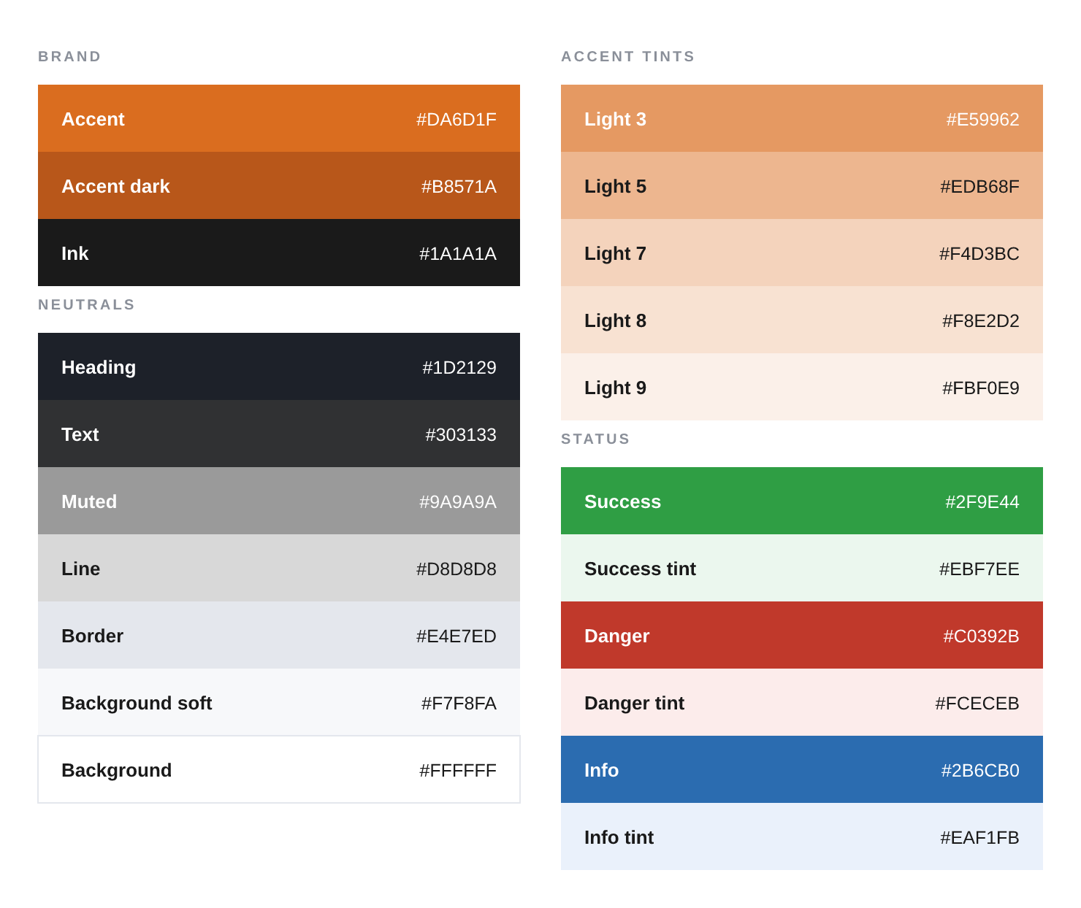
Figure 4.2 Color Palette

Typography Hierarchy Rules
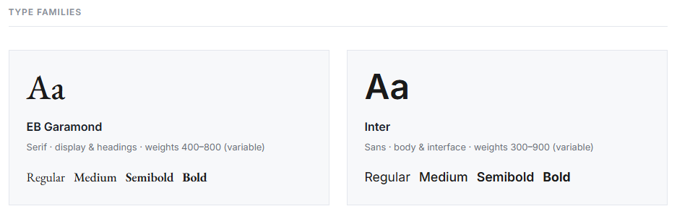
Figure 4.3 Typography Type Families
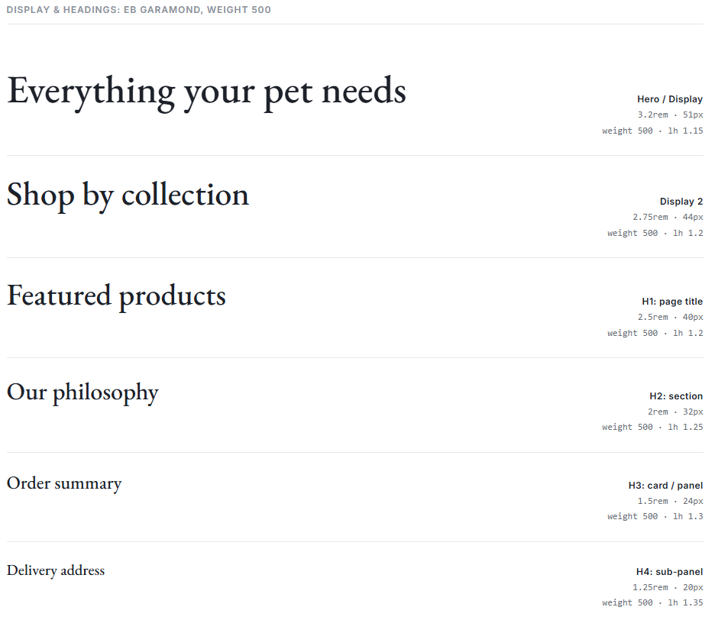
Figure 4.4 EB Garamond
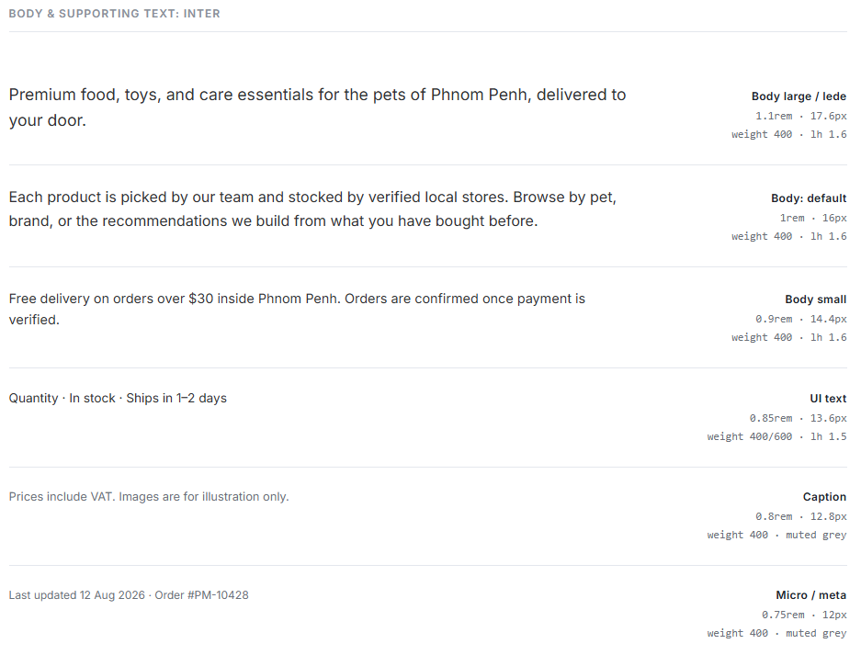
Figure 4.5 Inter

UI Iconography Assets

Figure 4.6 Icon set

4.3 Functional Platform Demonstration
The figures below should be captured directly from the running PawMart application to demonstrate its key end-to-end capabilities: pet-profile registration feeding the recommendation engine, the recommendation results themselves, and the KHQR/Bakong scan-to-pay confirmation that is the platform's most locally distinctive checkout step.
Landing and Authentication

Figure 4.7 Login Page
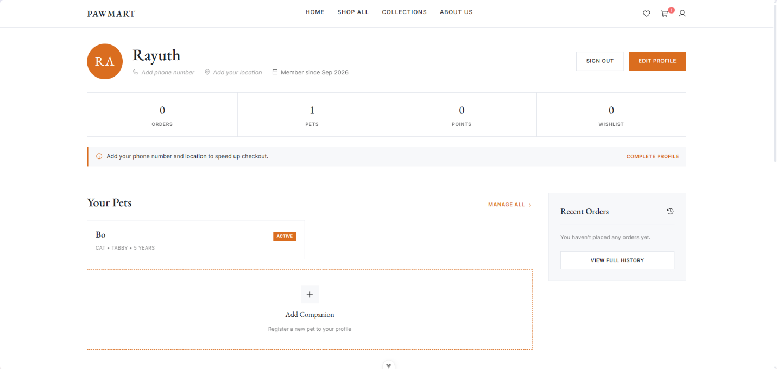
Figure 4.8 Profile Page
Dashboard and New Session
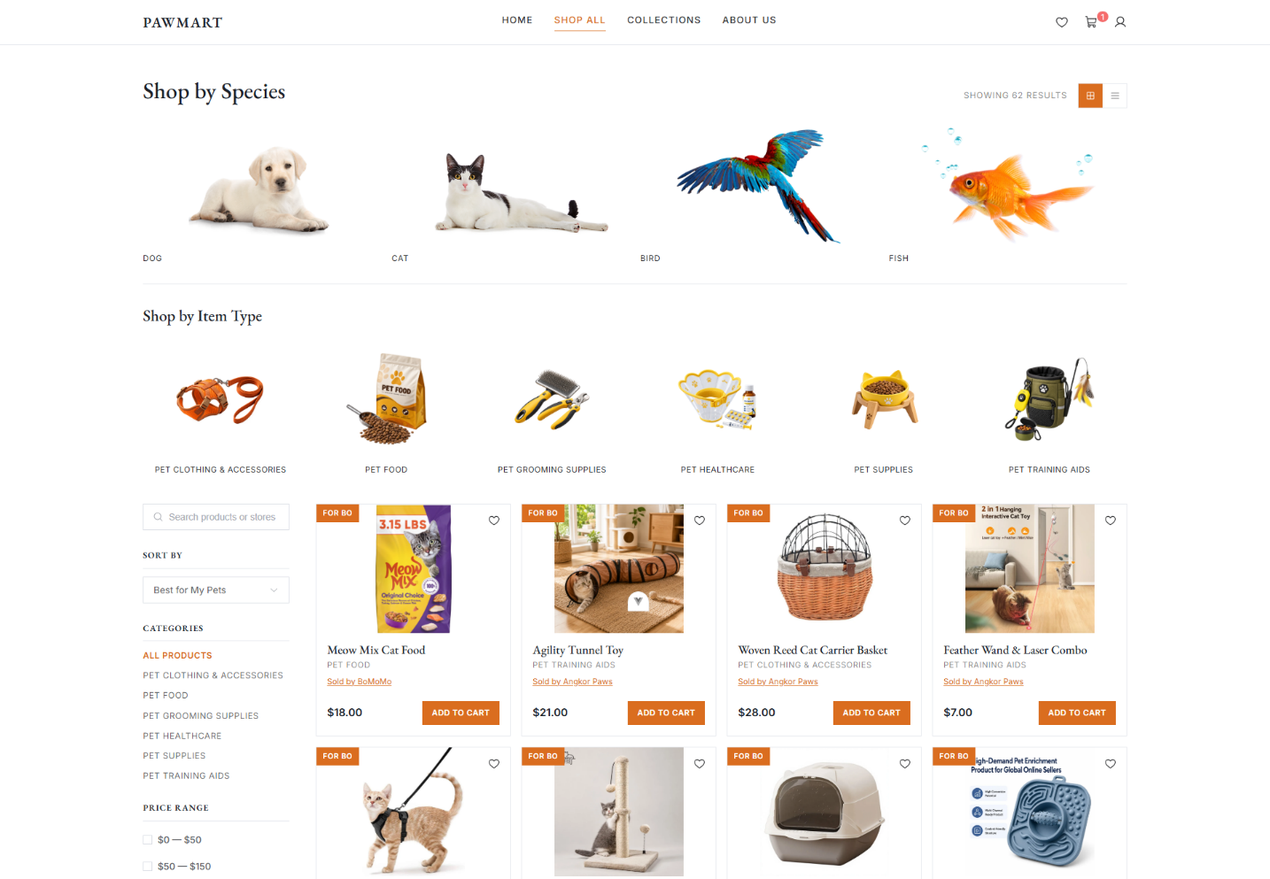
Figure 4.9 Personalized Recommendation
Active Session
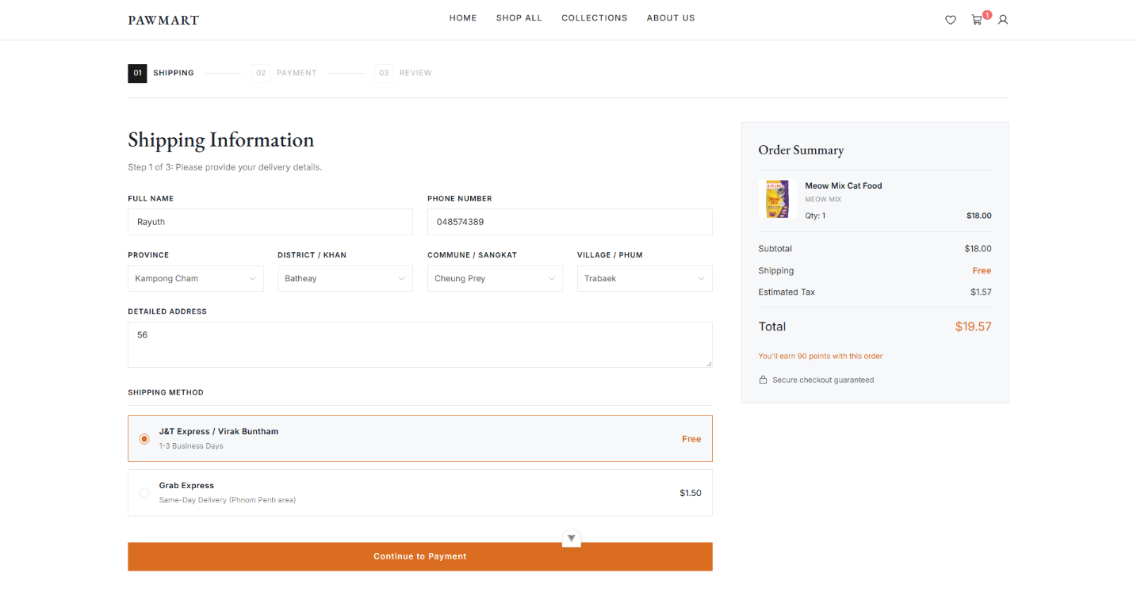
Figure 4.10 Shipping Info
Session Detail and Export
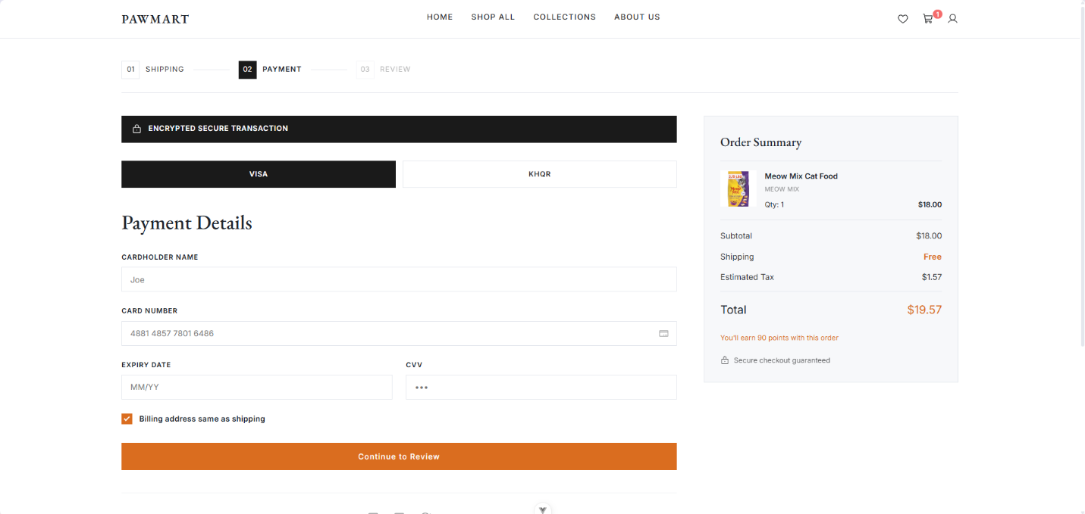
Figure 4.11 Payment
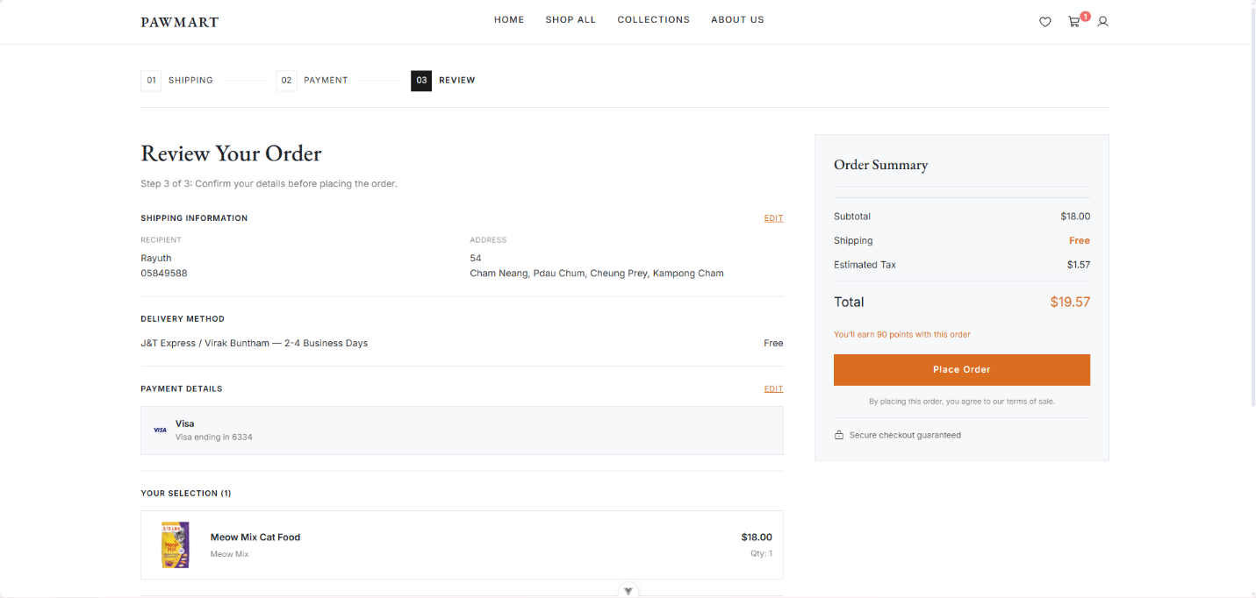
Figure 4.12 Review order before payment confirmation
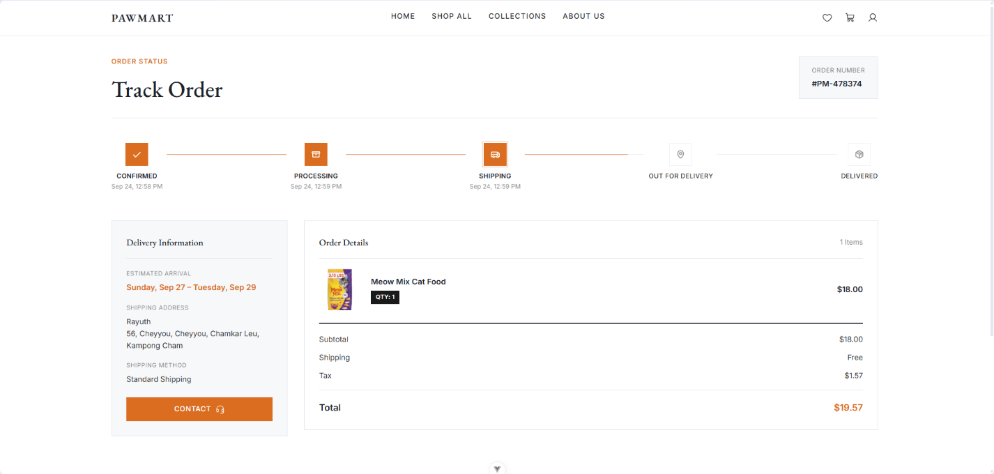
Figure 4.13 Tracking Order

PRODUCTION TECHNOLOGY STACK SPECIFICATIONS

5.1 Technology Stack Layer Summary
- Frontend Client Layer: Vue 3 (Composition API, TypeScript, Element Plus, Phosphor icons), built with Vite. Chosen for component reuse, compile-time type safety, and shared patterns with a concurrent freelance project by the same developer, which reduced context-switching across two simultaneous builds. State is managed with Pinia across four stores (auth, cart, pets, wishlist), and routing uses Vue Router 5 with role-aware navigation guards.
- Backend Application Layer: Python 3.11, FastAPI, managed with uv. Handles API endpoints, core business logic, routing, and service orchestration; role enforcement runs through explicit dependency-injection gates (require_admin, require_store_owner, require_admin_or_store_owner, plus an active-store check that locks out banned owners).
- Database Management System: Supabase (managed PostgreSQL) with Row-Level Security enforced throughout. Chosen to bundle the relational database, authentication, and file storage into a single managed service appropriate to a solo-developer build, avoiding the overhead of running and securing separate infrastructure for each.
- Payments Layer: a manual mock Visa card-entry flow for Visa/card payments, and a KHQR/Bakong QR code generated client-side via the qrcode library. The mock Visa flow keeps the implementation simple by never persisting card details to application state; KHQR was prioritised because 81% of validation-survey respondents named it their preferred payment method.
- Containers and Hosting: Docker Compose for hot-reloading local development (frontend on Vite at :5173, backend on Uvicorn at :8000) against the hosted Supabase project, and Vercel for production frontend hosting with SPA rewrites (vercel.json).
Environment variables keep real secrets out of version control on both sides: the frontend uses VITE_SUPABASE_URL, VITE_SUPABASE_ANON_KEY, and VITE_API_BASE_URL, while the backend uses SUPABASE_URL, SUPABASE_KEY (the service-role key), and CORS_ORIGINS, documented in .env.example on each side.

5.2 Technology Interaction Overview
Two write paths coexist by design. Simple, Row-Level-Security-safe reads and writes, including browsing the catalogue, managing a pet profile, adding to the wishlist, reading reviews and loyalty balances, and most product/store CRUD, go directly from the Vue 3 frontend to Supabase over HTTPS, authorised by the customer's own Supabase Auth session and enforced entirely by Postgres Row-Level Security policies. Anything with cross-cutting business logic, such as creating an order, verifying a payment, decrementing stock, advancing an order's status, or provisioning a new store owner during seller approval, goes through the FastAPI backend instead, which holds the Supabase service-role key server-side and therefore bypasses Row-Level Security as the real, authoritative enforcement point for those actions. The backend safely isolates that service-role key behind server-side environment variables; it is never exposed to the client. All traffic runs over HTTPS/TLS, and every backend-mediated write independently re-validates the request, for example by re-validating the mock Visa payment's amount and owning customer server-side before an order is ever created, rather than trusting a success signal sent by the frontend.

5.3 Infrastructure and Hosting Cost
PawMart runs on managed cloud services, so there are no servers to buy and the monthly bill grows with use. The build and the demo run fully on free tiers. A commercial launch needs paid tiers because the free tiers either forbid commercial use or stop the service when it is not used.
Current setup (development and demo):
Service | Plan | Cost | Limit that matters
Supabase (database, auth, storage) | Free | $0 | Project is paused after about a week with no activity, 500 MB database, 1 GB file storage, no daily backups
Vercel (frontend) | Hobby | $0 | For personal and non-commercial use only
Render (FastAPI backend) | Free web service | $0 | Sleeps after about 15 minutes with no traffic, the next request waits for a cold start of up to around a minute
GitHub | Free | $0 | Enough for one developer
Total |  | $0 a month
The Render cold start is the most visible free tier problem: the first checkout after a quiet period can take close to a minute because the backend has to start again. This is fine for a demo and not fine for real buyers.
Production setup for launch (Year 1):
Service | Plan | Monthly cost | What it covers
Supabase | Pro | $25 | No pausing, 8 GB database, 100 GB file storage, 250 GB data transfer, daily backups kept for 7 days
Vercel | Pro (1 seat) | $20 | Commercial use, more bandwidth and build minutes
Render | Starter web service | $7 | Always on backend with 512 MB memory, no cold starts
Domain (.com) | Yearly | About $1.25 ($15 a year) | pawmart domain name
Business email | 2 users | About $14 | support@ and admin@ addresses
Transactional email | Free tier of an email API | $0 | Sign up, password reset and order emails beyond the Supabase built-in limit
Error tracking | Free tier | $0 | Frontend and backend errors with stack traces
Uptime monitoring | Free tier | $0 | Checks the site and API every 5 minutes
Total |  | About $67
Prices are in USD as listed by each provider at the time of writing. Cambodia charges 10% VAT on digital services bought from foreign providers, so the real card charge for these services can be up to about 10% higher. The $67 figure is used in the Year 1 fixed costs (section 3.14).
Storage and data transfer estimate. Product images are compressed before upload (about 150 KB each). With 4 images per product, 2,000 products in Year 2 use about 1.2 GB of storage, well inside the 100 GB of Supabase Pro. Most data transfer is images on product and catalogue pages. At about 2 MB per visit and 30,000 visits a month in Year 2, transfer is about 60 GB a month, also inside the plan.
Infrastructure cost per order:
Year | Hosting and software per year | Orders | Cost per order
Year 1 | $804 | 2,700 | $0.30
Year 2 | $1,200 | 10,800 | $0.11
Year 3 | $1,800 | 26,400 | $0.07
Hosting is a small part of the cost of running PawMart. Even in Year 1 it is $0.30 per order against $1.01 of contribution, and it falls quickly as orders grow, because the same plan can serve many more orders.

5.4 Development Effort and Cost
PawMart was built by one developer from 7 August to 20 September 2026, about six and a half weeks, across 50 commits and five phases tracked task by task in the checkpoint file. The hours below are estimated from the commit history and the checkpoint notes.
Phase | Dates | Estimated hours | Main output
1. Frontend scaffold | Early August | 70 | 16 static views: shop shell, catalogue, product, cart, checkout, tracking, account, admin
2. Backend foundation | Early August | 25 | FastAPI structure, Supabase schema with Row-Level Security, auth and storage
3. Wiring and marketplace pivot | August, pivot from 12 August | 110 | Live data, recommendations, loyalty, then stores, roles, storefronts, seller intake and bans
4. Payments | 27 August to 13 September | 35 | Mock Visa flow and client generated KHQR
5. Testing and polish | To 16 September, polish to 20 September | 60 | 239 automated tests, Row-Level Security audit, wishlist, options, reviews, address data
Design and documentation | Throughout | 30 | Brand guide, ERD, this document
Total |  | About 330 hours
Cost if the same work was paid for:
Option | Rate | Cost for about 330 hours
Cambodian freelance developer, mid level | Around $8 to $15 an hour | About $2,640 to $4,950
Planning figure used in this document | $12 an hour | About $3,960
Local software agency | Agency quote for a multi-vendor marketplace | Often several thousand dollars up to more than $10,000, plus design
Tools used in development were all free or open source: Vue, Vite, Element Plus, FastAPI, uv, Docker, VS Code, Git and GitHub, and the free tiers of Supabase, Vercel and Render. There were no paid licences, so the development cost is the time only.
Planned development work after launch:
Feature | Estimated hours | Linked section
Commission fields, payouts and payout statements | 40 | 3.6, 3.7
Weight based shipping and carrier rule | 20 | 3.8
Cancel, return and refund flow | 30 | 3.11
Bakong API payment check | 15 | 3.11
Store VAT TIN and tax invoices | 15 | 3.9
Featured slots | 15 | 3.6
Referral program and reorder reminders | 25 | 3.13
Total | About 160 hours, about $1,920 at $12 an hour
Ongoing maintenance (dependency updates, bug fixes, small requests from stores) is planned at about 20 hours a month in Years 1 and 2, done by the founder, and covered by the part time developer in Year 3.

5.5 Scaling Plan and Cost at Growth
The stack is sized for Year 1 and scaled up step by step when real usage crosses a trigger, not in advance. Each step below has a clear trigger, an action and the added monthly cost.
Trigger | Action | Added cost per month
Backend memory above 80% most of the day, or slow responses at peak | Move Render from Starter to Standard (2 GB memory) | About +$18
Database CPU often high or database above about 6 GB | Add a larger Supabase compute size | Around +$10 to +$60 depending on size
More than one person needs to deploy the frontend | Add a second Vercel seat | +$20
Image transfer close to the plan limit | Serve resized images and cache them longer | Usually $0
Weekly payouts or reminder emails take too long in a request | Move them to a scheduled background job | $0 to $7
Catalogue search slows down above a few thousand products | Add Postgres full text search indexes | $0
Hosting cost by year, used in the projection (section 3.14):
Year | Setup | Per month
Year 1 | Supabase Pro, Vercel Pro, Render Starter, domain, email | About $67
Year 2 | Render Standard, more email users, backups exported off site | About $100
Year 3 | Larger Supabase compute, second Vercel seat for the part time developer | About $150
Performance targets the scaling steps protect: 95% of API requests answered in under 500 ms, product and catalogue pages usable within 3 seconds on a normal 4G phone connection, and the site available 99.5% of the time in a month (about 3.6 hours of downtime at most).

5.6 Payment Integration Options and Cost
Payment is the part of PawMart where the technical choice directly changes the business numbers, because it decides the fee on every order, whether payments are checked automatically, and whether payouts to stores can be split by the payment provider. This section describes the payment setup in the current build and the options for the real launch.
Current build. The KHQR code is generated in the browser with the qrcode library from the PawMart merchant details and the order amount, and the buyer scans it with any Bakong member banking app. There is no live connection to Bakong, so the order is marked paid when the buyer clicks Place Order. Card payment is a simulated Visa form: the backend checks the amount and the owner of the payment again before creating the order, but no real card is charged. An early version used Stripe, which was removed because Stripe does not support businesses registered in Cambodia, so it could never be used for a real PawMart launch.
Options for the real launch:
Option | How it works | Fee to PawMart | Automatic check | Fit for PawMart
KHQR to a bank account, checked by hand | Same as now, admin matches bank statement with orders every day | About 0% | No | Launch only, does not scale past a few dozen orders a day
KHQR with Bakong API check | Backend creates the KHQR string, then asks the Bakong API whether a payment for that QR arrived before marking the order paid | About 0% | Yes | Best first step, removes most manual reconciliation
ABA PayWay | Bank payment gateway with KHQR, ABA Pay and cards in one checkout, with callbacks to the backend | Low on KHQR, around 2% to 3% on cards | Yes | Best for cards, and its payout features can support weekly store payouts
International card gateway (Stripe and similar) | Card form hosted by the gateway | Around 3% or more plus currency fees | Yes | Not available for a Cambodian registered business
Fees in the table are typical market ranges and are confirmed with the bank during the merchant agreement.
Planned path:
- Step 1, launch. KHQR with the Bakong API check. The order is created as unpaid, the buyer scans the QR, the backend checks the payment every few seconds for up to the QR expiry time, and only then marks the order paid and awards Paws Rewards points. Card stays as the simulated form or is hidden until Step 2.
- Step 2, Year 1 to 2. ABA PayWay for real card payments, using the PayWay callback to mark card orders paid.
- Step 3, with payouts. Use the bank payout features for the weekly store transfers (section 3.7), so PawMart does not hold buyer money longer than the 7 day return window.
Payment cost for every 1,000 orders of $25 with 85% KHQR and 15% card:
Method | Orders | Order value | Fee rate | Fee
KHQR | 850 | $21,250 | About 0% | $0
Card | 150 | $3,750 | About 2.8% | $105
Total | 1,000 | $25,000 | 0.42% blended | $105
If half the orders were paid by card the fee would be $350 for the same 1,000 orders, which is why KHQR stays the default and first option at checkout.
Refunds by method. A KHQR payment is refunded by a bank transfer back to the paying account, which needs the account details from the original payment. A card payment is refunded through the gateway to the same card, and card fees are usually not returned by the gateway, so a refunded card order still costs PawMart the fee. This is counted in the 0.5% refund loss in section 3.10.
Integration effort. The Bakong API check is about 15 hours of work (section 5.4). ABA PayWay is about 30 hours including the callback, refund and test environment, plus the time for the merchant application and approval by the bank.

FUNCTIONAL & NON-FUNCTIONAL REQUIREMENTS

6.1 Functional Requirements (FR) Matrix
ID Code | Target Module Component | Explicit Engineering System Requirement
FR-1.1 | Account Registration | The system shall allow customers to register via email/password or Google OAuth (Supabase Auth), and staff (admins, store owners) via email/password on a shared login screen.
FR-1.2 | Session & Role Verification | The system shall gate FastAPI endpoints by role through dependency injection (require_admin, require_store_owner, require_admin_or_store_owner) and lock out banned store owners via an active-store check.
FR-2.1 | Product Catalogue & Filtering | The system shall let users browse, filter, sort, and paginate products by category, pet type, brand, price range, and store, with slug-based product URLs.
FR-2.2 | Personalized Recommendations | The system shall compute rule-based product recommendations using weighted scoring (pet-species match, then purchase-category affinity, then new arrivals), falling back to newest arrivals for guests.
FR-3.1 | Cart & Checkout | The system shall maintain a server-persisted cart restricted to one store at a time, and guide checkout through a 3-step wizard (Shipping → Payment → Review), with a Buy-Now path for single items.
FR-3.2 | Payment Processing | The system shall validate a server-recomputed manual mock Visa payment for card payments and independently re-verify its status/amount/owner before creating an order; it shall generate a real KHQR/Bakong QR code client-side for local bank-app payment.
FR-3.3 | Zoned Shipping | The system shall price delivery by zone from the province in the shipping address: Standard (J&T Express / Virak Buntham) $1.50 in Phnom Penh and $2.50 for other provinces, Grab Express $3.00 same day in Phnom Penh only, and $0 standard shipping when a Free Standard Shipping reward is applied (Grab Express is still charged). The backend recompute this itself and reject Grab Express for addresses outside Phnom Penh.
FR-3.4 | Tax Line | The system shall treat all prices as VAT inclusive and never add tax on top. For a store an admin marked as VAT registered, it shall record and show the 10% VAT already inside the subtotal (subtotal x 10 / 110); other stores show no VAT line (section 3.9).
FR-4.1 | Order Tracking | The system shall expose a forward-only order status timeline (Confirmed → Processing → Shipping → Out for Delivery → Delivered) and a full order history with item images.
FR-4.2 | Loyalty (Paws Rewards) | The system shall award 5 points per $1 of post-discount subtotal on paid orders and allow redemption of points for a real checkout discount (a dollar amount and/or free shipping).
FR-5.1 | Pet Profile Management | The system shall let customers register and edit pet profiles (name, species, breed, age, weight, diet), available app-wide.
FR-6.1 | Seller Application & Approval | The system shall accept public seller applications, let an admin approve or reject them (with an optional rejection note), and provision a real Auth user and store row with a one-time temporary password on approval.
FR-6.2 | Store-Owner Dashboard | The system shall let a store owner manage only their own store's products (with image upload) and orders (forward-only status advance), view a sales overview and low-stock alerts, and edit their store profile.
FR-7.1 | Platform Admin Oversight | The system shall give admins aggregate platform statistics, a read-only stores directory, seller-application review, store ban/unban, and management of an upcoming-stores teaser list, without direct access to edit another store's products or orders.
FR-8.1 | Wishlist | The system shall let customers save products to a server-side wishlist that persists across refresh and device.
FR-9.1 | Product Options & Reviews | The system shall let sellers define product options (e.g. size/variant) and let customers submit and read product reviews on the detail page.

6.2 Non-Functional Requirements (NFR) Constraints
- Security & Encryption (NFR-1). All network traffic runs over TLS-secured HTTPS. Direct frontend-to-Supabase calls are enforced by Postgres Row-Level Security; backend-mediated actions are enforced by the FastAPI service-role key and its dependency-injection role gates. A privileged-column lockdown trigger (migration 20260913020000) blocks a customer from self-promoting their own role and blocks a banned store owner from un-banning themselves. Card details are collected only through the manual mock Visa form and are never persisted to application state, and every order is created only after the backend independently re-validates the mock payment's amount and owning customer.
- Reliability & Data Integrity (NFR-2). Order status can advance forward, including skipping ahead several steps in one update, but can never move backward, protecting the fulfilment record's integrity. Stock is enforced at the backend's pricing/order-creation step rather than only reactively in the cart UI.
- Scalability (NFR-3). The frontend is hosted on Vercel, which scales the built SPA without server management; the database and authentication layer run on Supabase's managed PostgreSQL, avoiding the need to provision or scale database infrastructure directly.
- Verifiability (NFR-4). 170 frontend tests across 17 spec files and 69 backend tests across 5 files cover authentication, catalogue, cart/checkout, tracking, pets/recommendations, loyalty, admin and store-owner flows, and Row-Level-Security spot-checks; linting and type-checking are clean, and the full stack has been verified booting from scratch via Docker Compose against a live Supabase project.
- Documented Limits (NFR-5). No per-vendor payout splitting exists yet, so all payments settle to one shared platform account. A store owner banned mid-session keeps that session until sign-out, though every read and write is still blocked at the Row-Level-Security and backend layers in the meantime. Mobile/responsive quality assurance was a code-level audit rather than a full manual pass across every breakpoint. On the business side, shipping is a flat zone price that ignore parcel weight, no commission is taken yet, and there is no cancel, refund or return flow in the app even though the product page mention a 7 day return policy (see sections 3.6 to 3.11). These are documented, deliberate trade-offs for this build stage rather than oversights, and are revisited in section 8.3.

SYSTEM ARCHITECTURE & DATABASE DESIGN

7.1 Hardware and Infrastructure Map
Infrastructure Node | Architecture Type | Scope of Responsibility
Client Devices (mobile / desktop browser) | User client hardware | Renders the Vue 3 SPA, captures user input, and holds ephemeral cart/UI state via Pinia until it is synced to the server.
Vercel Hosting | Cloud Frontend Hosting | Serves the built frontend with SPA rewrites (vercel.json) and scales automatically with traffic.
FastAPI Application Server | Cloud Application Server | Hosts business-logic endpoints (orders, loyalty, storage, seller provisioning), holds the Supabase service-role key, and is the authoritative enforcement point for cross-cutting actions.
Supabase Platform | Managed Relational Database + Auth + Storage | The single real datastore: evaluates queries, enforces Row-Level Security for direct frontend calls, issues Auth sessions, and stores product images.
KHQR-Bakong | External Payment Services | The manual mock Visa flow confirms card payments server-side; KHQR/Bakong QR codes are generated client-side and scanned by the buyer's own banking app.

7.2 Database Table Design & Schema Definitions
All schema changes live as 29 numbered migration files in supabase/migrations/, from 20260807000000_init_schema.sql through 20261003000000_store_vat_registration.sql, never as ad-hoc edits in the Supabase SQL editor. The tables group into four functional areas:
- Identity & Store Tracking. customers (one row per user; role of customer, store_owner, or admin; loyalty balance), stores (one per seller; status of active or banned; a vat_registered flag only an admin can change; a single owner_id), and upcoming_stores (admin-managed "Coming Soon" teaser rows with no owner or products).
- Catalogue Tables. products (belongs to a store_id and category; slug, stock, is_discounted/discount_percent, promotion_note), plus categories, product_options, and product_reviews for catalogue detail.
- Transactional Tables. cart_items (server-side cart per customer, with the single-store rule enforced in application logic), wishlist_items (unique per customer/product), and orders / order_items / order_status_history, scoped to a store_id with status that only ever advances forward.
- Loyalty & Marketplace-Intake Tables. loyalty_transactions and loyalty_rewards (rewards carry a discount_amount and/or free_shipping flag, so a redemption is a machine-readable checkout discount, not just a ledger entry), store_applications (a public seller-intake queue of pending/approved/rejected rows), and pet_profiles (customer-owned pet records driving recommendations).
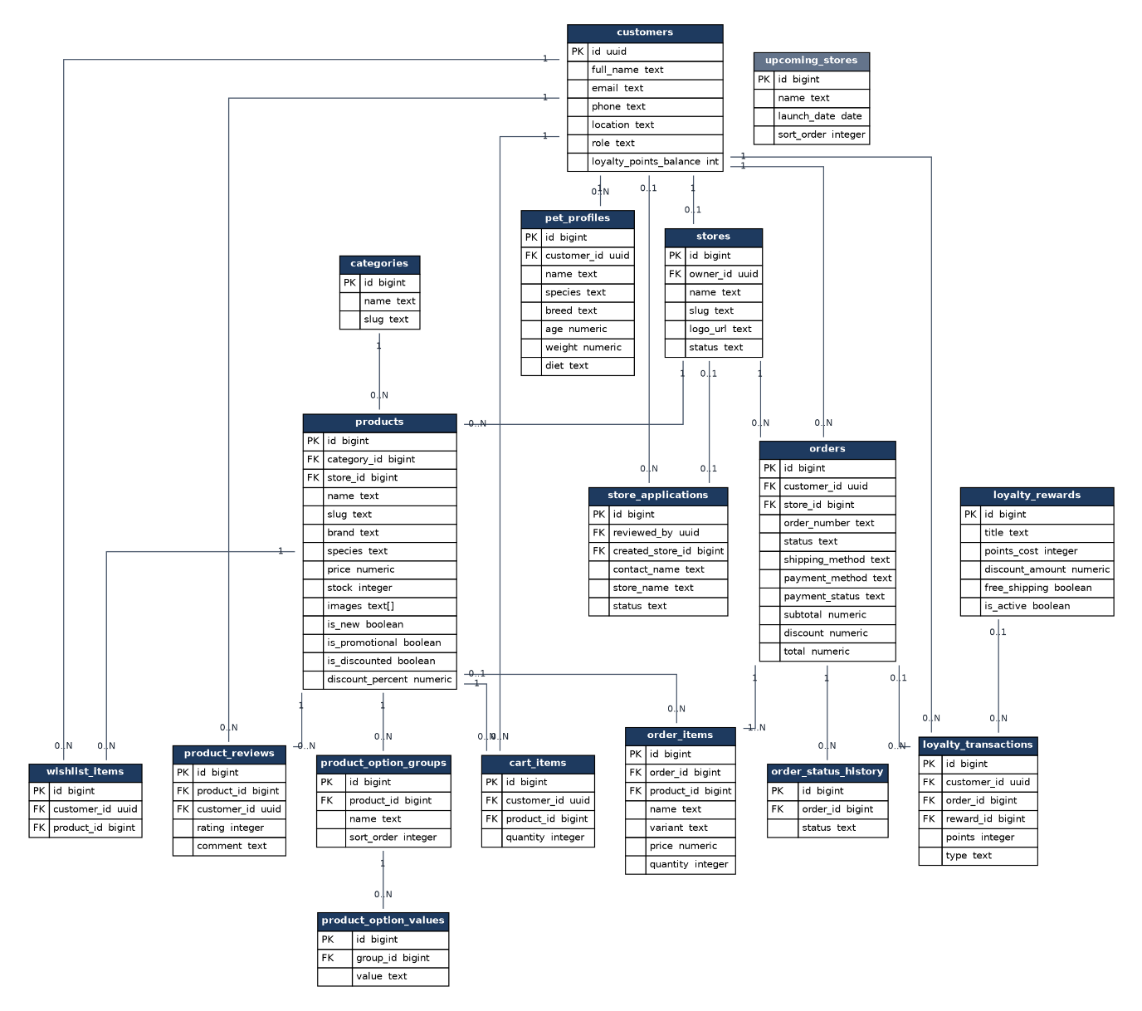
Figure 7.1 ERD Diagram

7.3 System Security and Data Integrity Controls
Security is enforced in layers rather than at a single point. Postgres Row-Level Security policies are the primary control for every direct frontend-to-Supabase call, including catalogue reads, pet profiles, wishlist, most product/store CRUD, and seller applications, while the FastAPI backend holds the Supabase service-role key and therefore bypasses Row-Level Security, making it the real enforcement point for the subset of actions (order creation, payment verification, stock decrement, seller provisioning) that require cross-cutting business logic no single row-level policy could safely express. A dedicated privileged-column lockdown trigger, added in migration 20260913020000 after a full Row-Level Security audit, closes two real privilege-escalation gaps that audit found: a customer could otherwise self-promote their own role, and a banned store owner could otherwise un-ban themselves. Payment compliance follows the same layered principle: the manual mock Visa form collects card details directly within the frontend session, so they never reach PawMart's own servers or database, and every order is created only after the backend independently re-validates the mock payment's amount and owning customer rather than trusting the frontend's claim of success. Server secrets (the Supabase service-role key) are isolated in backend-only environment variables and are never bundled into or exposed by the client application.

7.4 End-to-End Technical Flow Walkthrough
The trace below follows a single representative action; a customer placing and paying for an order; through every layer of the stack:
- Step 1: Vue 3 Client. The customer completes the three-step checkout wizard and submits the order.
- Step 2: Secure HTTPS/TLS Tunnel. The client serialises the request as JSON, including the customer's Supabase Auth JWT for authorisation.
- Step 3: FastAPI Application Server. The orders router validates the JWT, recomputes the order total server-side, including the zone based shipping fee, any Paws Rewards discount and the tax line (never trusting a client-supplied price), and independently re-validates the mock Visa payment's status, amount, and owning customer.
- Step 4: Supabase (PostgreSQL). On a verified payment, the backend, using the service-role key which bypasses Row-Level Security for this backend-mediated write, commits the order and order_items rows and decrements product stock, all within a single consistent operation.
- Step 5: Payment Confirmation (Mock Visa / KHQR). For a card payment, the backend confirms the mock Visa charge once validation passes; for KHQR, the order is marked paid at "Place Order" once the client-generated QR has been scanned, since no live Bakong webhook exists to gate on.
- Step 6: Vue 3 Client View Refresh. The backend returns a success payload; the frontend redirects the customer to the order confirmation screen, and the new order immediately appears in their order-tracking history.

7.5 Operational Workflow and Staffing
Running PawMart is mostly people work, not server work. The table lists every recurring task, who does it, how often and with which tool, and whether the tool already exists in the build.
Task | Who | How often | Time | Tool
Review seller applications | Admin | Daily | About 15 minutes | Admin seller applications page (built)
Match KHQR payments with paid orders | Admin | Daily | About 20 minutes | Bank statement and orders list (manual)
Answer buyer and store questions | Support | Daily | 1 to 2 hours | Telegram, Facebook page, email
Check late orders (not shipped in 48 hours) | Admin | Daily | About 15 minutes | Late order report (planned)
Check new listings for prohibited items | Admin | Weekly | About 1 hour | Catalogue spot check
Pay stores | Admin | Every Monday | About 1 hour | Payout statements (planned) and bank transfers
Social media posts | Founder or support | 3 times a week | About 2 hours a week | Facebook, TikTok, Telegram
Tax filing | Outsourced accountant | Monthly | n/a | GDT e-filing
Store performance review | Admin | Monthly | About 2 hours | Store dashboard data
Security and backup check | Developer | Quarterly | About 4 hours | Section 7.6
In Year 1 the daily tasks take around 2 to 3 hours a day, which the founder covers together with development.
Staffing plan:
Role | Year 1 | Year 2 | Year 3 | Monthly cost
Founder (admin, development, onboarding) | Yes, unpaid | Yes, unpaid | Yes | Not paid in Years 1 and 2
Customer support | Founder | Part time | Full time | $250 part time, $400 full time
Developer | Founder | Founder | Part time | $600
Accountant | Outsourced | Outsourced | Outsourced | $120 to $200
Customer support process. Buyers and stores reach support through the PawMart Telegram account, the Facebook page or the support email. The reply target is 24 hours on business days. Every case is logged with the order number. Payment problems go to the admin the same day, disputes follow the process in section 3.11, and anything that looks like a bug goes to the developer with the steps to repeat it.
Order fulfilment from the store side, matching the forward-only order statuses built into the system:
Status | What the store does | What the buyer sees
Confirmed | Receives the paid order in the store dashboard | Order confirmation page and first step of the timeline
Processing | Checks stock and packs the parcel within 24 hours | Second step, order is being prepared
Shipping | Hands the parcel to J&T, Virak Buntham or Grab within 48 hours | Third step, parcel is with the carrier
Out for Delivery | Updates when the carrier reports the parcel is on its way | Fourth step
Delivered | Updates when the carrier confirms delivery | Final step, 7 day return window starts

7.6 Monitoring, Backup and Maintenance
This section defines how PawMart is kept running after launch: what is watched, how data is protected, and the regular maintenance schedule.
Monitoring:
- Uptime. The website and the API health endpoint are checked every 5 minutes. An alert goes to the admin Telegram if either is down for two checks in a row.
- Errors. Frontend and backend errors are sent to the error tracking service with the page, user role and stack trace, never with card or password data.
- Database. The Supabase dashboard is checked weekly for database size, slow queries and storage use, against the triggers in section 5.5.
- Business numbers. The admin dashboard shows revenue, orders and average order value for this month and last month (built). The monthly early warning numbers in section 3.15 are added to it.
Backup and recovery:
- Daily backups. Supabase Pro keeps a daily backup for 7 days.
- Weekly export. A weekly database export is stored outside Supabase, so data is safe even if the Supabase project itself has a problem.
- Schema in git. Every schema change lives as a numbered migration in supabase/migrations/, so the database structure can be rebuilt from scratch at any time.
- Restore test. Once a quarter a backup is restored into a separate test project to prove it actually works.
- Recovery targets. At most 24 hours of data lost in the worst case, and the site back online within 4 hours.
Maintenance schedule:
Task | How often
Update frontend and backend dependencies, then run type check, lint and tests | Monthly
Review Row-Level Security policies and the privileged column triggers, repeating the audit from Phase 5 | Quarterly and after every schema change
Rotate the Supabase service role key and other secrets | Every 6 months, or right away if one may have leaked
Restore test of a backup | Quarterly
Check carrier rates and update shipping prices | Every 6 months
Check tax rates, thresholds and filing rules with the accountant | Yearly
Incident handling. When something breaks, the admin first posts a short notice on the Telegram channel and Facebook page, the developer fixes or rolls back the last deploy (Vercel and Render both keep previous versions that can be restored in one click), orders placed during the problem are checked against the bank statement, and a short note of what happened and what was changed is added to the project records.
Account security. Admin and store owner accounts use strong passwords, and multi-factor sign in through Supabase Auth is planned for admin accounts. The service role key only exists on the backend server, and banned store owners are blocked at the Row-Level Security and backend layers (section 7.3).

CONCLUSION & FUTURE WORK

8.1 Summary
PawMart began as a single-shop pet e-commerce concept and, following client confirmation of the real business intent, was reworked mid-build into a full multi-vendor marketplace made up of independent stores, each with their own owner, storefront, and dashboard, under one platform-wide catalogue, cart, and checkout. The project moved from an initial concept note, through a 34-respondent validation survey used to confirm demand and prioritise features (Chapter 2), into a phased build: a static frontend scaffold, a Supabase/FastAPI backend foundation, live wiring of the catalogue and checkout, the marketplace pivot itself, manual mock Visa and real KHQR payment integration, and a five-phase testing programme that included a dedicated Row-Level Security audit. By close, every planned task across all phases was checked off, the platform carried 170 frontend and 69 backend tests, and the full stack was verified booting from scratch via Docker Compose against a live Supabase project, with the frontend deployed to Vercel.

8.2 Lessons Learned
- Validate the business model before building deep. The mid-project pivot from a single shop to a multi-vendor marketplace required reworking schema, permissions, routing, and already-built admin views that had been designed around the earlier, incorrect assumption, a direct lesson in confirming the real business model as early as possible even when a build is already under way.
- A dedicated security pass finds what code review alone does not. A late-stage Row-Level Security audit uncovered two genuine privilege-escalation gaps, a customer could self-promote their own role, and a banned store owner could un-ban themselves, neither of which had surfaced during normal feature development, underscoring the value of a security-focused review even on a small, solo-built system.
- Cut steps that give an illusion of safety without adding real verification. An originally planned "admin manually confirms KHQR payment" step was dropped once it became clear it added friction for every order without adding any actual verification beyond what the client-side QR generation already provided.
- Shared patterns across projects pay off under time pressure. Deliberately matching this project's stack, auth setup, and Docker configuration to a concurrent freelance build reduced context-switching and let proven patterns (like the KHQR integration) be reused rather than re-derived.

8.3 Future Development Plans
- Per-Vendor Payout Splitting. Move from a single shared payout account to a real commission model, retaining an agreed percentage per order before settling the remainder to each individual store owner, the natural monetisation path proposed in the Business Model Canvas (section 3.4), with the actual rates and weekly payout rules worked out in sections 3.6 and 3.7.
- Weight Based Shipping. Use the weight column the products table already has to price delivery by weight and pick J&T or Virak Buntham automatically (section 3.8), then connect to the J&T API so the tracking number show up in the order timeline.
- VAT Invoices. VAT inclusive pricing and the per store vat_registered flag are done, next is saving each store VAT TIN, giving a proper tax invoice, and PawMart adding VAT on its own commission once it is registered (section 3.9).
- Cancel, Refund and Return Flow. Build the cancel button, return request and refund records from section 3.11, following the 7 day return policy the product page already show.
- Bakong Payment Check. Check the KHQR payment with the Bakong API before the order is marked paid, instead of trusting the Place Order click.
- Featured Slots and Referrals. Add paid featured slots for stores from Year 2 and a buyer referral reward of 200 points each, as planned in sections 3.6 and 3.13.
- Immediate Ban Enforcement. Invalidate a store owner's session immediately on ban, rather than relying on Row-Level Security and backend checks to block their reads and writes until they next sign out.
- Reactive Stock Display. Surface stock constraints directly and reactively in the cart UI, rather than enforcing them only at the backend's order-creation step.
- ABA PayWay Automation. Move ABA PayWay from an informational panel to a fully automated payment path, alongside the existing mock Visa and KHQR options.
- Full Manual Responsive QA. Extend the existing code-level mobile/responsive audit into a complete manual pass across every breakpoint.
- Marketplace Growth. Expand seller categories and geographic coverage, and deepen the rule-based recommendation engine's signal set as real order history accumulates.

APPENDIX & REFERENCES

9.1 Initial Research Findings
The raw field data behind this project is the 30-question, multiple-choice validation survey distributed to 34 respondents and described in section 2.1, covering current pet ownership, purchasing habits, shopping pain points, trust factors, feature-usefulness ratings, and payment, device, and spending preferences. The analysed results, including the typology breakdown into Groups A through C and the three personas built from them, are presented in full in sections 2.1 through 2.5 rather than repeated here.
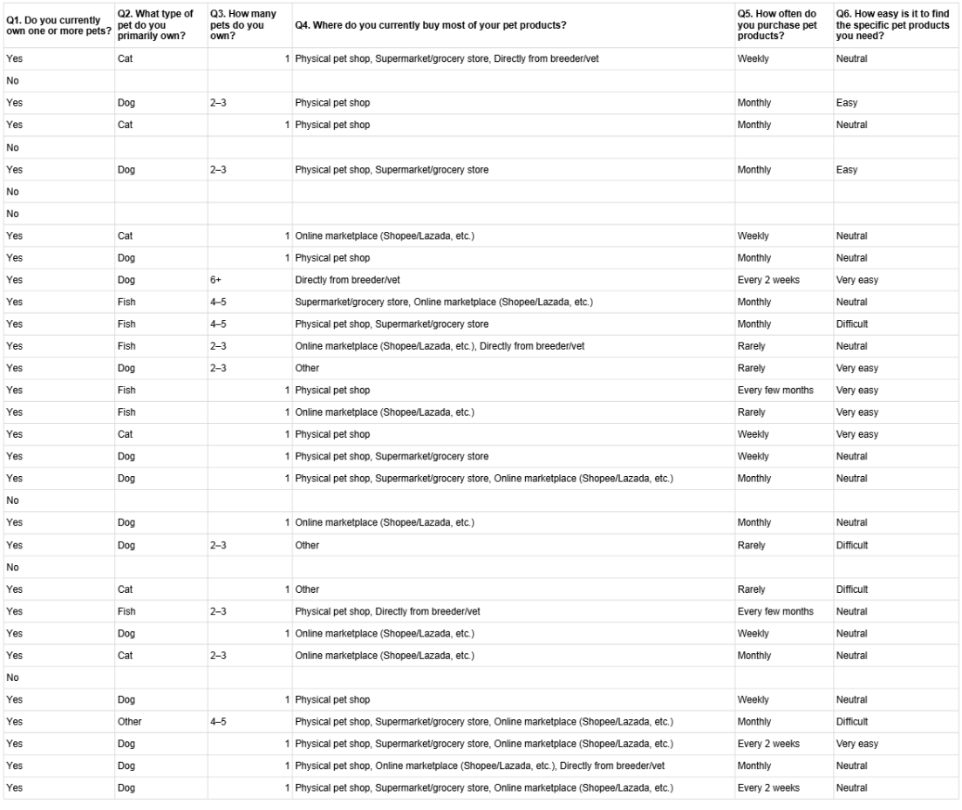
Figure 9.1 Survey Data 0.1
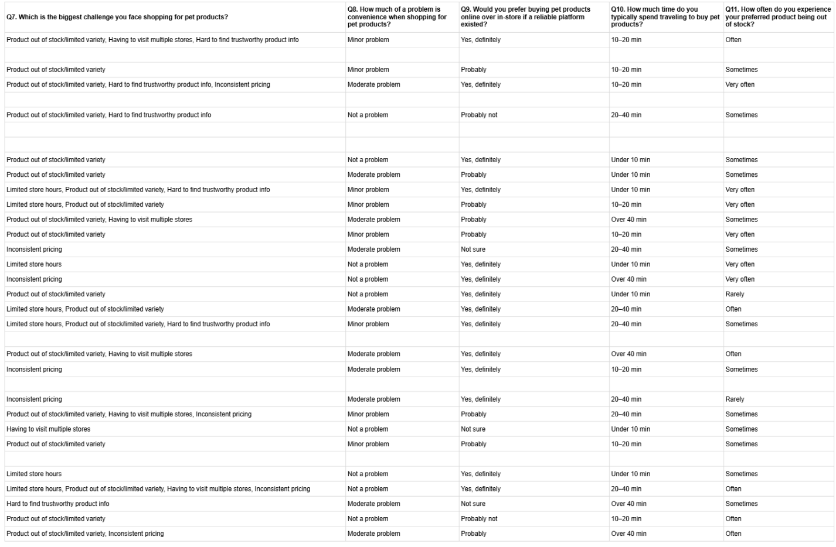
Figure 9.2 Survey Data 0.2
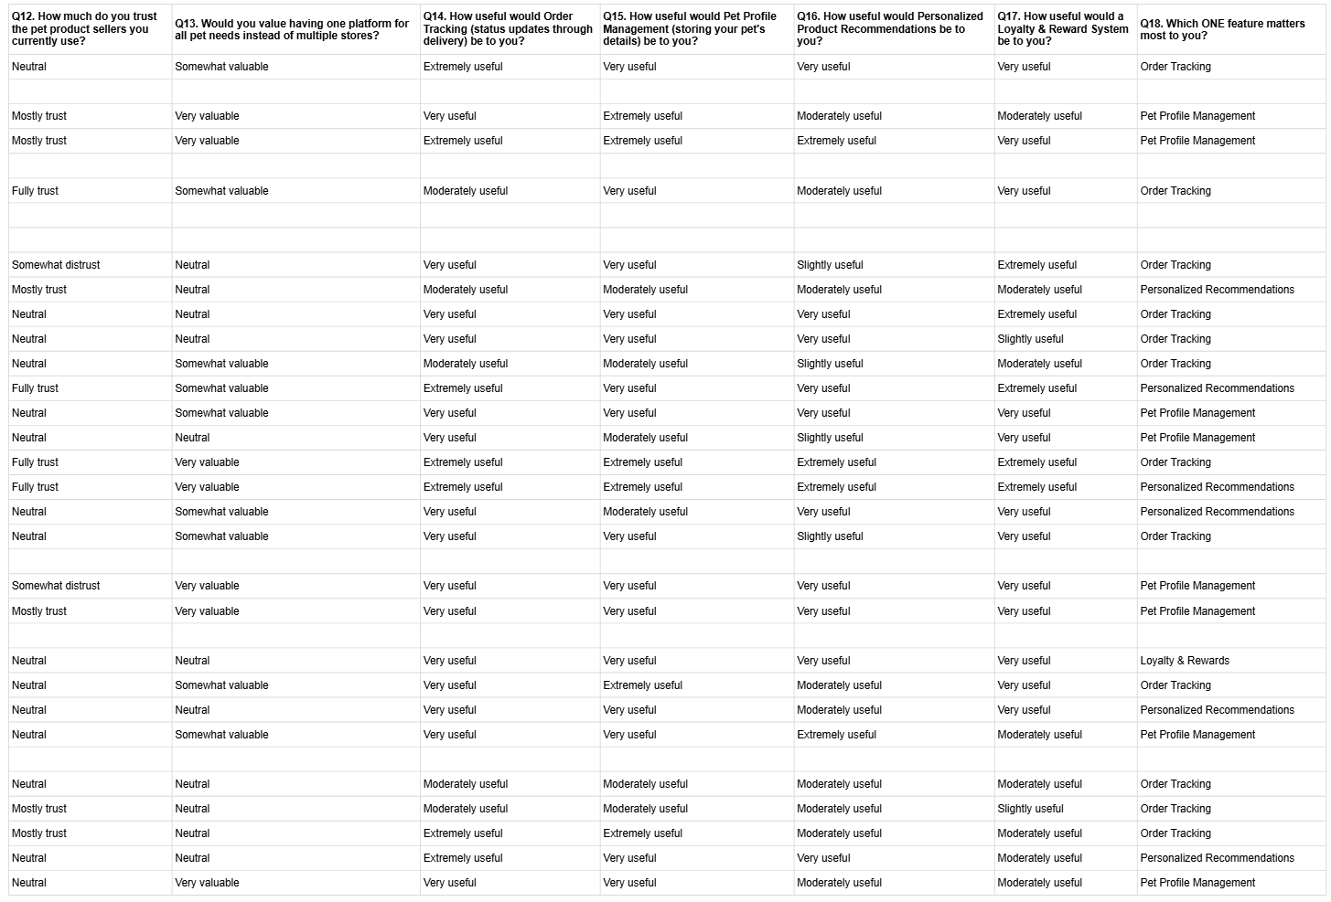
Figure 9.3 Survey Data 0.3
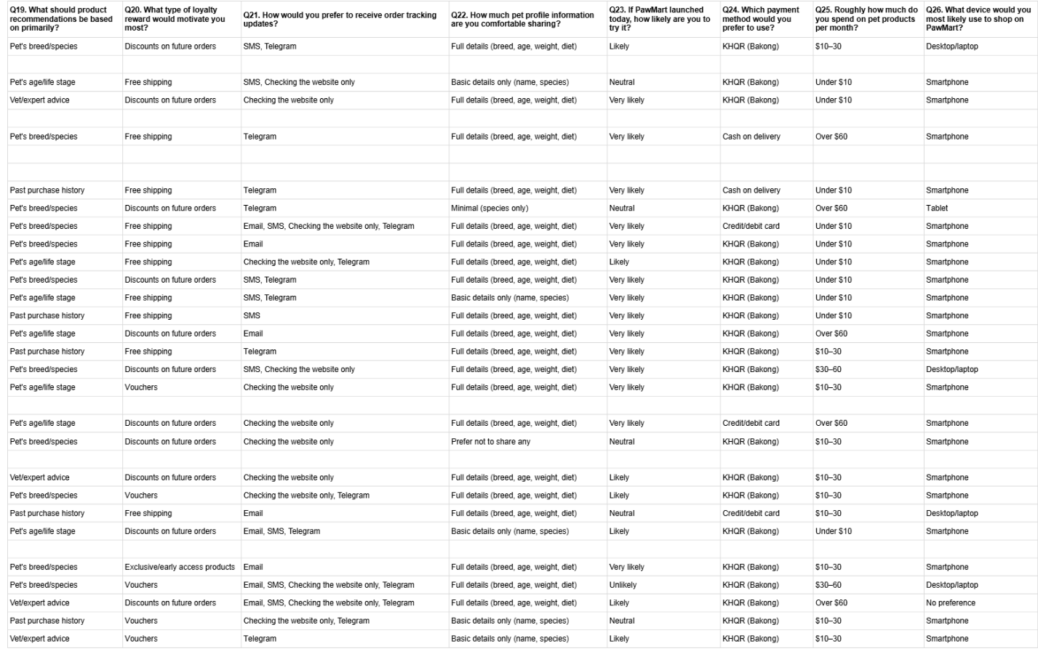
Figure 9.4 Survey Data 0.4
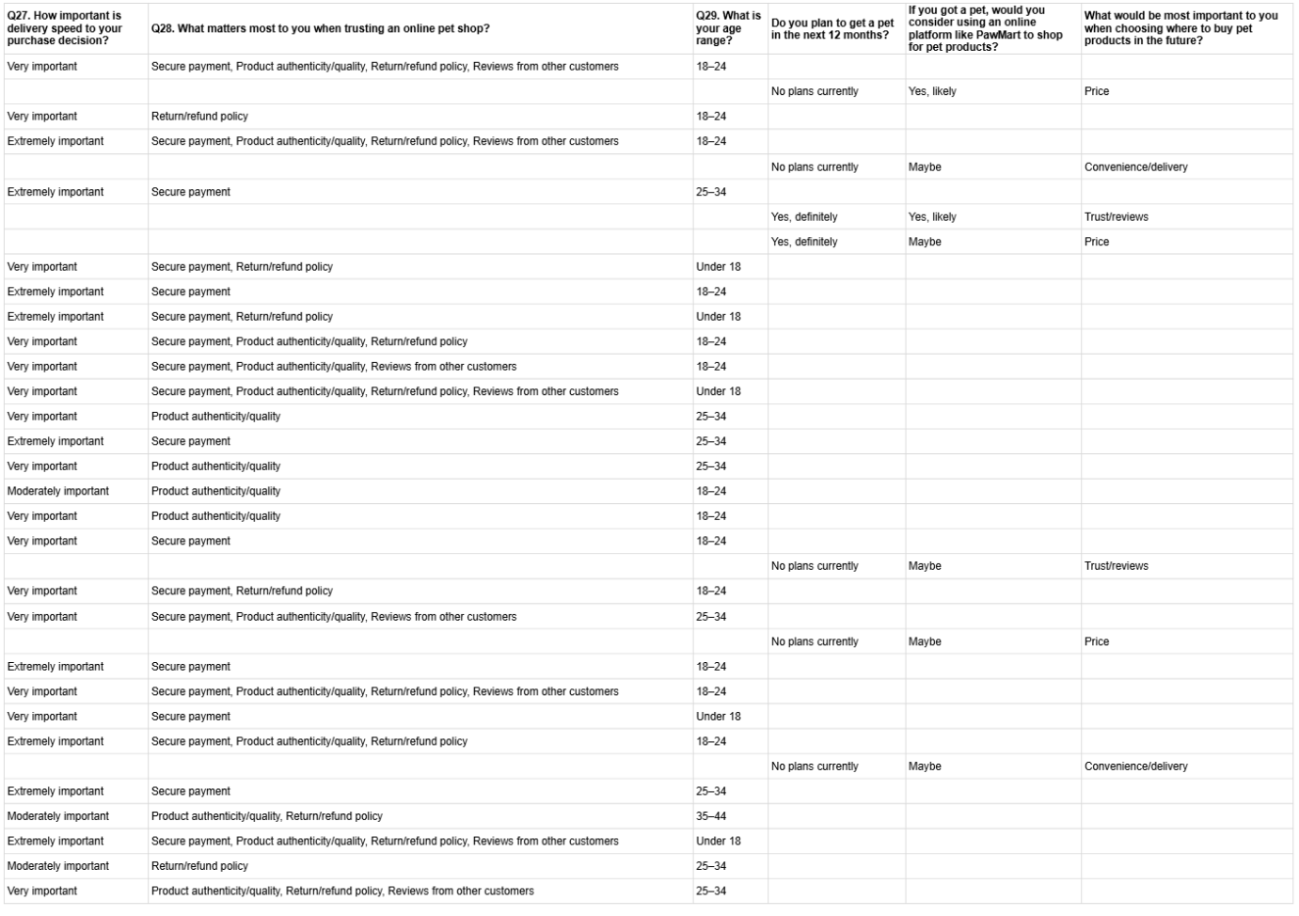
Figure 9.5 Survey Data 0.5

9.2 User Testing Feedback Matrices
PawMart's verification combined an internal, automated/structural testing pass with the pre-build validation survey used in place of a post-launch expert review panel. Both are summarised below in the same profile-and-matrix format, each finding traceable to a real, shipped change rather than sitting unused in a research document.
Profile 1: Backend & System Testing Notes
Test Area | Noted System Flaw / Issue | Severity | Implemented Update / Resolution | Status
Row-Level Security audit | Two privilege-escalation gaps: a customer could self-promote their own role, and a banned store owner could un-ban themselves. | High | Added a privileged-column lockdown trigger (migration 20260913020000) blocking both actions. | Resolved
KHQR / Bakong payment flow | An earlier manual admin-confirmation step added checkout friction without adding any real verification beyond the client-side QR generation. | Medium | Removed the manual step; the order is marked paid once the client-generated QR has been scanned. | Resolved
Production deployment (Vercel) | A build-blocking vue-tsc type error surfaced only at production build time, after passing local development. | Medium | Fixed the type error and confirmed a clean production build before redeploying. | Resolved
Mobile / responsive audit | A fixed-width dialog and a flex-overflow bug broke layout on small viewports. | Medium | Adjusted the dialog's width constraints and corrected the flex-wrap rules. | Resolved
Backend security tests | Confirmed role-gated endpoints (require_admin, require_store_owner) correctly rejected out-of-role requests across 69 backend tests. | Low | No defect found; retained as a regression guard for future changes. | Passing
Profile 2: Pre-Build Market Validation Notes (34-respondent survey, in place of a post-launch expert panel)
Finding Area | Insight | Confidence | Design Decision Shaped | Status
Payment preference | 81% of respondents preferred KHQR (Bakong) over credit/debit card or cash on delivery. | High (n=27) | Built KHQR as a native, first-class checkout path rather than a secondary option. | Applied
Feature priority | Order Tracking was the single most-valued feature, the top pick for 44% of respondents and rated very/extremely useful by 81%. | High (n=27) | Elevated Order Tracking to a core, not secondary, capability. | Applied
Shopping friction | Stockouts/limited variety and having to visit multiple stores were the most-cited pain points. | High (n=27) | Prioritised a unified, multi-vendor catalogue over a single-shop model. | Applied
Device usage | 78% said they would shop on PawMart primarily via smartphone. | High (n=27) | Built the interface mobile-first rather than desktop-first. | Applied
Trust factors | Secure payment and product authenticity/quality were the most-cited factors in trusting an online seller. | High (n=27) | Added seller approval, product reviews, and explicit promotion/discount tagging. | Applied

9.3 Academic References
- Docker Inc. (2014). Docker Compose documentation. https://docs.docker.com/compose
- Element Plus. (2022). Element Plus component library. https://element-plus.org
- FastAPI. (2018). FastAPI documentation. https://fastapi.tiangolo.com
- National Bank of Cambodia. (2020). Bakong KHQR interoperability standard. https://bakong.nbc.gov.kh
- Supabase. (2020). Supabase documentation. https://supabase.com/docs
- Vercel Inc. (2020). Vercel deployment documentation. https://vercel.com/docs
- Vite. (2020). Vite documentation. https://vitejs.dev
- Vue.js. (2014). Vue.js documentation. https://vuejs.org

