

IE3090
Network Programming
3rd Year, Semester I

RemoteOps: A Remote System Monitoring and Management Tool over TCP/IP
Submitted to
Sri Lanka Institute of Information Technology

IT24100454
Chandrasiri PGSK

In partial fulfillment of the requirements for the
Bachelor of Science Special Honors Degree in Information Technology

Contents
1. Introduction 3
2. Personalisation Details 3
3. System Architecture 4
3.1 Concurrency Model 5
4. TCP Protocol Implementation 6
4.1 Authentication 7
5. Implemented Commands 8
5.1 SYSINFO 8
5.2 LISTPROC 8
5.3 Restricted EXEC 9
6. File Transfer 9
6.1 PUT — Upload 9
6.2 GET — Download 10
7. UDP Monitoring 11
8. Logging and Error Handling 11
8.1 Error Handling 12
9. Personalisation Proof 13
10. Annotated Code Evidence 15
11. Testing and Results 18
12. Design Decisions and Assumptions 19
12.1 Why pthreads were used 19
12.2 Why a separate monitoring thread was used 19
12.3 Why EXEC is restricted 19
12.4 File transfer assumption 19
12.5 Logging assumption 19
13. Problems Faced and what Solved 19
14. Process Evidence 20
15. Files Included in the Project 20
16. Conclusion 21
17. Submission 21
18. Reference 21

1. Introduction
This project is my implementation of the RemoteOps assignment for IE3090 Network Programming. The aim was to build a small remote system monitoring and management tool using TCP/IP. The system has two programs: an Agent, which runs on the managed Ubuntu machine, and a Controller, which is used by an administrator to connect to the Agent.
The TCP connection is used for authentication, system information, process listing, restricted command execution, file upload/download and session control. A separate UDP channel is used for periodic monitoring. I implemented the system in C using standard socket programming and POSIX threads.
I tried to keep the implementation simple enough to understand and test. Instead of adding a large framework, I used normal TCP sockets, UDP sockets, pthreads, Linux system information files and standard C functions.

2. Personalisation Details
The assignment uses the registration number to create several values that must be unique to the submission. I calculated these values first and used them consistently in the source code, log file and storage directory.
Item | Value | How it was obtained
Registration number | IT24100454 | SLIIT registration number
First four digits | 2410 | First four numeric digits
Agent TCP port | 9410 | 7000 + 2410
Last four digits | 0454 | Last four numeric digits
Session ID (SID) | 4540 | 0454 reversed
Authentication token | OPS-0454 | OPS- + last four digits
Source suffix | 454 | Last three digits
Agent source | agent_454.c | Personalised source name
Controller source | controller_454.c | Personalised source name
Makefile | Makefile_454 | Personalised Makefile name
Log file | remoteops_IT24100454.log | Personalised log name
Storage path | ./agentfiles/IT24100454/ | Personalised storage directory
Final ZIP name | IE3090_IT24100454.zip | Assignment naming format
These values are visible in the program configuration and were checked during testing. The Agent listens on TCP port 9410 and uses SID:4540 in TCP responses and UDP monitoring packets.
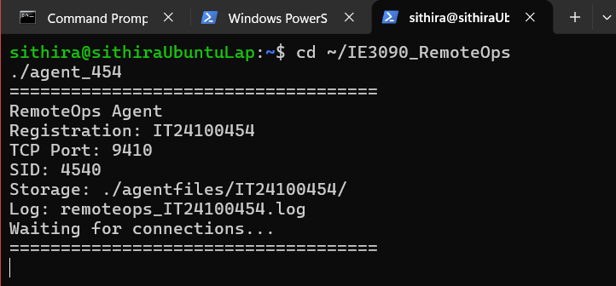
Figure 1. Personalisation values visible in the Agent source code

3. System Architecture
The RemoteOps system follows a simple client/server structure. The Controller acts as the client and the Agent acts as the server. The Agent creates a TCP listening socket on port 9410. When a Controller connects, the Agent accepts the connection and creates a separate thread to handle that client. This allows more than one Controller to be served at the same time.
The normal commands use the TCP control connection. When monitoring is started, the Agent creates a UDP socket in a monitoring thread and sends system statistics to the Controller IP at regular intervals. In implementation the monitoring updates are sent every 5 seconds.
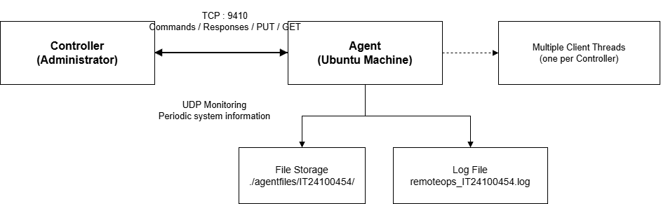
Figure 2. RemoteOps architecture diagram

- Controller program — connects to the Agent and sends commands.
- TCP Agent listener — accepts incoming Controller connections.
- Per-client thread — handles authentication and commands for one Controller.
- Monitoring thread — sends periodic UDP system statistics for a session.
- Personalised storage directory — stores uploaded files.
- Log file — records connections, commands and file-transfer activity with timestamps.

3.1 Concurrency Model
I used a thread-per-client model with pthreads. Every accepted TCP connection is passed to a new client-handling thread. I selected this approach because it is easier to understand and implement for this assignment than using select(), poll() or epoll(). It also allows several Controllers to stay connected without one client blocking the others.
The monitoring operation is handled separately for the session. This is important because UDP monitoring should continue periodically without stopping normal TCP command handling.
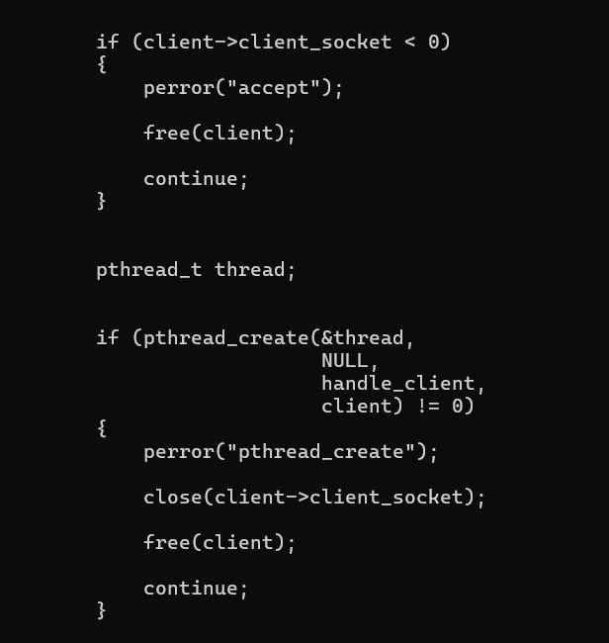
Figure 3. Agent connection handling and pthread_create()

4. TCP Protocol Implementation
The assignment specifies a line-based TCP protocol. Text commands and responses are terminated by a newline. PUT and GET are different because the command line is followed by an exact number of raw file bytes.
I implemented line reading until a newline is found. This avoids assuming that one TCP receive always equals one complete command. During testing, multiple commands sent together were processed correctly. For file transfers, the program keeps receiving or sending until the required number of bytes has been handled.
Every normal TCP response includes my session tag, SID:4540. The UDP monitoring packets also include the same tag.
Command | Purpose | Implemented behaviour
AUTH OPS-0454 | Authenticate Controller | Accepts correct token and rejects incorrect token
SYSINFO | System information | Returns CPU load, memory usage and uptime
LISTPROC | Process listing | Returns a snapshot of running processes
EXEC DATE / UPTIME / DISKFREE / HOSTNAME / WHOAMI | Restricted command | Runs only the fixed whitelist
EXEC <other> | Restricted command | Rejected as disallowed
PUT | Upload file | Stores file under personalised directory
GET | Download file | Sends previously stored file
MONITOR START | Start UDP monitoring | Starts periodic system-stat packets
MONITOR STOP | Stop UDP monitoring | Stops monitoring stream
QUIT | Close session | Stops monitoring and closes connection
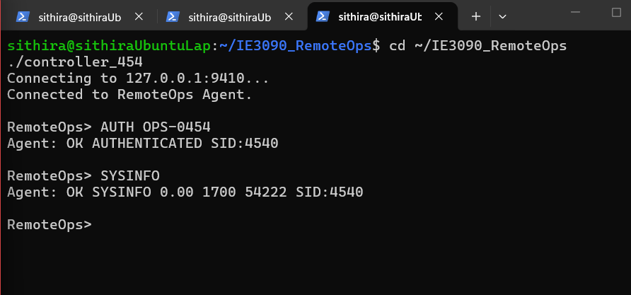
Figure 4. Full TCP request/response exchange showing SID:4540

4.1 Authentication
Authentication is required before the Agent accepts the other commands. The Controller sends AUTH OPS-0454 first. If the token is correct, the Agent marks that session as authenticated and returns a successful response containing SID:4540. If the token is incorrect, the Agent sends an authentication error and does not allow normal commands before successful authentication.
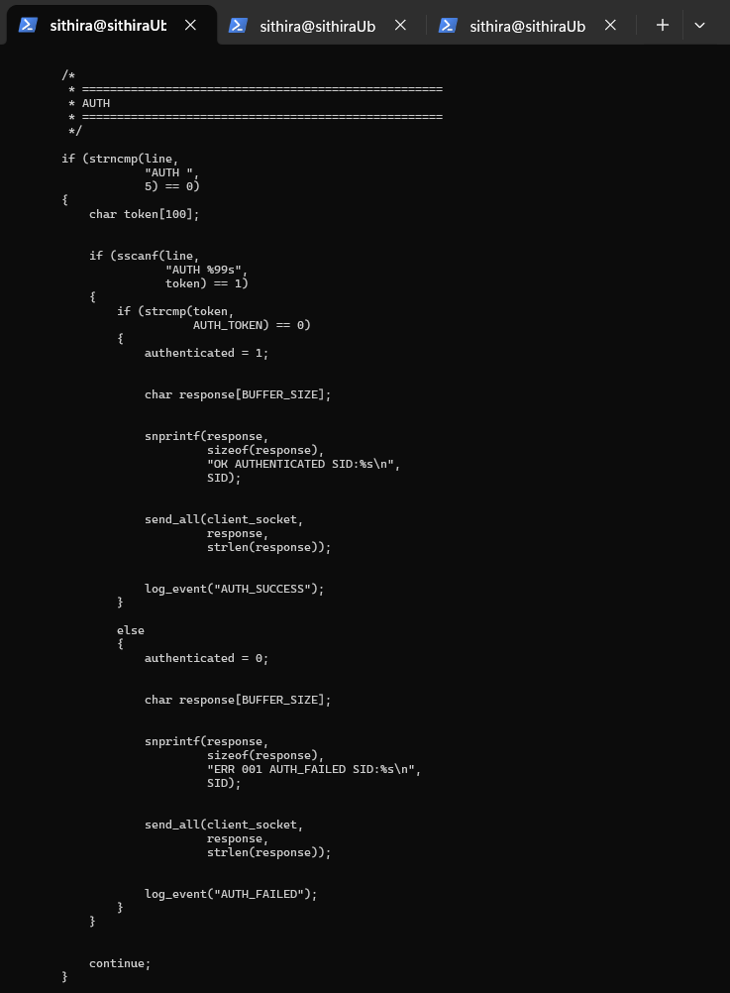
Figure 5. Authentication code

5. Implemented Commands

5.1 SYSINFO
SYSINFO returns CPU load, memory usage and system uptime. Linux information is read from files such as /proc/loadavg, /proc/meminfo and /proc/uptime. The response is returned through TCP and includes SID:4540.
Figure 6. SYSINFO execution

5.2 LISTPROC
LISTPROC provides a snapshot of currently running processes. I used Linux process information available through standard system commands and return the result through TCP.

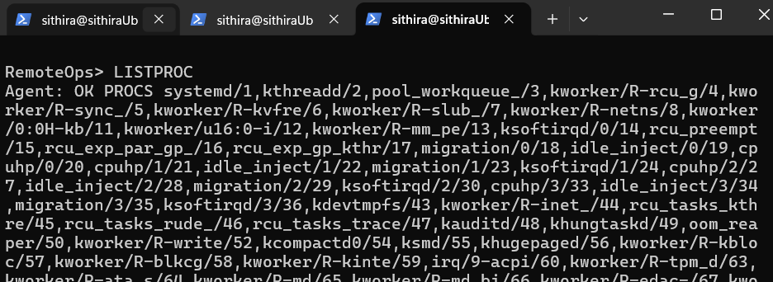
Figure 7. LISTPROC execution

5.3 Restricted EXEC
Remote command execution is intentionally restricted. The Agent accepts only DATE, UPTIME, DISKFREE, HOSTNAME and WHOAMI. Any other command is rejected.
This was an important design choice because allowing arbitrary shell commands would make the program much less controlled. The whitelist makes the behaviour predictable and follows the assignment protocol.
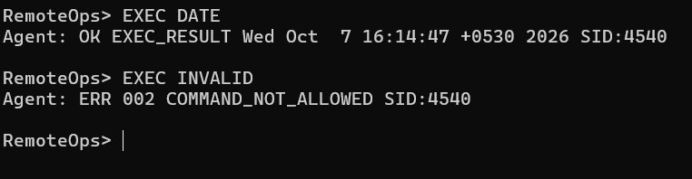
Figure 8. EXEC DATE and rejected EXEC command

6. File Transfer

6.1 PUT — Upload
PUT allows the Controller to send a file to the Agent. The Agent stores the file inside ./agentfiles/IT24100454/. The transfer is handled using the file size so that the Agent receives the correct number of raw bytes.
The important part is that the program does not assume the complete file will arrive in one recv() call. The received byte count is tracked until the expected number of bytes has been received.
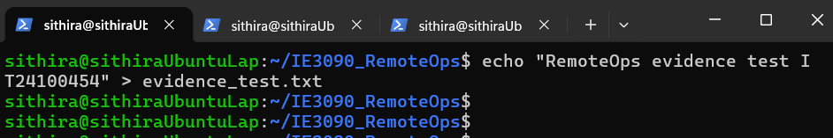

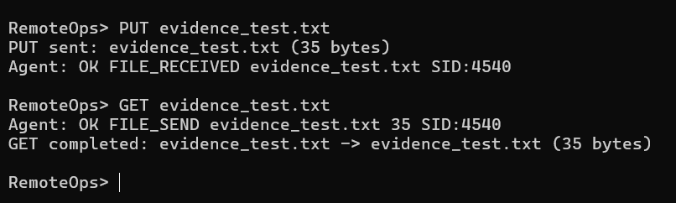
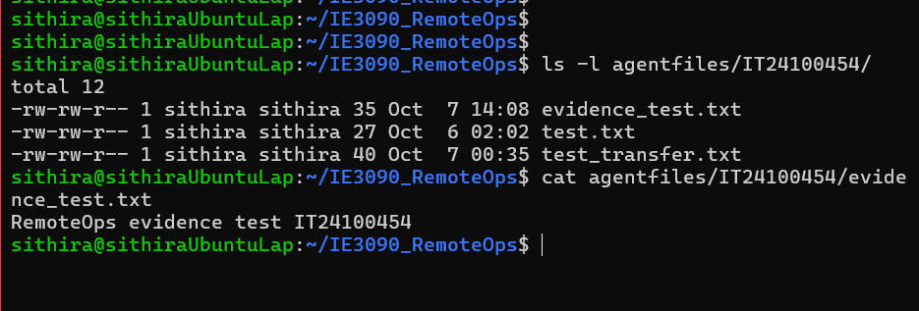
Figure 10. Successful PUT and personalised storage directory

6.2 GET — Download
GET retrieves a file that was previously uploaded. The Agent checks the requested file and then sends its size followed by the file bytes. The Controller receives the exact number of bytes and saves the downloaded file.
PUT and GET were tested together so that a file uploaded to the Agent could be downloaded again and checked against the original.

Figure 11. Successful GET

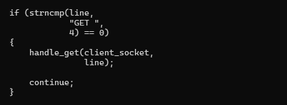
Figure 12. PUT and GET implementation code

7. UDP Monitoring
The MONITOR command uses a second communication channel based on UDP. When the Controller sends MONITOR START with a UDP port, the Agent starts a monitoring thread. The thread periodically collects CPU load, memory usage and uptime and sends a UDP datagram to the Controller IP address.
The monitoring interval used in my implementation is 5 seconds. The UDP packet includes the session identifier, for example: SYSINFO <cpu> <memory> <uptime> SID:4540. MONITOR STOP stops the monitoring thread for that session. QUIT also stops active monitoring before the TCP connection is closed.
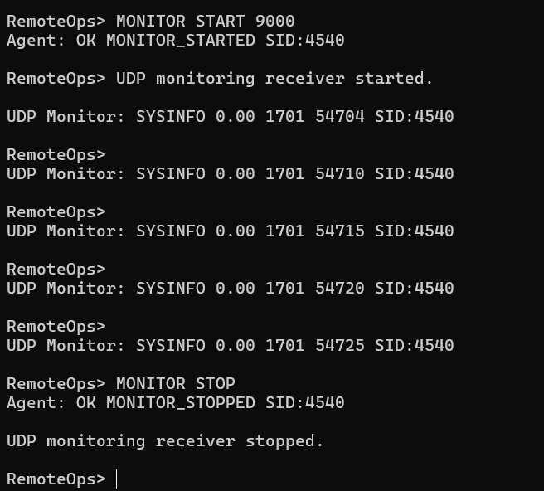
Figure 13. UDP monitoring stream at the Controller

8. Logging and Error Handling
The Agent writes activity to remoteops_IT24100454.log. The log contains timestamps and records important events such as startup, client connections, commands, authentication results, file transfers, monitoring and disconnects.
A mutex is used around log writing so that multiple client threads do not write to the log at the same time in an unsafe way. I also ignore SIGPIPE so an unexpected client disconnect does not immediately terminate the Agent when it tries to write to a closed socket.
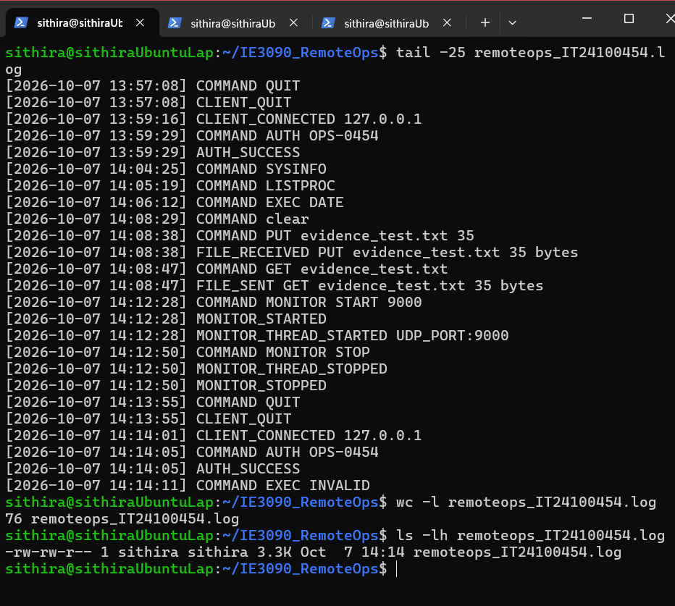
Figure 15. Personalised log file

8.1 Error Handling
The program handles common errors instead of simply crashing. Examples tested include an invalid EXEC command and unsuccessful file operations. The Agent also handles client disconnects and stops monitoring activity belonging to a session.
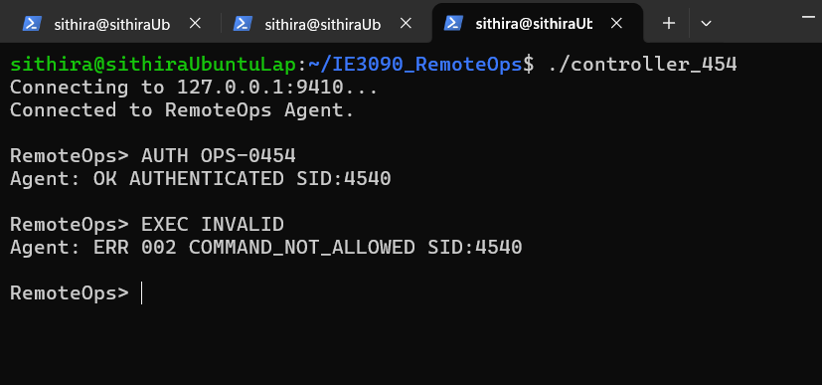
Figure 16. Error handling example

9. Personalisation Proof
The following evidence is intended to show that the running system uses the values calculated from my registration number. The screenshots should be from the actual Ubuntu environment used for the project.
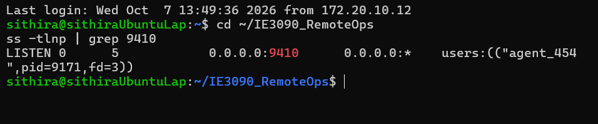
Figure 17. Agent listening on TCP port 9410

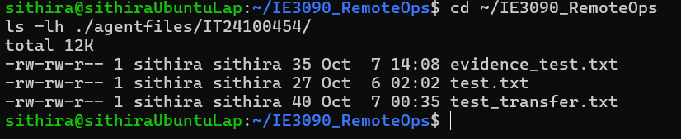
Figure 18. Personalised storage path containing uploaded file

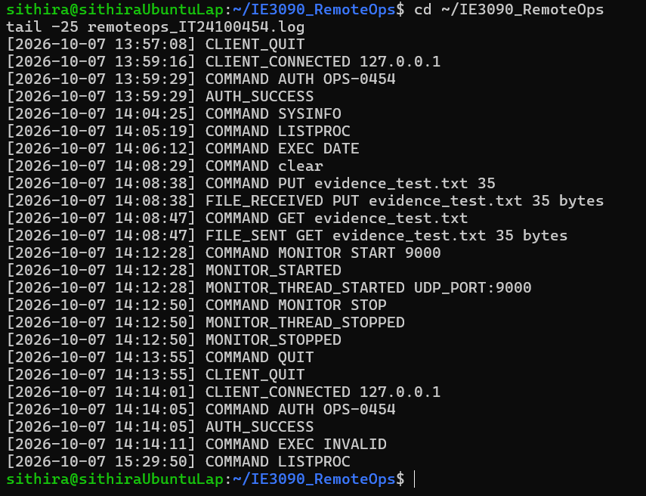
Figure 19. Personalised log file

10. Annotated Code Evidence
The following figures are reserved for the main code areas requested by the assignment. Each screenshot should be cropped so the code is readable. A short explanation is included for each area.
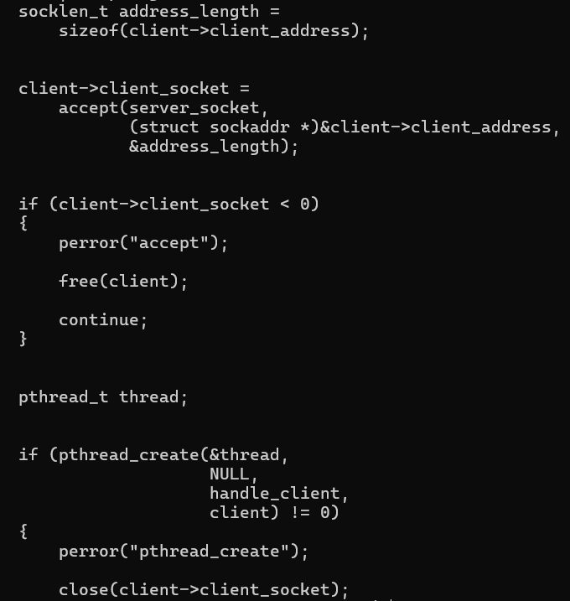
Figure 20. TCP accept() and client thread creation

Explanation: The listener waits for new TCP connections. After accept(), the connection is passed to a new thread so multiple clients can be handled at the same time.

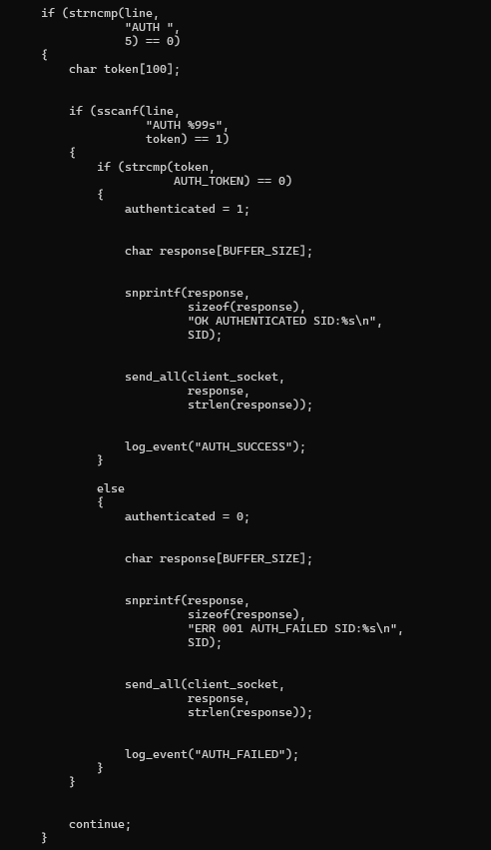
Figure 22. Command dispatch

Explanation: After authentication, the received command is matched and the correct handler is called.
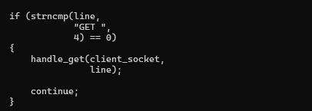 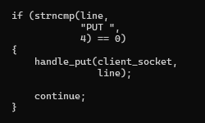
Figure 23. PUT and GET handlers

Explanation: The code tracks the required file size so partial TCP receives do not cause incomplete transfers.
Figure 24. UDP monitoring loop

Explanation: A separate thread sends system statistics over UDP at the selected interval until monitoring is stopped.

11. Testing and Results
I tested the program from the Ubuntu environment after completing the main implementation. The final build was performed using the personalised Makefile with -Wall -Wextra -pthread. The final clean build completed without compiler warnings or errors.
Test | Expected result | Actual result
Build with Makefile | Agent and Controller compile successfully | Passed — final build completed without warnings/errors
Agent startup | Agent listens on port 9410 | Passed
Correct AUTH | Session becomes authenticated and returns SID:4540 | Passed
Invalid authentication | Authentication is rejected | Passed during error testing
SYSINFO | CPU, memory and uptime returned | Passed
LISTPROC | Process snapshot returned | Passed
EXEC DATE | Whitelisted command executes | Passed
EXEC invalid command | Command is rejected | Passed
PUT | File stored in personalised directory | Passed
GET | Previously uploaded file is returned | Passed
MONITOR START | UDP packets arrive periodically | Passed
MONITOR STOP | UDP stream stops | Passed
QUIT | Session closes cleanly | Passed
Logging | Connections, commands and transfers are timestamped | Passed
Compiler warning check | No gcc warnings/errors | Passed

The testing was functional testing rather than only checking whether the program compiled. For example, successful compilation alone does not prove that authentication, file transfer or UDP monitoring works. I tested the commands through the Controller and checked the Agent output, storage directory and log file.
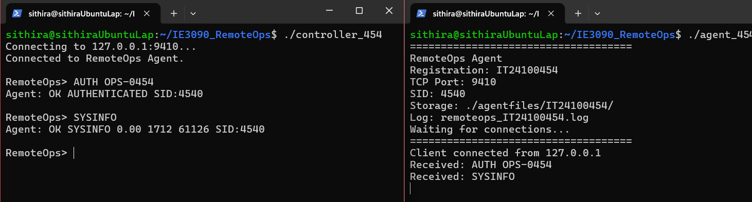
Figure 25. Final Agent startup and Controller session

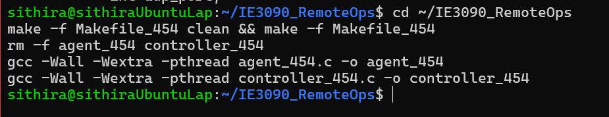
Figure 26. Final build with no warnings

12. Design Decisions and Assumptions

12.1 Why pthreads were used
I selected pthreads because the assignment requires simultaneous Controller connections and pthreads provide a straightforward way to give each connection its own execution path. It also made the implementation easier for me to understand while learning network programming.

12.2 Why a separate monitoring thread was used
UDP monitoring is periodic, so putting it directly inside the main command loop could delay normal commands. A separate monitoring thread allows the TCP session to continue responding while UDP packets are being sent.

12.3 Why EXEC is restricted
The assignment defines a fixed list of allowed commands. I kept this as a whitelist rather than passing arbitrary input to the shell. This makes the program easier to test and explain.

12.4 File transfer assumption
TCP is a byte stream, so a single send() or recv() is not treated as one complete file. The implementation keeps track of the expected number of bytes for transfers.

12.5 Logging assumption
The log is stored locally on the Agent. Its purpose is to provide a simple record of activity for this assignment rather than a full enterprise audit system.

13. Problems Faced and what Solved
During development I faced several small issues. They were useful because they made me check how the different parts of the system actually worked instead of only writing the code.
- TCP port conflicts — I checked listening sockets and stopped the process using the selected port before starting the Agent again.
- Compiler warning in the Controller — the compiler warned that formatted input could be truncated. I changed the snprintf() format to limit the copied input and rebuilt the project.
- Empty Makefile — the personalised Makefile was initially incomplete. I added build and clean targets for both programs and tested them with make.
- Git/GitHub authentication — the repository needed authentication setup. GitHub CLI authentication and git configuration were used so the repository could be pushed normally.
- TCP stream handling — I had to understand that TCP does not preserve message boundaries. Line reading and exact byte counting were used for commands and files.
- Documentation and evidence — I kept separate files for the design diary, prompt log and reflection so the development process could be explained separately from the main report.

14. Process Evidence
The project was developed in stages and the repository contains the personalised source files, Makefile and supporting documentation. The design diary records the main implementation decisions and obstacles. The prompt log records substantive AI assistance used during Part 1, and the reflection discusses what was learned from using AI and testing the implementation.
The assignment requires a GitHub repository, a design diary, a prompt log and a structured reflection as process evidence. The supporting files are maintained alongside the project.
Process item | File / location | Purpose
GitHub repository | IE3090_RemoteOps | Source code, Makefile and project history
Design diary | design_diary.txt | Records decisions, progress and obstacles
Prompt log | prompt_log.txt | Records substantive AI interactions and how they were used
Reflection | reflection.txt | Structured reflection required by the assignment
README | README.md | Build instructions and project overview

The report should be submitted together with these supporting items as required by the assignment.

15. Files Included in the Project
File | Description
agent_454.c | Agent/server implementation
controller_454.c | Controller/client implementation
Makefile_454 | Build and clean commands
README.md | Project overview and usage information
design_diary.txt | Development diary
prompt_log.txt | AI interaction record
reflection.txt | Required 300–500 word reflection
remoteops_IT24100454.log | Agent activity log

16. Conclusion
Overall, I implemented the main RemoteOps requirements using C socket programming on Ubuntu. The system has a TCP Agent and Controller, authentication, system information, process listing, restricted command execution, file upload and download, UDP monitoring, logging and session handling.
The main part I had to understand carefully was TCP stream handling. Commands are separated by newlines, but the underlying TCP connection is still a stream of bytes. File transfers also need exact byte counting. Testing these parts helped me understand why network programs cannot simply assume that one send() always matches one recv().
I also learned that getting a program to compile is only the first step. I had to test the real Controller-Agent communication, check the stored files, observe the UDP packets and inspect the log. The final clean build completed without compiler warnings or errors, and the main functional tests passed.
The project gave me practical experience with TCP sockets, UDP sockets, threads, Linux system information, file transfer and basic client/server design. These are areas I can continue improving in future network programming work.

17. Submission
- Implementation Report — this document
- Personalised Agent source: agent_454.c
- Personalised Controller source: controller_454.c
- Personalised Makefile: Makefile_454
- README.md with build instructions
- Sample log excerpt: remoteops_IT24100454.log
- Design diary: design_diary.txt
- Prompt log: prompt_log.txt
- Structured reflection: reflection.txt
- GitHub repository link: https://github.com/SithiraChandrasiri/IE3090_RemoteOps.git
- Final ZIP: IE3090_IT24100454.zip

18. Reference
Department of Computer Systems and Engineering, Faculty of Computing, IE3090 Network Programming, Assignment Brief — RemoteOps: A Remote System Monitoring and Management Tool over TCP/IP, 2026.
The report structure and requirements were prepared using sections 2.2–2.9 of the assignment brief, including the mandatory functional requirements, communication protocol, personalisation requirements, Implementation Report requirements and process evidence.

END OF THE REPORT

