Mr. RIN SITHPONG  Lower Secondary School Teacher specialized in Math and Physics  Address: Sangkat Prek Ruessei, Ta Khmau City, Kandal Province, Cambodia  Phone: 088 567 0036 (Telegram)  Email: sithpongrin4@gmail.com | 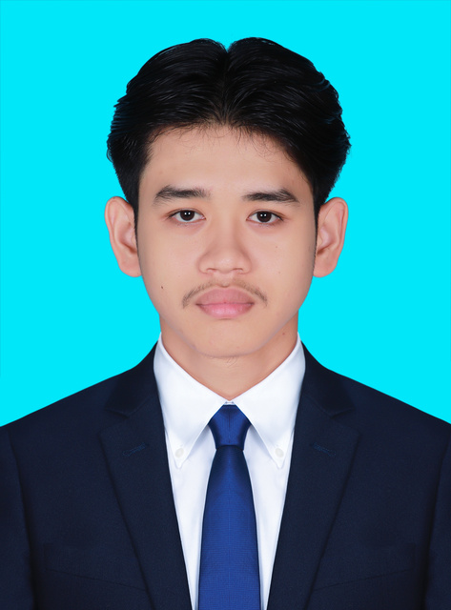
Hello! I’m Sithpong, a certified Lower Secondary Teacher in Mathematics and Physics, recently graduated from RTTC Kandal and newly appointed as a state teacher. I bring a strong pedagogical foundation, practical teaching internship experience, and digital classroom skills to deliver interactive, student-centered lessons. Passionate about making math and physics simple to understand and dedicated to inspiring student academic success.
WORK EXPERIENCES
Teaching Intern, Hun Sen Serypheap High School  P Taught Mathematics and Physics to secondary school students based on the national curriculum.  P Developed structured lesson plans, interactive exercises, and customized educational worksheets.  P Managed classroom activities, facilitated collaborative learning, and systematically assessed student progress. | Ta Khmau, Kandal, Cambodia  Dec 2025 – Mar 2026
Teaching Intern, Hun Sen TaKhmau High School  P Assisted senior educators in delivering secondary-level Mathematics and Physics instruction in classroom settings.  P Learned and applied modern secondary pedagogical methodologies and classroom management techniques.  P Supported classroom logistics, homework review, and individualized academic assistance for students. | Ta Khmau, Kandal, Cambodia  Nov 2024 – Aug 2025  Period 1: Nov 2024 – Mar 2025  Period 2: Jul 2025 – Aug 2025
Online Educator (Part-time), Self-employed  P Taught interactive online Mathematics and Physics lessons using Zoom, Google Meet, and Telegram.  P Designed digital learning materials, practice quizzes, and explanatory presentation slides.  P Provided tailored academic support, homework troubleshooting, and preparation for national examinations. | Remote / Online  2023 – 2025

EDUCATION
Bachelor of Mathematics at Cambodia University of Specialties (CUS)  P Pursuing advanced academic coursework in pure mathematics, applied analysis, and mathematical theories. | Phnom Penh, Cambodia  Oct 2023 – Present
Specialized Teaching Certificate (Secondary Level in Mathematics & Physics) at Hun Sen Regional Teacher Training Center (RTTC), Kandal  P Specialized in advanced secondary pedagogy, classroom leadership, and STEM teaching methods.  P Completed national pedagogical training and officially appointed as a state teacher to Damnak Pring Lower Secondary School (Ponhea Lueu, Kandal). | Kandal Province, Cambodia  Nov 2024 – Jun 2026
Bachelor of Data Science (Year 1 Completed) at Cambodia Academy of Digital Technology (CADT)  P Completed foundational coursework in computer algorithms, digital literacy, and data foundations. | Phnom Penh, Cambodia  Nov 2023 – Aug 2024
High School Diploma (Bac II, Grade B) & French Baccalaureate (Grade E) at Hun Sen Serypheap High School  P High School Education (Grades 10–12). Passed National Baccalaureate Examination in 2023 with Grade B.  P Awarded Diplôme du Baccalauréat à Mention Francophone (Grade E); completed French bilingual stream from Grade 7 to 12. | Ta Khmau, Kandal, Cambodia  Nov 2020 – Oct 2023
Lower Secondary Education (Grades 7–9) at Hun Sen Serypheap High School  P Completed lower secondary general education curriculum with focus on science and mathematics. | Ta Khmau, Kandal, Cambodia  Oct 2017 – Oct 2020
Primary Education (Grades 1–6) at Hun Sen Prek Ruessei Primary School  P Completed primary education foundations. | Ta Khmau, Kandal, Cambodia  Oct 2011 – Jul 2017
SKILLS
Technical & Digital Skills
P Microsoft Office Suite (Word, Excel, PowerPoint) – lesson planning, exam design, and student grade tracking.
P Online Teaching Platforms & Virtual Classrooms: Zoom, Google Meet, Telegram, and digital instructional tools.
P Technology-Enhanced Instruction: Digital presentations, scientific simulations, and interactive STEM content.
P Digital Literacy & Computational Logic: Programming foundations and algorithmic thinking from CADT Data Science.
Teaching & Pedagogical Skills
P Secondary Mathematics & Physics instruction, conceptual breakdown, and national curriculum alignment.
P Modern student-centered pedagogy, active engagement strategies, and interactive classroom management.
P Formative and summative student assessment, examination preparation, and personalized feedback delivery.
Leadership & Core Competencies
P Student mentoring, academic counseling, patience, and empathetic communication.
P Collaborative teamwork, stakeholder communication, adaptability, and high professional ethics.
P Time management, structured lesson organization, and reflective teaching practice.
Languages
P Khmer: Native Speaker
P English: Upper-Intermediate (B2 / Band score B2)
P French: Bilingual Stream (Grades 7–12), Diplôme du Baccalauréat à Mention Francophone
REFEREES
SAT SOLINA: Lower Secondary School Mathematics Teacher & Mentor, Hun Sen Serypheap High School
Phone: 017 250 536
KOL SARAVUTH: Lower Secondary School Physics Teacher & Mentor, Hun Sen TaKhmau High School
Phone: 016 535 906

