Akin 

**Factors that Affect Students’ Alcohol Consumption and Ways to Get Rid of Them.**

A PROJECT PROPOSAL SUBMITTED FOR THE PARTIAL FULFILLMENT OF THE REQUIREMENTS OF THE ADVANCED DIPLOMA IN DATA SCIENCE (FULL TIME) PROGRAMME.

By :- A.H.S.S.HEWAWASAM (COADDS22.2F – 019)

Bachelor of Science (Hons) in Data Science

National Institute of Business Management (NIBM)

Colombo, Sri Lanka

Date of submission – 14th September 2023

i

**DECLARATION**

I hereby declare that the work presented in this project report was carried out independently by myself and have cited the work of others and given due reference diligently.

……………………………

Sithumi Hewawasam

……………………………

Date

I certify that the above student carried out his/her project under my supervision and guidance.

……………………………

Supervisor

……………………………

ii Date

**Acknowledgement**

I take this opportunity to offer my heartiest regards to all the teachers who have assisted me in this project, especially my project supervisor Mr. T. Balakumar who has given me great support by guiding and encouraging me. Likewise, I would like to take this opportunity to add heartfelt respect to my friends and parents who have always supported me and helped me complete the work of this project by giving advice and guidance in various ways.

**Dedication**

To all the students who are dedicated for a successful future,

I dedicate this project to all those who are interested in students' alcohol use and who are trying to find a solution for it. May this help all those leading society for a healthy future. I dedicate my hard work to a bright future for students of our age.

A.H.S.S.Hewawasam

iii

Table of Contents

Chapter 1 : Introduction - 1 -

1.1Background - 1 -

1.2Research Problem - 2 -

1.3Objectives of the Project - 3 -

1.4Research Questions - 3 -

1.5Scope of the Research - 4 -

1.6Justification of the Research - 5 -

1.7 Expected Limitations - 6 -

1.8 Proposed work schedule - 7 -

Chapter 2 : Literature Review - 8 -

2.1 Introduction to the research theme - 8 -

2.2 Theoretical explanation of the keywords in the topic - 8 -

2.3 Findings by other Researchers - 9 -

2.4 Research Gap - 13 -

2.5 Table for variables, their definitions, and sources - 14 -

2.6 Chapter Conclusion - 15 -

Chapter 3 : Methodology - 15 -

3.1Introduction - 15 -

3.2Population, Sample and Sampling Technique - 16 -

3.3Type of Data to be collected and data sources - 16 -

3.4Data collection tools and plan - 17 -

3.5Conceptual framework - 18 -

3.6Hypothesis - 18 -

3.7Operationalization Table - 19 -

3.8Methods of data analysis - 20 -

Chapter 4: Data Analysis - 21 -

4.1 Data Analysis - 21 -

4.2Findings and Interpretation - 23 -

Chapter 5: Discussion and Recommendations - 34 -

5.1 Discussion - 34 -

5.2 Recommendations - 35 -

5.3 Conclusions - 36 -

References - 37 -

**List of Tables**

Table 1.1 Work Schedule - 7 -

Table 2.1 Variable Definitions - 15 -

Table 3.1 Operationalization Table - 20 -

**List of Figures**

Figure 3.3. 1 A Rough Picture of my Dataset………………………………………………….- 17 -

Figure 4.1. 1 Structure of the Dataset………………………………………………………….- 22 -

Figure 4.2. 1 Regression Analysis Statistical Test……………………………………………..- 24 -

Figure 4.2. 2 Scatter Plot – How family relationship affects students Alcohol Consumption - 28 -

Figure 4.2. 3 Scatter Plot – How Parents status affects students Alcohol Consumption - 30 -

Figure 4.2. 4 Correlation Statistical Test - 31 -

Figure 4.2. 5 Scatter Plot – Graphical Representation for 1st Minor Objective - 32 -

Figure 4.2. 6 ANOVA Statistical Test - 33 -

v

# **Chapter 1 : Introduction**

## **1.1Background**

School children are a main social division in society. They are the main inventors of different things. Also, they are the ones who like to get new experiences for life with their friends. Therefore, there is a possibility to addict them to something wrong. Therefor if they become addicted to something wrong, it can become indispensable in their life. So, this analysis is done by taking a sample of children who are used to alcohol in this way, to find out the reasons why they are used to it and thus to get a good understanding of the measures that can be taken by those responsible to prevent another group of students from resorting to it. In the same way, this also basically checks the behavior and school attendance of the children who have already been referred to it. One of the primary objectives of this is to seek remedies for the evil that has happened in their lives due to alcoholism. Lack of parental attention and peace and freedom in the family environment will be affected as the reasons for turning to alcohol. An attempt is made here to explain it by the sample of these children. In the same way, there are many harms caused to children due to getting used to such harmful things like alcohol. Rejection from society, deterioration of mental and physical health, impaired learning due to memory impairment, are some of them.

## **1.2Research Problem**

Alcohol consumption is one of the most serious problems in current society. Indulging in it from childhood is unacceptable because that gives severe results. Among the social age groups, teenagers are a section that faces many of these problems. Therefore, this study analyzes the family environment for alcoholism and the problems caused by alcoholism.

Three main problems were identified in this research. They identify the relationship between alcohol use and the negative effects/results of it considering parents’ status, family relationship and school attendance level.

Here, it investigates whether there is a relationship between alcohol use and the parents’ status. This seeks to determine the extent to which parents are with children, that is, whether they are together or separated, affects children's misbehavior. This means to find out whether the lack of parental care and attention towards children makes children more likely to engage in such acts or has no effect.

Likewise, to find out how much the children's relationship with their parents has an impact on this problem is another task to find out the relationship between the level of the relationship with the family, that is, whether it is the maximum or the minimum factor and the child's possibility to alcohol use.

Another research problem is to consider the obstacles caused to children's education due to their exposure to alcohol. Determining whether the attendance rate cause to this habit and how this alcohol consumption affects, is the other question that will be solved by this research.

## **1.3Objectives of the Project**

1.Identify the relationship between family relationship, Attendance**,** Parents’ status with students’ alcohol usage.

2.Analyse the relationship between Alcohol consumption and Student’s School attendance.

3.Examine how Alcohol consumption is affected with family relationship and parents’ status.

## **1.4Research Questions**

1. What is the relationship between parents’ status, family relationship and school attendance level with the Alcohol usage of students ?
2. Is there a relationship between Alcohol consumption and Students’ school attendance ?
3. How is Alcohol consumption affected with family relationship and parents’ status ?

## **1.5Scope of the Research**

The dataset selected for this research is a set of data collected using one group of students in a school. It is not the entire student population. Therefore, the data is managed according to the number of selected students to test all the research problems.

This will consider the influence of parental inattention and social factors as reasons for children's tendency to use alcohol.

It is intended to show the change in the strength of the family relationship, the change in the mental and physical health status, the impact on the school education activities, etc. using various appropriate statistical tests.

Due to the proper identification of these issues, this will help to reduce the tendency of another group of students to succumb to this in the future and to save the children who are currently suffering from this and create a better life for them.

## **1.6 Justification of the Research**

Nowadays, the percentage of young people harming their own lives has increased. Mental problems caused indirectly or by resorting to such habits are the causes of such a mental level. Due to lack of attention from parents, they associate different people in society. It is quite easy to get used to things like alcohol in their way. And sad situations regarding the peacefulness of their parents are also included as a problem that mentally torments children.

Separation from marriage or loss of one of the parents due to some accident will also strongly affect the different mentality of the children. The use of drugs like alcohol to get rid of it is also seen as a problem.

Drug use like alcohol also appears to be a problem. The other factor for these misbehaviors is the lack of children's schooling. Their education system is deteriorating day by day as their tendency to attend school is decreasing. Disruption of education can ruin their whole life. They neglect their life lessons such as what are good things and what are the bad things in the current society. Therefore, considering these facts, the justification of these research questions is confirmed.

## **1.7 Expected Limitations**

According to my dataset from Kaggle, it is hoped to analyze the data here according to that sample as they got. And there are many factors that affect the tendency to alcohol, but here only two main factors are considered. Likewise, there are many harms caused to students due to alcohol consumption.

Social environment and cultural factors may also influence alcohol use. But here, research is conducted within one limit and such effects are framed within a limit. And since each student has different mental conditions and different economic and social conditions, it is difficult to control this and gather data. Therefore, we have to ignore the changes caused by those conditions. The other major uncontrollable problem is the slight variations in the selection of students in giving out their true information. The problem is that we cannot influence them for that. Because it is the privacy, personality, and security of their lives.

By identifying these limitations, the results of the research can be analyzed.

Finding a suitable dataset according to the self-preferences was hard and there are limitations by searching for a proper dataset from secondary data sources.

## **1.8 Work schedule**

|  |  |  |
| --- | --- | --- |
| Work | Starting date | Finishing date |
| Initiating the project | July 10th , 2023 | September 15th , 2023 |
| Completion of proposal | July 17th , 2023 | July 23rd , 2023 |
| Data collection | July 17th , 2023 | July 19th , 2023 |
| Analysis | July 19th , 2023 | September 12, 2023 |
| Submission of first draft | July 17th , 2023 | July 23rd , 2023 |
| Final submission | July 10th , 2023 | September 15th , 2023 |

Table 1.1 Work Schedule

# **Chapter 2 : Literature Review**

## **2.1 Introduction to the research theme**

Alcohol consumption among school children is a problem faced by all countries. The responsible persons and researchers who identified it have taken samples of various students and analyzed this.

These researchers have shown poor academic performance, long-term health problems, psychological and social withdrawal from depression, and separation from loved ones. In the same way, the researchers have identified and outlined the steps to be taken to reduce and avoid children's addiction to alcohol consumption.

**2.2 Theoretical explanation of the keywords in the topic (**Results and factors that affect students’ Alcohol Consumption and ways to get rid of them.)

* **Factors** – Factors are the components that affect the results. According to this topic, family relationship, School attendance and parents’ status are the selected factors that contribute to the students’ alcohol consumption.
* **Affect** – The effect of causing something to happen is the definition. As it stated here, it describes the impact of students’ alcohol consumption.
* **Students’** – I consider this as a key word because it is the main targeting sample of the research. They are the specific group of individuals from the selected school.
* **Alcohol consumption** – This refers to the drinking of intoxicating liquids that contain ethyl alcohol.
* **Ways** – Implies the actions and steps to reduce the alcohol consumption of students.
* **Get rid** – This means the reduction or discard from consuming alcohol.

## **2.3 Findings by other Researchers**

1. **Alcohol Consumption and Behavioral Consequences in**

**Romanian Medical University Students – July 2021**

This research paper is authored by seven researchers including Bogdana Adriana Nasui and Monica Popa. Here they have surveyed the information from 722 both male and female Romanian medical university students. Emphasis has been given here to identify alcohol consumption and thereby their behavior patterns. They have identified that there is no significant difference between male or female alcohol consumption in Romania.

1. **Knowledge and Practice towards Alcohol Consumption in a Sample of University Students – September 2021**

This was published by a group of eight other researchers including Marisa Patrizia Messina and Gemma Battagliese. Here, they intend to identify them by analyzing how knowledge level and experience factors affect alcohol consumption. A group of Italian university students have been selected as a sample for this. A major conclusion drawn from this is that these students do not have proper knowledge about the harmful effects of alcohol consumption.

1. **Is Alcohol Consumption Related to Lifestyle Factors in Romanian University Students? – February 2021**

This is also a research paper compiled by a group of 1212 children between the ages of 21-24 in Romania. Alcohol consumption of alcohol has been examined here regarding its effect on their daily lifestyle. The purpose of this is to identify the change in the factors of students' daily diet, study time, and sleep period.

1. **The association between levels of alcohol consumption and mental health problems and academic performance among young university students – June 2017**

Chimwemwe Tembo, Sharyn Burns and Fatch Kalembo are the authors of this research paper. Main target by doing this research is find students’ mental health. It has been identified that there is a high prevalence of various types of alcohol among students and that prompt action should be taken to resolve mental problems.

1. **Alcohol consumption and awareness of its effects on health among secondary school students in Nigeria – November 2017**

This analysis was conducted using data collected from school students in Nigeria to find out the extent of alcohol use and the health problems caused by it. The main findings of the authors Ngozi M.Eze, Helen Amaka Njoku and others are that there is a difference in the awareness between girls and boys about the harm by consuming alcohol and that students consume more wine regardless of gender.

1. **Determinants of positive and negative consequences of alcohol consumption in college students: alcohol use, gender, and psychological characteristics – 2005**

This research has further studied the psychological factors that affect alcohol use and the psychological advice needed to get rid of its side effects. The special thing is that both the positive and negative aspects of alcohol consumption are discussed here. As a result, it has been found that alcohol is used regardless of gender, and boys use more and are punished more for it.

1. **Positive and Negative Consequences of Alcohol Consumption in College Students – March 2004**

According to this research report by Crystal L. Park, it has been tried to find out about both the positive and negative sides of alcohol use and how much these students will resort to this in the future. Through the results of this, he has shown that both the female and male categories have the same experiences and effects of alcohol use. And this has revealed that students experience positive results from drinking alcohol. Likewise, problems with a more significant level will also be faced.

1. **College Student Alcohol Consumption, Day of the Week, and Class Schedule – July 2007**

Based on this research topic, the relationship between study schedules and alcohol consumption has been investigated. It is clear from this that on the days with schedules where the next day is a study day, the consumption of alcohol on the previous day is minimal. Min says that the reason may be the need to be active during the next day's study period. Therefore, there is a relationship between class schedules and alcohol use and researchers have emphasized the importance of renewing the class schedule as a solution to reduce alcohol consumption.

1. **Drink and Be Merry? Gender, Life Satisfaction, and Alcohol Consumption Among College Students – 2005**

Researchers Murphy, Devitt-Murphy and Barnett have studied college students and their life satisfaction with the theme of life satisfaction and alcohol consumption. Because they are afraid of going. It has further been found that men use alcohol more for social satisfaction. This test report highlights the value of alcohol-free social activities and the positive side of alcohol use.

1. **College Student Employment and Drinking: A Daily Study of Work Stressors, Alcohol Expectancies, and Alcohol Consumption – July 2011**

This experimental data report on occupational stress and alcohol use was presented by Butler et al. Here, factors such as gender, nature of work, income, working hours etc. have been examined for alcohol use and stress. Meanwhile, conflict at work and at school had a negative relationship. That is, it has been proven that there is a minimum tendency to use alcohol when experiencing a problem or a conflict. Finally, the implications of this are the importance of examining the individual problems of alcohol consumption and stress.

## **2.4 Research Gap**

A research gap may occur due to research limitations and social security reasons. According to this research, the topic of students' alcohol consumption, which does not receive much attention, was chosen. Mostly, society is talking about the alcohol consumption of the older generation. Therefore, studies about students are rare.

Although there are more research papers about health issues by using alcohol, there are only few about school students’ educational side. That is, the lack of inquiry into the relationship between alcohol consumption and children's school attendance is a problem.

And the change of geographical factors from place to place should also be taken as a limiting factor.

## **2.5 Table for variables, their definitions, and sources**

|  |  |  |
| --- | --- | --- |
| **Variable** | **Definition** | **Source** |
| Age | Student’s age | Openly available website |
| Sex | Student’s gender | Openly available website |
| Parents’ Status | How parents live (Together / Apart) | Openly available website |
| Family Relationship | The connection level to family (High, Low, Medium) | Openly available website |
| Weekly using times | Number of times student uses alcohol per week | Openly available website |
| Using times in 100 days | Number of times student uses alcohol in 100 days | Openly available website |
| Absences in 100 days | Number of school absence days in 100 days | Openly available website |

Table 2.1 Variable Definitions

## **2.6 Chapter Conclusion**

At the end of the literature review chapter, the data of the previous research, the researched problems and the conclusions obtained from it can be stated. Likewise, a good introduction to the key words related to the main topic and the useful variables in the dataset obtained for this research have also been introduced at the end.

# **Chapter 3 : Methodology**

## **3.1Introduction**

Various statistical tests are used to analyze the factors affecting students' alcohol consumption and their results. For these research questions, it is hoped to observe the results using statistical tests such as multiple linear regression, ANOVA, and correlation. This data has been obtained through a survey from a sample of students selected from a certain school. Information such as age, gender, family relationship, Number of times student uses alcohol per week, parents’ status, school attendance patterns have been collected through this survey. This information is presented anonymously because it is important for their personal and social security.

## **3.2Population, Sample and Sampling Technique**

**Population** - All secondary education students at selected schools are the population here.

**Sample** - Among the population, the selected sample has nearly 425 selected children.

**Sampling Technique** - The school selected to provide information, and the children presented there to supply information, are a very randomly selected sample.

## **3.3Type of Data to be collected and data sources**

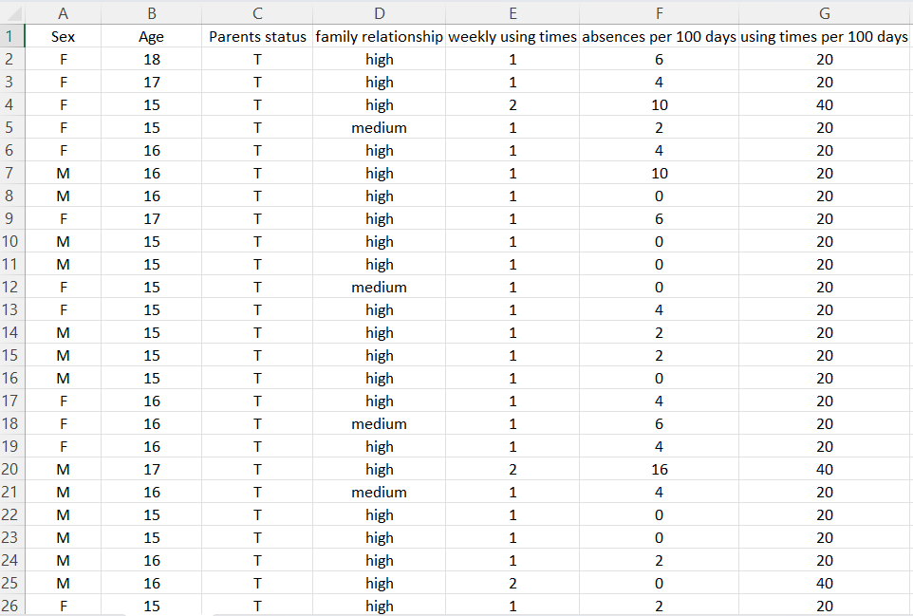According to the main points expected in this research, the data was collected from the personal information obtained from the children. This dataset has been prepared by collecting the number of times they consume alcohol per week numerically and their parents’ status and family relationship as categorical data. Checking the attendance of children is not difficult. Because it is marked every day in school. So, data has been processed by surveying and interviewing sample students and checking their attendance records. After processing, this data has been uploaded to the openly available website called ‘Kaggle’. In that website, this dataset has a variable named as weekly using times of alcohol. But the school absences are reported in a specific 100 days. Therefor I have to add a new variable to that dataset named as using times in 100 days by calculating the weekly usage fairly.

Figure 3.3. 1 A Rough Picture of my Dataset

## **3.4Data collection tools and plan**

A survey is given to the selected sample to collect data. It contains the questions you need to know. That is, how is their family relationship level, how is their parents’ status, and whether these students consume alcohol or not, and if so, how many times a week do they consume, a survey is provided, and the necessary details are taken**.**

I hope to use the dataset required for my research as a secondary dataset from the openly available website Kaggle, which has uploaded data using this plan and tools.

## **3.5Conceptual framework**

The conceptual framework is like the road map of my research. Here, the relationship between the variables related to the research questions is described.

According to the main objective of the research, mainly try to find the relationship among these variables. Family relationship, absences and parents’ status are independent variables, and weekly alcohol use is the dependent variable. Variations in weekly alcohol consumption are identified according to changes in family relationship,school absences and parents’ status data.

## **3.6Hypothesis**

1. Major objective

**Null Hypothesis ;** There is a significant relationship between Parents’ status, Family Relationship and School absences for students’ Alcohol usage.

**Alternative Hypothesis ;** There is no significant relationship between Parents’ status, Family Relationship, School absences for students’ Alcohol usage.

1. 1st Minor objective

**Null Hypothesis ;** There is correlation between Students’ Alcohol usage and School Absences.

**Alternative Hypothesis ;** There is no correlation between Students’ Alcohol usage and School Absences.

1. 2nd Minor objective

**Null Hypothesis ;** Alcohol consumption is affected with family relationship and parents’ status.

**Alternative Hypothesis ;** Alcohol consumption is not affected with family relationship and parents’ status.

## **3.7Operationalization Table**

|  |  |  |  |  |
| --- | --- | --- | --- | --- |
| Variable | Definition | Indicators | Measures | References |
| Parents’ Status | How parents live | Together / Apart | Nominal Scale | From students’ questionnaire survey |
| Family Relationship | The extent of bond to family | High, Medium, Low | Ordinal Scale | From students’ questionnaire survey |
| Using times in 100 days | Number of times students use alcohol in 100 days | Using times | Ratio | From students’ questionnaire survey |
| School Absences in 100 days | Number of school absences in 100 days | Number of days | Ratio | School Records |

Table 3.1 Operationalization Table

## **3.8Methods of data analysis**

1.To identify the relationship between family relationship, Absences**,** Parents’ status for students’ alcohol consumption.

* **Regression Analysis** – Multiple Linear Regression analysis can be used to identify the relationship between given variables because dependent variable is a numerical one while independent variables are categorical.

2.To analyze the relationship between Alcohol consumption and Student’s School absences.

* **Correlation Test** – Pearson Correlation Test will be used to measure strength and direction of these two numerical variables, Alcohol use and School absences.

3.To Examine how Alcohol consumption is affected with family relationship and parents’ status.

* **ANOVA test** – Two-way ANOVA test can be used to examine how these variables affect others because this statistical test is used between two categorical variables with one numerical variable.

# **Chapter 4: Data Analysis**

# **4.1 Data Analysis**

This chapter primarily concentrated on the strategies and techniques of analyzing and visualizing data to address the research objectives of studying students' alcohol consumption patterns and by analyzing this knowledge to mitigate such behavior. The dataset used for this analysis was obtained from a secondary data source.

Figure 4.1 1 Structure of the Dataset

The structure of the dataset that I am using here is shown above. It has sex, Parents status and family relationship as categorical variables and age, weekly using times, absences per 100 days and using times per 100 days are numerical variables. Among them, I have used categorical variables, Parents status, family relationship and numerical variables, absences per 100 days, using times per 100 days to examine the factors affecting the use of alcohol.

\***Parents status** - Parent's cohabitation status. ( 'T' - living Together or 'A' - Apart)

\***Family relationship** - Quality of family relationships. (High, medium, low)

\***Weekly using times** - Workday alcohol consumption times.(1-5)

\***Using times per 100 days** – By multiplying weekly using times into 20, here has got the using times per 100 days.(20-100)

\***Absences per 100 days** - Number of school absences in 100 days.

## **4.2Findings and Interpretation**

**1.Major Objective -** To identify the relationship between family relationship, Absences, Parents’ status for students’ alcohol usage.

* **Regression Analysis** – Multiple Linear Regression analysis can be used to identify the relationship between given variables.
* Dependent Variable - Using times in 100 days
* 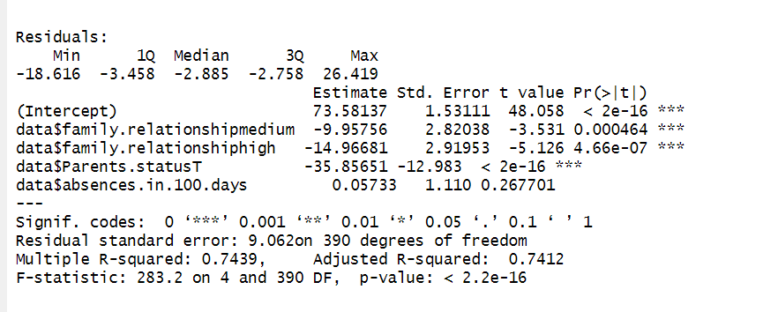Independent Variables - Family relationship, Absences in 100 days, Parents’ status.

Figure 4.2 1 Regression Analysis Statistical Test

Hypothesis for this objective is,

**H0** : There is no significant relationship between Parents’ status, Family Relationship and Absences for students’ Alcohol consumption.

**H1** : There is a significant relationship between Parents’ status, Family Relationship, and Absences for students’ Alcohol consumptions.

When comparing the significance value(0) and p value of this test, p value (< 2.2e-16) is less than the significance value. Therefor null hypothesis (H0) can be rejected. It proves that there is a significant relationship between Parents’ status, Family Relationship, and Absences for students’ Alcohol consumption.

Residuals are the differences between observed and predicted values, that measure how far away an observed point is from predicted regression line.

~ The minimum residual is -18.616.

~ The 1st quartile (25th percentile) of residuals is -3.458.

~ The median (50th percentile) of residuals is -2.885.

~ The 3rd quartile (75th percentile) of residuals is -2.758.

~ The maximum residual is around 26.419.

According to the estimated coefficients, the regression equation (y=mx+c) can be written as,

{ Using times in 100 days = -9.95756*family relationship medium -14.96681*family relationship high – 35.85651*parents status + 0.06363*absences in 100 days + 73.58137 }

1.Family relationships

For medium family relationships, the coefficient is -9.95756. This means when all other variables are constant, how much does using times in 100 days change for a one-unit change of medium family relationship. Here when family relationships are at a medium level, alcohol use times in 100 days are decreased by 9.96 points approximately while other variables are held constant. As well as when the family relationship is at a high level, alcohol usage tends to decrease by 14.97 points. It is a considerable amount to prove that family relationships affect the students alcohol consumption.

2.Parent status

Also, parents' status is one of the main factors affecting children's behavior patterns, it is well shown by the coefficient for parents' statusT here. That is, if parents live together, it is well understood that the tendency of children to consume alcohol drops by a significant amount of 35 units when other variables hold constant.

3.School absences

Another reason for the increase in alcohol consumption is that students do not attend school properly. This test shows that it is only a marginally significant factor. This is because, when other factors remain constant, using times increases by 0.06 for one unit increase in the variable of school absence. This proves that continuous absence from school can be considered as a reason for habituation to alcohol consumption, but it is not the most significant factor.

Based on the significance codes that shown here, family relationship level and parents status have ‘***’. That indicates those variables are highly significant to measure students alcohol consumption.

The residual standard error is about 9.06 in here. Which means the observed values of using times in 100 days deviate from the estimated values by 9.06 units. As it is a somewhat lower value, this indicates the model’s predictors are higher precise.

As a percentage, Multiple R-squared is equal to 74.39% . According to that percentage this coefficients are better to interpret the case.

The F-statistic is 283.2, and the p-value is < 2.2e-16, which is extremely small. This indicates that the overall model is statistically significant.

Graphical representation to identify the relationship between family relationship, Absences, Parents’ status for students’ alcohol usage.

1.How family relationship affects students Alcohol consumption

Figure 4.2 2 Scatter Plot – How family relationship affects students Alcohol Consumption

The above scatter plot depicts two factors that affect students' alcohol consumption. They are school absences and family relationship level. Among them, it shows that there is no significant relationship between school absence and alcohol use. This is because the points in the graph are more scattered with a greater tendency towards the lowest number of school absences. The other factor that appears is the family relationship level. It has been tested under three categories high, medium, and low. In the graph, blue points show high family relationship and black points show medium level of family relationship.

The points that appear better in red indicate a low family relationship level. That is, this scatter plot is used to confirm how far the family relationship level affects the students' behavior patterns. Here, the red points are towards the top of the graph, which means that the number of times alcohol is used is increasing. Similarly, because there are more points in red color, it is proved that the family relationship level has more influence for this case.

Finally, if we consider this graph fairly, there is a positive correlation between alcohol consumption and family relationships. But it cannot be said with certainty that only family relationships affect students' alcohol consumption patterns. Because the students who have medium and high family relationships, also some of them have used to this as well.

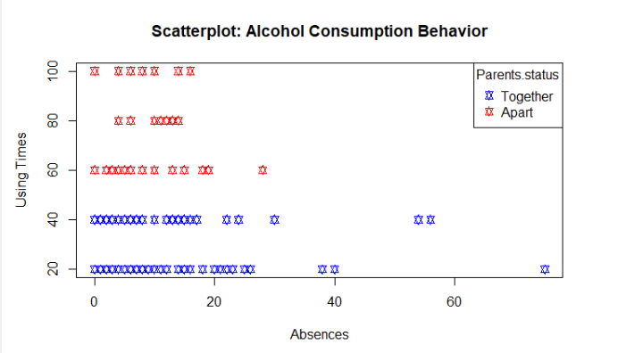**2.** How Parents status affects students Alcohol consumption.

Figure 4.2. 3 Scatter Plot – How Parents status affects students Alcohol Consumption

The above scatter plot shows the relationship between the number of absences and the using times of alcohol, where the colors of the points indicate the parents status (Together or Apart) of the students. Absences are not a significant factor as has been proven before and this can indicate that parents' status has some effect on students’ alcohol consumption.

There is a positive correlation between alcohol consumption behavior and parental status. That means the students who have departed parents are more likely to incline alcohol. They have more chances to become addicted to these behaviors because they don’t have proper guide. However, it is certain that many other factors also influence such behavior. It can be confirmed that parents status is a significant factor that is tested here.

**2. 1st Minor Objective -** To analyze the relationship between Alcohol consumption and Student’s School absences.

* 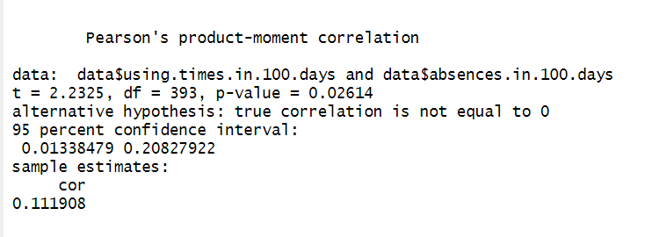**Correlation Test** – Pearson Correlation Test will be used to measure strength and direction of these two numerical variables, Alcohol use and School absences**.**

Figure 4.2. 4 Correlation Statistical Test

This result shows that the correlation between alcohol usage times in 100 days and school absences in 100 days. Hypothesis for this objective is as follows,

**H0 :** There is no correlation between Students’ Alcohol usage and School Absences.

**H1 :** There is correlation between Students’ Alcohol usage and School Absences.

Based on the results, the p value (0.02614) is less than the general significance value (0.05) and as mentioned in the results the true correlation is not equal to zero. Therefor null hypothesis should be rejected. There is a correlation between students’ alcohol usage and school absences.

The correlation coefficient is equal to 0.112 approximately, that there is a positive but weak correlation. That indicates that the two variables behave inversely, but there is a very slight trend.

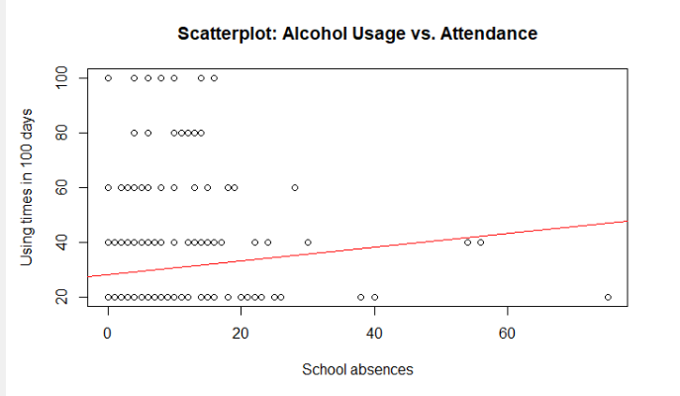Graphical representation for 1st minor objective

Figure 4.2. 5 Scatter Plot – Graphical Representation for 1st Minor Objective

The scatterplot shows the relationship between alcohol usage and school absences. There is a positive correlation between the two variables. That means the students who have more school absences are more likely to consume more alcohol. But the correlation is not very strong. Because the data points are not scattered with the abline. More points are in the left corner. That shows the school absences are not mainly affecting this trend. Thus, we cannot surely mention that the absences influence students’ alcohol consumption.

1. **2nd Minor Objective -** To Examine how Alcohol consumption is affected with family relationship and parents’ status.

* 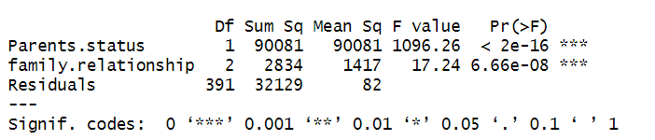ANOVA test – Two-way ANOVA test can be used to examine how these variables affect others because this statistical test is used between two categorical variables with one numerical variable.

Figure 4.2. 6 ANOVA Statistical Test

Parents status – P value (< 2e-16) of this variable is much less than its significance value (zero). That indicates this factor has a highly significant effect on the dependent variable. That is there is a significant difference in the means of the dependent variable among the parents status levels.

Family relationship – This variable also has a highly significant effect on alcohol consumption because the p value of this variable is also much less than its significance value. (6.66e-08 < 0) This results indicate that there is a significant difference in the means of dependent variable among the levels of family relationships.

# **Chapter 5: Discussion and Recommendations**

## **5.1 Discussion**

I think that I can get a valuable understanding about the alcohol consumption of school students, which is a big problem in society. As I first hypothesized, the factors of family relationship level, parents status and school absences can be understood from this report.

**Family relationship** - It can be understood that children who have a high relationship with their family have the lowest level of alcohol use, and students who have less or medium family attention and less relationship with each other are more likely to use alcohol.

**Parents status** - whether the status of the parents, i.e., both the mother and the father are together or whether one of the children is separated (dead or separated due to parental issues), this can also give a good understanding of how the behavior patterns of the students have been affected. This means that it is more common for such students to turn to alcohol if one of their parents is not with their children than the students whose parents are together.

**School absences** - This tried to find out how important school education is for children to resort to bad habits like alcohol. But it was emphasized that school attendance does not have a big impact on this. That is, it is not possible to get knowledge about students' alcohol use due to absences. It is further proved that although absences are affected to some extent, it is not a significant factor.

## **5.2 Recommendations**

**Self-control** - First such students should be given necessary instructions to control themselves. That is, they should be informed about the negative effects caused by such bad habits. It can be done through education itself. But often the advice of teachers or adults should try to reduce this temptation of such students by peers themselves. Studies have shown that peer-led, rather than teacher-led, interventions have had better success.

**Social Interference** – There are many things that can be done to stop or minimize this if the whole society comes together. In other words, underage people should not resort to things like illegal drugs. And programs can be presented on the negative impact of such things through communication media. Organizing special workshops at the school level is another way for this.

**Counseling services** - Those responsible should take measures to provide necessary psychological counseling for people who are already addicted to alcohol. Likewise, not only children but also their families should participate in such counseling programs. It is important to educate parents about their children at the school level on a regular basis. Likewise, it is important for parents to know how to behave in front of their children and not to show their private problems with their children. As parents' separation or their problems affect the children in the same way, such students may turn to alcohol to get rid of those mental conditions.

**Goal setting -** By giving children the choice of their preferred educational path and making them interested in the goals of life, it is possible to reduce the referral to external things.

## **5.3 Conclusions**

In conclusion, the family relationship level and parents status identified by this research report understand how much impact the students have on alcohol use. Parents, peers, and teachers around the students should understand how important it is to minimize these behavior patterns. This will prevent more students from engaging in such bad habits in the future. It is up to the responsible people to identify such problems and provide necessary remedies as soon as possible through further research and paying more attention to the students, and I hope that this research report will also help in that.

# References

**Literature Reviews References**

1.https://www.mdpi.com/1660-4601/18/14/7531

2.https://www.mdpi.com/1660-4601/18/18/9528

3.https://www.mdpi.com/1660-4601/18/4/1835

4.https://www.ncbi.nlm.nih.gov/pmc/articles/PMC5728797/

5. https://journals.plos.org/plosone/article?id=10.1371/journal.pone.0178142

6. https://www.sciencedirect.com/science/article/pii/S0306460304002990

7. https://www.sciencedirect.com/science/article/pii/S0306460303001199

8. https://onlinelibrary.wiley.com/doi/abs/10.1111/j.1530-0277.2007.00402.x

9. https://psycnet.apa.org/record/2005-07161-008

10. https://psycnet.apa.org/record/2010-13667-007

**Other References**

11. https://asana.com/resources/project-proposal

12. https://proposalsforngos.com/what-is-the-project- justification/#:~:text=The%20project%20justification%20basically%20explains,positive%20effects%20will%20it%20have%3F

13. https://www.simplilearn.com/what-is-data-collection-article 14.https://www.scribbr.com/methodology/conceptual-framework/ 15.https://www.indeed.com/career-advice/career-development/operationalization#:~:text=Operationalization%20is%20a%20method%20of,trends%20that%20otherwise%20defy%20quantification.

16. https://apps.who.int/gb/ebwha/pdf_files/WHA63/A63_13-en.pdf