**VehicleController.java**

package com.example.demo.controller;  
  
import com.example.demo.model.Vehicle;  
import com.example.demo.service.VehicleService;  
import org.springframework.beans.factory.annotation.Autowired;  
import org.springframework.web.bind.annotation.*;  
  
import java.util.List;  
  
@RestController  
@RequestMapping("/api/vehicles")  
public class VehicleController {  
  
 @Autowired  
 private VehicleService vehicleService;  
  
  
  
 // Save a vehicle (helper endpoint to add test data)  
 @PostMapping  
 public Vehicle createVehicle(@RequestBody Vehicle vehicle) {  
 return vehicleService.saveVehicle(vehicle);  
 }  
  
 // Q1: get all vehicles by year  
 @GetMapping("/year/{year}")  
 public List<Vehicle> getVehiclesByYear(@PathVariable int year) {  
 return vehicleService.getVehiclesByServiceYear(year);  
 }  
  
 // Q2: get vehicle type by service id  
 @GetMapping("/type/{serviceId}")  
 public String getVehicleTypeByServiceId(@PathVariable Long serviceId) {  
 return vehicleService.getVehicleTypeByServiceId(serviceId);  
 }  
  
 // Q3: delete all vehicles for a year  
 @DeleteMapping("/year/{year}")  
 public String deleteVehiclesByYear(@PathVariable int year) {  
 vehicleService.deleteVehiclesByServiceYear(year);  
 return "Deleted all vehicle service records for year " + year;  
 }  
}

**Vehicle.java**

package com.example.demo.model;  
  
import jakarta.persistence.Entity;  
import jakarta.persistence.GeneratedValue;  
import jakarta.persistence.GenerationType;  
import jakarta.persistence.Id;  
import jakarta.persistence.Column;  
  
@Entity  
public class Vehicle {  
  
 @Id  
 @GeneratedValue(strategy = GenerationType.*IDENTITY*)  
 private Long serviceId;  
  
 @Column(nullable = false)  
 private String vehicleType;  
  
 private String vehicleNumber;  
 private int serviceYear;  
  
 // Constructors  
 public Vehicle() {  
 }  
  
 public Vehicle(String vehicleType, String vehicleNumber, int serviceYear) {  
 this.vehicleType = vehicleType;  
 this.vehicleNumber = vehicleNumber;  
 this.serviceYear = serviceYear;  
 }  
  
 // Getters and Setters  
 public Long getServiceId() {  
 return serviceId;  
 }  
  
 public void setServiceId(Long serviceId) {  
 this.serviceId = serviceId;  
 }  
  
 public String getVehicleType() {  
 return vehicleType;  
 }  
 public void setVehicleType(String vehicleType) {  
 this.vehicleType = vehicleType;  
 }  
  
 public String getVehicleNumber() {  
 return vehicleNumber;  
 }  
  
 public void setVehicleNumber(String vehicleNumber) {  
 this.vehicleNumber = vehicleNumber;  
 }  
  
 public int getServiceYear() {  
 return serviceYear;  
 }  
  
 public void setServiceYear(int serviceYear) {  
 this.serviceYear = serviceYear;  
 }  
}

**VehicleRepository.java**

package com.example.demo.repository;  
  
import com.example.demo.model.Vehicle;  
import org.springframework.data.jpa.repository.JpaRepository;  
import org.springframework.data.jpa.repository.Modifying;  
import org.springframework.data.jpa.repository.Query;  
import org.springframework.stereotype.Repository;  
import org.springframework.transaction.annotation.Transactional;  
  
import java.util.List;  
  
@Repository  
public interface VehicleRepository extends JpaRepository<Vehicle, Long> {  
  
 // Q1: find all by service year  
 List<Vehicle> findByServiceYear(int serviceYear);  
  
 // Q2: get only vehicleType by serviceId  
 @Query("SELECT v.vehicleType FROM Vehicle v WHERE v.serviceId = :serviceId")  
 String findVehicleTypeByServiceId(Long serviceId);  
 @Modifying  
 @Transactional  
 @Query("DELETE FROM Vehicle v WHERE v.serviceYear = :serviceYear")  
 void deleteByServiceYear(int serviceYear);  
}

**VehicleServiceImpl.java**

package com.example.demo.service.impl;  
  
import com.example.demo.model.Vehicle;  
import com.example.demo.repository.VehicleRepository;  
import com.example.demo.service.VehicleService;  
import org.springframework.beans.factory.annotation.Autowired;  
import org.springframework.stereotype.Service;  
  
import java.util.List;  
  
@Service  
public class VehicleServiceImpl implements VehicleService {  
  
 @Autowired  
 private VehicleRepository vehicleRepository;  
  
 @Override  
 public List<Vehicle> getVehiclesByServiceYear(int serviceYear) {  
 return vehicleRepository.findByServiceYear(serviceYear);  
 }  
  
 @Override  
 public String getVehicleTypeByServiceId(Long serviceId) {  
 return vehicleRepository.findVehicleTypeByServiceId(serviceId);  
 }  
  
 @Override  
 public void deleteVehiclesByServiceYear(int serviceYear) {  
 vehicleRepository.deleteByServiceYear(serviceYear);  
 }  
  
 @Override  
 public Vehicle saveVehicle(Vehicle vehicle) {  
 return vehicleRepository.save(vehicle);  
 }  
}

**VehicleService.java**

package com.example.demo.service;  
  
import com.example.demo.model.Vehicle;  
import java.util.List;  
  
public interface VehicleService {  
 List<Vehicle> getVehiclesByServiceYear(int serviceYear);  
 String getVehicleTypeByServiceId(Long serviceId);  
 void deleteVehiclesByServiceYear(int serviceYear);  
 Vehicle saveVehicle(Vehicle vehicle); // helper to add sample data via API  
}

**DemoApplication**

package com.example.demo;  
import org.springframework.boot.SpringApplication;  
import org.springframework.boot.autoconfigure.SpringBootApplication;  
  
@SpringBootApplication  
public class DemoApplication {  
 public static void main(String[] args) {  
 SpringApplication.*run*(DemoApplication.class, args);  
 }  
}

**applicationProperties**

spring.datasource.url=jdbc:mysql://localhost:3306/vehicle_db?createDatabaseIfNotExist=true&useSSL=false&allowPublicKeyRetrieval=true&serverTimezone=UTC  
spring.datasource.username=root  
spring.datasource.password=1234  
  
spring.jpa.hibernate.ddl-auto=update  
spring.jpa.show-sql=true  
spring.jpa.properties.hibernate.dialect=org.hibernate.dialect.MySQLDialect  
  
server.port=8081

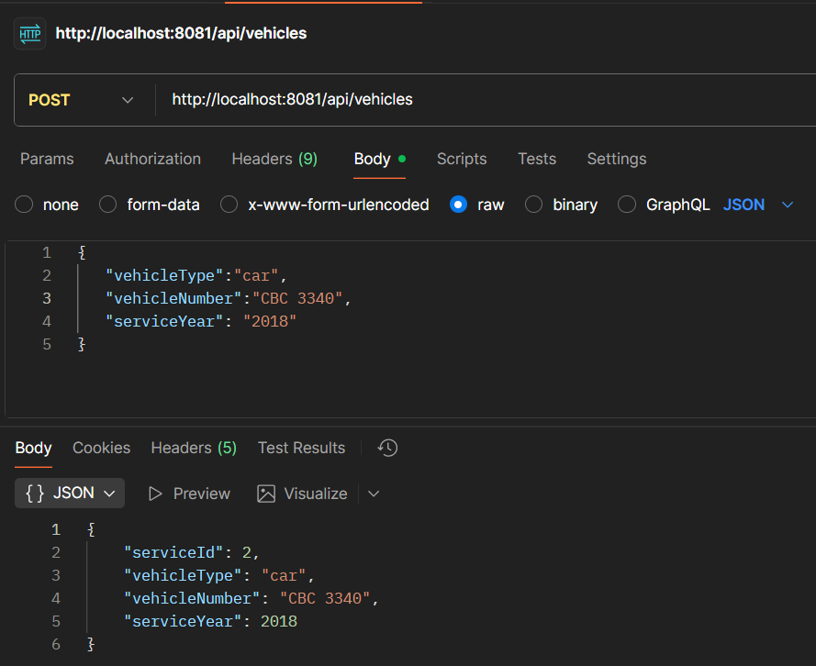

1. How can we retrieve a list of all vehicles serviced in a specific year?

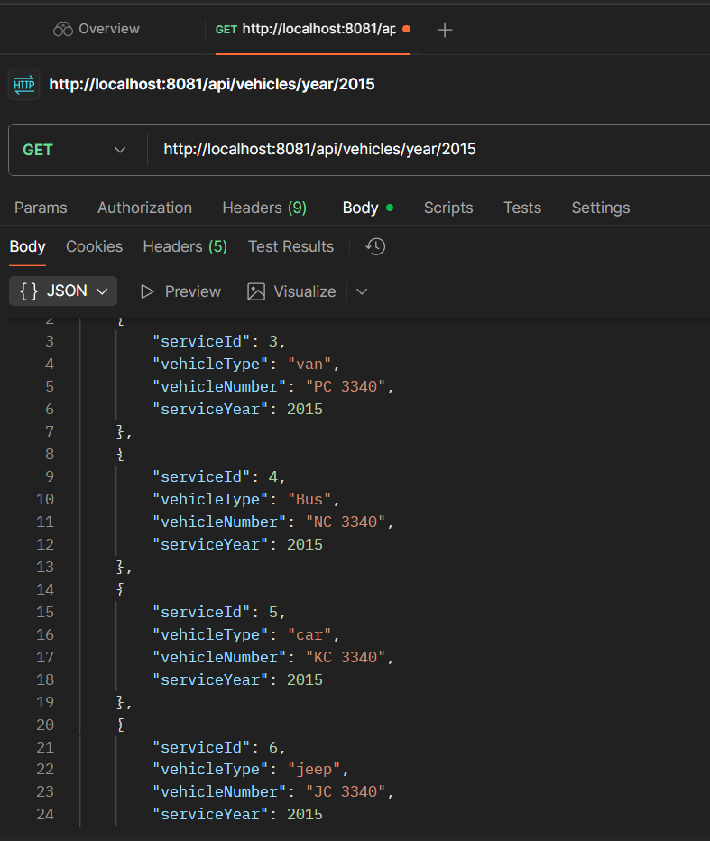

2. How can we retrieve only the vehicle type given the service ID?

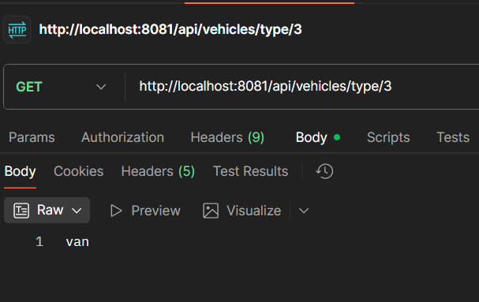

3. How can we remove all vehicle service records for a given year?

