**Step-by-Step Guide to Creating an FPGA-Based Spectrum Analyzer**

**1. Understand the Basics**

* **Concept**: A spectrum analyzer visualizes signals in the frequency domain. It captures a time-domain signal and transforms it into the frequency domain using the Fast Fourier Transform (FFT).
* **Components**: Key components include an Analog-to-Digital Converter (ADC) for signal sampling, an FPGA for processing, and a display interface.
* **Block Diagram**

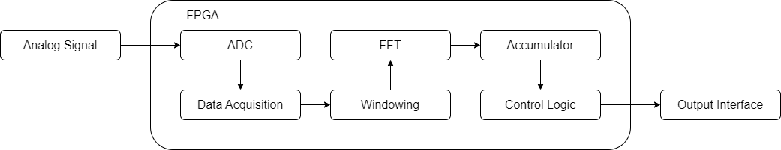

**2. Select Hardware**

* **FPGA Development Board**: Choose an appropriate FPGA development board, such as the Virtex-5 (used in Borade et al.) or similar.
* **ADC**: Use a high-speed, high-resolution ADC. For instance, the LTC2255 14-bit, 100 MSPS ADC was used in the reference design.
* **Peripheral Devices**: Include necessary peripherals like RS232 for communication, switches, and LEDs for testing and indication.

**3. Setup the FPGA Environment**

* **Tools**: Install and configure the Xilinx ISE Design Suite or a similar FPGA development environment.
* **Libraries**: Ensure you have access to necessary IP cores, such as the Xilinx FFT IP core.

**4. Design the Data Flow**

* **Data Acquisition**: Use the ADC to sample the input analog signal.
* **Pre-processing**: Implement windowing functions (e.g., Hamming, Blackman-Harris) to reduce spectral leakage.
* **FFT Processing**: Utilize the FFT IP core to transform the pre-processed signal from the time domain to the frequency domain.
* **Post-processing**: Accumulate multiple FFT outputs to enhance accuracy and sensitivity.

**5. Implement the Design in VHDL**

* **Module Creation**: Create VHDL modules for each stage of the data flow:
  + **ADC Interface**: Capture and digitize the input signal.
  + **Windowing**: Apply window functions to the input data.
  + **FFT**: Transform the windowed data using the FFT IP core.
  + **Accumulator**: Sum multiple FFT outputs for improved sensitivity.
* **Control Logic**: Implement control logic for managing data flow and interfacing with peripherals.

**6. Simulate the Design**

* **Create Testbenches**: Develop VHDL testbenches for each module and the overall design to simulate the functionality.
* **Verification**: Use simulation tools provided by the FPGA development environment to verify the correctness of the design.
* **Waveform Analysis**: Analyze the output waveforms to ensure the design works as expected. Check for correct ADC interfacing, proper windowing, accurate FFT computation, and correct accumulation.
* **Iterate**: Refine the design based on simulation results. Fix any issues identified during simulation.

**7. Optimize the Design**

* **Resource Utilization**: Optimize the design to fit within the FPGA's resources. Balance between throughput and resource usage.
* **Pipelining**: Use pipelined architectures for continuous data processing and improved performance.
* **Memory Management**: Efficiently manage memory for storing input, intermediate, and output data.

**8. Test and Calibrate**

* **Prototype Testing**: Test the design on the actual FPGA board. Use known signals to verify the accuracy of the spectrum analysis.
* **Calibration**: Calibrate the system to ensure accurate frequency and amplitude measurements.

**9. Develop the User Interface**

* **Display**: Use a graphical interface (e.g., LABVIEW) to display the spectrum. Provide options to view the spectrum in linear or logarithmic scales.
* **Storage**: Implement functionality to store the spectral data for further analysis.

**10. Documentation and Future Scope**

* **Documentation**: Document the design, implementation steps, and testing results.
* **Improvements**: Identify potential areas for future improvements, such as increasing the FFT size, enhancing the user interface, or adding additional signal analysis features.

**References:**

1. Borade, R., Dimber, A., Gharpure, D., & Ananthakrishnan, S. (2018). Design and Development of FPGA-Based Spectrum Analyzer. IETE Journal of Education. [DOI: 10.1080/09747338.2018.1450648](https://doi.org/10.1080/09747338.2018.1450648)
2. Qi, J. (2015). [Detailed reference on FPGA implementation].