citrainput=[3 1 2; 0 1 0; 4 7 3]

citraoutput=[6 1 1; 4 3 4; 5 3 6]

citrainput =

3 1 2

0 1 0

4 7 3

citraoutput =

6 1 1

4 3 4

5 3 6

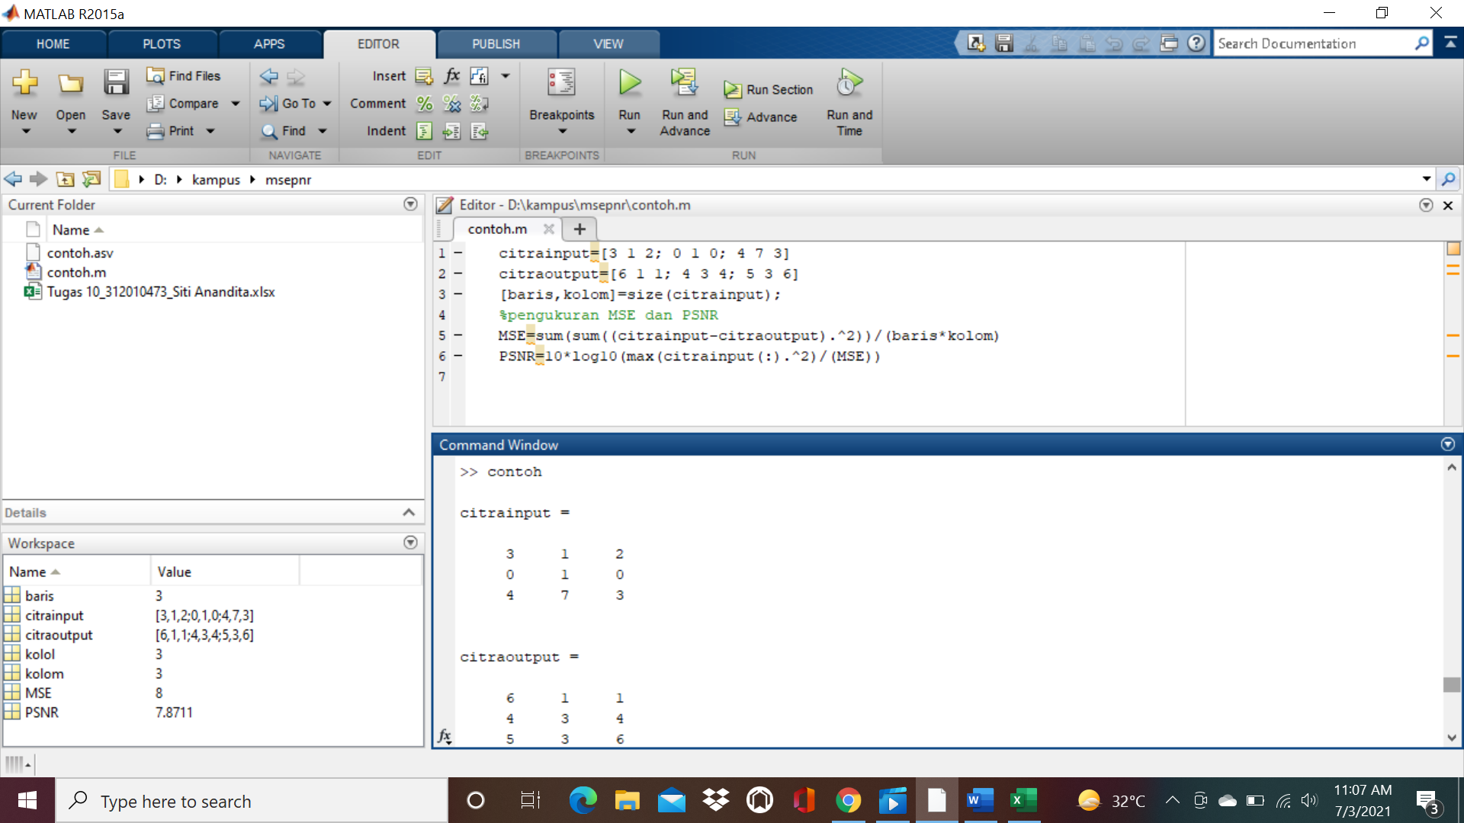

[baris,kolom]=size(citrainput);

%pengukuran MSE dan PSNR

MSE=sum(sum((citrainput-citraoutput).^2))/(baris\*kolom)

PSNR=10\*log10(max(citrainput(:).^2)/(MSE))

MSE =

8

PSNR =

7.8711

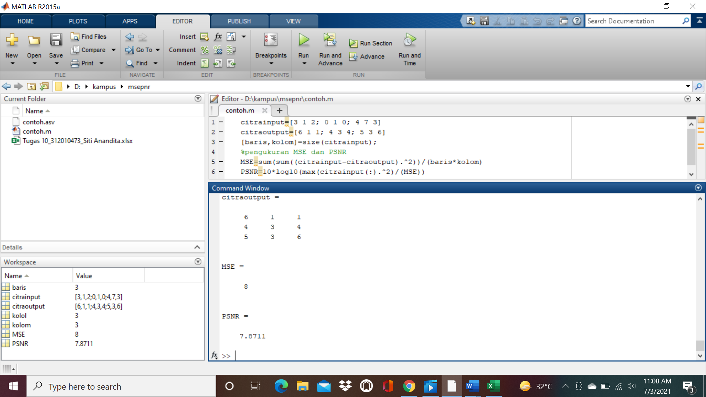

Dalam Ms. Excel

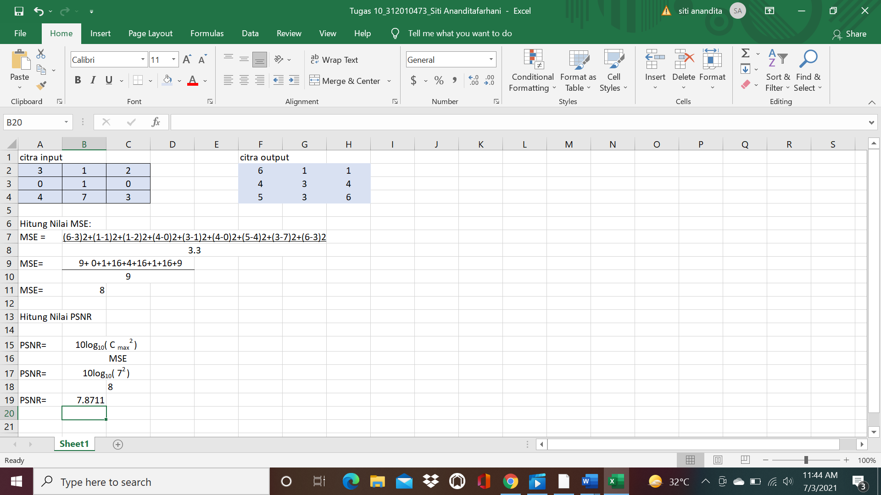

Dalam Matlab

citrainput=[8 2 3; 3 4 5; 2 2 1]

citraoutput=[6 1 2; 1 1 1; 2 1 1]

[baris,kolom]=size(citrainput);

%pengukuran MSE dan PSNR

MSE=sum(sum((citrainput-citraoutput).^2))/(baris\*kolom)

PSNR=10\*log10(max(citrainput(:).^2)/(MSE))

>> tugas10

citrainput =

8 2 3

3 4 5

2 2 1

citraoutput =

6 1 2

1 1 1

2 1 1

MSE =

4

PSNR =

12.0412

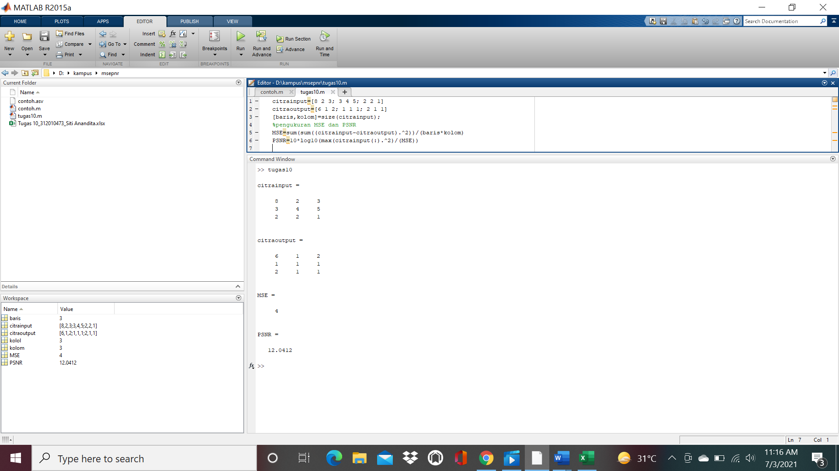

Dalam Ms. Excel

