居安思維

・資料介紹 :

1. 犯罪資料

來源：<http://data.gov.tw/node/14200>

格式：.CSV

資料描述：提供毒品、強盜、搶奪、住宅盜竊、汽車竊盜、機車竊盜、強制性交等7案類犯罪發生資料。

欄位：案類、發生日期、發生地點（鄉、鎮、市、區）

1. 桃園市狹小巷弄列管清冊

來源：<http://data.tycg.gov.tw/opendata/datalist/datasetMeta?oid=65c58683-220f-4075-a555-f80c7e580e5e>

格式：.CSV

資料描述：桃園市政府消防局搶救不易地區-狹小巷弄列管清冊，總計392處

欄位：序號、行政區、狹小巷弄地址

## R Markdown

This is an R Markdown document. Markdown is a simple formatting syntax for authoring HTML, PDF, and MS Word documents. For more details on using R Markdown see <http://rmarkdown.rstudio.com>.

When you click the **Knit** button a document will be generated that includes both content as well as the output of any embedded R code chunks within the document. You can embed an R code chunk like this:

summary(cars)

## speed dist   
## Min. : 4.0 Min. : 2.00   
## 1st Qu.:12.0 1st Qu.: 26.00   
## Median :15.0 Median : 36.00   
## Mean :15.4 Mean : 42.98   
## 3rd Qu.:19.0 3rd Qu.: 56.00   
## Max. :25.0 Max. :120.00

## Including Plots

You can also embed plots, for example:

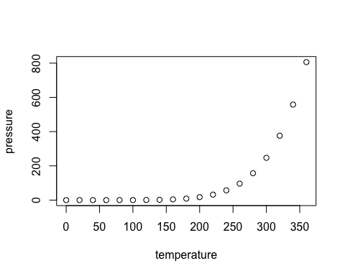

Note that the echo = FALSE parameter was added to the code chunk to prevent printing of the R code that generated the plot.