Klik brigde lalu ubah nama

Buat bridge 1 dan 2 di hubungkan

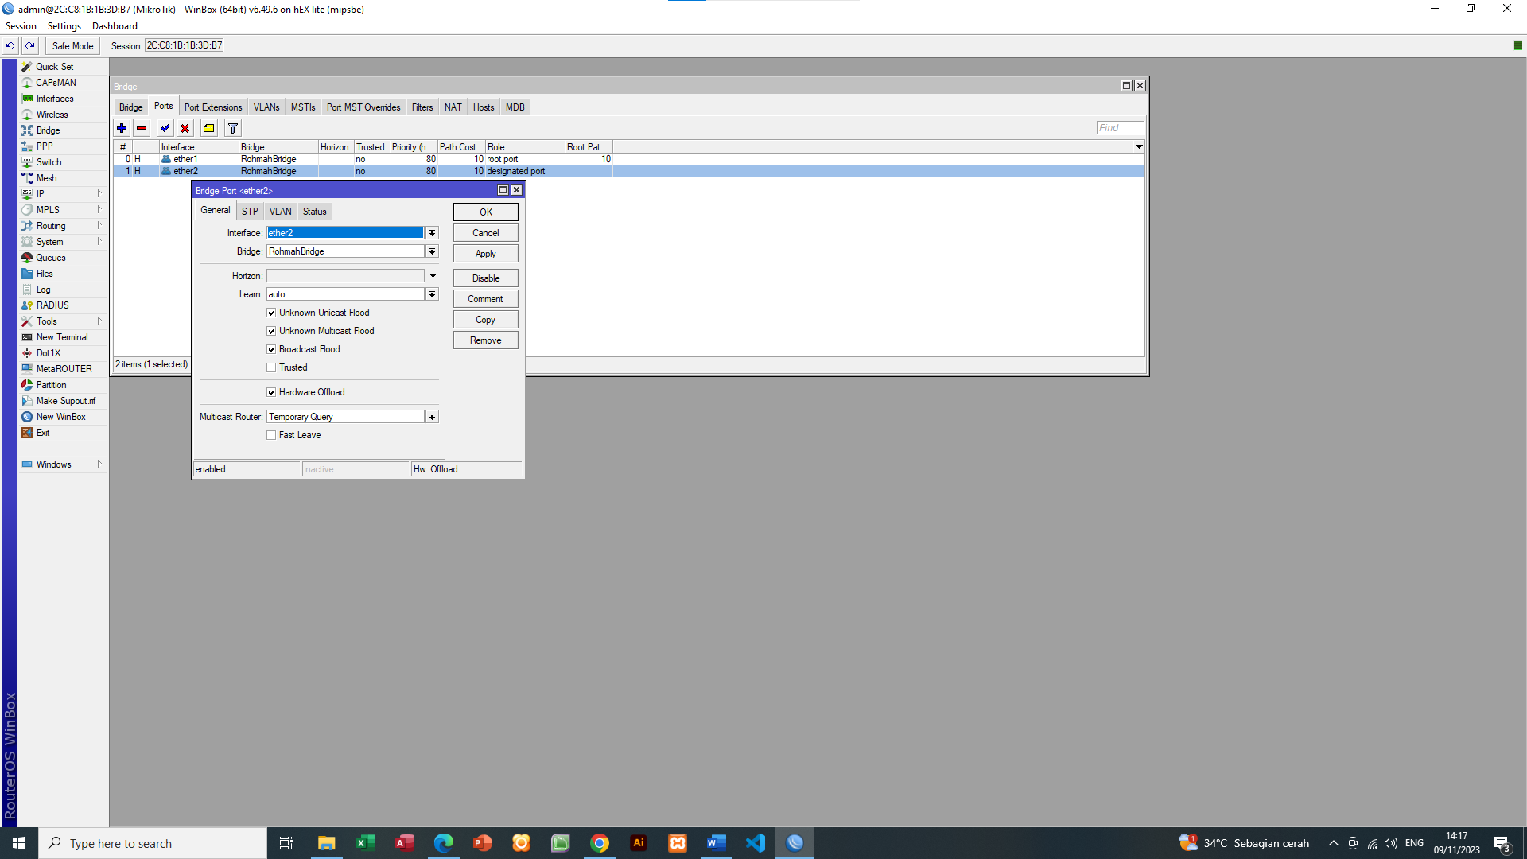

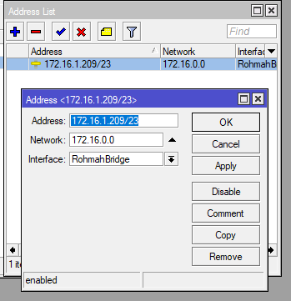

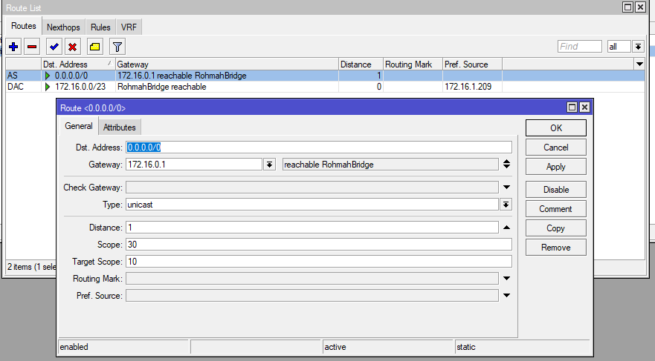

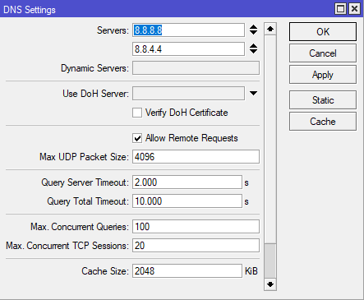

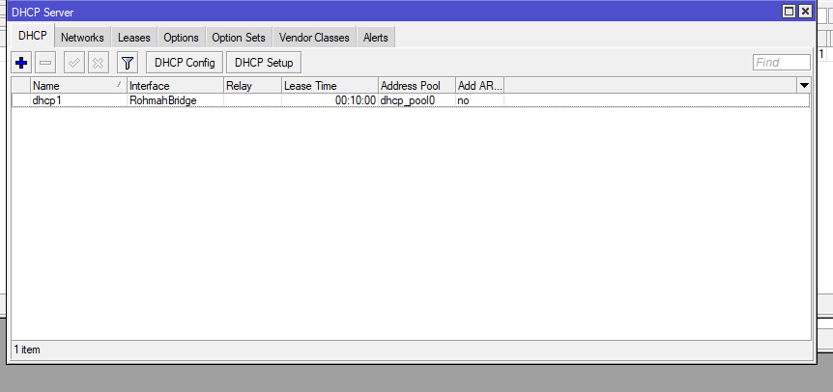

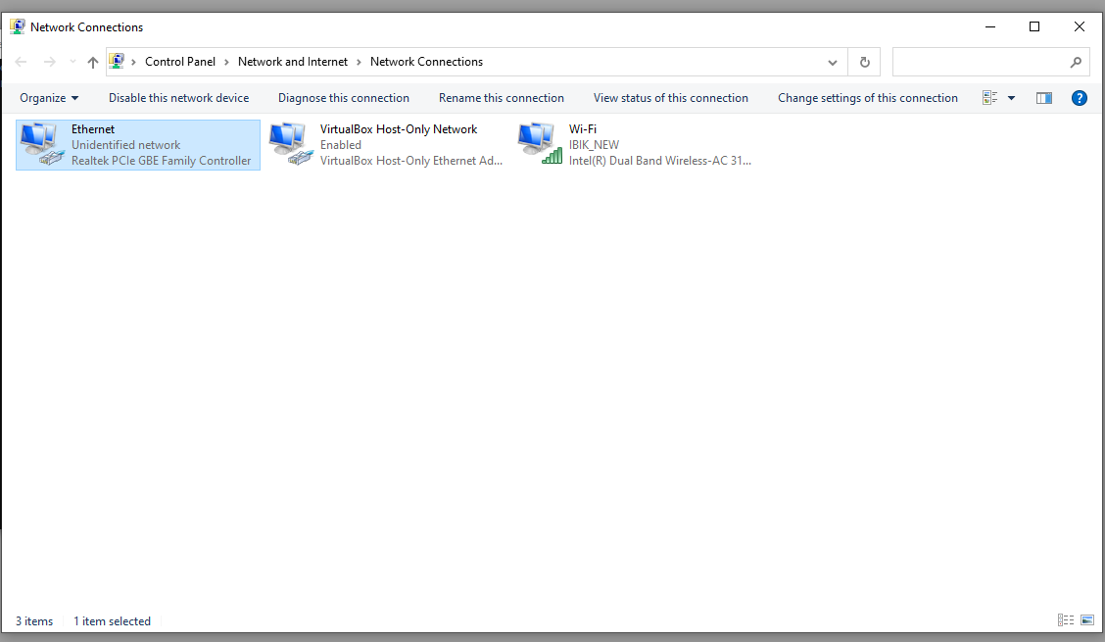

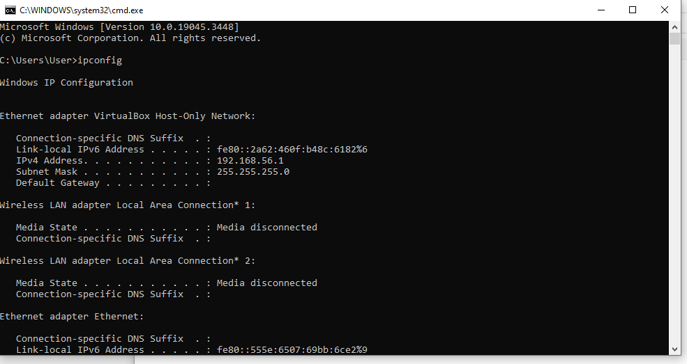

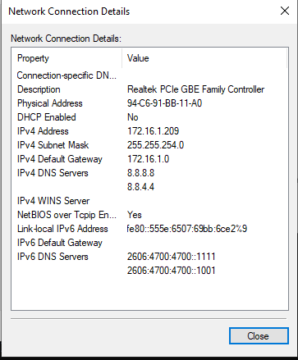

Menggunakan wireless mikrotik.

Rb750r2

Rb= router bord

7 = seri

5 = port

0 = wireless

R2=

Klik wireless lalu ubah nama lalu ikon wireless

Ada 2 ap = aceses point , station = penerima



