CYS Chinese Website — Design & Wireframe Feedback
Follow-up from vendor meeting, 12:00 PM, September 1, 2026

1. Landing Page — Ready to Move Into Design
We're happy with the landing page and would like to move forward with the design phase. However, after review, our management team felt the pages currently lack interactivity. For the design phase, we'd like to request the following enhancements:
- Number / counter animations (scrolling numbers)
- Interactive background elements
- Transition effects between sections when scrolling — each section should have a responsive page transition, rather than displaying as a static image

2. Wireframe Completion — Outstanding Page Layouts
We'd like the remaining page wireframes completed next. Right now, the About Us, Individual, Business, and Corridor pages are all using the exact same layout (see screenshots below) — the same hero, the same image-and-text blocks, and the same 3-card grid, regardless of what each page is actually about. Below are three specific items, each with a side-by-side comparison of the current wireframe layout against the actual content and design intent, so the request is unambiguous.
Here is content Canva file link, in case you can’t find it.
https://canva.link/3aeym6j52ach89u

2.1 About Us — History Section Layout
The History section layout is suitable — we already flagged this in our wireframe feedback comments two weeks ago, but we're concerned the intent wasn't clear, so here it is with a visual side-by-side:
Our earlier comment (Aug 17): "History. This layout doesn't look right for History — it should be the one with an earth/globe background. Let us know if you need this content."
Current wireframe layout (About Us page)  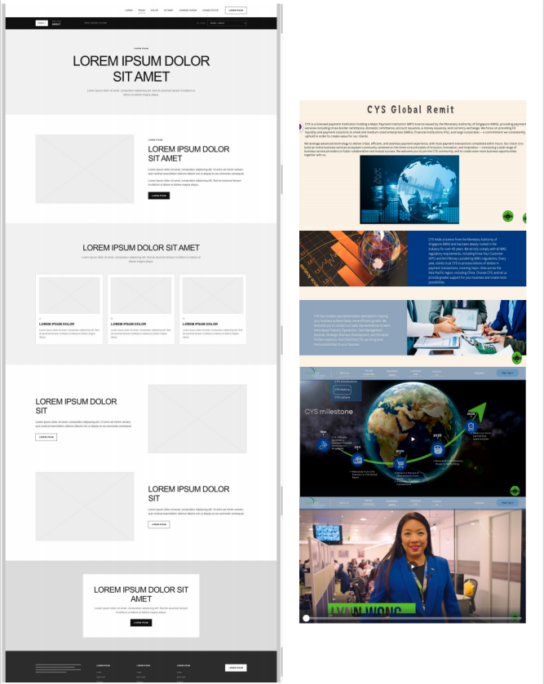  Generic hero + text/image block template — no dedicated History/Milestone section. | Reference content & design intent (CYS Milestones)  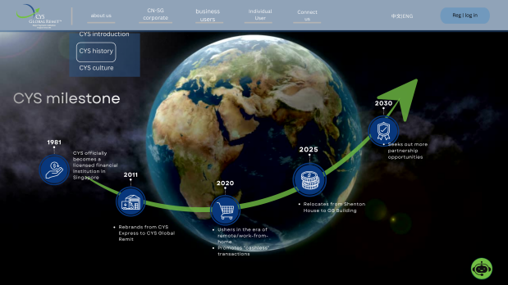  Milestone timeline on a rotating-earth background, one icon per year (1981–2030).  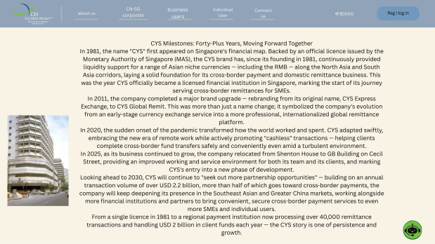  Full milestone narrative content for reference.「I'm not sure if you still remember — when we showed you this section before, the page interaction we wanted here was: when you hover the mouse over each year, the content for that year expands, without needing to click.」
Our original design intent: each year on the milestone timeline has its own content, and hovering over a year expands to reveal the details — not a static block of text.

2.2 Corridor Page — Two Distinct Sections
The Corridor page should have two clearly distinct sections: a partner/investor showcase and a partnership stories/articles section. The current wireframe doesn't distinguish between them at all:
Current wireframe layout — Corridor page  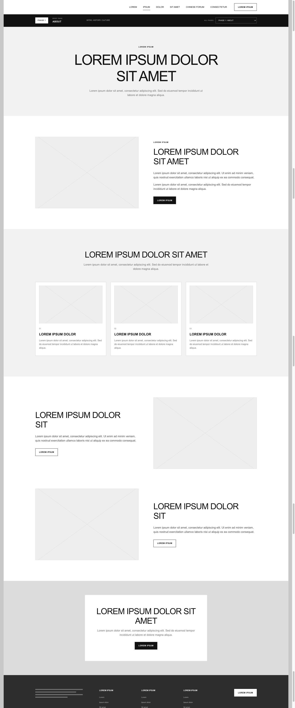  Same generic long template as every other page — no distinction between the two content types below. | Actual content — two sections  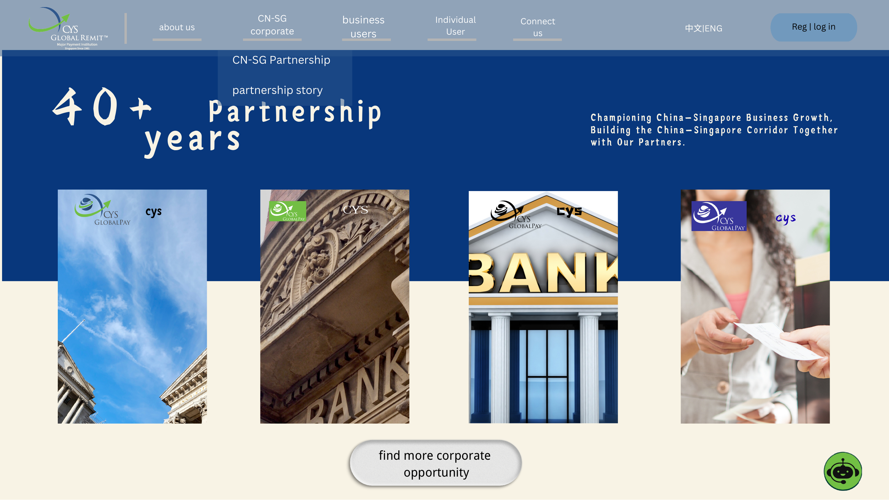  Section A — "40+ Years Partnership" hero with partner/investor logo tiles.    Section A (cont.) — Partners & Investors description.  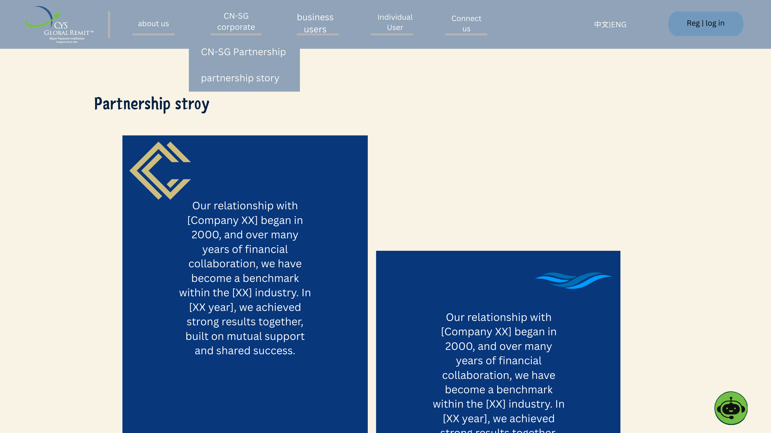  Section B — Partnership story / article cards (separate content type from the partner showcase above).

2.3 Individual & Business Pages — Condense the Layout
Please condense the layout of the Individual and Business pages to match the amount of actual content — right now both use the same long generic template (hero → image/text block → 3-card grid → two more image/text blocks → CTA → footer), which is far more sections than the real content needs.
Current wireframe layout — Individual page  Same generic long template as every other page. | Actual content — Individual (3 simple use cases)  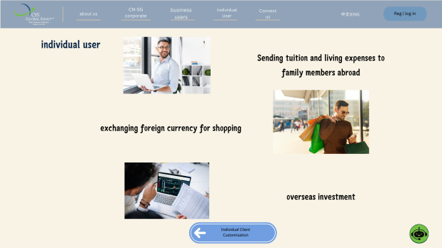  Three use cases only: remittance to family, FX exchange for shopping, overseas investment.
Current wireframe layout — Business page  Same generic long template as every other page. | Actual content — Business (2 sub-audiences)  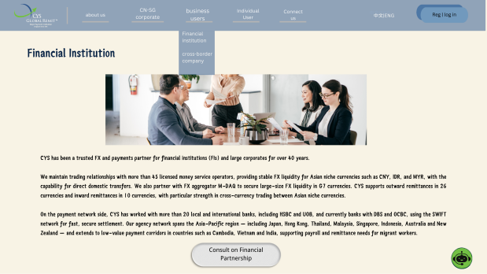  Financial Institution content.  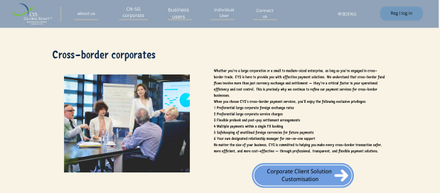  Cross-border Corporates content.

