LTE REDIRECTION : TAU REJECT FLOW  + ATTACH REJECT OR SERVICE REJECT

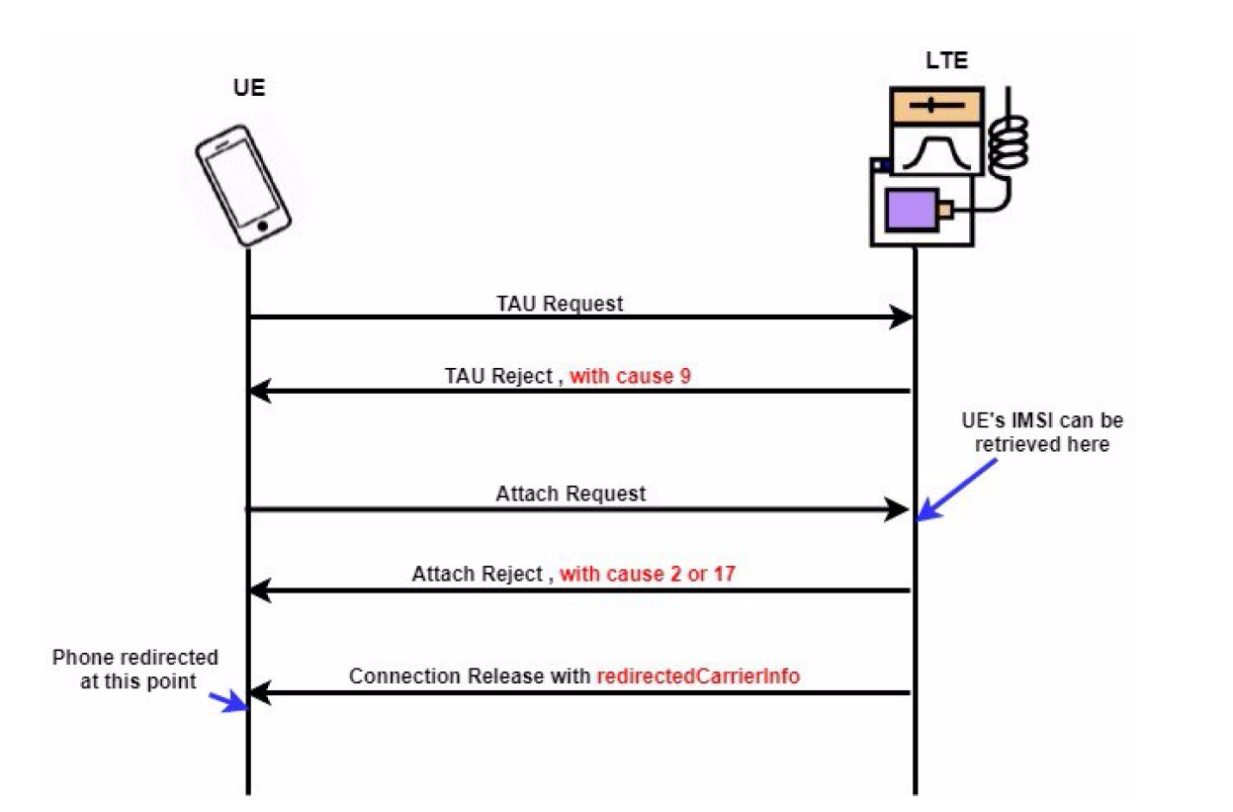

https://gitlab.modalai.com/srs-opensource/srsLTE/blob/master/lib/include/srslte/asn1/liblte_mme.h

Changer : LIBLTE_MME_EMM_CAUSE_IMPLICITLY_DETACHED 0x0A en LIBLTE_MME_EMM_CAUSE_UE_IDENTITY_CANNOT_BE_DERIVED_BY_THE_NETWORK 0x09

AUTRES CODES A CONNAITRE :

LIBLTE_MME_EMM_CAUSE_IMSI_UNKNOWN_IN_HSS 0x02

LIBLTE_MME_EMM_CAUSE_ILLEGAL_UE 0x03

LIBLTE_MME_EMM_CAUSE_NETWORK_FAILURE 0x11

SRSLTE

------

https://github.com/srsran/srsRAN_4G/blob/master/srsepc/src/mme/nas.cc

tau_rej.emm_cause

service_rej.emm_cause

à modifier bastien error :

https://github.com/bbaranoff/srslte_to_gsm/blob/main/redirection_srslte_gsm.patch

https://github.com/bbaranoff/srslte_to_gsm

OPEN LTE:

---------

attach_rej.emm_cause

+ LIBLTE_MME_TRACKING_AREA_UPDATE_REJECT_MSG_STRUCT ta_update_rej;

+ LIBLTE_BYTE_MSG_STRUCT msg;

+ ta_update_rej.emm_cause = user->get_emm_cause();

Bastien mandeha tsara :

https://github.com/bbaranoff/telco_story

OAI :

-----

TAU Reject :

------------

<https://github.com/brchiu/openair-cn-new/tree/master/src/nas>

<https://github.com/lfarizav/openair-cn>

openair-cn/SRC/NAS/EMM/nas_proc.c:

openair-cn/blob/develop/src/nas/emm/TrackingAreaUpdate.c :

i f ( ue_ctx ) {

r c = emm_proc_tracking_area_update_re ject

( ue_id , EMM_CAUSE_IMPLICITLY_DETACHED) ;

OAILOG_FUNC_RETURN (LOG_NAS_EMM, r c ) ;

} e l s e {

r c = emm_proc_tracking_area_update_re ject

( ue_id , EMM_CAUSE_IMPLICITLY_DETACHED) ;

OAILOG_FUNC_RETURN (LOG_NAS_EMM, r c ) ;

}

SERVICE REJECT :

---------------

<https://github.com/brchiu/openair-cn-new/blob/master/src/nas/nas_proc.c>

openair-cn/SRC/NAS/nas_proc.c:

switch ( s6a_error ) {

case DIAMETER_AUTHENTICATION_DATA_UNAVAILABLE:

return NAS_CAUSE_NO_SUITABLE_CELLS_IN_TRACKING_AREA

FOR imsicatcher default : ILLEGAL UE (by default by OAI-5G-NR)

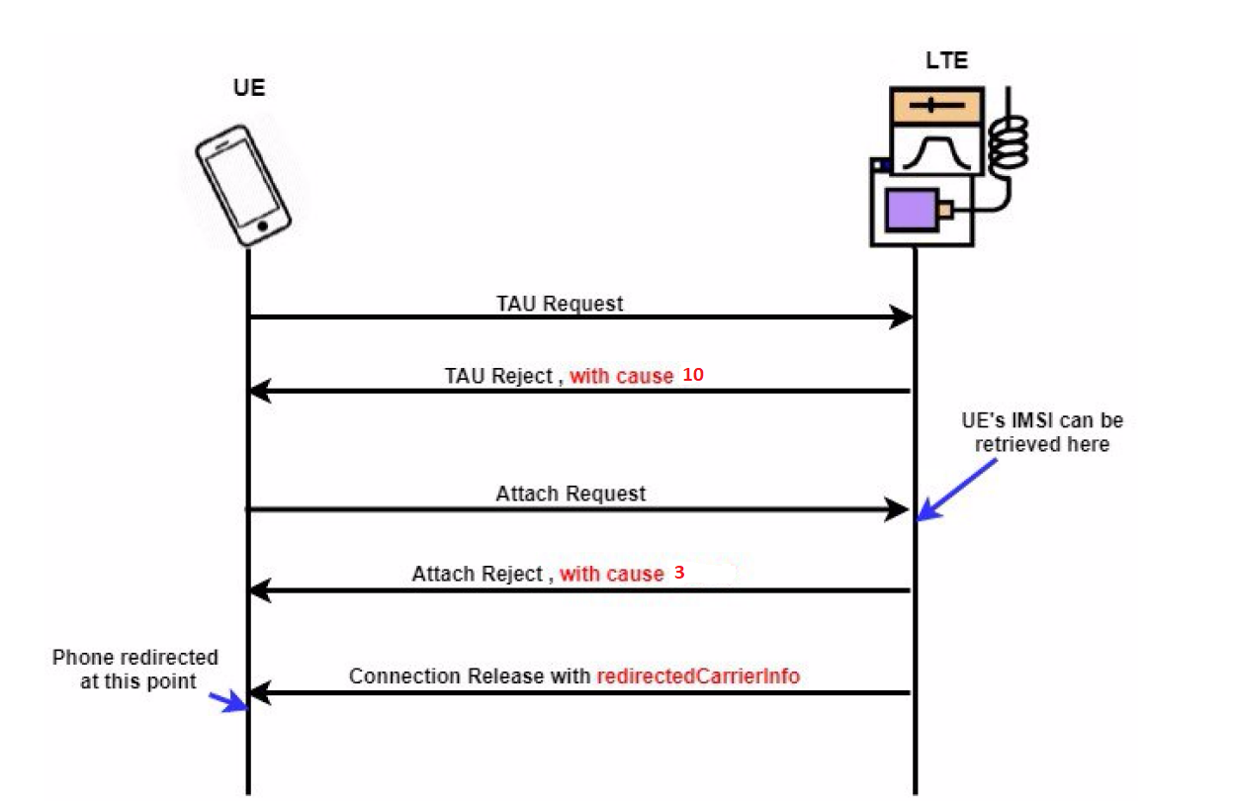

IMSI-CATCHER WITHOUT PERTURBATION CODE FLOW (REAL_IMSICATCHER):

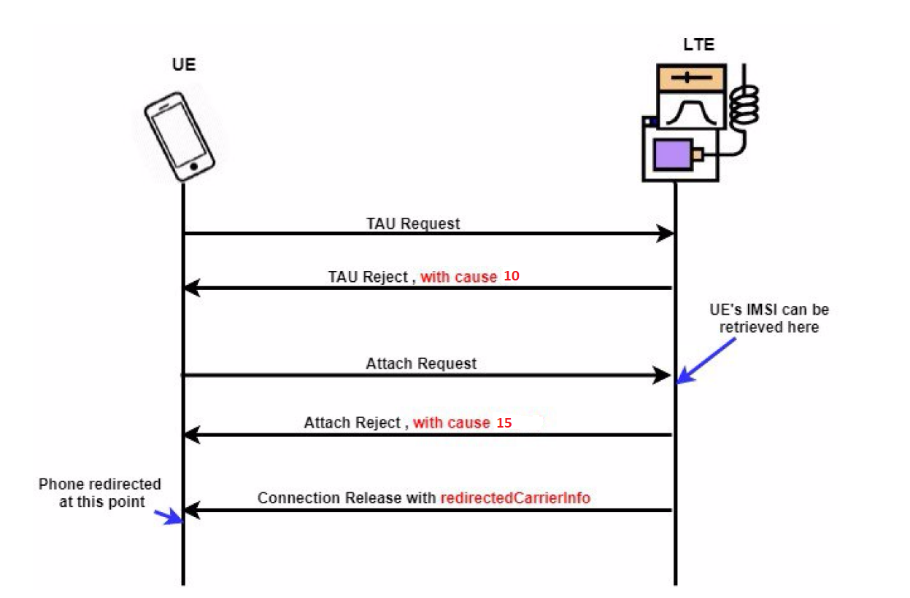

FOR 5G :

<https://github.com/bbaranoff/redir5Gted2Gsm/blob/main/sib.conf>

[Imsi Catcher de haut niveau avec le suivi GPS - Chine Signal Imsi Catcher, signal brouilleur (made-in-china.com)](https://fr.made-in-china.com/co_ptcjammer/product_High-Level-Imsi-Catcher-with-GPS-Tracking_enueunihy.html)