INSTALLATION KARLI BTS

apt-get install build-essential libgmp3-dev libmpfr-dev libx11-6 libx11-dev flex bison libncurses5 libncurses5-dev libncursesw6 zlibc zlib1g-dev libmpc-dev

apt-get install libboost-dev libmpfr-doc libmpfr6 libmpfrc++-dev

sudo apt-get install libghc-system-filepath-dev libghc-parsec3-dev libghc-mtl-dev

sudo apt-get install cmake libusb-1.0-0-dev python-cheetah liborc-0.4-dev sqlite3 libdbd-sqlite3 autoconf libtool libdbi1 libdbi-dev libpcsclite1 libpcsclite-dev libncurses5-dev libopencore-amrnb-dev libsofia-sip-ua-dev libortp-dev telnet

apt-get install gnutls-doc libgnutls28-dev gnutls-bin

# libssl1.1-dbgsym

apt-get install libssl1.1 libssl-dev libssl-doc

# libdbd-sqlite

apt-get install libdbd-sqlite3 libdbi-dev libdbi-doc libdbi1 libdbi1-dbg node-nodedbi libsctp-dev

# libxml2-dbg

apt-get install libxml2 libxml2-dev libxml2-doc libxml2-utils

apt-get install git-core subversion libjansson-dev sqlite autoconf automake libxml2-dev libncurses5-dev libtool

apt-get install dahdi-source lemon libtinfo-dev sofia-sip-bin libsofia-sip-ua-dev sofia-sip-bin alsa-oss cmake

sudo apt-get install libcurl4-openssl-dev

sudo apt-get install libffi-dev

apt-get install libncursesw5-dev libncursesw5

sudo apt-get install debhelper libssh2-1-dev

apt-get install asn1c libdbd-sqlite3

apt-get install libgl1-mesa-dev

# libcppunit-1.14-0

apt-get install libcppunit-dev libcppunit-doc libcppunit-subunit-dev libcppunit-subunit0

# libwxgtk3.0-dev

# libsoapysdr-dev

sudo apt-get install git g++ cmake libsqlite3-dev libi2c-dev libusb-1.0-0-dev freeglut3-dev gnuplot

python-scipy

qt4-bin-dbg

qt4-default

qt4-doc

libqt4-dev

libqt4-dev-bin

python-qt4

python-qt4-dbg

python-qt4-dev

python-qt4-doc

libqwt6abi1

libqt4-dev

qt4-default

qt4-dev-tools

libqwt5-qt4-dev

pyqt4-dev-tools

python-qwt5-qt4

python-gtk2

libzmq-dev

libzmq1

python-requests

python-sphinx

python-zmq

libgps-dev

sudo apt-get -y install git swig cmake doxygen build-essential libboost-all-dev libtool libusb-1.0-0 libusb-1.0-0-dev libudev-dev libncurses5-dev libfftw3-bin libfftw3-dev libfftw3-doc libcppunit-dev libcppunit-doc ncurses-bin cpufrequtils python-numpy python-numpy-doc python-numpy-dbg python-docutils libfftw3-bin libfftw3-dev libfftw3-doc ncurses-bin libncurses5 libncurses5-dev libfontconfig1-dev libxrender-dev libpulse-dev swig g++ automake autoconf libtool python-dev libfftw3-dev libcppunit-dev libboost-all-dev libusb-dev libusb-1.0-0-dev fort77 libsdl1.2-dev python-wxgtk3.0 git-core python-numpy ccache python-opengl libgsl-dev python-cheetah python-mako python-lxml doxygen libusb-1.0-0-dev cmake git-core wget libxi-dev gtk2-engines-pixbuf r-base-dev python-tk liborc-0.4-0 liborc-0.4-dev libasound2-dev libcomedi-dev python3-dbg python3-dev python3-pip python3-tk python3-lxml python3-six libpcsclite-dev libtalloc-dev libortp-dev libsctp-dev libmnl-dev libdbi-dev libdbd-sqlite3 libsqlite3-dev sqlite3 libc-ares-dev libxml2-dev libssl-dev python-setuptools

apt-get install libtalloc-dev libtalloc2 libboost-all-dev shtool automake git-core pkg-config make

apt-get install fftw-dev fftw-docs fftw2 libfftw3-3 libfftw3-bin libfftw3-dev libfftw3-doc libfftw3-double3 libfftw3-mpi-dev libfftw3-mpi3 libfftw3-single3

apt-get install dahdi-source lemon libtinfo-dev sofia-sip-bin libsofia-sip-ua-dev sofia-sip-bin alsa-oss cmake

sudo apt-get install debhelper libssh2-1-dev

apt-get remove texinfo

apt-get remove libsoapysdr-dev

mkdir /root/Desktop/karli

cd /root/Desktop/karli/

tar xvf texinfo-4.13.tar.gz

cd texinfo-4.13

./configure --build=aarch64-unknown-linux-gnu

make -j$(nproc)

make -j$(nproc) install

cd ..

unzip gnuarm_for_ubuntu.zip

cd gnuarm

chmod +x gnu-arm-build.2.sh

bash gnu-arm-build.2.sh

BOIRE QUELQUES BIERRES PARCE QUE CA VA PRENDRE ENVION 5H :

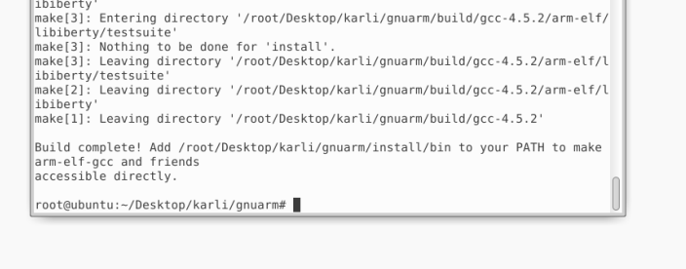

make[1]: Leaving directory '/root/Desktop/karli/gnuarm/build/gcc-4.5.2'

Build complete! Add /root/Desktop/karli/gnuarm/install/bin to your PATH to make arm-elf-gcc and friends

accessible directly.

**(commande en un seul ligne)**

**export PATH=$PATH:**/root/Desktop/karli/gnuarm/install/bin

cd /root/Desktop/karli/

git clone https://github.com/osmocom/libosmocore

cd libosmocore

git checkout cf70aa0c40c574c32b832454f725cc37459c5d8d

cd ..

zip -r libosmocore.zip libosmocore/

cd libosmocore

autoreconf -i

./configure

make -j4

make install

ldconfig -i

cd /root/Desktop/karli/

git clone https://github.com/osmocom/osmocom-bb

cd osmocom-bb/

git checkout 4f677e6ba8434dab376495cd996d140548fa6e93

mousepad src/target/firmware/Makefile

*| #uncomment CFLAGS += -DCONFIG_TX_ENABLE |*

*| #ctrl+o return ctrl+x

cd ..

zip -r osmocom-bb.zip osmocom-bb/

cd osmocom-bb/

cd src

make -j4

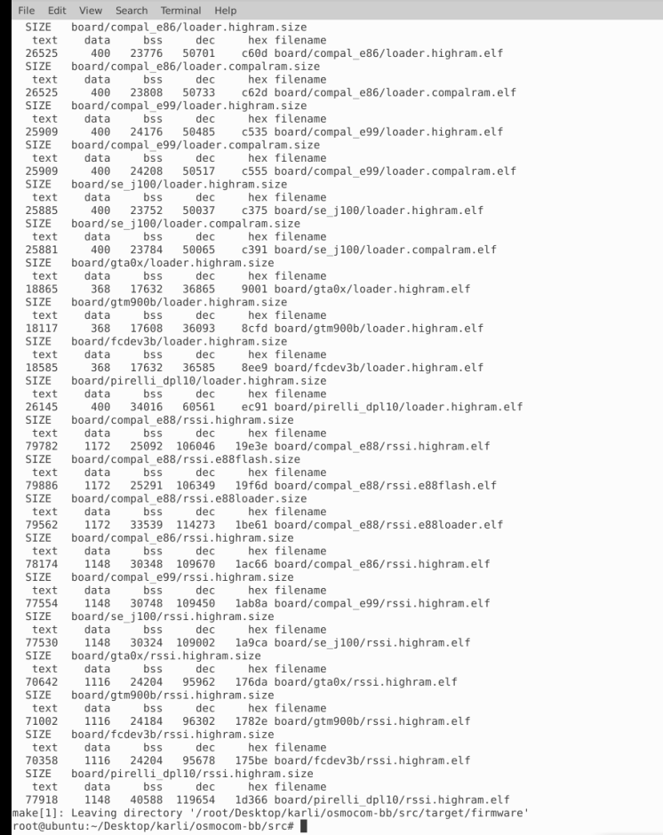

cd /root/Desktop/karli/

git clone <https://github.com/osmocom/libosmo-dsp>

cd libosmo-dsp

git checkout 551b9752bcd5d3d21bb2df0736b1801bda3d0d10

cd ..

zip -r libosmo-dsp.zip libosmo-dsp

cd /root/Desktop/karli/libosmo-dsp/

autoreconf -i

./configure

make -j4

make install

ldconfig -i

#Installing libosmocore latest

cd /root/Desktop/karli/

git clone https://github.com/osmocom/libosmocore libosmocore_trx

**export PATH=$PATH:**/root/Desktop/karli/gnuarm/install/bin

cd libosmocore_trx

**git checkout 1.3.0**

cd ..

zip -r libosmocore_trx.zip libosmocore_trx/

cd libosmocore_trx

autoreconf -i

./configure

make -j4

make install

ldconfig -i

cd /root/Desktop/karli/

**git clone https://github.com/osmocom/osmocom-bb trx**

**cd trx**

**#git checkout jolly/testing**

**git checkout 620fe497efa492feff4550e336cc3f8167715936**

**cd src**

**wget https://github.com/bbaranoff/telco_install_sh/raw/main/trx.highram.bin**

**(commande en un seul ligne)**

**sed -i -e 's/#CFLAGS += -DCONFIG_TX_ENABLE/CFLAGS += -DCONFIG_TX_ENABLE/g' target/firmware/Makefile**

**cd ../..**

**zip -r trx_for_ubuntu.zip trx/**

**cd trx/src**

make -j4 HOST_layer23_CONFARGS=--enable-transceiver

cd /home/debian/osmocom/libosmo-abis/ && \

autoreconf -i && \

./configure && \

make -j4 && \

make install && \

ldconfig && \

\

cd /home/debian/osmocom/libosmo-netif/ && \

autoreconf -i && \

./configure && \

make -j4 && \

make install && \

ldconfig && \

\

cd /home/debian/osmocom/openbsc/openbsc/ && \

autoreconf -i && \

./configure && \

make -j4 && \

make install && \

ldconfig && \

\

cd /home/debian/osmocom/osmo-bts/ && \

autoreconf -i && \

./configure --enable-trx && \

make -j4 && \

make install && \

ldconfig && \

\

**#Installing libosmocore latest**

**cd /root/Desktop/karli/**

**git clone https://github.com/osmocom/libosmocore libosmocore_trx**

**export PATH=$PATH:/root/Desktop/karli/gnuarm/install/bin**

**cd libosmocore_trx**

**git checkout 1.3.0**

**cd ..**

**zip -r libosmocore_trx.zip libosmocore_trx/**

**cd libosmocore_trx**

**autoreconf -i**

**./configure**

**make -j4**

**make install**

**ldconfig -i**