[Open5GS and OAI gNB | openverso-charts (gradiant.github.io)](https://gradiant.github.io/openverso-charts/open5gs-oaignb.html)

[Hakim badis's Home Page (univ-mlv.fr)](http://igm.univ-mlv.fr/~badis/)

[doc/TESTBenches.md · develop · oai / openairinterface5G · GitLab (eurecom.fr)](https://gitlab.eurecom.fr/oai/openairinterface5g/-/blob/develop/doc/TESTBenches.md)

[ci-scripts/conf_files/du.band7.tm1.100PRB.usrpb210.conf · develop · oai / openairinterface5G · GitLab (eurecom.fr)](https://gitlab.eurecom.fr/oai/openairinterface5g/-/blob/develop/ci-scripts/conf_files/du.band7.tm1.100PRB.usrpb210.conf)

LTE REDIRECTION : TAU REJECT FLOW  + ATTACH REJECT OR SERVICE REJECT

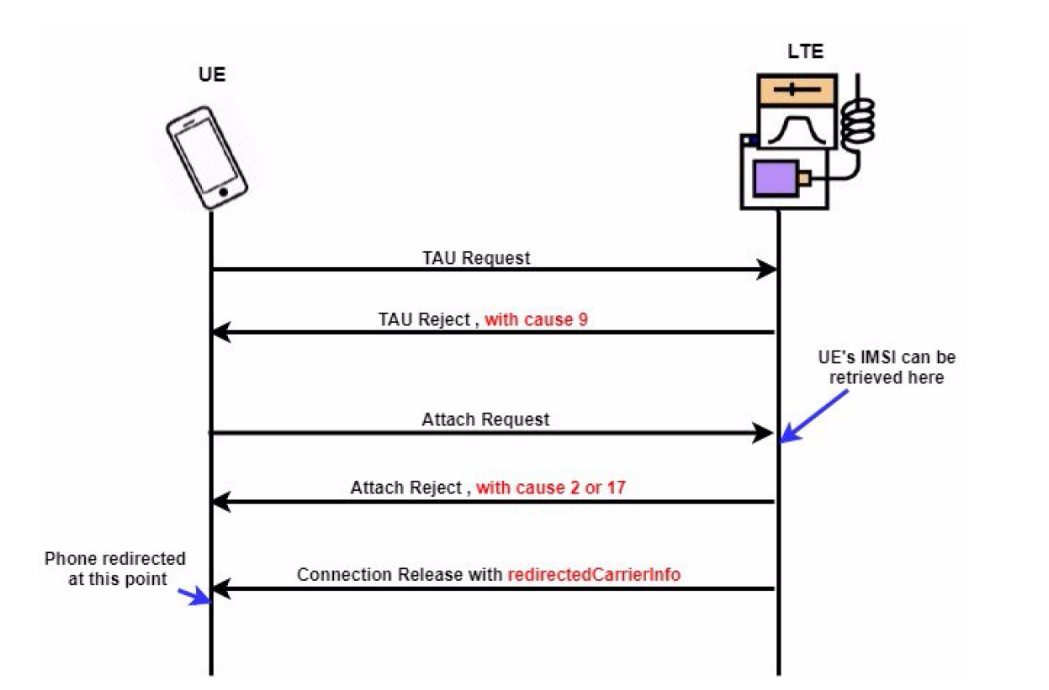

https://gitlab.modalai.com/srs-opensource/srsLTE/blob/master/lib/include/srslte/asn1/liblte_mme.h

Changer : LIBLTE_MME_EMM_CAUSE_IMPLICITLY_DETACHED 0x0A en LIBLTE_MME_EMM_CAUSE_UE_IDENTITY_CANNOT_BE_DERIVED_BY_THE_NETWORK 0x09

AUTRES CODES A CONNAITRE :

LIBLTE_MME_EMM_CAUSE_IMSI_UNKNOWN_IN_HSS 0x02

LIBLTE_MME_EMM_CAUSE_ILLEGAL_UE 0x03

LIBLTE_MME_EMM_CAUSE_NETWORK_FAILURE 0x11

SRSLTE

------

https://github.com/srsran/srsRAN_4G/blob/master/srsepc/src/mme/nas.cc

tau_rej.emm_cause

service_rej.emm_cause

à modifier bastien error :

https://github.com/bbaranoff/srslte_to_gsm/blob/main/redirection_srslte_gsm.patch

https://github.com/bbaranoff/srslte_to_gsm

OPEN LTE:

---------

attach_rej.emm_cause

+ LIBLTE_MME_TRACKING_AREA_UPDATE_REJECT_MSG_STRUCT ta_update_rej;

+ LIBLTE_BYTE_MSG_STRUCT msg;

+ ta_update_rej.emm_cause = user->get_emm_cause();

Bastien mandeha tsara :

https://github.com/bbaranoff/telco_story

OAI :

-----

TAU Reject :

------------

<https://github.com/brchiu/openair-cn-new/tree/master/src/nas>

<https://github.com/lfarizav/openair-cn>

openair-cn/SRC/NAS/EMM/nas_proc.c:

openair-cn/blob/develop/src/nas/emm/TrackingAreaUpdate.c :

i f ( ue_ctx ) {

r c = emm_proc_tracking_area_update_re ject

( ue_id , EMM_CAUSE_IMPLICITLY_DETACHED) ;

OAILOG_FUNC_RETURN (LOG_NAS_EMM, r c ) ;

} e l s e {

r c = emm_proc_tracking_area_update_re ject

( ue_id , EMM_CAUSE_IMPLICITLY_DETACHED) ;

OAILOG_FUNC_RETURN (LOG_NAS_EMM, r c ) ;

}

SERVICE REJECT :

---------------

<https://github.com/brchiu/openair-cn-new/blob/master/src/nas/nas_proc.c>

openair-cn/SRC/NAS/nas_proc.c:

switch ( s6a_error ) {

case DIAMETER_AUTHENTICATION_DATA_UNAVAILABLE:

return NAS_CAUSE_NO_SUITABLE_CELLS_IN_TRACKING_AREA

FOR imsicatcher default : ILLEGAL UE (by default by OAI-5G-NR)

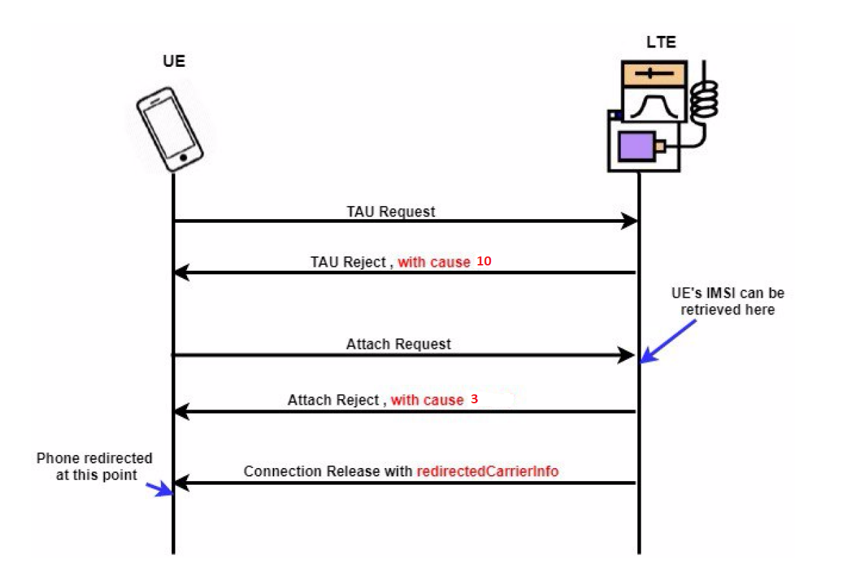

DOS : attach reject : 2,3,7,8,14, 17

IMSI-CATCHER WITHOUT PERTURBATION CODE FLOW (REAL_IMSICATCHER):

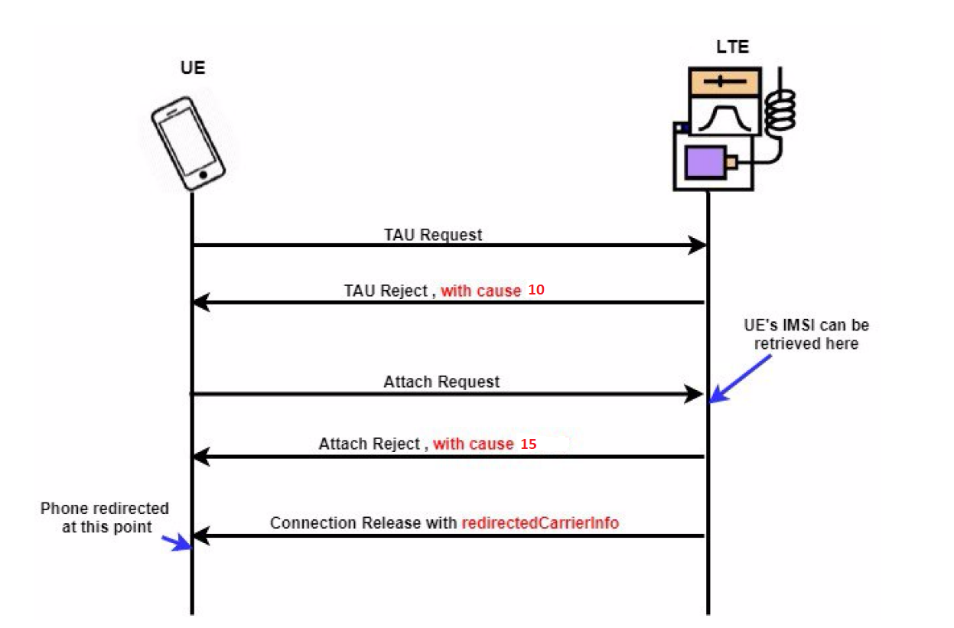

FOR 5G :

<https://github.com/bbaranoff/redir5Gted2Gsm/blob/main/sib.conf>

[Imsi Catcher de haut niveau avec le suivi GPS - Chine Signal Imsi Catcher, signal brouilleur (made-in-china.com)](https://fr.made-in-china.com/co_ptcjammer/product_High-Level-Imsi-Catcher-with-GPS-Tracking_enueunihy.html)

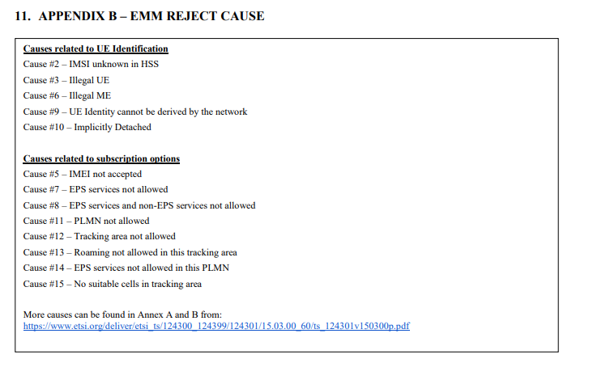

REDIRECTED OAI 4G :

<https://icepng.github.io/2020/09/23/RRCConnectionRelease/>

<https://www.programmersought.com/article/67481124166/>

UMTS :

https://github.com/RangeNetworks/OpenBTS-UMTS/blob/master/ASN/rrc.asn1

RRCConnectionReject

https://github.com/RangeNetworks/OpenBTS-UMTS/blob/master/UMTS/URRCMessages.cpp

When the RNC decides to reject the RRC connection request due to ICSU overload. After this, the RNC sends an

RRC: RRC CONNECTION REJECT message to the UE.

Search request : https://github.com/RangeNetworks/OpenBTS-UMTS/blob/master/UMTS/URRC.cpp

handleRrcConnectionRequest

// AttachRequest, AttachComplete,

// DetachRequest, DetachAccept (todo),

// RoutingAreaUpdateRequest, RoutingAreaUpdateComplete

FOR HACKING : sending routing are update reject : https://github.com/RangeNetworks/OpenBTS-UMTS/blob/master/SGSNGGSN/GPRSL3Messages.cpp

RRC connection request : https://github.com/RangeNetworks/OpenBTS-UMTS/blob/master/UMTS/URRCMessages.h

https://github.com/RangeNetworks/OpenBTS-UMTS/blob/master/ASN/rrc.asn1

https://github.com/RangeNetworks/OpenBTS-UMTS/blob/master/UMTS/URRCMessages.h

https://sourceforge.net/p/openbts/mailman/message/36090903/

https://github.com/RangeNetworks/OpenBTS-UMTS/blob/master/UMTS/URRCMessages.cpp

https://github.com/RangeNetworks/OpenBTS-UMTS/blob/master/ASN/rrc.asn1

https://github.com/RangeNetworks/OpenBTS-UMTS/tree/master/UMTS

https://github.com/RangeNetworks/OpenBTS-UMTS/blob/master/UMTS/URRC.cpp

https://www.sqimway.com/rrc_umts.html

https://github.com/RangeNetworks/OpenBTS-UMTS/blob/master/ASN/makefile

https://github.com/RangeNetworks/OpenBTS-UMTS/blob/master/ASN/rrc.asn1

https://www.hackers-arise.com/scada-hacking

https://github.com/RangeNetworks/OpenBTS-UMTS/tree/master/UMTS

https://github.com/RangeNetworks/OpenBTS-UMTS/blob/master/UMTS/URRC.cpp

https://github.com/RangeNetworks/OpenBTS-UMTS/blob/master/UMTS/URRCTrCh.cpp

https://github.com/RangeNetworks/OpenBTS-UMTS/blob/master/UMTS/URRCMessages.cpp

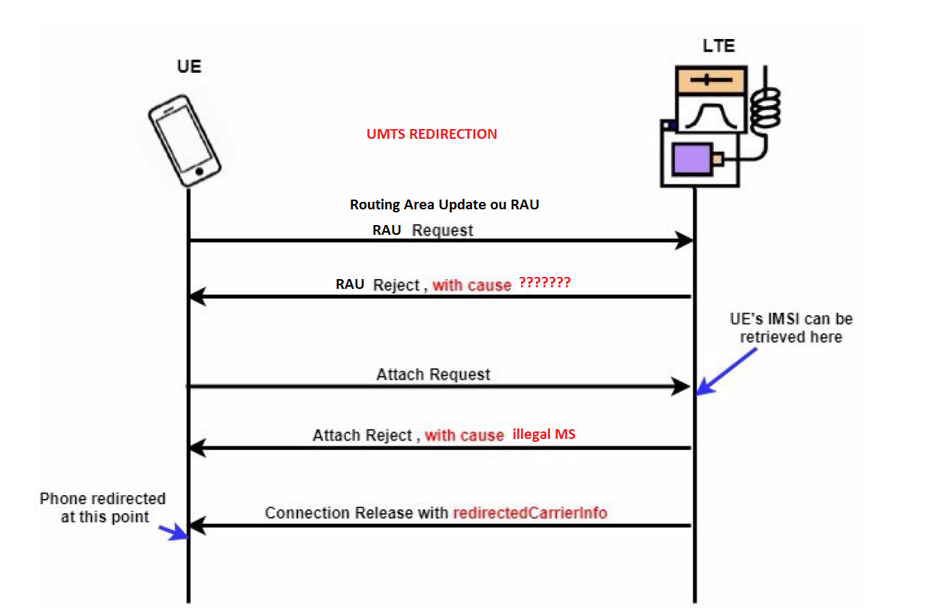

Routing area Reject : Find on google : RoutingAreaUpdateReject + openbts-umts

FOR HACKING : sending routing are update reject :

* <https://github.com/RangeNetworks/OpenBTS-UMTS/blob/master/SGSNGGSN/GPRSL3Messages.cpp>
* <https://github.com/RangeNetworks/OpenBTS-UMTS/blob/master/SGSNGGSN/Sgsn.cpp>
* <https://discourse.myriadrf.org/t/openbts-umts-with-lilme-sdr/2033>

Chercher : sendRrcConnectionRelease dans : <https://github.com/RangeNetworks/OpenBTS-UMTS/blob/master/UMTS/URRCMessages.cpp>

Regarder dans : <https://github.com/RangeNetworks/OpenBTS-UMTS/blob/master/ASN/rrc.asn1> chercher RRCConnectionRelease-r3-IEs Le fichier asn generé etant : <https://github.com/RangeNetworks/OpenBTS-UMTS/blob/master/UMTS/URRCMessages.cpp> avec comme nom : RRCConnectionRelease-r3-IEs.c

CHOIX 1 : REMPLACER TOUS LES RELEASE EN REJECT

Lire le fichier asn et le fichier redirection est dans la fonction : sendRrcConnectionRelease :

ASN::RRCConnectionRelease_r3_IEs_t *ies = &msg.message.choice.rrcConnectionRelease.choice.r3.rrcConnectionRelease_r3;

Cet variable ies, il est possible de modifier la cause du rejet et le canal GSM à rediriger dans la partie OPTIONAL de l’asn est dans : RRCConnectionReject-v690ext-IEs

Pour l’inspiration est dans le fichier asn de l’umts dans le lien tout à l’heure :

RRCConnectionReject-r3-IEs ::= SEQUENCE {

|  |
| --- |
| -- TABULAR: Integrity protection shall not be performed on this message. |
| -- User equipment IEs |
| initialUE-Identity InitialUE-Identity, |
| rrc-TransactionIdentifier RRC-TransactionIdentifier, |
| rejectionCause RejectionCause, |
| waitTime WaitTime, |
| redirectionInfo RedirectionInfo OPTIONAL |
| } |
|  |
| RRCConnectionReject-v690ext-IEs ::= SEQUENCE { |
| redirectionInfo-v690ext GSM-TargetCellInfoList OPTIONAL |
| } |

Redirection

// Allocate and set values for the redirect_info IE

ASN::RedirectInfo_t *redirect_info = new ASN::RedirectInfo_t();

redirect_info->set_redirectingReason(ASN::RedirectingReason(1)); // Set redirecting reason to "User Busy"

redirect_info->set_redirectingPartyID("0123456789"); // Set redirecting party ID

redirect_info->set_redirectionNumber("9876543210"); // Set redirection number

// Add the redirect_info IE to the ies structure

ies->redirect_info = redirect_info;

::::::::::::::::::::::::::::::

void URRCMessages::sendRrcConnectionRelease(int32_t ueIdx, uint8_t releaseCause, uint8_t redirectInfo, uint16_t arfcn) {

Debug(_LAYER_RRC, "sendRrcConnectionRelease(): entering. UE Index: %d, Release Cause: %d, Redirect Info: %d, ARFCN: %d.\n", ueIdx, releaseCause, redirectInfo, arfcn);

if (g_UE_list.find(ueIdx) == g_UE_list.end()) {

Error("sendRrcConnectionRelease(): UE Index %d does not exist.\n", ueIdx);

return;

}

UE& ue = g_UE_list[ueIdx];

ASN::RRCConnectionReject message;

message.criticalExtensions.present = ASN::RRCConnectionReject__criticalExtensions_PR_rrcConnectionReject_r3;

ASN::RRCConnectionReject_r3_IEs_t *ies = &message.criticalExtensions.choice.rrcConnectionReject_r3;

ies->releaseCause.present = ASN::RRCConnectionRelease_r3_IEs__releaseCause_PR_unspecified;

ies->redirect_info_v690ext = NULL; // set redirect_info_v690ext to NULL by default

switch (releaseCause) {

case 1: {

ies->releaseCause.present = ASN::RRCConnectionRelease_r3_IEs__releaseCause_PR_normalRelease;

break;

}

case 2: {

ies->releaseCause.present = ASN::RRCConnectionRelease_r3_IEs__releaseCause_PR_rrcConnectionReject;

break;

}

case 3: {

ies->releaseCause.present = ASN::RRCConnectionRelease_r3_IEs__releaseCause_PR_rrcConnectionReleaseWithRedirection;

break;

}

default: {

Error("sendRrcConnectionRelease(): Invalid release cause: %d.\n", releaseCause);

return;

}

}

if (ies->releaseCause.present == ASN::RRCConnectionRelease_r3_IEs__releaseCause_PR_rrcConnectionReleaseWithRedirection) {

ies->redirect_info_v690ext = (ASN::RedirectInformation_v690ext_t*)calloc(1, sizeof(ASN::RedirectInformation_v690ext_t));

ies->redirect_info_v690ext->redirectedCarrierInfo.carrierFreq = arfcn;

ies->redirect_info_v690ext->redirectedCarrierInfo.cellReselectionPriority = 7;

ies->redirect_info_v690ext->redirectedCarrierInfo.q_RxLevMin = -110;

// Set the channel number (EARFCN) for GSM

ies->redirect_info_v690ext->redirectedCarrierType.present = ASN::RedirectedCarrierInfo_v8a0_IEs__redirectedCarrierType_PR_gsm;

ies->redirect_info_v690ext->redirectedCarrierType.choice.gsm.buf = (uint8_t*)calloc(1, sizeof(uint8_t));

ies->redirect_info_v690ext->redirectedCarrierType.choice.gsm.buf[0] = arfcn - 935;

ies->redirect_info_v690ext->redirectedCarrierType.choice.gsm.size = 1;

// Set the redirect info

ies->redirect_info_v690ext->redirectingReason.present = ASN::RedirectInformation_v690ext_IEs__redirectingReason_PR_servingPLMNRateControl;

ies->redirect_info_v

<https://github.com/RangeNetworks/OpenBTS-UMTS/blob/master/UMTS/URRC.h>

Modifier le code : sendRrcConnectionRelease en sendRrcConnectionReject

CHOIX 2 : ajouter dans la fonction sendRrcConnectionRelease la redirection

Regarder dans asn de RRCConnectionRelease dans la partie : laterNonCriticalExtensions

<https://www.sqimway.com/rrc_umts.html>

bool URRC::sendRrcConnectionRelease(GSM::Time ms, uint8_t trx, uint8_t ts, uint8_t ulTsOffset, uint32_t channel, uint32_t mobile_id, bool abort, uint8_t wait)

{

ASN::RRCConnectionReject *rrc = new ASN::RRCConnectionReject();

ASN::RRCConnectionReject_r3_IEs_t *ies = &rrc->value.u.rrcConnectionReject_r3;

ies->rrc_TransactionIdentifier = transactionNumber;

transactionNumber = (transactionNumber+1)&7;

ies->wait_Time = wait;

if (abort) {

ies->criticalExtensions.present = ASN::RRCConnectionReject_r3_IEs__criticalExtensions_PR_c1;

ies->criticalExtensions.choice.c1.present = ASN::RRCConnectionReject_r3_IEs__criticalExtensions__c1_PR_rrcConnectionReject_r3;

ies->criticalExtensions.choice.c1.choice.rrcConnectionReject_r3.rrc_TransactionIdentifier = ies->rrc_TransactionIdentifier;

ies->criticalExtensions.choice.c1.choice.rrcConnectionReject_r3.wait_Time = wait;

}

bool success = false;

uint8_t *buffer;

uint32_t buffer_len;

if (rrc->toByteArray(&buffer, buffer_len)) {

success = sendRrc(rrc->messageId(), buffer, buffer_len, ms, trx, ts, ulTsOffset, channel, mobile_id);

}

free(buffer);

delete rrc;

return success;

}

ASN::RRCConnectionReject_r3_IEs_t *ies = &reject->u.r3.protocolSpecific.rejectionSpecificInformation.u.spare3;

ies->redirect_info = NULL; // Add redirect_info here

ASN_SEQUENCE_ADD(&ies->spare2, &spare2_member);

// Add GSM channel ARFCN number 11

ASN::GSM_ChannelList_t *gsm_channel_list = &ies->redirect_info->cell_change_order;

gsm_channel_list->present = ASN::GSM_ChannelList_t_PR_gsm_ARFCN_List;

gsm_channel_list->choice.gsm_ARFCN_List = (ASN::GSM_ARFCN_List_t*)calloc(1, sizeof(*gsm_channel_list->choice.gsm_ARFCN_List));

gsm_channel_list->choice.gsm_ARFCN_List->list.count = 1;

gsm_channel_list->choice.gsm_ARFCN_List->list.array[0] = 11;

CHATGPT :

void sendRrcConnectionRelease(UEInfo *uep) {

// Create the RB Setup Message.

ASN::DL_DCCH_Message_t msg;

memset(&msg, 0, sizeof(msg));

msg.message.present = ASN::DL_DCCH_MessageType_PR_rrcConnectionRelease;

msg.message.choice.rrcConnectionRelease.present = ASN::RRCConnectionRelease_PR_r3;

ASN::RRCConnectionRelease_r3_IEs_t *ies =

&msg.message.choice.rrcConnectionRelease.choice.r3.rrcConnectionRelease_r3;

// Set the transaction ID

unsigned transactionId = uep->newTransactionId();

ies->rrc_TransactionIdentifier = transactionId;

// Set the release cause to normal event

ies->releaseCause = toAsnEnumerated(ASN::ReleaseCause_normalEvent);

// Set the non-critical extensions

ies->m.v690NonCriticalExtensionsPresent = true;

// Add the RRCConnectionRelease-v690ext-IEs extension

ies->v690NonCriticalExtensions.rrcConnectionRelease_r6_add_extPresent = true;

// Add the RedirectionInfo-r6 extension

ASN::RedirectionInfo_r6_t &redirectionInfo = ies->v690NonCriticalExtensions.rrcConnectionRelease_r6_add_ext.redirectionInfo_r6;

redirectionInfo.m.criticalExtensionsPresent = false;

redirectionInfo.redirectionType = ASN::RedirectionType_geranToUtran;

// Add the FrequencyInfo extension

ASN::FrequencyInfo_t &frequencyInfo = redirectionInfo.frequencyInfo;

frequencyInfo.m.frequencyInfoTDDPresent = false;

frequencyInfo.m.frequencyInfoFDDPresent = true;

frequencyInfo.frequencyInfoFDD.ul_CarrierFrequency = uep->ulFrequency();

frequencyInfo.frequencyInfoFDD.dl_CarrierFrequency = uep->dlFrequency();

// Add the InterRATInfo-r6 extension

ASN::InterRATInfo_r6_t &interRATInfo = redirectionInfo.interRAT_Info_r6;

interRATInfo.m.halfRateInterRAT_ParamsPresent = false;

interRATInfo.m.fddInterRAT_ParamsPresent = true;

interRATInfo.fddInterRAT_Params.interRAT_Handover_Info.m.criticalExtensionsPresent = false;

interRATInfo.fddInterRAT_Params.interRAT_Handover_Info.gsm_TargetCellInfoList.m.cellParametersIdPresent = true;

interRATInfo.fddInterRAT_Params.interRAT_Handover_Info.gsm_TargetCellInfoList.cellParametersId = 1;

interRATInfo.fddInterRAT_Params.interRAT_Handover_Info.gsm_TargetCellInfoList.m.arfcnValuePresent = true;

interRATInfo.fddInterRAT_Params.interRAT_Handover_Info.gsm_TargetCellInfoList.arfcnValue = uep->dlFrequency();

ByteVector result(1000);

if (!encodeDcchMsg(uep, SRB2, &msg, result, descrRrcConnectionRelease)) {

return;

}

// Prepare to receive the reply to this message:

UeTransaction(uep, UeTransaction::ttRrcConnectionRelease, 0, transactionId, stIdleMode);

uep->ueWriteHighSide(SRB2, result, descrRrcConnectionRelease);

}

OTHER :

void sendRrcConnectionRelease(UEInfo *uep) {

// Create the RB Setup Message.

ASN::DL_DCCH_Message_t msg;

memset(&msg, 0, sizeof(msg));

msg.message.present = ASN::DL_DCCH_MessageType_PR_rrcConnectionRelease;

msg.message.choice.rrcConnectionRelease.present = ASN::RRCConnectionRelease_PR_r3;

ASN::RRCConnectionRelease_r3_IEs_t *ies =

&msg.message.choice.rrcConnectionRelease.choice.r3.rrcConnectionRelease_r3;

// RRC_TransactionIdentifier_t rrc_TransactionIdentifier;

unsigned transactionId = uep->newTransactionId();

ies->rrc_TransactionIdentifier = transactionId;

// N_308_t *n_308 /* OPTIONAL */;

// N308 is the number of times UE sends response RrcConnectionReleaseComplete.

// It is mandatory when this message is sent on DCCH.

ies->n_308 = RN_CALLOC(ASN::N_308_t); // It is a long.

*ies->n_308 = 1; // must be 1..8

// ReleaseCause_t releaseCause;

// Causes we might use are: normalEvent, userInactivity, pre_emptiveRelease.

ies->releaseCause = toAsnEnumerated(ASN::ReleaseCause_normalEvent);

// Add extensions

ies->rrcConnectionRelease_r3_add_ext = RN_CALLOC(ASN::RRCConnectionRelease_r3_add_ext_IEs_t);

ies->rrcConnectionRelease_r3_add_ext->present = ASN::RRCConnectionRelease_r3_add_ext_IEs_PR_c1;

// Add v690NonCriticalExtensions

ASN::RRCConnectionRelease_v690ext_IEs_t *v690ext = &ies->rrcConnectionRelease_r3_add_ext->choice.c1.v690ext_IEs;

v690ext->present = ASN::RRCConnectionRelease_v690ext_IEs_PR_c1;

v690ext->choice.c1.present = ASN::RRCConnectionRelease_v690ext_IEs__c1_PR_redirectionInfo_r6;

// Add RedirectionInfo-r6

ASN::RedirectionInfo_r6_t *redirectionInfo = &v690ext->choice.c1.choice.redirectionInfo_r6;

redirectionInfo->present = ASN::RedirectionInfo_r6_PR_redirection_info_r6;

// Add FrequencyInfo

ASN::FrequencyInfo_t *frequencyInfo = &redirectionInfo->frequencyInfo;

frequencyInfo->present = ASN::FrequencyInfo_PR_fdd;

// Add InterRATInfo-r6

ASN::InterRATInfo_r6_t *interRatInfo = &redirectionInfo->interRAT_Info_r6;

interRatInfo->present = ASN::InterRATInfo_r6_PR_geranToUtranInfo_r6;

// Add GSM-TargetCellInfoList

ASN::GSM_TargetCellInfoList_t *targetCellList = &interRatInfo->choice.geranToUtranInfo_r6.gsm

void sendRrcConnectionRelease(UEInfo *uep) {

// Create the RB Setup Message.

ASN::DL_DCCH_Message_t msg;

memset(&msg, 0, sizeof(msg));

msg.message.present = ASN::DL_DCCH_MessageType_PR_rrcConnectionRelease;

msg.message.choice.rrcConnectionRelease.present = ASN::RRCConnectionRelease_PR_r3;

ASN::RRCConnectionRelease_r3_IEs_t *ies = &msg.message.choice.rrcConnectionRelease.choice.r3.rrcConnectionRelease_r3;

// Set the RRC transaction identifier.

unsigned transactionId = uep->newTransactionId();

ies->rrc_TransactionIdentifier = transactionId;

// Set the release cause to normal event.

ies->releaseCause = toAsnEnumerated(ASN::ReleaseCause_normalEvent);

// Set the number of times the UE should send a response to this message.

ies->n_308 = RN_CALLOC(ASN::N_308_t);

*ies->n_308 = 1;

// Add the R3 extensions to the message.

ies->criticalExtensions.present = ASN::RRCConnectionRelease_r3_IEs__criticalExtensions_PR_c1;

ies->criticalExtensions.choice.c1.present = ASN::RRCConnectionRelease_r3_IEs__criticalExtensions__c1_PR_rrcConnectionRelease_r3_add_ext;

ASN::RRCConnectionRelease_r3_IEs__criticalExtensions__c1__rrcConnectionRelease_r3_add_ext_t& r3_add_ext =

ies->criticalExtensions.choice.c1.choice.rrcConnectionRelease_r3_add_ext;

// Set the R6 extensions.

r3_add_ext.nonCriticalExtension.present = ASN::RRCConnectionRelease_r3_IEs__criticalExtensions__c1__rrcConnectionRelease_r3_add_ext__nonCriticalExtension_PR_v690NonCriticalExtensions;

ASN::V690NonCriticalExtensions_t& v690NonCriticalExtensions = r3_add_ext.nonCriticalExtension.choice.v690NonCriticalExtensions;

v690NonCriticalExtensions.interRATInfo_r6.present = ASN::InterRATInfo_r6_PR_interRATInfoCDMA2000_r6;

ASN::InterRATInfoCDMA2000_r6_t& interRATInfoCDMA2000_r6 = v690NonCriticalExtensions.interRATInfo_r6.choice.interRATInfoCDMA2000_r6;

// Set the RedirectionInfo field.

interRATInfoCDMA2000_r6.redirectInfo_r6.present = ASN::RedirectInfo_r6_PR_gsmToUtran;

ASN::RedirectInfo_gsmToUtran_t& redirectInfoGsmToUtran = interRATInfoCDMA2000_r6.redirectInfo_r6.choice.gsmToUtran;

// Set the GSM-TargetCellInfoList.

redirectInfoGsmToUtran.gsm_TargetCellInfoList_r6.present = ASN::GSM_TargetCellInfoList_r6_PR_setup;

// Set the FrequencyInfo.

ASN::FrequencyInfo_t& frequencyInfo = redirectInfoGsmToUtran.frequencyInfo_r6;

frequencyInfo.arfcn = ASN::ARFCN_ValueEUTRA(uep->chanNum);

frequencyInfo.bandwidth.present = ASN::BandwidthEUTRA_PR_bw6;

frequencyInfo.bandwidth.choice.bw6 = ASN::BandwidthEUTRA::BandwidthEUTRA_bw6;

//

OTHES :

void sendRrcConnectionRelease(UEInfo *uep) {

// Create the RB Setup Message.

ASN::DL_DCCH_Message_t msg;

memset(&msg,0,sizeof(msg));

msg.message.present = ASN::DL_DCCH_MessageType_PR_rrcConnectionRelease;

msg.message.choice.rrcConnectionRelease.present = ASN::RRCConnectionRelease_PR_r3;

ASN::RRCConnectionRelease_r3_IEs_t *ies =

&msg.message.choice.rrcConnectionRelease.choice.r3.rrcConnectionRelease_r3;

// RRC_TransactionIdentifier_t

unsigned transactionId = uep->newTransactionId();

ies->rrc_TransactionIdentifier = transactionId;

// N_308_t

ies->n_308 = RN_CALLOC(ASN::N_308_t);

*ies->n_308 = 1;

// ReleaseCause_t

ies->releaseCause = toAsnEnumerated(ASN::ReleaseCause_normalEvent);

// v690NonCriticalExtensions

ies->m.v690NonCriticalExtensionsPresent = true;

ASN::RRCConnectionRelease_r3_IEs_t_v690NonCriticalExtensions &v690ext = ies->v690NonCriticalExtensions;

// RRCConnectionRelease-v690ext-IEs

v690ext.m.r3_IEsPresent = true;

ASN::RRCConnectionRelease_r3_IEs_t_v690NonCriticalExtensions_r3_IEs &r3_ext = v690ext.r3_IEs;

// RedirectionInfo-r6

r3_ext.m.redirectionInfo_r6Present = true;

ASN::RedirectionInfo_r6 &redir_info = r3_ext.redirectionInfo_r6;

redir_info.m.redirectionTypePresent = true;

redir_info.redirectionType = ASN::RedirectionType_geranToUtran;

redir_info.targetCellInfoList.m.gSM_TargetCellInfoListPresent = true;

ASN::GSM_TargetCellInfoList &gsm_target_list = redir_info.targetCellInfoList.gSM_TargetCellInfoList;

// Add GSM redirection target info

ASN::GSM_TargetCellInfoList_Elem_t gsm_target;

gsm_target.m.cellIdentityPresent = true;

gsm_target.cellIdentity.mcc = 123;

gsm_target.cellIdentity.mnc = 456;

gsm_target.cellIdentity.lac = 789;

gsm_target.cellIdentity.ci = 12345;

gsm_target.routingAreaCode = 123;

gsm_target.frequencyInfo.m.fddPresent = true;

gsm_target.frequencyInfo.fdd.downlinkFrequency = 975;

gsm_target.frequencyInfo.fdd.uplinkFrequencyOffset = ASN::UARFCN_Value_t::UplinkOffset_t::UARFCN_Value_t__uplinkOffset_f1;

gsm_target.m.hcs_CellSelectInfoPresent = true;

gsm_target.hcs_CellSelectInfo.temporaryOffset = 1;

gsm_target.hcs_CellSelectInfo.penaltyTime = ASN::PenaltyTime_t::penaltyTime_v5;

gsm_target.hcs_CellSelectInfo.hcs_RSCP_Evaluation = 3;

gsm_target.hcs_CellSelectInfo.q_HCS = 4;

gsm_target.m.q_RxLevMinPresent = true;

gsm_target.q_RxLev

OTHERS :

void sendRrcConnectionRelease(UEInfo *uep) {

// Create the RB Setup Message.

ASN::DL_DCCH_Message_t msg;

memset(&msg,0,sizeof(msg));

msg.message.present = ASN::DL_DCCH_MessageType_PR_rrcConnectionRelease;

msg.message.choice.rrcConnectionRelease.present = ASN::RRCConnectionRelease_PR_r3;

ASN::RRCConnectionRelease_r3_IEs_t *ies =

&msg.message.choice.rrcConnectionRelease.choice.r3.rrcConnectionRelease_r3;

// RRC_TransactionIdentifier_t

unsigned transactionId = uep->newTransactionId();

ies->rrc_TransactionIdentifier = transactionId;

// N_308_t

ies->n_308 = RN_CALLOC(ASN::N_308_t);

*ies->n_308 = 1;

// ReleaseCause_t

ies->releaseCause = toAsnEnumerated(ASN::ReleaseCause_normalEvent);

// v690NonCriticalExtensions

ies->m.v690NonCriticalExtensionsPresent = true;

ASN::RRCConnectionRelease_r3_IEs_t_v690NonCriticalExtensions &v690ext = ies->v690NonCriticalExtensions;

// RRCConnectionRelease-v690ext-IEs

v690ext.m.r3_IEsPresent = true;

ASN::RRCConnectionRelease_r3_IEs_t_v690NonCriticalExtensions_r3_IEs &r3_ext = v690ext.r3_IEs;

// RedirectionInfo-r6

r3_ext.m.redirectionInfo_r6Present = true;

ASN::RedirectionInfo_r6 &redir_info = r3_ext.redirectionInfo_r6;

// Set the redirection type to GERAN to UTRAN

redir_info.m.redirectionTypePresent = true;

redir_info.redirectionType = ASN::RedirectionType_geranToUtran;

// Set the target cell info list for GSM redirection

redir_info.targetCellInfoList.m.gSM_TargetCellInfoListPresent = true;

ASN::GSM_TargetCellInfoList &gsm_target_list = redir_info.targetCellInfoList.gSM_TargetCellInfoList;

// Add GSM redirection target info

ASN::GSM_TargetCellInfoList_Elem_t gsm_target;

gsm_target.m.cellIdentityPresent = true;

gsm_target.cellIdentity.mcc = 123;

gsm_target.cellIdentity.mnc = 456;

gsm_target.cellIdentity.lac = 789;

gsm_target.cellIdentity.ci = 12345;

gsm_target.routingAreaCode = 123;

gsm_target.frequencyInfo.m.fddPresent = true;

gsm_target.frequencyInfo.fdd.downlinkFrequency = 975;

gsm_target.frequencyInfo.fdd.uplinkFrequencyOffset = ASN::UARFCN_Value_t::UplinkOffset_t::UARFCN_Value_t__uplinkOffset_f1;

gsm_target.m.hcs_CellSelectInfoPresent = true;

gsm_target.hcs_CellSelectInfo.temporaryOffset = 1;

gsm_target.hcs_CellSelectInfo.penaltyTime = ASN::PenaltyTime_t::penaltyTime_v5;

gsm_target.hcs_CellSelectInfo.hcs_RSCP_Evaluation = 3;

g

OTHERS :

void sendRrcConnectionRelease(UEInfo *uep) {

// Create the RB Setup Message.

ASN::DL_DCCH_Message_t msg;

memset(&msg,0,sizeof(msg));

msg.message.present = ASN::DL_DCCH_MessageType_PR_rrcConnectionRelease;

msg.message.choice.rrcConnectionRelease.present = ASN::RRCConnectionRelease_PR_r3;

ASN::RRCConnectionRelease_r3_IEs_t *ies =

&msg.message.choice.rrcConnectionRelease.choice.r3.rrcConnectionRelease_r3;

// RRC_TransactionIdentifier_t

unsigned transactionId = uep->newTransactionId();

ies->rrc_TransactionIdentifier = transactionId;

// N_308_t

ies->n_308 = RN_CALLOC(ASN::N_308_t);

*ies->n_308 = 1;

// ReleaseCause_t

ies->releaseCause = toAsnEnumerated(ASN::ReleaseCause_normalEvent);

// v690NonCriticalExtensions

ies->m.v690NonCriticalExtensionsPresent = true;

ASN::RRCConnectionRelease_r3_IEs_t_v690NonCriticalExtensions &v690ext = ies->v690NonCriticalExtensions;

// RRCConnectionRelease-v690ext-IEs

v690ext.m.r3_IEsPresent = true;

ASN::RRCConnectionRelease_r3_IEs_t_v690NonCriticalExtensions_r3_IEs &r3_ext = v690ext.r3_IEs;

// RedirectionInfo-r6

r3_ext.m.redirectionInfo_r6Present = true;

ASN::RedirectionInfo_r6 &redir_info = r3_ext.redirectionInfo_r6;

redir_info.m.redirectionTypePresent = true;

redir_info.redirectionType = ASN::RedirectionType_geranToUtran;

redir_info.targetCellInfoList.m.gSM_TargetCellInfoListPresent = true;

ASN::GSM_TargetCellInfoList &gsm_target_list = redir_info.targetCellInfoList.gSM_TargetCellInfoList;

// Add GSM redirection target info

ASN::GSM_TargetCellInfoList_Elem_t gsm_target;

gsm_target.m.cellIdentityPresent = true;

gsm_target.cellIdentity.mcc = 123;

gsm_target.cellIdentity.mnc = 456;

gsm_target.cellIdentity.lac = 789;

gsm_target.cellIdentity.ci = 12345;

gsm_target.routingAreaCode = 123;

gsm_target.frequencyInfo.m.fddPresent = true;

gsm_target.frequencyInfo.fdd.downlinkFrequency = 975;

gsm_target.frequencyInfo.fdd.uplinkFrequencyOffset = 0;

gsm_target.m.hcs_CellSelectInfoPresent = true;

gsm_target.hcs_CellSelectInfo.temporaryOffset = 1;

gsm_target.hcs_CellSelectInfo.penaltyTime = ASN::PenaltyTime_t::penaltyTime_v5;

gsm_target.hcs_CellSelectInfo.hcs_RSCP_Evaluation = 3;

gsm_target.hcs_CellSelectInfo.q_HCS = 4;

gsm_target.m

gsm_target.m.q_RxLevMinPresent = true;

gsm_target.q_RxLevMin = -105;

gsm_target.m.q_RxLevMinOffsetPresent = true;

gsm_target.q_RxLevMinOffset = -12;

gsm_target.m.cellEnvironmentPresent = true;

gsm_target.cellEnvironment = ASN::CellEnvironment_urban;

gsm_target.m.reportingCellStatusPresent = true;

gsm_target.reportingCellStatus = ASN::ReportingCellStatus_notMeasured;

// Set the number of targets to 1

gsm_target_list.n = 1;

gsm_target_list.elem = &gsm_target;

// Serialize the message.

std::vector<uint8_t> buffer = ASN::serialize(msg);

// Send the message.

uep->sendMessage(buffer.data(), buffer.size());

// Remove UE context.

uep->release();

}

5G SIB :

[5G NR System Information Block Type 8 -SIB8 - RRC Signalling (techplayon.com)](https://www.techplayon.com/5g-nr-system-information-block-type-8-sib8/)

[5G NR System Information Type#1 - SIB 1 - RRC Signalling - Techplayon](https://www.techplayon.com/5g-nr-system-information-type1-sib-1/)