
CA PROPOSAL
DATA STRUCTURES & ALGORITHM

March 15, 2026
Certificate Verification Code: HIy3vkMcVY
DENISE BALASMEH X24701351

Contents
Theme chosen 2
Class diagram 3
GitHub 4

Theme chosen
The theme I chose for this continuous assessment is a Bike Parking Manager which falls under the Mobility Innovation theme of the Smart Docklands pilot call. The goal of this application is to manage bike parking spaces efficiently in the Docklands area while encouraging sustainable and active travel. As Dublin continues to promote cycling as a greener alternative to cars, one of the common challenges cyclists face is finding a secure and available place to park their bikes. The Bike Parking Manager aims to address this problem by providing a simple system that tracks available bike parking spaces and manages demand when those spaces are full.
The Docklands area is a busy part of the city where many people travel for work, school and leisure. As more people choose cycling as their way of getting around, the demand for bike parking increases. Sometimes bike parking areas become full which can make it difficult for cyclists to find a place to leave their bikes. This can cause inconvenience and may even discourage people from cycling.
The Bike Parking Manager helps solve this problem by keeping track of parking spaces. Each bike rack or parking slot is recorded in the system. When a cyclist arrives, they can park their bike if there is an available space. The system updates to show that the space is now occupied. When the cyclist leaves they can remove their bike which frees up the parking space for someone else.
Users can also check how many spaces are available before trying to park. This helps cyclists decide if they should go to that parking area or try another nearby location. If all the spaces are full, users can join a waiting list. When a space becomes available, the next person on the waiting list can take it. This helps manage parking fairly when there is high demand.
This idea fits the Mobility Innovation theme because it supports cycling and sustainable transport. By making bike parking easier to manage, it encourages more people to travel by bike instead of using cars. This can help reduce traffic congestion and support environmentally friendly transport options.
In conclusion, this application is a simple system that helps organise bike parking spaces and improve the experience for cyclists in the Docklands area. It also provides a clear example of how algorithms and data structures can be used to manage resources efficiently in a real-world mobility scenario.

Class Diagram
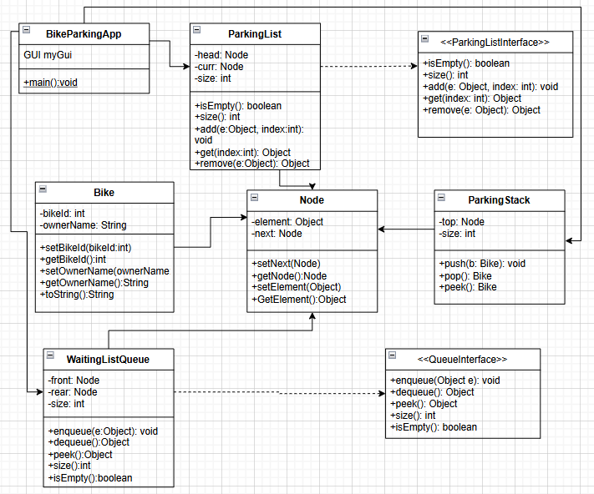

GitHub

