# Lesson 2

Today we will be talking about:

(Reviewing last lesson – content in Lesson 2 handout)

* Structural approaches

(onward)

* Coherence and cohesion
* Transitions
* Guidelines for drafting paragraphs and sections

## Coherence and Cohesion

*Coherence* concerns unity on a text level, whereas *cohesion* deals with unity on a sentence level.

A text has **coherence** if its constituent sentences follow on one from the other in an orderly fashion so that the reader can make sense of the entire text. The relationship between ideas is clear. There is a clear logical or chronological structure.

**Cohesion** describes the way in which a text is tied together by linguistic devices, such as *And so we see . . . , Additionally . . . , Therefore . . . , However . . .* and *On the other hand . . .*

Cohesion it is unity on a sentence level, it's "the glue that sticks a sentence to another in a paragraph or a paragraph to another in a text."

#### Example

**Text 1**

Summer was over. The boy went to school. The building: Peter had never liked it. All the other class members became easy targets of the lawmaker's son's gun. At 8.15 am the massacre began. 7 children would not go home. The last words of the juvenile perpetrator: "I hate Mondays."

**Text 2**

You may not fully understand the reasons for the incident so let me try to explain. Namely, it may help your understanding to know that Peter had not been happy about the oranges, after all. Nor was the other Peter ever able to fly after the fruity explanation. Then, weeks later, he realised that is was because my fruit and wings rationale is lacking in substance. If that is all, you may find it hard to get the point of what I'm driving at. Nevertheless, I think it was worth trying to explain.

1. For each text state whether you think the text is coherent, cohesive, both or neither.
2. If you consider a text **incoherent**, discuss how you could make it more coherent. .   
   We're going to come back to this question after reading the next section.
3. If you notice a lack of **cohesion**, think about how you could improve a text.   
   We're going to come back to this question after reading all the sections.

### Achieving Coherence

**Coherence** means that the text is easy to read and understand because the text follows a certain kind of logical order and the organization of ideas is systematic and logical.

A strong structural plan is your first tool for coherence. Think about the structural approaches we talked about before (narrative, library, process-based, system-based). Most likely, you will use a combination of these approaches. Again, this decision will be informed by your audience. It is rare to find just one structural approach, especially in large document. Typical software documentation (for example) will be process-based with narrative elements (intro, overview). A coherent document will result if you

* Include everything your reader needs – and nothing else!
* Use some kind of logical order:
  + chronological
  + spatial
  + order of importance
* Group together the items your reader will use together (see Fig. **6.1**)
* Think about how your readers will approach the text (audience analysis)
* Revisit the decisions you made in the planning stage (these can be taken at every level)
* For repetitive writing tasks, use an appropriate "superstructure" or other pattern familiar to your readers (see Fig. **6.2**)

Tools for Structuring:

* Layout
* Headings

#### Layout for Structural Coherence:

Use indentation, lists, colours, font, white space. We will talk more about using layout for document function later in the semester.

Let's practice coherence for a document. The document L2\_coherence\_exercise.docx under today's lesson on Moodle shows the contents of a memo that have been mixed up. Based on the content, try to put the memo back into coherent order.

#### Headings for Structural Coherence:

Headings are like signposts – they help the user to find information quickly and grasp hierarchical organisation. They should make it clear what are the main points in a document and what are the subordinate points. They should also show you how certain points are related to each other. Let's have a look at some examples.

*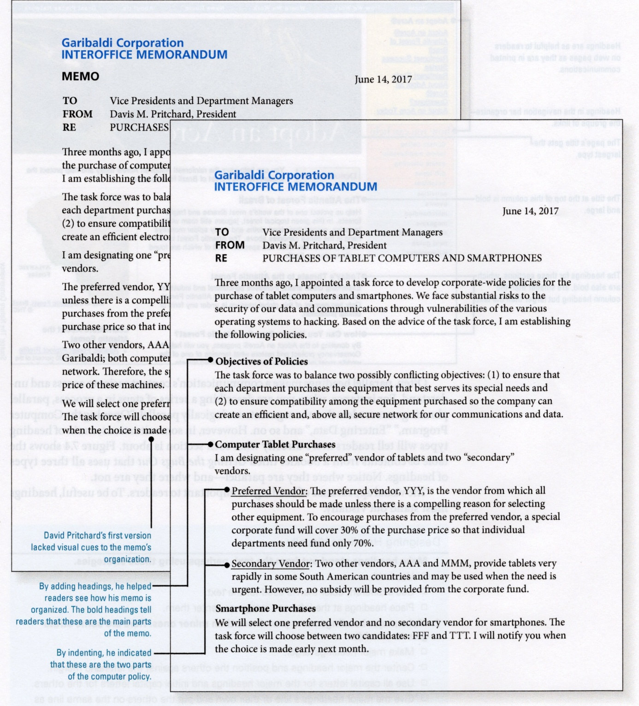The headings in this memo make it much easier to assess the document at a glance. Anderson, 2014.*

*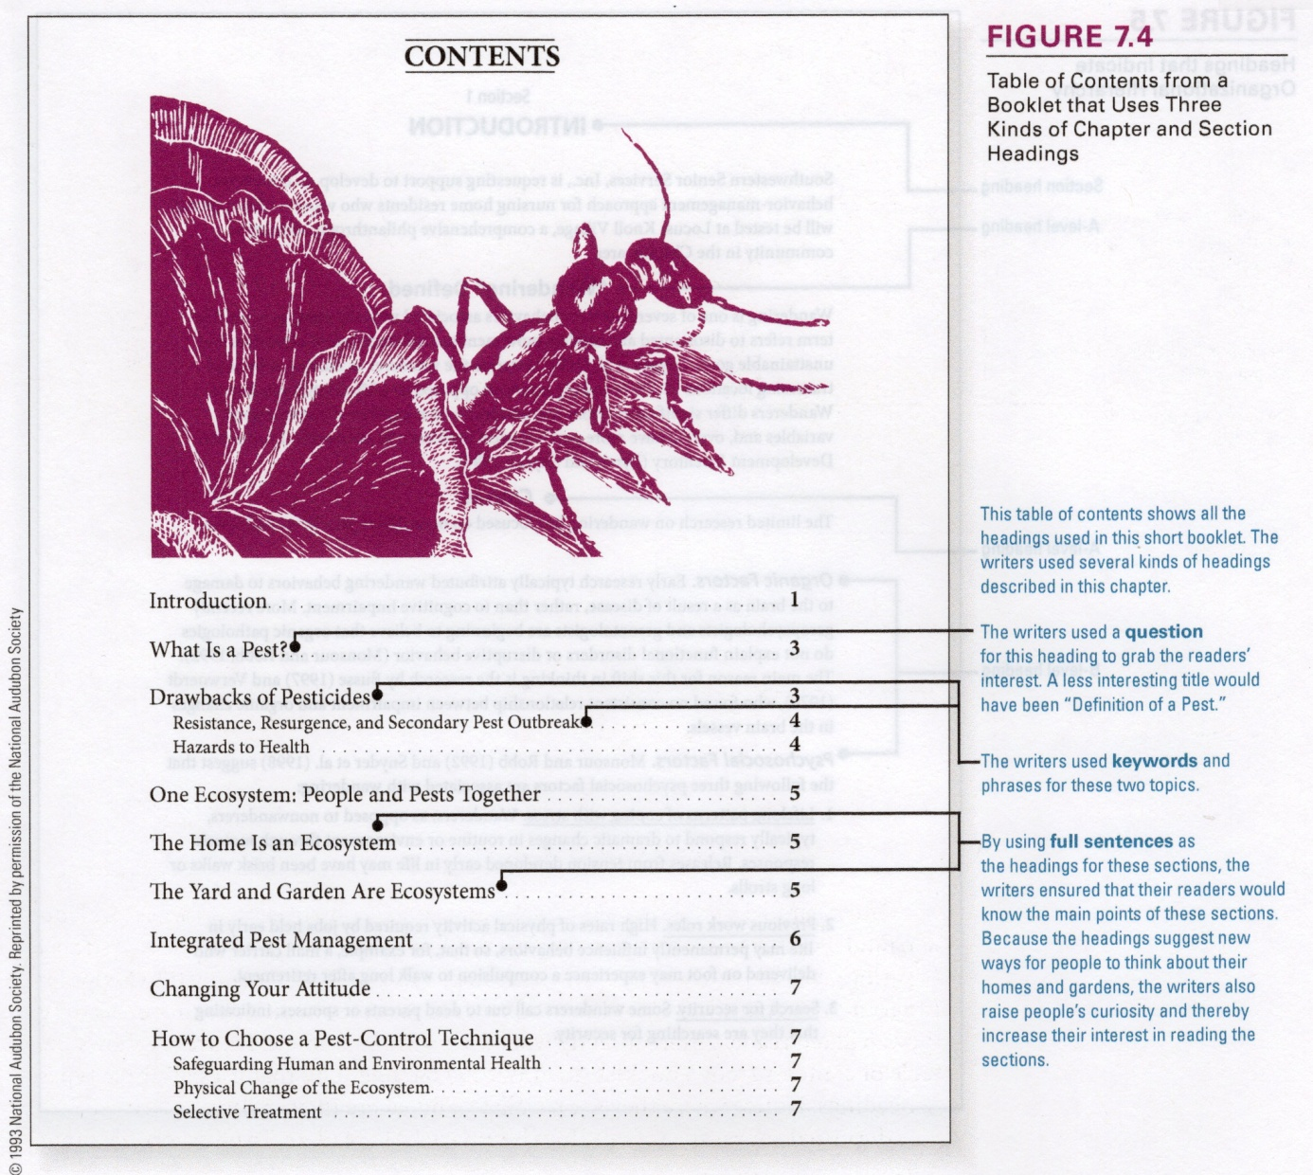This example shows the different levels of headings in a table of contents. Anderson, 2014*

*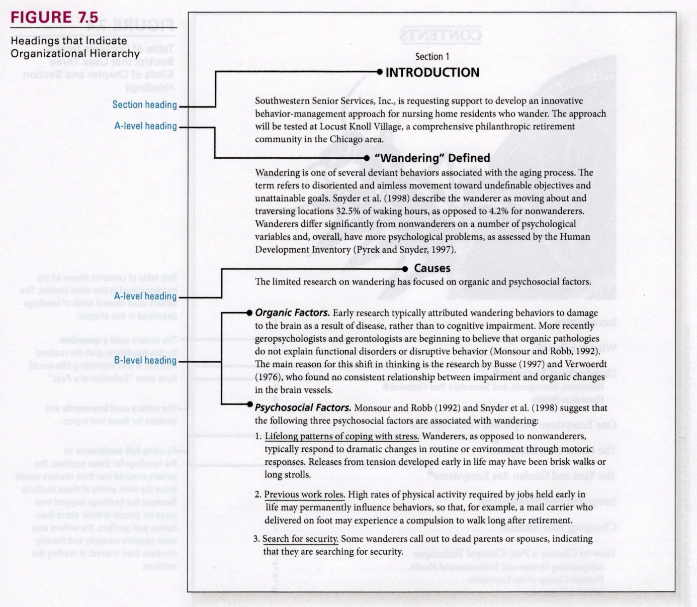This example shows different typographical and formatting methods for differentiating between heading levels. Anderson, 2014.*

**How to write headings:**

Headings should be useful - they should tell clearly and specifically what information is in the section.

Content:

* Use a question that the segment will answer.
* State the main idea of the segment.
* Use key words or phrases.
* Keep the above things parallel.
* Use standardization (building blocks, consistency)/repetition

Visuals:

* Give headings the correct emphasis: font size, weight, indentation, etc.
* (As with content), use formatting to emphasize main points and subordinate secondary points
* Be consistent in your use of formatting.

Decisions to be made:

* How many levels? Depends on how text is accessed, text type, intended audience etc.
* Numbered or not? Scientific numbering?
* How many headings to use in a text? Use headings for shifts in topic, and to signpost the text for skim readers or users looking for specific information.

Too few headings will make a text hard to navigate, but too many will affect cohesion of text (like transitions, which we will see next).

We will also talk next lesson (drafting paragraphs) about the interplay between headings and *topic statements*.

Let's look back to the examples in Example on page 14 and try to answer question 2.



Let's try an exercise on headings. Open the document L2\_exercise1:headings.docx from today's lesson on Moodle.

This is the introduction to a book called " Technical Report Writing and Style Guide: How to write even better technical reports" by Tony Atherton.

The introduction contains really good information, but I think it could benefit from headings that reveal its structure to the reader, making it easier to access, process and remember the information.

Add headings to the document, remembering that you made need more than one hierarchical level. Think about the aspects of useful headings that we have just talked about.

### Achieving Cohesion

A text can be **cohesive** through the use of the following devices:

#### Repetition

Use repetition to reinforce a key idea, or clarify the most important concept. In sentence B (the second of any two sentences), repeat a word from sentence A.

You can also use pronouns for repetition, as long as the antecedent is clear.

**Example**

Our *guidelines* for handling Exban are now complete. *They* can be referenced for all stages of the process.

#### Synonymy

If direct repetition is too obvious, use a synonym of the word you wish to repeat. This strategy is call 'elegant variation.'

**Example**

Representative of many American university towns is Middletown. *This Midwestern town*, formerly *a small farming community*, is today the home of a large and vibrant *academic community*. Attracting students from all over the Midwest, *this university town* has grown very rapidly in the last ten years.

Using the 'opposite' word, an antonym, can also create sentence cohesion, since in language antonyms actually share more elements of meaning than you might imagine.

#### Parallelism

Repeat a sentence structure. This technique is the oldest, most overlooked, but probably the most elegant method of creating cohesion. Also can be used in design, headings, logos, etc.

**Example**

#### Enumeration

**Example**

The recommendation rests on two conditions. *First*, the department staff must be expanded to handle the increased workload. *Second*, sufficient time must be provided for training the new staff.

#### Transitions

Transitions are like a two-way signpost. They provide readers with points for linking ideas and clarifying relationships between them. Use a conjunction or conjunctive adverb to link sentences with particular logical relationships. There are many kinds of transitions.

**Examples**

*Having considered* the technical problems outlined in this proposal, *we move next* to the question of adequate staffing. (sequential)

*Even if* technical problems could be solved, there *still remains* the issue of adequate staffing.

*After* we developed our hypothesis, *we were ready* to design our experiment.

This large increase in contributions will enable us to expand our free health care program in several ways. (cause and effect)

**Using Transitions**

* Use transitional words and phrases (or design! or format!)
* Repeat keywords or key ideas
* Use pronouns with clear antecedents
* Use enumeration
* Summarize a previous paragraph
* Ask a question
* Use a transitional paragraph
* Don't overdo it!

|  |  |
| --- | --- |
| Function | Transitional Words |
| Result | therefore, as a result, consequently, thus, hence |
| Example | for example, for instance, specifically, as an illustration |
| Comparison | similarly, likewise, in comparison |
| Contrast | but, yet, still, nevertheless, however, on the other hand |
| Addition | moreover, furthermore, also, too, besides, in addition |
| Time | now, later, meanwhile, since then, after that, before that time |
| Sequence | first, second, third, initially, then, next, finally |



Let's look back to the examples in Example on page 14 and try to answer question 3.

# Drafting Sections and Paragraphs

After creating a structural plan, the next step in document creation it to transform plans into action and draft the text. This is a major transition from defining objectives and creating plans to transforming your plans into action.

The guidelines and strategies we are going to talk about in this class can be applied on all levels of granularity: a small group of related sentences, a group of paragraphs within a document, a whole document. How can the guidelines apply to segments that are of such different length? Basically, all segments have the same basic structure:

* a paragraph is a group of sentences on the same topic
* a section is a group of paragraphs on the same topic
* a document is a group of sections on the same topic

Also, all segments make the same basic demand on readers: to understand, readers must determine what the topic is and how its various parts (sentences, paragraphs, etc.) fit together.

They also need to know which of the points discussed is the most important, which of the problems identified is the most serious, which of the recommended actions is most urgent.

The guidelines and strategies we discuss here are particularly good for drafting long documents.

## Guidelines for Structuring Texts

1. Begin by announcing your topic
2. Present your generalizations before your details
3. Move from most to least important
4. Reveal your organization
5. Use conventional strategies

* grouping facts
* describing objects and processes
* comparing/contrasting
* explaining cause and effect
* describing problems and solutions

### Begin by Announcing your Topic

Use *topic sentences*. You can apply this guideline to all segments, large and small. Topic sentences, which tell the reader what the topic is about, are very useful tools for all the reasons listed above.

Readers need to establish in their own minds a meaningful pattern to the various pieces of information conveyed within a section. Unless the writer helps, this can be difficult. See example below.

Topic sentences work best at the **beginning**: they allow for *top-down* rather than *bottom-up* processing (seeing the picture of the jigsaw puzzle then putting the pieces in place, rather than assembling all the pieces of the puzzle and trying to eventually figure out what the picture is). Readers actually continually engage in both processes, but the more top-down processing they can perform while reading, the more easily they can understand and remember the message.

Yes, topic sentences also help with **recall**!

Important for **skim readers** to help them ascertain how pieces of the document relate to each other and get a quick idea about what's in each section.

How to indicate your topic?

* Announce it in a sentence
* Indicate it with a single word (e.g., "First...")
* Ask a question

What does this remind you of? That's right, headings! Headings and topic sentences have a lot in common.

**Examples**

Before we can sell the gypsum produced by our stack scrubbers, we will have to process the wet gypsum cakes they produce.

Companies that make cement and wallboard cannot use wet gypsum cakes. The cakes must be transformed into dry pellets, using a process called agglomeration. We could enter the agglomeration business ourselves or hire another company to agglomerate the gypsum for us. Also, the chloride content of the cakes is too high for use in wallboard. Our engineers can probably devise inexpensive cakewashing equipment that will reduce the chlorides to an acceptable level.

If you saw the second piece of text (without the topic sentence), you would probably eventually figure it out. But your job as a reader is made so much easier when the writer adds a topic sentence, telling you what the section is about.

### Present Your Generalizations before Your Details

State the generalization to save the reader having to figure out your main point. The general point you want to make (not *always* the topic of the section) is also good at the beginning.

**Example**

The topic of this section is the relative costs of shipping our company's products by truck and by train.

vs.

We can save 15% of transportation costs by shipping certain products by train rather than by truck.

Knowing the conclusion the author has reached helps the reader to use the details that are presented in order to evaluate whether or not the conclusion is valid. This makes your writing not just more understandable and useful to your readers, but also more persuasive.

**Examples**

We have conducted a test that demonstrates the ability of our sampling tube to absorb the necessary amount of VCM under the conditions specified.

Using the sampling technique described above, we passed a gas sample containing 500 micrograms of VCM through the tube in a test chamber set at 25°C. Afterwards, we divided the charcoal in the sampling tube into two equal parts. The front half of the tube contained approximately 2/3 of the charcoal while the back half contained the rest. Analysis of the back half of the tube revealed no VCM; the front half contained the entire 500 micrograms.

If you were a manager reading the second part of the text, you might think "so what?". Without any generalization around which to organize the details, you might remember very few of them. You will remember far more if the writer begins with the general statement shown above.

Users can draw unpredictable generalizations, but you can control the conclusions they jump to using generalizing statements. You save the user the work of figuring out what the main point is. As they read they can concentrate on other tasks. For **example**:

Richard moved the gas chromatograph to the adjacent lab.

He also moved the electronic balance.

And he moved the XT computers.

Different readers could infer different things from these three sentences! One reader might read the three sentences above and note that everything Richard moved is a piece of laboratory equipment and might generalize that "Richard moved some laboratory equipment from one place to another."

Another user might observe that everything he moved was heavy and might generalize "Richard is strong."

A member of the trade union in Richard's organization might generalize that "Richard was doing work that should have been done by a union member, not by a manager", and might file a complaint. Different generalizations lead to different outcomes.

#### Exception

The one case where it is not recommended that you start your segment by presenting your generalizations is when the generalization might provoke a negative reaction from your reader. In this case, it is better to withhold the generalizations until you have laid some groundwork (for persuasive texts). Beginning with details and introducing the bottom line later in the text is called *indirect organization*.

*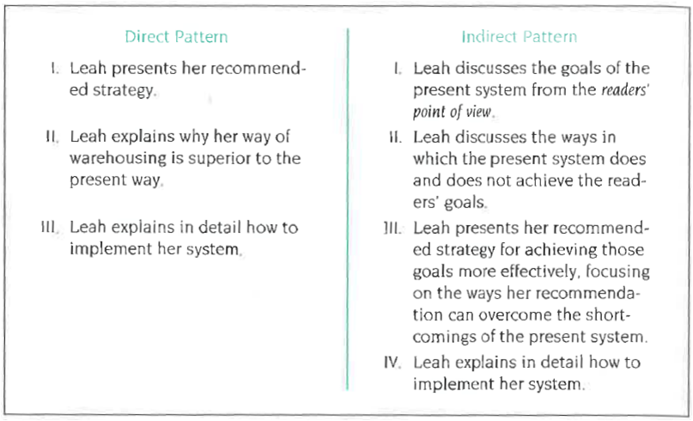Comparison of direct and indirect patterns for organizing a memo, Anderson.*

In the graphic above, the writer chose the direct pattern of organization because management had already expressed dissatisfaction with the warehousing system, and so (as her readers) will be receptive to her recommended strategy immediately. If, however, she had any reason to suspect the readers needed more persuasion, indirect organization might be helpful.

**Example combining guideline 2 with guideline 1:**

Our tests showed three shortcomings in plastic resins that make it undesirable for us to use them to replace metal in the manufacture of the CV-200 housing.

Guideline 2 and guideline 1 are very closely related. Since your generalizations will often be about your topic, you can often follow both guidelines in a single sentence, see above.

You won't always be able to present both in a single sentence, but the user will find it helpful to have both at the beginning of a segment.

### Move from Most to Least Important

Guidelines 1 and 2 have to do with how you begin your segment, this guideline has to do with how you order information after your opening sentence(s).

Putting the most important pieces of information first has several advantages:

* it emphasizes that information
* it helps readers (such as decision makers) who are scanning your document to find the key points
* it increases the likelihood that the information will be read

Particularly in a professional situation, readers often suffer from interruptions or time constraints: if a user stops reading (for whatever reason) they may never get to the subsequent pieces of information.

Also, if you start off with unimportant points, your readers may stop paying attention before they get to the important ones.

You must consider the user's point of view when deciding what are the important pieces of information.

### Reveal Your Organization

It helps users if you reveal your organization by "drawing a map" of how you are presenting information.

You may think that if you've organized your document carefully, it should be clear to users. But take into account that documents contain two distinct kinds of information:

* information about the subject matter
* information about how the writer has organized the discussion of that subject matter

See the following graphic.

To puzzle out the organization of a document, readers have to do a lot of hard work. But if you provide a good map of your message, readers can discern the organization without even knowing anything about the subject matter.

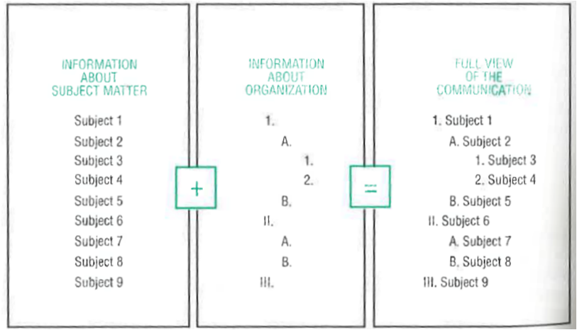*Relationship of information about subject matter and information about organization*

This graphic shows the relationship between the subject matter and how it is organized. If you have written the document, you can clearly see both kinds of information, even if you included only subject-matter information and no organizational information. Your readers, however, must construct a mental map of your organization as they read.

The tools for revealing the organization of a document.

* Table of contents
* Forecasting statements
* Transitions
* Layout
* Headings

We already spoke about most of these tools in lesson 4, but let's look at *forecasting statements*, and in particular, how they differ from the topic sentences we discussed in the last section:

**Topic sentence**:

Our first topic is the trees found in the American Southwest.

**Topic sentence and forecasting statement**:

Our first topic is the trees found in the American Southwest. Some of the trees are native some imported.

or

Our first topic is the trees – both native and imported – found in the American Southwest.

Topic sentences tells users what the segment is about but *nothing* about how it is organised. See above: first sentence (topic sentence) gives no information about what organisation is coming, second two (alternatives to each other) tell you that the discussion will be divided between two different types of tree, native and imported.

To solve this problem, the department must take the following actions.

This tells the user we're going to discuss the actions to take, but gives no information about what those actions are or how many of them there are.

Provide enough detail so that your readers will know something specific about the arrangement of the section that follows. The more complex the relationship between the parts, the more detail will be required in the forecasting statement.

Do not provide more detail than your readers can easily remember. The purpose of the forecasting statement is to help your readers to understand what is to come, not to test their memory. If you are introducing three steps to a solution, you could name them before explaining them. If, however, the solution contains eight steps, you will be better off just stating that there are eight steps, rather than naming them.

Let's try some exercises on the topics we've just talked about. The files you need are all under today's lesson on Moodle.

**L2\_exercise2\_revealyourorganisation.png**

This graphic shows the table of contents from an instruction manual for an electronic balance, a device used to weigh samples in a laboratory. The writer has done a good job of listing the contents but has done a poor job of indicating coordination and subordination. Try to **create a table of contents** that **reveals the organisation** more effectively. You can add headings if necessary.

**L2\_exercise3\_topicsentences.docx**

Underline or highlight all the **topic sentences** in the text.

**L2\_exercise4\_forecastingstatements.docx**

Underline all the **forecasting statements** in the text.

### Use Conventional Strategies

If you are having difficulties organizing information, there are some conventional, formulaic strategies that you can use. These are outlined in the next section. Probably won't talk about it until tomorrow.

## Strategies for Organizing Texts

The organisational strategies we're going to talk about here work for segments of any kind and are based on recurring issues when presenting information.

Thes strategies are listed separately, but (like most guidelines) they are often intermixed with one another.

* Grouping facts (Fig. **1**, **2**, **3**)
* Describing physical objects (Fig. **4**)
* Describing processes (Fig. **5**)
* Presenting comparisons (Fig. **4**, **5**)
* Explaining cause and effect (Fig. **8**, **9**)
* Describing problems and solutions (Fig. **91**, **92**)

### Grouping Facts

This also called *classification*. Classification is a good way to deal with a miscellaneous set of facts.

**The pattern you choose must be meaningful for your reader.**

This is my mantra in this discussion of strategies for organising segments. It applies at **all levels**.

One way is to organise material into parallel groups of related items. The groups must provide a place, and *only one* place, for every item that has to be classified and must accommodate the information in a way your readers will find useful.

#### Formal Classification

In *formal classification*, you group items according to a principle of classification, i.e., according to some observable characteristic that every item in the group possesses. For example for cars: price, colour, horsepower. Each car has a colour, price and horsepower value, and because each car has only one price, one colour, etc., there will be one place for each item. You only use one principle at a time:

|  |  |  |
| --- | --- | --- |
| * Cars built in the US * Cars built in other countries | * Cars built in the US * Cars built in other countries * Cars that are expensive | * Cars built in the US   + Expensive cars   + Inexpensive cars * Cars built in other countries   + Expensive cars   + Inexpensive cars |
| C:\Users\Synnøva\AppData\Local\Microsoft\Windows\INetCache\IE\38F2NI41\978px-Green-checkmark.svg[1].png | C:\Users\Synnøva\AppData\Local\Microsoft\Windows\INetCache\IE\38F2NI41\1024px-Red_x.svg[1].png | C:\Users\Synnøva\AppData\Local\Microsoft\Windows\INetCache\IE\38F2NI41\978px-Green-checkmark.svg[1].png |

Use only one characteristic (first list).

The second list does not work, because two characteristics have been used. In this case, you need another level of classification (third list).

#### Informal Classification

In *informal classification*, items are classified not using objective characteristics, but by applying subjective interpretation:

|  |  |
| --- | --- |
| * Focus on price * Focus on established reputations * Focus on advantages over a competitor's product * Focus on one of the product's key features * Focus on several of the product's key features * Use photographs | * Focus on price * Focus on established reputations * Focus on advantages over a competitor's product * Focus on product's key features * Focus on one of the product's key features * Focus on several of the product's key features |
| C:\Users\Synnøva\AppData\Local\Microsoft\Windows\INetCache\IE\38F2NI41\1024px-Red_x.svg[1].png | C:\Users\Synnøva\AppData\Local\Microsoft\Windows\INetCache\IE\38F2NI41\978px-Green-checkmark.svg[1].png |

The first list is not parallel. The last two categories are at a lower hierarchical level than the other three. To make the categories parallel, you could combine them, as shown in the second list.

This is a problem that you will encounter *very often* in software documentation. Often you have a list of features or functionality, and you need to figure out if they are "equal" to each other, or if some need to be combined under a common heading (and then you need to figure out what to name the combined section).

Also, in the first list, you have *overlap*. The last item overlaps the others, because photographs can be used in any of the other types of advertisements listed.

### Describing Physical Objects

This also called *partitioning*. This is very useful for describing a physical object, e.g., device, equipment, machine.

Partitioning is dividing the object into its major components. It is the same basic idea as classification – the object is a collection of parts that you then group by principle, e.g., *function* or *location.*

#### Describing Objects – Grouping by Function or Location

For example: If you are describing the parts of a car. You could group them by

* **Location**: interior, exterior, underside.
* **Function**: parts providing power, parts that guide the car.

As with all strategies, this depends on the user's requirements.

Location and function are principles that are commonly used for grouping, and they often coincide. But think also about materials used? Or country manufactured in?

Principle has to suit your readers and your purpose.

To assure that you have one and only one place for each part you describe, use only one basis for partitioning at a time.

Make sure to arrange parts in a useful way (logical progression).

### Describing Processes

This also called *segmentation*. You will use this a lot of your are writing instructions. It helps you to describe

* How something is done
* How something works
* How something happened

There is a relationship of events over time. So readers can perform a process or understand a process.

Begin with the list of steps or events involved in the process, then separate those steps into related groups. If the process is long enough, you may divide those groups of steps into subgroups, thereby creating an organisational hierarchy.

Use a guiding principle for segmentation (as with classification and partitioning). Again, the principle you choose has to suit your readers and your purpose.

If you are writing instructions, group them in ways that support an efficient or comfortable rhythm of work. If you are trying to help your readers understand a process, build your organisation around concerns that are of interest or use to your readers.

Make your smallest groupings manageable. If they include too many steps or too few, your readers will not see the process as a structured hierarchy of activities or events, but as a long, unstructured list of steps. A lack of structure will make it harder for your readers to learn the task.

If your readers understand the relationship between the steps, it will make it easier for them to understand and remember the process. Make the relationship clear using informative headings, an overview, additional explanations, or a summary.

### Presenting Comparisons or Contrasts

This strategy can be used to help users make a decision, or to understand by means of analogy (building on the reader's existing knowledge).

Begin with a large set of facts, then group around points so user can see what's alike or unalike. You might use

* An alternating pattern
* A dividing pattern

#### Presenting Comparisons – Alternating vs. Dividing Pattern

In an *alternating pattern*, you organise your facts around your criteria. This pattern enables your readers to make a point-by-point comparison without flipping back and forth from one section to another. When this pattern is used, it is often necessary to precede the evaluation with an overview of the alternatives (see below). Otherwise, readers may have to piece together an overall understanding of each alternative from the specific details you provide when discussing the alternatives point by point.

In a *divided pattern*, you organise not around the criteria but around the alternatives themselves. This pattern is well suited to situations where both the general nature and the details of each alternative can be described in a short space, say one page or so.

|  |  |
| --- | --- |
| Alternating Pattern of Comparison | Dividing Pattern of Comparison |
| * Statement of Criteria * Overview of the Two Alternatives * Criterion 1   + Alternative A   + Alternative B * Criterion 2   + Alternative A   + Alternative B * Criterion 3   + Alternative A   + Alternative B | * Statement of Criteria * Description of Alternatives * Alternative A   + Overview   + Criterion 1   + Criterion 2   + Criterion 3 * Alternative B   + Overview   + Criterion 1   + Criterion 2   + Criterion 3 |

As with all other strategies, the principle you choose for comparison has to suit your readers and your purpose.

If you're preparing comparisons for decision makers, be sure to include not only the criteria they consider important, but any additional criteria that you – with your expert knowledge – regard as significant.

When you are writing comparisons to create analogies, be sure to compare and contrast only those features that will help your readers understand the point you are trying to make. Avoid comparing extraneous details.

Arrange hierarchically, for example, group information on all aspects of cost in once place, information on all aspects of performance in another place.

Make sure to arrange the information in a helpful way. For example, If your comparison is intended to help readers make a decision, start with the criteria that reveal the biggest differences between the things you are comparing. If your comparison should help a user understand something, start with the points of similarity. In this way, you being with what your readers will find familiar and then lead them to the less familiar.

### Explaining Cause and Effect

Explaining cause and effect can be descriptive or persuasive. If your aim is descriptive, you want to help users understand the cause or consequences of some action or event.

If your aim is persuasive, you try to persuade readers that some event or action had certain specific causes, or that some event or action will have certain specific consequences. E.g., you might try to persuade your readers that the damage to a large turbine generator (effect) resulted from metal fatigue in a key part (cause) rather than from a failure to provide proper lubrication.

**Descriptive**:

Your readers will want to know from the beginning of the segment exactly what you are trying to explain.

Remember that you are not simply listing the steps in a process, you want your readers to understand how each step leads to the next step or is caused by the preceding step.

Categories can help readers understand a complex chain of events.

**Persuasive**:

Where possible, focus on undisputed facts, because your readers' willingness to agree with you depends largely on their willingness to accept your evidence. Use lines of reasoning your users will accept as logically sound.

Users may object to your evidence or line of reasoning. Avoid the *post hoc ergo propter hoc* fallacy.

### Describing Problems and Solutions

As with explaining cause and effect, this can be descriptive or persuasive. You can use a problem-and-solution strategy *descriptively* to explain events that have occurred, or *persuasively* to convince your readers to agree that the actions you are recommending will solve a problem that they want to overcome.

**Descriptive**:

Make the problem seem significant to your readers and emphasize the aspects of the problem that were affected most directly by the solution.

Make sure your readers understand how the problem was overcome by the solution.

Grouping several actions into categories will help users understand complex solutions.

**Persuasive**:

Remember that your aim is to persuade the reader to take the action you recommend. They will not be interested in taking action to solve a problem they consider insignificant.

Use evidence that your readers will find sufficient and reliable, and reasoning they will find logically sound.

Devote special attention to determining what users' objections to your evidence or reasoning might be so that you can respond to them.