GROUP32

**Comp Virtual File System (CVFS)**

**User Manual**

**Contents**

# Ⅰ Getting started

1 Introduction of Comp Virtual File System (CVFS)

# Ⅱ Function and Features

1 “New” Commands: newDisk, newDoc, newDir

2 Basic Management Commands: Delete, rename, changeDir

3 Lists Commands: list, rList

4 Filtering Criterion Management Commands: newSimpleCri, IsDocument, newNegation, newBinaryCri, printAllCriteria

5 Search Commands: search, rSearch

6 Path Commands: save, load

7 Quit

# Ⅲ Troubleshooting

1 Common Issues And Errors

# Ⅳ Appendix

1 Frequently Asked Questions (FAQs)

2 Technical Support

**Introduction of Comp Virtual File System (CVFS)**

**Welcome to the Comp Virtual Filesystem**

The comp virtual file system is a virtual layer of the operating system's file system that simulates a file system in memory. This allows upper-layer software to communicate with different underlying file systems through a unified interface.

**What Can You Do With CVFS?**

1. File Management:

Easily create, delete, and organize your files and directories. Keep your data structured and accessible.

2. Document creation and editing:

In the working directory, you can quickly create new documents and customize their name, type, and content to suit your needs.

3. Quick search:

File search with simple and composite criteria allows you to quickly find the documents you need.

4. Ensure data persistence:

Ensure your data is safe by saving your virtual environment to your local file system,  preventing any loss of information**.**

**Commands Overview**

**1. newDisk**

**Functionality:**

Creates a new virtual disk with a specified size. This command closes any previous working disk and sets the newly created disk as the current working disk, with the root directory as the default working directory.

**How to use:**

**General format:**

*newDisk disSize*

**Step-by-Step Instructions:**

1. Access the command interface

2. Type newDisk followed by the size of the disk, for example: newDisk 1024

3. Press Enter

**Example:**

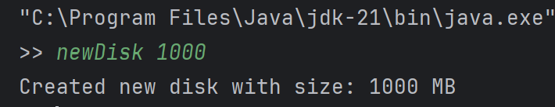

**2. newDoc**

**Functionality:**

Generates a new document in the current directory with a specified name, type, and content.

**How to use:**

**General format:**

newDoc documentName documentType documentContent

**Step-by-Step instructions:**

1. Ensure that you are in the correct directory

2. Type newDoc followed by the document name, type, and content.

For example: newDoc report txt “example”

3. Press Enter

**Example:**

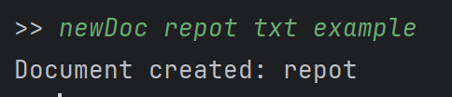

**3. newDir**

**Functionality:**

Creates a new directory in the current working directory.

**How to Use:**

**General format:**

newDir dirName

**Step-by-Step instructions:**

1. Ensure that you are in the right directory

2. Type newDir followed by the new directory name.

For example newDir computing

3. Press Enter

**Example:**

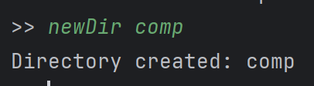

**4. delete**

**Functionality:**

Removes an existing file in the current working directory.

**How to Use:**

**General format:**

Delete filename

**Step-by-step-instruction:**

1. Ensure that you are in the right directory

2. Type delete followed by the file name of the file that you want to delete. For example: delete report

3. Press Enter

**Example:**

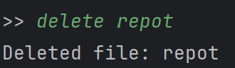

**5. rename**

**Functionality:**

Renames an existing file in the current working directory

**How to Use:**

**General format**

rename oldFileName newFileName

**Step-by-step instruction:**

1. Ensure that you are in the right directory

2. Type rename followed by the old file name and the new file name.

For example: rename report summary

3. Press Enter

**Example:**

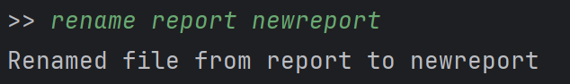

**6.changeDir**

**Functionality:**

Changes the working directory to a specified directory within the current directory or moves up a level.

**How to Use:**

**General format**

changeDir directoryName

**Step-by-step instructions:**

1. Type changeDir followed by the directory name. For example: changeDir polyu

2. To move up a level, type changeDir ..

3. Press Enter

**7. list**

**Functionality:**

Get an overview of your current directory’s contents. This command will list all files and directories in the current working directory. For each item, display the name, type, and size.

**How to Use:**

**General format**

List

**Step-by-step instructions:**

1. Type list in the command interface

2. Press Enter.

**8. rList**

**Functionality:**

Showing all files and directories in and below the current directory

**How to Use:**

**General format**

rList

**Step-by-Step Instructions:**

1. Type rList in the command interface.

2. Press Enter.

**9. newSimpleCri**

**Functionality:**

Creates a simple filter criterion based on file attributes. Which allow you to filter files using specific attributes.

**How to Use:**

**General format**

newSimpleCri criName attrName operator value.

**Step-by-Step Instructions:**

1. Type newSimpleCri followed by criName, attrName, operator, and value.

* criName: Two-letter identifier for the criterion.
* attrName: Can be name, type, or size.
* operator: Includes contains, equals, >, =, <=, ==, or !=.
* value: A string (in quotes) for name or type, an integer for size.

2. Press Enter to create the criterion.

**10. newNegation**

**Functionality:**

Supports the construction of composite criteria

**How to Use:**

**General format**

newNegation criName1 criName2  
.

**Instructions:**

1. Type newNegation followed by criName1 and criName2.

* + criName1: Name for the new negated criterion.
  + criName2: Existing criterion to negate.
* Press Enter to establish the negation.

**11. newBinaryCri**

**Functionality:**  
Creates a composite criterion using logical operators (&&, ||) between two criteria and allows the user to combine multiple criteria for advanced filtering.

**How to Use:**

**General format**

newBinaryCri criName1 criName3 logicOperator criName4

**Instructions:**

* Type newBinaryCri followed by criName1, criName3, logicOperator and criName4.
  + criName1: Name for the new composite criterion.
  + criName3 and criName4: Existing criteria.
  + logicOp: && or ||.
* Press Enter to create the composite criterion.

**12. printAllCriteria**

**Functionality:**

**Reviewing the criteria you’ve set up. This command shows all defined criteria in their detailed form.**

**How to Use:**

**General format**

printCritrtia

**Step-by-step Instructions:**

1. Type printAllCriteria in the command interface

2. Press Enter.

**13. search**

**Functionality:**Search for files in the current working directory that satisfy a specific criterion. Use this command to list files meeting the specified criterion in the current directory.

**How to Use:**

**General format**

search criName

**Step-by-Step Instructions:**

1. Type search followed by the criterion name (e.g., search txtFiles).

2. Press Enter.

**14. rSearch**

**Functionality:**Support recursively searching for files in the working directory and subdirectories based on a criterion. This command will list all the files contained in the working directory that satisfy the criteria.

**How to Use:**

**General format**

rSearch criName

**Step-by-Step Instructions:**

1. Type rSearch followed by the criterion name (e.g., rSearch largeFiles).

2. Press Enter.

**Example:**

**15. save**

**Functionality:**Save the current virtual disk and its contents to a file on the local file system. This command is useful for backing up your virtual disk.

**How to Use:**

**General format**

save path

**Step-by-Step Instructions:**

1. Type save followed by the desired file path (e.g., save /path/to/backup.vdisk).

2. Press Enter.

3. Confirm that the virtual disk is saved to the specified location.

**16. load**

**Functionality:**Load a virtual disk from a file on the local file system and set it as the current working disk. Use this command to restore a previously saved virtual disk.

**How to Use:**

**General format**

load path

**Step-by-Step Instructions:**

1. Type load followed by the file path (e.g., load /path/to/backup.vdisk).

2. Press Enter.

**Example:**

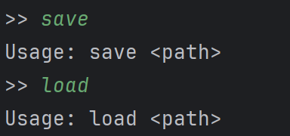

**17. quit**

**Functionality:  
Terminate the current execution of the system. Use this command to close the virtual file system safely.**

**How to Use:**

**General format**

quit

**Step-by-Step Instructions:**

1. Type quit.

2. Press Enter.

**Example:**

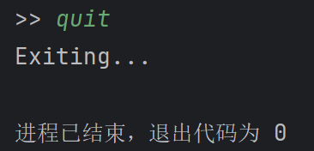

Common Issues And Errors

**Issue 1: Unable to Create a New Disk**

* **Problem**: Error message: "No disk created."
* **Solution**: Ensure you have called the newDisk(int size) method to create a new disk with sufficient size before performing operations.

**Issue 2: Document Already Exists**

* **Problem**: Error message: "Document already exists: [document name]."
* **Solution**: Check the current directory for existing documents with the same name. Use a unique name or delete the existing document if it's no longer needed.

**Issue 3: Document Not Found**

* **Problem**: Error message: "Document not found: [document name]."
* **Solution**: Check the document name and ensure it is correct. Check the current directory for the document's existence and ensure you are in the correct directory. You can use changeDir to visit the correct directory.

**Issue 4: Invalid Criterion Name or Attribute**

* **Problem**: Error message: "Criterion name must contain exactly two English letters" or "Attribute name must be either name, type, or size."
* **Solution**: Ensure criterion names are two letters long and use valid attribute names. Refer to the documentation for allowed attributes and operations(Page x).

**Issue 6: Criterion Not Recognized**

* **Problem**: Error message: "Criterion not recognized or not implemented."
* **Solution**: Verify that the criterion name is correctly defined and added to the criteria map.

**Issue 7: Directory Not Found**

* **Problem**: Error message: "Directory not found: [directory name]."
* **Solution**: Ensure the directory name is correct, and you are in the correct parent directory. Use listFiles() to check the directories available in the current directory.

**Issue 8: Error Saving or Loading Data**

* **Problem**: Error message when saving or loading criteria or virtual disk.
* **Solution**: Check file paths for correctness.

**Issue 9: Invalid Logic Operator in Binary Criterion**

* **Problem**: Error message: "Invalid logic operator: [operator]."
* **Solution**: Use correct logic operators in binary criteria(Page x). Ensure correct syntax when defining binary criteria.

**Issue 10: Unable to Change Directory**

* **Problem**: Error message: "Already at the root directory" or unable to change to a specified directory.
* **Solution**: Check the directory structure and use changeDir(name) correctly. Use .. to move to the parent directory if applicable.

**Frequently Asked Questions (FAQs)**

1. **What is a virtual file system?**

A virtual file system (VFS) is an abstraction layer that allows users to access files and directories uniformly, regardless of the underlying storage technology.

1. **How can I report a bug or issue?**

Please report any bugs or issues through our support ticket system at [www.example.com/support](http://www.example.com/support).

**Technical Support**

If you require further assistance, please contact our technical support team:

* **Email Support**: [support@example.com](mailto:support@example.com)
* **Phone Support**: +1 (010) 101-10101 (Available Monday to Friday, 9 AM - 5 PM EST)
* **Live Chat**: Visit [www.group32.com/chat](http://www.group32.com/chat) for real-time assistance.

We are committed to helping you resolve any issues you may encoun ter while using the Comp Virtual File System!