Front Page



ABSTRACT

Fitness Data Hub

The Fitness Data Hub database is a systematic arrangement of details controlled in a gym.

This gym database is a software which is helpful for both the gym authority and the members. In

the current system all the activities are done manually in register books. This database is time

saving and scalable.

In the system we have relations, “Member” for controlling the details of the members in

the gym, “Trainer” for controlling the details of the trainers in the gym, “Competition” for

controlling the details of the competitions that the members have participated in and won,

“Membership Plan” for controlling the details of the membership plan taken by the members,

“Equipment” for storing the details of the equipment available in the gym. Also, there are

relationships like “Log Book” and “Supplements”. Finally, a “Gym” entity for storing the details of

the gym. We can have multiple gym’s data but in the real-world each gym maintains their own

data.

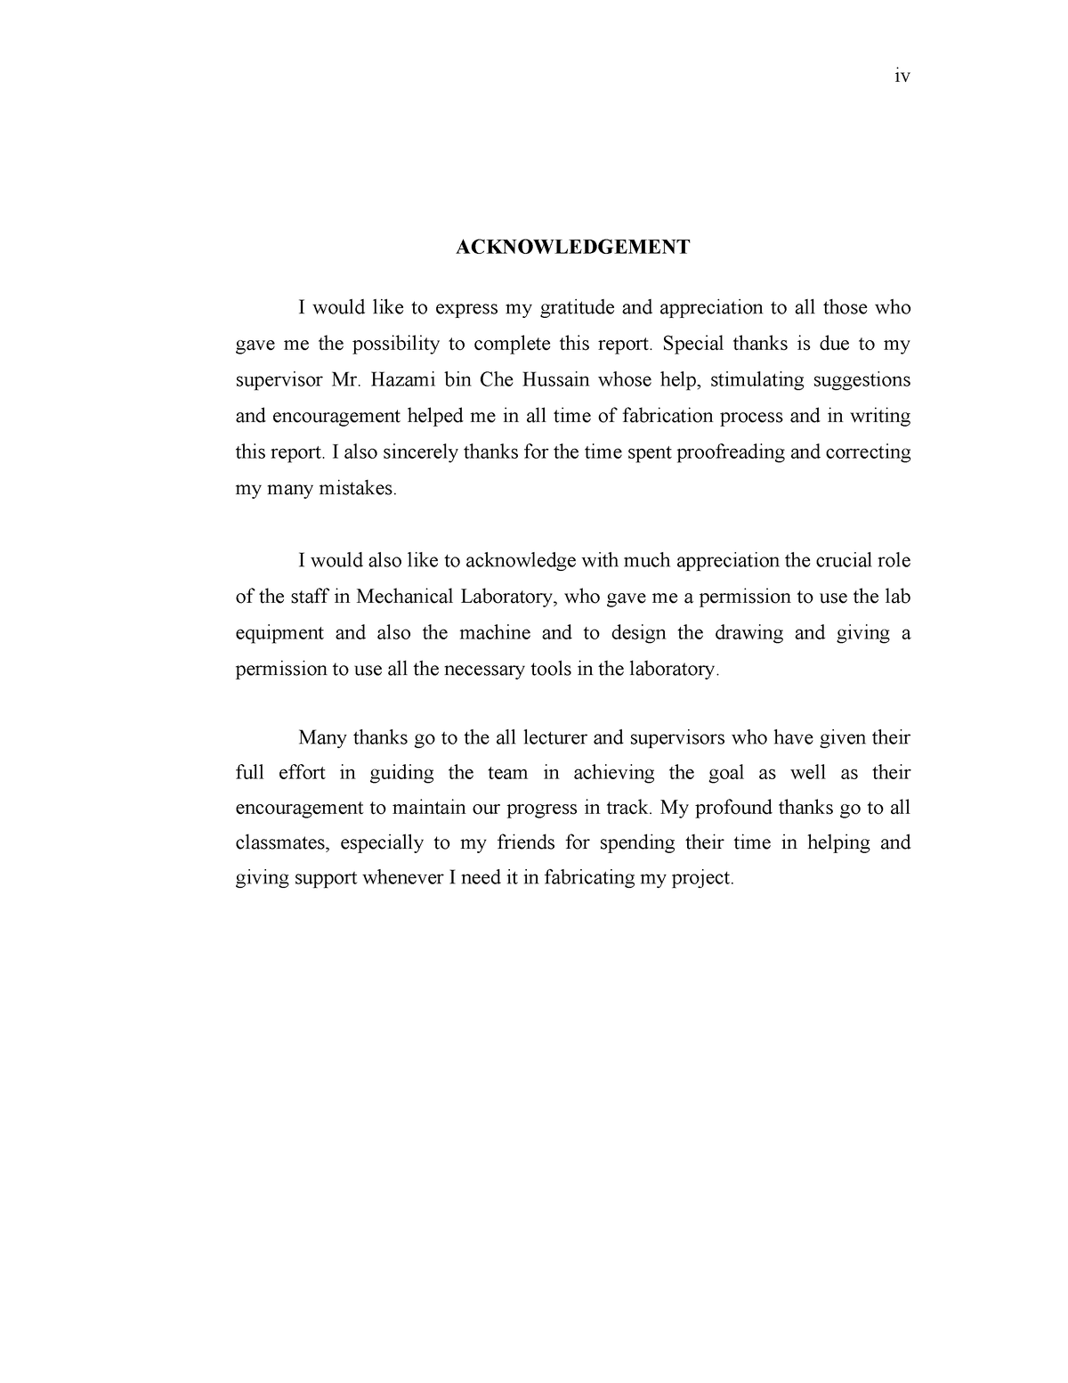

CONTENT

Objective

ER diagram

Relational Schema diagram

Implementation

Output Screenshots

Conclusion

References