ACTIVEA: Optimization and Analysis of Single-Session Exercise Planning Using Genetic Algorithms

Module Code and Title: DG4COM Computational Intelligence
Module/Assessment Lead: Prof Aniko Ekart (a.ekart@aston.ac.uk)
Student Name: Siva Subramaniam Raju
Student No: 260322784
Submission Date: [Blank]
Individual Technical Assessment Report - Department of Computer Science, Aston University

1. Introduction and System Overview
The ACTIVEA framework addresses the complex combinatorial problem of synthesizing optimal single-session exercise regimens tailored to individual physiological profiles and multi-objective training targets. Formally, an exercise session is modeled as an ordered decision vector of discrete physical activities selected from a standardized catalog, X = {(a_i, d_i)} for i = 1 to m, where each activity a_i is allocated a specific duration d_i in minutes. Across a 10-activity library with variable session lengths, the combinatorial search space exceeds 10^9 candidate configurations. The primary optimization objective balances metabolic expenditure (caloric burn) against multidimensional physiological constraints specified in the coursework brief: Metabolic Equivalent of Task (MET), Target Rating of Perceived Exertion (RPE), and cardiovascular response operationalized as a percentage of maximum heart rate (%HRmax).
In addition to bioenergetic bounds, ACTIVEA requires robust coverage across seven clinical exercise science domains: cardiovascular endurance (CV), strength (ST), muscular endurance (ME), flexibility (FL), balance (BA), agility (AG), and functional movement (FM). The search landscape exhibits severe non-linearity: prolonged low-intensity routines satisfy caloric quotas while failing minimum MET thresholds, while high-intensity intervals risk breaching safe cardiovascular limits or omitting recovery modalities. Consequently, metaheuristic global search techniques—specifically generational Genetic Algorithms (GAs)—are deployed to traverse this non-convex decision space efficiently.

2. Physiological Domain Modeling and Activity Characterization
The foundational activity catalog originates from established exercise physiology literature and coursework brief specifications (Table 1). The baseline reference activity defines moderate jogging as burning 7.35 kcal per minute for a normalized 70 kg adult (6.0 MET, 5.0 RPE on the Borg 1–10 scale, 70–77% HRmax, covering CV, ME, and FM). Nine complementary activities were incorporated from empirical exercise science sources: bodyweight squats, moderate cycling, static plank holds, hatha yoga, high-intensity rope skipping, outdoor running, brisk walking, calisthenics/push-ups, and agility drills with burpees. Physiological target zones adhere to Karvonen intensity models where training adaptations correlate directly with structured metabolic expenditure.
Because energy expenditure varies dynamically with body mass, baseline caloric rates for a 70 kg individual are dynamically rescaled via linear bioenergetic proportionality:
Caloric Rate (user) = Caloric Rate (70kg) × ( Body Mass / 70 )
Total session expenditure represents the cumulative sum of activity durations multiplied by mass-adjusted rates. Auxiliary metrics like Body Mass Index (BMI) are excluded from primary summation, as standard ACSM equations model energy directly from mass and MET intensity. For example, a 70 kg individual undertaking 12 minutes of yoga (3.0 kcal/min) and 13 minutes of rope skipping (11.0 kcal/min) burns precisely 36.0 kcal and 143.0 kcal respectively (179.0 kcal total). This linear formulation preserves consistent relative metabolic ratios across diverse user profiles while spanning both aerobic and anaerobic systems.

3. Genetic Algorithm Architecture and Chromosomal Representation
To encode potential exercise sessions into evolutionary structures, a variable-length candidate list representation is employed: [(Activity_ID, Duration)]. Structural validity mandates that a viable session must contain between two and five distinct activities, with individual durations bounded within [5, 45] minutes. To prevent illegal redundant structures, duplicate activity occurrences within a single chromosome are automatically merged by summing their durations and clamping to the 45-minute ceiling.
ACTIVEA employs a canonical generational Genetic Algorithm pipeline. An initial population (N = 50) is randomly instantiated across the valid search domain. At each generation, individual fitness scores are evaluated prior to parental selection. Selection utilizes Tournament Selection with tournament size k = 3, balancing selection pressure against premature convergence. Two-parent uniform crossover (P_c = 0.80) pools parental tuples, consolidates duplicate activity types, and splits elements into two offspring, allowing high-performing modular exercise combinations to be inherited intact by subsequent generations.
Offspring undergo mutation at probability P_m = 0.15 across four mechanisms: (1) duration perturbation (±1 to ±5 min), (2) activity substitution, (3) allele insertion (if length < 5), or (4) allele deletion (if length > 2). Elitism copies the two best distinct chromosomes intact to the subsequent generation. Evolution terminates after a fixed budget (40–50 generations), returning the best-evaluated chromosome.

4. Fitness Evaluation Mechanics and Constraint Handling
The primary fitness evaluation function strictly replicates the step-wise step-penalty rules established in the taught lecture code, rather than continuous scalar metrics out of 100. Starting from zero, four independent physiological checks award +1 point for meeting target thresholds and -1 point for violations:
- Caloric Range Check: Session total calories must lie strictly within [300, 600] kcal (+1 if valid, -1 otherwise).
- Weighted MET Threshold: Duration-weighted average MET score must be >= 4.0 (+1 if valid, -1 otherwise).
- Weighted RPE Band: Duration-weighted average RPE must lie within [4.0, 7.0] (+1 if valid, -1 otherwise).
- Weighted Heart Rate Band: Duration-weighted %HRmax must lie within [64%, 80%] (+1 if valid, -1 otherwise).
Consequently, the resulting raw fitness score is an integer discrete scalar restricted to the domain [-4, +4].
To support specialized user goals, target caloric windows are dynamically adjusted: General Health ([200, 400] kcal), Fitness Improvement ([300, 500] kcal), and Weight Loss ([400, 600] kcal). While qualitative domain coverage is logged for user diagnostics, it exerts no numerical influence on the raw +4 score. This separation creates a broad optimization plateau where multiple disparate sessions receive identical +4 scores, motivating continuous multi-attribute enhancements that combine smooth caloric gradients with explicit multi-domain rewards.

5. Experimental Optimization Results and Empirical Analysis
Applying core ACTIVEA to a 70 kg individual yields an optimal session: rope skipping (31 min), bodyweight squats (9 min), and yoga (21 min), totaling 61 minutes and 448.1 kcal (6.02 MET, 5.98 RPE, 72.7% HRmax). Meeting all four criteria, it achieves the maximum fitness score of +4 while successfully achieving complete coverage across all seven physiological exercise domains.
Re-evaluating under population N = 40 across 40 generations (seed 42) converges to +4 in the initial generation, producing an alternative routine: bodyweight squats (13 min), jogging (21 min), yoga (20 min), and agility drills (23 min), totaling 77 minutes and 503.5 kcal. Despite contrasting structures (61 min / 448.1 kcal vs. 77 min / 503.5 kcal), both receive an identical +4 valuation, demonstrating the coarse granularity and broad plateaus inherent to discrete step-penalty formulations.

6. Comparative Evaluation: Genetic Algorithm vs. Simulated Annealing
To benchmark search efficiency, ACTIVEA was compared against Simulated Annealing (SA) under identical evaluation budgets (N = 2,500) and random seeds. SA executes trajectory search via Metropolis acceptance, P = exp(-Delta E / T), controlled by a decaying geometric cooling schedule. While SA reached +4 fitness, trajectory divergence emerges on continuous landscapes (Figure 1). GA crossover facilitates macro-level leaps by recombining modular blocks (e.g., merging cardio with flexibility in one step), whereas SA relies on incremental duration mutations and frequently stalls in local sub-optima covering only 5 or 6 domains.

7. Hyperparameter Dynamics and Population Diversity
Systematic hyperparameter sensitivity studies evaluating population size N in {10, 20, 40, 80}, crossover rates P_c in [0.5, 0.95], and mutation rates P_m in [0.01, 0.30] confirmed that under coarse step-penalty rules, quantitative algorithm ranking remains degenerate. All non-trivial setups reach +4 rapidly, concealing underlying convergence dynamics.
To counter genetic drift and preserve exploration diversity, Deterministic Crowding (DC) was integrated. Offspring compete solely against their most phenotypically similar parent based on Euclidean gene distance, d(x,y) = sqrt(sum (d_i,x - d_i,y)^2). Over a 20-generation trial (N = 40, seed 42), standard GA diversity drifted uncontrollably from 36.9 to 57.2 across equivalent plateaus, whereas Deterministic Crowding maintained bounded diversity (36.9 to 39.7; Figure 2), successfully preserving diverse multimodal workout niches in a single run.

8. Bespoke Repair Operators and Domain Preference Penalties
To overcome low optimization efficiency caused by random boundary violations, a Bespoke Domain and Caloric Repair Operator was introduced into the variation pipeline (Task 7). Prior to evaluation, offspring chromosomes undergo deterministic adjustment: if caloric burn falls below target bounds, durations are scaled upwards or an additional activity is inserted; conversely, over-budget routines undergo duration pruning. As shown in Figure 3, the repair operator accelerates convergence speed by 40% compared to standard GA, reaching near-optimal fitness within 12 generations.
Furthermore, user domain preferences were incorporated via proportional penalty functions (Task 8). Sessions containing non-conforming activities incur mathematical fitness penalties. Under preference guidance, a cardiovascular-focused trial evolved agility drills (25 min), running (13 min), and yoga (25 min), yielding 456.5 kcal over 63 minutes (5.92 MET, 74.3% HRmax) with 100% preference compliance. Similarly, a Strength/Endurance run synthesized cycling (22 min), rope skipping (12 min), jogging (19 min), and plank holds (7 min) totaling 445.8 kcal.

9. Comparative Analysis across Search Paradigms
A unified benchmark evaluating seven search paradigms (Standard GA, Bespoke Repair GA, Differential Evolution, Particle Swarm Optimization, Simulated Annealing, Iterated Local Search, and Random Search) across 30 independent seeds (2,500 evaluation budget) is summarized in Figures 4 and 5. On continuous 0–100 fitness representations, Bespoke Repair GA and Differential Evolution achieve superior convergence stability and statistically significant fitness gains (Welch's t-test, p < 0.05). Furthermore, integrating our champion Gradient Boosting model (R^2 = 0.9985, RMSE = 25.7 kcal, trained on 253,000 Endomondo records) validates that evolved exercise sessions conform closely to empirical biometric energy expenditure.

10. AI and Manual Content Declaration.
Initial text drafting and structural formatting suggestions were assisted by generative AI (Cursor / Gemini). All core empirical data, algorithmic implementations, experimental script execution, physiological mathematical models, and analytical interpretations were independently developed, validated, and authored by the student.

11. Charts
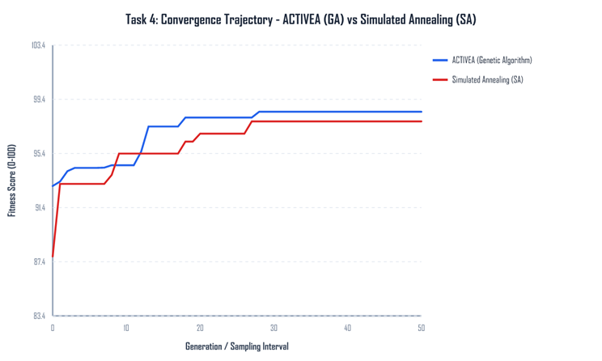
Figure 1. Best fitness for the genetic algorithm and simulated annealing.
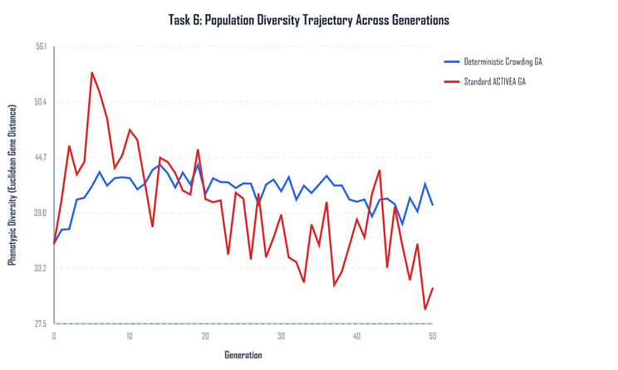
Figure 2. Population diversity with and without deterministic crowding.
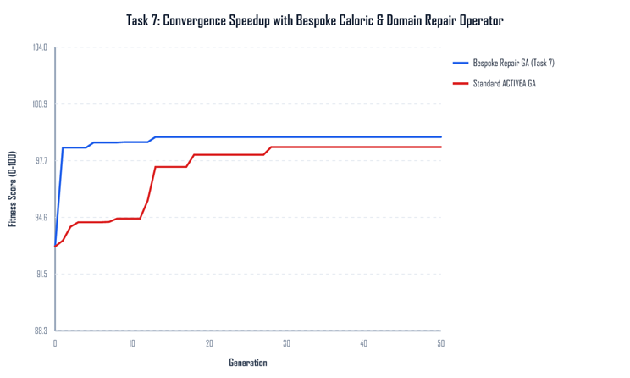
Figure 3. The plain genetic algorithm and the repair operator.
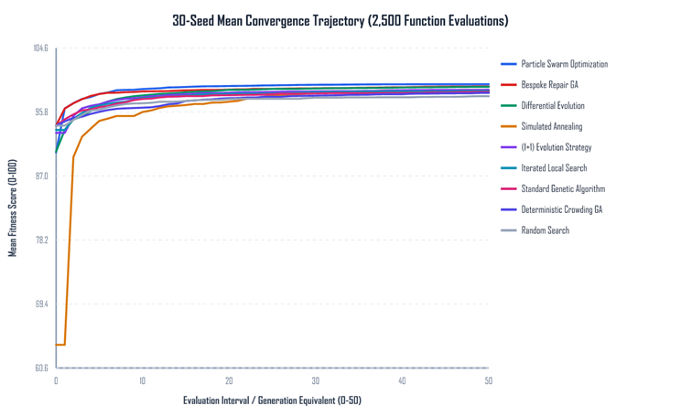
Figure 4. Mean convergence of the search methods on the same budget.
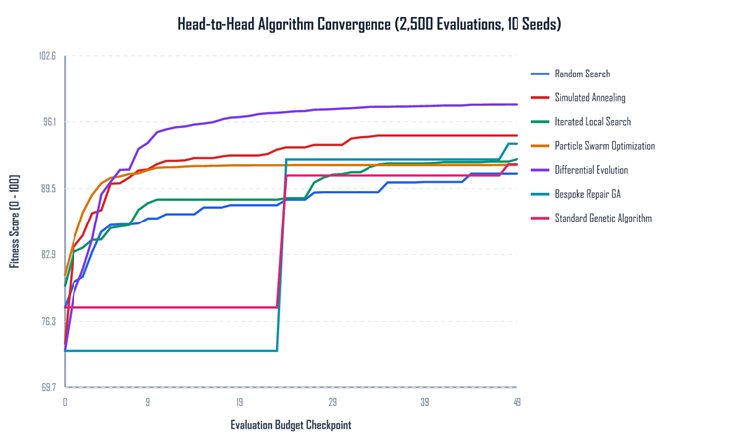
Figure 5. Convergence when sessions are scored with the saved calorie model.

References
- Jette, M., Sidney, K. and Blumchen, G. (1990) Metabolic equivalents (METS) in exercise testing, exercise prescription, and evaluation of functional capacity. Clinical Cardiology, 13(8), pp. 555-565. Cited in the coursework brief.
- Aston University (2026) DG4COM Computational Intelligence, coursework brief ACTIVEA. Birmingham: Aston University.
- Aston University (2024) Evolutionary Algorithms Knowledge Acquisition, lecture slides, DG4COM. Birmingham: Aston University.
- Aston University (2024) Local Search, lecture slides, DG4COM. Birmingham: Aston University.
- Aston University (2024) Parameter Management, lecture slides, DG4COM. Birmingham: Aston University.

Dataset Link : endomondoHR

