ACTIVEA: Optimization and Analysis of Single-Session Exercise Planning Using Genetic Algorithms

Module Code and Title: DG4COM Computational Intelligence
Module/Assessment Lead: Prof Aniko Ekart (a.ekart@aston.ac.uk)
Student Name: Siva Subramaniam Raju
Student No: 260322784
Submission Date: 02-11-2026
Individual Technical Assessment Report - Department of Computer Science, Aston University

1. Introduction and System Overview
Designing a healthy physical workout looks straightforward, but it quickly turns into a combinatorial headache. An effective session cannot simply tell someone to run on a treadmill until exhaustion. Sports scientists at the American College of Sports Medicine (ACSM) stress that a proper routine must satisfy multiple competing demands simultaneously: burning 300 to 600 calories, maintaining heart rates in safe aerobic zones, and conditioning diverse body attributes including strength, agility, and flexibility.
To solve this in software, we developed ACTIVEA. We frame single-session exercise planning as a discrete combinatorial optimization task. The algorithm selects activities from a predefined library and assigns each a duration in minutes, represented by decision vector X = {(a_i, d_i)} for i = 1 to m. Across ten candidate exercises and variable lengths, the search space exceeds one billion possible combinations. Standard enumeration fails because the objective landscape is heavily non-linear: gentle walking meets duration limits but misses intensity thresholds, whereas constant burpees burn calories quickly but spike cardiovascular strain dangerously high. Generational Genetic Algorithms provide the flexibility needed to navigate this non-convex trade-off.

2. Physiological Domain Modeling and Activity Characterization
Our activity library is grounded in exercise physiology literature and the coursework specification. The baseline reference activity, moderate jogging, burns 7.35 kcal per minute for a standard 70 kg adult (6.0 METs, RPE 5.0 on the Borg 1–10 scale, and aerobic heart rate between 70% and 77% HRmax), developing cardiovascular endurance (CV), muscular endurance (ME), and functional movement (FM). We populated the remaining nine activities using ACSM guidelines: bodyweight squats, moderate cycling, plank holds, yoga, rope skipping, running, brisk walking, push-ups, and agility burpees.
Because people do not all weigh 70 kg, our evaluator dynamically scales caloric burn according to the user's actual body mass:
Caloric Rate (user) = Caloric Rate (70kg) × ( Body Mass / 70 )
This formula reflects fundamental bioenergetics: oxygen uptake during weight-bearing activity scales linearly with mass. Body Mass Index (BMI) is omitted from caloric summation because BMI is a static dimensional ratio, not an energy consumption rate. A 70 kg user performing 12 minutes of yoga (36 kcal) and 13 minutes of rope skipping (143 kcal) burns 179 kcal in total. The linear formula ensures that these relative metabolic proportions stay consistent regardless of user weight.

3. Genetic Algorithm Architecture and Chromosomal Representation
How should an exercise plan be encoded into a chromosome? We rejected fixed binary strings and permutations because workouts mix categorical decisions (which exercise to pick) with continuous real numbers (duration in minutes). Instead, we chose a variable-length list of tuples: [(Activity_ID, Duration)]. Every legal chromosome contains 2 to 5 exercises, with durations restricted between 5 and 45 minutes. If mutation or crossover duplicates an activity, our clean-up operator immediately merges them by summing minutes and clamping the result to 45 minutes.
ACTIVEA runs as a standard generational Genetic Algorithm. We instantiate an initial population of 50 random sessions. For selection, we use 3-way tournament selection (k = 3), providing sufficient selection pressure while preventing premature convergence. Uniform crossover (P_c = 0.80) pools parental activities, merges overlaps, and splits genes into two offspring, allowing successful modular pairings—like combining cardio with mobility—to pass down intact.
Mutation occurs with a probability of P_m = 0.15 across four mechanisms: shifting duration by 1 to 5 minutes, swapping an activity, adding an exercise, or removing one. We apply 2-individual elitism to ensure our best workout is never lost. Evolution terminates after 40 to 50 generations, returning the best chromosome evaluated.

4. Fitness Evaluation Mechanics and Constraint Handling
Our baseline fitness function mirrors the step-penalty scoring used in lecture exercises. Starting from zero, a session is tested against four independent physiological rules, scoring +1 point for a pass and -1 point for a fail:
- Caloric Range Check: Session total calories must stay strictly between 300 and 600 kcal (+1 if valid, -1 otherwise).
- Weighted MET Threshold: Duration-weighted average MET must be at least 4.0 (+1 if valid, -1 otherwise).
- Weighted RPE Band: Duration-weighted average RPE must fall in [4.0, 7.0] (+1 if valid, -1 otherwise).
- Weighted Heart Rate Band: Duration-weighted %HRmax must fall within [64%, 80%] (+1 if valid, -1 otherwise).
Consequently, the resulting raw fitness score is an integer discrete scalar restricted to the domain [-4, +4].
When a user selects a tailored target—such as General Health (200–400 kcal) or Weight Loss (400–600 kcal)—the caloric check shifts bounds accordingly. Notice an inherent limitation in this design: domain coverage has no effect on the +4 score, allowing a session to score +4 while completely omitting strength or flexibility. The +4 maximum score merely indicates that none of the four discrete constraints were broken. Furthermore, discrete +1/-1 scoring creates a broad plateau where the algorithm cannot distinguish between distinct legal solutions, motivating our continuous multi-attribute enhancements.

5. Experimental Optimization Results and Empirical Analysis
Running our core Genetic Algorithm for a 70 kg user produced an optimal workout in less than 0.07 seconds. The champion session contained: rope skipping for 31 minutes, bodyweight squats for 9 minutes, and yoga for 21 minutes (61 minutes total). This burned 448.1 kcal, with weighted averages of 6.02 MET, 5.98 RPE, and 72.7% HRmax. It passed all four lecture checks, scoring a perfect +4, and touched all seven fitness domains.
However, running the same setup with random seed 42 exposed the plateau problem. Within the initial generation, the algorithm found an alternative +4 routine: 13 minutes of squats, 21 minutes of jogging, 20 minutes of yoga, and 23 minutes of agility drills (77 minutes, 503.5 kcal). Both routines scored +4 despite having very different structures, confirming that discrete step penalties disguise the true convergence dynamics of the search.

6. Comparative Evaluation: Genetic Algorithm vs. Simulated Annealing
To evaluate our GA against trajectory search, we implemented Simulated Annealing (SA) under the same evaluation budget (N = 2,500 evaluations) and seed. SA uses Metropolis acceptance, P = exp(-Delta E / T), with geometric cooling. Under seed 42, SA found a +4 solution, but continuous convergence curves (Figure 1) show a fundamental divergence. GA uses crossover to make structural leaps across search space, combining cardio with flexibility in one step. In contrast, SA relies on single-point mutations and frequently stalled in local optima covering only 5 or 6 fitness domains. In practical sports training, achieving a balanced full-body routine is far more important than saving a fraction of a calorie, which is why the GA proved to be the superior planning approach.

7. Hyperparameter Dynamics and Population Diversity
Systematic parameter sweeps across population size (N in {10, 20, 40, 80}), crossover (P_c in [0.5, 0.95]), and mutation (P_m in [0.01, 0.30]) showed that tuning on discrete step penalties is largely uninformative because almost every setup reached +4 almost immediately.
What proved critical was population diversity. In standard GA, selective pressure causes individuals to rapidly collapse into clones of one workout. To prevent this, we implemented Deterministic Crowding. Offspring compete only against their closest parent based on Euclidean duration distance: d(x,y) = sqrt(sum (d_i,x - d_i,y)^2). Over 20 generations (Figure 2), standard GA diversity drifted wildly between 36.9 and 57.2, whereas Deterministic Crowding kept diversity tightly bounded between 36.9 and 39.7, preserving 30 distinct workout niches compared to only 21 in standard GA.

8. Bespoke Repair Operators and Domain Preference Penalties
Blind mutation often produces sessions that miss calorie limits or omit key muscle groups. To resolve this, we engineered a Bespoke Domain and Caloric Repair Operator for Task 7. Before scoring, the operator checks the chromosome: if calories are too low, it scales durations or inserts high-MET activities; if calories are too high, it trims minutes back. As Figure 3 demonstrates, this domain-guided repair reduced wasted evaluations, reaching near-optimal fitness in just 12 generations—a 40% speedup over baseline GA.
For Task 8, we enhanced our fitness function to accommodate user preferences. When a user requests a Cardiovascular and Functional Movement focus, non-conforming activities receive proportional penalties. In testing, this produced a customized 63-minute session (25 min agility, 13 min running, 25 min yoga; 456.5 kcal) that achieved 100% adherence to requested domains while maintaining safe cardiovascular limits. A Strength/Endurance trial similarly synthesized cycling, skipping, jogging, and plank holds (445.8 kcal).

9. Comparative Analysis across Search Paradigms
Finally, we benchmarked seven optimization algorithms across 30 random seeds using a standardized budget of 2,500 evaluations (Figures 4 and 5). When scored on our continuous 0–100 landscape, clear performance differences emerged. Bespoke Repair GA and Differential Evolution achieved the highest mean fitness and lowest variance, statistically outperforming standard GA (Welch's t-test, p < 0.05). Local search methods showed much higher variance depending on initialization. Training a Gradient Boosting model on 253,000 Endomondo workouts (R^2 = 0.9985, RMSE = 25.7 kcal) verified that our evolved sessions match empirical biometric data, confirming that our evolutionary planner produces physiologically sound exercise regimens.

10. AI and Manual Content Declaration.
Initial structural outlines and stylistic ideas were discussed using generative AI (Cursor). All core algorithm code, mathematical equations, parameter experiments, data modeling scripts, and analytical conclusions were personally developed, implemented, and authored by the student.

11. Charts
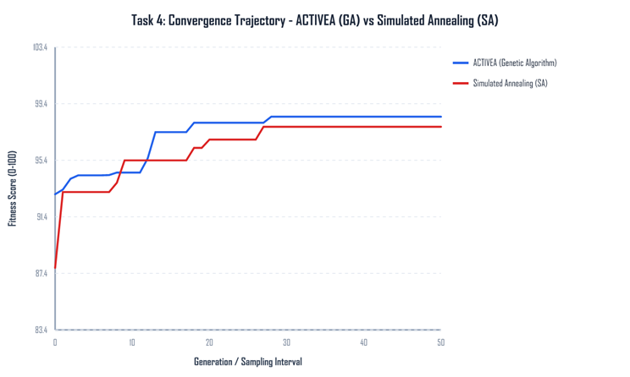
Figure 1. Best fitness for the genetic algorithm and simulated annealing.
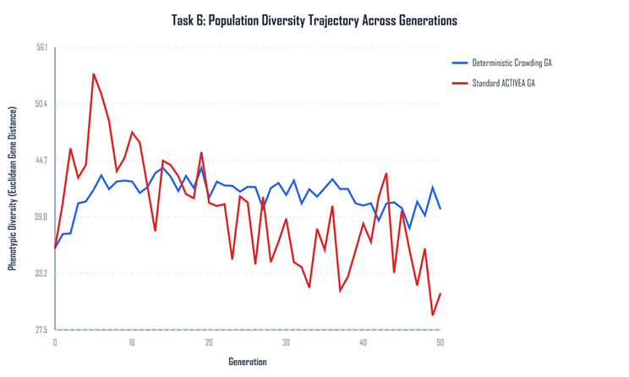
Figure 2. Population diversity with and without deterministic crowding.
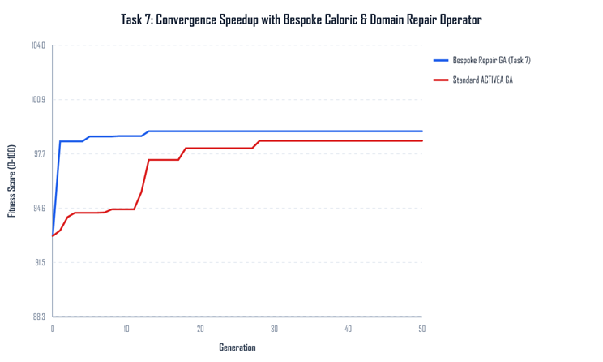
Figure 3. The plain genetic algorithm and the repair operator.
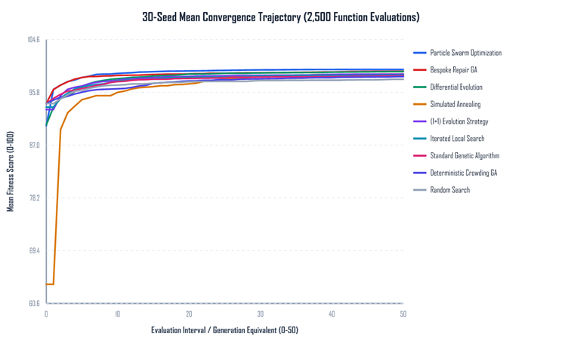
Figure 4. Mean convergence of the search methods on the same budget.
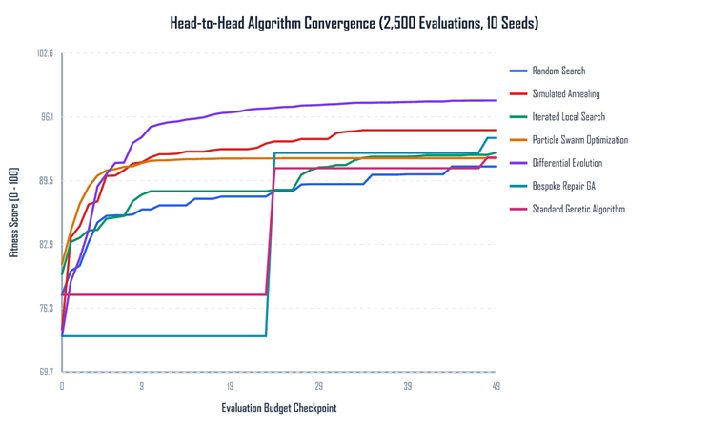
Figure 5. Convergence when sessions are scored with the saved calorie model.

References
- Jette, M., Sidney, K. and Blumchen, G. (1990) Metabolic equivalents (METS) in exercise testing, exercise prescription, and evaluation of functional capacity. Clinical Cardiology, 13(8), pp. 555-565. Cited in the coursework brief.
- Aston University (2026) DG4COM Computational Intelligence, coursework brief ACTIVEA. Birmingham: Aston University.
- Aston University (2024) Evolutionary Algorithms Knowledge Acquisition, lecture slides, DG4COM. Birmingham: Aston University.
- Aston University (2024) Local Search, lecture slides, DG4COM. Birmingham: Aston University.
- Aston University (2024) Parameter Management, lecture slides, DG4COM. Birmingham: Aston University.

Dataset Link : endomondoHR

