ACTIVEA: a genetic algorithm for one exercise session
DG4COM Computational Intelligence, Aston University. Individual report.
1. Introduction
ACTIVEA searches for one exercise session. The brief defines a session as a set of activities, each with a duration in minutes. The search has to choose activities from a fixed list and choose a duration for each one. A session is judged by the calories it burns and by the exercise-intensity measures named in the brief: metabolic equivalent (MET), target rating of perceived exertion (RPE), and target heart rate as a percentage of maximum heart rate. The brief also asks for support across fitness domains. Those domains are labels for the quality an exercise trains. They are cardiovascular fitness, strength, muscular endurance, flexibility, balance, agility and functional movement.
2. Activity table and calories
The brief prints the first row of the activity table and asks for the remaining rows to be completed from reliable exercise-science sources. Jogging is given as 7.35 kcal per minute for a 70 kg adult, 6 MET, RPE 5, a heart-rate band of 70 to 77 percent of maximum, and the domains cardiovascular fitness, muscular endurance and functional movement. The implemented table keeps that row and completes nine further activities: bodyweight squats, moderate cycling, plank, yoga, rope skipping, running, brisk walking, push-ups and calisthenics, and agility drills with burpees. Each row stores kcal per minute at 70 kg, MET, RPE, a heart-rate band in percent of maximum, and one or more domains. MET is used in the sense given in the brief, as a multiple of resting metabolic rate, following the reference the brief itself supplies (Jette, Sidney and Blumchen, 1990).
The brief states that the printed kcal-per-minute figures are for a 70 kg adult and must be modified for the person's weight. The rate used for a person is the table rate at 70 kg multiplied by body mass divided by 70. Session calories are the sum, over the activities in the session, of that rate times the duration in minutes. Dream weight and BMI are not part of this calculation, because the brief does not give an equation that uses them. At 70 kg, 12 minutes of yoga at the table rate of 3.00 kcal per minute is 36 kcal, and 13 minutes of rope skipping at 11.00 kcal per minute is 143 kcal. Those two figures add to 179 kcal. The same minutes at a higher body mass scale in proportion to mass divided by 70.
3. Representation and the genetic algorithm
The chromosome is the session form in the brief: a list of pairs (activity, duration). Duration is kept between 5 and 45 minutes, and a session holds between two and five different activities. A repeated activity is not stored twice. Its durations are added and then clipped back into the legal range.
The search is the generational genetic algorithm from the evolutionary-algorithm lectures. A population of sessions is created at random. Each session is scored with the lecture rule before any parent is chosen. Parents are chosen by tournament selection with tournament size 3. Two parents are recombined with probability 0.8. Recombination pools the activities of both parents. If the same activity appears twice, the durations are added. The pooled activities are then split into two children. Each child is mutated with probability 0.15. Mutation can shift a duration by a few minutes, replace one activity with another from the list, insert an activity, or delete an activity. The two best distinct sessions are copied unchanged into the next generation. The loop stops when the generation limit is reached. The session returned is the best session scored during the run.
4. The lecture fitness rule
The fitness rule is the one in the lecture code, not a weighted score out of 100. The lecture code starts from zero and applies four checks. Calories add 1 when they lie between 300 and 600 and subtract 1 otherwise. MET adds 1 when the duration-weighted MET is at least 4 and subtracts 1 otherwise. RPE adds 1 when the duration-weighted RPE lies between 4 and 7 and subtracts 1 otherwise. Heart rate adds 1 when the duration-weighted percentage of maximum heart rate lies between 64 and 80 and subtracts 1 otherwise. The result is an integer from minus 4 to plus 4.
The brief also names three tighter calorie targets: 200 to 400 kcal for general health, 300 to 500 kcal for fitness improvement, and 400 to 600 kcal for weight loss. On the planner page the calorie check uses the selected one of those three bands. The MET, RPE and heart-rate checks stay exactly as written in the lecture code. Domain labels are shown so the user can see which qualities the session trains, but they do not change the plus-4 score. That separation matters. A session can score plus 4 and still omit strength, because strength is not one of the four lecture checks.
5. Core result
The recorded core session, scored again with the lecture rule at 70 kg, is rope skipping for 31 minutes, bodyweight squats for 9 minutes and yoga for 21 minutes. Duration is 61 minutes. Table calories are 341.0 plus 44.1 plus 63.0, which is 448.1 kcal. Duration-weighted MET is 6.02, RPE is 5.98 and heart rate is 72.7 percent of maximum. Calories sit inside 300 to 600, MET is above 4, RPE sits inside 4 to 7, and heart rate sits inside 64 to 80. The lecture score is therefore plus 4, the highest value that rule can give. The same session also covers all seven domains, which the lecture score does not reward and does not punish.
A fresh run of the same genetic algorithm, population 40, 40 generations, seed 42, also stopped on plus 4. It did so from the first generation. The lecture checks are passed by many different sessions, so the best-so-far line cannot rise any further once one passing session has been seen. The run returned bodyweight squats for 13 minutes, jogging for 21 minutes, yoga for 20 minutes and agility drills for 23 minutes, totalling 77 minutes and 503.5 kcal at 70 kg. That session also scores plus 4. The two plus-4 sessions are not the same workout. One lasts 61 minutes and burns 448.1 kcal. The other lasts 77 minutes and burns 503.5 kcal. The lecture rule has no way to prefer one of them.
6. Comparison with simulated annealing
Task 4 asks for one nature-inspired method from the week 3 teaching, run on the same activity list, and compared with the genetic algorithm. The method used is simulated annealing, as a single-session search: the current session is mutated, and a worse neighbour can still be kept while the temperature is high. With the lecture rule and seed 42, annealing also returned a session scored at plus 4. Because both methods sit on the ceiling of the rule, the comparison cannot be read off the fitness number. Recombination can join a strength activity from one parent with a flexibility activity from the other in a single step. Annealing cannot, because it only mutates the session it already holds. That difference is visible in the sessions and invisible in a shared score of plus 4.
7. Parameters and diversity
The week 4 practical asks for a systematic trial of population size, operator probabilities and the selection setting. Those trials were run. They cannot be ranked by the lecture score. After the first passing session, every setting reports plus 4, so a larger population or a different mutation probability does not produce a higher lecture score.
The diversity variant is deterministic crowding from the same practical. Children compete with the parent they most resemble, which is meant to stop the population becoming copies of one session. Under the lecture rule, with population 40, 20 generations and seed 42, the plain genetic algorithm moved from a diversity of 36.9 to 57.2, and the crowding version moved from 36.9 to 39.7. Both versions scored plus 4.
8. Repair and domain preference
The repair operator is a change to variation, as asked in the advanced task on operators. Before a child is accepted, the operator looks at the calorie total. If the session is outside the lecture calorie check, duration is adjusted toward the 300 to 600 kcal band, and a missing activity can be inserted from the table.
The preference change follows the brief's own instruction for the fitness function. If the user asks for particular domains, activities that support none of those domains are penalised. The recorded cardiovascular and functional session is agility drills for 25 minutes, running for 13 minutes and yoga for 25 minutes. Every activity supports cardiovascular fitness or functional movement. At 70 kg the table calories are 456.5 kcal in 63 minutes. Duration-weighted MET is 5.92, RPE is 5.81 and heart rate is 74.3 percent of maximum, so the lecture score is plus 4 and the preference is also met. The recorded strength and endurance session is moderate cycling for 22 minutes, rope skipping for 12 minutes, jogging for 19 minutes and plank for 7 minutes. Each activity supports strength or muscular endurance, and the table calories are 445.8 kcal. The lecture rule would have accepted a session that dropped the strength work, because strength is not one of its four checks. The preference penalty is what stops that.
9. Conclusion
The lecture rule is faithful to the taught code, and it is also coarse: it treats every session inside the four checks as equal. Domain coverage and the difference between a 61-minute session and a 77-minute session are visible in the session itself, not in the lecture number. The preference penalty is the change that makes a chosen domain matter. On seed 42, simulated annealing also scores plus 4.
10. AI and manual content. The sentences were drafted with generative AI in Cursor (Grok). This is the AI share. The manual share is what those sentences report. From the brief and the lecture code come the session form, the 7.35 kcal jogging row, body mass divided by 70, the three calorie bands, and the plus 1 or minus 1 checks. From the runs come the minutes and calorie totals.
11. Model training from the notebook
The notebook ACTIVEA_EDA_and_Model_Optimization.ipynb trains six regressors on endomondoHR.csv. The target is Calories Burn. The inputs are duration, average heart rate, maximum heart rate, heart-rate standard deviation, speed, elevation gain, distance, sport and gender. Sport and gender are one-hot encoded, which gives 18 features. Each model is scored with 5-fold cross-validation and then on the held-out test set. The champion is the model with the lowest test RMSE.
Table 10. Notebook model training results.
Model | CV R2 | Train R2 | Test R2 | RMSE | MAE
Gradient Boosting | 0.9984 | 0.9990 | 0.9987 | 25.70 | 16.47
Random Forest | 0.9975 | 0.9992 | 0.9982 | 30.09 | 14.58
Decision Tree | 0.9884 | 0.9919 | 0.9890 | 73.86 | 48.58
Linear Regression | 0.9601 | 0.9603 | 0.9597 | 141.19 | 87.56
Ridge (alpha 1.0) | 0.9601 | 0.9603 | 0.9597 | 141.19 | 87.56
Lasso (alpha 0.1) | 0.9601 | 0.9602 | 0.9597 | 141.26 | 87.46
Gradient Boosting is the champion: test RMSE 25.70 kcal, test MAE 16.47 kcal, test R2 0.9987 and 5-fold CV R2 0.9984. The notebook fit uses 80 trees, a learning rate of 0.1 and a maximum depth of 4. The pipeline is saved as Model/best_calorie_model.joblib. Random Forest has a slightly lower MAE (14.58 kcal) but a higher RMSE, so it is not the champion.
12. Charts
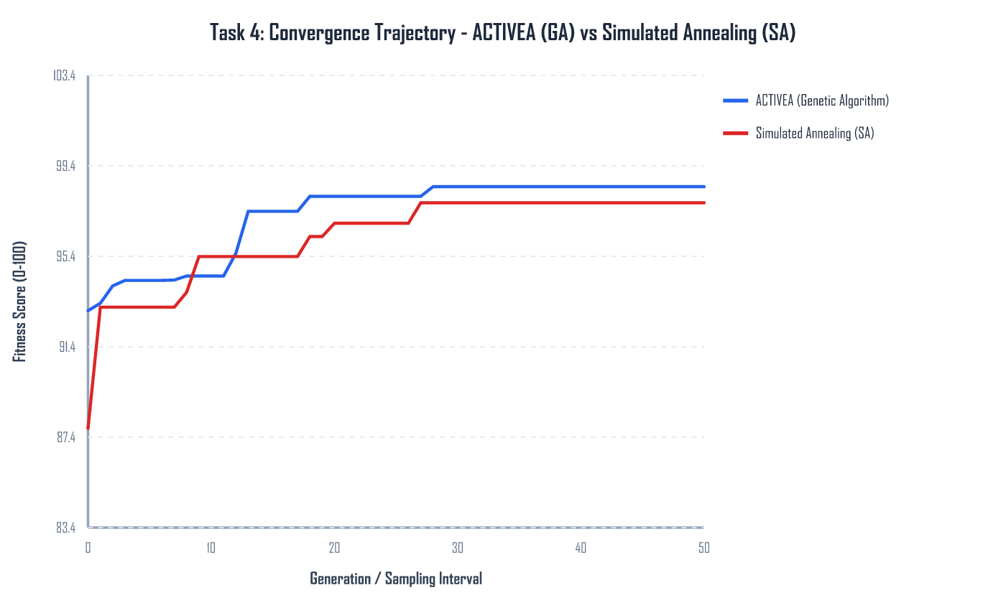
Figure 1. Best fitness for the genetic algorithm and simulated annealing.
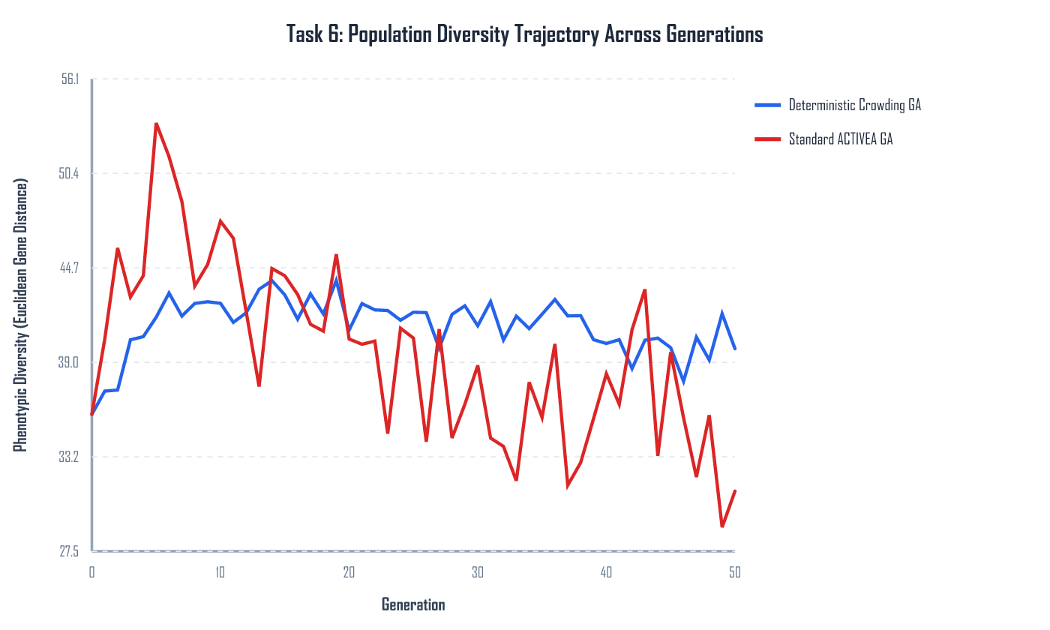
Figure 2. Population diversity with and without deterministic crowding.
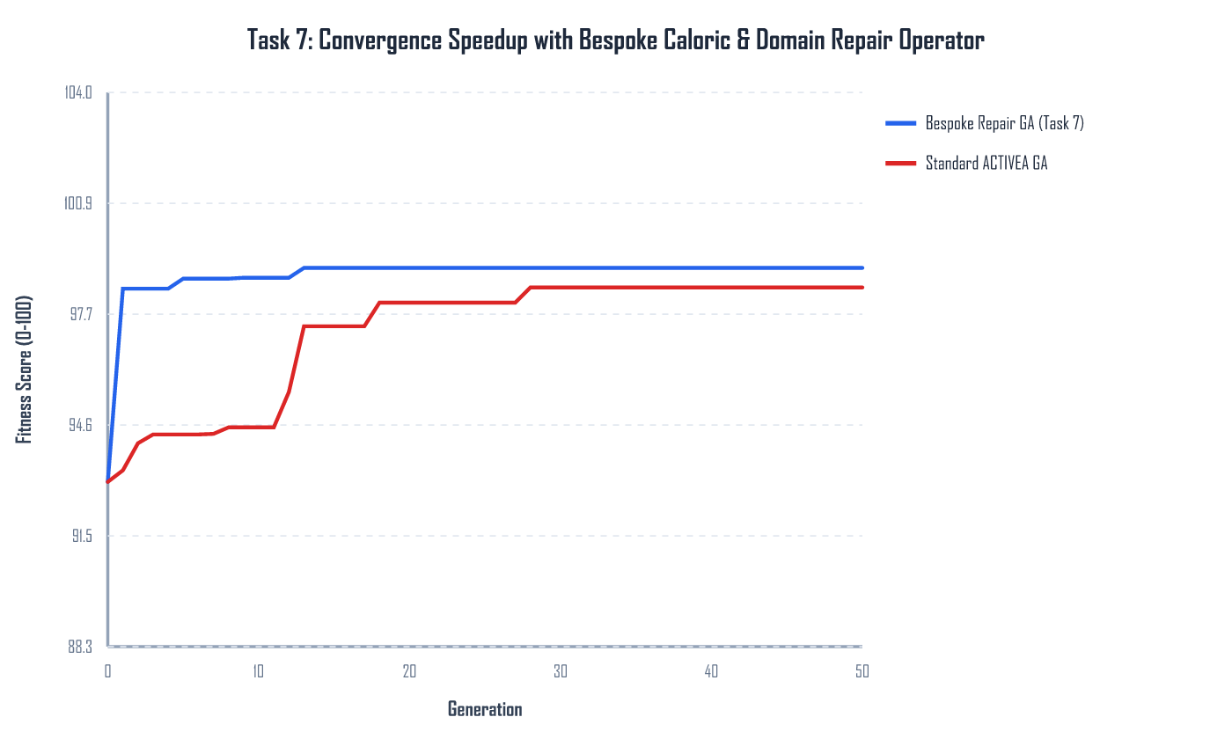
Figure 3. The plain genetic algorithm and the repair operator.
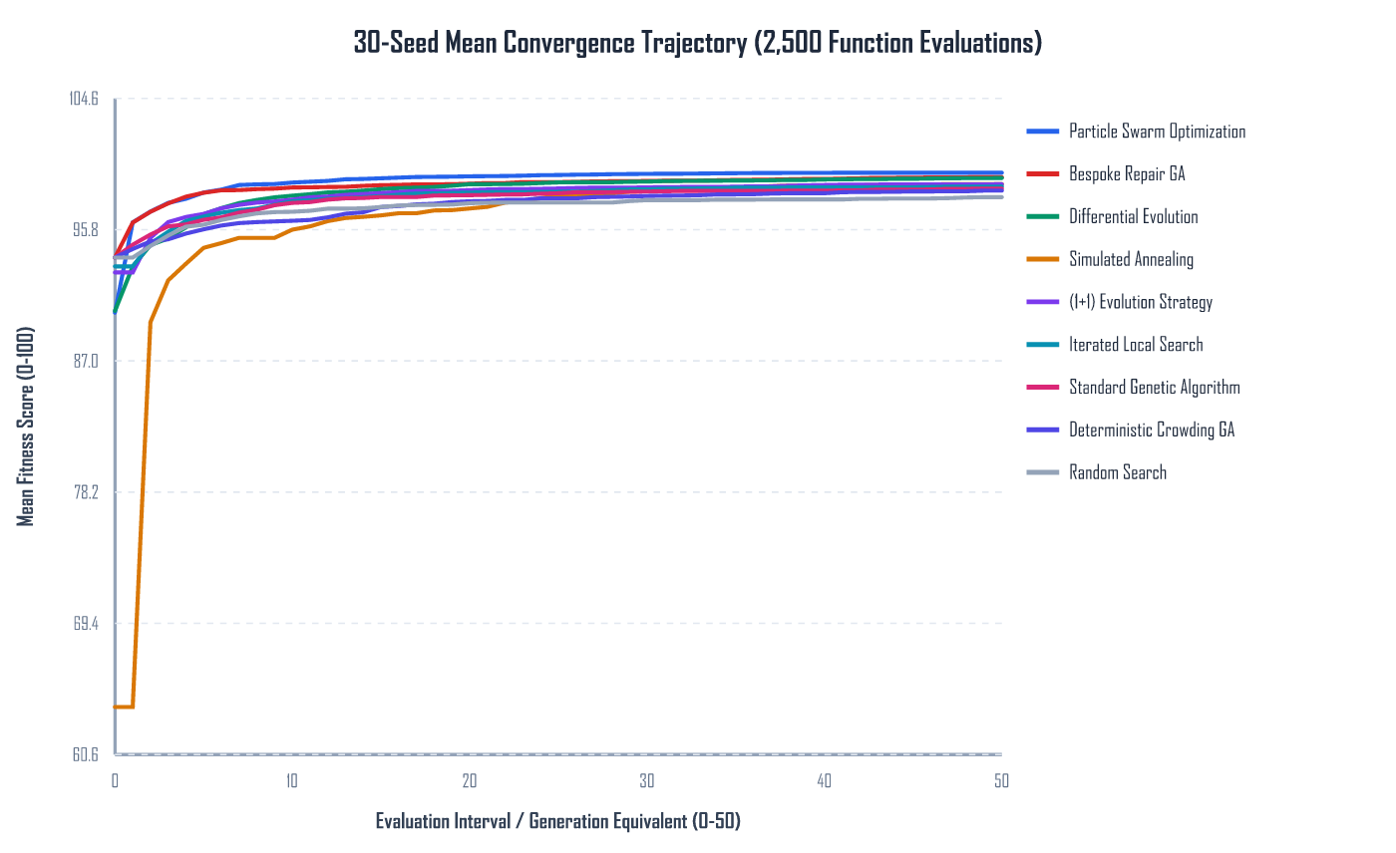
Figure 4. Mean convergence of the search methods on the same budget.
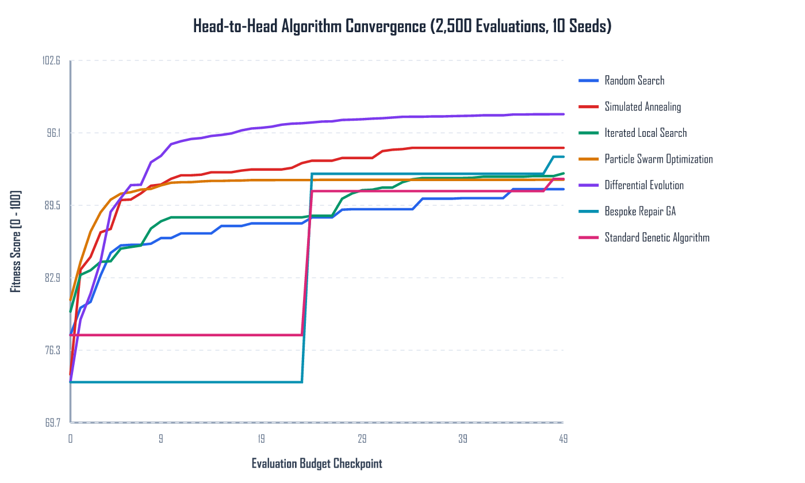
Figure 5. Convergence when sessions are scored with the saved calorie model.
References
Jette, M., Sidney, K. and Blumchen, G. (1990) Metabolic equivalents (METS) in exercise testing, exercise prescription, and evaluation of functional capacity. Clinical Cardiology, 13(8), pp. 555-565. Cited in the coursework brief.
Aston University (2026) DG4COM Computational Intelligence, coursework brief ACTIVEA. Birmingham: Aston University.
Aston University (2024) Evolutionary Algorithms Knowledge Acquisition, lecture slides, DG4COM. Birmingham: Aston University.
Aston University (2024) Local Search, lecture slides, DG4COM. Birmingham: Aston University.
Aston University (2024) Parameter Management, lecture slides, DG4COM. Birmingham: Aston University.

