<!DOCTYPE html>

<html lang="en">

<head>

    <title>Document</title>

    <style>

        #box1{text-decoration: underline;}

        #box2{text-decoration: overline;}

        #box3{text-decoration: line-through;}

        .box2{text-decoration: underline;}

    </style>

</head>

<body>

    <h3 id="box1" class="box">Box1</h3>

    <h3 id="box2" class="box">Box2</h3>

    <h3 id="box3" class="box">Box3</h3>

</body>

</html>

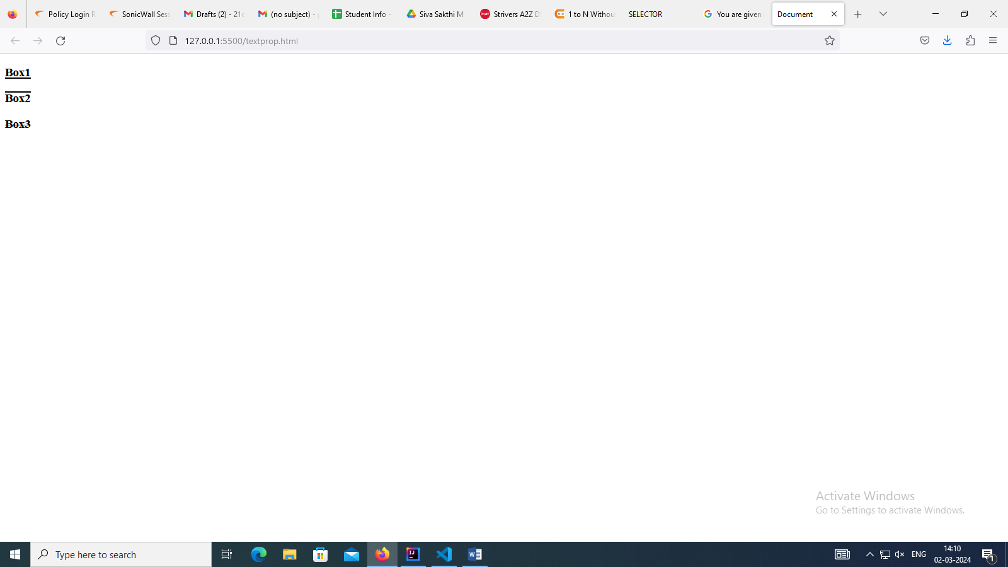

<!DOCTYPE html>

<html lang="en">

<head>

    <title>Document</title>

    <style>

       /\* #box1{text-decoration: underline;}

        #box2{text-decoration: overline;}

        #box3{text-decoration: line-through;}

        .box2{text-decoration: underline;}\*/

        #box1{text-decoration-color: black;}

        #box2{text-decoration-color: brown;}

        #box3{text-decoration-color: aqua;}

        .box{text-decoration: underline;}

    </style>

</head>

<body>

    <h3 id="box1" class="box">Box1</h3>

    <h3 id="box2" class="box">Box2</h3>

    <h3 id="box3" class="box">Box3</h3>

</body>

</html>

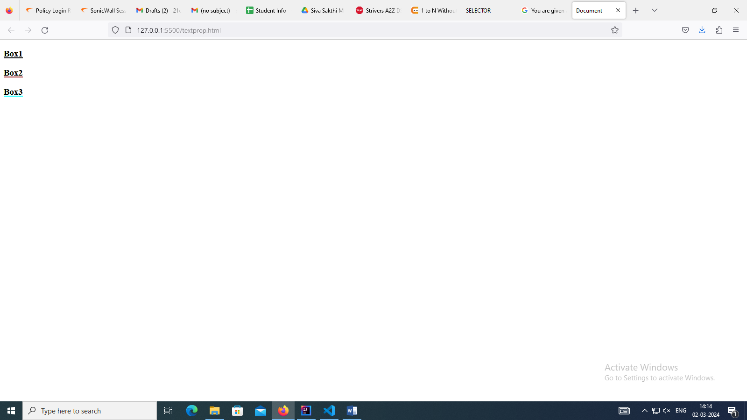

<!DOCTYPE html>

<html lang="en">

<head>

    <title>Document</title>

    <style>

       /\* #box1{text-decoration: underline;}

        #box2{text-decoration: overline;}

        #box3{text-decoration: line-through;}

        .box2{text-decoration: underline;}

        #box1{text-decoration-color: black;}

        #box2{text-decoration-color: brown;}

        #box3{text-decoration-color: aqua;}\*/

        .box{text-decoration: underline;}

        #box1{text-transform: uppercase;}

        #box2{text-transform: lowercase;}

        #box3{text-transform: capitalize;}

    </style>

</head>

<body>

    <h3 id="box1" class="box">Box1</h3>

    <h3 id="box2" class="box">Box2</h3>

    <h3 id="box3" class="box">Box3</h3>

</body>

</html>

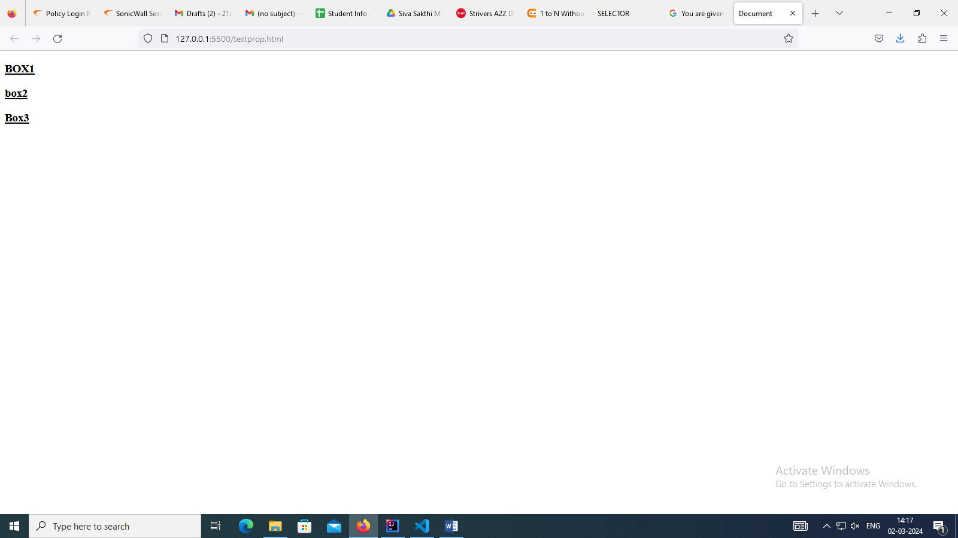<!DOCTYPE html>

<html lang="en">

<head>

    <title>Document</title>

    <style>

       /\* #box1{text-decoration: underline;}

        #box2{text-decoration: overline;}

        #box3{text-decoration: line-through;}

        .box2{text-decoration: underline;}

        #box1{text-decoration-color: black;}

        #box2{text-decoration-color: brown;}

        #box3{text-decoration-color: aqua;}

        .box{text-decoration: underline;}

        #box1{text-transform: uppercase;}

        #box2{text-transform: lowercase;}

        #box3{text-transform: capitalize;}\*/

        #box1{line-height: 6px;}

        #box2{line-height: 300px;}

        .box{text-decoration: underline;}

    </style>

</head>

<body>

    <h3 id="box1" class="box">Box1</h3>

    <h3 id="box2" class="box">Box2</h3>

    <h3 id="box3" class="box">Box3</h3>

</body>

</html>

<!DOCTYPE html>

<html lang="en">

<head>

    <title>Document</title>

    <style>

       /\* #box1{text-decoration: underline;}

        #box2{text-decoration: overline;}

        #box3{text-decoration: line-through;}

        .box2{text-decoration: underline;}

        #box1{text-decoration-color: black;}

        #box2{text-decoration-color: brown;}

        #box3{text-decoration-color: aqua;}

        .box{text-decoration: underline;}

        #box1{text-transform: uppercase;}

        #box2{text-transform: lowercase;}

        #box3{text-transform: capitalize;}

        #box1{line-height: 6px;}

        #box2{line-height: 300px;}\*/

        .box{text-decoration: underline;}

        #box1{font-size: large;}

        #box2{font-size: 10px;}

    </style>

</head>

<body>

    <h3 id="box1" class="box">Box1</h3>

    <h3 id="box2" class="box">Box2</h3>

    <h3 id="box3" class="box">Box3</h3>

</body>

</html>

<!DOCTYPE html>

<html lang="en">

<head>

    <title>Document</title>

    <style>

       /\* #box1{text-decoration: underline;}

        #box2{text-decoration: overline;}

        #box3{text-decoration: line-through;}

        .box2{text-decoration: underline;}

        #box1{text-decoration-color: black;}

        #box2{text-decoration-color: brown;}

        #box3{text-decoration-color: aqua;}

        .box{text-decoration: underline;}

        #box1{text-transform: uppercase;}

        #box2{text-transform: lowercase;}

        #box3{text-transform: capitalize;}

        #box1{line-height: 6px;}

        #box2{line-height: 300px;}

        #box1{font-size: large;}

        #box2{font-size: 10px;}\*/

        #box1{font-weight: 100;}

        #box2{font-weight: 200;}

        #box3{font-weight: 300;}

        .box{text-decoration: underline;}

    </style>

</head>

<body>

    <h3 id="box1" class="box">Box1</h3>

    <h3 id="box2" class="box">Box2</h3>

    <h3 id="box3" class="box">Box3</h3>

</body>

</html>

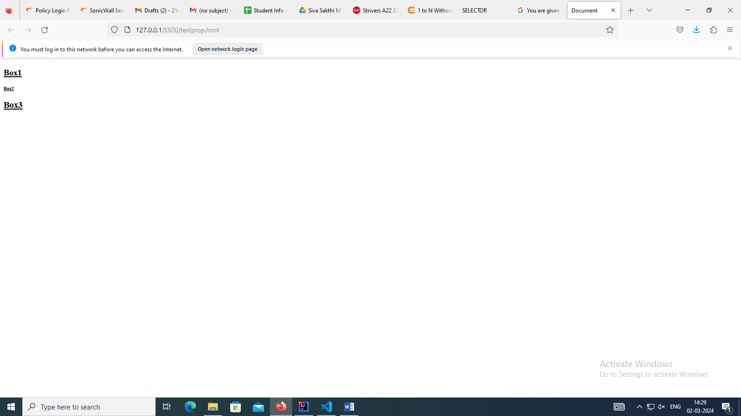

<!DOCTYPE html>

<html lang="en">

<head>

    <title>Document</title>

    <style>

       /\* #box1{text-decoration: underline;}

        #box2{text-decoration: overline;}

        #box3{text-decoration: line-through;}

        .box2{text-decoration: underline;}

        #box1{text-decoration-color: black;}

        #box2{text-decoration-color: brown;}

        #box3{text-decoration-color: aqua;}

        .box{text-decoration: underline;}

        #box1{text-transform: uppercase;}

        #box2{text-transform: lowercase;}

        #box3{text-transform: capitalize;}

        #box1{line-height: 6px;}

        #box2{line-height: 300px;}

        #box1{font-size: large;}

        #box2{font-size: 10px;}

        #box1{font-weight: 100;}

        #box2{font-weight: 200;}

        #box3{font-weight: 300;}\*/

        #box1{font-style: italic;}

        #box2{font-style:oblique;}

        #box3{font-style: normal;}

        .box{text-decoration: underline;}

    </style>

</head>

<body>

    <h3 id="box1" class="box">Box1</h3>

    <h3 id="box2" class="box">Box2</h3>

    <h3 id="box3" class="box">Box3</h3>

</body>

</html>

