**What is XAMPP?**  
XAMPP is a free and open-source software package that includes **Apache (web server), MySQL (database), PHP, and Perl**. It creates a local server environment for web applications like **OrangeHRM**.

**What is OrangeHRM?**  
OrangeHRM is an open-source **Human Resource Management** system. Companies use it for managing employees, attendance, leave, and payroll.

**Step 1:** Download Required Software

**Download XAMPP** from Apache Friends - <https://www.apachefriends.org/download.html>

* Choose the latest **Windows** version with PHP & MySQL.

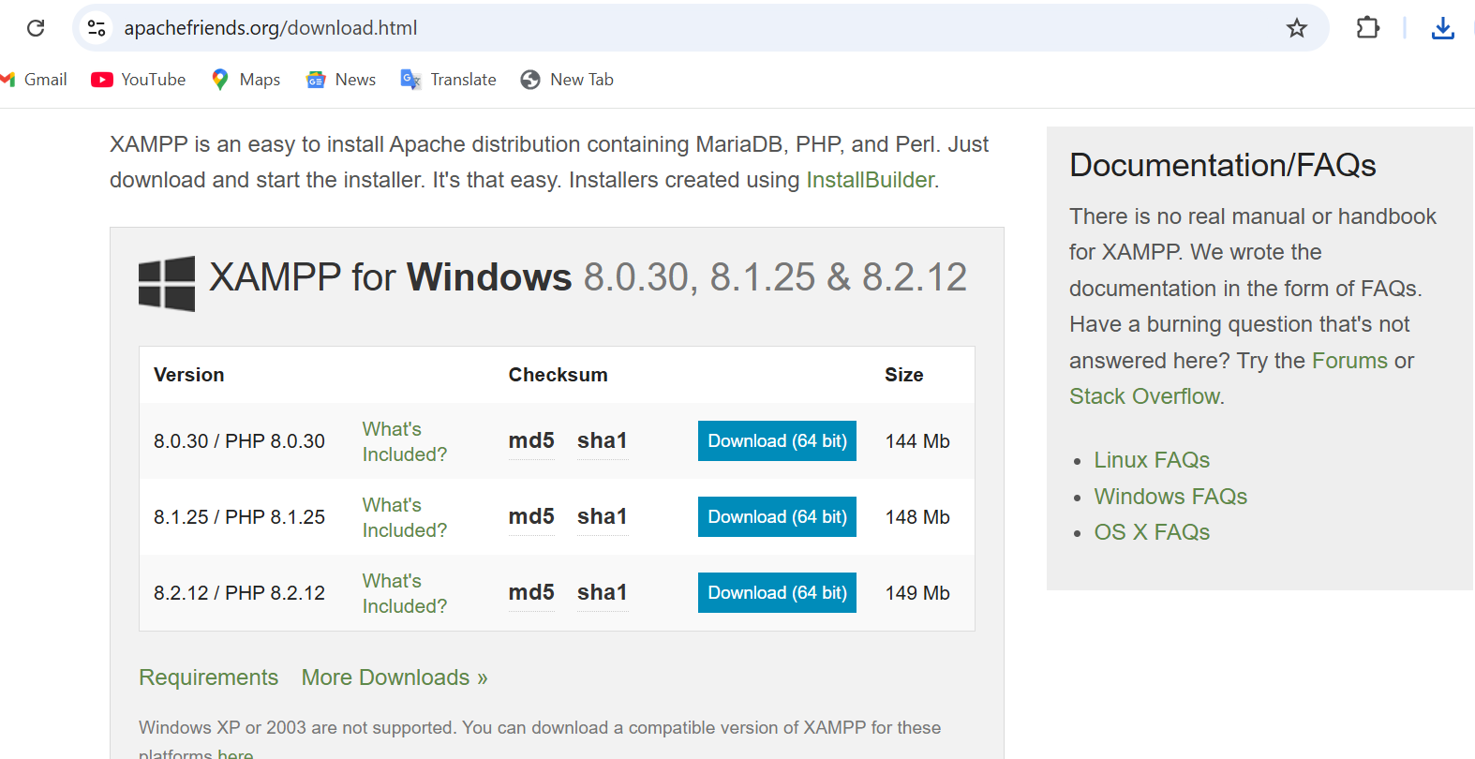

**Download OrangeHRM** from OrangeHRM SourceForge - <https://www.orangehrm.com/en/open-source/register-to-download>

* Get the **OrangeHRM open-source version** (.zip file).

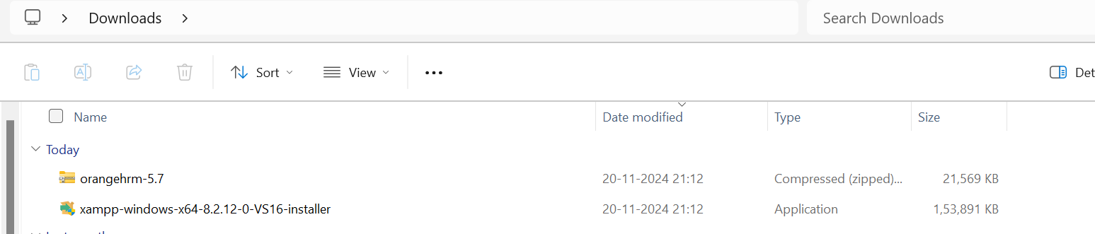

**Step 2: Install XAMPP** **in C:\xampp - screenshots are not available.**

**Step 3:** Start **Apache** and **MySQL** from the XAMPP Control Panel.

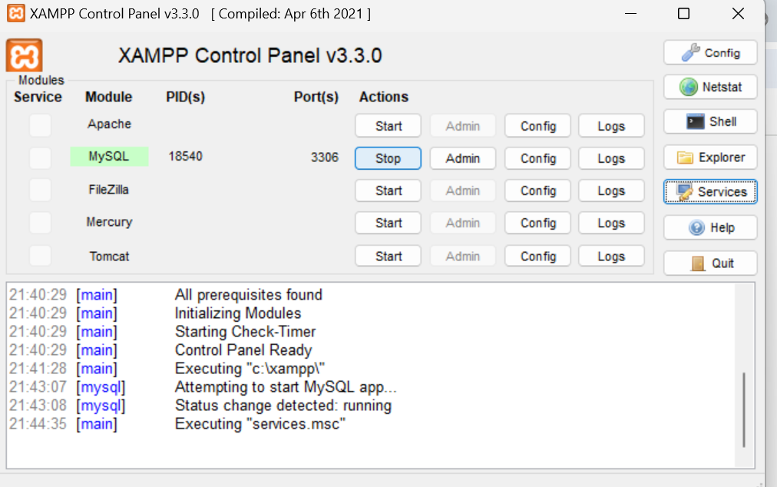

**Click on admin**

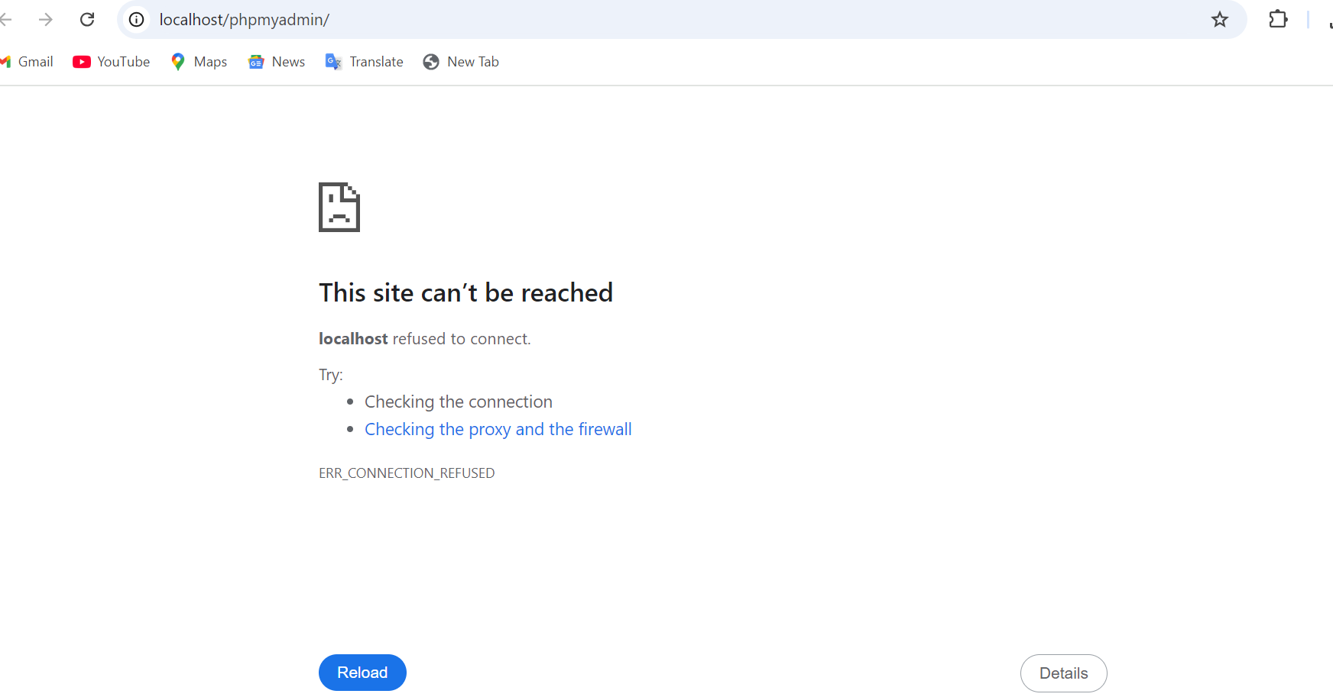

Both are started

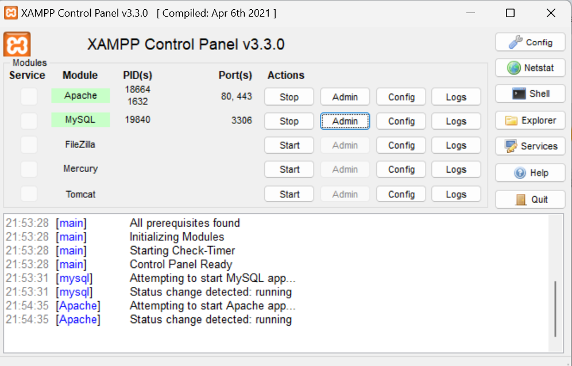

**Step 4: Create a Database in phpMyAdmin**

1. Open **phpMyAdmin**:
   * Visit <http://localhost/phpmyadmin/> in your browser.

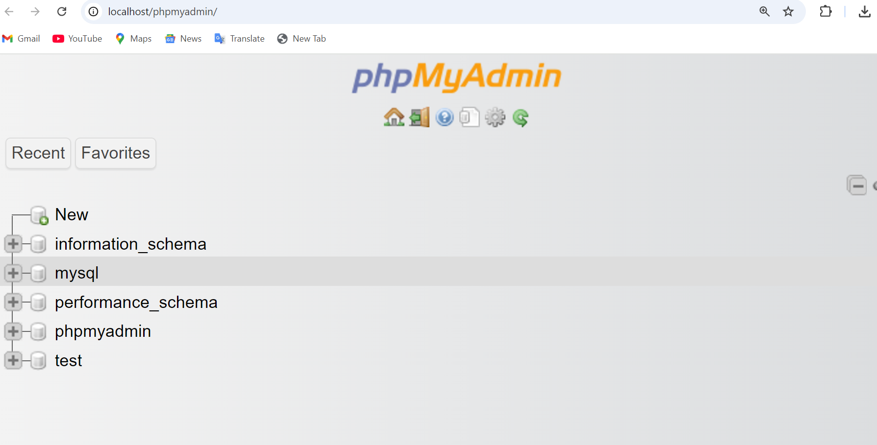

1. Click **New > Create Database**.
2. Enter **orangehrm** as the database name and click **Create**.



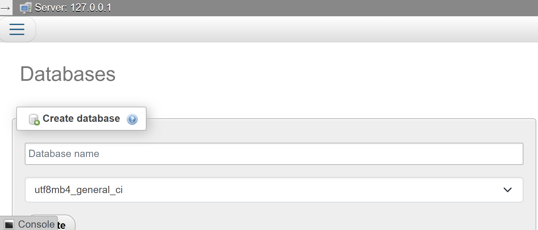

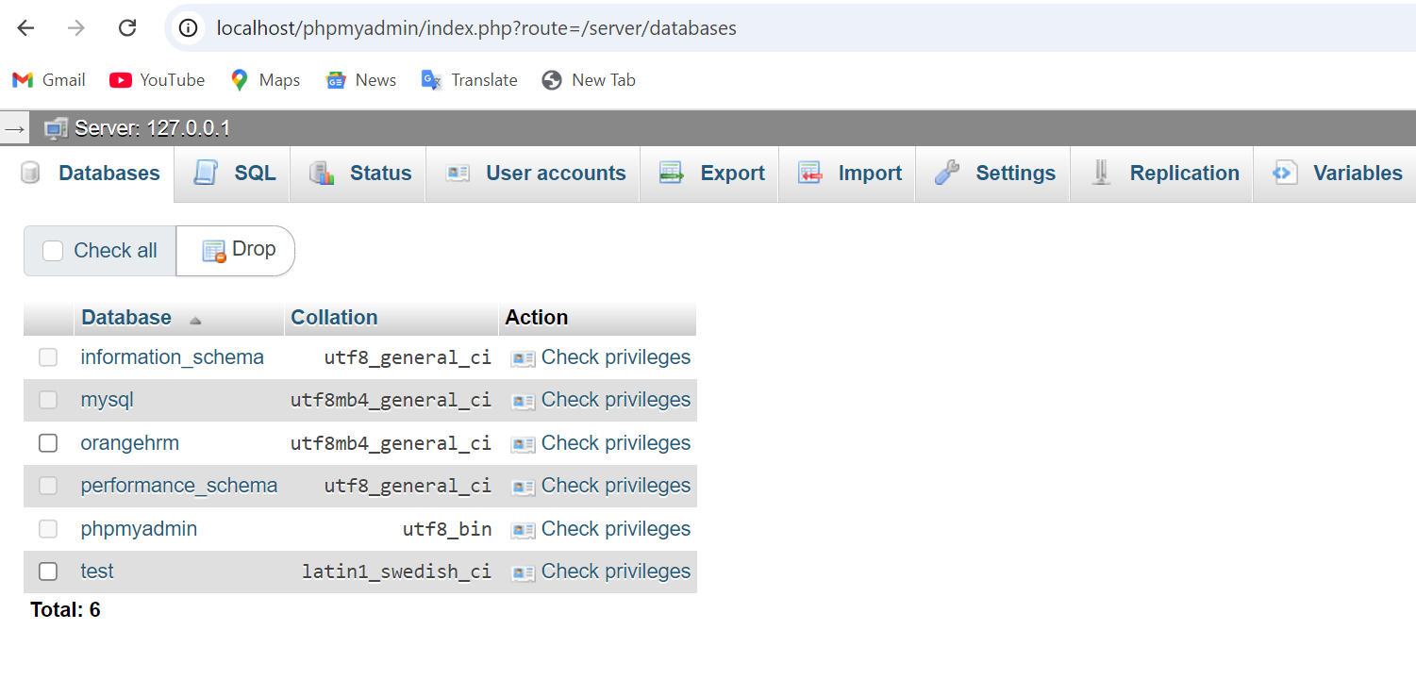

**Step 5: Drop orangehrm folder in below location**

1. Extract the downloaded OrangeHRM ZIP file.
2. Move the extracted **OrangeHRM** folder to:

C:\xampp\htdocs\

1. Rename the folder if needed (e.g., orangehrm).

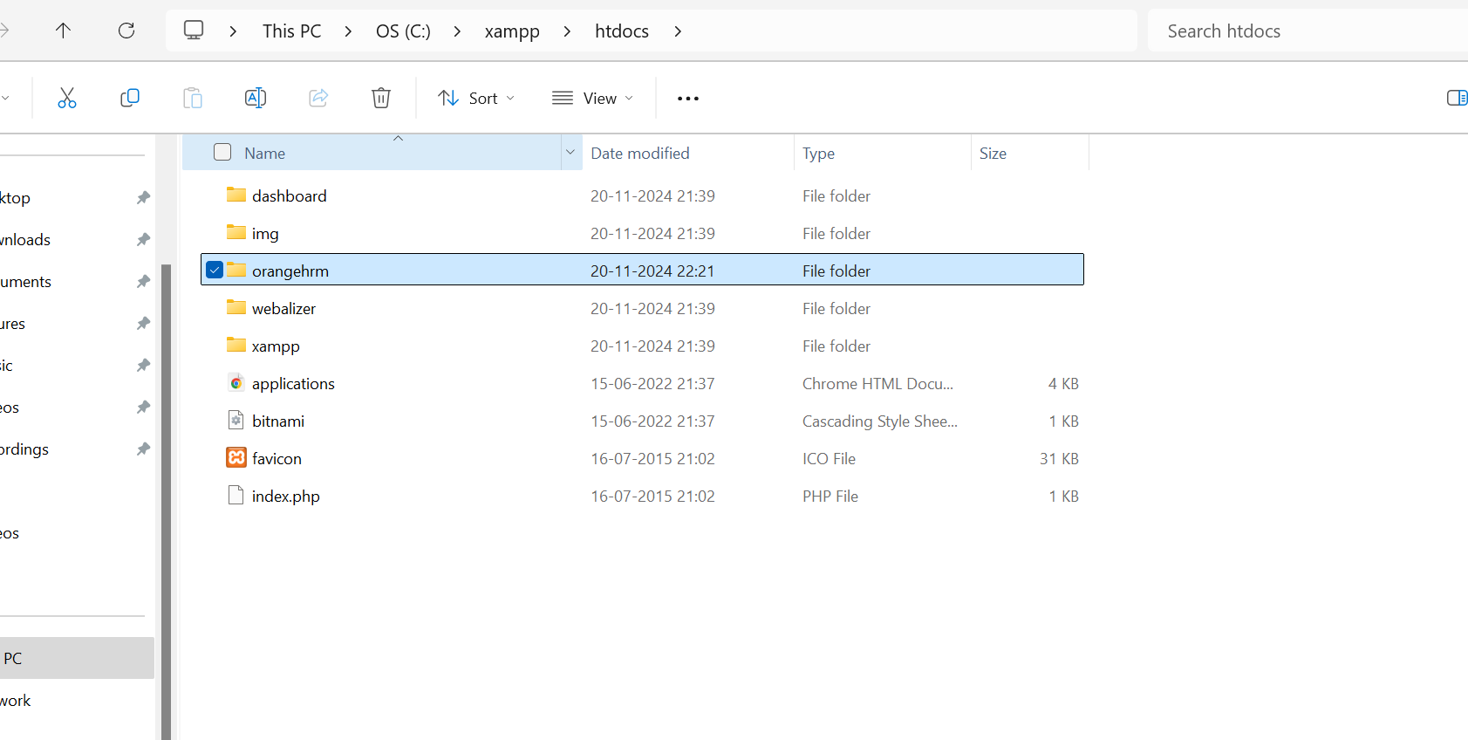

**Step 6: Install OrangeHRM**

1. Open your browser and go to:

[**http://localhost/orangehrm/**](http://localhost/orangehrm/)

1. Follow the **installation wizard**:
   * **Database Host**: localhost
   * **Database Name**: orangehrm
   * **Database User**: root
   * **Password**: (leave blank if no password is set)
2. Complete the setup and log in to OrangeHRM.

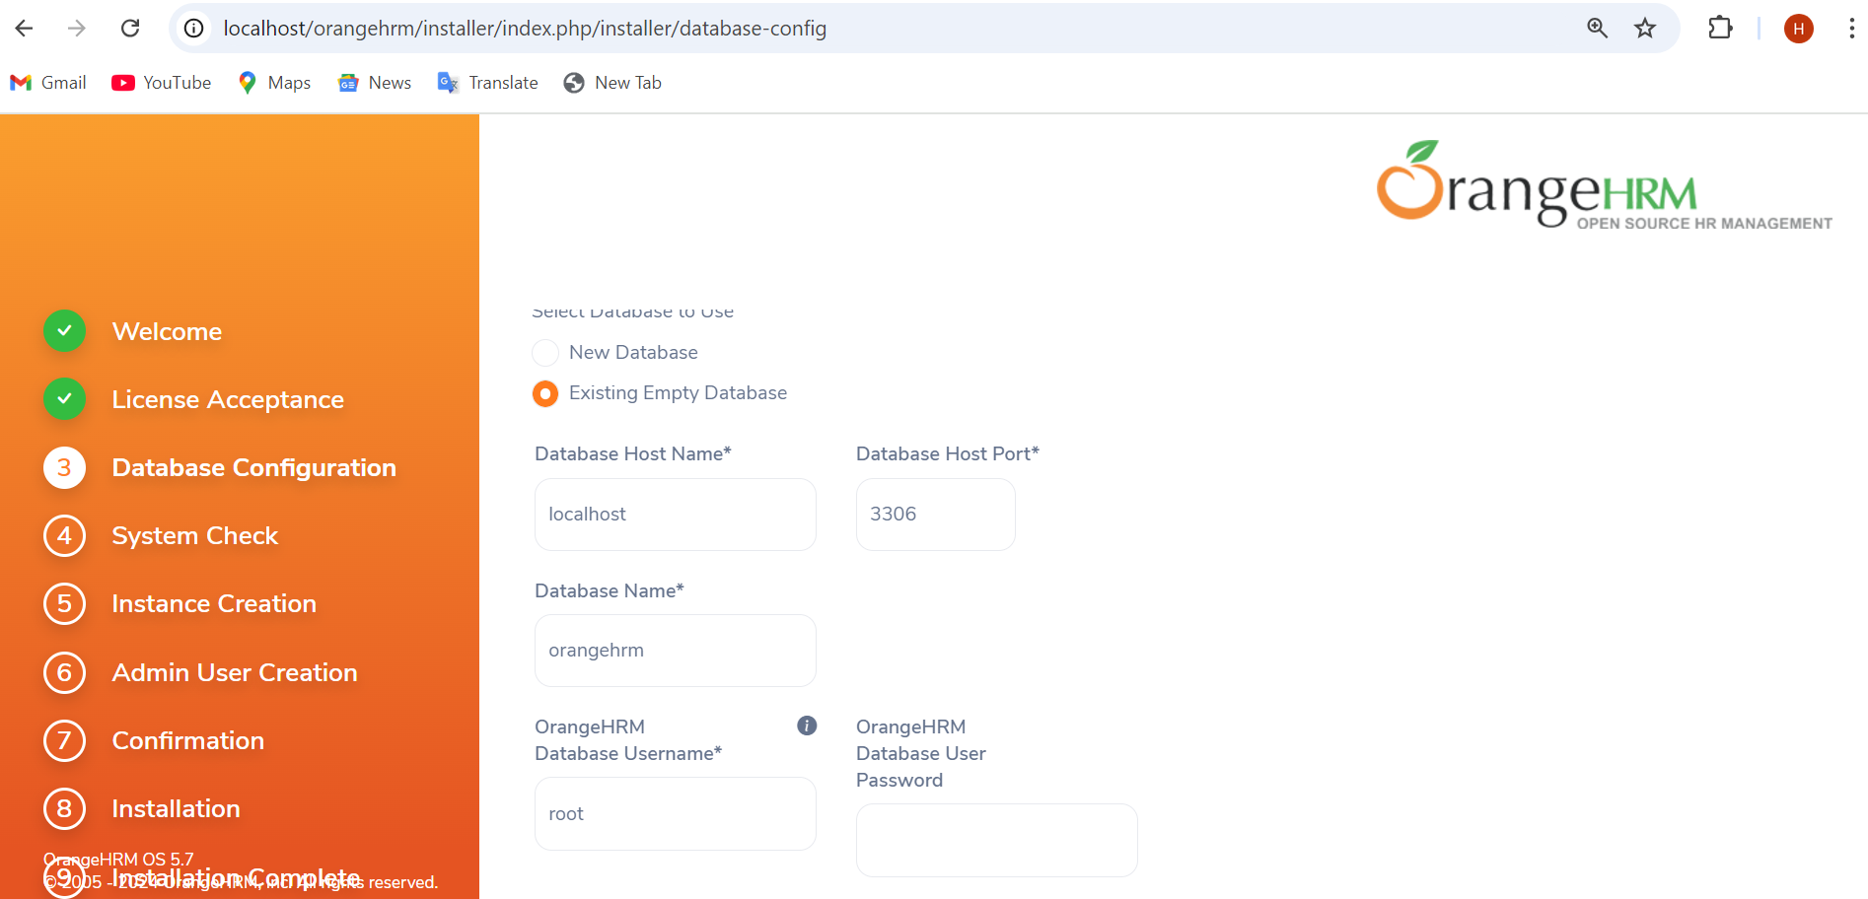

While installing if it is showing disabled – like extension=ldap then do the following (open **php.ini** file)

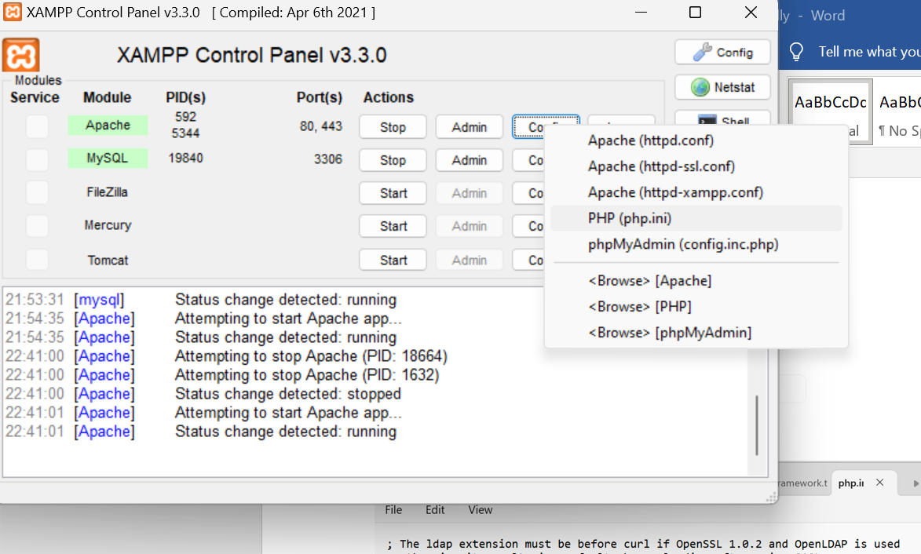

Remove the semicolon at the beginning

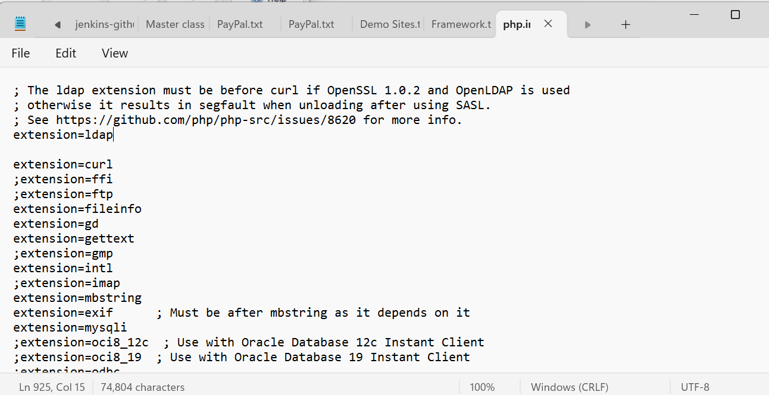

**Create admin user**

orangehrm_hverma

Pswd: **********

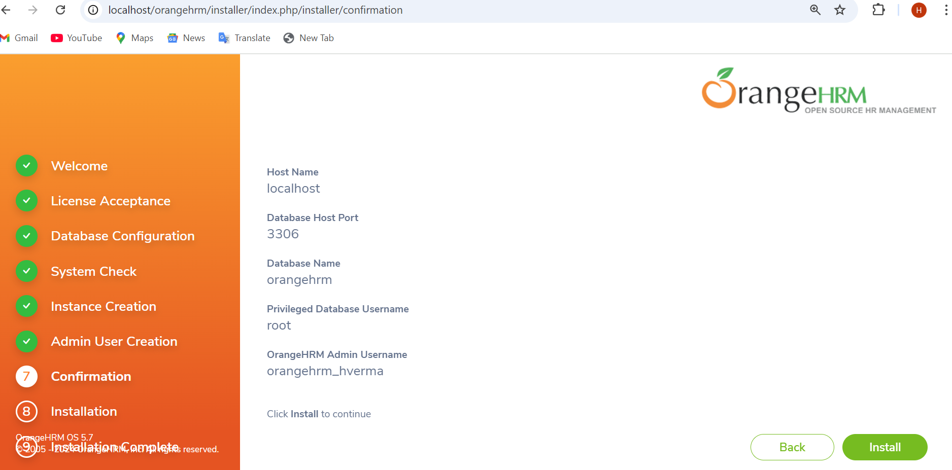

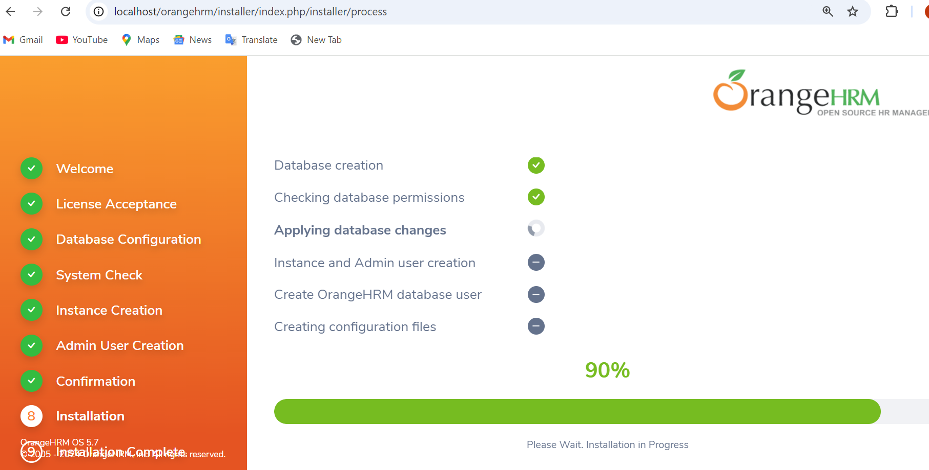

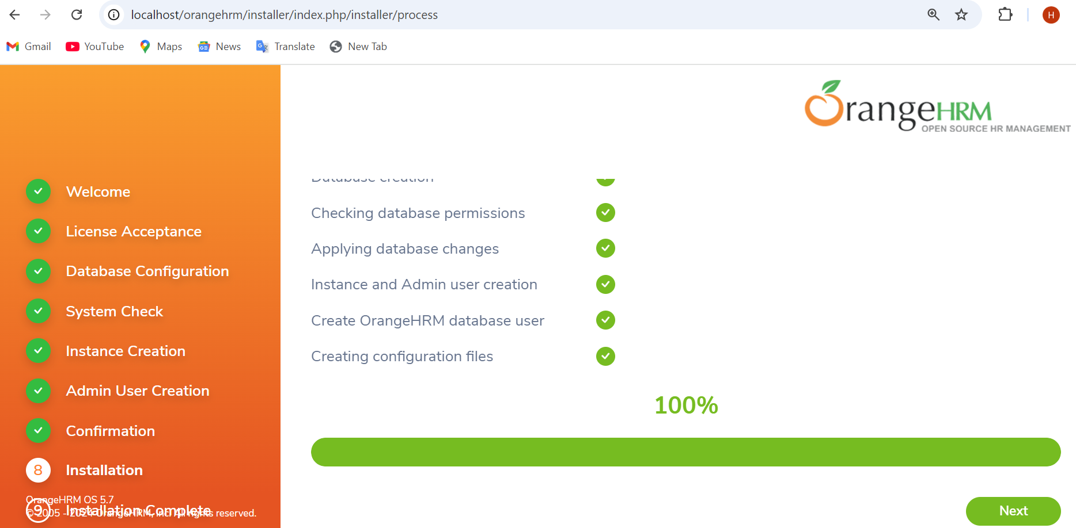

To access database: <http://localhost/phpmyadmin>

To access application: <http://localhost/orangehrm>

**Important note:**

If you get error like this below while running MySQL:

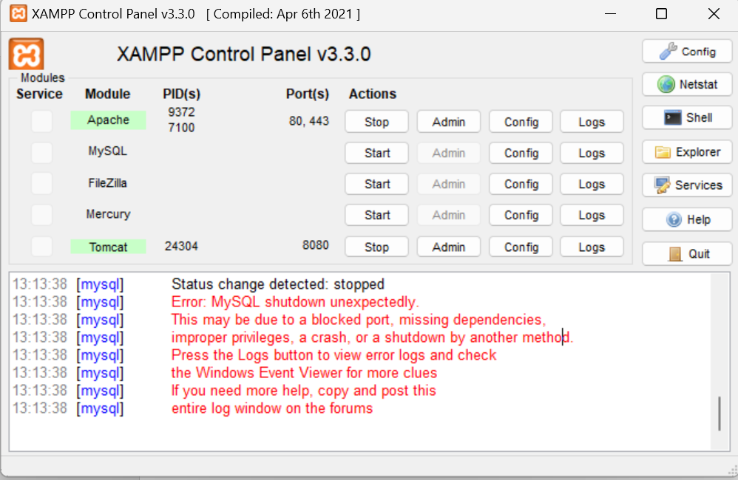

1. Rename folder mysql/data to mysql/data_old

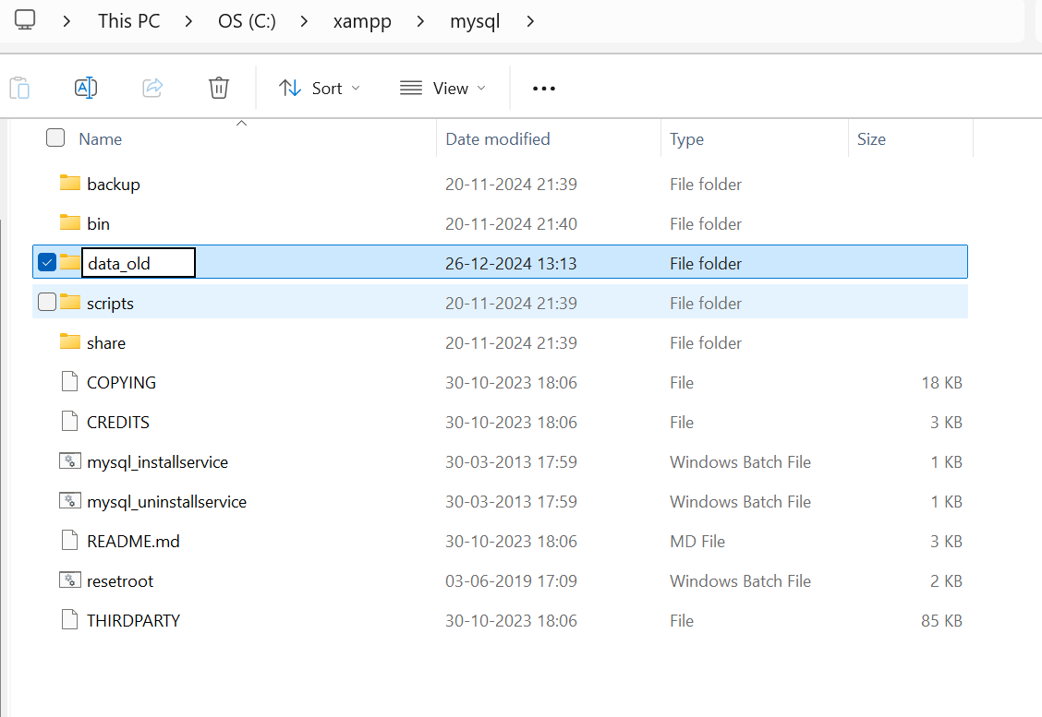

1. Make a copy of mysql/backup folder and name it as mysql/data

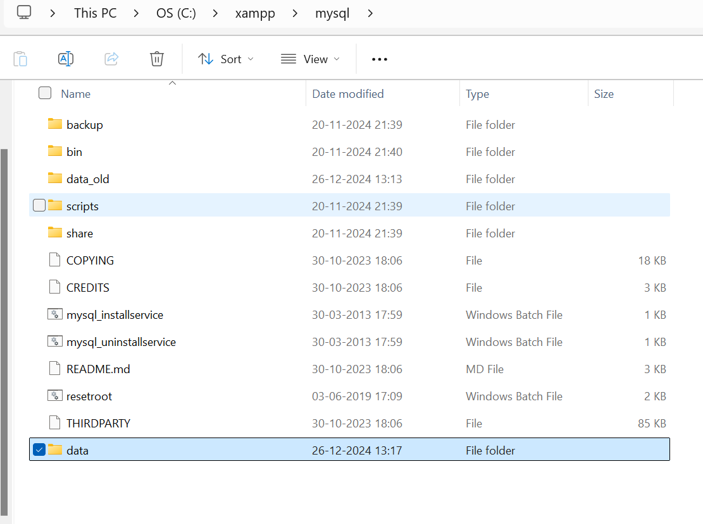

1. Copy all your database folders from mysql/data_old into mysql/data (except mysql, performance_schema, and phpmyadmin folders)

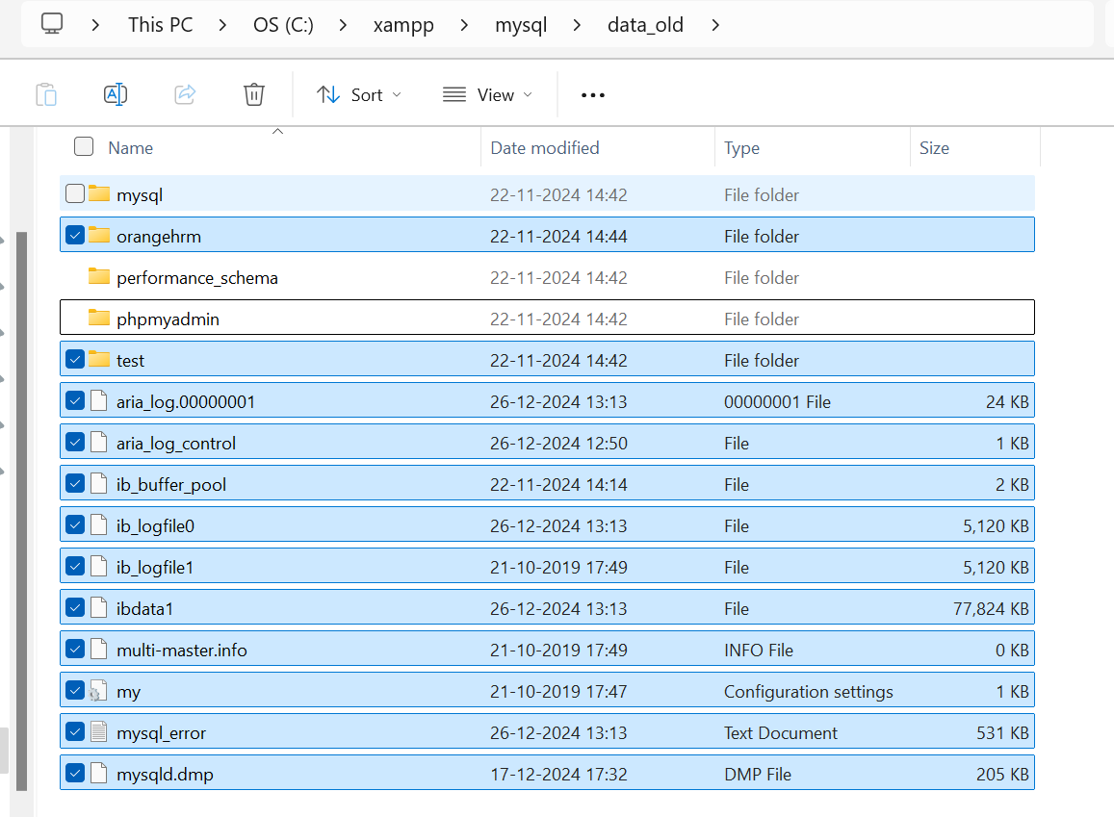

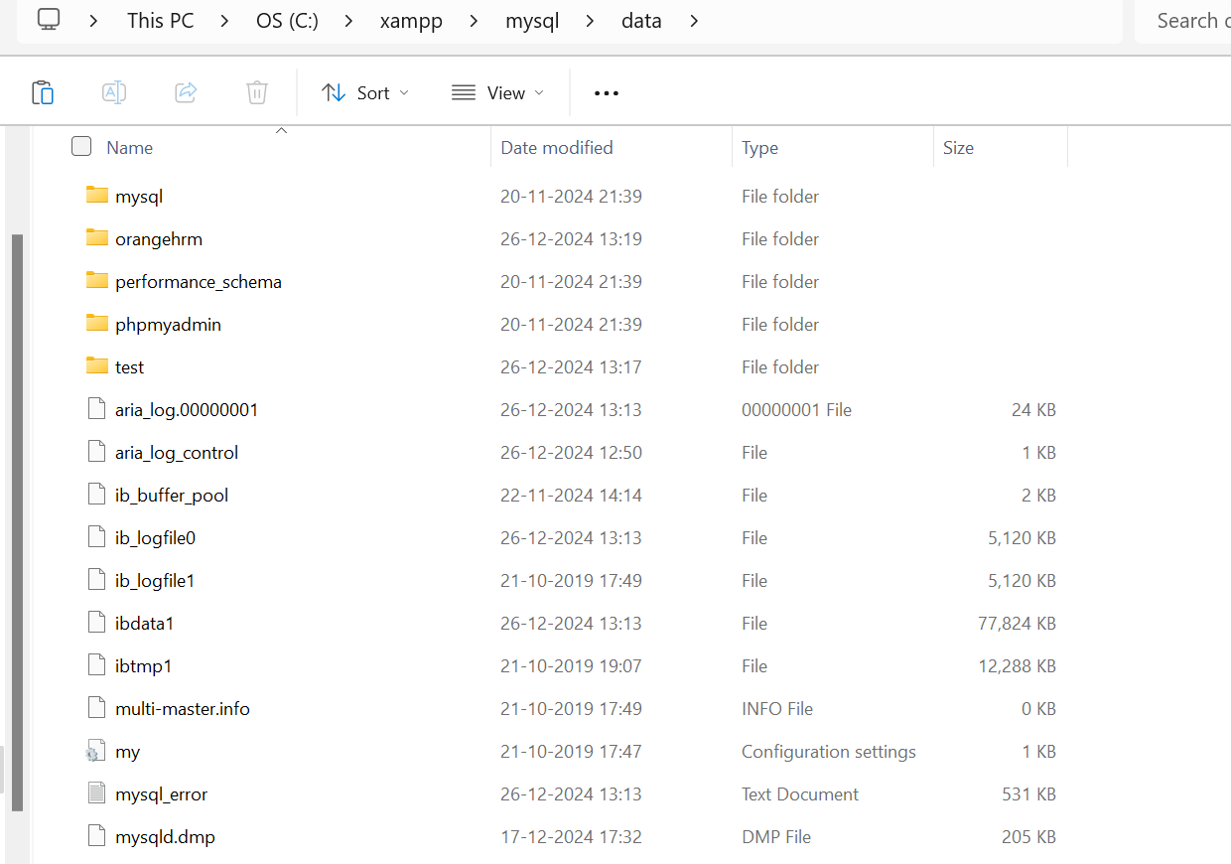

Now restart your Xampp control panel again now its up and running!

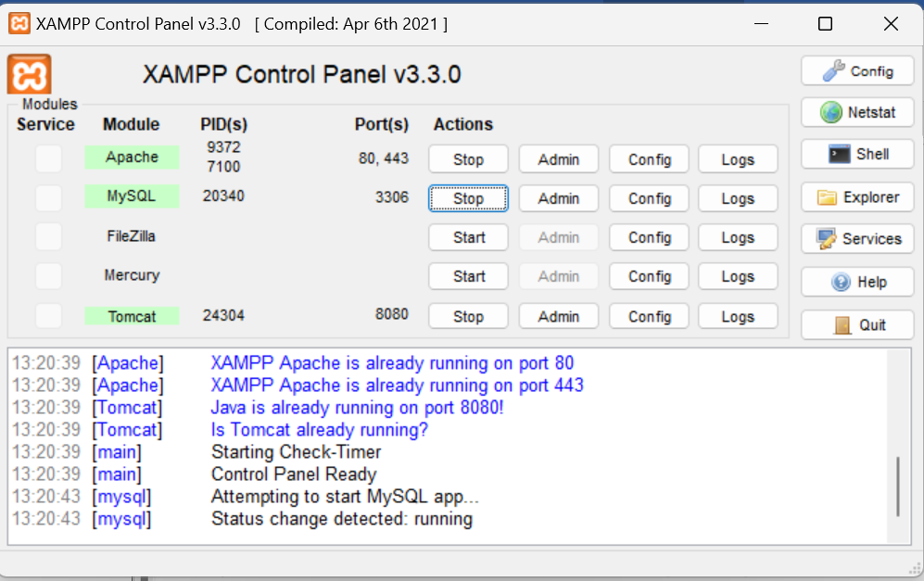

Site is up and running

