**Maven Setup**

1. Download maven and setup maven home directory:

<https://maven.apache.org/download.cgi>

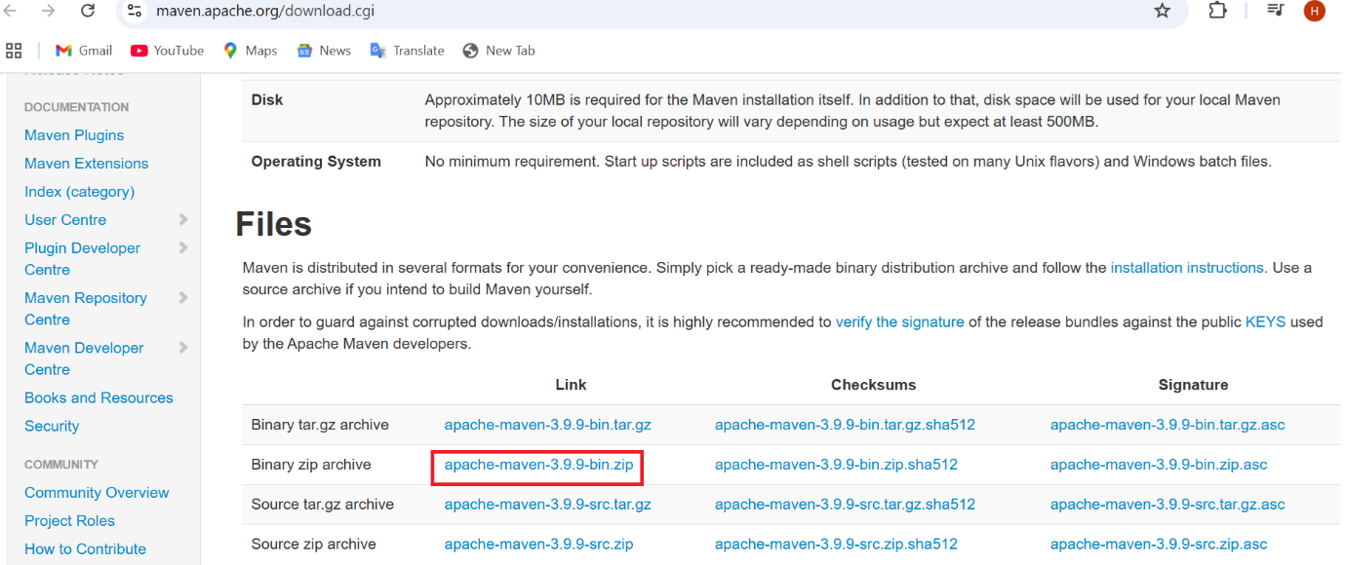

1. File is downloaded in downloads folder



1. Extract the folder and keep the folder in c drive

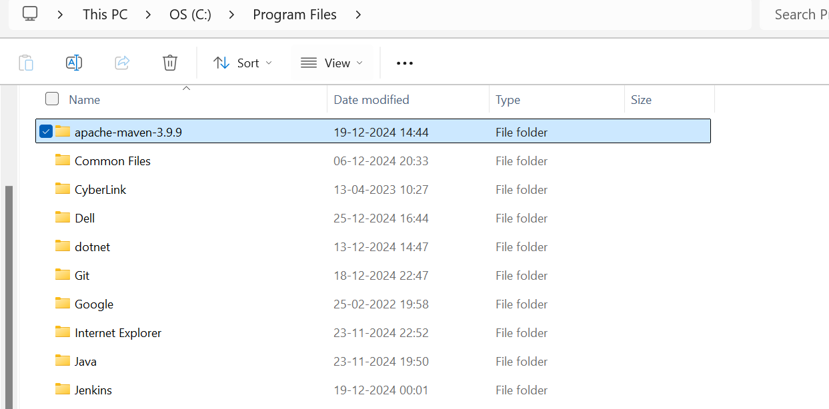

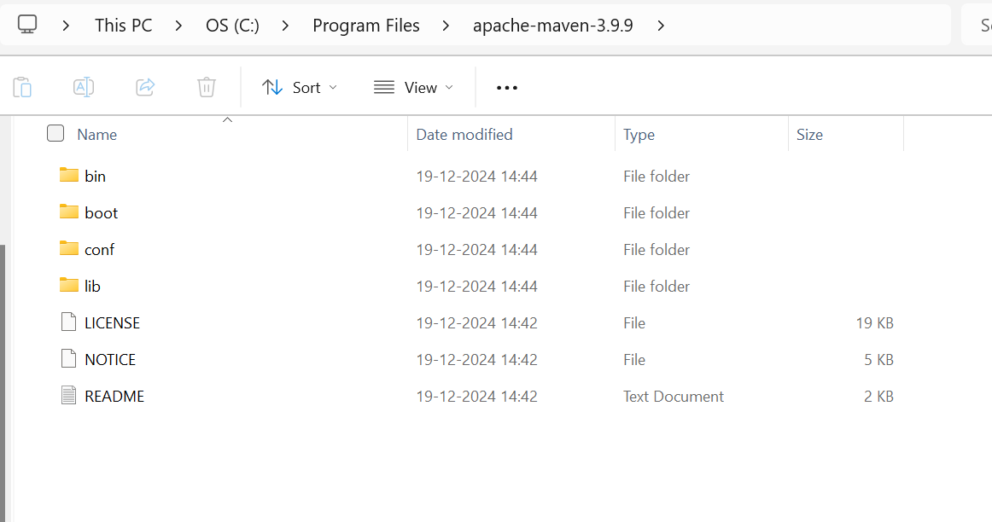

1. Path set for Maven and Java

Go to system properties

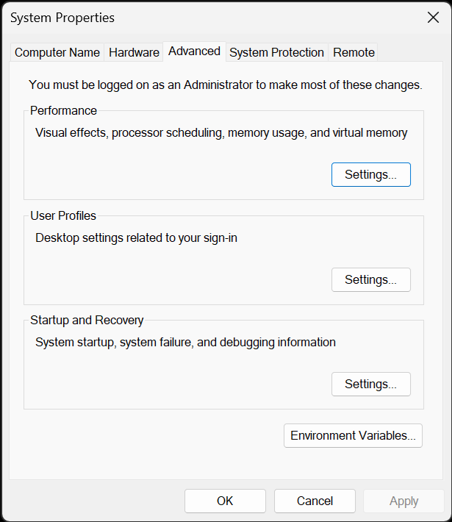

Click on environment variables

Set MAVEN_HOME in system variables

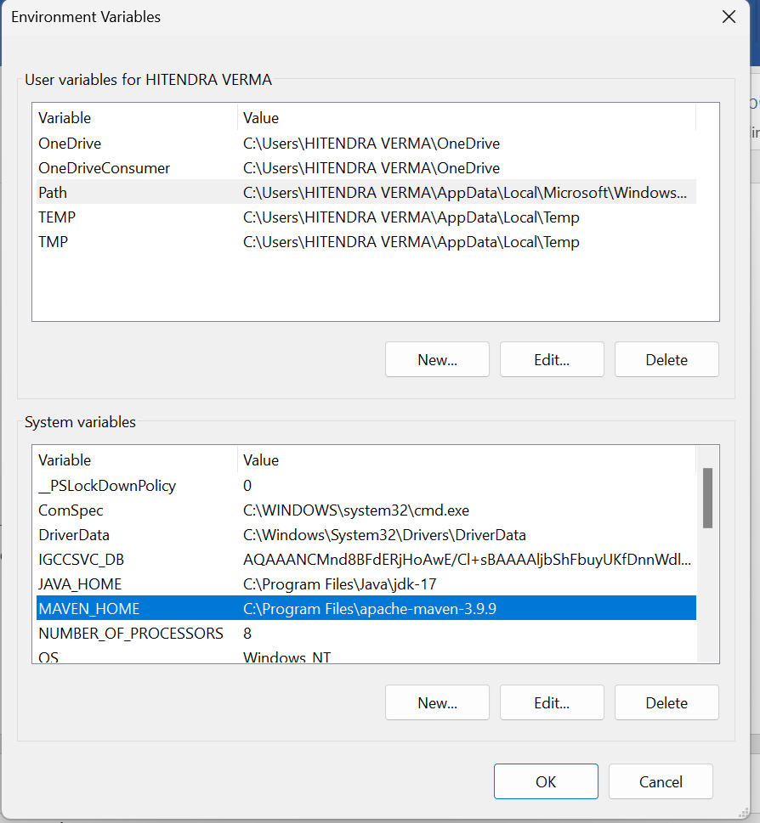

Setup JAVA_HOME as well if it is not done

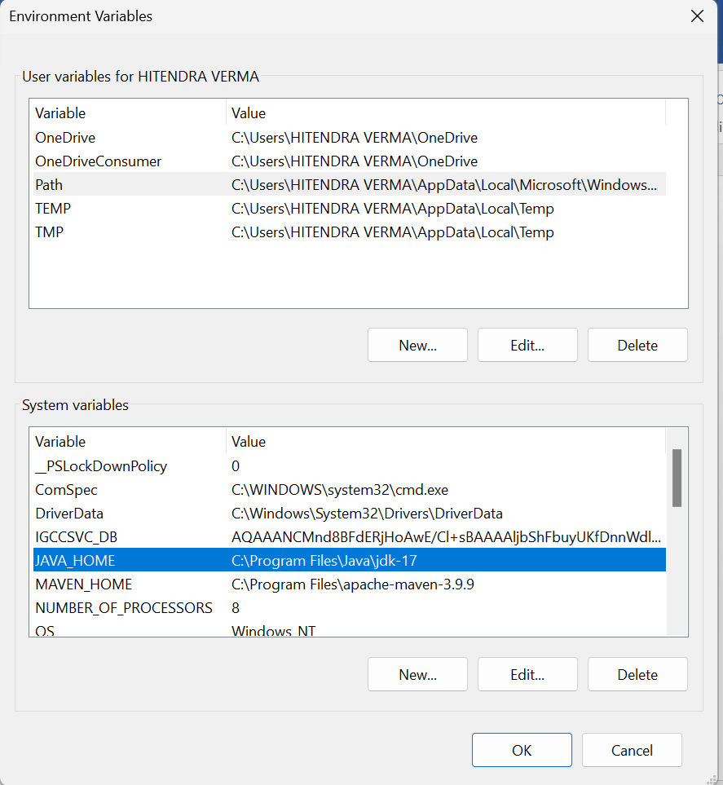

Set user variable for maven and java

