**Send auto email when build is done in Jenkins**

Login to Jenkins and navigate to Manage Jenkins 🡪 System

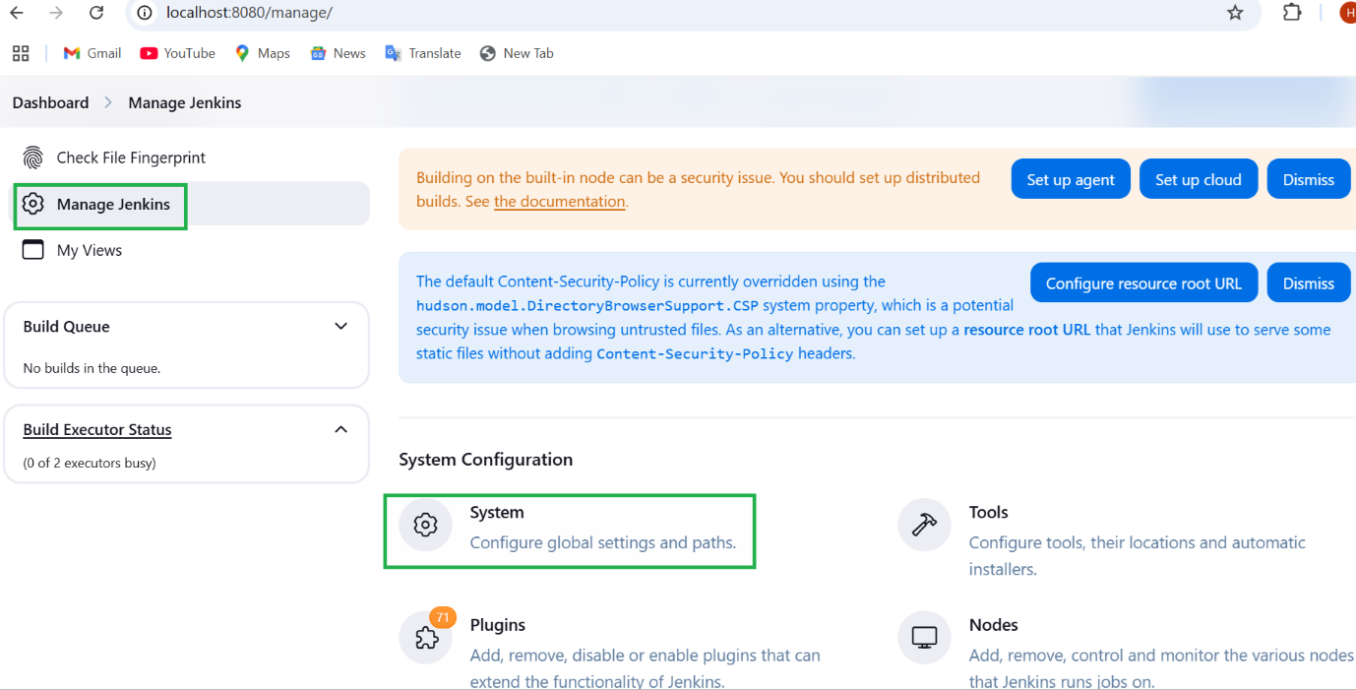

Update System admin email

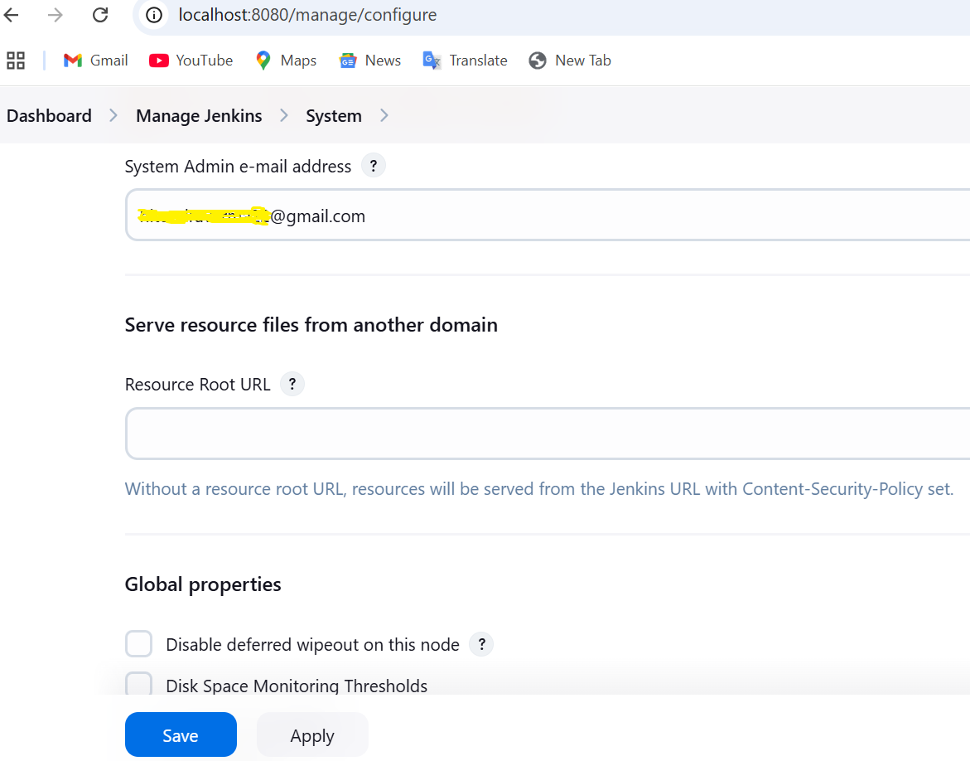

Navigate to **Extended E-mail Notification** section

Enter SMTP server for gmail - smtp.gmail.com

SMTP port – 587 (for TLS), 465 (for SSL)

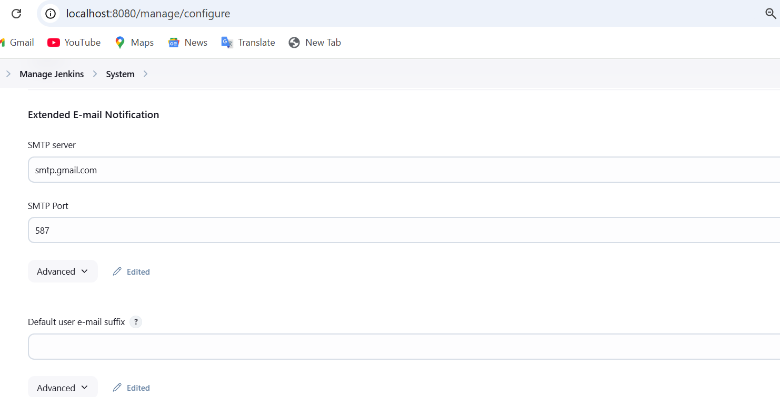

Click on Advanced

Enter credentials (email and app password) by clicking on Add button

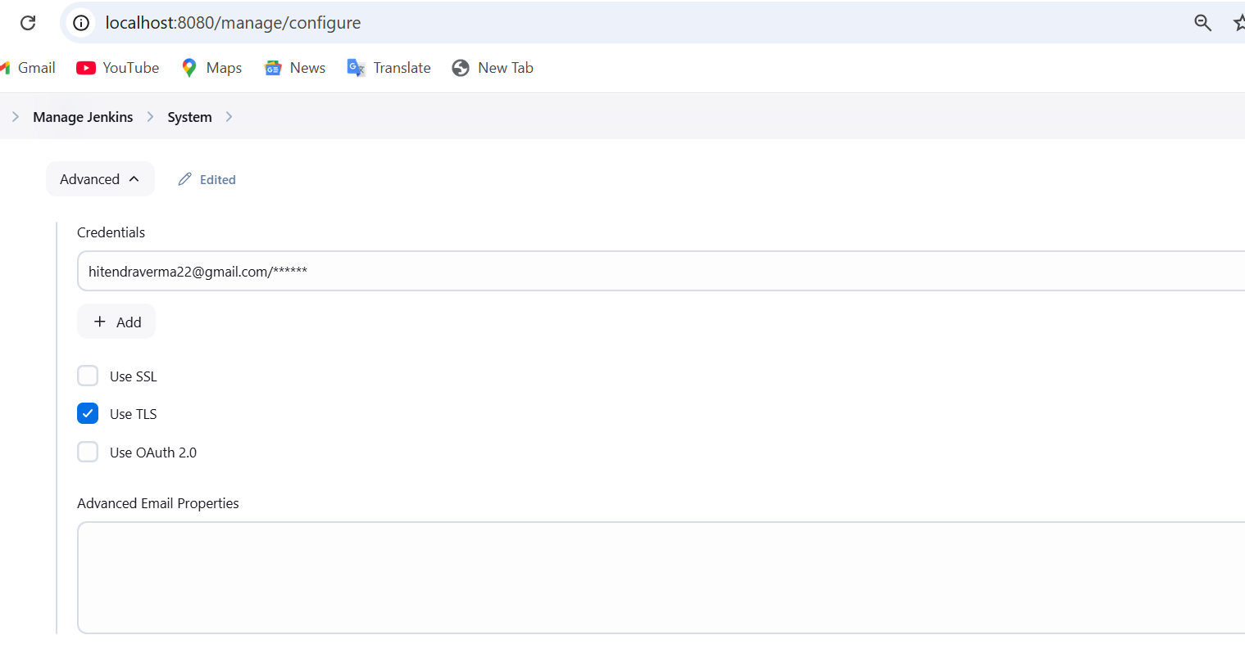

How to generate App password for gmail

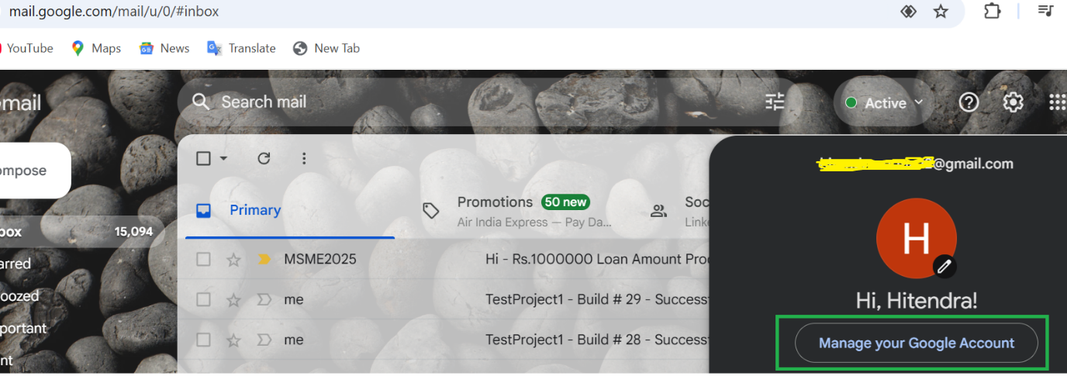

Click on Security

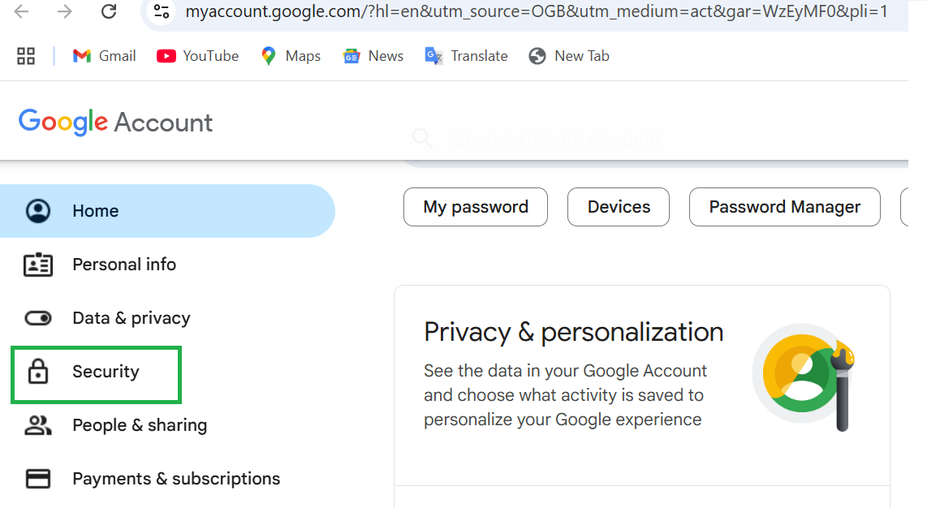

Click on 2-step verification

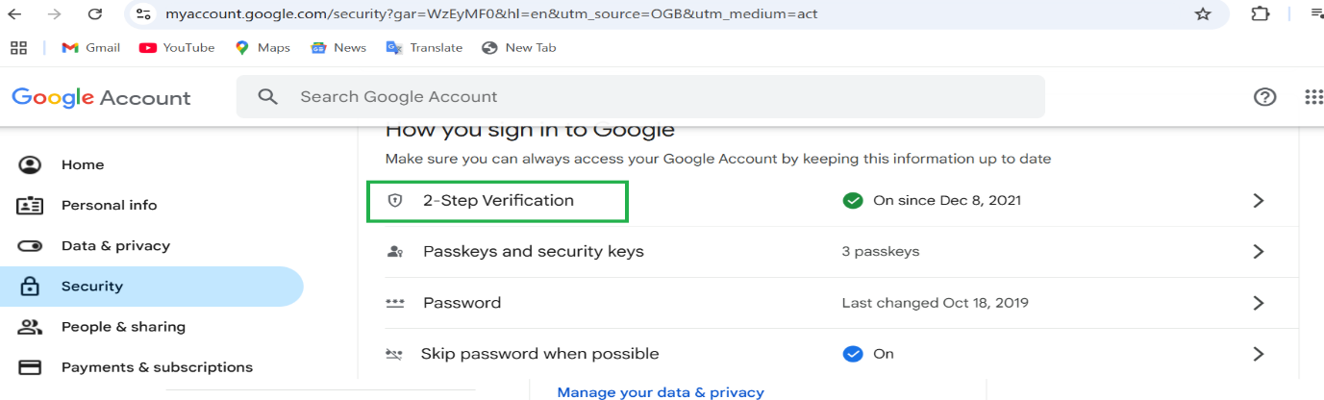

Scroll down to the end – App Passwords

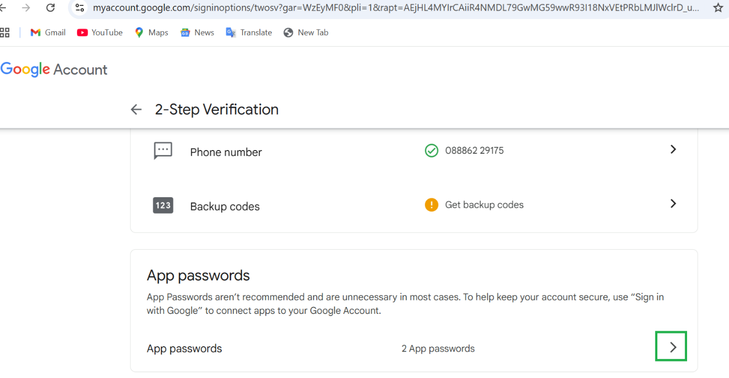

Enter the app name and generate the app password

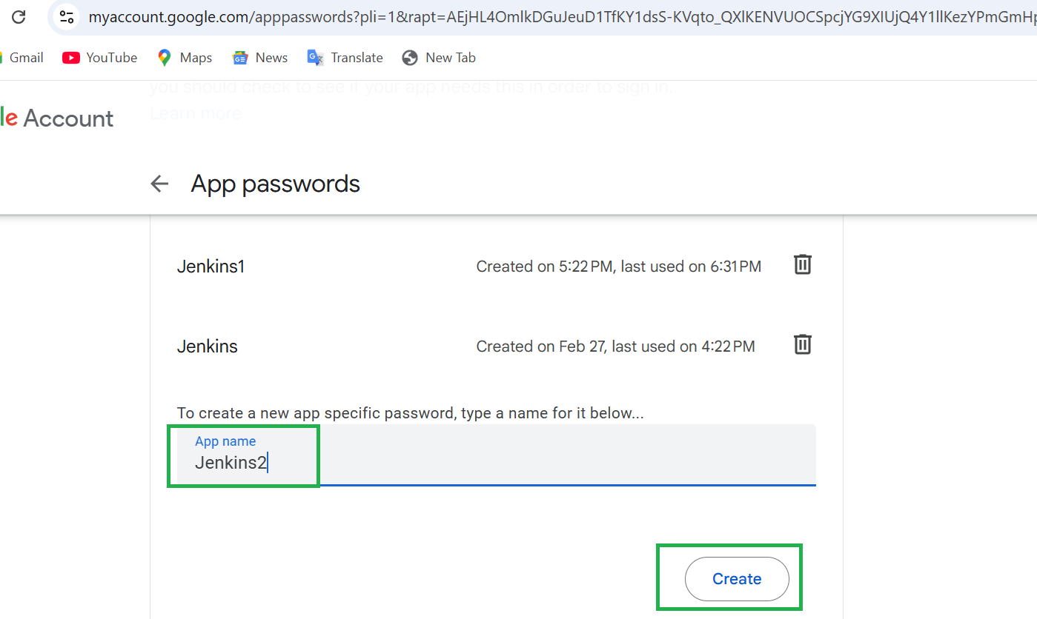

Now come back to Jenkins. there is another advanced setting. Enter the following

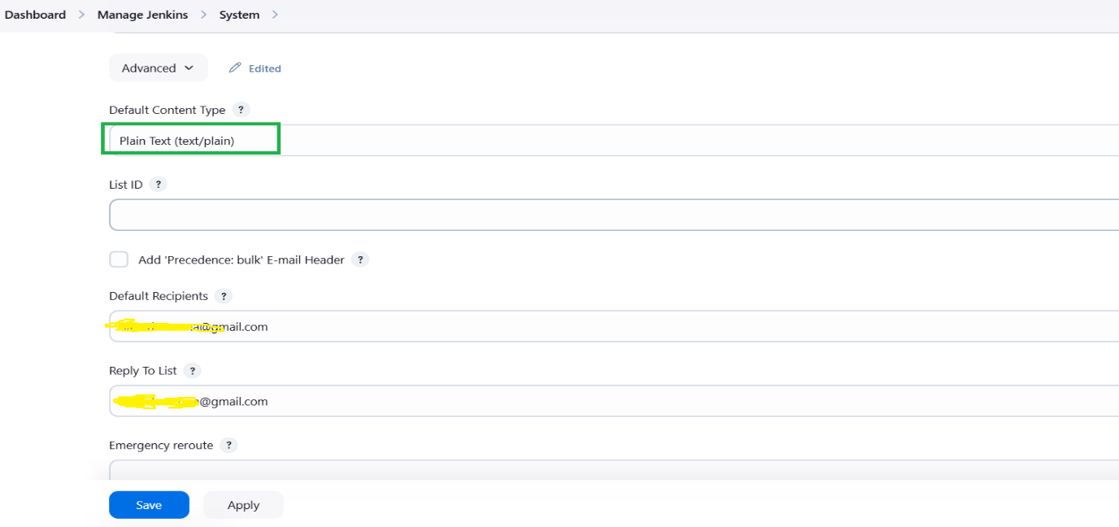

Enter subject and Default content

**Subject:** $PROJECT_NAME - Build # $BUILD_NUMBER - $BUILD_STATUS!

**Default Content (Email body)** –

Hello Team,

The latest Jenkins build has completed.

🛠 **Project Name**: $PROJECT_NAME

🔢 **Build Number**: #$BUILD_NUMBER

📜 **Build Status**: $BUILD_STATUS

🔗 **Build URL**: [Click here]($BUILD_URL)

📜 **Last Commit:**

$GIT_COMMIT

📂 **Branch**: $GIT_BRANCH

📎 **Build log is attached.**

📎 **Extent Report:** [Click here]http://localhost:8080/job/OrangeHRM_Build/HTML_20Extent_20Report/

Best regards,

Automation Team

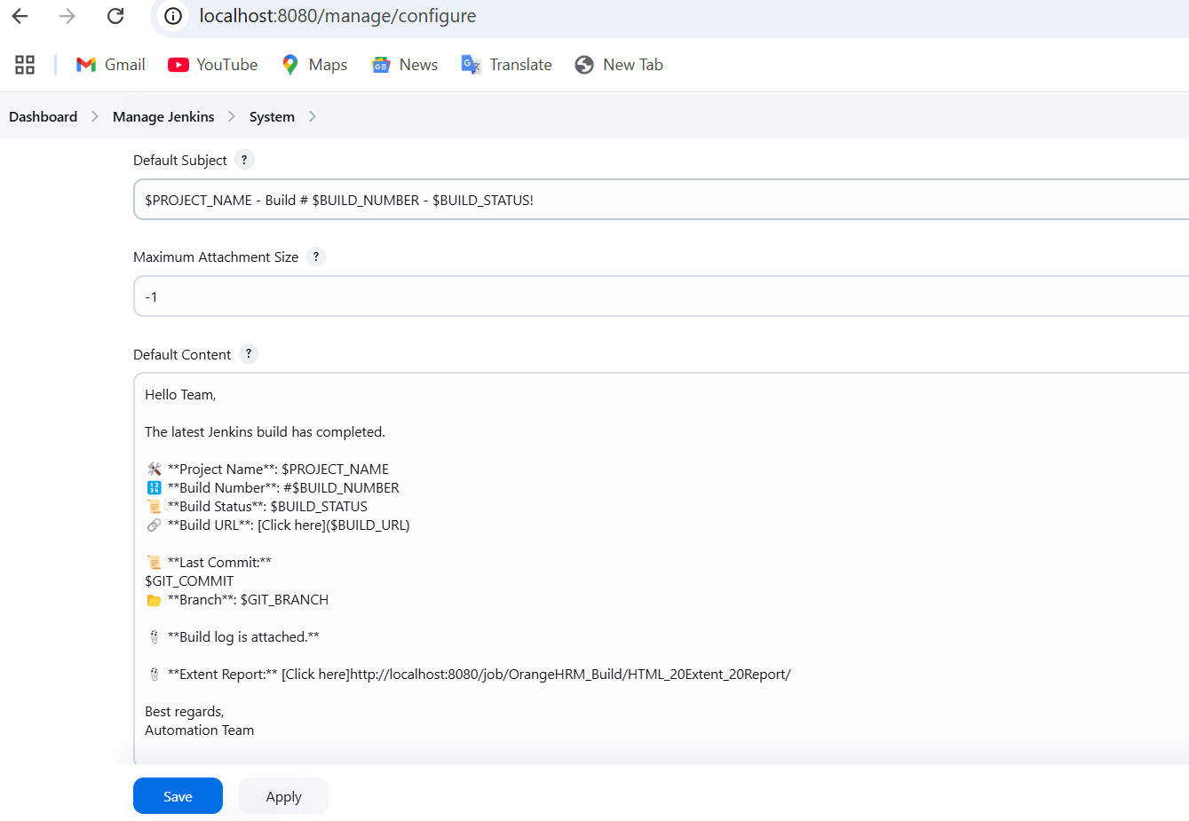

Default triggers should be checked as always

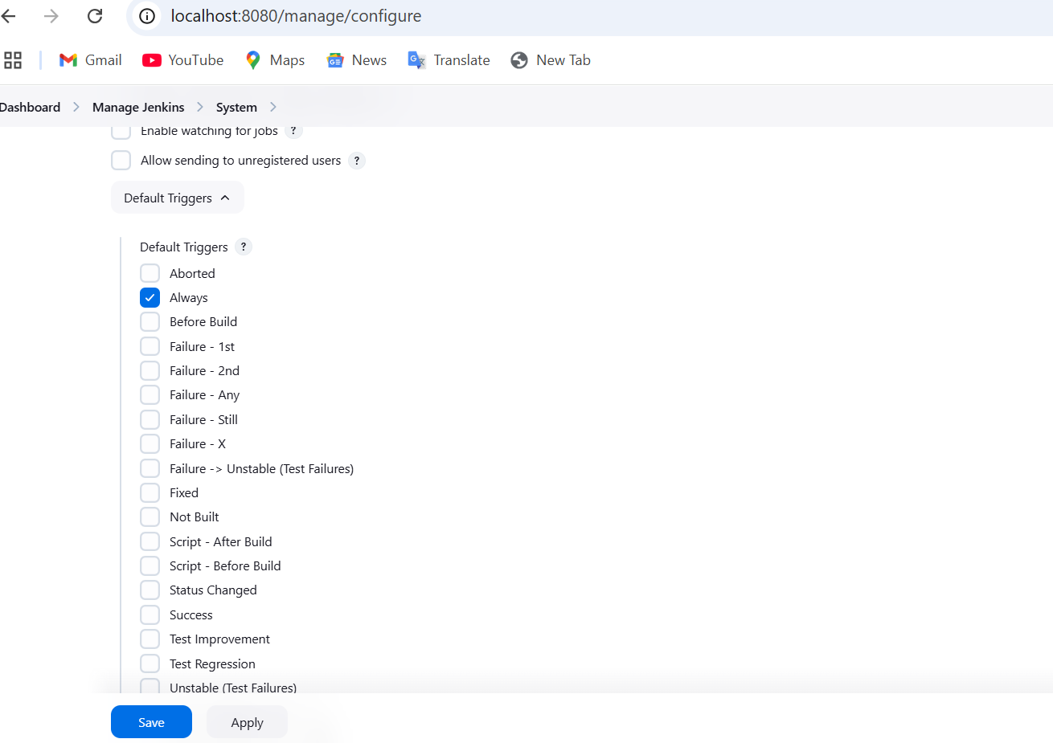

Email-Notification (optional)

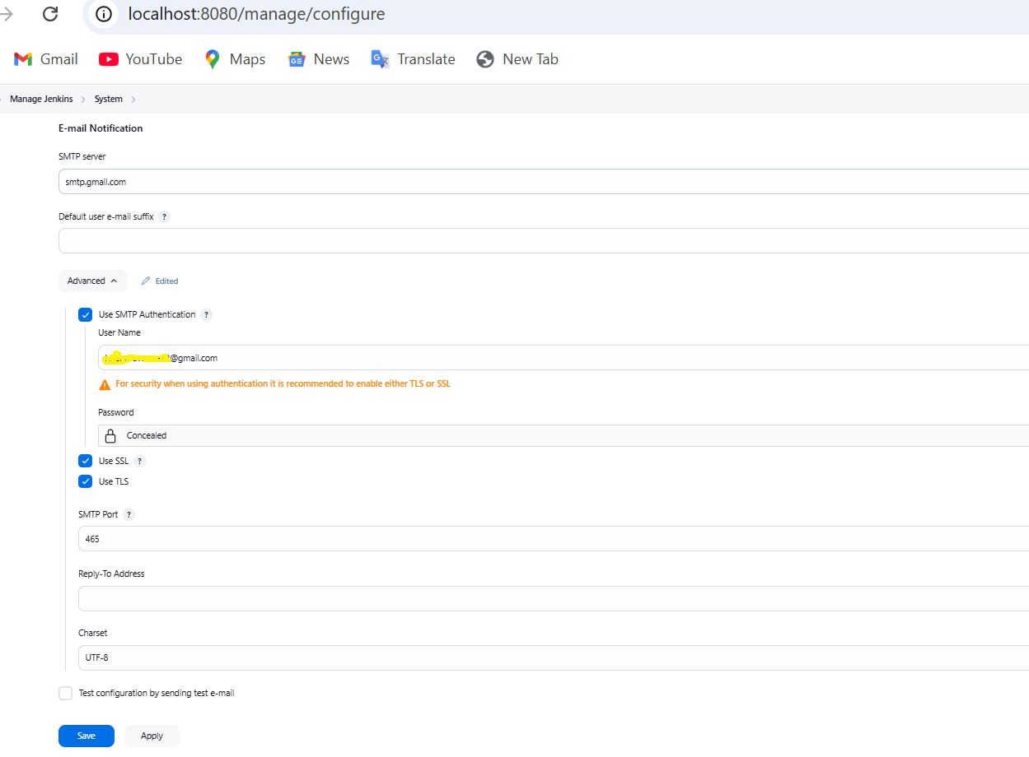

Project level setup – go to dashboard and select the job

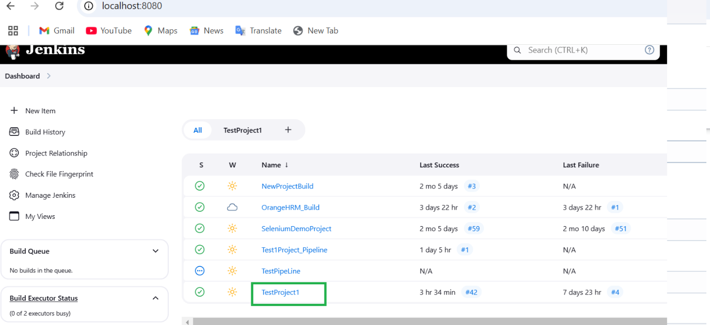

Click on configure

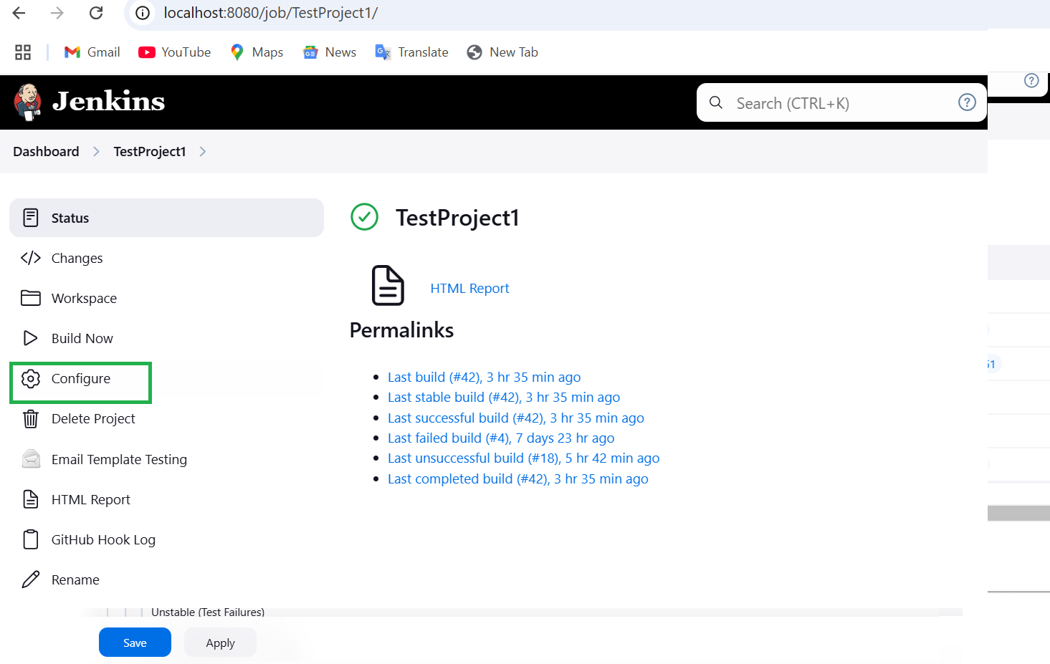

Go to **Editable Email Notification section**

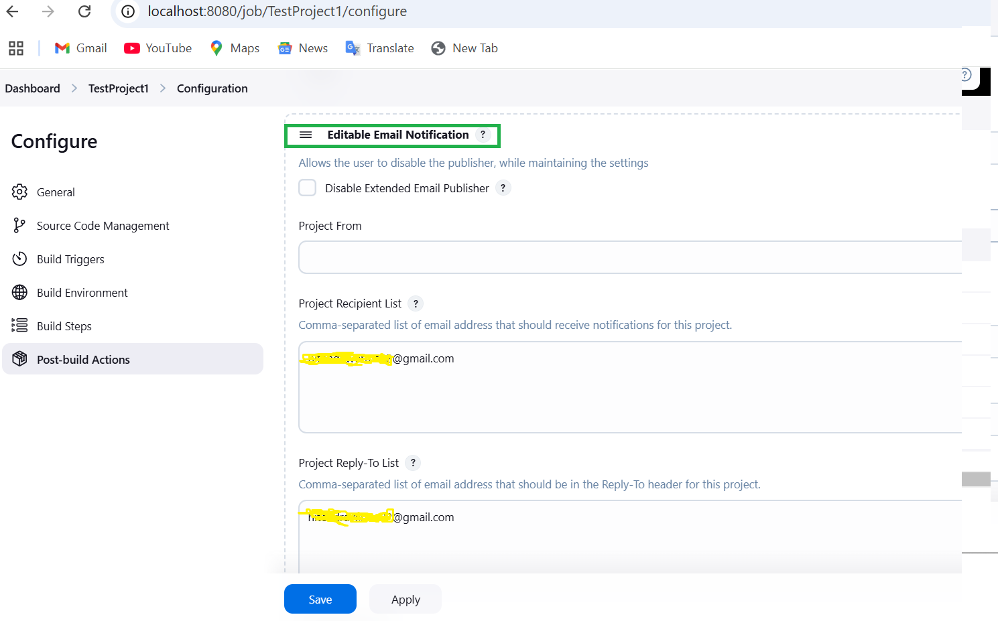

Enter attachment and attach build log

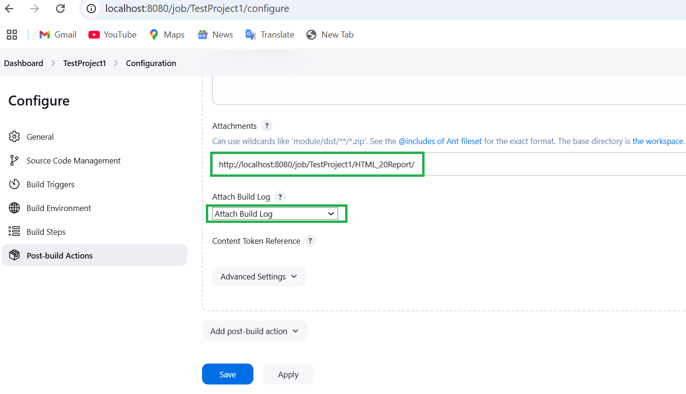

Click on Advanced setting and click on triggers

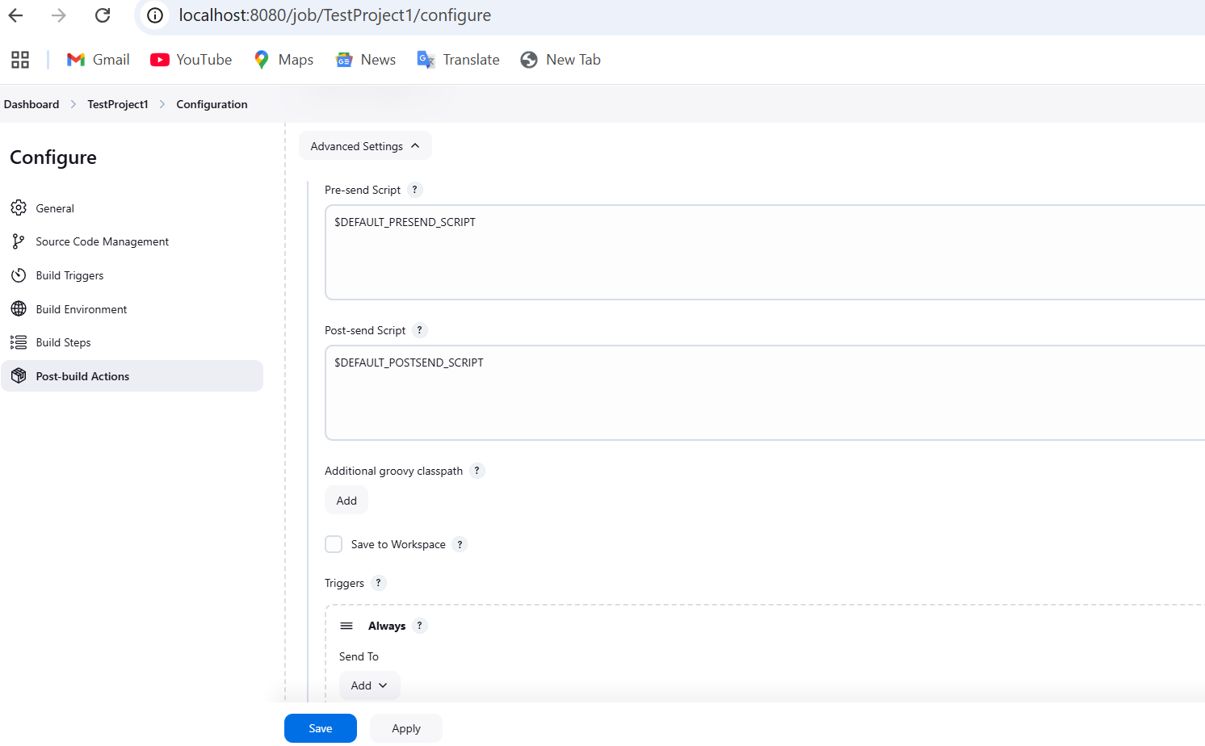

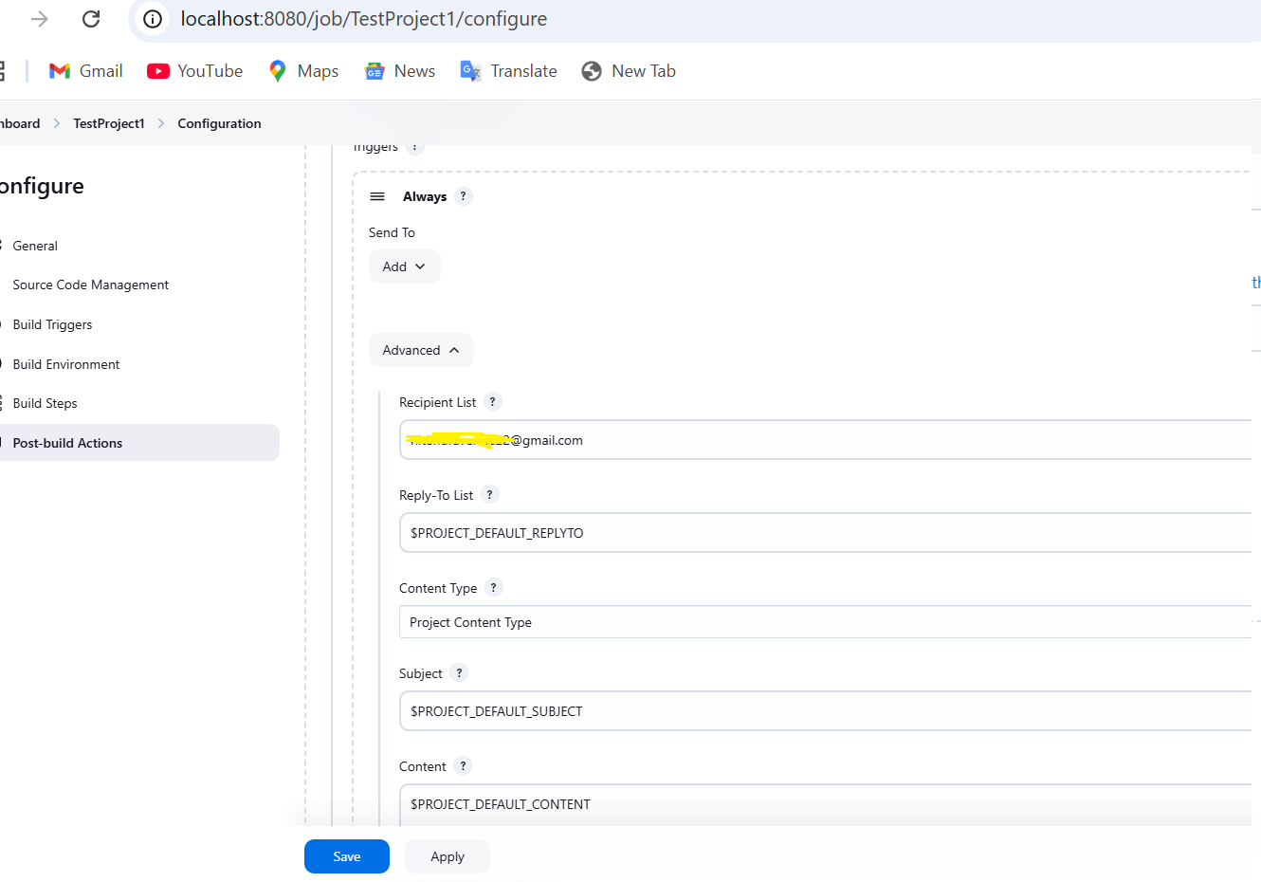

Run the build and verify the email

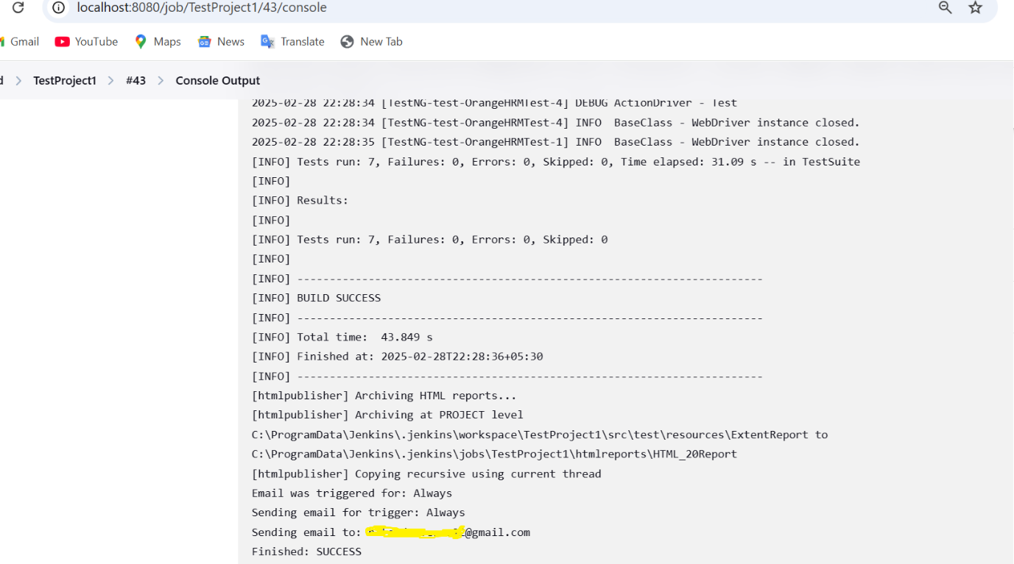

Check the gmail inbox

