Run the Jenkins build automatically when push the code to GitHub
Download ngrok
https://ngrok.com/downloads/windows?tab=download
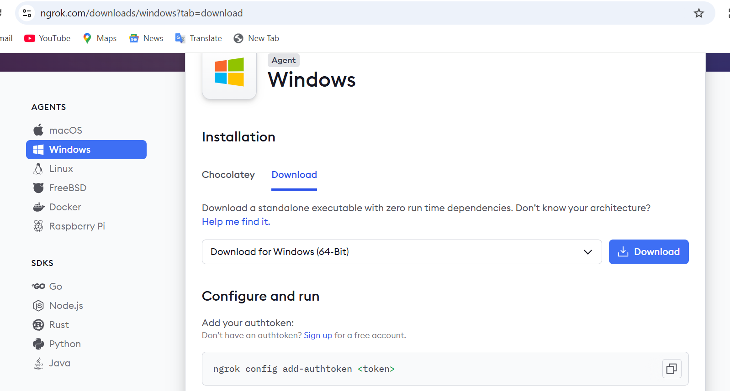
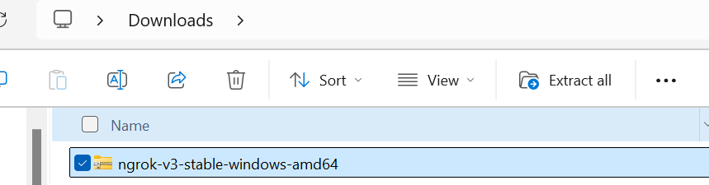
Extract it and copy the folder to c: drive, you can rename the folder to ngrok
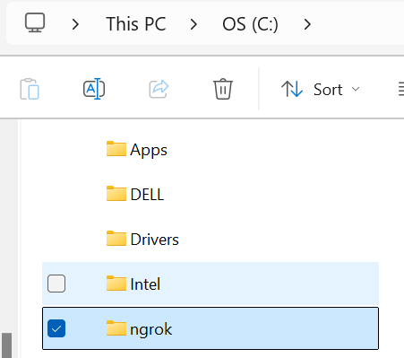

Signup to ngrok with google account
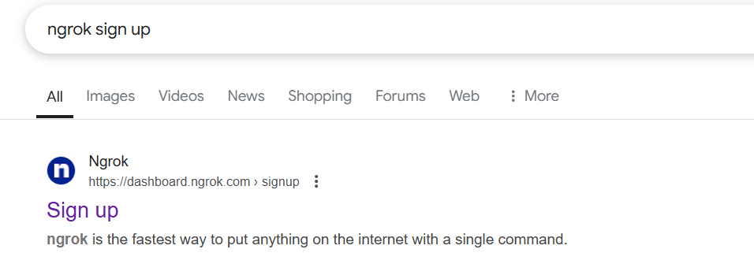
After signup
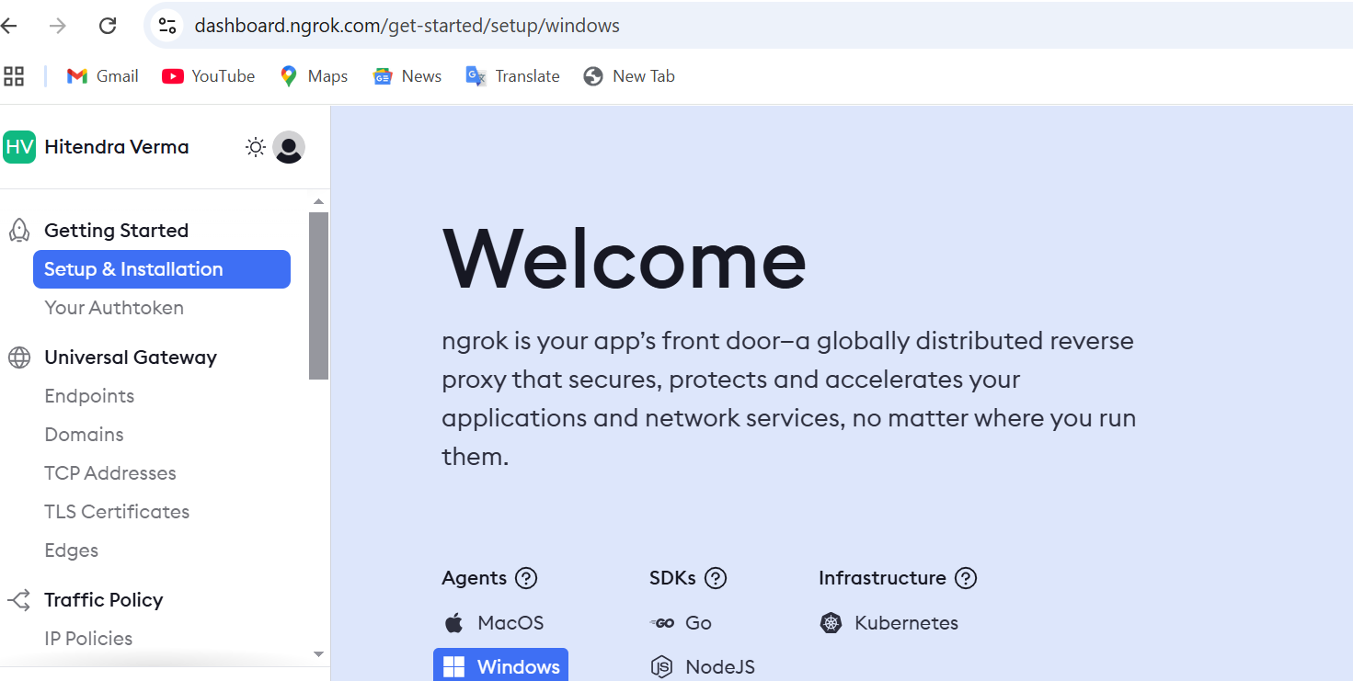
Navigate to Your Authentication tab
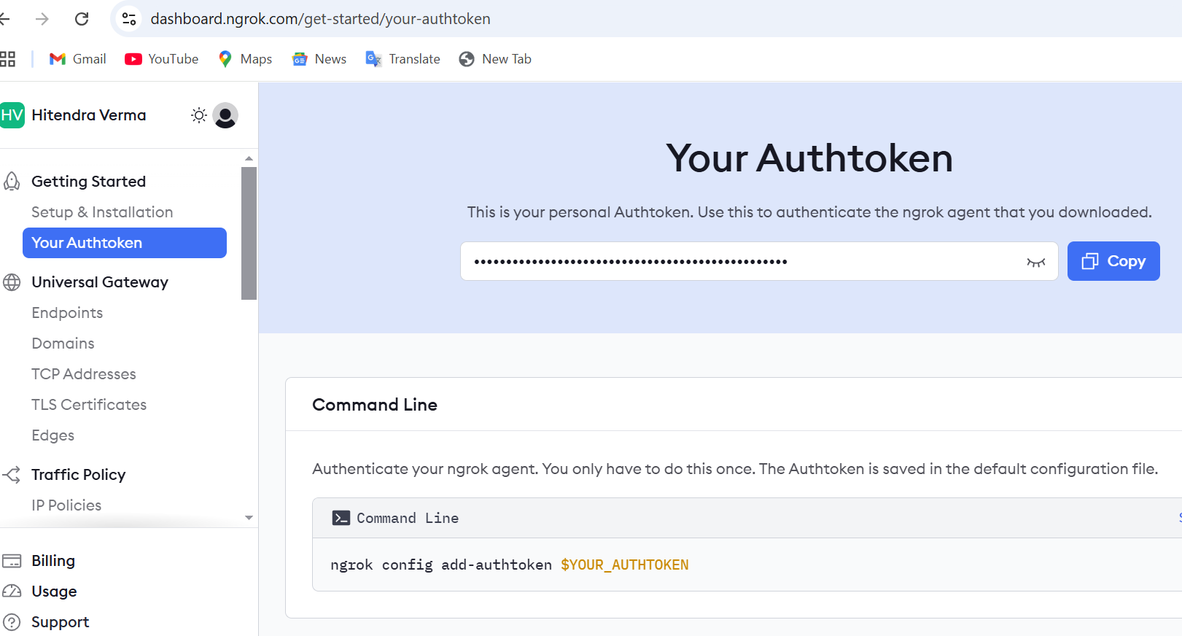
Now go to ngrok path and open cmd
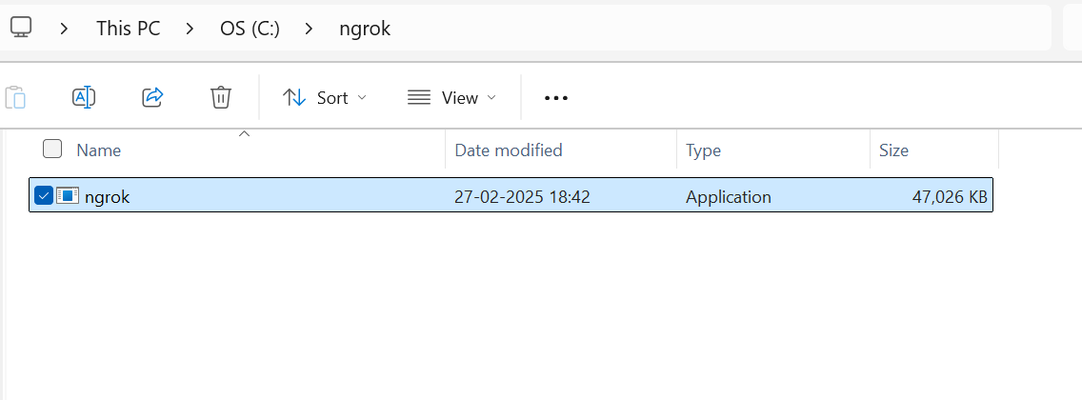
Run the below command
ngrok config add-authtoken $YOUR_AUTHTOKEN
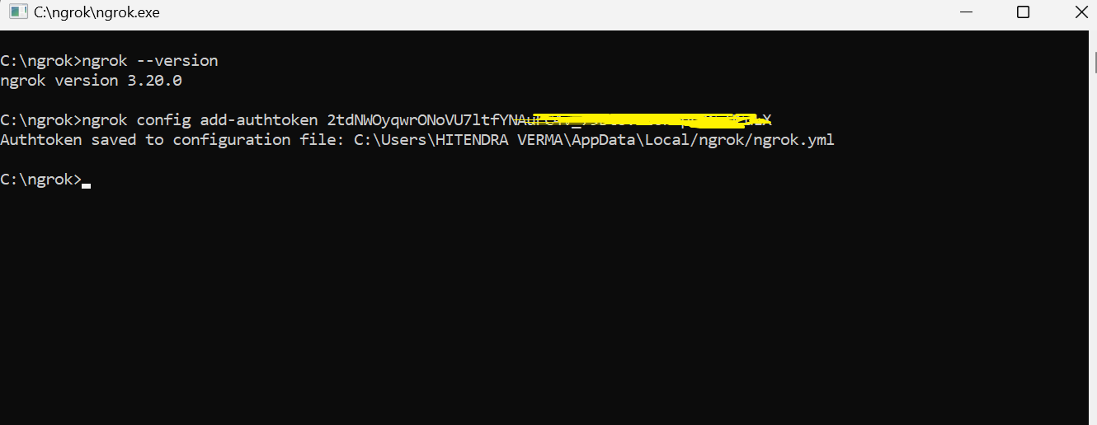
Now run the command ngrok http 8080 to get the public url
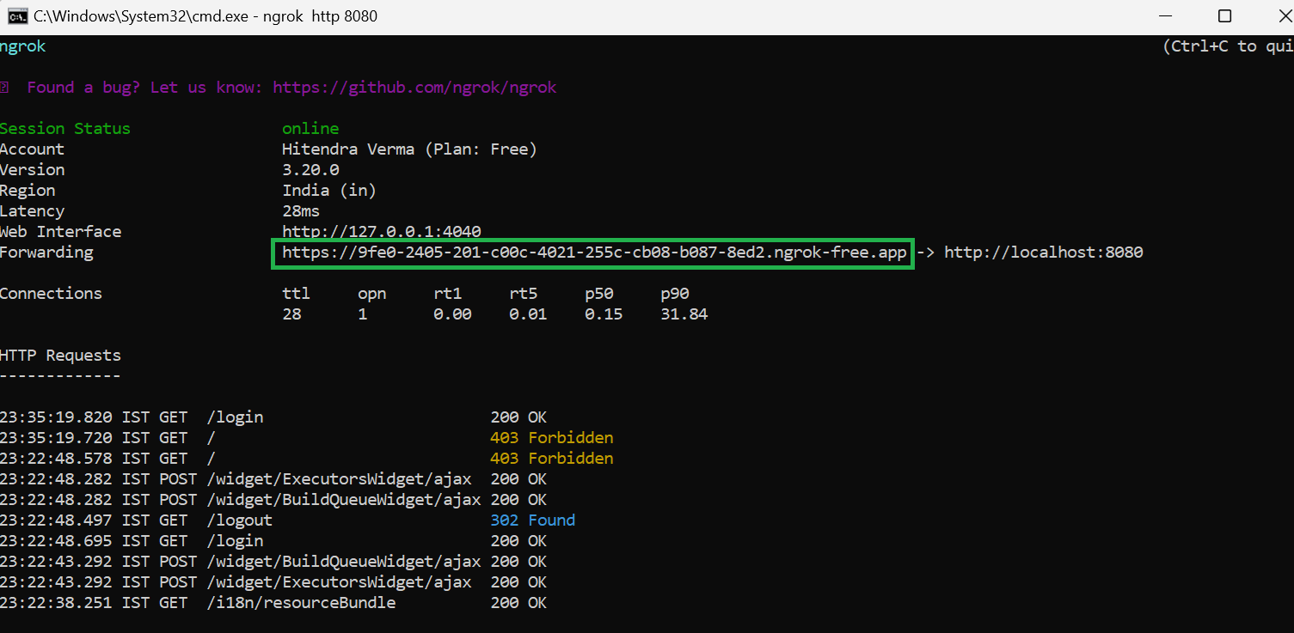
Fire the url on the browser:
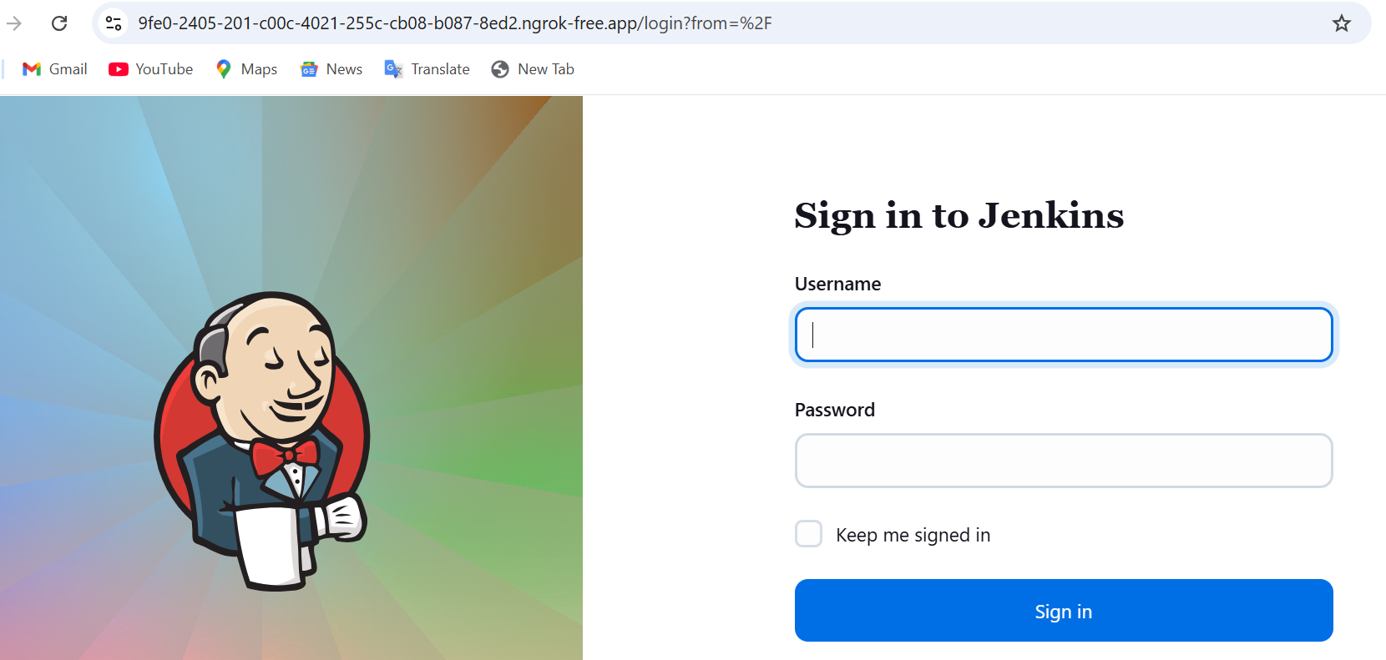
Add webhook in github repository – go to your repository and click on settings
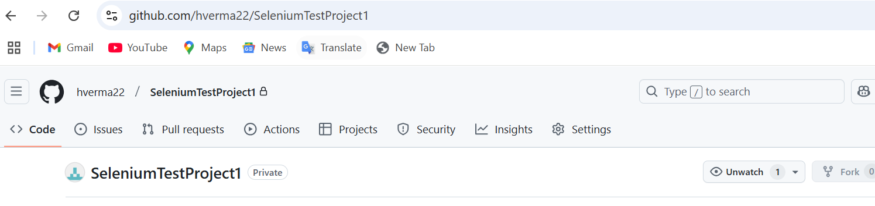
Click on webhooks and enter payload url
<jenkins url>/github-webhook/
Example: https://dc88-2405-201-c00c-4021-1cb2-e49d-7cbb-37d8.ngrok-free.app/github-webhook/
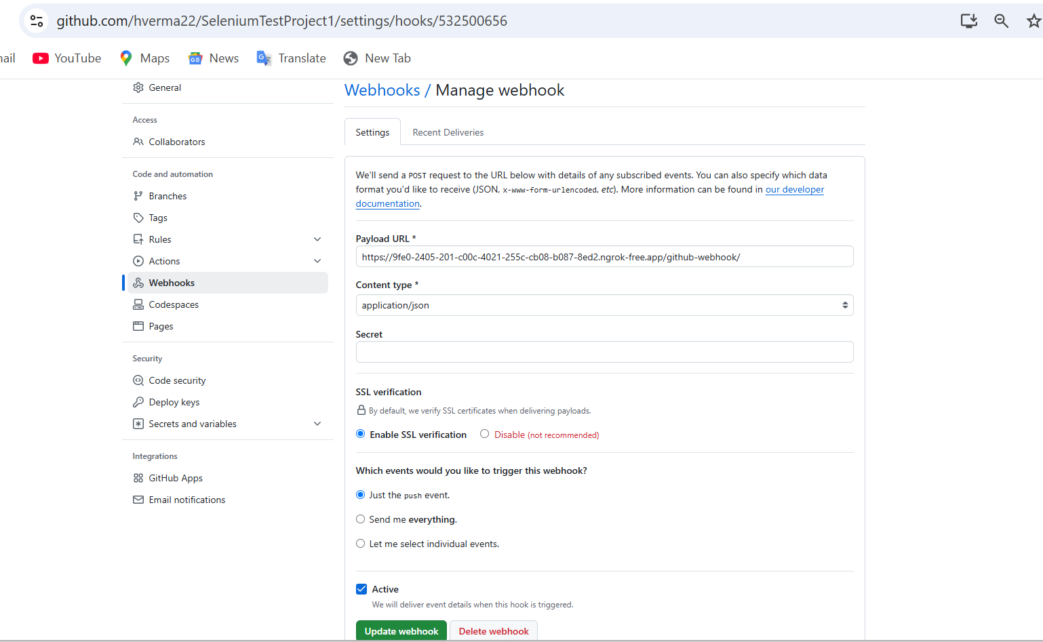
Now go to your jenkins job and select the option – GitHub hook trigger GITScm polling
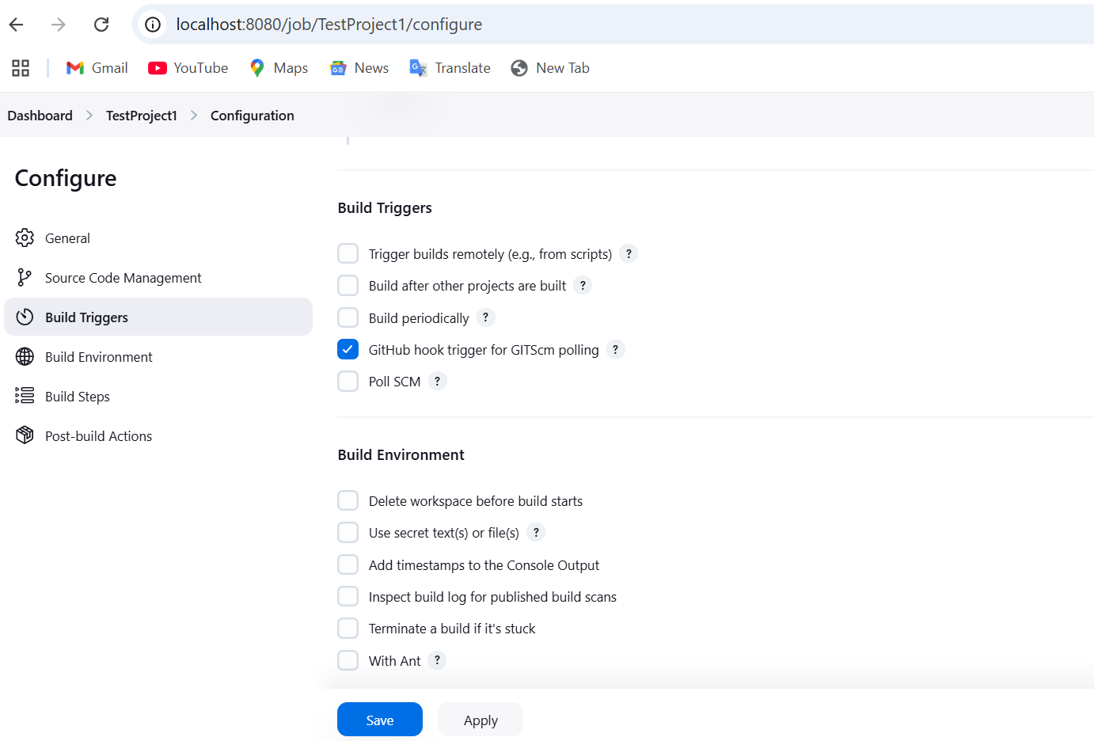

Now let’s check in the code
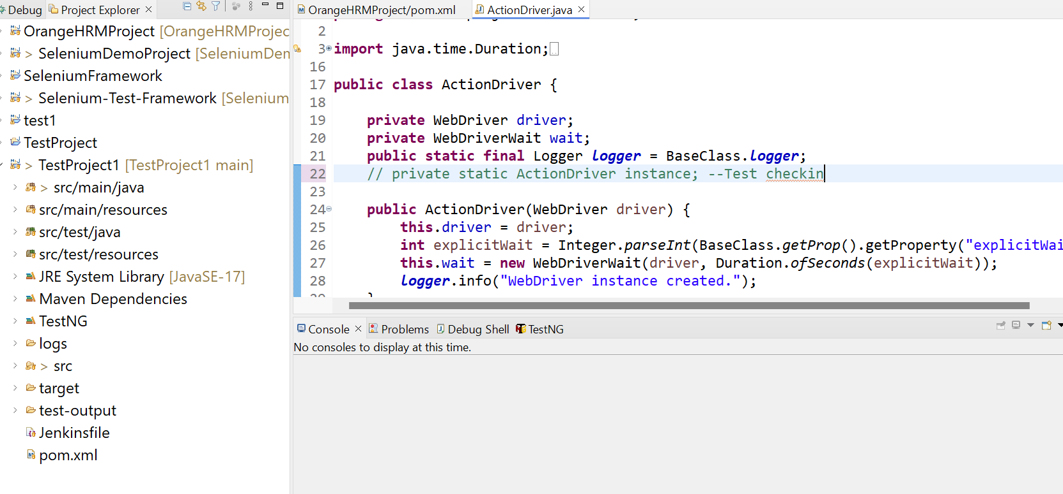
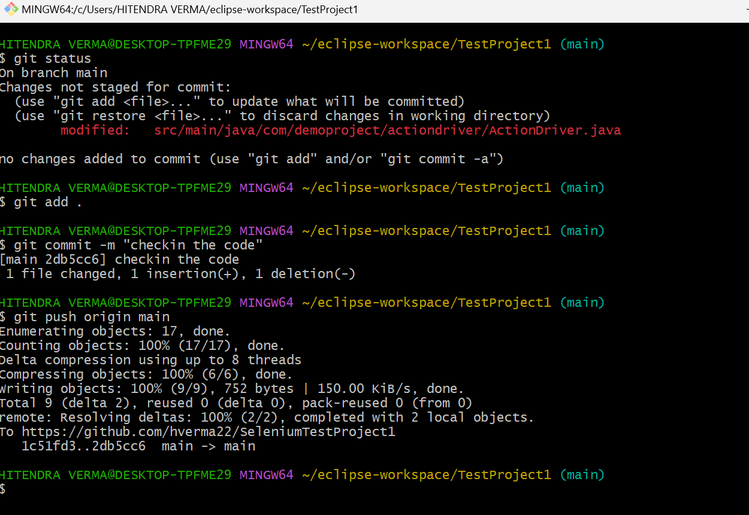

Automatically Build starts in jenkins
