1. Handset search high level architecture:

This is on-premises model.

Since cloud providing lot of readily available services with low initial and maintenance cost to setup this kind of search based application we can choose AWS/azure Cloud based model.

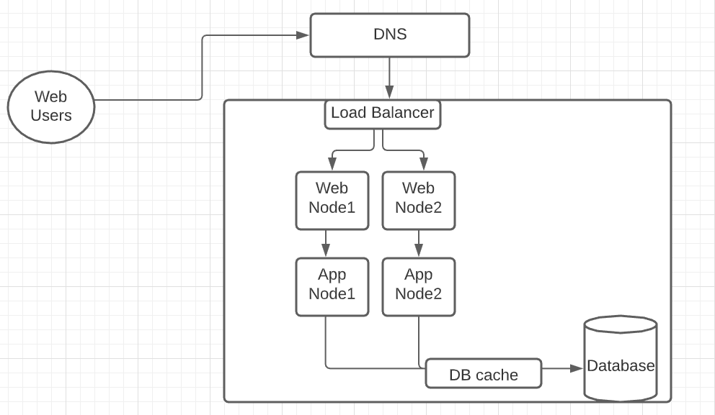

1. Load Static Json Data:

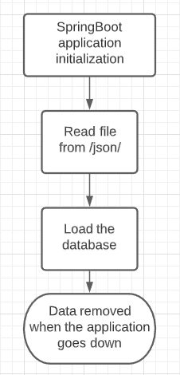

1. Search handset:

