DocSpot: Seamless Appointment Booking for Health
INTRODUCTION
Project Title: DocSpot: Seamless Appointment Booking for Health.
Team Members: Team Size: 4
Team Leader: Shaik Tasleem
Team member: Shaik Tayyibah
Team member: Chakala Sunitha
Team member: Vasantha Venkata Siva Reddy
DocSpot is a full-stack MERN application that enables patients to book doctor appointments seamlessly within a modern, futuristic healthcare ecosystem.The platform features secure authentication, doctor onboarding, appointment management, and role-based dashboards — all designed with a metaverse-inspired red & white UI system.
Description:
Booking a doctor's appointment has never been easier. With our convenient online platform, you can quickly and effortlessly schedule your appointments from the comfort of your own home. No more waiting on hold or playing phone tag with busy receptionists. Our user-friendly interface allows you to browse through a wide range of doctors and healthcare providers, making it simple to find the perfect match for your needs.
With our advanced booking system, you can say goodbye to the hassle of traditional appointment booking. Our platform offers real-time availability, allowing you to choose from a range of open slots that fit your schedule. Whether you prefer early morning, evening, or weekend appointments, we have options to accommodate your needs.
Scenario-based Case Study:
Scenario: Booking an Appointment with a Doctor
User Registration: John, who needs to see a doctor for a routine check-up, visits the Book a Doctor app and signs up as a Customer. He provides his email and creates a password.
Browsing Doctors: Upon logging in, John is presented with a dashboard displaying a list of available doctors and healthcare providers.
He filters the list based on his preferences, such as specialty, location, or availability.
Booking an Appointment: John finds a suitable doctor and clicks on "Book Now." A form appears where he selects the desired appointment date and uploads any necessary documents, such as medical records or insurance information.
After submitting the form, John receives a confirmation message indicating that his appointment request has been received.
Appointment Confirmation: The doctor reviews John's appointment request and availability. Once confirmed, the appointment status changes to "scheduled."
John receives a notification confirming his appointment and providing details such as the date, time, and location.
Appointment Management: As the appointment approaches, John can view and manage his upcoming appointments in the booking history section of his dashboard.
He has the option to cancel or reschedule appointments if needed and can update the status accordingly.
Admin Approval (Background Process): In the background, the admin reviews new doctor registrations and approves legitimate applicants.
Approved doctors are then registered in the app and can start managing their appointments.
Platform Governance: The admin oversees the overall operation of the appointment booking system and ensures compliance with platform policies, terms of service, and privacy regulations.
The admin addresses any issues or disputes to maintain a smooth user experience.
Doctor's Appointment Management: Dr. Smith, an approved doctor on the platform, logs into his account and manages his appointments.
He views his schedule, confirms or reschedules appointments, and updates appointment statuses based on patient interactions.
Appointment Consultation: On the day of the appointment, John visits the doctor's office for his check-up.
Dr. Smith provides medical care and advice during the consultation, fulfilling John's healthcare needs.
Post-Appointment Follow-up: After the appointment, Dr. Smith updates John's medical records and may prescribe medication or recommend further treatment if necessary.
John receives a visit summary and any follow-up instructions through the app.

TECHNICAL ARCHITECTURE
- The technical architecture of our Book a Doctor app follows a client-server model, where the front end serves as the client and the backend acts as the server. The front end encompasses not only the user interface and presentation but also incorporates the Axios library to connect with the backend easily by using RESTful Apis.
- The front end utilizes the bootstrap and material UI library to establish a real-time and better UI experience for any user whether it is an admin, doctor, or ordinary user working on it.
- On the backend side, we employ Express.js frameworks to handle the server-side logic and communication.
- For data storage and retrieval, our backend relies on MongoDB. MongoDB allows for efficient and scalable storage of user data, including user profiles, for booking rooms, adding rooms, etc. It ensures reliable and quick access to the necessary information.
- Together, the frontend and backend components, along with Moment, Express.js, and MongoDB, form a comprehensive technical architecture for our Book a Doctor app. This architecture enables real-time communication, efficient data exchange, and seamless integration, ensuring a smooth and immersive booking of an appointment and many more experiences for all users.

ER DIAGRAM
The Doctor Appointment Booking ER-diagram represents the entities and relationships involved in an online doctor appointment system. It illustrates how users, doctors, and appointments are interconnected. Here is a breakdown of the entities and their relationships:
USER:
Represents individuals who register in the system. A user can book multiple appointments. The user entity contains details such as name, email, phone number, password, notifications, role type, and a flag indicating whether the user is a doctor. A user may also register as a doctor (isdoctor = true).
DOCTOR:
Represents medical professionals registered in the system. A doctor is associated with a user account through the userID (acts as a foreign key referencing the USER entity). The doctor entity contains details such as full name, email, phone number, address, specialization, timings, experience, consultation fees, and approval status. One doctor can have multiple appointments.
APPOINTMENT:
Represents a booking made by a user to consult a doctor. An appointment contains details such as doctor information, user information, date of appointment, uploaded documents (if any), and appointment status (e.g., pending, approved, rejected). A user can book multiple appointments, and a doctor can receive multiple appointments.
Relationships:
- One USER can book many APPOINTMENTS (One-to-Many).
- One DOCTOR can have many APPOINTMENTS (One-to-Many).
- Each DOCTOR is linked to one USER account through userID (One-to-One).
This ER-diagram ensures proper management of users, doctors, and appointments within the system.
PREREQUISITES:
Here are the key prerequisites for developing a full-stack application using Node.js, Express.js, MongoDB, and React.js:
Node.js and npm:
Node.js is a powerful JavaScript runtime environment that allows you to run JavaScript code on the server side. It provides a scalable and efficient platform for building network applications.
Install Node.js and npm on your development machine, as they are required to run JavaScript on the server side.
Download: https://nodejs.org/en/download/
Installation instructions: https://nodejs.org/en/download/package-manager/
npm init
Express.js:
Express.js is a fast and minimalist web application framework for Node.js. It simplifies the process of creating robust APIs and web applications, offering features like routing, middleware support, and modular architecture.
Install Express.js, a web application framework for Node.js, which handles server-side routing, middleware, and API development.
Installation: Open your command prompt or terminal and run the following command:
npm install express
MongoDB:
MongoDB is a flexible and scalable NoSQL database that stores data in a JSON-like format. It provides high performance, horizontal scalability, and seamless integration with Node.js, making it ideal for handling large amounts of structured and unstructured data.
Set up a MongoDB database to store your application's data.
Download: https://www.mongodb.com/try/download/community
Installation instructions: https://docs.mongodb.com/manual/installation/
Moment.js:
Momentjs is a JavaScript package that makes it simple to parse, validate, manipulate, and display date/time in JavaScript. Moment. js allows you to display dates in a human-readable format based on your location. Install React.js, a JavaScript library for building user interfaces.
Follow the installation guide: https://momentjs.com/
React.js:
React.js is a popular JavaScript library for building user interfaces. It enables developers to create interactive and reusable UI components, making it easier to build dynamic and responsive web applications.
Install React.js, a JavaScript library for building user interfaces.
Follow the installation guide: https://reactjs.org/docs/create-a-new-react-app.html
Antd:
Ant Design is a React. js UI library that contains easy-to-use components that are useful for building interactive user interfaces. It is very easy to use as well as integrate. It is one of the smart options to design web applications using react.
Follow the installation guide: https://ant.design/docs/react/introduce
- HTML, CSS, and JavaScript: Basic knowledge of HTML for creating the structure of your app, CSS for styling, and JavaScript for client-side interactivity is essential.
- Database Connectivity: Use a MongoDB driver or an Object-Document Mapping (ODM) library like Mongoose to connect your Node.js server with the MongoDB database and perform CRUD (Create, Read, Update, Delete) operations. To Connect the Database with Node JS go through the below provided link: https://www.section.io/engineering-education/nodejs- mongoosejs-mongodb/
- Front-end Framework: Utilize Reactjs to build the user-facing part of the application, including entering booking room, status of the booking, and user interfaces for the admin dashboard.
For making better UI we have also used some libraries like material UI and boostrap.
Install Dependencies:
• Navigate into the cloned repository directory:
cd book-a-doctor
• Install the required dependencies by running the following commands:
cd frontend
npm install
cd ../backend
npm install
Start the Development Server:
• To start the development server, execute the following command:
npm start
• The book a doctor app will be accessible at http://localhost:3000
You have successfully installed and set up the online complaint registration and management app on your local machine. You can now proceed with further customization, development, and
PROJECT STRUCTURE:
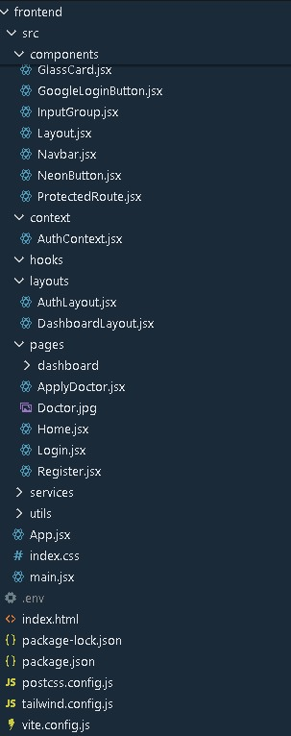
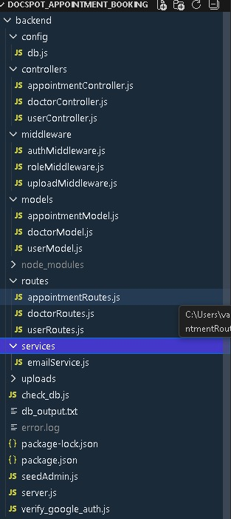
The first image is of frontend part which is showing all the files and folders that have been used in UI development
The second image is of Backend part which is showing all the files and folders that have been used in backend development
Application Flow: The project has 2 type of user – Customer and Doctor and other will be Admin which takes care to all the user. The roles and responsibilities of these two types of users can be inferred from the API endpoints defined in the code. Here is a summary:
Customer/Ordinary:
- Create an account and log in to the system using their email and password.
- They will be shown automatically all the doctors in their dashboard.
- After clicking on the Book Now, a form will generate in which date of appointment and documents need to send.
- They can sees the status of their appointment and can get a notification if the appointment is schedule or not.
- The user can also cancel it`s booking in booking history page and can change the status of booking.
Admin:
- Manage and monitor the overall operation of the appointment and the type of users and doctors to the application.
- He monitors the applicant of all doctors and approve them and then doctors are registered in the app.
- Implement and enforce platform policies, terms of service, and privacy regulations.
Doctor:
- Gets the approval from the admin for his doctor account.
- Manages all the appointments that are getting from the users.

PROJECT FLOW:
Milestone 1: Project setup and configuration.
- Folder setup:
- Create frontend and
- Backend folders

Open the backend folder to install necessary tools

For backend, we use:
- cors
- bcryptjs
- express
- dotenv
- mongoose
- Multer
- Nodemon
Milestone 2: Backend Development:
Setup express server
- Setup express server
- Create index.js file in the server (backend folder).
- define port number, mongodb connection string and JWT key in env file to access it.
- Configure the server by adding cors, body-parser.
- Add authentication: for this,
- You need to make a middleware folder and in that make an authMiddleware.js file for the authentication of the projects and can use in.
Reference video for backend code: link
Milestone 3: Database development
Configure MongoDB
- Import mongoose.
- Add database connection from config.js file present in config folder
- Create a model folder to store all the DB schemas like renter, owner and booking, properties schemas.
ref: link
Milestone 4: Frontend development.
Installation of required tools:
For frontend, we use:
- React
- Bootstrap
- Material UI
- Axios
- Antd
- mdb-react-ui-kit
- react-bootstrap
Reference video for backend code: link
Milestone 5: Project Implementation.
In this milestone explains about project implementation
Landing page:
On completing the development part, we then run the application one last time to verify all the functionalities and look for any bugs in it. The application's user interface looks a bit like the one provided below.

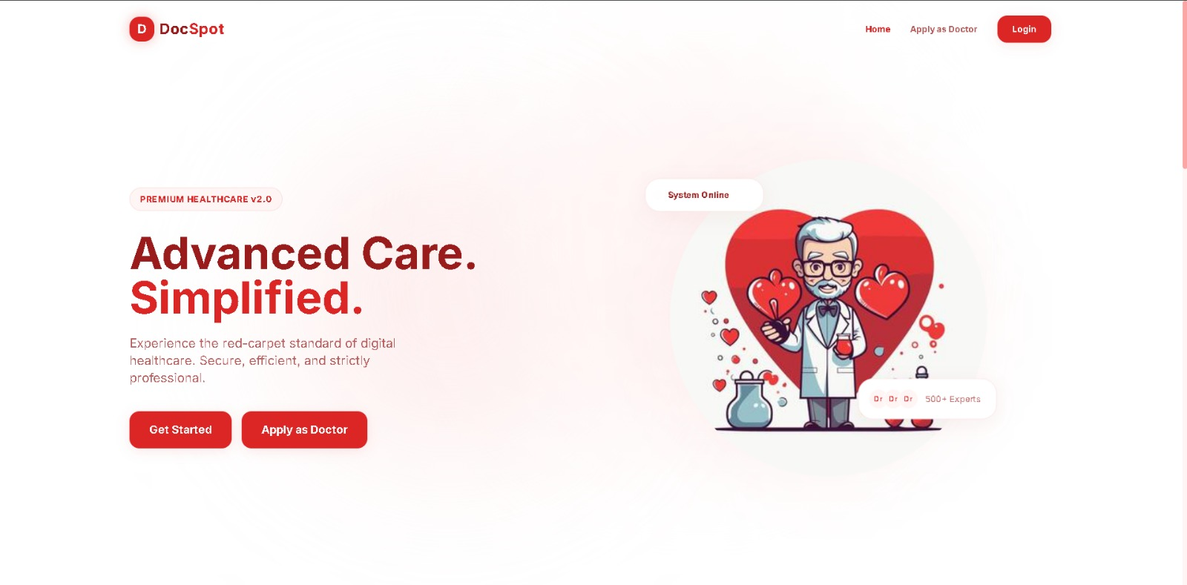
Register page:
When the application runs, the register page allows new users to create their account in the system. The page includes input fields such as Full Name, Email, Phone Number, Password, and Confirm Password. Validation rules are applied to ensure all required fields are filled, the email format is correct, the password meets security criteria, and both password fields match.
An “Initialize Profile” button is provided to submit the form, and a link is available for existing users to access the login page. The design is clean, responsive, and user-friendly, ensuring a secure and smooth registration experience.
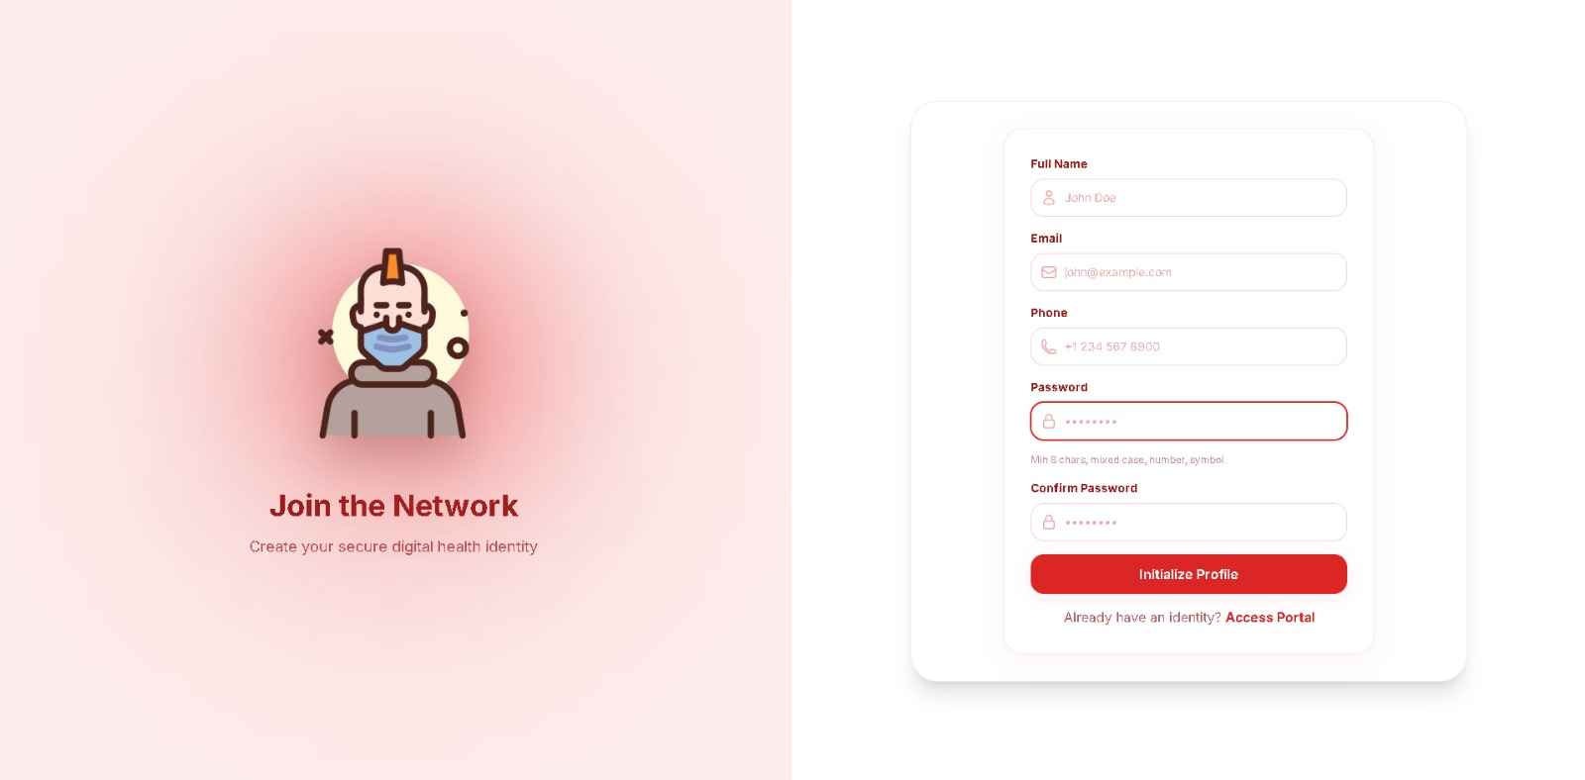

Login page:
When the application runs, the login page allows existing users to access their accounts. The page includes input fields for Email and Password. Validation is applied to ensure that all required fields are filled and that the entered credentials match the records stored in the database.
Upon successful authentication, the user is redirected to the appropriate dashboard. If invalid credentials are entered, an error message is displayed. The page also provides a link to the registration page for new users. The design is simple, responsive, and user-friendly, ensuring a secure and smooth login experience.
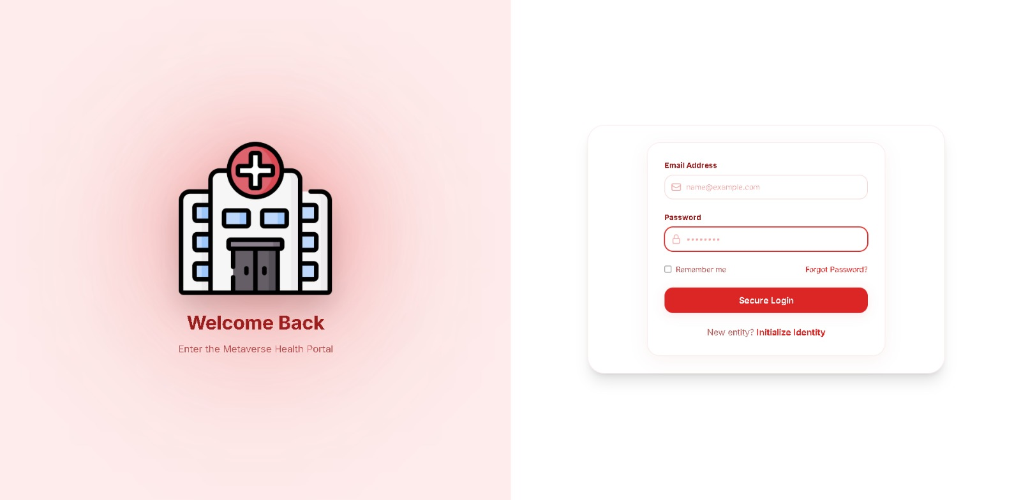

Admin Dashboard:

The admin dashboard provides a centralized interface for managing the entire healthcare appointment system. It includes sections to view and manage registered users, doctors, and appointments. The admin can approve or reject doctor requests, monitor appointment details, and oversee overall system activities.

The dashboard displays data in a structured format, making it easy to track records and perform actions efficiently. Proper authentication ensures that only authorized administrators can access this panel. The design is clean, organized, and responsive, allowing smooth navigation and effective system administration.

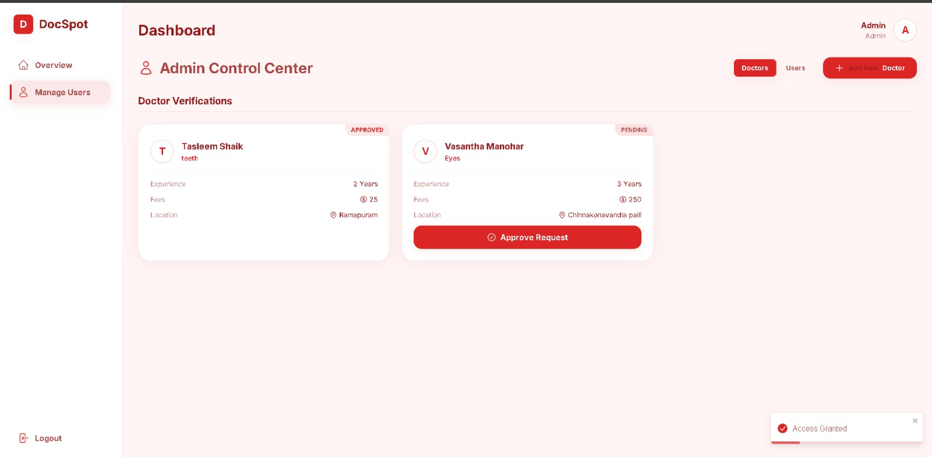

Apply Doctor:

The Apply as Doctor page allows registered users to submit their request to join the platform as a doctor. The form collects important details such as Full Name, Email, Phone Number, Specialization, Experience, Fees, Address, and Available Timings. Validation rules are applied to ensure all required fields are properly filled before submission.

Once the form is submitted, the application is sent to the admin for review and approval. The page is designed with a clean and professional layout, ensuring a smooth and user-friendly experience for applicants.

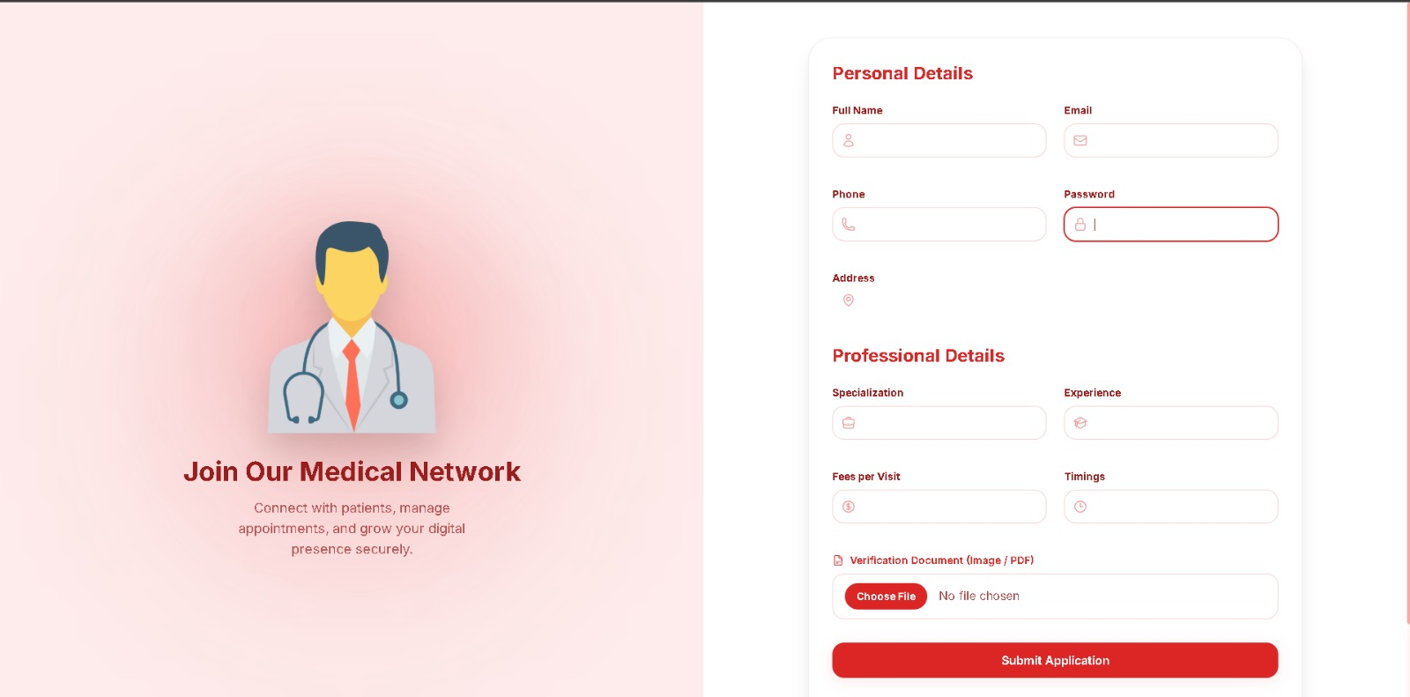

Doctor dashboard:

The doctor dashboard provides a personalized interface for approved doctors to manage their activities within the system. It allows doctors to view their profile details, check appointment requests, and monitor patient information. Doctors can update their availability timings and manage their appointment status.

The dashboard presents information in a structured and organized manner for easy navigation. Secure authentication ensures that only authorized doctors can access this panel. The design is clean, responsive, and user-friendly, enabling doctors to efficiently manage their services on the platform.

User dashboard:
The user dashboard provides a personalized interface for registered users to manage their activities within the healthcare appointment system. It allows users to view and update their profile details, book appointments with doctors, and track the status of their scheduled appointments.
All appointment information is displayed in an organized format, making it easy for users to monitor their bookings. Secure authentication ensures that only authorized users can access their dashboard. The design is clean, responsive, and user-friendly, providing a seamless experience for managing healthcare services online.

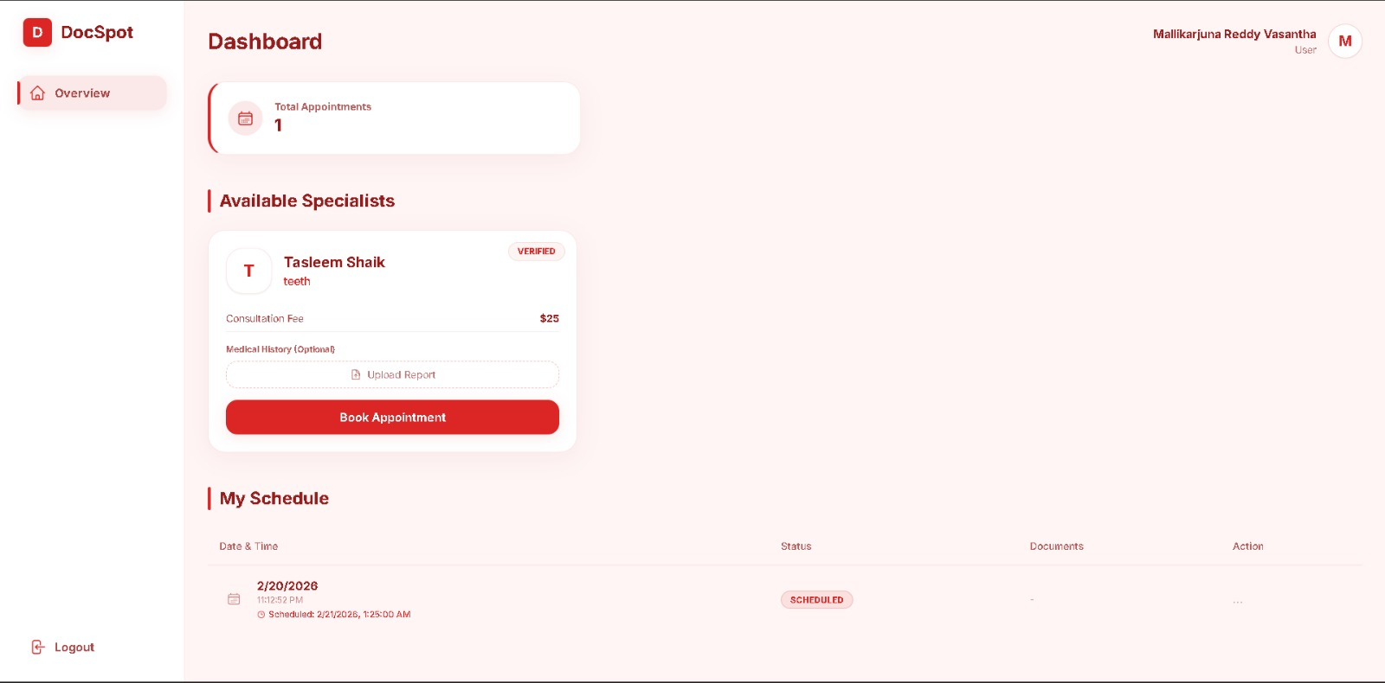
Project FlowDemo Video and reference code link:
reference video link:
reference code link:
** Happy Coding **

