

**Diversity and Inclusion Model/Playbook Implementation and**

**Development**

# Introduction

This document describes about the prerequisites and the various process/procedures that needs to be followed for End to end execution of D&I women/minority owner application. Also, it describes in detail about the different tool stacks that are used.

**Source Code Management:**

For this hackathon we are hosting our source code on GitHub.

The link is as follows:

<https://github.com/Siva7/hackathon0522>

Below are the 3 main modules for solving this use case

1. Web Scrapping (Package Name: Webscrapping)
2. Azure components (Package Name: Azurecomp)
3. NLP Modelling (Package Name: Wfhack2022)
4. Unit Test (Package Name: Testing)
5. CICD (Package Name: Github/workflows)

**Deployment Management :**

1. As per Agile methodology, we should push any code changes via github.

A sample git PR link

<https://github.com/Siva7/hackathon0522/pull/6>

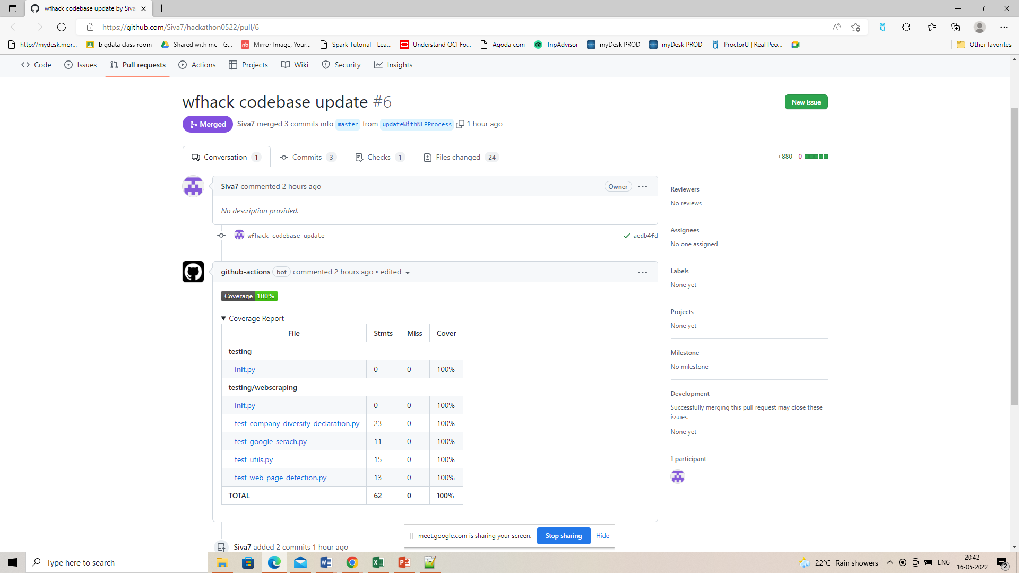

1. Successful pull request will push the changed code to docker hub.

<https://hub.docker.com/repository/registry-1.docker.io/siva7/hack0522/general>

1. Trigger the Azure Notebook

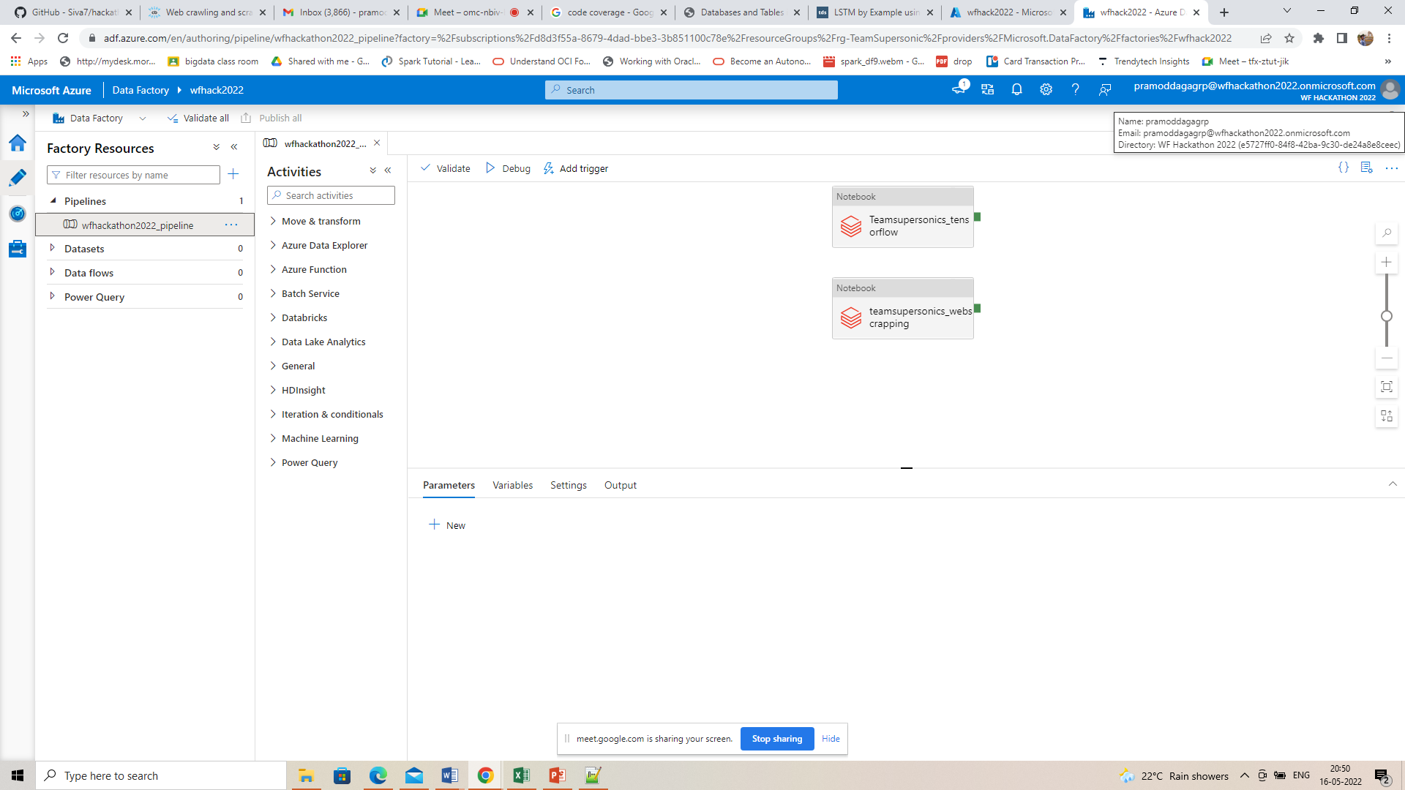

1. Monitoring Notebook execution

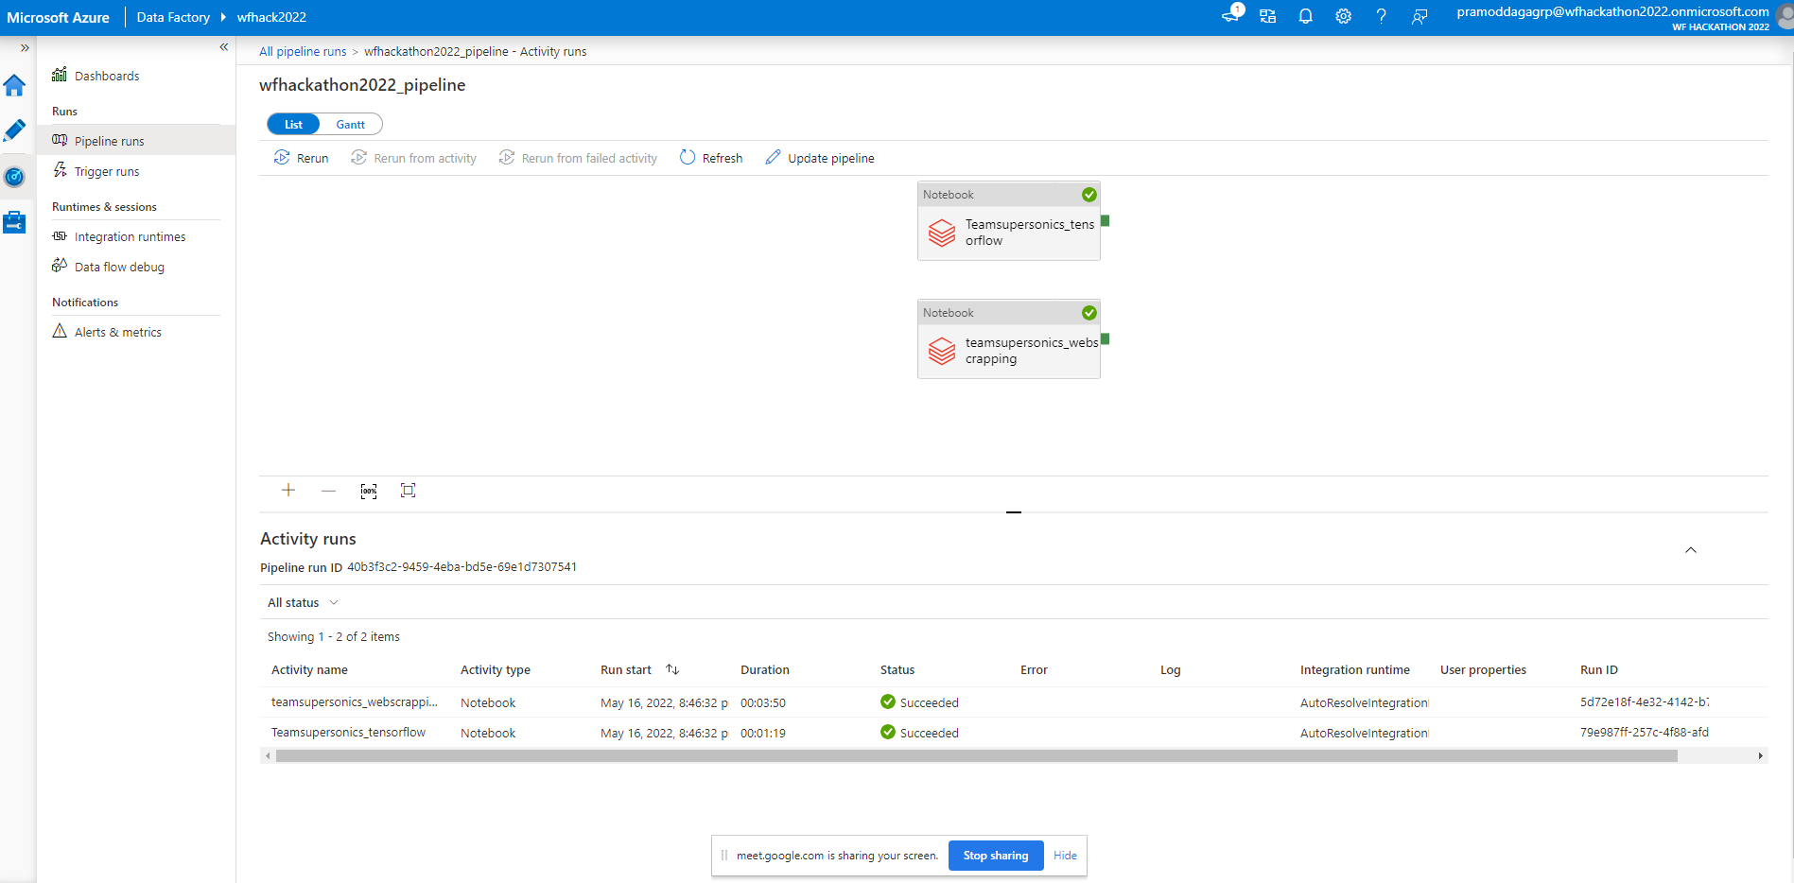

1. To trigger the workflow at scale below codes are to be used.

-- Commands to trigger Web Scapping Container

az container delete --name webscraping202201 \

--resource-group rg-TeamSupersonic -y az container create \

--resource-group rg-TeamSupersonic \

--name webscraping202201 \

--image siva7/hack0522:1.0.0 \

--restart-policy Never \

--cpu 4

--memory 4 \

--command-line "python Executor.py 0 1 DefaultEndpointsProtocol=https;AccountName=codesanddoc;

AccountKey=ydz3XndrMKSX4aYFOc/TQfr8C6gj2/jQddc75+7FNshlqIGf5bieFfJvDg0M6YFCvGHYwOcU/CKm+AStyw"

-- Command to trigger the Consolidation of Web Scrapping Results

az container delete --name webscrapingconslidateresults --resource-group rg-TeamSupersonic -y

az container create \

--resource-group rg-TeamSupersonic \

--name webscrapingconslidateresults \

--image siva7/hack0522:1.0.0 \

--restart-policy Never \

--cpu 1 --memory 6 \

--command-line "python consolidate_webscrapping_output.py DefaultEndpointsProtocol=https;AccountName=codesanddoc;AccountKey=ydz3XndrMKSX4aYFOc/TQfr8C6gj2/jQddc75+7FNshlqIGf5bieFfJvDg0M6YFCvGHYwOcU/CKm+AStywykNA==;EndpointSuffix=core.windows.net"

-- Command to trigger the Final Result Population

az container delete --name finalresultpublish --resource-group rg-TeamSupersonic -y

az container create \

--resource-group rg-TeamSupersonic \

--name finalresultpublish \

--image siva7/hack0522:1.0.0 \

--restart-policy Never \

--cpu 1 --memory 6 \

--command-line "HackathonResults.py"

1. Final output is stored at azure blob storage

Final Result :

<https://codesanddoc.blob.core.windows.net/finalresult/Final_Result_hack2022.xlsx>

Detailed Report :

<https://codesanddoc.blob.core.windows.net/finalresult/Final_Result_With_Details_hack2022.xlsx>

