1. Write a Selenium Java script to automate the following scenario:

https://jqueryui.com/datepicker/ URL

Switch to the iframe that contains the datepicker

Write the code to select the next month from the datepicker

Write the code to select the date "22" from the datepicker

Here we can pick the date in two types of code

1. Writing all tag names in xapth we can fetch the date from clander

Like tale tagname, rowtagname, and cell tagname;

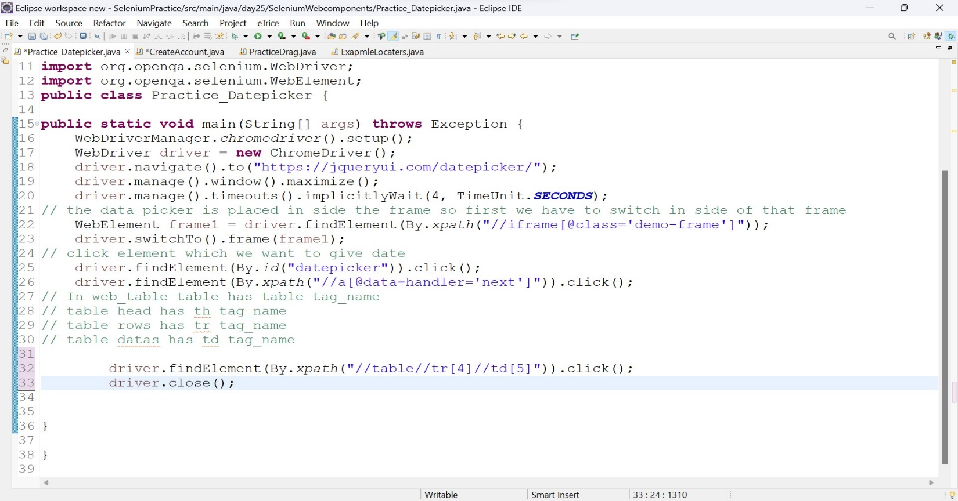//table//tr [4]//td [5]

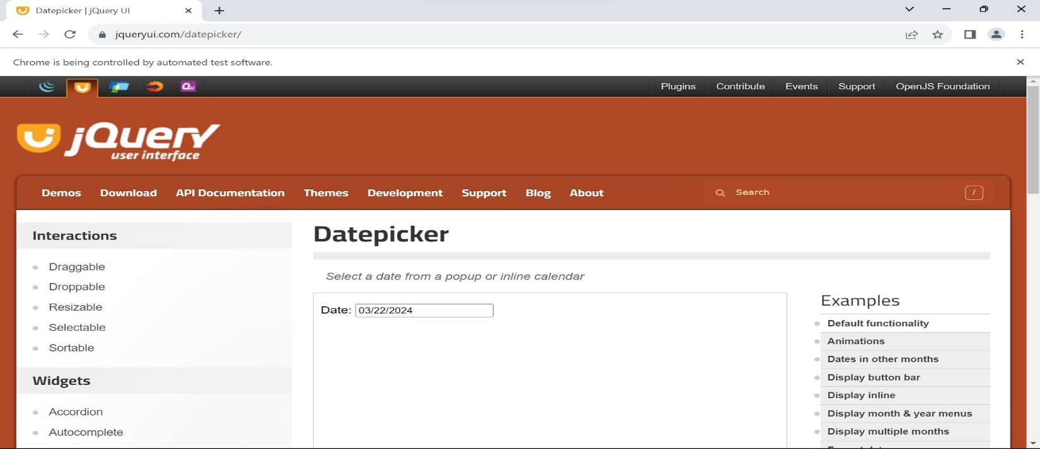Output:

1. Here we fetch the data in ide

* Here first we find the table first and
* we have to frtch the row
* then fetch the date

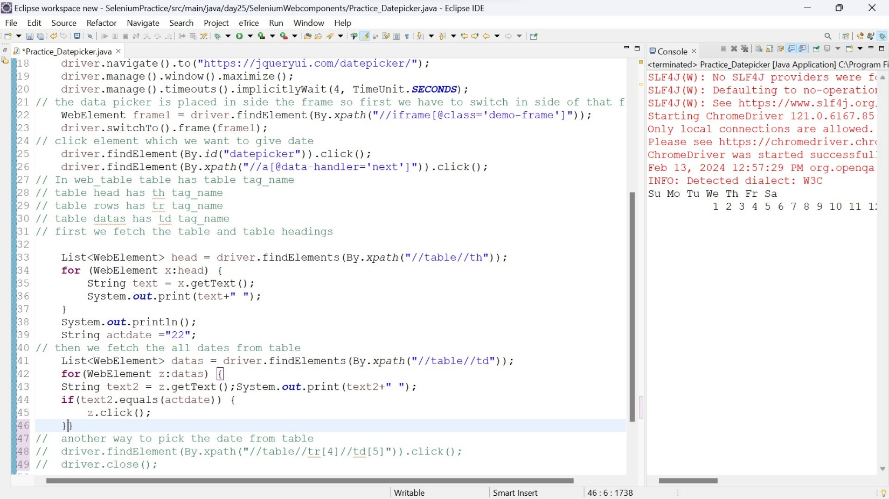

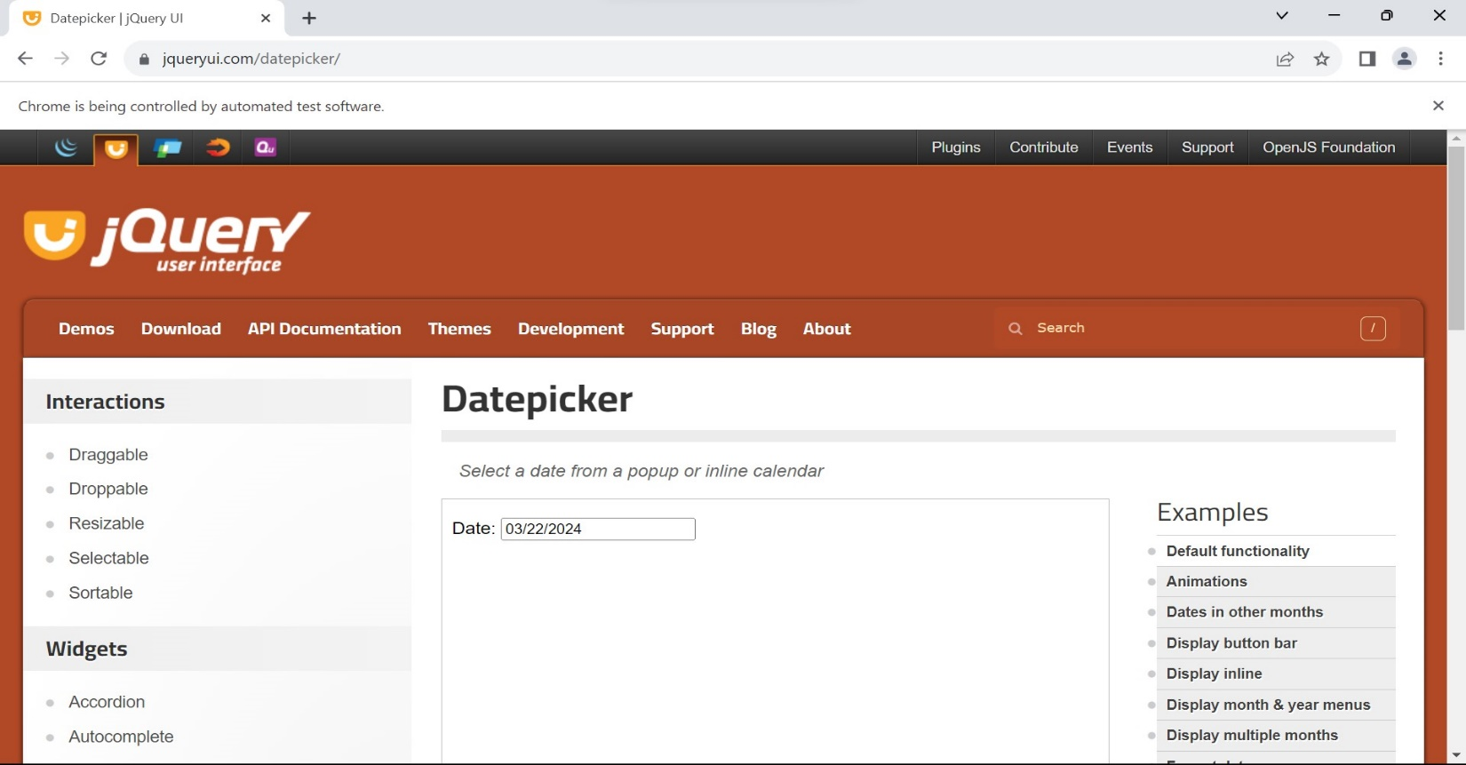Output

2.To Automate Signup and Login process for https://www.guvi.in/ Steps: Launch the website https://www.guvi.in/ using Selenium WebDriver. Locate the Signup button on the top right corner of the page and click on it. Fill in the signup form with required details like name, email, password, etc.

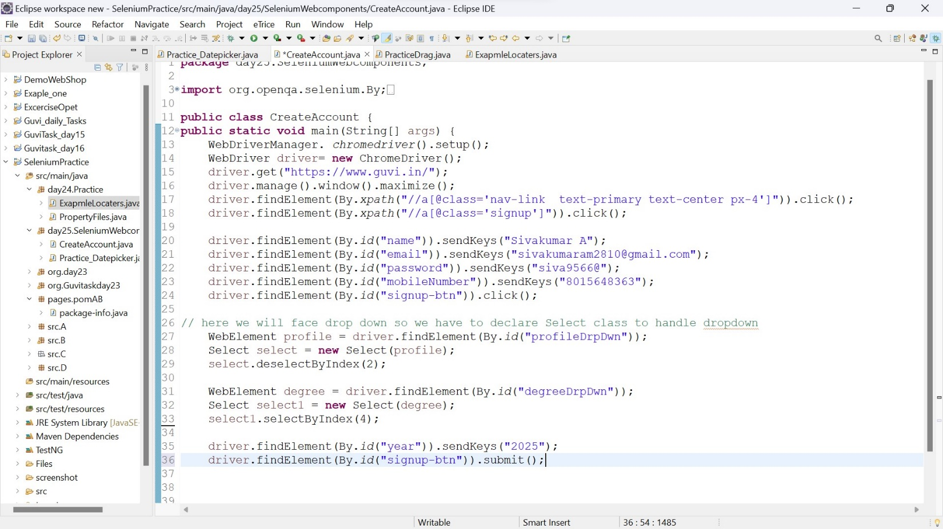

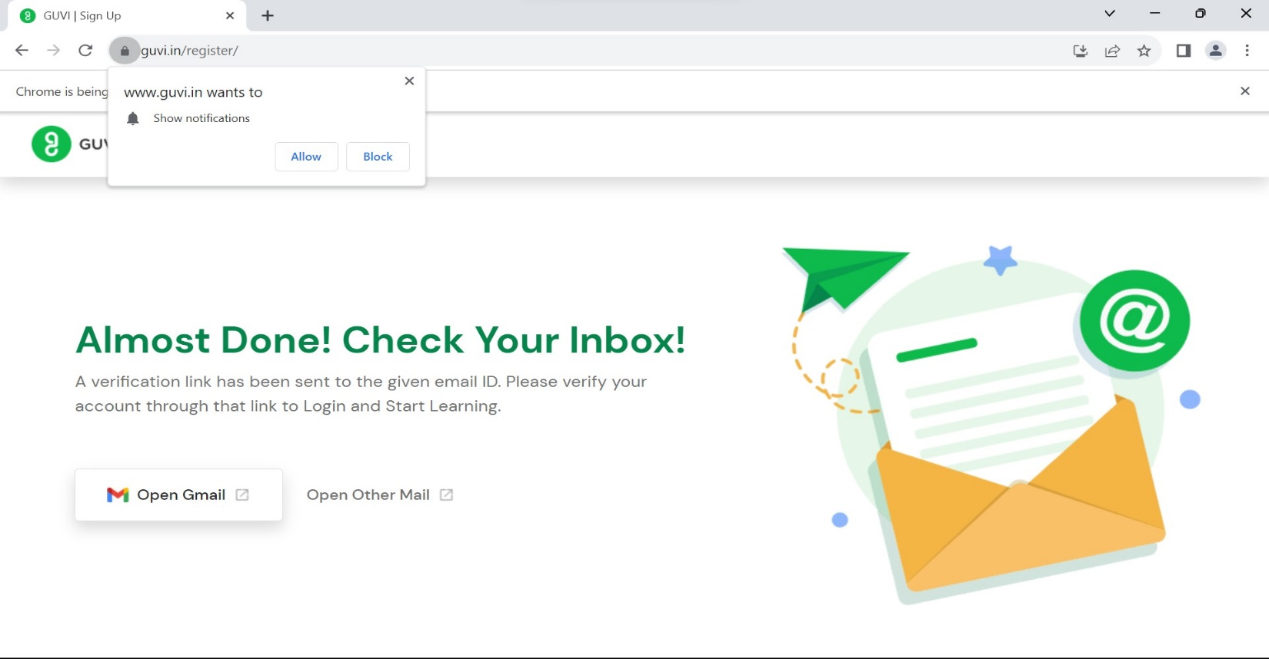Output

Signin with valid credential

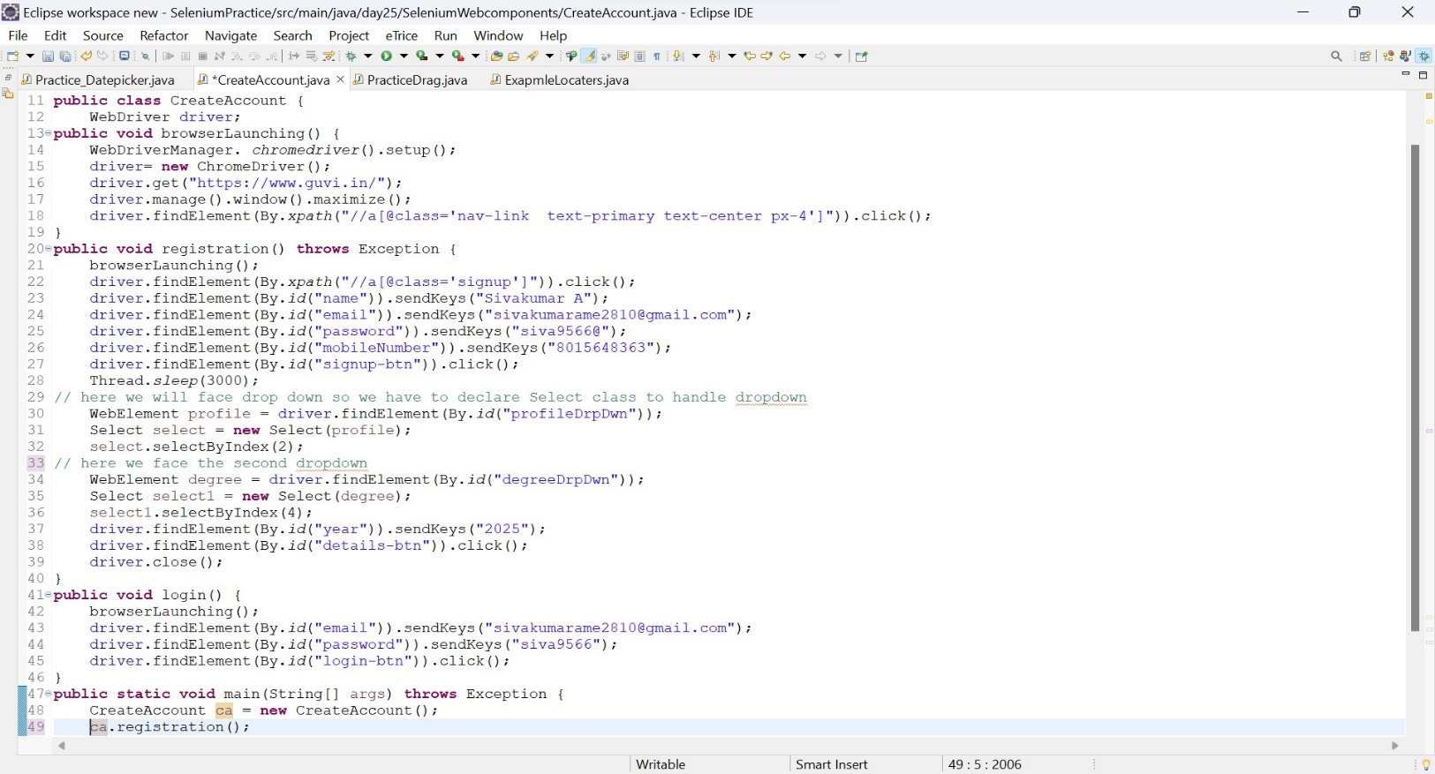

Output

