1)Write a Selenium script to automate the following task:

1. Open a new instance of the Chrome/Firefox/Safari browser.

2. Navigate to the URL "https://the-internet.herokuapp.com/iframe".

3. Switch to the iframe using the iframe using css Selector or Xpath.

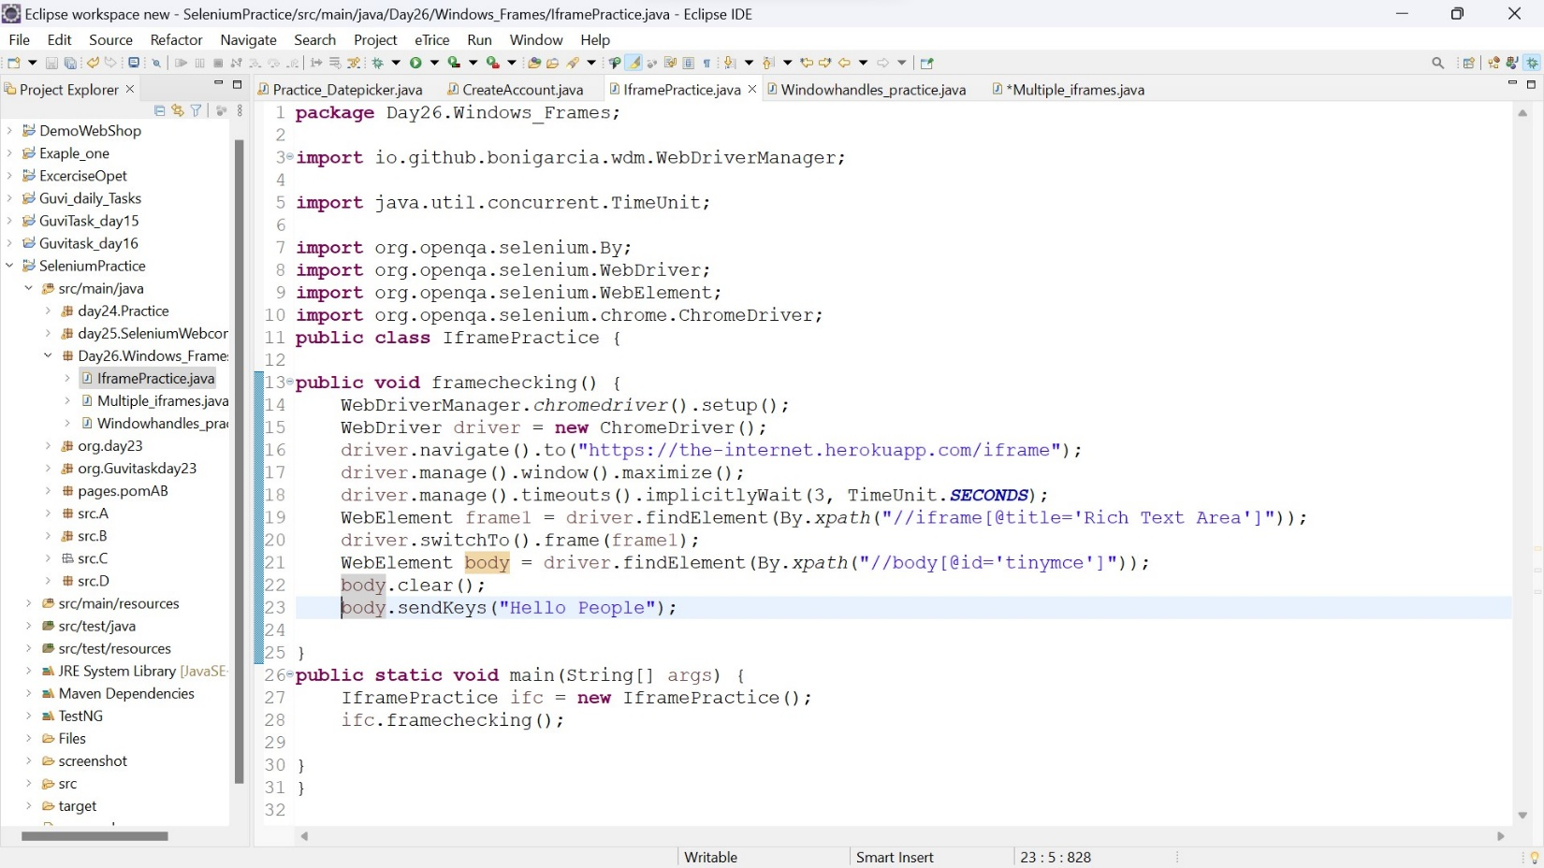4. Locate the "p" tag inside the iframe and write the text "Hello People".

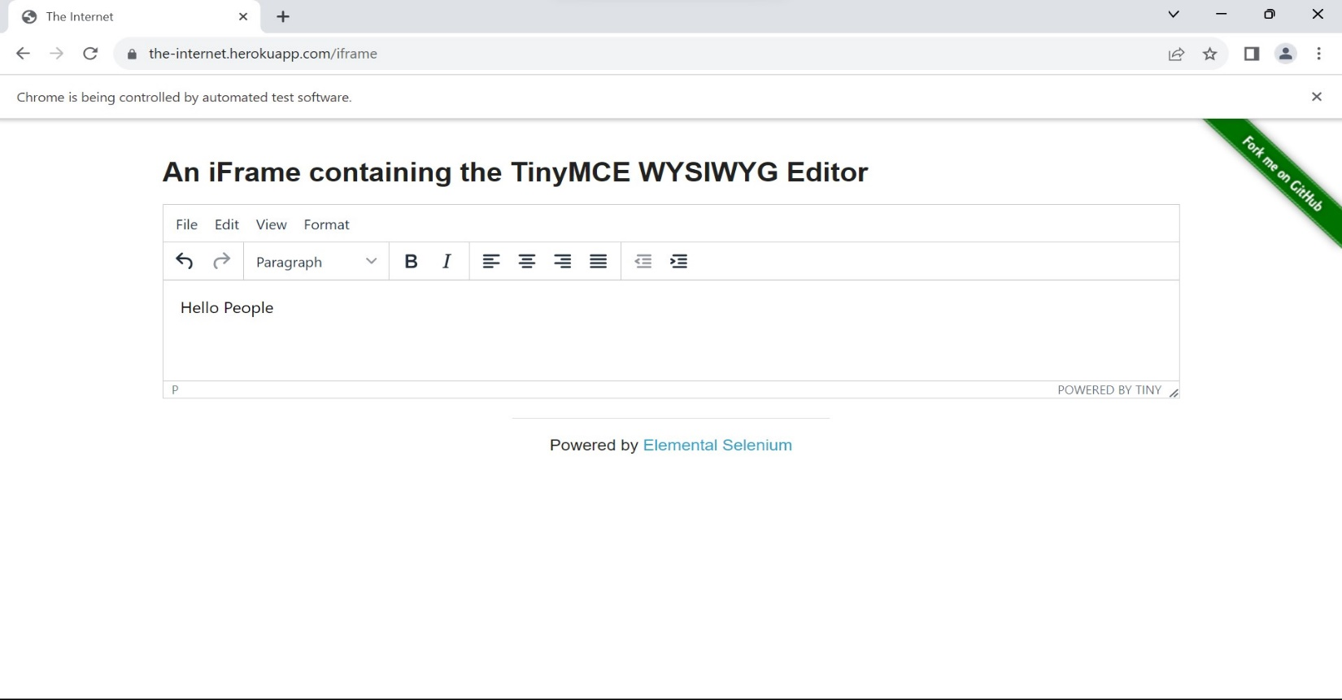Output :

2.Write a Selenium script to automate the following task:

1. Open a new instance of the Chrome/Firefox/Safari browser.

2. Navigate to the URL "https://the-internet.herokuapp.com/windows".

3. Click the "Click Here" button to open a new window.

4. Switch to the newly opened window.

5. Verify that the text "New Window" is present on the page.

Windows Handling:

* Some case we have to work with multiple windows. Whenever we made any actions in webpage the current window only response the actions. in case, we want to work with multiple windows means we can use Windows Handling:
* Each browser window or tab is assigned a unique identifier called a "window handle." These handles are strings that help identify and switch between different open windows.

Managing Multiple Windows:

* When a new window is opened (for example, due to a button click or a link), you can obtain the handles of all open windows using getWindowHandles() method provided by Selenium WebDriver.

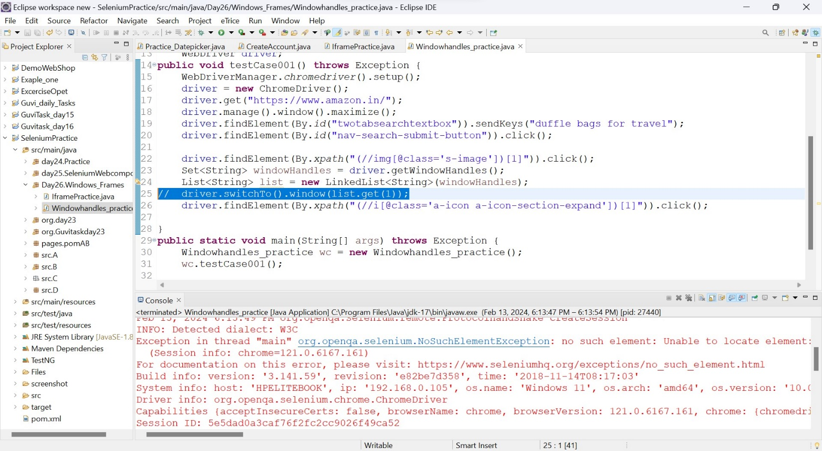

* Here I comment the switch to the window line so selenium throws no such element exception
* It try to find the element in the parent window so it can’t find that element so it throws exception

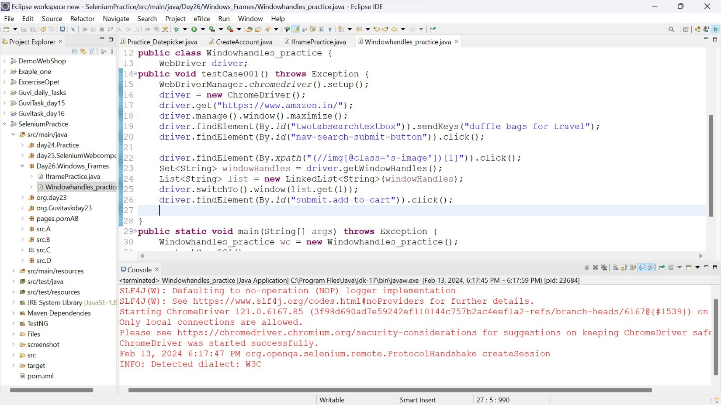After enable the comments line

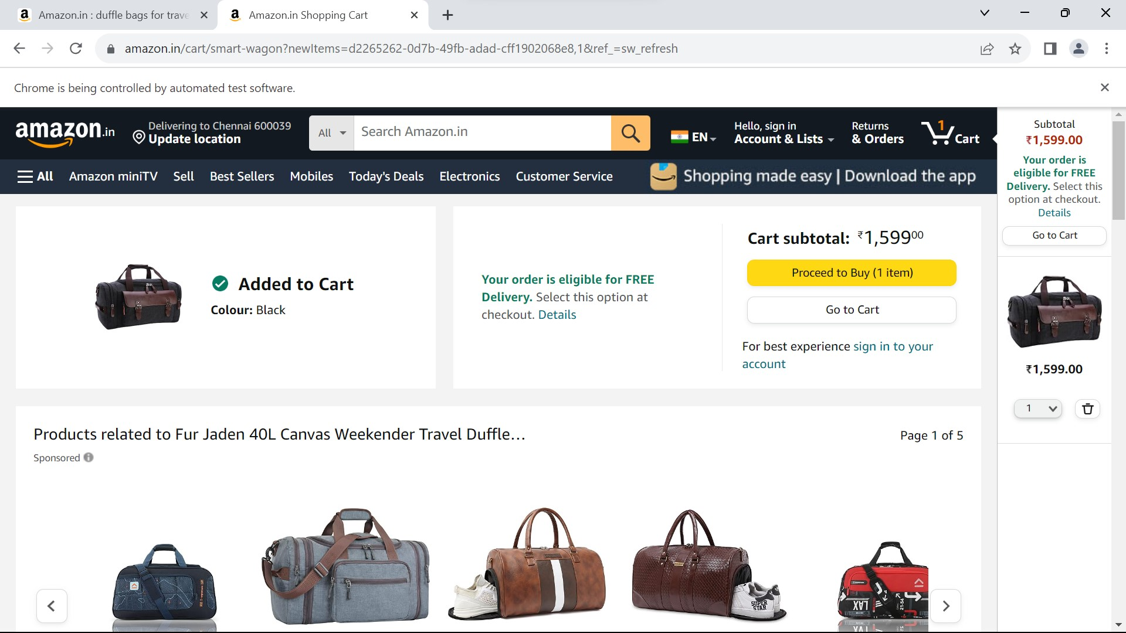Output:

3.Write a Selenium Java code to automate the following scenario:

* Open the URL http://the-internet.herokuapp.com/nested frames
* Use only css selector or Xpath.
* Switch to the top frame.
* Verify that there are three frames on the page.
* Switch to the left frame.
* Verify that the left frame has a text "LEFT".
* Switch back to the top frame.
* Switch to the middle frame.
* Verify that the middle frame has a text "MIDDLE".
* Switch back to the top frame.
* Switch to the right frame.
* Verify that the right frame has a text "RIGHT".
* Switch back to the top frame.
* Switch to the bottom frame.
* Verify that the bottom frame has a text "BOTTOM".
* 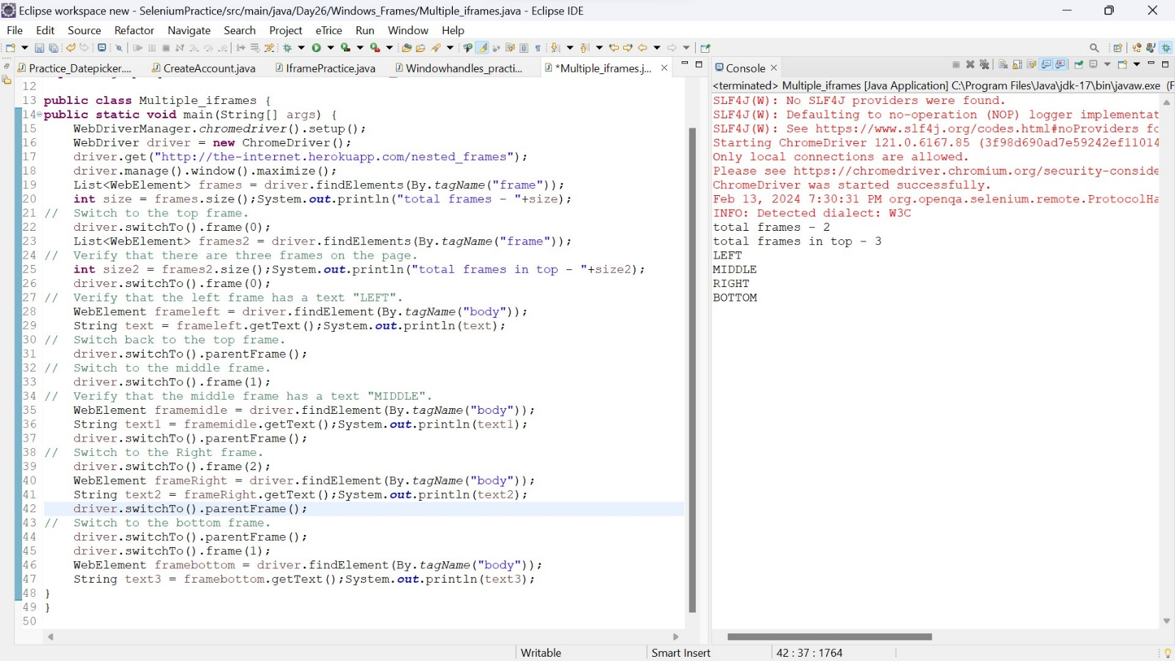Switch back to the top frame.