1. Here we will validate the create new account process in facebook

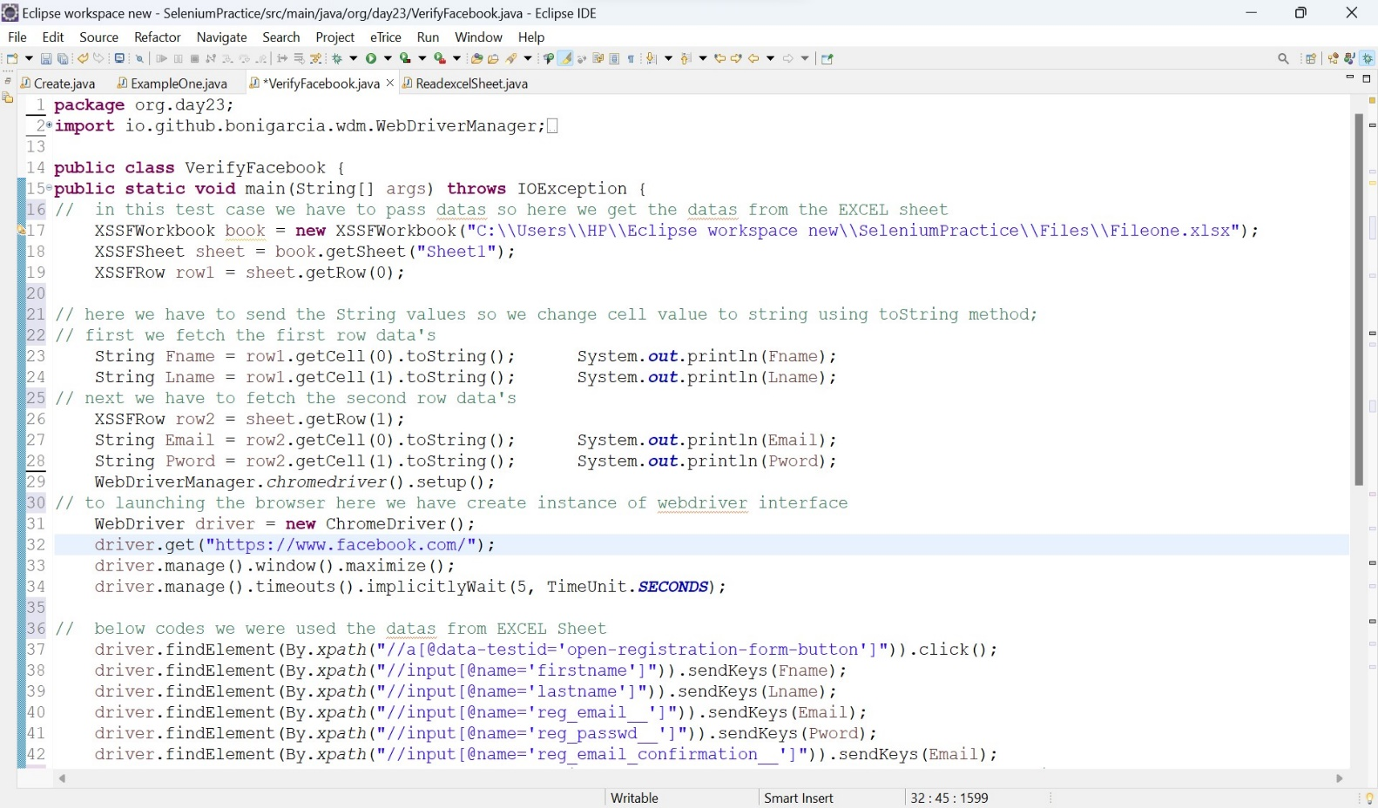

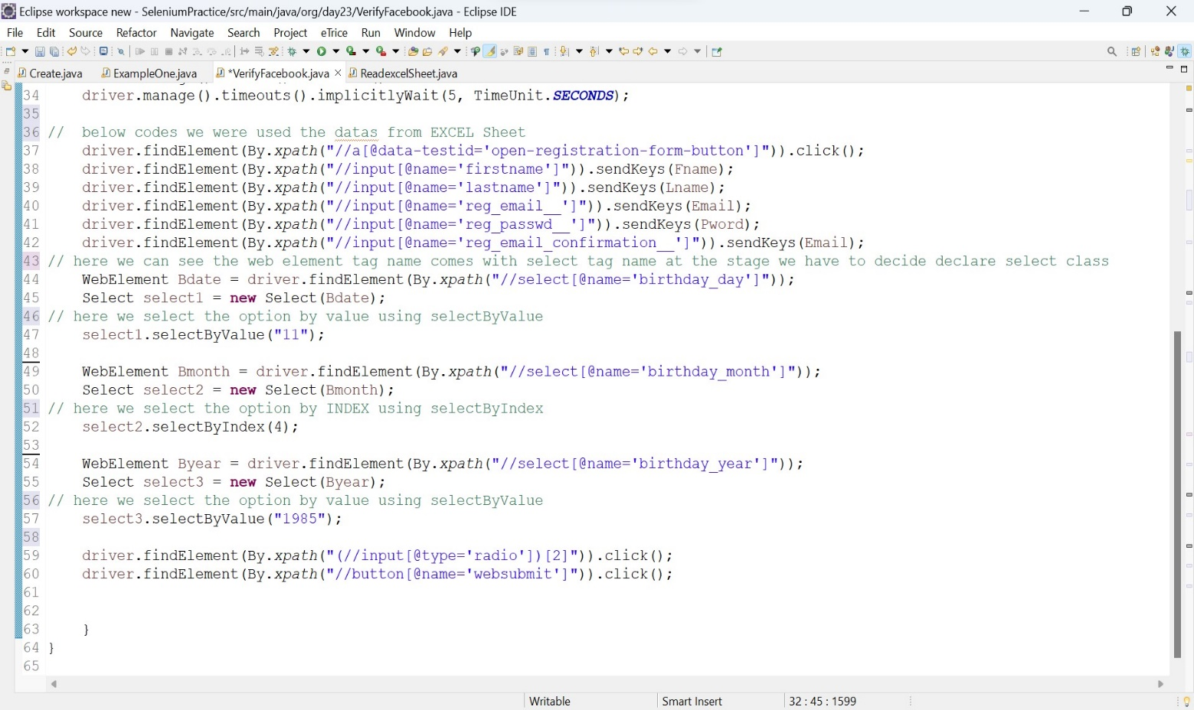

* Before the browser launching we have to setting the data driven to get the data’s from the Excel Sheet
* Then launching the browser we have call the (chromedriver)method from webdriver interface.
* For synchronization we can give implictiywait for entire operation broserlaunching and close
* Here we going to face Dropdown if is any sropdown means they are formed by select tag name in html tree.
* So we can find there is any dropdown in html tree we can search the select tag name.

Declare Select class.

Select class take one argument that is WebElement type

Select select = new Select(Element);

select.selectByIndexValue();

select.selectByVisibleText();

select.selectByValue();

* For create new account we have to give date of birth, so date and year I using selectByvalue() and I using selectByIndex() method for giving Month.

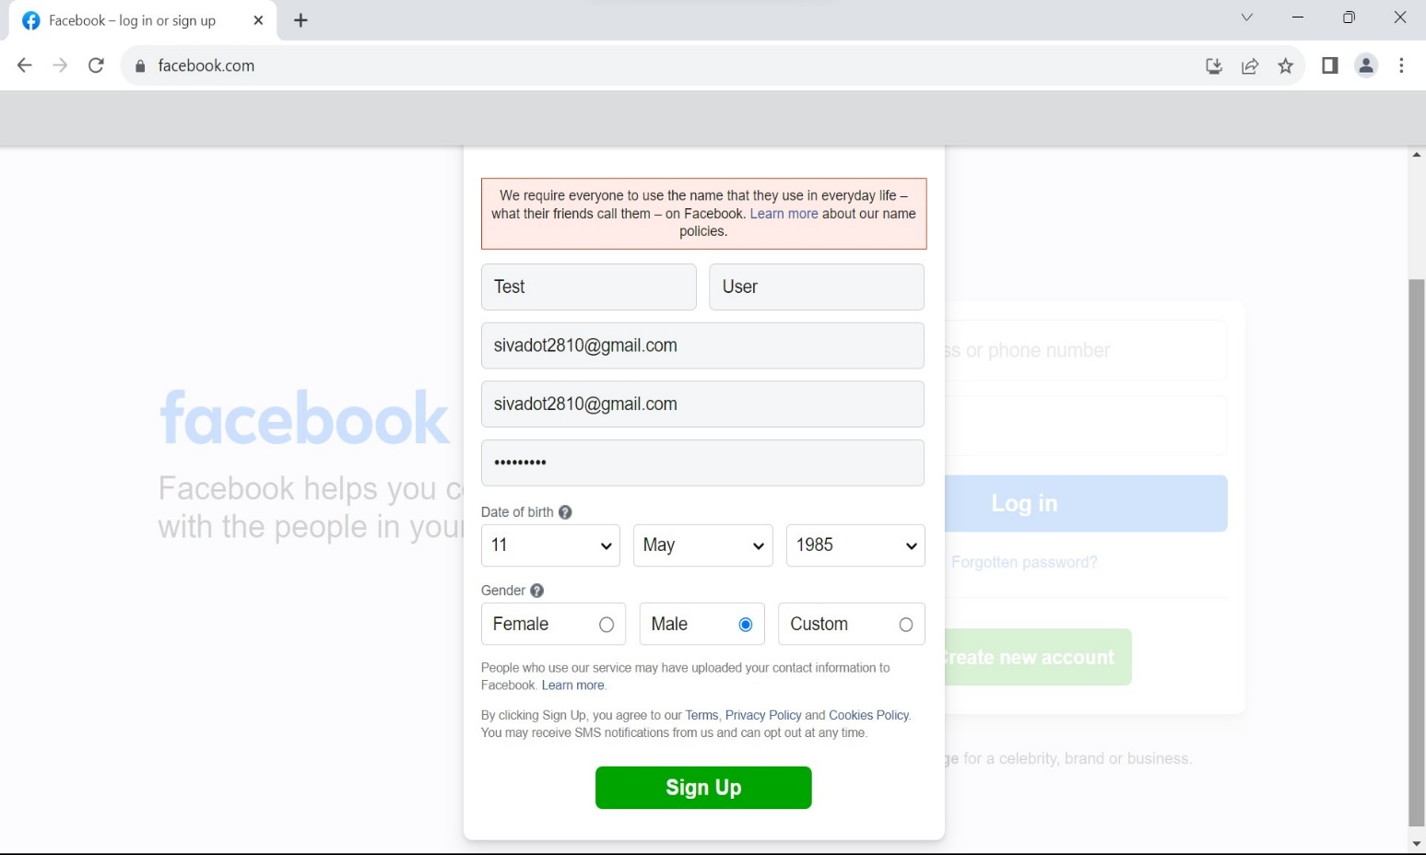Output :

1. To Automated Drag and Drop Operation using Selenium Java.

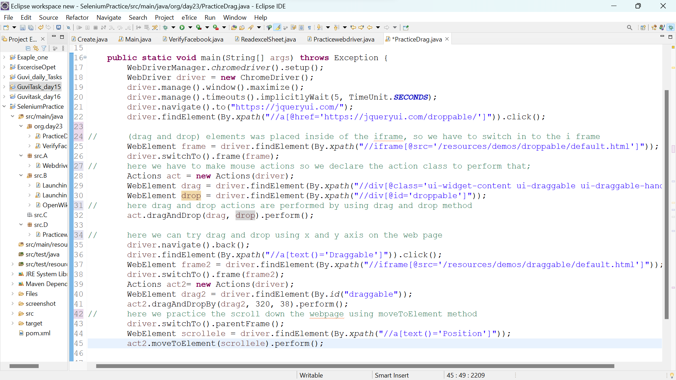

First we launching the browser

* We mention the Webdriver manager so it is simplify the code instead of using System.setproperty.
* Then create instance for webdriver interface for using chromedriver method.
* Then maximise the window using manage window mthod and synchronization the application using implicity wait

Actions Class :

* Action class is used to automate mouse hover actions and keyboard Actions.

Declaring the Action class :

Actions class takes one argument it is type of driver;

Actions actions = new Action(driver);

action.dragAndDrop(sor, des);

action.dragAndDropBy(sor, X, Y);

action.contaxtClick();

action.DoubleClick();

action.moveToElement();

action.sendKeys(“null”)

* Here three actions will be done first is drag and drop using X and Y axis, Then drag and drop using dragAndDrop(); method , we can scroll down the webpage using Move to element.

Output :

1. Drag and Drop Using X, Y axis method

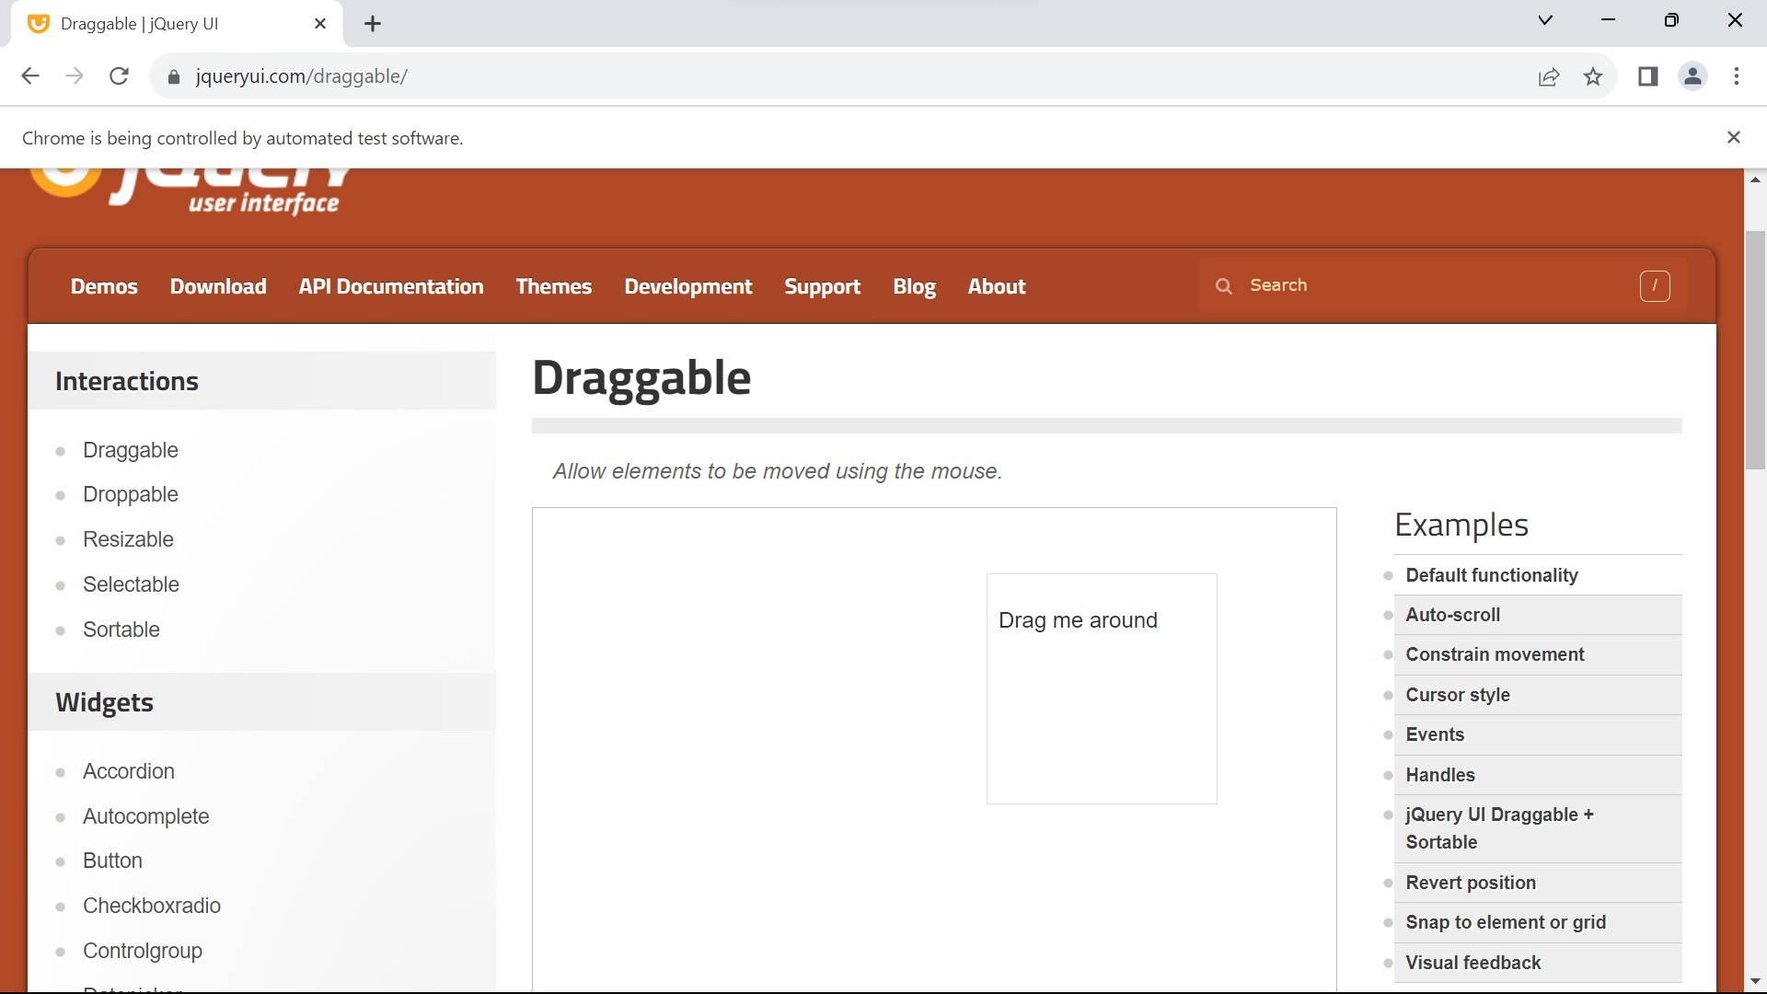

1. 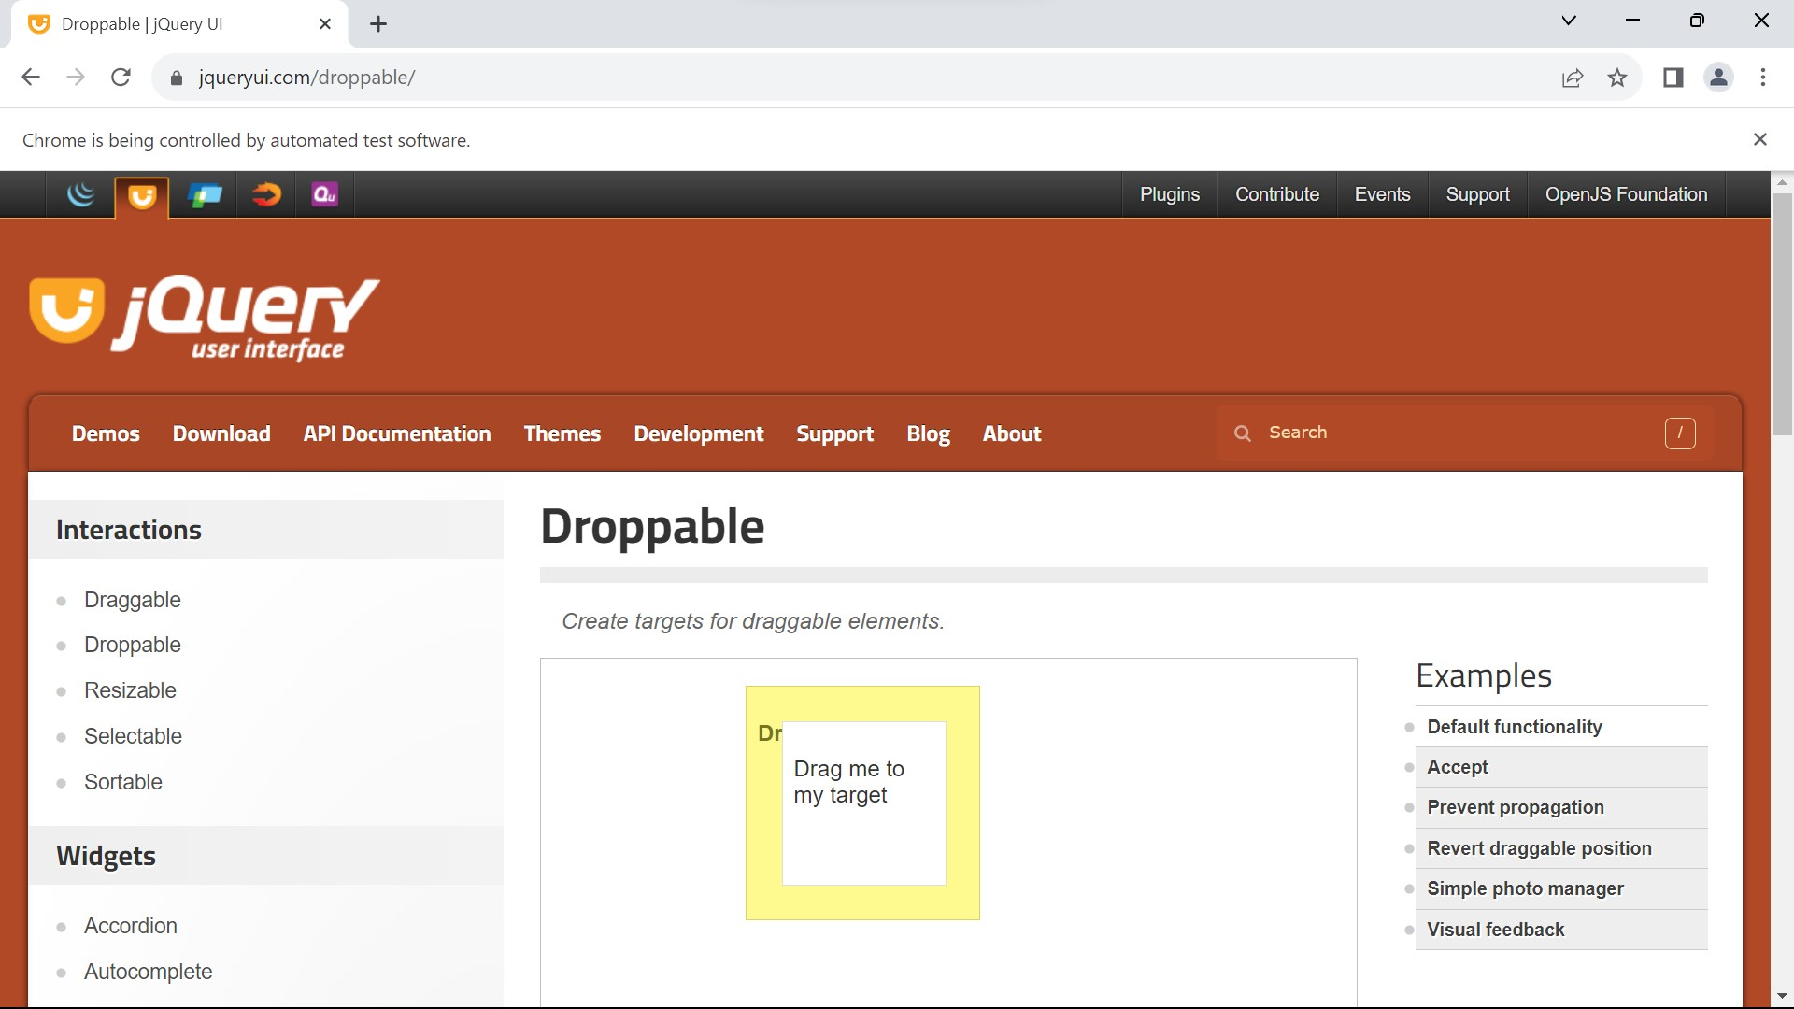Drag and Drop Using dragAndDrop();

Scroll down the WebPage using moveToElement();

