1. Write a selenium script to Automate Form using Webdriver wait:

Go to the form page of phptravels.com at https://phptravels.com/demo/

Fill in the form details

Add the logic for sum verification.

Verify that the form is submitted successfully by checking the message displayed.

Take a screenshot of the page after the form submission.

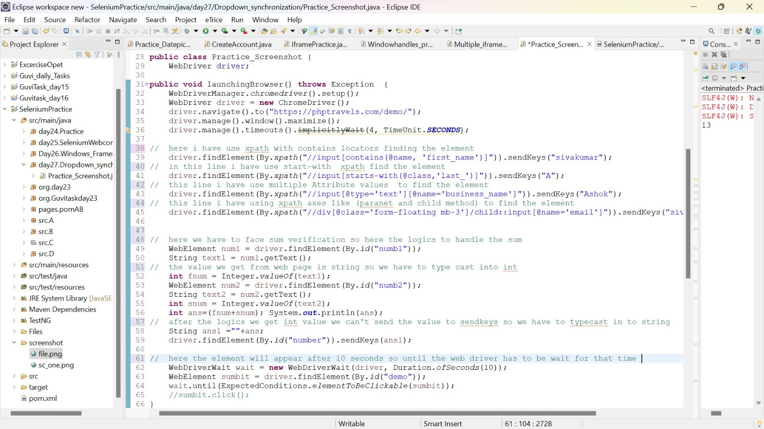

* here I have used the different types of xpath to find the Webelement.
* like : xpath with contains, start-with xpath, multiple Attribute values, xpath axes.
* In this page the submit button will take some time to appear so until selenium has to wait so, here I have declare webdriverWait so it check every 500millisecond the element is present or not.
* If element is appear it will return the element actions, if not means again it will chechk for the given time
* WebdriverWait takes takes two arguments one is time duration another one is driver.

WebDriverWait wait = new WebDriverWait(driver, Duration.ofSeconds(10));

WebElement sumbit = driver.findElement(By.id("demo"));

wait.until(ExpectedConditions.elementToBeClickable(sumbit));

* after the element is appear it can’t wait for remaining time it will execute next step

Screenshot :

To take the screen schot we can use two methods

1.TakesScreenshot (interface) method

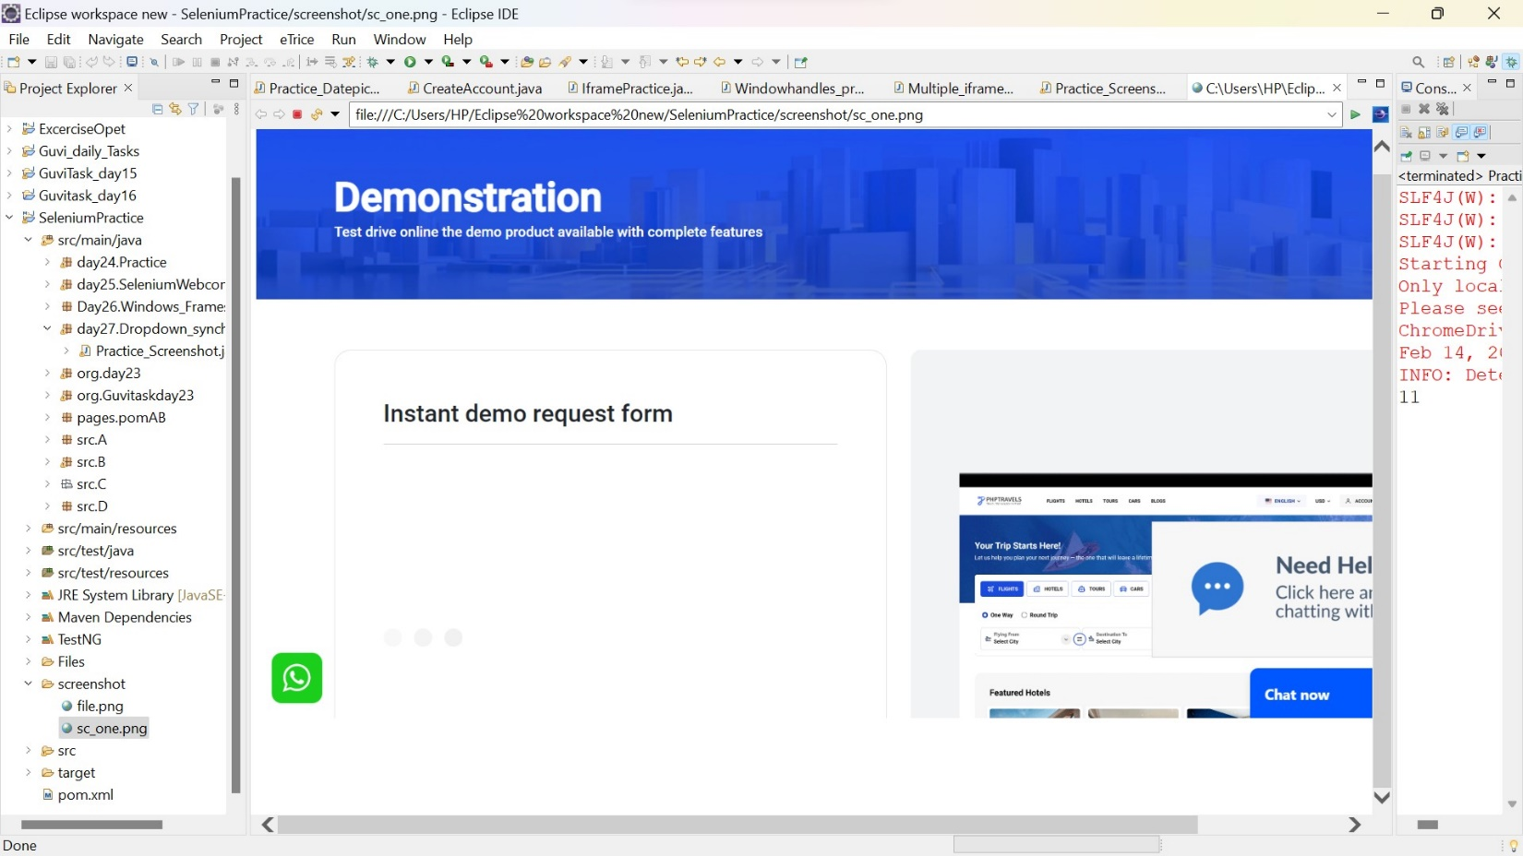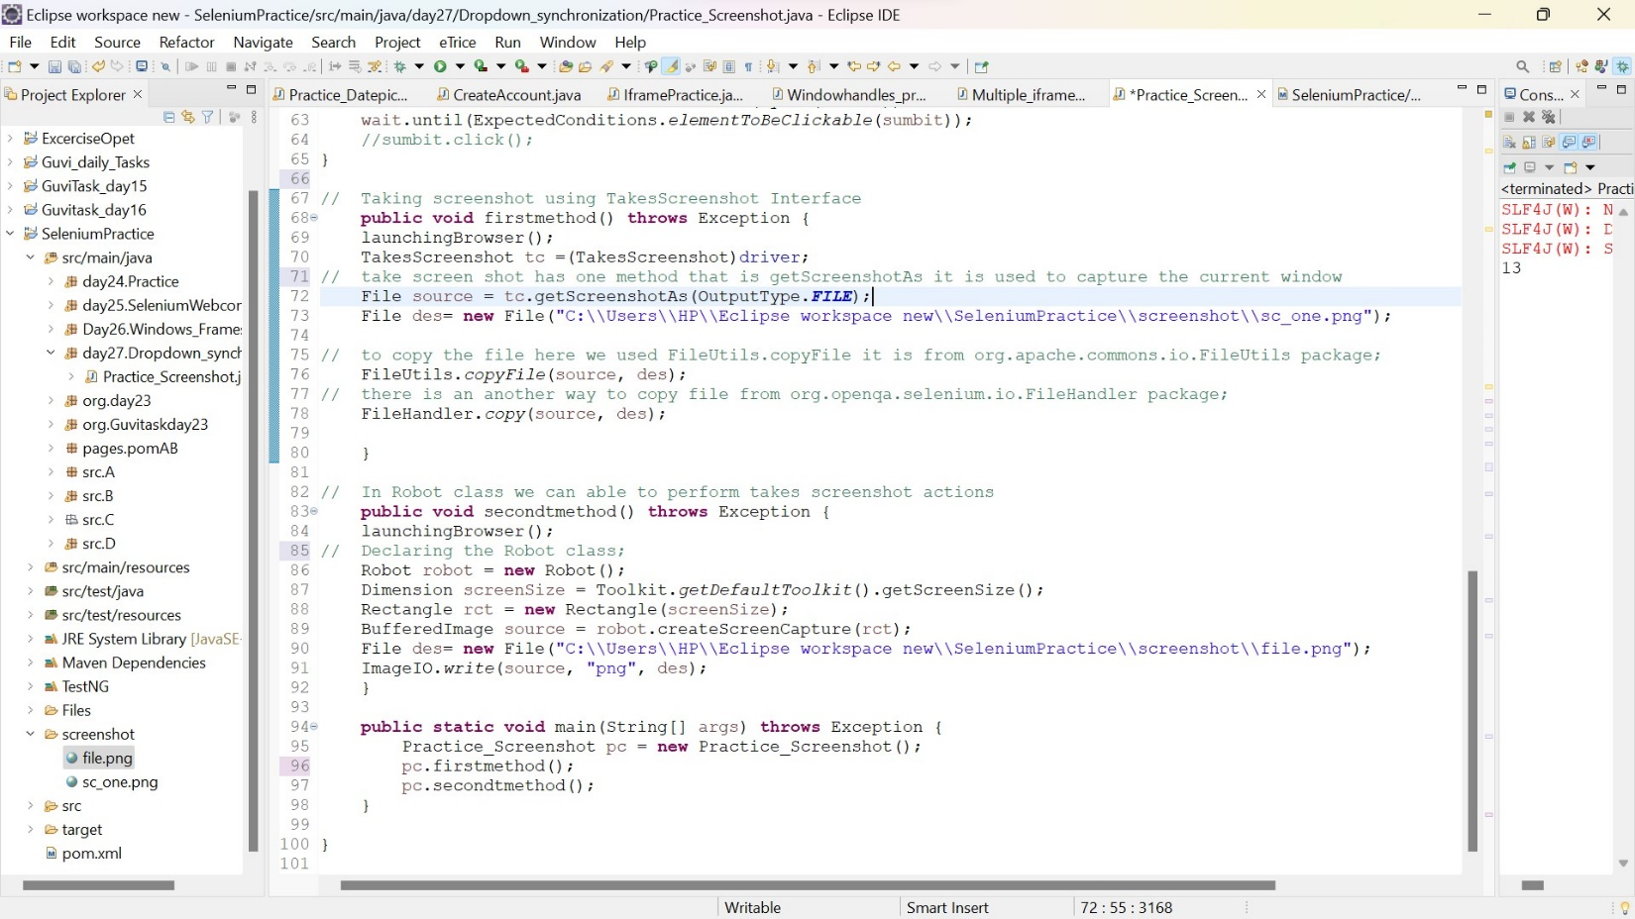2.Using robot class we can take the screen shot

Output :