1.Write all possible locators for given URL on given website : https://www.guvi.in/register

1. ID 2. ClassName 3. TagName : 4. CSS Selector 5. Xpath

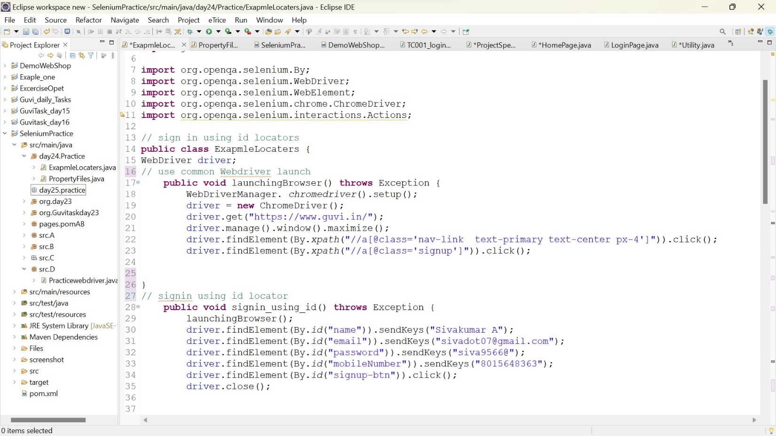a) Here we find the element Using id(locators)

Here I have used common webbrowser Launch

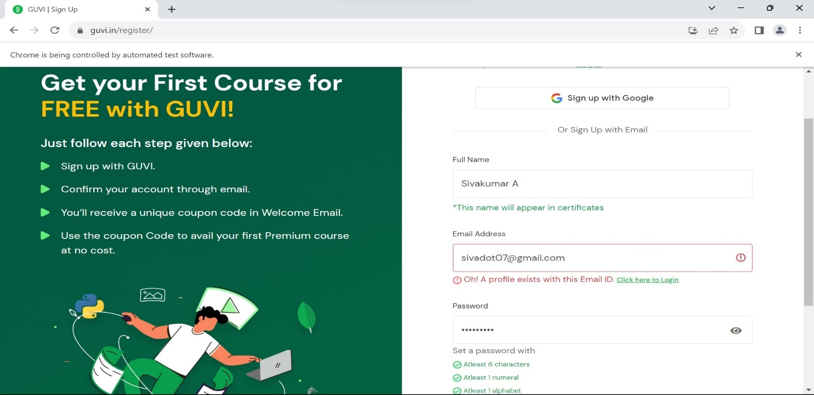Output:

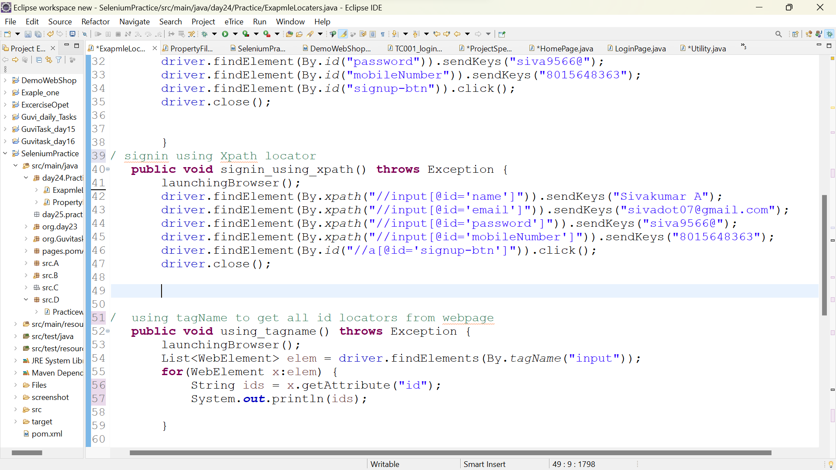b) here We using Xpath to find the locators

Output:

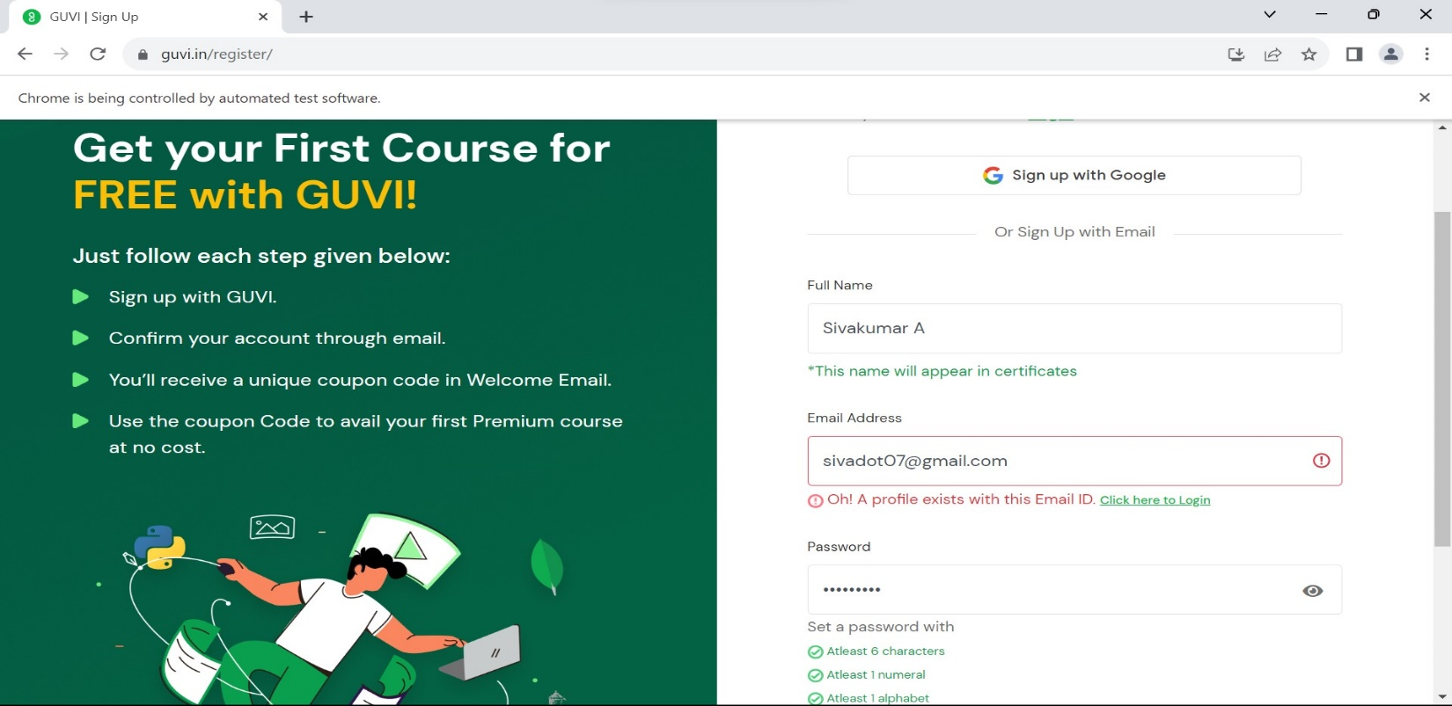

C) Tag name using tagname we can get the element attributes

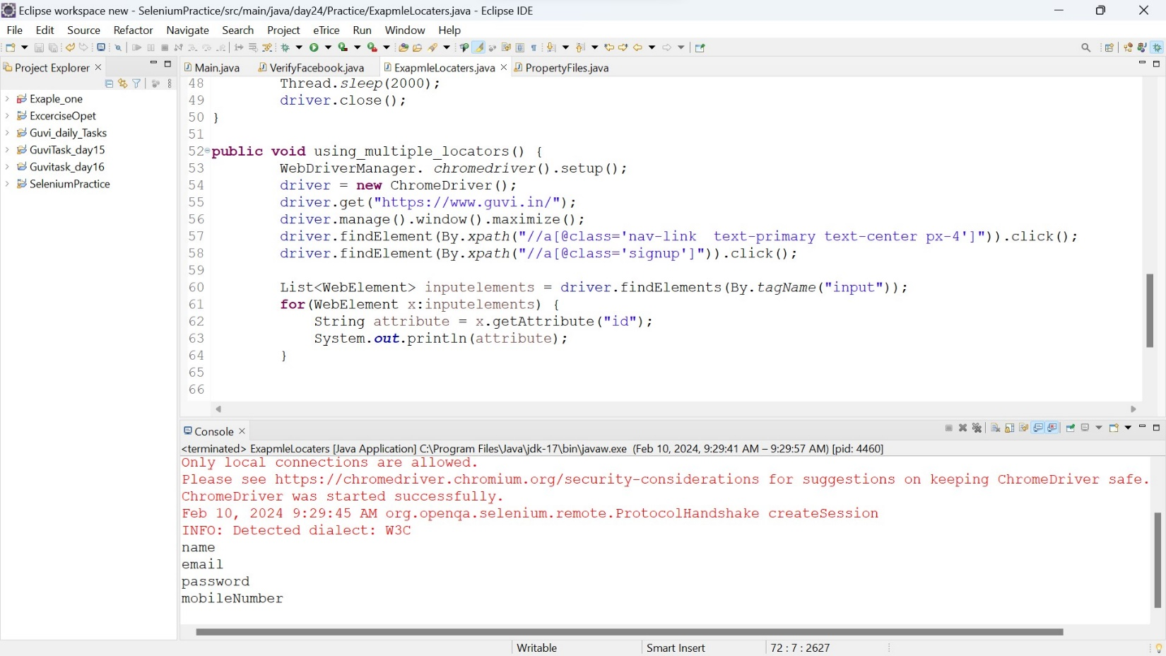

* Here I have try to fetch the data’s from the webpage using tagName. So login elements like username, password, and phno has same tagname
* Here the tag name is “input” so find element By.tagname I have given input tagname
* And mention fetch the datas from id attribute.

d) linkText

Input

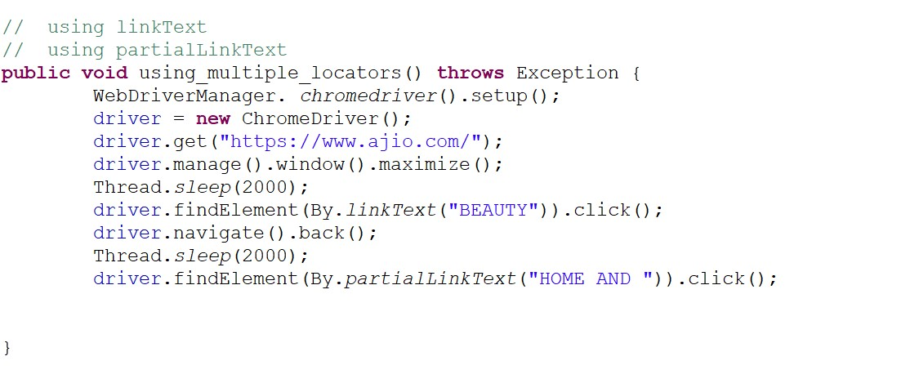

Output : linkText

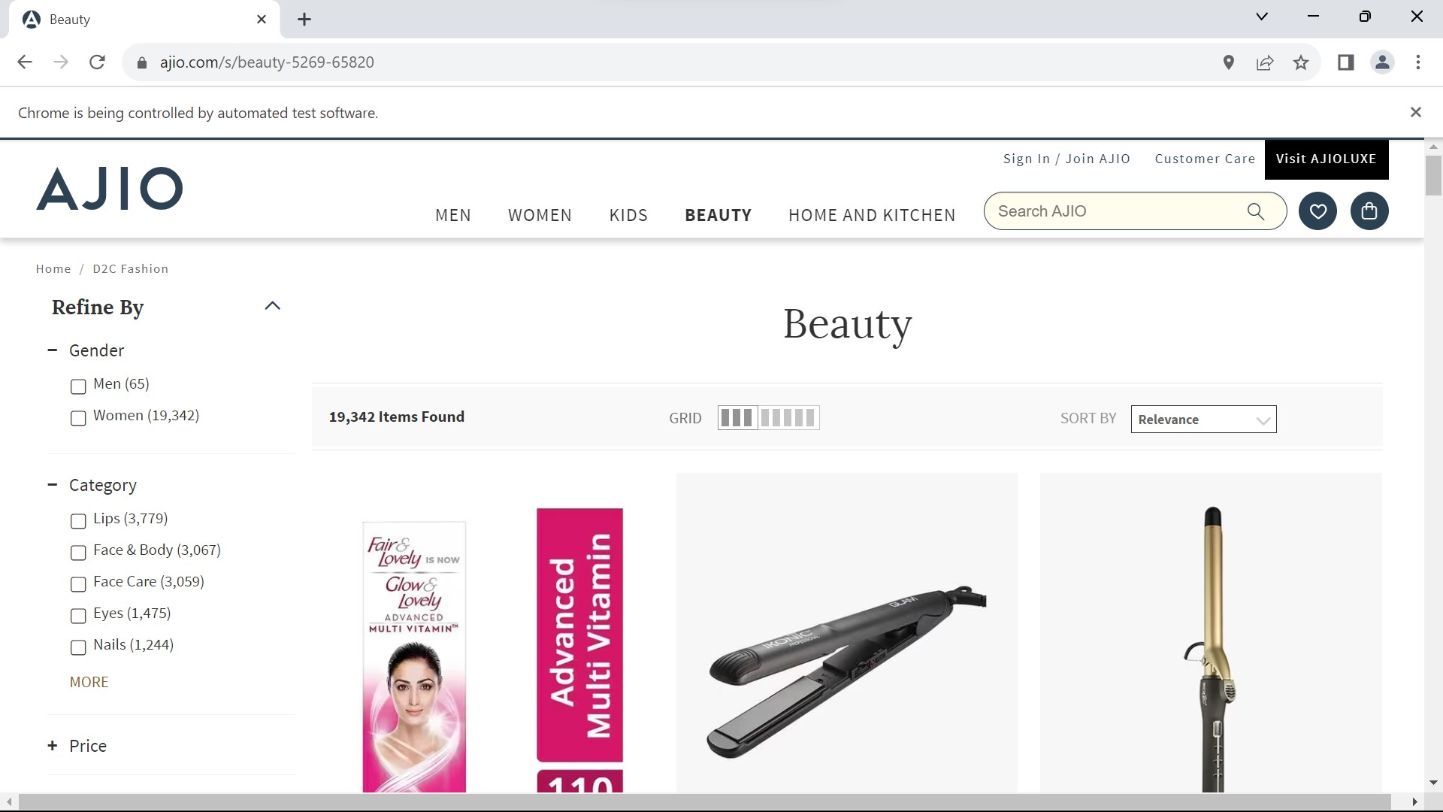

Output :partialLinkText

