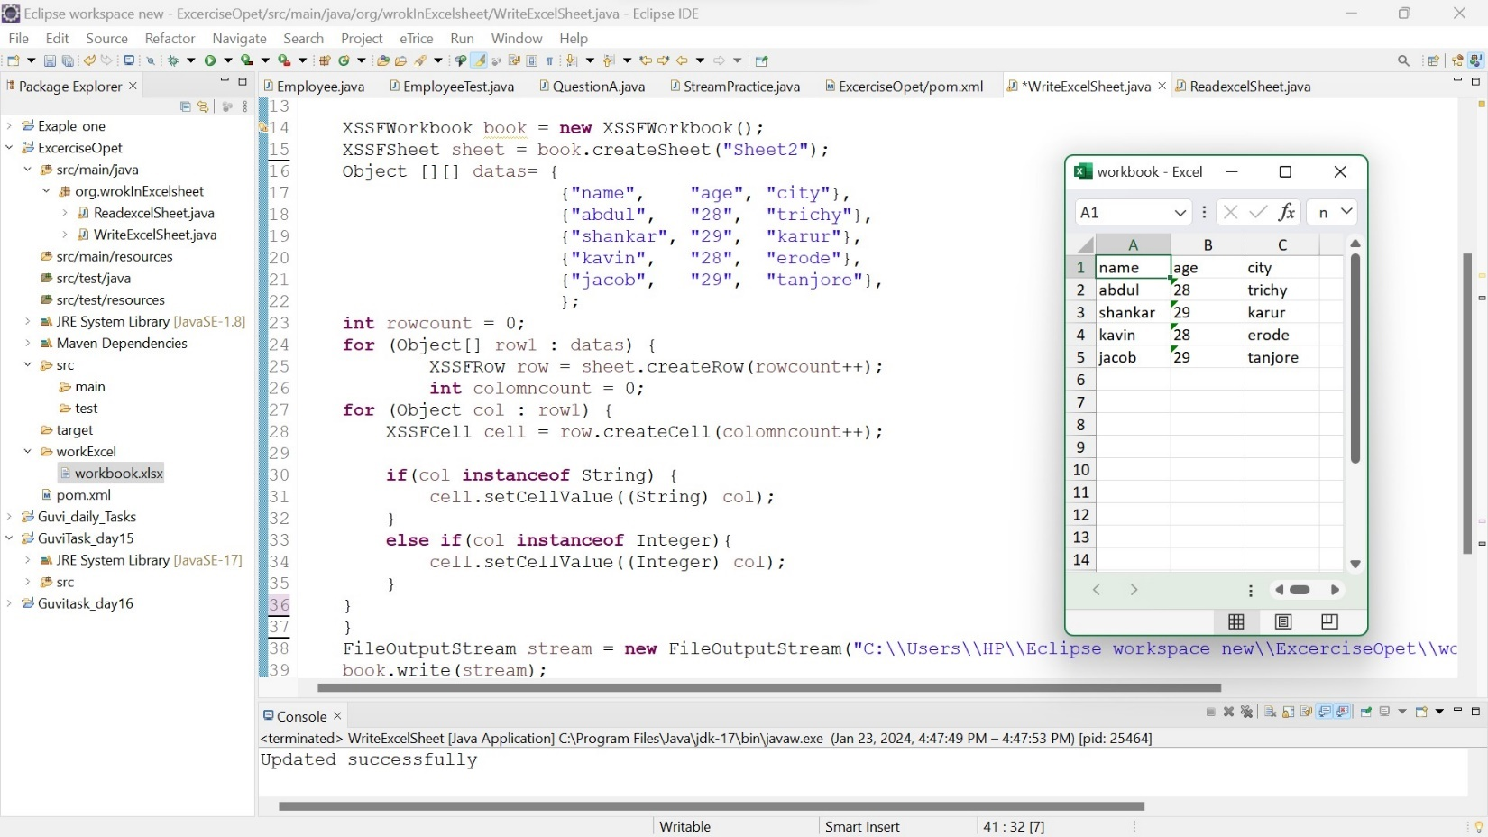1.Write datas in Excel file using java

* Here we try to write Data in Excel file using Apache POI dependencies. First step we declared XXSFWorkbook class.
* XXSFWorkbook class is used to create workbook and we can mention the file loctation in the arguments part of the xxsfworkbook

Like

XXSFWorkbook book = new XXSFWorkbook(“file path”);

* This workbook has method createSheet(), so we can create Excel sheet using this method.
* Then we have to feed the data here we use TowDimennsionArray because more than one datas we need to feed.
* Then initiate the local variable as rowcount to find the total row in the input
* And using nested foreach loop first we declare the createRow(i); it is the method of XXSFWorkbook class,then increase the row next we create an local variable as colomncount to find the total colomn in the input.
* Here another for each loop we declare createCell();it is method of XXSFWorkbook class then we have to increase the colomncount.
* Then we check each data is instance of string if instance of string means type cast to String
* If else any Integer is there type cast into integer that particular data
* Then declare file input stream write the datas and store into the permanent file.
* Then using book.write() ; method we have write the datas in to the file this method belongs to the XXSFWorkbookClass

2.Read the Excel file and print the datas in to the console

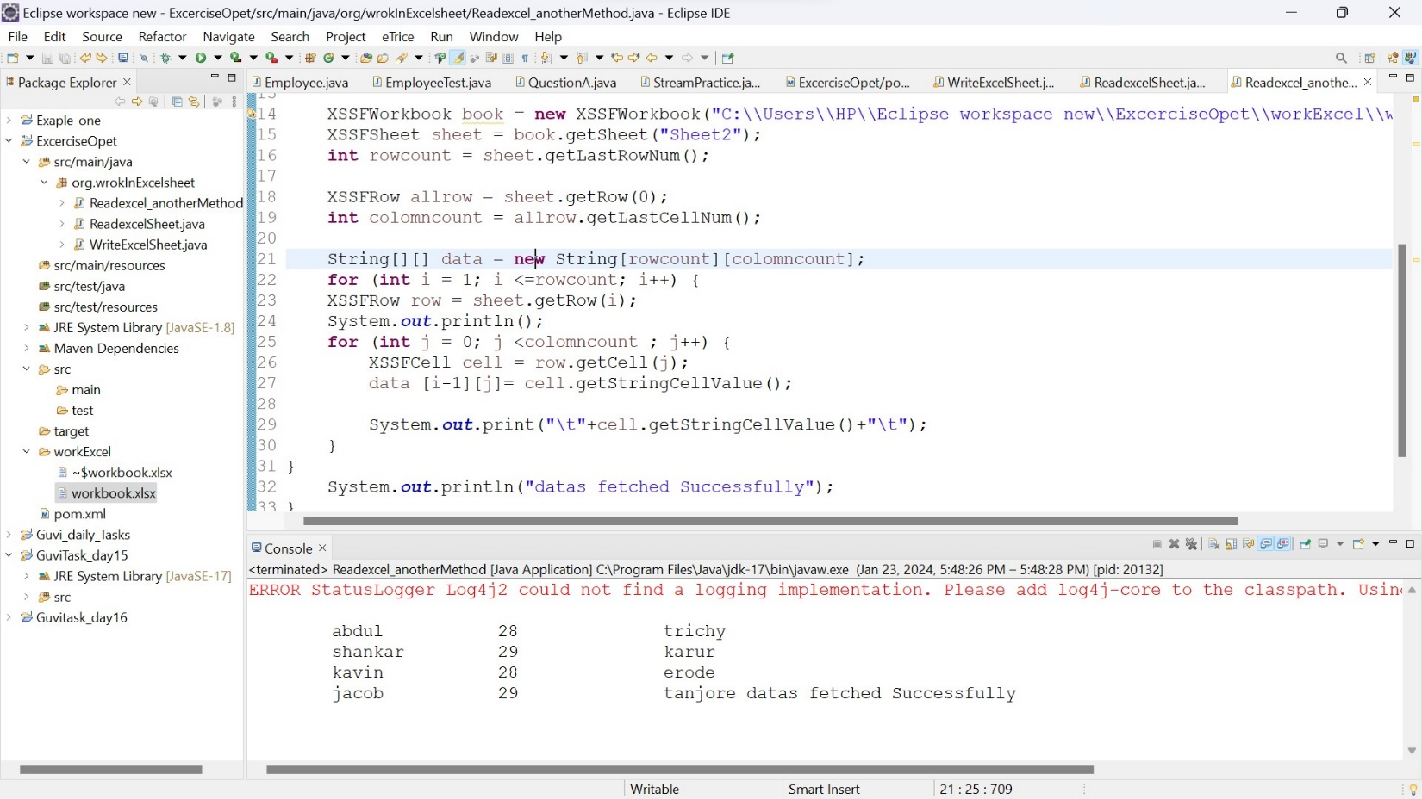

* Here we try to fetch the datas from the Excel file using using Apache POI dependencies. First step we declared XXSFWorkbook class.
* XXSFWorkbook class is used to create workbook and we can mention the file loctation in the arguments part of the xxsfworkbook

Like

XXSFWorkbook book = new XXSFWorkbook(“file path” );

* Then get the sheet using getSheet( “Sheet2” ); method
* Using getlastrownumber(); to find entire row make store in a reference name as rowcount.
* Then Using getlastcellnumber(); to find entire cell
* To get the all cell value we have to use nested for loop, in first loop we get all row in the excelfile so we use getRow();
* Then second for loop we have to fetch the all cell value so here we use getCell();
* To get the cell value in String we can use getStringcelvalue();

3.Anothe method to read the values from Excel file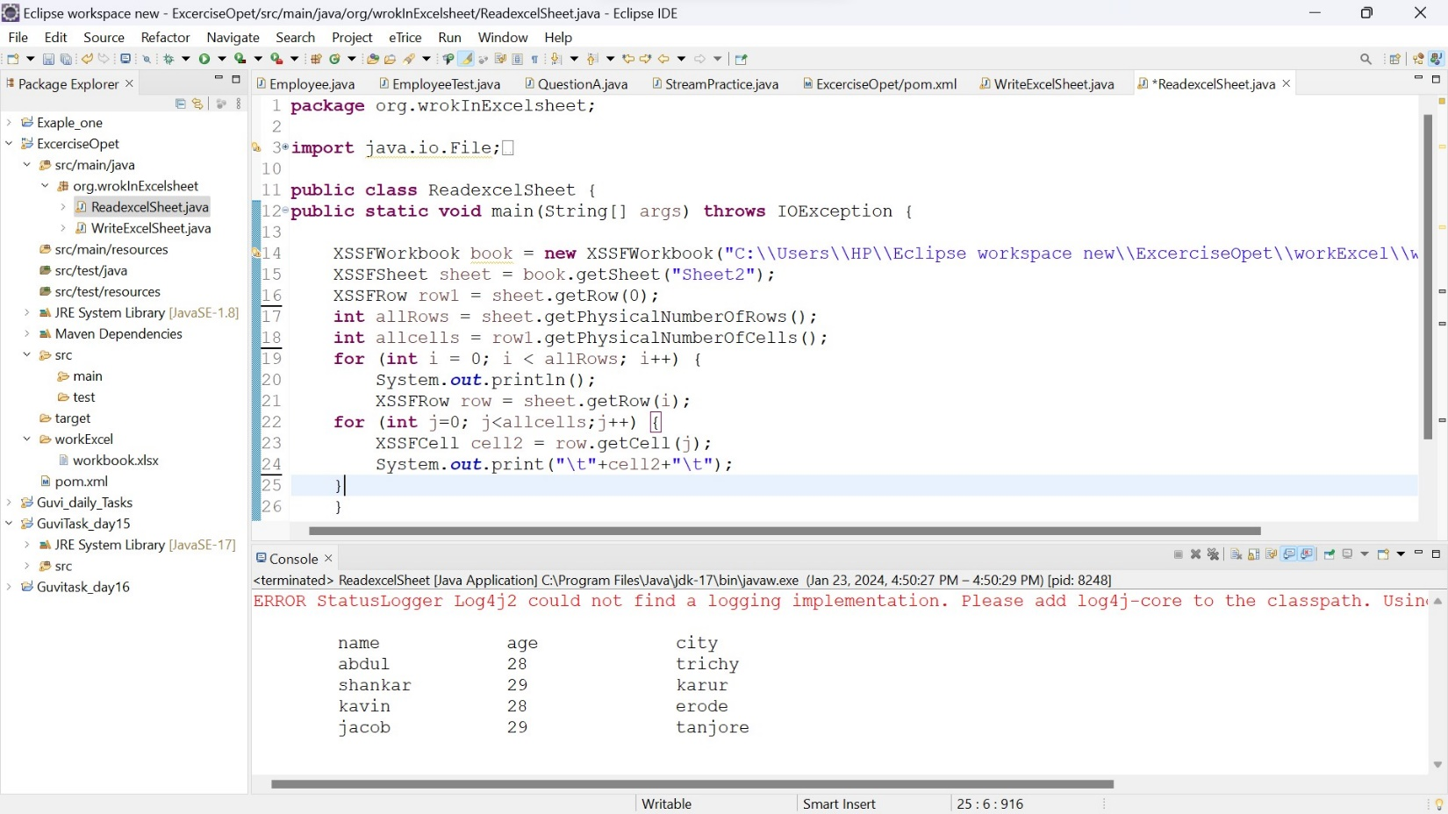

* Here we try to write Data in Excel file using Apache POI dependencies. First step we declared XXSFWorkbook class.
* XXSFWorkbook class is used to create workbook and we can mention the file loctation in the arguments part of the xxsfworkbook
* Here we have get the datas from Excel file using getPhysicalNumberOfRows(); and getPhysicalNumberOfCells(); methods.
* Here we use nested for loop for getting datas
* First for loop we get the Row using getRow(); method
* In second for loop we get cells using getCell(); method

4.here these Apache poi dependencies used to read and write the values from Excel file

