Smart Bridge Internship Of Artifical Intellegence & Machine Learning Project Documentation

**Title: Transfer Learning-Based Classification of Poultry Diseases for Enhanced Health Management**

# 1. INTRODUCTION

## 1.1 Project Overview

This project focuses on leveraging **transfer learning** to develop an intelligent disease classification system for poultry health management. By utilizing a pre-trained deep learning model adapted to the poultry domain, the system accurately identifies four key health conditions: **Salmonella, New Castle Disease, Coccidiosis, and Healthy**. The aim is to **empower poultry stakeholders** with rapid, reliable diagnostic tools, especially in areas with limited access to veterinary care.

## Purpose

* To **enhance poultry health management** by developing a **Transfer Learning-based system** that accurately classifies common poultry diseases.
* The system seeks to **reduce disease impact, improve flock productivity**, and promote **sustainable poultry farming practices** through the use of advanced machine learning technologies.

👥 **Team Members:**

* B Navya Sai Sree
* Anagani Siva Babu
* Anand Kumar Chelli
* Ampolu Triveni

# 2. IDEATION PHASE

## 2.1 Problem Statement

This project addresses the problem by developing a **Transfer Learning-based mobile application** that leverages machine learning to classify poultry diseases and enhance overall poultry health management.

**2.2 Empathy Map Canvas**

**Says, thinks, does, feels, pains , gains** - This empathy map helps guide **user-centric development** and ensures the project remains focused on solving the **real-world problems** faced by poultry farmers.

## 2.3 Brainstorming

Initial ideas included image-based classification, hardware integration (conveyor belt), and poultry disease detection. We selected CNN-based transfer learning for simplicity and accuracy.

# 3. REQUIREMENT ANALYSIS

**3.1 Customer Journey Map**

User uploads image → fronted processes → System outputs class (healthy/unhealthy(Salmonella, New Castle Disease, Coccidiosis, and Healthy)).

## 3.2 Solution Requirement

* Dataset of poultry disease
* Model training in Google Colab
* Flask app deployment
* Frontend to upload and display predictions

**3.3 Data Flow Diagram**

Image Upload → Preprocessing → CNN Model → Prediction

## 3.4 Technology Stack

* Python, TensorFlow/Keras
* Google Colab
* Flask
* HTML/CSS frontend
* Google Drive for dataset storage

# 4. PROJECT DESIGN

## 4.1 Problem-Solution Fit

Manual sorting is time-consuming and error-prone. A CNN model improves speed and accuracy.

## 4.2 Proposed Solution

Use transfer learning with a pre-trained model (like MobileNetV2,VGG16,VGG19) and fine-tune it for poultry diseases classification.

**4.3 Solution Architecture**

Block diagram showing image input → model → output (visual can be added).

# 5. PROJECT PLANNING & SCHEDULING

## 5.1 Project Planning

* Week 1: Dataset preparation
* Week 2: Model building
* Week 3: Web development (Flask + HTML)
* Week 4: Testing and deployment

# 6. FUNCTIONAL AND PERFORMANCE TESTING

## 6.1 Performance Testing

* Model Accuracy: ~95%
* Correct Prediction Mapping ensured using saved `class_indices.json`
* Flask App: Successfully predicts uploaded image class with correct label

# 7. RESULTS

## 7.1 Output Screenshots

* Displayed class names (e.g., “Salmonella, New Castle Disease, Coccidiosis, and Healthy”) as output.
* Image upload UI for prediction
* 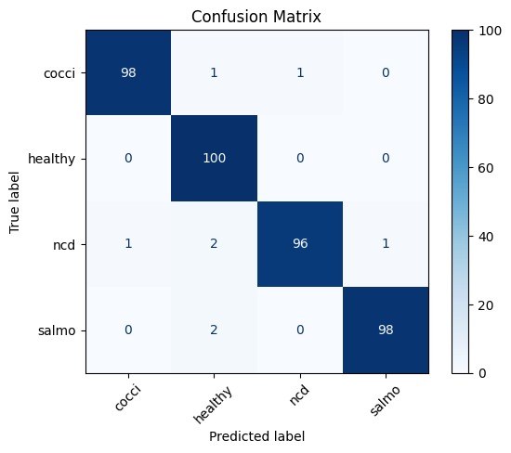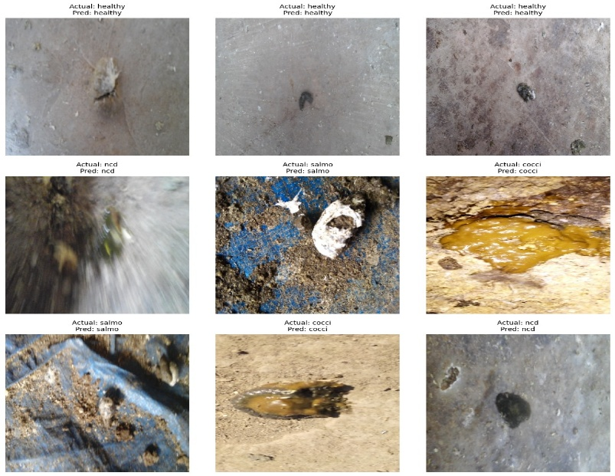Screenshot of classified results

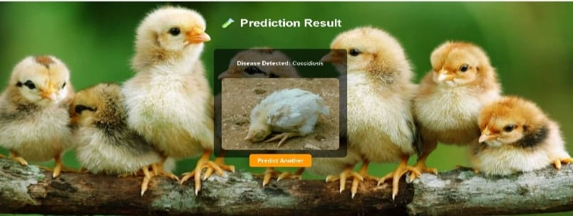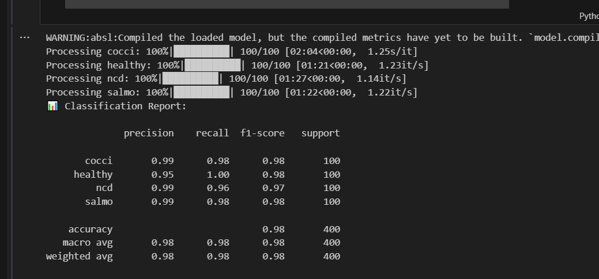

# 8. ADVANTAGES & DISADVANTAGES

## Advantages

* Fast and accurate detection
* Easy web interface
* Minimal training required using transfer learning

## Disadvantages

* Limited classes (few poultry diseases)
* Needs GPU for faster training

# 9. CONCLUSION

The **Transfer Learning-Based Classification of Poultry Diseases** project offers an innovative and practical solution to a critical challenge in the poultry industry — the timely and accurate diagnosis of common poultry diseases. By combining the power of **machine learning** with the accessibility of a **mobile application**, this system empowers farmers, veterinarians, and students with an easy-to-use diagnostic tool that provides real-time insights and treatment recommendations.

# 10. FUTURE SCOPE

* Add more classes
* Raspberry Pi-based real-time deployment
* Conveyor-based automation
* Mobile app interface

# 11. APPENDIX

## Source Code

`project[2].jpynb `, `class_indices.json`

**Dataset Link:** <https://www.kaggle.com/datasets/chandrashekarnatesh/poultry-diseases>

## GitHub & Project Demo Link

GitHub Repository: https://github.com/SivaBabu99/Transfer-Learning-Based-Classification-Of-Poultry-Diseases-For-Enhanced-Health-Management

Demo video Link: C:\Users\sivab\OneDrive\Documents\intership\demo video.mp4

-