# 27-06-25-Coding Challenge

## Section 1: Python Programming & OOP

Q1. Functional Coding Challenge – Movie Booking System   
- Show available movies (stored in a list)

- Allow user to select movie & number of tickets

- Calculate and show total amount (use a dictionary to store movie: price)

- Use functions for showing movies, booking logic, and calculating amount

**movies = ["Movie A", "Movie B", "Movie C"]**

**prices = {"Movie A": 100, "Movie B": 120, "Movie C": 80}**

**def show_movies():**

**print("Available Movies:")**

**for movie in movies:**

**print(movie)**

**def book_movie():**

**show_movies()**

**selected_movie = input("Select a movie: ")**

**num_tickets = int(input("Number of tickets: "))**

**total_amount = calculate_amount(selected_movie, num_tickets)**

**print(f"Total amount for {num_tickets} tickets of {selected_movie}: ${total_amount}")**

**def calculate_amount(movie, tickets):**

**return prices[movie] * tickets**

**book_movie()**

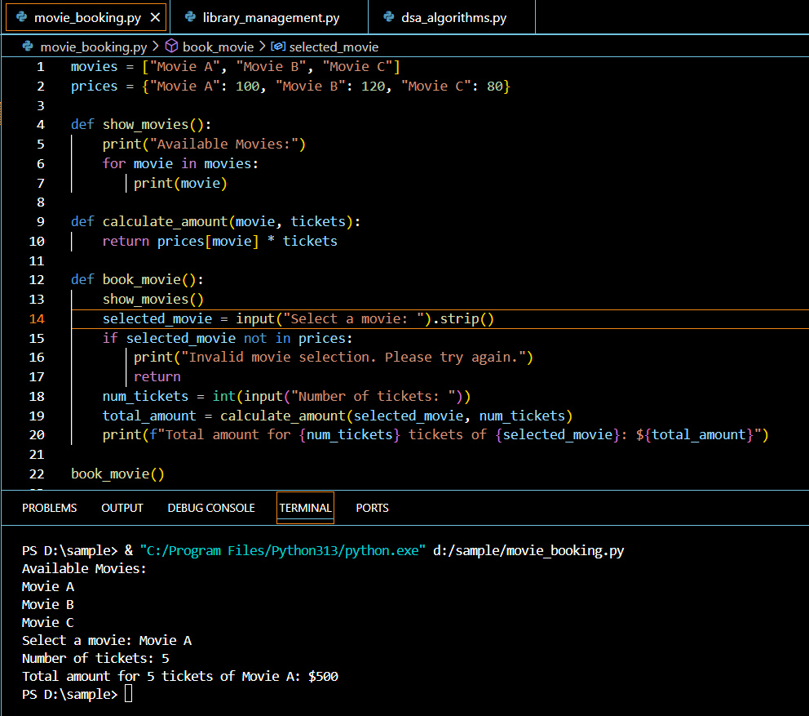

Q2. OOP Implementation – Library Management

- Library contains a collection of books  
- User can borrow/return/view books  
- Use class, constructor, inheritance, method overriding

**class Book:**

**def __init__(self, title, author):**

**self.title = title**

**self.author = author**

**class Library:**

**def __init__(self):**

**self.books = []**

**def add_book(self, book):**

**self.books.append(book)**

**def view_books(self):**

**for book in self.books:**

**print(f"{book.title} by {book.author}")**

**class User:**

**def __init__(self, name):**

**self.name = name**

**self.borrowed_books = []**

**def borrow_book(self, book, library):**

**library.books.remove(book)**

**self.borrowed_books.append(book)**

**def return_book(self, book, library):**

**self.borrowed_books.remove(book)**

**library.add_book(book)**

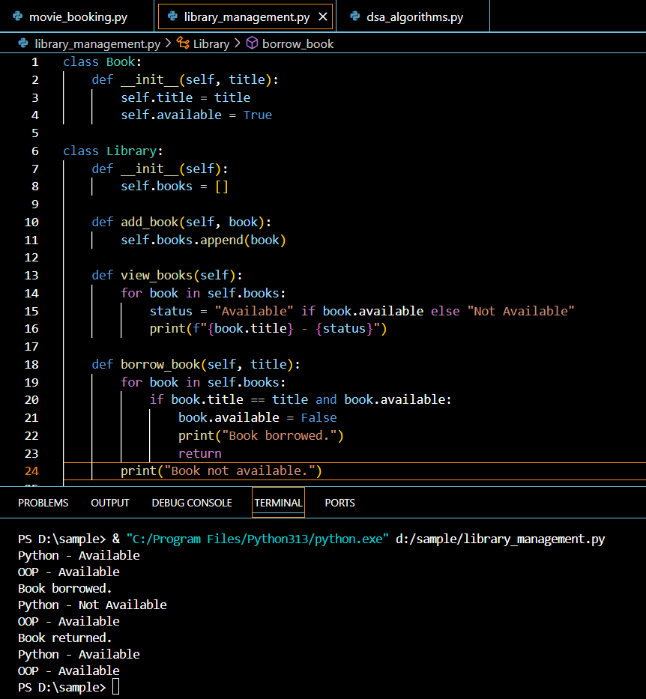

## Section 2: Data Structures & Algorithms

Q3. Algorithm Problem – Minimize Coins (Greedy)  
- Find minimum number of coins needed for a given amount  
- Denominations: [1, 2, 5, 10, 20, 50, 100, 200, 500]

**def minimize_coins(amount):**

**denominations = [500, 200, 100, 50, 20, 10, 5, 2, 1]**

**coin_count = 0**

**for coin in denominations:**

**while amount >= coin:**

**amount -= coin**

**coin_count += 1**

**return coin_count**

Q4. Data Structure Usage   
- Stack: Evaluate postfix expression '231*+9-'

**def evaluate_postfix(expression):**

**stack = []**

**for char in expression:**

**if char.isdigit():**

**stack.append(int(char))**

**else:**

**b = stack.pop()**

**a = stack.pop()**

**if char == '+':**

**stack.append(a + b)**

**elif char == '*':**

**stack.append(a * b)**

**elif char == '-':**

**stack.append(a - b)**

**return stack[0]**

- Linked List class: append(), display(), reverse()

**class Node:**

**def __init__(self, data):**

**self.data = data**

**self.next = None**

**class LinkedList:**

**def __init__(self):**

**self.head = None**

**def append(self, data):**

**new_node = Node(data)**

**if not self.head:**

**self.head = new_node**

**return**

**last = self.head**

**while last.next:**

**last = last.next**

**last.next = new_node**

**def display(self):**

**current = self.head**

**while current:**

**print(current.data, end=" -> ")**

**current = current.next**

**print("None")**

**def reverse(self):**

**prev = None**

**current = self.head**

**while current:**

**next_node = current.next**

**current.next = prev**

**prev = current**

**current = next_node**

**self.head = prev**

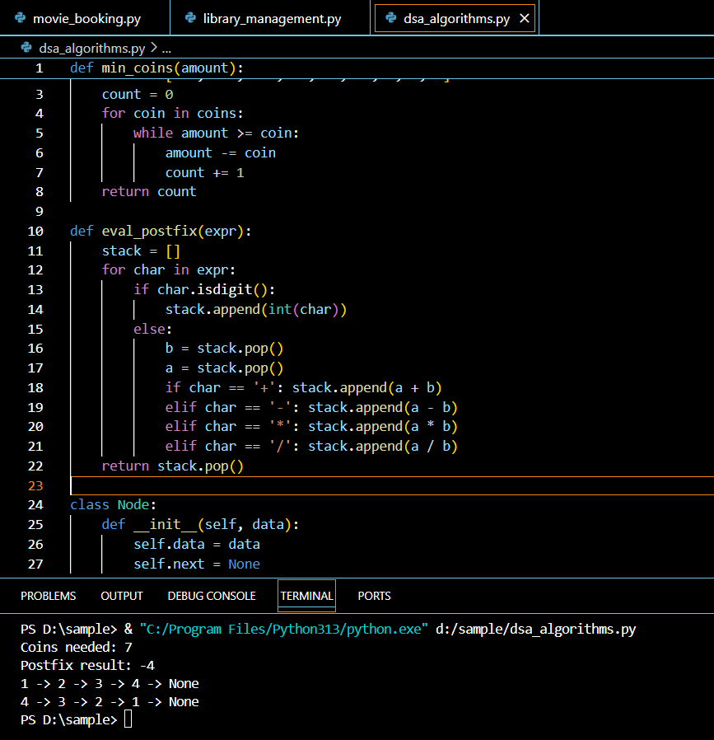

## Section 3: SQL with Python Integration

Q5. SQL + Python – Student Scores Table  
- Create table StudentScores(name VARCHAR, subject VARCHAR, marks INT)  
- Insert sample data  
- Use Python to display records, show average marks, list students scoring <40

**import sqlite3**

**conn = sqlite3.connect('school.db')**

**cursor = conn.cursor()**

**cursor.execute('''CREATE TABLE StudentScores (name VARCHAR, subject VARCHAR, marks INT)''')**

**cursor.execute("INSERT INTO StudentScores VALUES ('Alice', 'Math', 85)")**

**cursor.execute("INSERT INTO StudentScores VALUES ('Bob', 'Math', 35)")**

**conn.commit()**

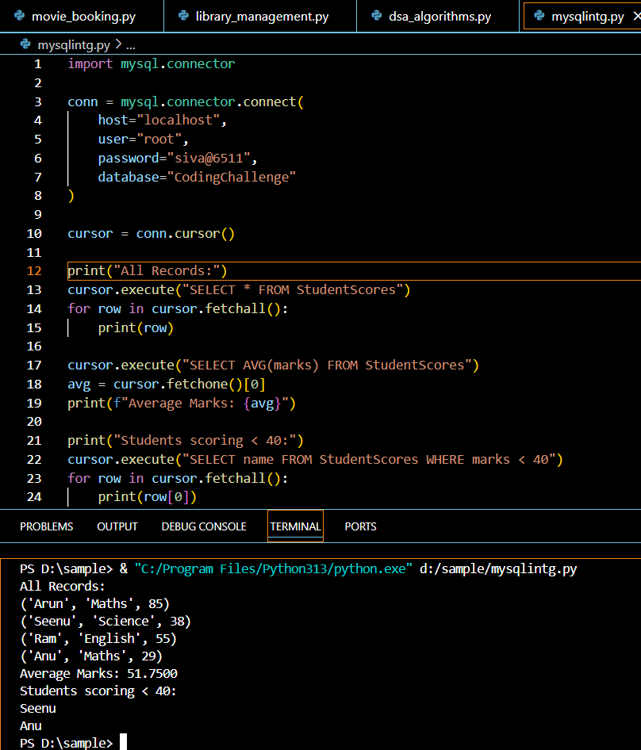

## Section 4: Version Control with Git (10 mins)

Q6. Git Challenge  
- Initialize Git repository

**git init**  
- Create and switch to branch feature/students

**git checkout -b feature/students**  
- Add and commit your Python code

**git add .**

**git commit -m "Add movie booking system and library management"**- Merge feature/students into main

**git checkout main**

**git merge feature/students**  
- Provide Git commands

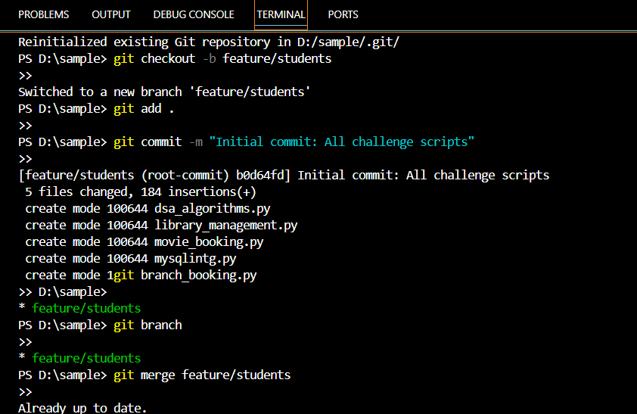

## Bonus Section: PyUnit Test Case

Q7. PyUnit test cases for Q1 (Booking System)  
- 1 test case for calculate_amount()  
- 1 test case for booking() using mocks if needed  
- Use unittest.TestCase, setUp(), tearDown()

**import unittest**

**class TestBookingSystem(unittest.TestCase):**

**def setUp(self):**

**self.movie = "Movie A"**

**self.tickets = 2**

**def test_calculate_amount(self):**

**self.assertEqual(calculate_amount(self.movie, self.tickets), 20)**

**def test_booking(self):**

**with unittest.mock.patch('builtins.input', side_effect=[self.movie, self.tickets]):**

**with unittest.mock.patch('builtins.print') as mocked_print:**

**book_movie()**

**mocked_print.assert_called_with("Total amount for 2 tickets of Movie A: $20")**

**if __name__ == '__main__':**

**unittest.main()**

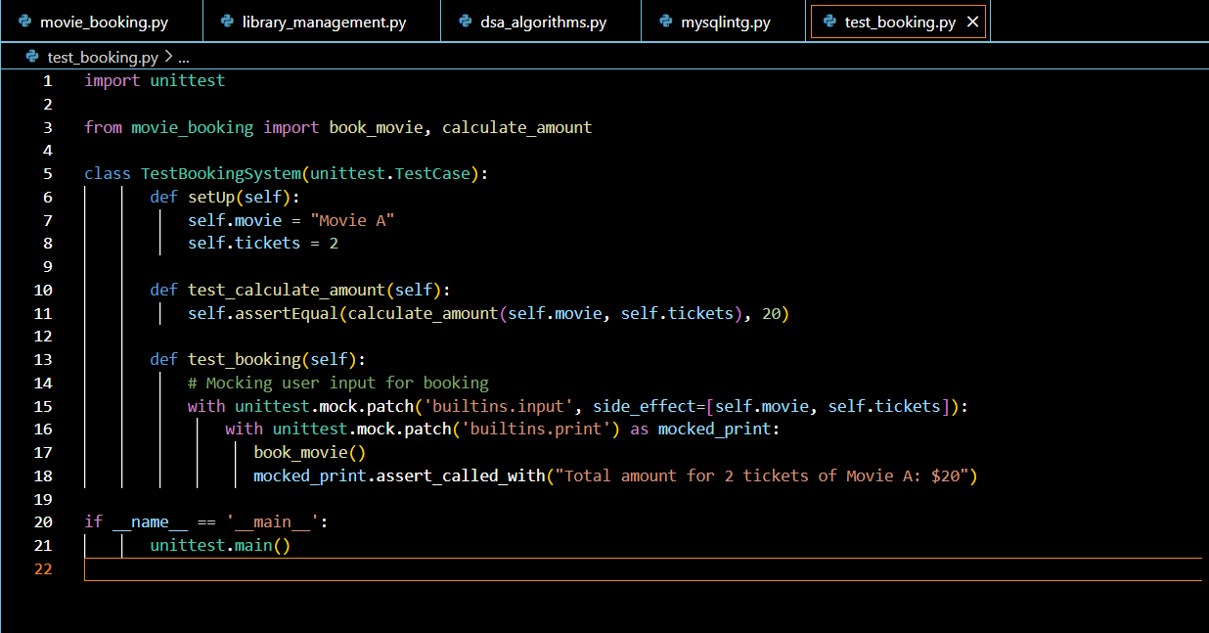

**Submitted by**

**SIVA BALAN T**