**INDUSTRIAL BATCH PROCESS USING IoT**

A Project Report submitted by

# ARCHANA D 19EI1005

**BALASUBRAMANIAM B 19EI1007**

**BHUVANESH M 19EI1012**

# SIVASUBRAMANIAN G 19EI1017

# NIRUBASRI C 19EI1036

Under the Guidance of

**Dr. S. MOUROUGA PRAGASH, B.E,M.E,Ph.D**

In partial fulfillment of the requirements for the award of the degree of

**BACHELOR OF TECHNOLOGY**

in

**ELECTRONICS AND INSTRUMENTATION ENGINEERING**



**PUDUCHERRY TECHNOLOGICAL UNIVERSITY PUDUCHERRY – 605014**

**MAY – 2023**

# DEPARTMENT OF

**ELECTRONICS AND INSTRUMENTATION ENGINEERING PUDUCHERRY TECHNOLOGICAL UNIVERSITY**

# PONDICHERRY- 605014

**BONAFIDE CERTIFICATE**

This is to certify that this mini project report titled**“INDUSTRIAL BATCH PROCESS USING IOT”** is the bonafide report work done by **ARCHANA D (19EI1005), BALASUBRAMANIAM B (19EI1007), BHUVANESH M(19EI1012), SVASUBRAMANIAN G(19EI1017),** and **NIRUBASRI C(19EI1036)** in partial fulfillment of the requirements for the award of the degree of **BACHELOR OF TECHNOLOGY** *in* **ELECTRONICS AND INSTRUMENTATION ENGINEERING** *in* **PUDUCHERRY TECHNOLOGICAL UNIVERSITY.** Certified further that this work reported herein does not form part of any other thesis or dissertation on the basis of which degree or award was conferred on an earlier date on this or any other candidate.

**PROJECT GUIDE HEAD OF THE DEPARTMENT**

**(Dr. S. MOUROUGAPRAGASH) (Dr. S. MOUROUGAPRAGASH)**

Submitted to evaluation committee during review presentation held on

**INTERNAL EXAMINER EXTERNAL EXAMINER**

# ACKNOWLEDGEMENT

It is our privilege to submit our profound sense of gratitude and respectful regards to our esteemed master and Professor **Dr. S. MOUROUGAPRAGASH,** Department of Electronics and Instrumentation Engineering, Puducherry Technological University, for his personal interest, constant encouragement, valuable advices given throughout the tenure of our project work, which provoked our thoughts and ideas to do this mini project.

We would like to extend our sincere thanks to our Beloved and Respected Head of the Department, **Dr. S. MOUROUGAPRAGASH,** Department of Electronics and Instrumentation Engineering, Puducherry Technological University, who helped us in making the project a successful one by his valuable advice and providing adequate facilities to carry out the project work.

We wish to express our sincere thanks to **Dr. S. MOHAN,** Vice Chancellor, Puducherry Technological University, for providing us all resources to carry out our project work.

Our heartfelt thanks to all **Teaching and Non-Teaching staffs,** Department of Electronics and Instrumentation Engineering, Puducherry Technological University, Pillaichavady, Puducherry, for their valuable helps and support in the work carried out by us.

**ARCHANA D**

**BALASUBRAMANIAM B**

**BHUVANESH M**

**SIVASUBRAMANIAN G**

**NIRUBASRI C**

**ABSTRACT**

Modernization and automation are sweeping the globe, with IoT-based industrial monitoring solutions at the forefront. The importance of assessing the state of the industry is vital to the safety and efficiency of the products. In industrial automation control, a wide number of process variables such as, temperature, stream, pressure, distance, and fluid levels can be detected all the while. By implementing NODE MCU and IoT standards, industrial parameters can be controlled and checked distantly. It reduces designing expenses regarding manual arrangements of all involved gadgets. In this project, a system is created which will monitor automatically the industrial applications, the temperature, gas, concentration of fluids and fluid levels and control the actuators. These are utilized for identifying and alerting from undesirable activities in surrounded region of industry. In the proposed system NODE MCU is utilized as controller and the data is monitored in things-speak and the control of the actuator is done in Blynk IoT. When the information is associated with the web server, it will store and give the information at required time. The proposed technology could be beneficial to manufacturing industries. Adding technology to any kind of manufacturing industry will assure the safety and well-being of the people as well as prevent accidents. Using automation technology reduces the chances of loss and accidents in the machinery world.

|  |  |  |
| --- | --- | --- |
|  | **TABLE OF CONTENTS** |  |
| **Chapter No.** | **Topic** | **Page No** |
|  | **Acknowledgement** | **i** |
|  | **Abstract** | **ii** |
|  | **Table of Contents** | **iii** |
|  | **List of Abbreviation** | **V** |
|  | **List of Figures** | **V** |
|  | **List of Table** | **vi** |
| **1** | **INTRODUCTION** | 1 |
|  | 1.1 OVERVIEW | 1 |
|  | 1.2 PROBLEM STATEMENT | 2 |
|  | 1.3 OBJECTIVE OF THE PROJECT | 2 |
|  | 1.4 OUR PROPOSED WORK | 2 |
|  | 1.5 PLAN OF IMPLEMENTATION | 2 |
|  | 1.6 SUMMARY | 3 |
| **2** | **LITERATURE SURVEY** | 4 |
|  | 2.1 INTRODUCTION | 4 |
|  | 2.2 LITERATURE REVIEW OF EXISITING  SYSTEM | 4 |
|  | 2.3 SUMMARY | 7 |
| **3** | **HARDWARE DESCRIPTION** | 8 |
|  | 3.1 INTRODUCTION | 8 |
|  | 3.2 FUNCTIONAL BLOCK DIAGRAM | 8 |
|  | 3.3 COMPONENTS FUNCTION | 9 |
|  | 3.3.1 NODE MCU | 9 |
|  | 3.3.2 POWER UNIT |  |
|  | 3.3.3 MQ2 GAS SENSOR |  |
|  | 3.3.4 Ph SENSOR |  |
|  | 3.3.5 TEMPERATURE SENSO |  |
|  | 3.3.6 LEVEL SENSOR |  |
|  | 3.3.7 SOLENOID VALVE |  |
|  | 3.3.8 RELAY MODULE |  |
|  | 3.3.9 HEATER |  |
|  | 3.4 SUMMARY |  |
|  |  |  |
| **4** | **SOFTWARE DESCRIPTION** |  |
|  | 4.1 INTRODUCTION |  |
|  | 4.2 ARDUINO IDE |  |
|  | 4.3 ALGORITHM |  |
|  | 4.4 FLOWCHART |  |
|  | 4.5 SUMMARY |  |
|  |  |  |
| **5** | **RESULT AND CONCLUSION** |  |
|  | 5.1 INTRODUCTION |  |
|  | 5.2 IMAGE OF THE PROTOTYPE |  |
|  | 5.3 RESULTS FROM THINGSPEAK |  |
|  | 5.4 RESULTS FROM BLYNK |  |
|  | 5.5 RESULT |  |
|  | 5.6 FUTURE WORK |  |
|  | 5.7 CONCLUSION |  |
|  |  |  |
|  | **REFERENCES** |  |
|  |  |  |
|  |  |  |
|  |  |  |
|  |  |  |
|  |  |  |
|  |  |  |
|  |  |  |
|  |  |  |
|  |  |  |
|  |  |  |
|  |  |  |
|  |  |  |
|  |  |  |
|  |  |  |
|  |  |  |
|  |  |  |
|  |  |  |
|  |  |  |

**LIST OF ABBREVIATION**

|  |  |  |
| --- | --- | --- |
| **S.NO** | **ACRONYM** | **ABBREVIATIONS** |
| 1. |  |  |
| 2. |  |  |
| 3. |  |  |
| 4. |  |  |
| 5. |  |  |
| 6. |  |  |
| 7. |  |  |
| 8. |  |  |
| 9. |  |  |
| 10. |  |  |
| 11. |  |  |
| 12. |  |  |

**LIST OF FIGURES**

|  |  |  |
| --- | --- | --- |
| **FIGURE NO.** | **NAME OF THE FIGURE** | **PAGE NO.** |
| 1 | **Functional Block Diagram** |  |
| 2 | **NodeMCU** |  |
| 3 | **Power Unit Circuit Diagram** |  |
| 4 | **MQ-2 Gas Sensor** |  |
| 5 | **Ph Sensor** |  |
| 6 | **DS18B20 Temperature Sensor** |  |
| 7 | **Level Sensor** |  |
| 8 | **Solenoid Valve** |  |
| 9 | **Relay (Pnp)** |  |
| 10 | **Stainless Steel Iron Heating Element** |  |
| 11 | **Batch Process Setup.** |  |
| **12** | **Embedded Kit** |  |
| **13** | **Thingspeak Output** |  |
| **14** | **Blynk Output** |  |

**LIST OF TABLES**

|  |  |  |
| --- | --- | --- |
| **S.NO.** | **NAME OF THE TABLE** | **PAGE NO.** |
| 1 | Specifications of NodeMCU |  |
| 2 | Pin Description |  |
| 3 | Specification of DS18B20 Temperature Sensor |  |
| 4 | Specification of Solenoid Valve |  |
| 5 | Specifications for relay |  |
| 6 | Specifications of Heating Element |  |

**CHAPTER 1**

**INTRODUCTION**

* 1. **OVERVIEW**

The concept of IoT in the automation aims in making Internet more ubiquitous and immersive. Accelerating the internet to make it enable by any authorized person for easy access and to have an interaction with enormous variety of devices. Industrial automation is the use of control systems, such as computers or robots, and information technologies for handling different processes and machineries in an industry to replace a human being. It is the second step beyond mechanization in the scope of industrialization. In not a distance future, it’s possible that we can have not only human-human communication but also device-device communication which is called “Internet of Things” where Things refers to various electronic devices. With IoT not only we can access the information from any place, at any time, by any person, but we can also control and monitor various devices from anyplace, at any time, on any network, by any authenticated person, this technology is called Internet of Things (IoT). In this project we propose efficient batch process system that allows user to efficiently control industry appliances/ machines over the internet. We are also using Different sensor (Temperature sensor, pH sensor, Gas Sensor, Level Sensor) to monitor and control the industry appliances with the help of Internet- Websites and Smartphones

**1.2 PROBLEM STATEMENT**

The main theme of the project is to Control and Monitor an Industrial Batch Process via the Internet. Industries operate with the help of various PC automated systems. But there is lot of wastage in energy at industrial work environment and the real status of the installed system may be hiding through workers. This system requires a greater number of equipment layers and requires more amount of floor space.

**1.3 OBJECTIVE OF THE PROJECT**

The main objective of the project is to automate, control and monitor an industrial batch process. In this process parameters such as temperature, gas, concentration of fluids and fluid levels are used for identifying and alerting from undesirable activities in the batch process.

**1.4 OUR PROPOSED WORK**

The System can provide both controlling and monitoring via Internet. The values that are sensed by various sensors that are installed (Ph sensor, level sensor, gas sensor, temperature sensor) in the process are monitored by Thingspeak an IoT platform which allows aggregating, visualizing, and analysing live data in the cloud and the controlling of the Heater in the system is done with the help of Blynk IoT.

**1.5 PLAN OF IMPLEMENTATION**

How the system work is once the NodeMCU is connected through the WIFI the process starts to Operate, the system consists of two inlet valves, one outlet valve, a heater, a level sensor, a temperature sensor, a Ph sensor and a Gas sensor. The Process starts by reading the level sensor value, once the tank is empty, inlet 1 turns on and fills till half of the tank and then once it reaches the halfway mark, the Ph of the solution is monitored if the Ph goes above 7 then in that case inlet 2 is turned on to neutralize the solution. When the solution is neutralized and level of tank is full the heater is turned on via the Blynk platform. So while the Heater is turned on the temperature sensor comes in to play and the outlet valve is turned on when the level of the tank is full, Temperature is above 50 and the fluid is neutralised. And all these data are analysed in Thingspeak and the control of the heater is done in Blynk.

Thus systems such as these can be used to monitor and control the process parameters away from the industries, which makes it easier for engineers to analyse the data’s that are monitored, there is lot of wastage in energy at industrial work environment and the real status of the installed system may be hiding through workers. These systems require more number of equipment layers and requires more amount of floor space. The operation of these system differs from manufacturer to manufacturer which makes it more difficult for operators to handle these systems.

STAGE 1: Choosing of Microcontroller, necessary Sensor and heater.

STAGE 2: Assembling the Mechanical Kit and Interfacing it with the Controller.

STAGE3: Developing code for the automation part, monitoring data in Thingspeak and controlling in Blynk.

**1.6 SUMMARY**

There is lot wastage in energy at industrial work environment and the real status of the installed system may be hiding through workers. To add a solution to this circumstance, this project gives the design of a prototype of an Industrial Batch Process system where the NodeMCU and internet of things are involved. This gives a demonstration of how to build up a remotely controlled system that can enable the person away from the industry surroundings to control the system by and get the related data on the Internet.

**CHAPTER - 2**

**LITERATURE SURVEY**

**2.1 INTRODUCTION**

This chapter describes the literature survey and a review of the existing methods The design and proto type implementation of new industrial automation system, that uses Wi-Fi technology as a network infrastructure connecting its parts. The proposed system consists of two main components first part is the server (web server), which presents system core that manages, controls, and monitors. Users and system administrator can locally (LAN) or remotely (internet) manages and control system code. Second part is hardware interface module, which provides appropriate interface to sensors and actuator of the system. Unlike most of available automation system in the market the anticipated system is scalable that one server can manage lots of hardware interface modules as long as it exists on (Wi-Fi) network coverage's. The proposed system is better from the scalability and elasticity point of view than the commercially available home computerization systems.

**2.2 LITERATURE REVIEW OF EXISTING SYSTEM**

**2.2.1 IoT based Industrial Automation using Raspberry Pi**

This project involves the design of a prototype of an Industrial automation system utilizing Raspberry Pi board and internet of things.[1] This gives a demonstration of how to build up a remotely controlled system that can enable the person away from the industry surroundings to control the system by accessing Raspberry pi, and get the related data by SMS (short message service) on phone.

**2.2.2 Industrial Process Monitoring System Using Esp32**

This system is implemented with ESP32-DEV module by interconnecting DC motor and distinctive sensors like temperature, smoke, flame sensor is interfaced to cloud by enabling inbuilt Wi-Fi module of ESP32, the system is connected to the cloud as well as android mobile loaded with Blynk application tool kit.[2] The sensor parameter variation is uploaded to the cloud. Through the Cloud all sensors in the industrial applications are monitored easily and efficiently. In this application is Cayenne project builder is used as cloud and user mobile is connected using Blynk, which is android application tool kit. Blynk can be accessed through mobile or Laptop and used as the cloud. If the sensor parameters limit exceeds than specified limit motor or load which is connected to the load automatically triggered and informed through SMS or electronic mail to the registered users such application very uses full for small scale industry. In this system, industrial processes like energy meter monitoring, DC speed control, Temperature, Humidity, Gas levels and Fire accidents if any are monitored through android mobiles, and parameters data can be updated periodically by using cloud.

**2.2.3 Industrial Monitoring and Control Applications Using IOT**

Industrial monitoring and control is a combination of architectures, mechanisms, and algorithms used in the industrial factory for monitoring and control the activities of industrial processes, motors, machines and devices employed in industry premises to achieve the goal. Though it sounds good enough to have a smart industrial environment soon but it will also have to face hurdles of handling big data as all the devices will communicate with each other and exchange their information over a common-platform.[3] The present project is focused on Industrial applications that will be continuously monitored through a set of sensors that constitutes a sensor module. The sensor module collects the relevant data to determine whether the applications to be monitored are working well under certain threshold values. The LCD displays the sensed data at control room in industry premises or where the control unit is actually placed as it is interfaced with microcontroller. With this implementation we can achieve continuous monitoring of 3 phase voltage supply (R, Y, and B) given to the industrial applications, room temperature in (°C), speed (in rpm) and vibration count of industrial applications such as motors. After logging this data at industry control room, it is necessary to forward it to the Internet cloud to be accessed remotely. For that we use a GPRS activated GSM modem interfaced with microcontroller at its UART pins. Using the GPRS service of modem the sensed parameters are routed from microcontroller to Internet cloud through GSM modem using TCP\IP protocol.

**2.2.4 Industrial Automation Using Raspberry Pi**

The Raspberry Pi single board computer is used as the main device controller in the project. It is used to establish communication with the remote IOT server using the IOT protocols over the Wi-Fi connection. The Raspberry Pi controller has built-in Wi-Fi, USB, and A/V ports. There are four relays connected to the output pins of the Raspberry Pi controller. Four different industrial devices are connected to these relays. And four different sensors are also connected to Raspberry pi. The Raspberry Pi board communicates with the remote server based IOT platform by means of built-in Wi-Fi. The control commands are provided by the user in the IOT platform. These commands are then communicated to the Raspberry Pi controller over the Wi-Fi using IOT protocols. According to these commands, the Raspberry Pi controller turns the relays on and off. An LCD is also connected to the Raspberry Pi controller which is used to display the device statuses as well as other messages.

**2.3 SUMMARY**

This chapter explained briefly about the literature survey of existing system. There are many disadvantages in these systems, most of these systems monitor data and only some have the options of controlling. In our system we are building our own batch process station which we are automating and also monitoring and controlling the process in real time remotely. The implementation is not only for safety reasons, but it also has the potential to increase industry yields. In our project, the Internet of Things (IoT) is used to collect data and communicate through the internet.

**CHAPTER – 3**

**HARDWARE DESCRIPTION**

**3.1 INTRODUCTION**

This chapter explains about the system design and the components used in hardware implementation along with their specifications and the working process of our proposed system.

The components used in the project are:

* NodeMCU
* Power unit
* MQ2 Gas sensor
* Ph sensor
* Temperature sensor
* Level sensor
* Solenoid valve
* Relay module
* Heater

**3.2 FUNCTIONAL BLOCK DIAGRAM**

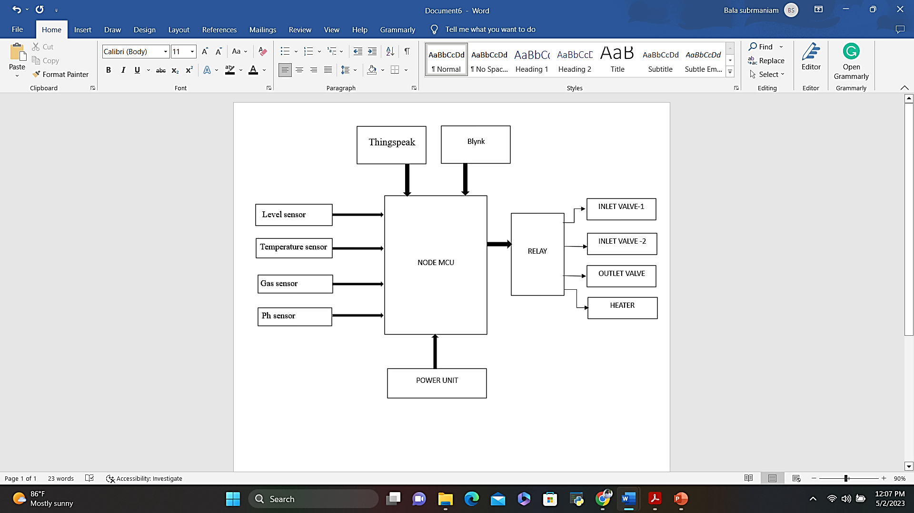

**FIG.3.1 FUNCTIONAL BLOCK DIAGRAM**

**3.3 COMPONENTS FUNCTION**

**3.3.1 NODEMCU**

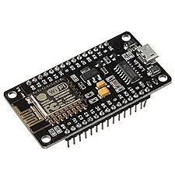

**Fig 3.2 NodeMCU**

The best way to develop quickly an IoT application with less Integrated circuits to add is to choose this circuit “NodeMCU”. NodeMCU is an open-source firmware and development kit that plays a vital role in designing a proper IoT product using a few script lines. The module is mainly based on ESP8266 that is a low-cost Wi-Fi microchip incorporating both a full TCP/IP stack and microcontroller capability. It is introduced by manufacturer Espressif Systems. The ESP8266 NodeMCU is a complex device, which combines some features of the ordinary Arduino board with the possibility of connecting to the internet. Arduino Modules and Microcontrollers have always been a great choice to incorporate automation into the relevant project. But these modules come with a little drawback as they don’t feature a built-in Wi-Fi capability, subsequently, we need to add external Wi-Fi protocol into these devices to make them compatible with the internet channel.

**Table 3.1 Specifications of NodeMCU**

|  |  |
| --- | --- |
| Microcontroller | ESP8266 |
| Operating Voltage | 3.3V |
| Input Voltage | 7-10V |
| Digital I/O Pins (DIO) | 16 |
| Analog Input Pins (ADC) | 1 |
| UARTs | 1 |
| SPIs | 1 |
| I2Cs | 1 |
| Flash Memory | 4 MB |
| SRAM | 64 KB |
| Clock Speed | 80 MHz |

**3.3.2 POWER UNIT**

The ac voltage, typically 220V rms, is connected to a transformer, which steps that ac voltage down to the level of the desired dc output. A diode rectifier then provides a full-wave rectified voltage that is initially filtered by a simple capacitor filter to produce a dc voltage. This resulting dc voltage usually has some ripple or ac voltage variation.

A regulator circuit removes the ripples and also remains the same dc value even if the input dc voltage varies, or the load connected to the output dc voltage changes. This voltage regulation is usually obtained using one of the popular voltage regulator IC units. When four diodes are connected as shown in figure, the circuit is called as bridge rectifier. The input to the circuit is applied to the diagonally opposite corners of the network, and the output is taken from the remaining two corners. A fixed three-terminal voltage regulator has an unregulated dc input voltage, Vi, applied to one input terminal, a regulated dc output voltage, Vo, from a second terminal, with the third terminal connected to ground. The series 78 regulators provide fixed positive regulated voltages from 5 to 24 volts. Similarly, the series 79 regulators provide fixed negative regulated voltages from 5 to 24 volts.

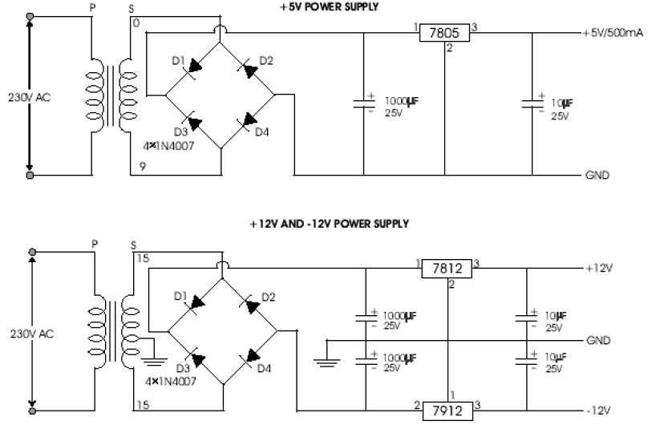

**Fig 3.3 Power Unit Circuit Diagram**

**3.3.3 MQ2 GAS SENSOR**

[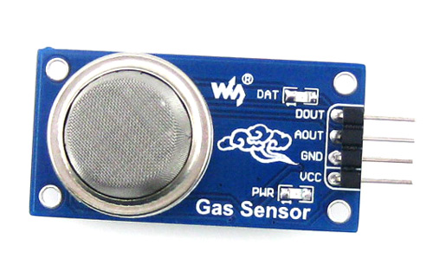](https://components101.com/sites/default/files/components/MQ2-gas-sensor.jpg)

**FIG 3.4 MQ-2 GAS SENSOR**

The **MQ-2 Gas sensor** can detect or measure gasses like LPG, Alcohol, Propane, Hydrogen, CO and even methane. The module version of this sensor comes with a Digital Pin which makes this sensor to operate even without a microcontroller and that comes in handy when you are only trying to detect one gas. When it comes to measuring the gas in ppm the analog pin must be used, the analog pin also TTL driven and works on 5V and hence can be used with most common microcontrollers.

**Table 3.2 Pin Description**

|  |  |  |
| --- | --- | --- |
| **Pin No:** | **Pin Name:** | **Description** |
| 1 | Vcc | This pin powers the module, typically the operating voltage is +5V |
| 2 | Ground | Used to connect the module to system ground |
| 3 | Digital Out | You can also use this sensor to get digital output from this pin, by setting a threshold value using the potentiometer |
| 4 | Analog Out | This pin outputs 0-5V analog voltage based on the intensity of the gas |

**3.3.4 Ph Sensor**

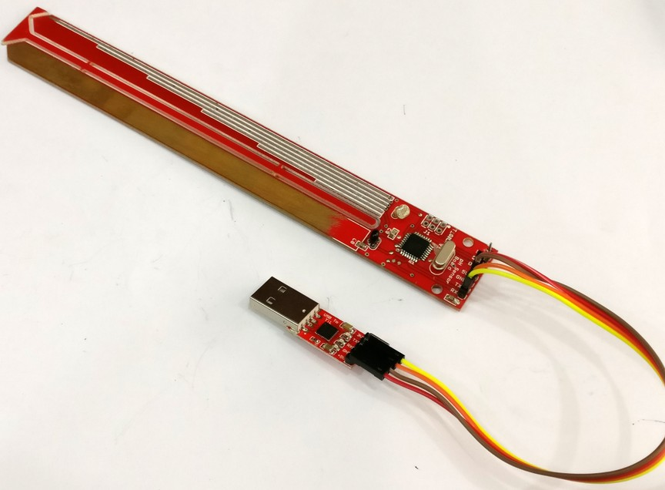

**Fig 3.5 – Ph sensor**

A pH Meter is a device used for [potentiometrically](https://en.wikipedia.org/wiki/Potentiometer_(measuring_instrument)" \o "Potentiometer (measuring instrument)) measuring the [pH](https://en.wikipedia.org/wiki/PH), which is either the [concentration](https://en.wikipedia.org/wiki/Concentration) or the [activity](https://en.wikipedia.org/wiki/Activity_(chemistry)) of hydrogen ions, of an [aqueous solution](https://en.wikipedia.org/wiki/Aqueous_solution). It usually has a [glass electrode](https://en.wikipedia.org/wiki/Glass_electrode) plus a [calomel](https://en.wikipedia.org/wiki/Mercury(I)_chloride#Calomel_electrode) [reference electrode](https://en.wikipedia.org/wiki/Reference_electrode), or a combination electrode. Ph meters are usually used to measure the pH of liquids, though special probes are sometimes used to measure the pH of semi-solid substances.

**Specification:**

* Meter: 5 x 8 x 3.5cm [2 x 3.2 x 1.5"]
* Probe length: 21cm [8"]
* Bronze probe diameter: 4.8mm
* silver probe diameter: 5.1mm
* Distance between probes: 1.2cm
* Color: Green
* Item size: 330*100*30mm

**3.3.5 TEMPERATURE SENSOR**

The digital temperature sensor DS18B20 follows single wire protocol and it can be used to measure temperature in the range of -67oF to +257oF or -55oC to +125oC with +-5% accuracy. The range of received data from the 1-wire can range from 9-bit to 12-bit. Because, this sensor follows the single wire protocol, and the controlling of this can be done through an only pin of Microcontroller. This is an advanced level protocol, where each sensor can be set with a 64-bit serial code which aids to control numerous sensors using a single pin of the microcontroller.

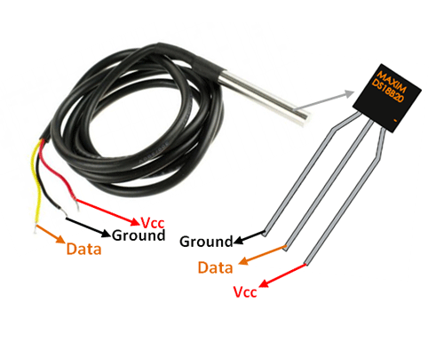

**Fig 3.6 – Ds18B20 Temperature Sensor**

* Pin1 (Ground): This pin is used to connect to the GND terminal of the circuit
* Pin2 (Vcc): This pin is used to give the power to the sensor which ranges from 3.3V or 5V
* Pin3 (Data): The data pin supplies the temperature value, which can communicate with the help of 1-wire method.

**Table 3.3- Specification of DS18B20 Temperature Sensor**

|  |  |
| --- | --- |
| Power Supply | 3V to 5.5V |
| Current Consumption | 1mA |
| Temperature Range | -55 to 125°C |
| Accuracy | ±0.5°C |
| Resolution | 9 to 12 bit (selectable) |
| Conversion Time | < 750ms |

**3.2.6 LEVEL SENSOR**

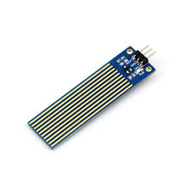

**Fig 3.7Level Sensor**

The sensor has ten exposed copper traces, five of which are power traces and the remaining five are sense traces. These traces are interlaced so that there is one sense trace between every two power traces. Normally, power and sense traces are not connected, but when immersed in water, they are bridged. The operation of the water level sensor is fairly simple. The power and sense traces form a variable resistor (much like a potentiometer) whose resistance varies based on how much they are exposed to water. This resistance varies inversely with the depth of immersion of the sensor in water:

* The more water the sensor is immersed in, the better the conductivity and the lower the resistance.
* The less water the sensor is immersed in, the poorer the conductivity and the higher the resistance.

The sensor generates an output voltage proportional to the resistance; by measuring this voltage, the water level can be determined.

**3.2.7 SOLENOID VALVE**

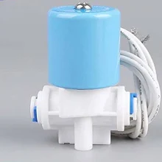

**Fig.3.8 Solenoid Valve**

Solenoid valves are control units which, when electrically energized or de-energized, either shut off or allow fluid flow. The actuator inside a solenoid valve takes the form of an electromagnet. When energized, a magnetic field builds up, which pulls a plunger or pivoted armature against the action of a spring. When de-energized, the plunger or pivoted armature is returned to its original position by the spring action. According to the mode of [actuation](https://www.sciencedirect.com/topics/earth-and-planetary-sciences/actuation), a distinction is made between direct-acting valves, internally piloted valves, and externally piloted valves. A further distinguishing feature is the number of port connections or the number of flow paths or “ways”.

**Table 3.4 – Specification of Solenoid Valve**

|  |  |
| --- | --- |
| Product Dimensions | ‎6L x 3.5W x 3.5H Centimeters |
| Material | ‎Metal |
| Capacity | ‎1 Cubic Centimeters |
| Included Components | ‎24v DC, 0-120 PSI, 2.5 MM Solenoid Valve |

**3.3.8 RELAY MODULE**

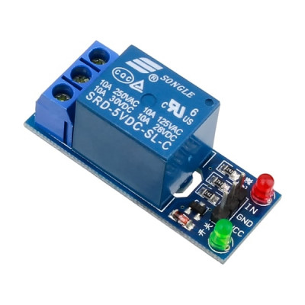

**Fig.3.9 Relay (PNP)**

Relay is an electromechanical device that uses an electric current to open or close the contacts of a switch. The single-channel relay module is much more than just a plain relay, it comprises of components that make switching and connection easier and act as indicators to show if the module is powered and if the relay is active or not. The second is the relay itself, which, in this case, is a blue plastic case. Lots of information can be gleaned from the markings on the relay itself. The part number of the relay on the bottom says “05VDC”, which means that the relay coil is activated at 5V minimum – any voltage lower than this will not be able to reliably close the contacts of the relay. There are also voltage and current markings, which represent the maximum voltage and current, the relay can switch.

The 'relay status LED' turns on whenever the relay is active and provides an indication of current flowing through the relay coil. The input jumper is used to supply power to the relay coil and LEDs. The jumper also has the input pin, which when pulled high activates the relay.

The switching transistor takes an input that cannot supply enough current to directly drive the relay coil and amplifies it using the supply voltage to drive the relay coil. This way, the input can be driven from a microcontroller or sensor output. The freewheeling diode prevents voltage spikes when the relay is switched off. The power LED is connected to VCC and turns on whenever the module is powered.

Table 3.5 Specifications for relay

|  |  |
| --- | --- |
| Supply voltage | 3.75V to 6V |
| Quiescent current | 2mA |
| Current when the relay is active | ~70mA |
| Relay maximum contact voltage | 250VAC or 30VDC |
| Relay maximum current | 10A |

**3.3.9 HEATER**



# Fig 3.10 Stainless Steel Iron Heating Element

# TABLE 3.6 Specifications for Heating element

|  |  |
| --- | --- |
| Material | Stainless Steel |
| Usage/Application | Iron |
| Compatible Power | 1500 W |
| Brand | Airex |
| Voltage | 240 V |
| Temperature | 280 Degree C |
| Frequency | 50 Hz |

**3.4 SUMMARY**

This chapter has detailed description of various hardware components used in the project along with the images and specifications. In this hardware set we have a power circuit, Node MCU microcontroller, MQ-2 Gas sensor, Ph sensor, Temperature sensor, Level sensor, relay, and a heater.

**CHAPTER 4**

**SOFTWARE DESCRIPTION**

**4.1 INTRODUCTION**

This chapter explains about the software we use in executing and interfacing. In our project we use Arduino IDE software through we which we upload our code to the NodeMCU. We use Embedded C for the programming part which makes us understand easily. Also, the interfacing of the IoT platforms with the NodeMCU that we are using i.e., Thingspeak and Blynk IoT are also coded in the Arduino IDE software.

**4.2 ARDUINO IDE**

The Arduino Integrated Development Environment (IDE) is a cross-platform application (for Windows, macOS, Linux) that is written in functions from C and C++. It is used to write and upload programs to Arduino compatible boards, but also, with the help of third-party cores, other vendor development boards. The source code for the IDE is released under the GNU General Public License, version 2. The Arduino IDE supports the languages C and C++ using special rules of code structuring. The Arduino IDE supplies a software library from the Wiring project, which provides many common input and output procedures. User-written code only requires two basic functions, for starting the sketch and the main program loop, that are compiled and linked with a program stub main () into an executable cyclic executive program with the GNU toolchain, also included with the IDE distribution. The Arduino IDE employs the program avrdude to convert the executable code into a text file in hexadecimal encoding that is loaded into the Arduino board by a loader program in the board's firmware. By default, avrdude is used as the uploading tool to flash the user code onto official Arduino boards. Arduino IDE is a derivative of the Processing IDE, however as of version 2.0, the Processing IDE will be replaced with the Visual Studio Code-based Eclipse Theia IDE framework. And the Arduino IDE has been designed so that it's very easy for anyone to add support for any microcontroller which is an added advantage so with it we are using Arduino IDE to code our Node MCU.

**4.3 ALGORITHM**

Step1: Start

Step2: Initialize the header files for Wi-Fi module, thingspeak, Blynk and the sensors used.

Step3: Configure the Wi-Fi settings of the Node MCU with its id and password.

Step4: Set the channel number and api key for thingspeak and blynk.

Step5: Configure digital pins 0,5,6,7,8 as output to relay and 1 as input from gas

Step6: If any gas is detected buzzer at D0 is turned on

Step7: If the level sensor reads 0 the inlet valve is turned on

Step8: The inlet valve 1(Relay-1) is turned on till it reaches halfway point of level sensor.

Step9: Now the Ph of the fluid is monitored based on which inlet 2(Relay 2) turns on if Ph is greater than 7

Step10: Once the water level reaches the maximum height. Inlet valves are turned off.

Step11: While the inlet valves are turned off the temperature sensor reads the temperature.

Step12: The Outlet valve(Relay 4) will open when the fluid is neutralized, the level reaches maximum and the temperature goes above 50.

Step13: To rise the temperature above 50 we use the heater (Relay 3) which is controlled by blynk.

Step 14: This automation process runs continuously.

Step 16: END

**4.5 SUMMARY**

In this chapter the software source Arduino IDE which is explained briefly along with the algorithm of the program code used in the project for interfacing. Also, the working flow chart explains the steps involved in the process of execution of the project.

**CHAPTER – 5**

**RESULT AND CONCLUSION**

**5.1 INTRODUCTION**

This chapter deals with the output obtained from the prototype designed, process station that is built is also included in this chapter.

**5.2 IMAGE OF THE PROTOTYPE**

The batch process station is shown in Fig.5.1. in which the two inlet valves and outlet valves are seen, the sensors that are used in the process can also be seen i.e., Ph sensor, level sensor, temperature sensor. The valves are actuated by the relay and the supply to the Node MCU is given via the power unit which produces a +5v DC.

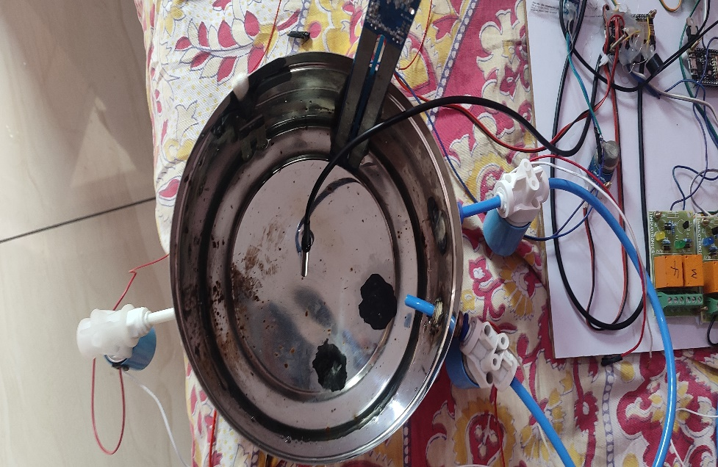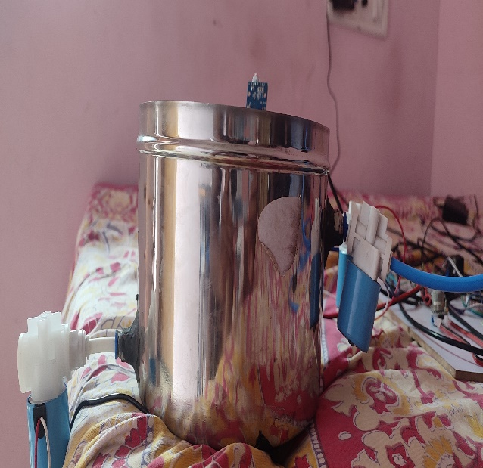

**Fig 5.1 Batch Process setup.**

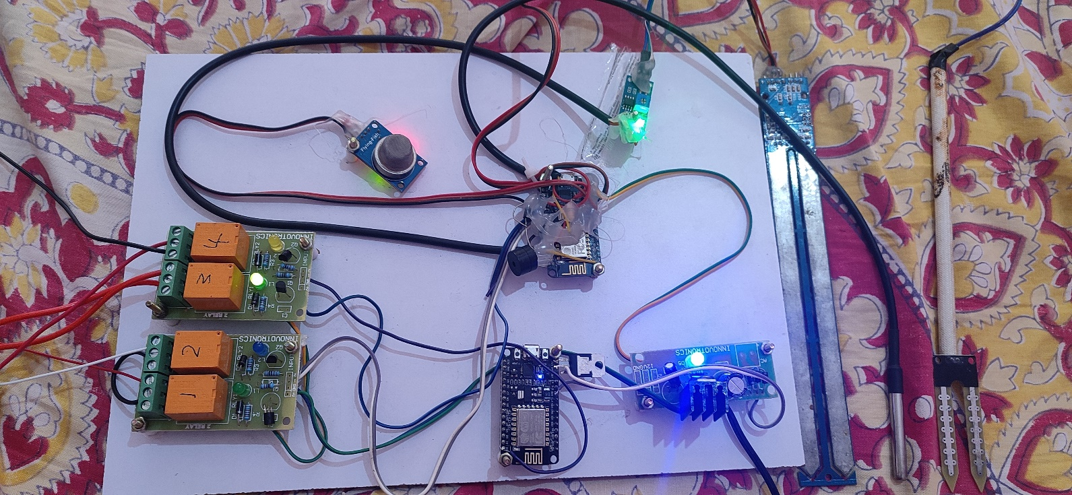

**Fig 5.2 Embedded Kit**

**5.3 RESULTS FROM THINGSPEAK.**

As soon as the kit is on the sensor values are updated in the thingspeak platform every 10 sec. This transmission of the data also depends on the network strength of the connected device.

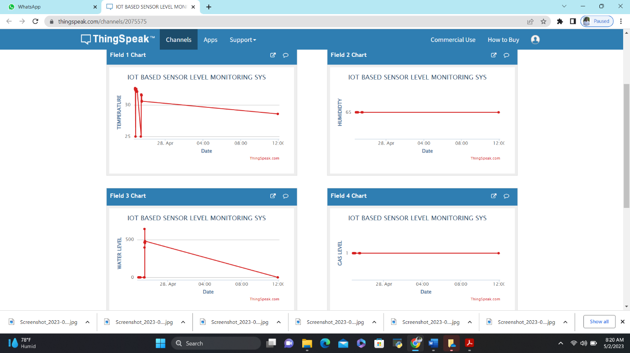

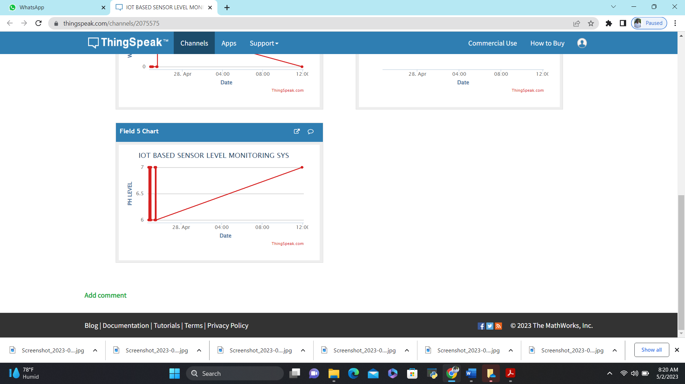

**Fig 5.3 – Thingspeak Output**

**5.4 RESULTS FROM BLYNK**

The control of the heater is done via blynk IoT platform to which we have created a template that turns on/off via the cloud which is shown in Fig 5.4.

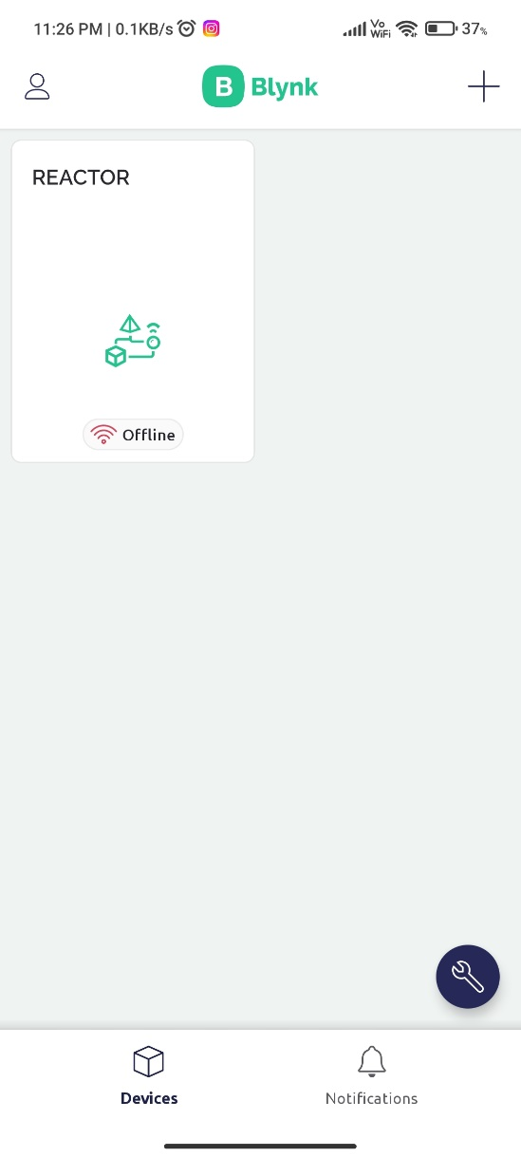 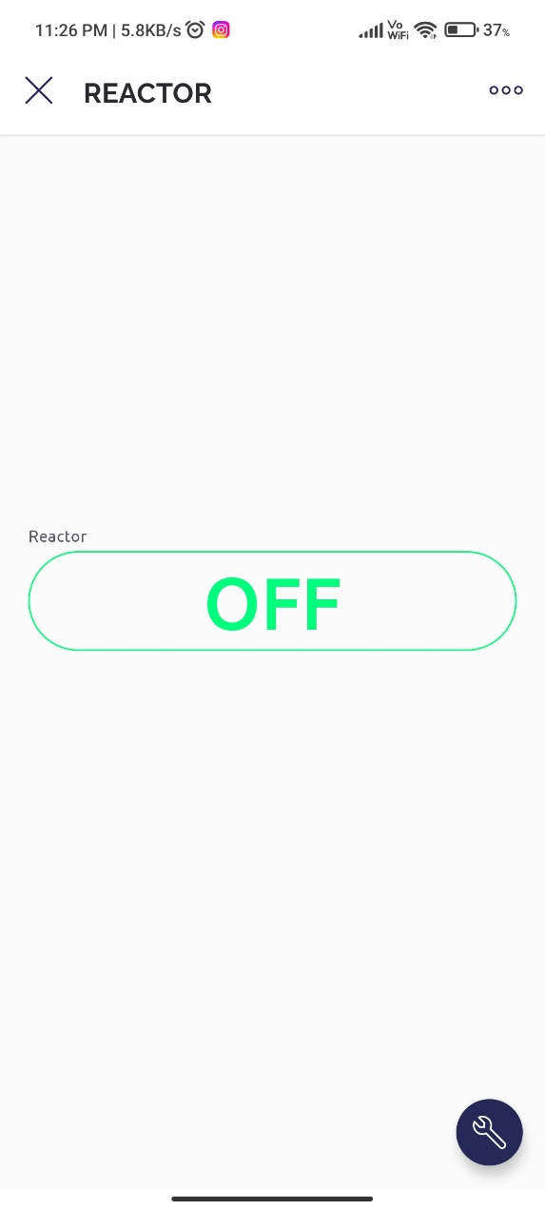

**Fig 5.4 Results from Blynk**

**5.6 RESULT**

From the images we infer the successful execution of the process and the monitoring and controlling the process with the IoT platforms Thingspeak and Blynk.

**5.7 FUTURE WORK**

The project can further be extended by developing it for various processes based on the need of the industries and include more sensor such as camera and monitor the industry in the absence of engineers. More work can be done to improve the safety and security protocols in the industry.

**5.8 CONCLUSION**

We hope to gain hands-on experience with the trending technologies of "Embedded System" and "Internet of Things" through this project. IoT-enabled industrial monitoring systems have become increasingly popular in a variety of industries because they improve safety standards by providing real-time monitoring of critical parameters such as temperature, humidity, and smoke, as well as alerting officials and workers regularly. The implementation is not only for safety reasons, but it also has the potential to increase industry yields. In our project, the Internet of Things (IoT) is used to collect data and communicate through the internet. We hope that our project will be beneficial enough to be implemented in industries across India, saving lives and property from accidents and risks that are often overlooked by industry personnel and users. Companies in the industrial and logistics sectors can better meet the new era of instant needs by utilizing the Industrial Internet of Things (IoT). IoT technologies are used in manufacturing processes and across supply chains in the Industrial Internet of Things. Industrial IoT strategy should include machine learning and big data technology.

**REFERENCES**

[1].H.K.Merchant,D.D.Ahire, “Industrial automation using IOT with Raspberry Pi” , International Journal of Computer Applications , Volume 168 – No.1, June 2017

[2] Thimmapuram Swati, K. Raghavendra Rao “Industrial Process Monitoring System Using Esp32” International Journal of Recent Technology and Engineering (IJRTE) ISSN: 2277-3878, Volume-7, Issue-6S4, April 2019

[3] Shrushti Panpaliya, Nita Surayawansi Nikhil S. Mundane “Industrial Monitoring and Control Applications Using IOT” International Journal of Emerging Technologies in Engineering Research (IJETER) Volume 6, Issue 1, January (2018)

[4] Himanshu kr. Singh, Ayush Srivastava, Irfanuddin “IOT Industrial Automation Using Raspberry Pi” *International Journal of Engineering Research and Applications*