**Class 8 – IMPLEMENTING UART TO TRANSMIT AND RECEIVE DATA AND DO THE LED BLINKING OPERATIONS.**

**MICROCONTROLLER 1 PROGRAM:**

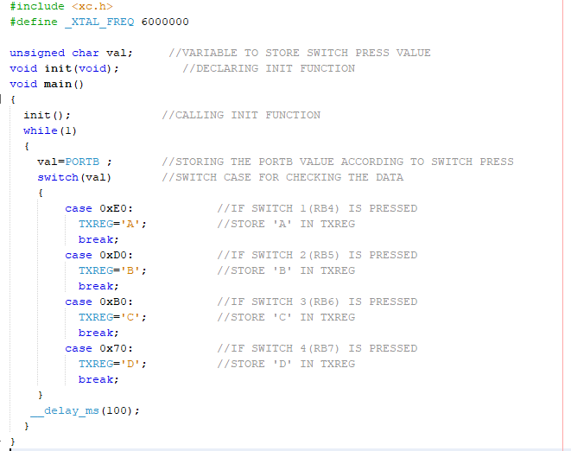

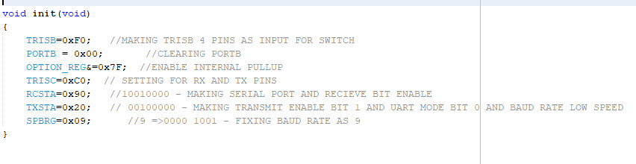

**MICROCONTROLLER 2 PROGRAM:**

