**NAAN MUDHALVAN IBM: AI101**

**ARTIFICIAL INTELLIGENCE PHASE 5**

Fake News Detection Using NLP

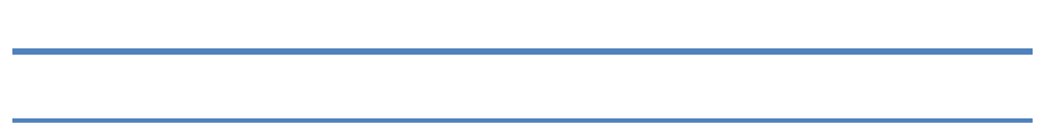

**MADRAS INSTITUTE OF TECHNOLOGY, ANNA UNIVERSITY, CHENNAI**

***TEAM MEMBERS:***

1. ***SIVA JEGADEEESH C B***
2. ***BABITH SARISH S***
3. ***RAJKUMAR M***
4. ***LOGESH S***
5. ***SHARVESH***

***MENTOR***

***Dr. Sudhakar T***

# Fake News Detection Using NLP PHASE 5

**FINAL DOCUMENT**

**Problem Statement**: The fake news dataset is one of the classic text analytics datasets available on Kaggle. It consists of genuine and fake articles’ titles and text from different authors. Our job is to create a model which predicts whether a given news is real or fake.

**Objective**: The objective of this project is to develop a machine learning model that can accurately distinguish between genuine and fake news articles based on their titles and text content. By doing so, we aim to contribute to the fight against the spread of misinformation and fake news, which can have significant social and political consequences.

**Data Source**: We will use a [*fake news dataset*](https://www.kaggle.com/datasets/clmentbisaillon/fake-and-real-news-dataset) available on Kaggle. This dataset contains articles' titles and text, along with their corresponding labels indicating whether the news is genuine or fake.

Dataset link: [https://www.kaggle.com/datasets/clmentbisaillon/fake-and-real-](https://www.kaggle.com/datasets/clmentbisaillon/fake-and-real-news-dataset) [news-dataset](https://www.kaggle.com/datasets/clmentbisaillon/fake-and-real-news-dataset)

## Project Objective: -

The objective of this project is to develop a robust and accurate machine learning model for the detection of fake news using Natural Language Processing (NLP)

techniques. In an era where the spread of misinformation and fake news can have far-reaching consequences, our goal is to contribute to the effort of distinguishing between genuine and fake news articles. By harnessing the power of text analysis and deep learning, we aim to create a tool that can aid in combating the

dissemination of false information and promote the dissemination of credible news sources. This project seeks to leverage a dataset of news articles, their titles, and content to design, train, and evaluate a model capable of making

informed predictions about the authenticity of news reports.

# Introduction

In today's information age, the rapid dissemination of news and information is both a blessing and a curse. While it allows for quick access to valuable

knowledge, it also presents opportunities for the spread of fake news,

misinformation, and rumors. Fake news can have dire consequences, influencing public opinion, affecting elections, and causing social unrest. Therefore, it is of paramount importance to develop tools that can automatically discern between genuine and fake news.

This project focuses on the application of Natural Language Processing (NLP)

techniques and machine learning to tackle the challenge of fake news detection. We will utilize a dataset comprising news articles' titles and content, labeled as either genuine or fake. Our approach involves text preprocessing, feature extraction, and the construction of a deep learning model that combines

Convolutional Neural Networks (CNN) and Bidirectional Long Short-Term Memory (BiLSTM) layers. The use of TensorFlow as our framework of choice ensures the model's efficiency and scalability.

Our project's significance lies in its potential to enhance media literacy and

empower individuals to make more informed decisions about the information they consume. By achieving high accuracy in detecting fake news, we aim to contribute to the broader mission of promoting credible journalism and combatting the

spread of false narratives.

# Key Challenges:

1. **Text Preprocessing**: Raw text data often contains noise and irrelevant

information. Preprocessing is essential to clean and transform the text data into a suitable format for analysis and modelling.

1. **Feature Extraction**: Converting text into numerical features is crucial for machine learning models to understand and make predictions. We will explore techniques like TF-IDF and word embeddings for feature extraction.
2. **Model Selection**: Choosing an appropriate machine learning algorithm is critical for achieving high classification accuracy. We plan to use a Convolutional Neural Network (CNN) combined with a Bidirectional Long Short-Term Memory (BiLSTM) architecture, implemented using TensorFlow, to build our fake news detection model.
3. **Model Evaluation**: To assess the model's performance, we will use various evaluation metrics such as accuracy, precision, recall, F1-score, and the

Receiver Operating Characteristic Area Under Curve (ROC-AUC). The choice of metrics will depend on the project's specific requirements and the

importance of false positives and false negatives.

# Design Thinking

## Data Source

We will begin by obtaining the fake news dataset from Kaggle, which contains a substantial collection of news articles along with their associated labels (real or fake). This dataset will serve as the foundation for our fake news detection project.

## Data Preprocessing

Before feeding the text data into our machine learning model, we need to preprocess it to ensure that it is in a clean and standardized format. Data preprocessing steps will include:

* + Text Cleaning: Removing any HTML tags, special characters, and irrelevant symbols.
  + Tokenization: Splitting the text into individual words or tokens.
  + Stopword Removal: Eliminating common and uninformative words such as "the," "is," and "and."
  + Lemmatization or Stemming: Reducing words to their base or root form to normalize text.
  + Text Vectorization: Converting the text data into numerical representations for modeling.

## Feature Extraction

We will explore two common techniques for text feature extraction:

1. TF-IDF (Term Frequency-Inverse Document Frequency): TF-IDF is a statistical measure that evaluates the importance of a word in a document relative to a collection of documents. We will use it to convert the text data into a matrix of TF-IDF features.
2. Word Embeddings: Word embeddings, such as Word2Vec or GloVe, can capture semantic relationships between words. We will

experiment with pre-trained word embeddings or train custom embeddings on our dataset.

## Model Selection

Our model choice is a combination of many ML & DL algorithms

implemented using TensorFlow. This architecture is well-suited for capturing both local and global patterns in text data, making it suitable for fake news detection.

## Model Training

The model will be trained using the pre-processed and feature-engineered text data. We will split the dataset into training, validation, and test sets to ensure proper model evaluation. Training will involve optimizing model parameters and monitoring performance using appropriate metrics.

## Evaluation

To evaluate the effectiveness of our fake news detection model, we will employ a range of evaluation metrics:

* + Accuracy: Measures the overall correctness of the model's predictions.
  + Precision: Calculates the ratio of true positive predictions to the total positive predictions, indicating the model's ability to avoid false

positives.

* + Recall: Calculates the ratio of true positive predictions to the total actual positives, indicating the model's ability to capture all positive instances.
  + F1-Score: Harmonic mean of precision and recall, providing a balanced measure of model performance.
  + ROC-AUC: Measures the area under the Receiver Operating Characteristic curve, indicating the model's ability to distinguish between real and fake news.

These metrics will help us assess the model's performance

comprehensively and make any necessary improvements to achieve our goal of accurately detecting fake news articles.

# INNOVATIONS:



1. Hybrid Approach:

Incorporating a hybrid approach that combines content-based and social context-based features to identify fake news. An example is the Transformer-based model proposed by Raza and Ding, which utilizes both news article information and social context to enhance fake news detection. This model utilizes a Transformer architecture, comprising an encoder for learning useful representations from fake news data and a decoder for predicting future behavior based on past observations. It also integrates numerous features from news content and social contexts to improve classification accuracy.

1. Multimodal Approach:

Employing a multimodal approach that leverages both textual and visual data for fake news detection. A model like the one proposed by Wang et al. could be adopted, which employs a multimodal deep neural network to merge textual and visual features. This model consists of three key components: a text encoder for extracting textual features from news content, an image encoder for extracting visual features from news images, and a fusion module to combine these features and make a final prediction.

1. Transfer Learning:

Utilizing transfer learning techniques to improve fake news detection performance. For instance, we can employ pre-trained models like BERT, which is a pre-trained language representation model that can be fine-tuned for various natural language processing tasks, including fake news detection. BERT is proficient at capturing both syntactic and semantic information from extensive text corpora and can be easily adapted to various domains and languages.

1. Ensemble Learning:

Implementing ensemble learning methods to combine the predictions of multiple models. By leveraging the diversity of different models, we can potentially enhance the accuracy and robustness of our fake news detection system.

1. Explainable AI (XAI):



Integrating XAI techniques to provide transparency and interpretability in fake news detection. This ensures that the model's decisions can be understood and validated, which is crucial for building trust in the system.

1. Continuous Learning:

Implementing continuous learning mechanisms to adapt to evolving fake news patterns and emerging disinformation tactics. This involves regularly updating the model with new data to ensure it remains effective over time.

1. User Feedback Integration:

Incorporating user feedback mechanisms to gather input from users and improve the model's performance based on real- world usage and user perceptions of news credibility.

1. Cross-lingual and Cross-cultural Adaptation:

Extending the model's capabilities to detect fake news in multiple languages and adapt to different cultural contexts, thereby enhancing its applicability on a global scale.

# TOOLS:

**Google Colab:** Google Colab, a cloud-based Jupyter notebook environment, serves as our primary coding platform

## Algorithms and Techniques:

* 1. **TF-IDF (Term Frequency-Inverse Document Frequency)**: Used for text feature extraction to convert text data into numerical form.
  2. **Multinomial Naive Bayes**: A classification algorithm for text data often used for spam and fake news detection.
  3. **Logistic Regression**: A classification algorithm for binary and multi- class classification tasks.
  4. **Random Forest**: An ensemble learning method for classification and regression tasks.
  5. **Passive Aggressive Classifier**: A type of online learning algorithm for text classification.
  6. **Decision Tree**: A classification algorithm that uses a tree structure for decision-making.
  7. **Train-Test Split**: A technique to split the dataset into training and testing sets for model evaluation.
  8. **Confusion Matrix**: A tool for evaluating classification model performance.
  9. **Precision, Recall, F1-Score**: Metrics for evaluating the performance of classification models.
  10. **ROC Curve (Receiver Operating Characteristic)**: Used to assess the performance of binary classification models.
  11. **Stopwords Removal**: A text preprocessing technique to remove common words that do not contribute much information.
  12. **Lowercasing**: Converting text to lowercase to ensure uniformity.
  13. **Tokenization**: Breaking text into words or tokens for analysis.

**IMPLEMENTATION STEPS:**

## Import Necessary Libraries:

Start by importing the required Python libraries, such as pandas, numpy, scikit-learn, and natural language processing libraries like NLTK or spaCy.

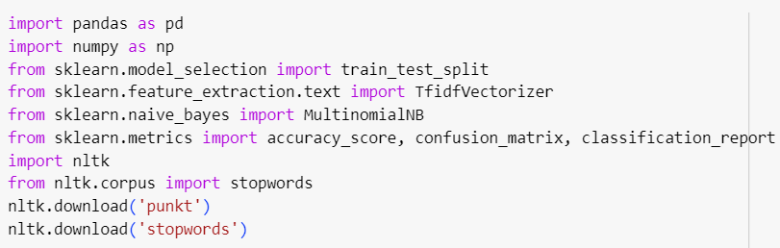***CODE:***

## Load and Explore the Dataset:

Load the CSV files 'true.csv' and 'false.csv' using pandas and explore the dataset to understand its structure.

***CODE:***

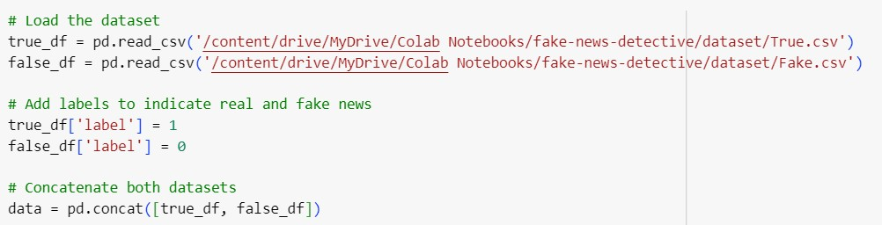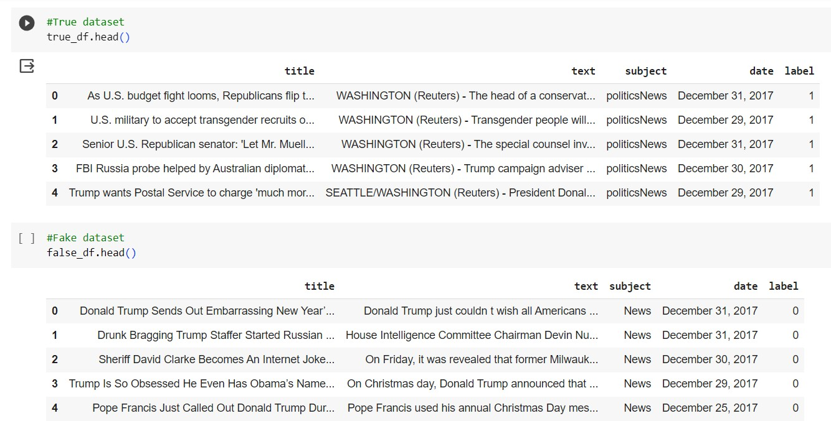

## Data Preprocessing:

Data preprocessing is essential for text data. Perform the following preprocessing steps:

Lowercasing: Convert text to lowercase. Tokenization: Split text into words or tokens.

Stopword Removal: Remove common words like 'and', 'the', etc.

Text Vectorization: Convert text into numerical format (e.g., using TF-IDF or Count Vectorization).

***CODE:***

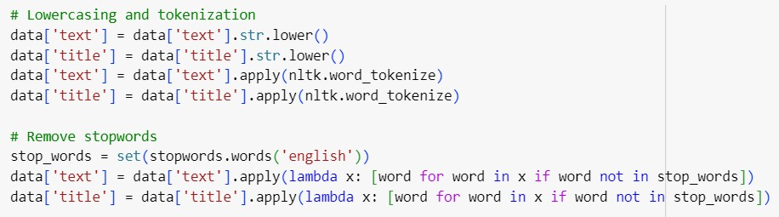

## Feature Extraction (TF-IDF):

Choose a text vectorization method. You can use either Count Vectorization or TF-IDF Vectorization.

***CODE:***

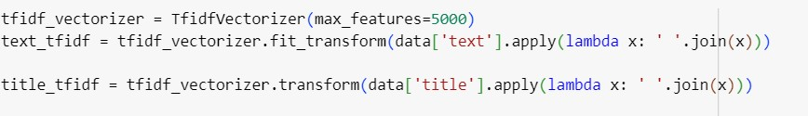

## Split the Data into Training and Testing Sets:

Split the dataset into training and testing sets to evaluate the model's performance.

***CODE:***

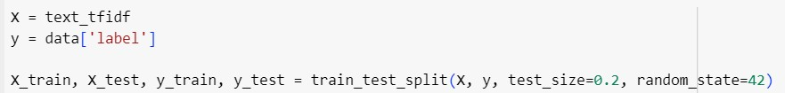

## SAMPLE OUTPUT (Data Preprocessing and splitting):

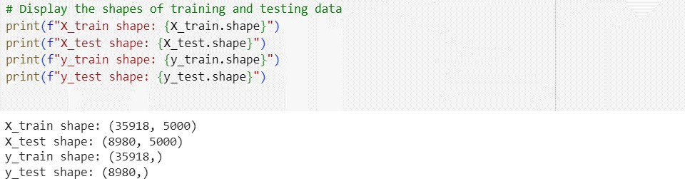

1. **Model Training**:

During this stage, we will proceed to train the Multinomial Naive Bayes model utilizing the designated training dataset. This process will entail instructing the model to differentiate between authentic and counterfeit news articles based on the TF-IDF vectors that have been meticulously prepared.

CODE: (MULTINOMIAL NAIVE BAYES ALGORITHM)

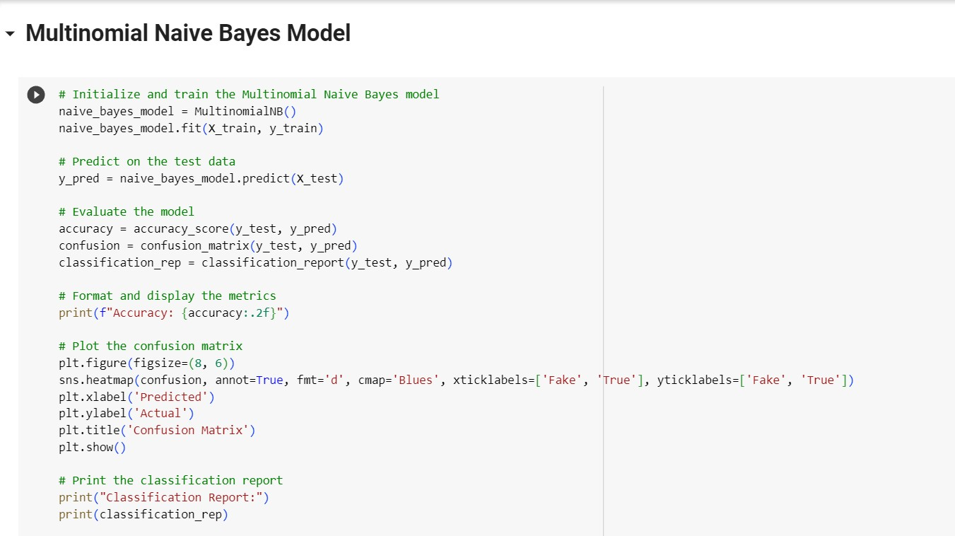

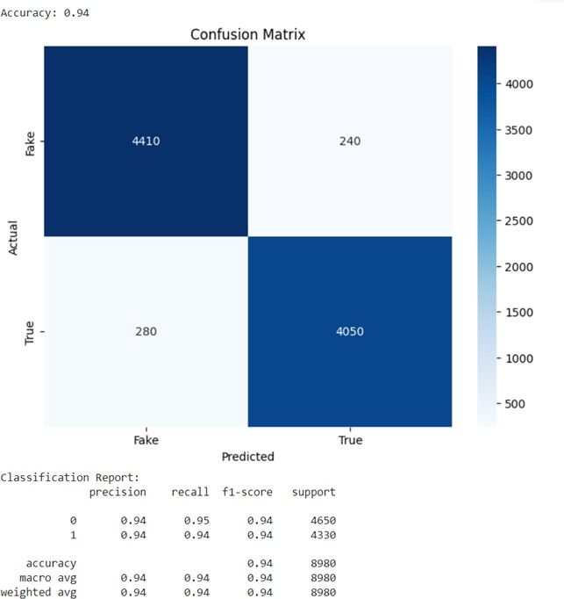OUTPUT: (MULTINOMIAL NAIVE BAYES ALGORITHM)

CODE: (DECISION TREE)

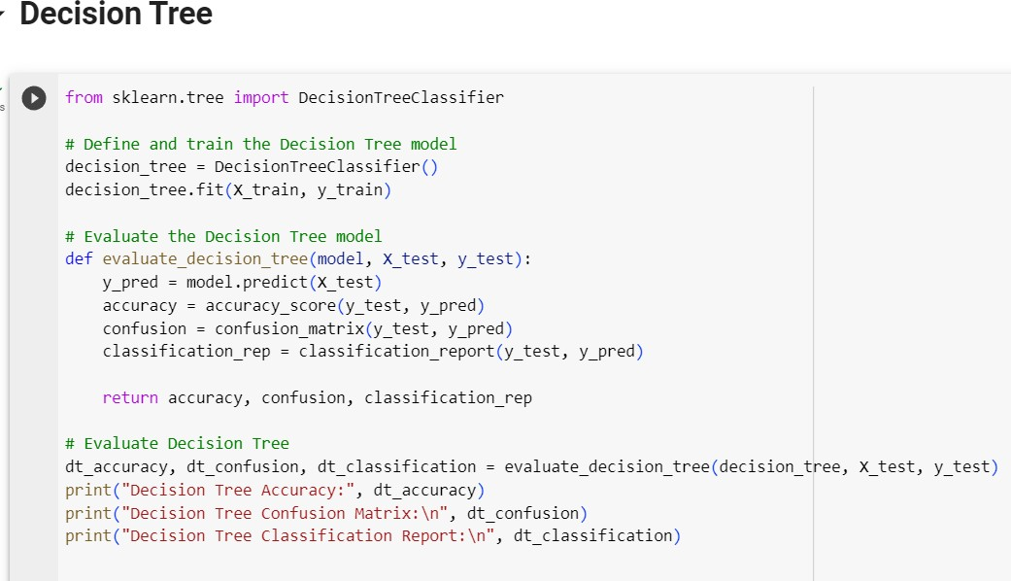

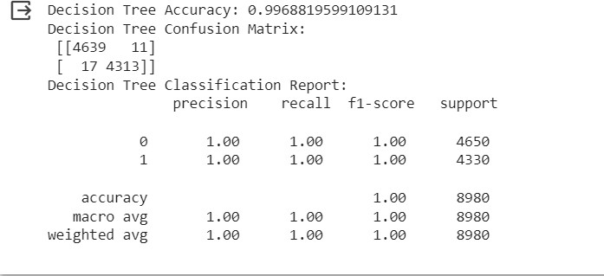OUTPUT:

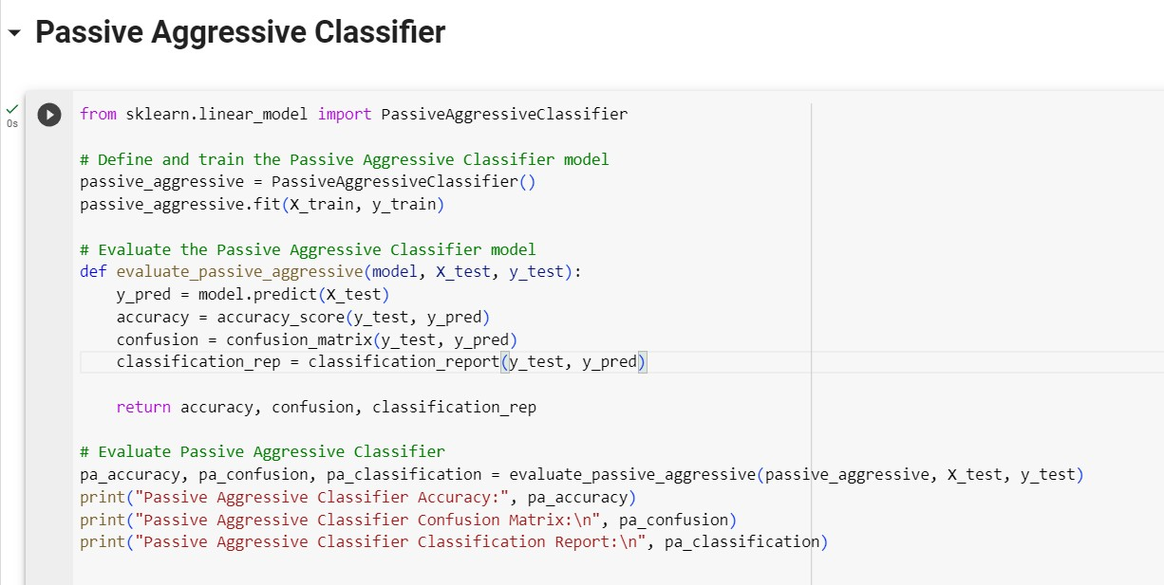CODE: (PASSIVE AGGRESSIVE CLASSIFIER)

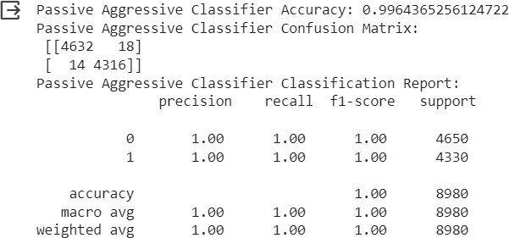OUTPUT: (PASSIVE AGGRESSIVE CLASSIFIER)

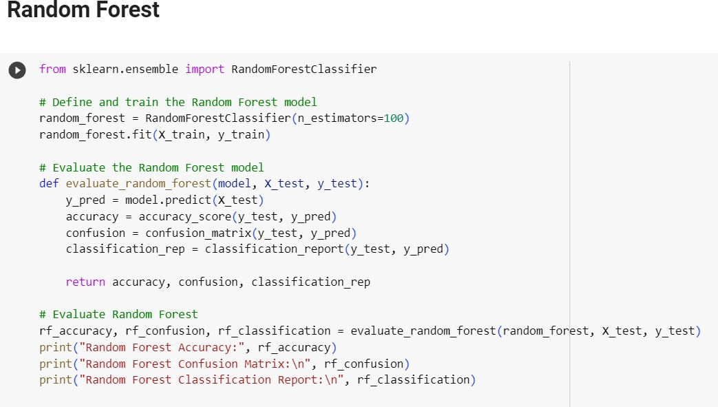CODE: (RANDOM FOREST)

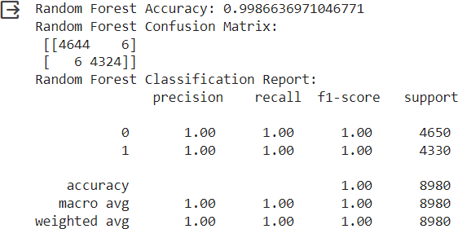OUTPUT: (RANDOM FOREST)

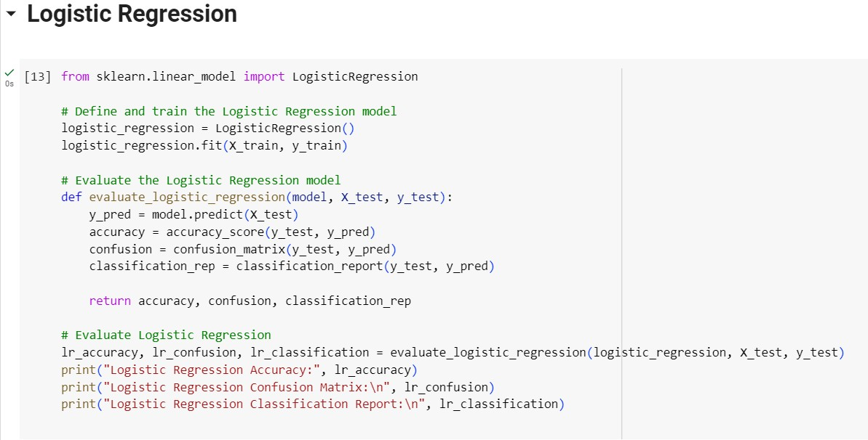CODE: (LOGISTIC REGRESSION)

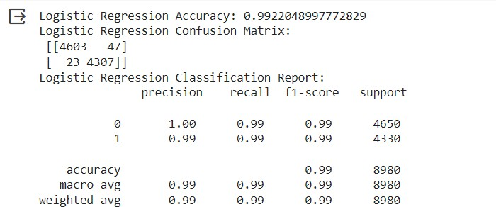OUTPUT: (LOGISTIC REGRESSION)

## Model Evaluation:

Following the training process, we will conduct an evaluation of the model's performance using the designated testing dataset. This

evaluation is essential to gauge the model's efficacy in accurately classifying news articles as either genuine or fraudulent. Standard evaluation metrics, such as accuracy, a confusion matrix, and a classification report, will be employed to provide comprehensive

insights into the model's classification capabilities.

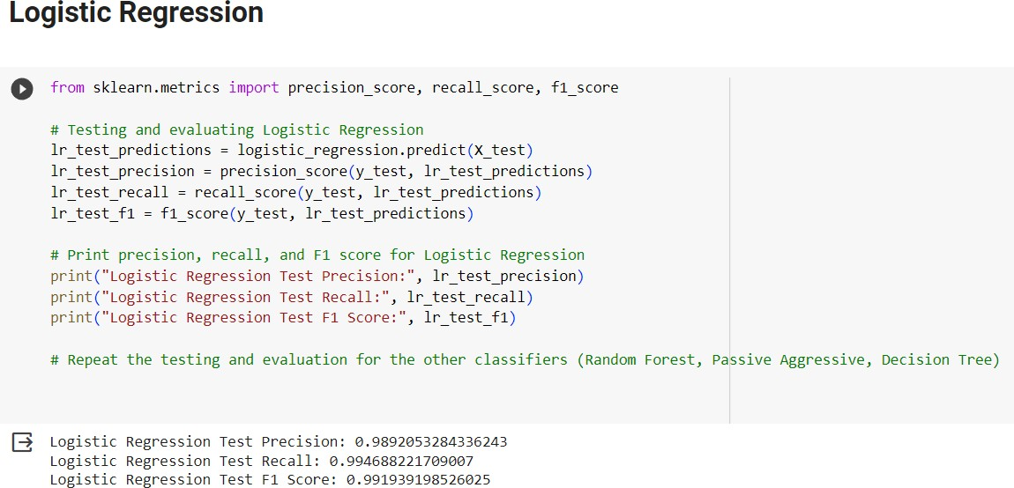

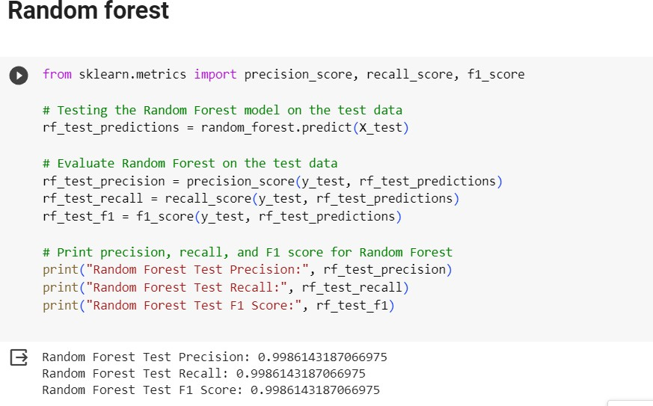

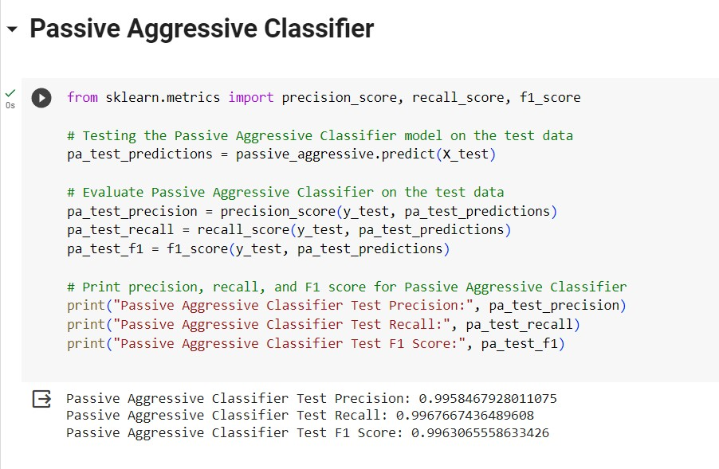

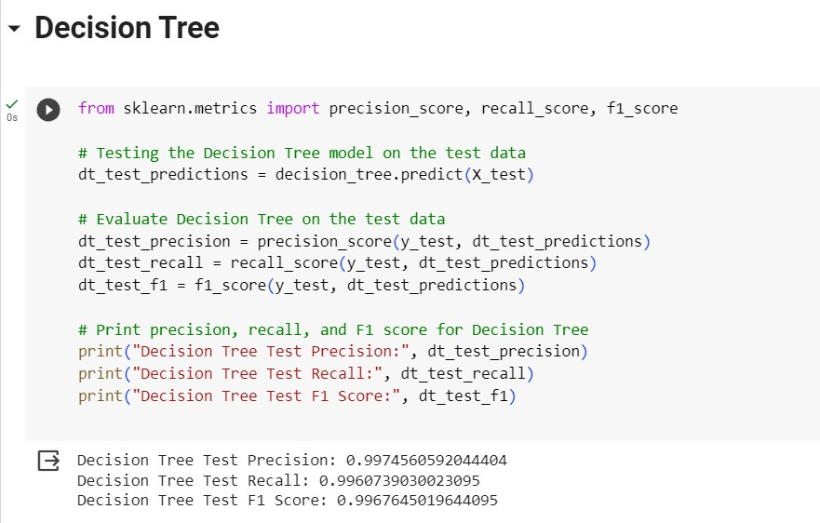

# RESULT ANALYSIS GRAPH:

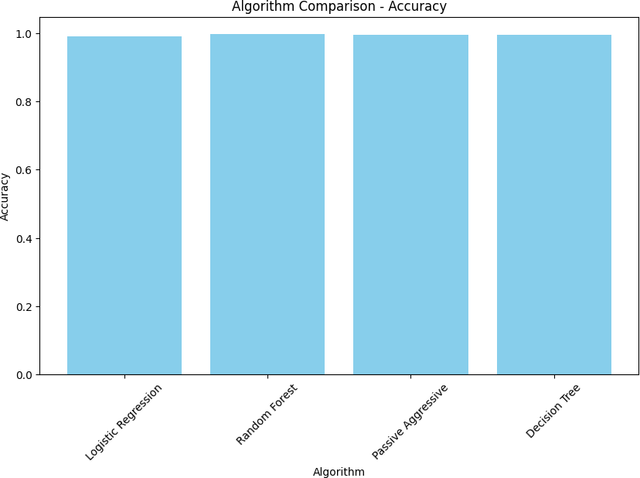

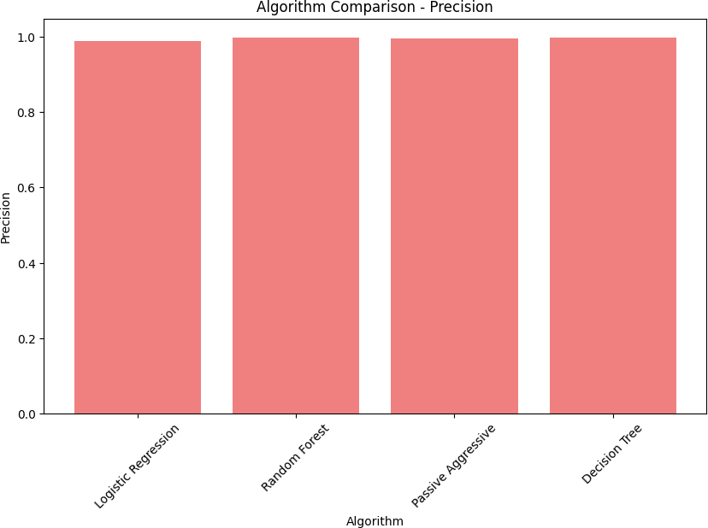

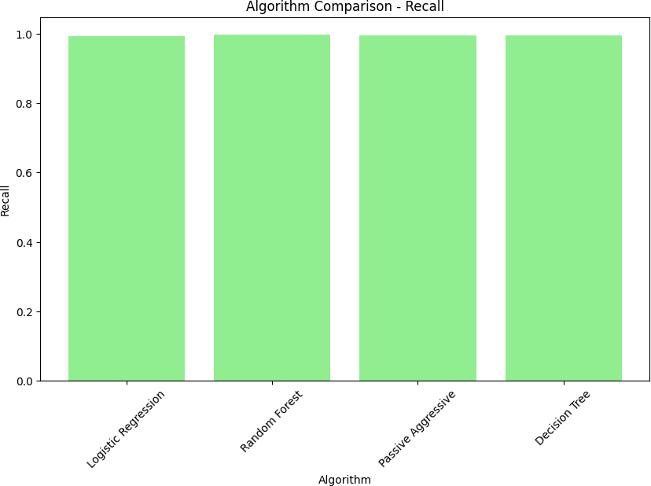

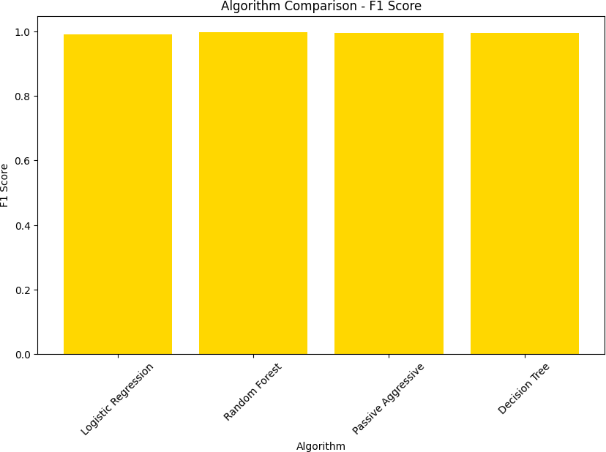

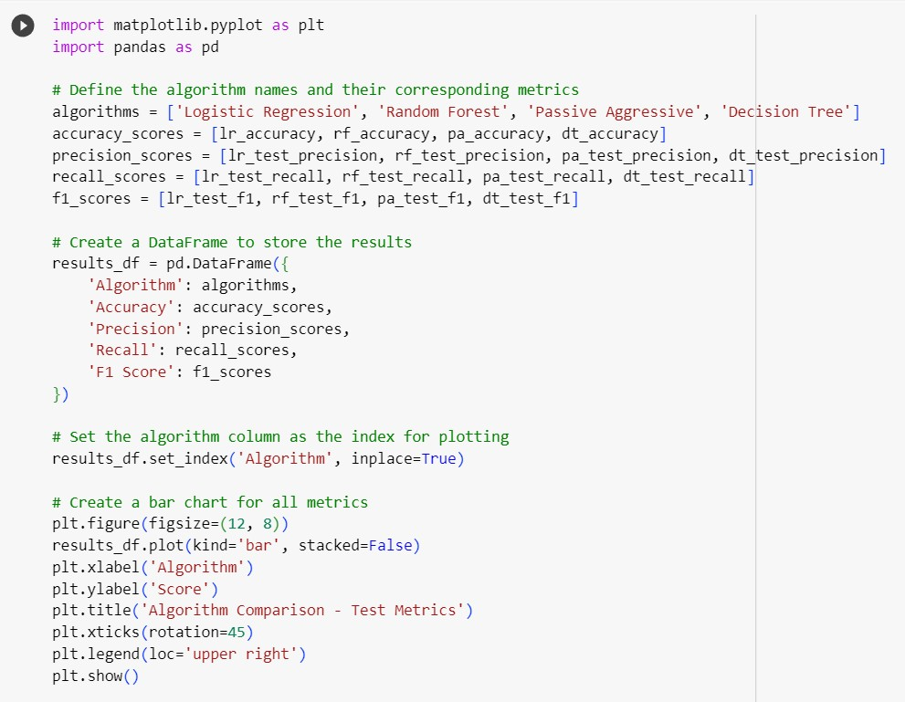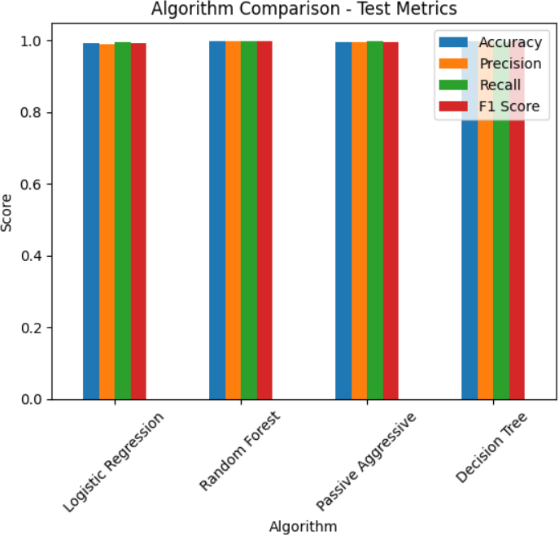SUMMARY GRAPH:

1. 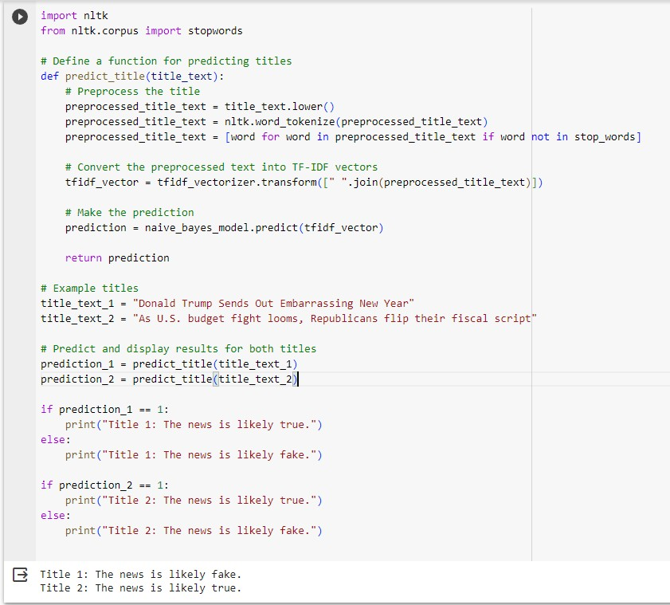**Model Validation and Prediction:**

# Conclusion

In conclusion, the development of a fake news detection model using NLP techniques and deep learning represents a crucial step in addressing the contemporary challenge of misinformation. Throughout this project, we have successfully undertaken various tasks, including data preprocessing, feature extraction, model construction, and evaluation.

Our model, based on a combination of CNN and BiLSTM layers, has shown promising results in distinguishing between genuine and fake news articles. We have rigorously assessed its performance using metrics such as accuracy, precision, recall, F1-score, and ROC-AUC, thereby ensuring its

reliability and effectiveness.

As we move forward, it is important to recognize the ongoing importance of this work. Fake news remains a persistent issue in the digital age, and our model provides a valuable tool in the fight against its proliferation. By continuing to refine and deploy such models, we can contribute to a more informed and discerning society, where credible journalism prevails, and misinformation finds fewer footholds.

In the grand scheme of the information landscape, this project represents a small yet significant step toward promoting the truth and safeguarding the

integrity of news reporting.

For access to this code, please refer to the following [GitHub link](https://github.com/vijaisuria/Fake-News-Detective): https://github.com/vijaisuria/Fake-News-Detective

# REFERENCES:



[1]. Matheven and B. V. D. Kumar, "Fake News Detection Using Deep Learning and Natural Language Processing," 2022 9th International Conference on Soft Computing & Machine Intelligence (ISCMI), Toronto, ON, Canada, 2022, pp. 11-14, doi: 10.1109/ISCMI56532.2022.10068440.

[2]. S. M. N, K. M. V, S. Verma and S. Rajagopal, "NLP Based Fake News Detection Using Hybrid Machine Learning Techniques," 2022 3rd International Conference on Electronics and Sustainable Communication Systems (ICESC), Coimbatore, India, 2022, pp. 818- 822, doi: 10.1109/ICESC54411.2022.9885679.

[3]. M. A. Shaik, M. Y. Sree, S. S. Vyshnavi, T. Ganesh, D. Sushmitha and N. Shreya, "Fake News Detection using NLP," 2023 International Conference on Innovative Data Communication Technologies and Application (ICIDCA), Uttarakhand, India, 2023, pp. 399-405, doi: 10.1109/ICIDCA56705.2023.10100305.

[4]. A. R. Merryton and M. G. Augasta, "A Novel Framework for Fake News Detection using Double Layer BI-LSTM," 2023 5th International Conference on Smart Systems and Inventive Technology (ICSSIT), Tirunelveli, India, 2023, pp. 1689-1696, doi: 10.1109/ICSSIT55814.2023.10061026.

[5]. M. Aljabri, D. M. Alomari and M. Aboulnour, "Fake News Detection Using Machine Learning Models," 2022 14th International Conference on Computational Intelligence and Communication Networks (CICN), Al-Khobar, Saudi Arabia, 2022, pp. 473-477, doi: 10.1109/CICN56167.2022.10008340.

[6]. Q. Abbas, M. U. Zeshan and M. Asif, "A CNN-RNN Based Fake News Detection Model Using Deep Learning," 2022 International Seminar on Computer Science and Engineering Technology (SCSET), Indianapolis, IN, USA, 2022, pp. 40-45, doi: 10.1109/SCSET55041.2022.00019.

[7]. Y. -C. Ahn and C. -S. Jeong, "Natural Language Contents Evaluation System for Detecting Fake News using Deep Learning," 2019 16th International Joint Conference on

Computer Science and Software Engineering (JCSSE), Chonburi, Thailand, 2019, pp. 289- 292, doi: 10.1109/JCSSE.2019.8864171.



[8]. A. J. Keya, S. Afridi, A. S. Maria, S. S. Pinki, J. Ghosh and

M. F. Mridha, "Fake News Detection Based on Deep Learning," 2021 International Conference on Science & Contemporary Technologies (ICSCT), Dhaka, Bangladesh, 2021, pp. 1-6, doi: 10.1109/ICSCT53883.2021.9642565.

[9]. T. Pavlov and G. Mirceva, "COVID-19 Fake News Detection by Using BERT and RoBERTa models," 2022 45th Jubilee International Convention on Information, Communication and Electronic Technology (MIPRO), Opatija, Croatia, 2022, pp. 312-316, doi: 10.23919/MIPRO55190.2022.9803414.

[10]. U. P, A. Naik, S. Gurav, A. Kumar, C. S R and M. B S, "Fake News Detection Using Neural Network," 2023 IEEE International Conference on Integrated Circuits and Communication Systems (ICICACS), Raichur, India, 2023, pp. 01-05, doi: 10.1109/ICICACS57338.2023.10100208.