**ETR PRODUCTION SUPPORT AND MONITORING**

|  |  |  |  |
| --- | --- | --- | --- |
| **Change logs** | | | |
| **Version** | **Date** | **Updated by** | **Nature of change** |
| 1_1,2,3 | 12-Dec-14 | Rajesh Maniraj | Initial version and changes |
| 1_4 | 8-Feb-15 | Lokesh | Included CPU Utilization, OMS Agent Monitoring |
| 1_5 | 18-Aug-15 | Lokesh | Updated CPU utilization, DB blocking sessions |
| 1_6 | 12-Oct-15 | Paari | Included PGS failover, PGS process, Architecture diagram with cloud servers, PRE-MTP server checks. |
| 1_7 | 15-Oct-15 | Lokesh | Added PMR instructions and troubleshooting / Must gather details. |
| 1_8 | 20-Oct-15 | Lokesh | Included additional details on CPU monitoring |
| 1_9 | 21-Oct-15 | Paari | Included HP support contacts |
| 2.0 | 21-Oct-15 | Lokesh | CPU threshold/lineperf.sh |
| 2.1 | 23-Oct-15 | Paari | Included additional details on MaxClients and DB blocking sessions.Uploaded the latest version of IBM quick reference document. |
| 2.2 | 17-Nov-15 | Prabu / Ananth | Included NFS details for CTO Servers. Cluster is now capable of performing site to site NFS package fail overs with minimum manual intervention on NFS clients |
| 2.3 | 14-Feb-16 | Sathish | Included automation of Address-Doctor Issue by identifying the error from the Servers and calculate the time taken for the issue with the order_id. Also a mail is triggered for the same to address doctor team. |
| 2.4 | 25-Apr-16 | Sathish | MTP Deployment Procedures for WCS, WESB, CTO/VM and OMS |
| 2.5 | 16-Aug-16 | Sathish / Bhagya | Included Dyna-cache clearance for prod live which is similar to stage servers, Now it can be used to clear Dyna-cache for live servers using separate script. |
| 2.6 | 30-Aug-16 | Sathish / DLP Team | Included Automation scripts for Akamai cache removal which will perform Akamai cache clear after getting the done file from user to clear the Akamai. |
| 2.7 | 02-Oct-16 | Velmurugan | Patching process automated and MI Approach Details. Both are used to reduce the time complexity of the process. |
| 2.8 | 05-Oct-16 | Sujai MB | Added Proxy cache clear and Pinpoint tool triage steps |
| 2.9 | 18-Oct-16 | Sujai MB | Added S2S Failover Visio |
| 3.0 | 18-Nov-16 | Sujai MB | Added IBM review (Runbook) comments |
| 3.1 | 05-Sep-17 | Sujai MB | Script to find and cleanup multiple catgroups for catentries in master catalog |
| 4.0 | 08-Sep-17 | ETR OPS | Upgraded to WCS8 |

Contents

CPU Utilization: 4

Ping / Proc alerts: 7

CPU Starvation: 9

DB Table Space Issue & DB sql blockings: 10

ApproachingMaxClients: 11

Out of Memory Exceptions: 13

Timed Out Exceptions: 13

Alert for LiveSiteURLs (30 sec error, 20 sec warn): 14

Thread Monitoring: 15

Disk Space Alert: 15

PROD File: 15

OMS Agent Monitoring: 16

Health Status Report: 17

Patching Process: 18

Ripple Start: 18

Automated Dyna Cache clear in production stage: 18

Dyna Cache clear in production Live : 19

SOLR Indexing / SOLR core check: 19

Akamai Cache: 21

WCS Stage and LIVE URL Details 21

Backup Strategy: 22

Application / DB Restoration: 22

Frequently used Order Status in WCS and OMS 23

Architecture diagram: 23

 24

PMR Approach Details 24

Risk of Delta Propagation: 27

Partial Stop of WCS servers 28

PGS Failover: 29

PRE-MTP SERVER CHECKS: 29

AUTOFS configuration for CTO clients 30

MTP Deployment Procedures for WCS, WESB, CTO/VM and OMS: 30

Proxy cache clear: 31

Pinpoint Tool Triaging: 32

S2S Failover: 32

HP Support contact details: 34

# 

# CPU Utilization:

If the CPU fluctuation is continuously high (70%, 80%), then it has to be taken care by checking App server SystemOut logs.

**Threshold limit set in Sitescope**-

When the utilization reaches “between” **40% to 70 %** in any of the server, an internal alert email would be triggered from site scope.

 

Below support PDL will get the internal alert:

**PDL-TCS-INTERNAL-PRODSUPPORT** [**pdl_tcs_prodsupport@hp.com**](mailto:pdl_tcs_prodsupport@hp.com)

If the alert reaches **70%** another alert email will be triggered from sitescope with larger audience.



The below recipients will get the notification email if any monitor fails or error’d out.

**B2C eTR Dev Engineering <B2C_eTR_Dev_Engineering@hp.com>;**

**ETR-TCS-PRODSUPPORT <pdl_tcs_prodsupport@hp.com>**

**Log collection-**

If the average cpu utilization reading by the monitor has been above 70% two times in a row, the log collection (linperf-performance.sh) will be triggered automatically to collect the must gather logs and it will be shared to Dev / IBM.

For uploading logs to IBM FTP server, please refer page 25.

Also, we have automated script to collect top CPU consuming process in all prod live app servers and it will send us a report for every 30 mins.



**Thread Dump: (Only Java core if needed)**

An automatic script has been written to take the thread dump in application servers when required.

Script is in **7207c Arcsight server** at **/opt/apps/scripts/WCS/threaddump.sh**

While running the script, you need to enter the details like server name in which you are going to take thread dump, no.of times the dump to be taken, time interval for each dump and your hp mail id. Once you entered all these details, it will start to take thread dump and will mail you the details of the thread dump taken (PFA), after completion. In case you have not got the mail you can track the details of the thread dump in taken in file generated in the same **7207c server** at the location **/opt/apps/scripts/WCS/logs**

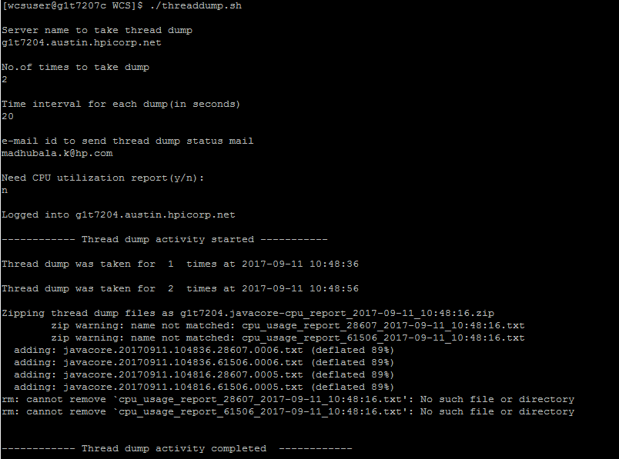

Please collect must gathers and report it to IBM for validation.

<http://www.ibm.com/support/docview.wss?uid=swg21115785>

**WebSphere Application Server Problems**

**MustGather: Read First for WebSphere Application Server (reference only):**

<http://www.ibm.com/support/docview.wss?uid=swg21145599>

Symptoms: High volume periods

**MustGather: Performance, hang, or high CPU issues with WebSphere Application Server on Linux:**

http://www.ibm.com/support/docview.wss?uid=swg21115785

Symptoms / Scenarios: High CPU, hang or performance problems

**Initial Analysis / Trouble shooting:**

* Check whether any specific job is running on the server which utilizes max cpu
* Collect must gather logs from the specific server and share it to dev team / IBM.

If the utilization is around 40 %( warning), check whether any job is utilizing the server’s CPU. Wait for 2 mins to see the utilization reduces or else report the problem.



**Monitor:**



**Support contact:**

* ETR-WCS-TCS [etr-wcs-tcs@hp.com](mailto:etr-wcs-tcs@hp.com)
* IBM via PMR

**Reports configured in sitescope**:



Monitor has been configured in sitescope to watch the CPU ulitzation and it will alert the group if the utilization reaches above 40%.

There is an automatic report been scheduled in sitescope, where we receive the min/max CPU usage for every hour.

Cron job to grep for “hung thread” message in system out log – use timestamp to alert on current event only)

Tools Used: Site Scope

**Note – We can pull historical CPU utilization report for all production servers from sitescope for cross comparison.**

# Ping / Proc alerts:

**Symptom:**

The server would not respond or the server would be down. An alert email will be triggered from sitescope when the server doesn’t respond.

**Initial Analysis / Trouble shooting:**

There could be wrong with the routers or the network is very busy. So when an alert received, ping the server and confirm.

There is a monitor configured in the sitescope, where it will monitor the ping / proc status for all the production servers.

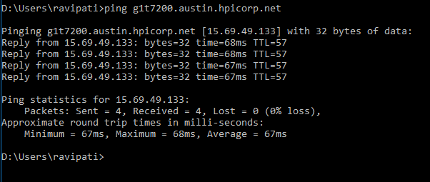

There are time, where the server may be went down. Immediately check and make the servers up and running. Or else raise a HPSM ticket to the unix team for the action and root cause.

To find the status of an application/IHS server, we can login in to the IBM console and check the status.

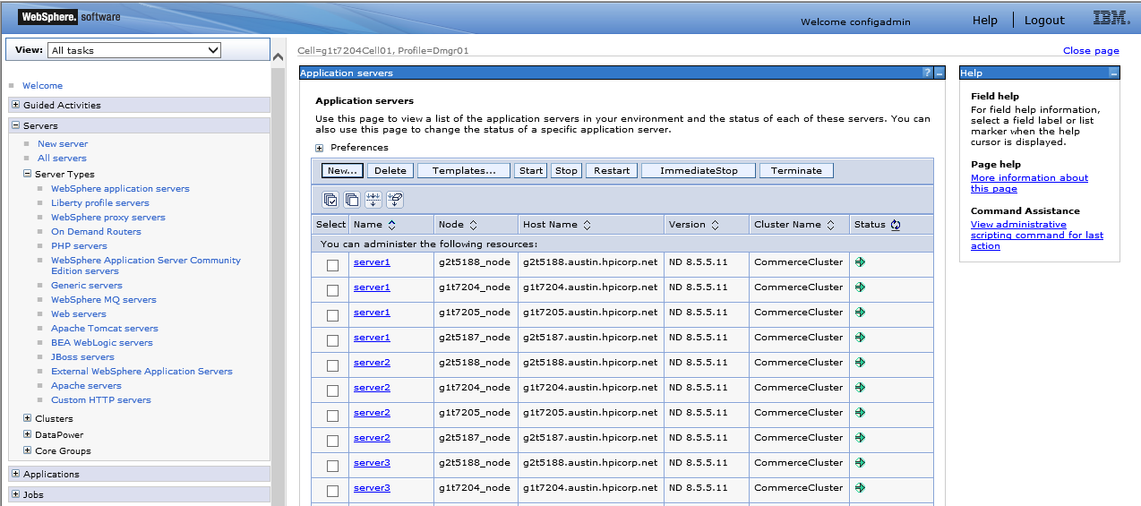

<https://g1t7204.austin.hpicorp.net:9043/ibm/console> Websphere Integrated Solution Console

**Support contact:**

* Raise HPSM ticket to UNIX support for the root cause.

Tools Used: Site Scope

# CPU Starvation:

**Symptom:**

The appserver will go down, when CPU starvation is detected. An alert email will be triggered from sitescope when the server doesn’t respond.

**Log collection-**

If the average cpu starvation reading by the monitor has been above 70% two times in a row, the log collection (linperf-performance.sh) will be triggered automatically to collect the must gather logs and it will be shared to Dev / IBM.

Please check App server SystemOut logs for CPU Starvation error messages.

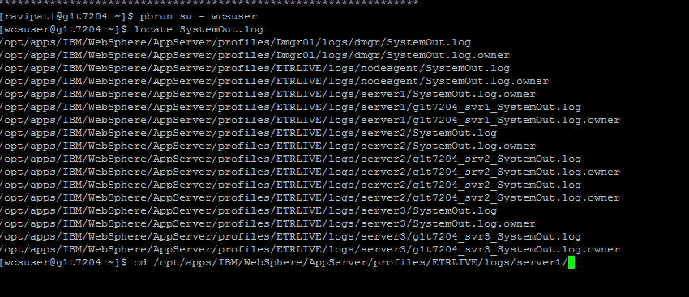

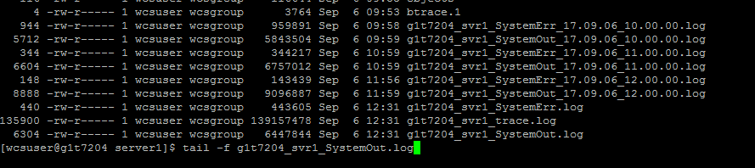

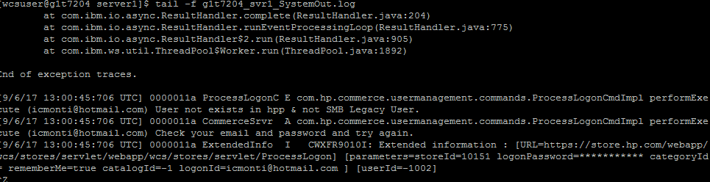

Monitor: Grep SystemOut logs for exceptions which could provide the exceptions regarding starvations.

Application server need to restart for this CPU starvation issue.

**Support contact:**

* ETR-WCS-TCS [etr-wcs-tcs@hp.com](mailto:etr-wcs-tcs@hp.com)
* IBM via PMR

Tools Used: Site Scope

# DB Table Space Issue & DB sql blockings:

**Symptom:**

We will get an email from sitescope, when the db tablespace reaches the threshold limit.

**Action:**

Drop mail to DBA team to add more space.

**Symptoms on DB blocking session:**

A cron job has been scheduled to monitor the blocking sessions in the production app servers.



**Action:**

Before killing the session, take high CPU MustGather / AWR & ADDM reports and share it to TCS DEV and IBM to analyze the issue.

**Note:** MustGather should be capture for all JVMs.

**MustGather: Performance, hang, or high CPU issues with WebSphere Application Server on Linux:**

http://www.ibm.com/support/docview.wss?uid=swg21115785

Symptoms / Scenarios: High CPU, hang or performance problems

**Support contact:**

* **IMAP POE GDBA DOC Oracle <** **imap.poe.doc.oracle@hp.com >**
* ETR-WCS-TCS [etr-wcs-tcs@hp.com](mailto:etr-wcs-tcs@hp.com)
* IBM via PMR

Tools: Pulse Check/Site Scope

DBPulsecheck - <http://databases.corp.hp.com/pulsecheck/(S(slucuhajikapq1c0eymskvfv))/default.aspx>

# ApproachingMaxClients:

**Symptoms:**

Site not responding / slowness, app server / IHS server might not respond.

When the servers are approaching maximum limit, the app servers and web servers need to be restarted. Connections are not being released which is why MaxClients is being reached.

<http://www.ibm.com/support/docview.wss?uid=swg21141306>

Suggestion from IBM:

IHS Max Clients issues are usually from a back end system not responding which causes more threads to wait.  It may not be useful to restart IHS without addressing issues in the back end systems.

Before restarting the web servers, an analysis of what modules the client threads are busy in should be done using mpmstats data (presuming mpmstats is loaded).  If mpmstats is not loaded, it should be **which would have to wait until after peak**.  It can provide critical data and historical load information.

**Action:**

Symptoms / Scenarios: Content from application server not displaying

* Monitor the Web container thread active per JVM
* No. of JDBC connections per JVM
* Monitor the response time -

**MustGather: Read First for IBM HTTP Server (reference only):**

http://www.ibm.com/support/docview.wss?uid=swg21192683

•**MustGather: Request failures accessing static content on IBM HTTP Server:**

http://www.ibm.com/support/docview.wss?uid=swg21666407

•Symptoms / Scenarios: Content in Web server layer (not application server) not displaying

•**MustGather: Request failures accessing WebSphere Application Server dynamic content through IBM HTTP Server:**

http://www.ibm.com/support/docview.wss?uid=swg21141306

Monitor: Greperror log for “reached MaxClients" or "approaching MaxClients“. Also, you can write a script to check for slow responses by defining a threshold, greppingon request ID and flagging any transaction that does not have a successful completion code within your defined threshold.

Run the below commands in the Arcsight server (g1t7207c.austin.hpicorp.net) to find out the busy threads.

/opt/apps/NFS/Pro/ETRLive/logs/WCS/IHS  
  
Run this is command in all IHS server directory,Replace the log file with previous date.   
  
grep "MaxClients" error_log.2017-07-28* | awk -v varTime="`date -d "now 24 hours ago" +"%a %b %d %H:%M"`" -F'[]]|[[]' \ '{ if ( $2 >= varTime ) print $0 }' |  awk -F[ '{print $2 $3}' | awk -F] '{print $1 $3}' | sort -k4 -nr   
  
grep "mpmstats: rdy" error_log.2017-07-28* | awk -v varTime="`date -d "now 24 hours ago" +"%a %b %d %H:%M"`" -F'[]]|[[]' \ '{ if ( $2 >= varTime ) print $0 }' | awk -F[ '{print $2 $3}' | awk -F] '{print $1$3}' | awk '$10>0' |  sort -k4 -nrs

_____________­­­­­­­­­­­------___________­­­­

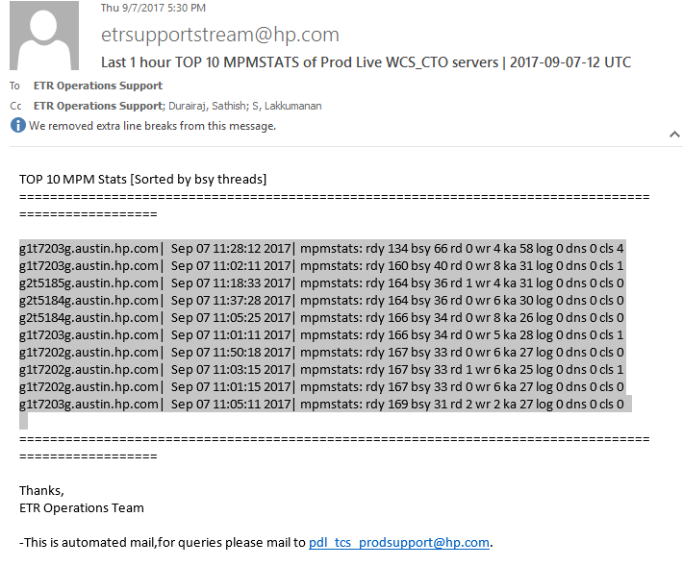



A script has been written to check the threshold and has been automated. When that reaches the threshold then the app servers and web servers needs to be restarted to release the ideal connections.

Monitor: Grep error log for “reached MaxClients" or "approaching MaxClients“. Also, you can write a script to check for slow responses by defining a threshold, grepping on request ID and flagging any transaction that does not have a successful completion code within your defined threshold.

**Support contact:**

* ETR-WCS-TCS [etr-wcs-tcs@hp.com](mailto:etr-wcs-tcs@hp.com)
* IBM via PMR

Tools: Site Scope

# Out of Memory Exceptions:

**Action:**

* Native_stderr.log
* Javacore
* Heapdump
* JVM core dump upon OOM (<https://developer.ibm.com/answers/questions/184986/how-can-i-manually-generate-javacores-on-websphere/>)

Tools: Site Scope

# Timed Out Exceptions:

<http://www.ibm.com/support/docview.wss?uid=swg21254645>

**Action:**

1. Does it happen for a specific operation? Has anything changed to that operation?
2. How much it takes in general for that operation to complete vs. transaction timeout?
3. Does it happen for all operation during a period of time? Is there a pattern when this happen?

That means server could be slow... then you want to take High CPU Must Gather

native_stderr.log

**Symptoms / Scenarios:** Database Connection timeout / failure

When there are db blocking sessions, we might get the time out exceptions. Please check for the automated alert emails on the db blocking sessions and kill the sql blockings.

Monitor: Cron job to detect errors when JDBC connections fail (“J2CA0045E” or “ConnectionWaitTimeoutException”) OR monitor number of JDBC connections and set alert threshold. Cron job to grep for “hung thread” message in system out log – use timestamp to alert on current event only)

**While enabling trace in production for any triaging activity, make sure the trace are enabled only during non-business hours or low traffic hours; so that it won’t affect the site. Enable trace in “Runtime” so that it won’t require server restart**

Tools: Site Scope

# Alert for LiveSiteURLs (30 sec error, 20 sec warn):

When a particular store url is taking long time to load, we will receive a sitescope alert.

This might be due connection timeout or a webserver might be down.

Particular web server is down. So would act to bring it back up. We raise a HPSM ticket against UNIX team to get the RCA.

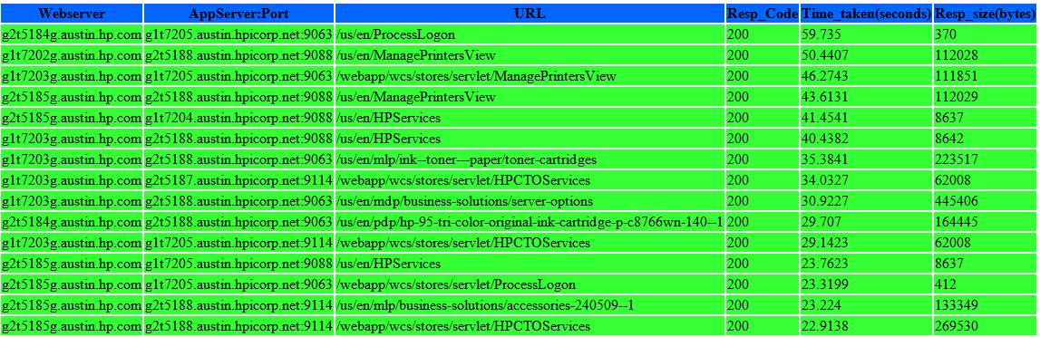

Will be receiving an automated mail attached above, which clearly describes the seconds taken to land the page.

Tools: Site Scope.

# Thread Monitoring:

Get the process Id which is running with more memory (Top running process) and convert the number to Hexadecimal and find in the thread dump. From that we can get the top running thread which is consuming more memory.

# **Disk Space Alert:**

**Symptom:**

An alert mail is set when the threshold reach 40%.



**Action:**

Have to clear the logs or archive it from opt/apps before reaching the actual threshold value 80%

Tools: Site Scope.

# PROD File:

**Symptom:**

We have a sitescope alert configured, when access_log or error_log didn’t generate for the current hour an automated email will be triggered for that.



**Action:**

The log file will be generated late by 5 to 10 mins in the server. For this issue we had changed the session interval from 600 to 60 in the httpd.conf file, so that there will not be gap in the log generation.

Even though after this change we are getting new alerts on this. These alerts will be generated only during non-business hours.

The below are the reason for the time delay.

If the lack of traffic on it is still causing it to not generate the modules

# OMS Agent Monitoring:

When we get a proc alert on a particular agent in the agent server, we should login in to the agent server check for that particular agent. If the agent is not running or stoped by case, need to start the agent.



cd /opt/apps/IBM/scripts

./startagents.sh <agentname>

Starting point for Sterling products

•**Sterling Selling and Fulfillment Suite (SSFS) List of MustGathers**: http://www.ibm.com/support/docview.wss?uid=swg21673807

Sterling Commerce Performance Problems

•**IBM Sterling Commerce -Performance MustGather**: http://www.ibm.com/support/docview.wss?uid=swg21614185

•Symptoms / Scenarios:

•Application / Agent / Integration Server Frozen or Non-Responsive

•Application / Agent / Integration Server Crashed or Shutdown

•Application / Agent / Integration Server Deadlocks

•Agent / Integration Server Very Slow or Backlog of messages

•DatabaseSlow Query Response

**•Sterling Performance Blocking** MustGather:http://www.ibm.com/support/docview.wss?uid=swg21670465

•Symptoms / Scenarios:

•All processesDatabase -Too many blocking locks

•All processesThread Dumps / Stuck Threads

**Sterling CPQ**

•Sterling Configure Price Quote MustGather:http://www.ibm.com/support/docview.wss?uid=swg21674326

•Symptoms / Scenarios:

•Problems with Configuration of Products (CTO)

•Problems with Visual Modeler (Dev Environment)

**Agent / Integration Servers (JVM)**

•Sterling Agent Error MustGather:http://www.ibm.com/support/docview.wss?uid=swg21674306

•Symptoms / Scenarios:

•Non Performance related problems

•Functionality Related issues

•Orders not getting released / scheduled

•Purge related problems

•Integration with backend systems Functional Problems

**OMS -Inventory Related RTAM Problems**

•Sterling RTAM MustGather:

http://www.ibm.com/support/docview.wss?uid=swg21674311

**OMS -Inventory Related Problems (Not RTAM)**

•Sterling OMS Inventory Related MustGather:

http://www.ibm.com/support/docview.wss?uid=swg21673613

•Symptoms / Scenarios: All

**OMS -Sourcing / Scheduling Problems (Application Server)**

•Sterling OMS Sourcing and Scheduling MustGather:

http://www.ibm.com/support/docview.wss?uid=swg21673605

•Symptoms / Scenarios:

•Orders not getting scheduled

•Not getting Order # / Errors with Orders

•Shipments not getting created

**Call Center for Commerce (Web Based)**

•Web Based Call Center Error Mustgather:http://www.ibm.com/support/docview.wss?uid=swg21675357

•Symptoms / Scenarios:

•Errors with Web Based Client

•Functional Problems with CCC

# Health Status Report:

We will get health status report of every server that has been configured in sitescope for every hour.

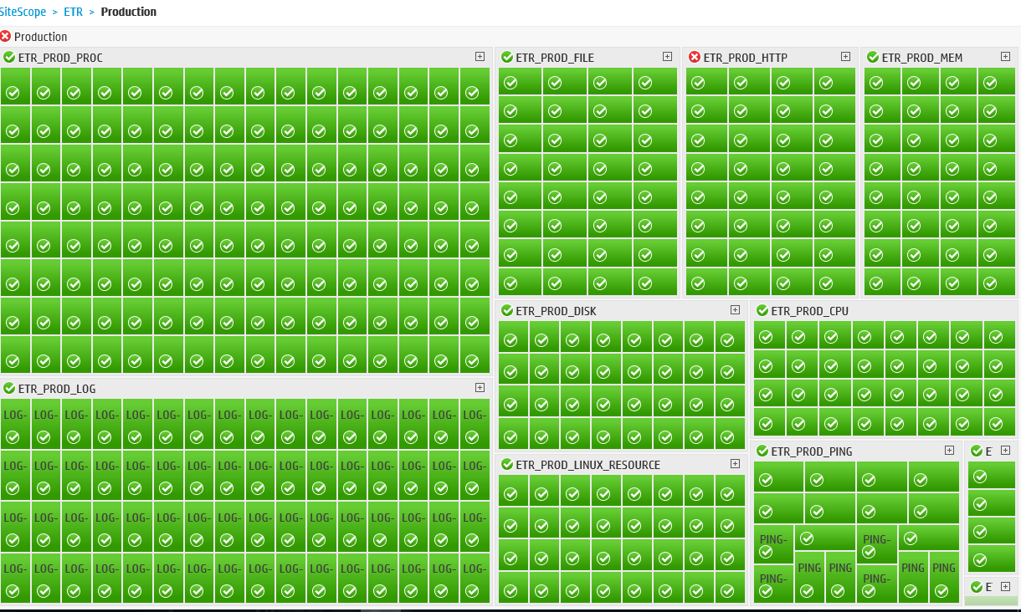

# Patching Process:

Patching is done through the hotfix tool which patches the files across all the respective servers in the cluster and sends an automated mail to the Prod Support PDL

Source Server- c9t27229.itcs.hpicorp.net

Location - /opt/apps/scripts

Scripts used - hotfix_multifile.sh , hotfix_singlefile.sh

Input file for running scripts- web_patches.txt, app_patches.txt

# **Ripple Start**:

Ripple start is triggered after stage propagation is completed during DLP jobs, configuration changes, DB changes and deployments

# Automated Dyna Cache clear in production stage:

The below caches will be cleared in prod stage automatically for every 15 mins.

**Clear baseCache,perfCache and Dm_Cache in : PRODUCTION STAGING**

<https://g1t7200.austin.hpicorp.net:9063/cachemonitor>

<https://g1t7200.austin.hpicorp.net:9088/cachemonitor>

<https://g2t5183.austin.hpicorp.net:9063/cachemonitor>

<https://g2t5183.austin.hpicorp.net:9088/cachemonitor>

# Dyna Cache clear in production Live :

On Request with only Approval if any featured products are not available in Prod Live.

<https://g1t7204.austin.hpicorp.net:9063/cachemonitor/>

<https://g1t7204.austin.hpicorp.net:9088/cachemonitor/>

<https://g1t7204.austin.hpicorp.net:9114/cachemonitor/>

<https://g1t7205.austin.hpicorp.net:9063/cachemonitor/>

<https://g1t7205.austin.hpicorp.net:9088/cachemonitor/>

<https://g1t7205.austin.hpicorp.net:9114/cachemonitor/>

<https://g2t5187.austin.hpicorp.net:9063/cachemonitor/>

<https://g2t5187.austin.hpicorp.net:9088/cachemonitor/>

<https://g2t5187.austin.hpicorp.net:9114/cachemonitor/>

<https://g2t5188.austin.hpicorp.net:9063/cachemonitor/>

<https://g2t5188.austin.hpicorp.net:9088/cachemonitor/>

<https://g2t5188.austin.hpicorp.net:9114/cachemonitor/>

CTO Live:

<https://g1t7194.austin.hpicorp.net:9443/cachemonitor/>

https://g2t5177.austin.hpicorp.net:9443/cachemonitor/

**Alternative approach scripts were implemented**:-

Source Server- g1t4723c.austin.hpicorp.net (Jobserver)

Location - /opt/apps/scripts/DynaCacheClearance/

Scripts used - CacheClearance_Live.sh

Running these scripts will clear dynamic cache for WCS Live servers.   
mail will be sent to pdl-et-ops-support@hp.com

# SOLR Indexing / SOLR core check:

During business everyhour, delta solr index is scheduled run for every one hour.

Also adhoc delta solr index would be run upon business request.

 

On every successful completion of the solr index, we would get notification email. we would also get the solr core count during solr index run.

Live : <http://g1t7195.austin.hpicorp.net:9083/solr/admin/cores>

<http://g2t5181.austin.hpicorp.net:9083/solr/admin/cores>

Stage : <http://g1t7198.austin.hpicorp.net:9084/solr/admin/cores>

<http://g2t5178.austin.hpicorp.net:9084/solr/admin/cores>

**SOLR index trouble shooting:**

* Monitor the index file size
  + Fix is to do the full index

MustGather: Search Runtime related issues for WebSphere Commerce V8.0 http://www.ibm.com/support/docview.wss?uid=swg21669528

•NOTE: Always check configfiles to make sure they are current and correct

•Symptoms/Scenarios and Monitor; issues with:

•di-preprocess

•Anytime when preprocess exits with non-zero exit code. In other words, you should collect MustGatherwhenever you do not see di-preprocess complete with Program exiting with exit code: 0. Data import pre-processing completed successfully with no errors from WC_installdir\logs\wc-dataimport-preprocess.log

•di-buildindex

•Anytime when preprocess exits with non-zero exit code. In other words, you should collect MustGatherwhenever you do notsee di-buildindexcomplete with Data import process completed successfully with no errors from WC_installdir\logs\wc-dataimport-buildindex.log

setupSearchIndex: Check working_dir/search/log/wc-search-index-setup.log with errors (i.e. with exit code other than 0).

•Indexprop

•Check WC_installdir\logs\wc-indexprop.log with errors (i.e. with exit code other than 0). Index holding different data across staging environment and production environment.

•UpdateSearchIndex

•Status of UpdateSearchIndexScheduler job indicates failure, checked either through WCS Admin Console or SCHSTATUS database table Items involved in emergency update does not have corresponding data in index updated

# Akamai Cache:

During DLP load, after the prod live restart we would clear the Akamai cache to reflect the new changes.

The clear would be triggered from the luna control center.

The below CP codes would be cleared.

274723 - HP store ion

275961 - Store.hp.com Mobile

288763 - cto.store.hp.com

We would receive notification from Akamai on the successful cache clear.



* After AMS 8.0 Akamai cache has been automated in DLP Jobs,

Where a dependency file is needed to start the process post stage propogation,

In /opt/apps/PDHDataLoad/signals location of g1t4723c.austin.hpicorp.net we have to touch a file ServerRestart*.done

Where Akamai flush will be carried out and a mail will be sent to PDL-TCS-INTERNAL-PRODSUPPORT & ETR DLP DEV Team.

We would receive notification from Akamai on the successful cache clear.



# WCS Stage and LIVE URL Details

|  |  |  |
| --- | --- | --- |
|  | WCS WAS Console | <https://g1t7204.austin.hpicorp.net:9043/ibm/console> |
|  | WCS Admin Console | <https://g1t7202g.austin.hpicorp.net:8002/adminconsole> |
| WCS-Live | OrgAdmin Console | <https://g1t7202g.austin.hp.com:8004/orgadminconsole> |
|  | Management Center | <https://glbecom-int.houston.hp.com:8000/lobtools/> |
|  | HP US Store URL | <http://glbecom-ext.austin.hp.com/us/en> |
|  |  |  |
|  |  |  |
|  |  |  |
|  | WCS WAS Console | <https://g1t7200.austin.hpicorp.net:9044/ibm/console/secure/securelogon.do> |
|  | WCS Admin Console | <https://g1t7197g.austin.hpicorp.net:8002/adminconsole> |
| WCS-Stage | OrgAdmin Console | <https://glbecom-edit-web.austin.hp.com:8000/lobtools/> |
|  | Management Center | <https://g1t7197g.austin.hpicorp.net:8004/orgadminconsole> |
|  | HP US Store URL | [http://glbecom-edit-web.austin.hp.com](http://glbecom-edit-web.austin.hp.com/) |
|  |  |  |

# Backup Strategy:

DB : DB backup is taken during MTP. The schema level backup is triggered for the components –WCS,CTO, OMS and WESB.

Also there would be weekly, daily and incremental backup is been scheduled from DBA side on all the db schemas.

Index backup: Index backup is taken before the solar index and stage propagation run in Prod Stag and Live respectively.

EAR backup: Before deployments of the components, the EAR is backed up for WCS, CTO, WESB and OMS.

# Application / DB Restoration:

DB: DB would be restored from the schema level backup

Components: Components will be restored from the backedup EAR.

# Frequently used Order Status in WCS and OMS

|  |  |
| --- | --- |
| WCS Order Status and Description | |
| Order Status | Description |
| H | Failed Order. |
| P | Pending: The customer can modify this order/ Still in cart. |
| M | The customer has initiated payment. Authorization is pending. |
| Y | The order is a private requisition list. |
| X | The order has been canceled. |
| J | Junk or Deleted Order. |
| F | The order is ready for fulfillment |

|  |  |
| --- | --- |
| OMS Order Status and Description | |
| Order Status | Description |
| 1100 | Created |
| 1500 | Scheduled |
| 3300 | Sent To Node |
| 3700 | Shipped |
| 3700.100 | Shipment Line Invoiced |
| 9000 | Cancelled |
| 1000 | Draft Order Created |
| 3950 | Receipt Closed |
| 1100.20.ex | Return Lost/Stolen |
| 3950.01 | Transfer Order Invoiced |
| 1300 | Backordered |
| 3200 | Released |

**Server Details of Production:**



# Architecture diagram:



PMR Approach Details:

Figure 1 Quick Reference Guide1PMR

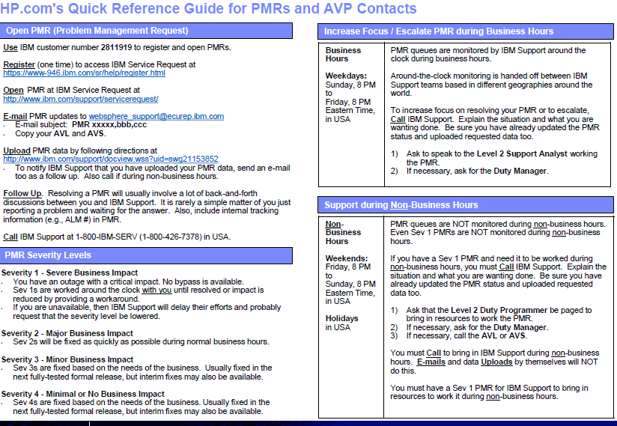

Figure 2 Quick Reference Guide1PMR

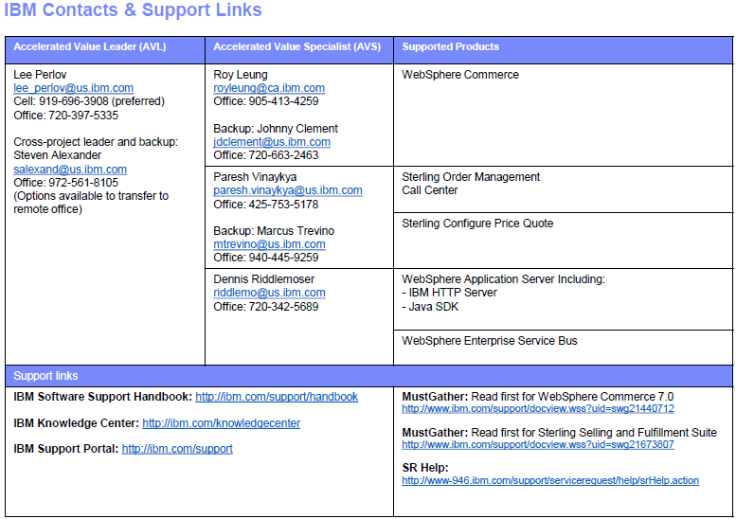

**Automated job to upload logs to PMR (IBM FTP location):**

Server: Arcsight (g1t7207c.austin.hpicorp.net)

Location: /opt/apps/scripts/WCS

Script: SCP2PMR.sh

FLOW: ( Sample screenshot from version 7)

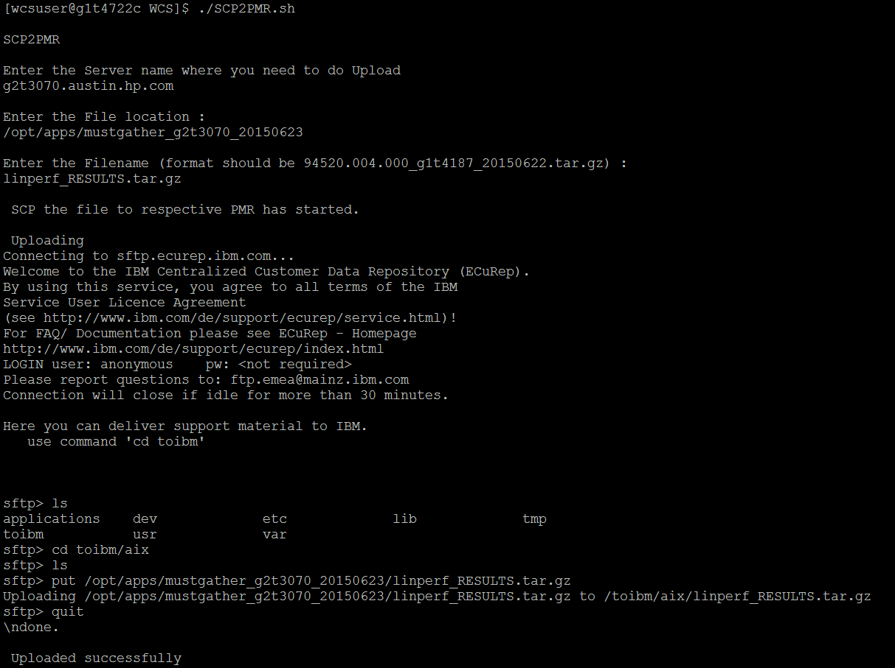

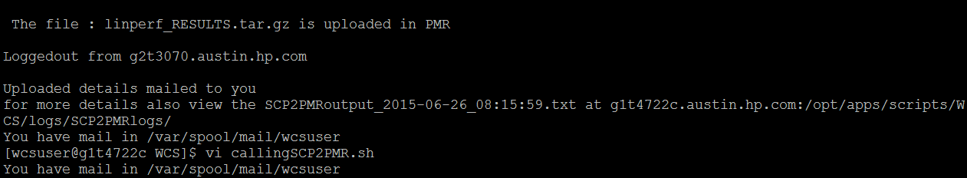

Mail:

From: [SCP2PMR_Automated@hp.com](mailto:SCP2PMR_Automated@hp.com) [<mailto:SCP2PMR_Automated@hp.com>]   
Sent: Friday, June 26, 2015 1:54 PM  
To: C, Moulidharan  
Subject: The Respective logs /opt/apps/mustgather_g2t3070_20150623 linperf_RESULTS.tar.gz from the server g2t3070.austin.hp.com is uploaded to PMR successfully

# **Risk of Delta Propagation:**

1. Accidental propagation of additional content from the delta run.  While we perform validation across common browse pages, there is a potential for content leak in the below cases:
   1. If there is a content scheduled for time basis during the middle of the day (mostly eSpot), the change will be propagated to live which may cause dead links.
   2. If there are any other content changes from any team, then those changes will also be propagated to Live.
   3. If there are any new products that are scheduled for next business day (i.e. Christmas), the content will be propagated to Live.
2. Server overload during business hours.
   1. For changes to be reflected in Live the Prod Live Dyna and DM cache have to be cleared. This increases the load on CPU by 50-70% higher.
   2. Akamai cache has to be cleared – If it is pointed (like home page), then no impact. But, if full Akamai has to be cleared, then it will cause server load to increase by 50% (approximately)
3. Potential for propagation issues with Index and Data:
   1. Index corruption or additional data triage. (see risks/rollback steps below)

**Delta Propagation MTP process summary:**

* Complete necessary changes in Stager including SOLR index run, dynacache flush, DM cache flush and QA validation.  Finalize if Akamai pinpoint or full flush is required.
* Take a backup of Live SOLR index (10 min)
* Query the staglog table from stager and find the tables that will be changed during the stage to live propagation. Take a table level back up of those tables within prod live database (20-25 min)
* Run Delta propagation (Data and then Index) from Stager to Live (approx. 20 mins – time dependent upon data volume at 0.5 Million records / minute + 20 min of data preprocess time)
* Clear the Cache
  + Clear DM and Dynacache
  + Clear Akamai cache as needed (pinpoint or full)
* Validation by QA/Production Support and business teams
* RISKS: Roll back steps if required:
  + Restore backup of Live index (approx. 20 mins)
    - If a full index run is required due to corruption, then it will take approx. 2 hours and site will be unstable with periodic link issues.

For data changes, restore the tables from the delta backup taken (Approx. 20-25 min) – During this time, site will be unstable as most changes affect catalog tables which is delivering the pages across browse site

# Partial Stop of WCS servers

Storefront is UP and There is no Performance or Blocking Issues- Live Sanity too Successful.

Application is working Fine

As part of DLP, when we are tried to do restart (Stop & Start) the Live App Servers, It shows below exception and couldn’t able to stop.

ADMU0111E: Program exiting with error:

com.ibm.websphere.management.exception.AdminException: ADMU3060E:

ADMU3028I: Conflict detected on port 9065.  Likely causes: a) An instance of the server server1 is already running b) some other process issuing port 9065

* On checking in Console, it shows the status as (Partial stop) and faced the same AdminException (below said) when we tried to restart the servers.
* Also, Cache monitor is not working for one port (9063/9088)
* RTAM Scheduler is not running.

But the Servers are running fine in background check (ps –ef | grep java)

            As discussed with Srikanth and RM Team, came to know that they faced similar issue in Lower Environment and to resolve that, they did a Clean Restart.

Related PMR - 30129,004,000

Related IM - IM19652547

**Understanding server process:**





Parent ID of the jvm should be node agents’s Process ID.

1001 is PID of Server1 jvm

29125 is Parent ID of Server 1 jvm (ie., Node agent’s PID)

But, during the issue, the Parent ID of jvm change to some other number (which means, Demon thread is running) – This is the procedure to identify the issue.

**Solution:**

Hence, we need to kill the PID of jvm and Start the jvm through console.

1. Open the WAS console to monitor the start/stop.
2. ps -ef | grep java | grep jvm
3. Kill -9 JVM’s PID 🡪 ex: Kill -9 1001
4. See the Stop status in Console.
5. START through WAS console.
6. Monitor the SystemOut.log for log rotation
7. Check the Cache monitor is whether Accessible or not for the affected port.
8. If above said everything is fine, it is good.

Note: Always do manually check the servers are stopped before restarting the server

# PGS Failover:

Once PGS failover is happened after confirmation from PGS team we have to restart all jvms of wcs app servers.

# PRE-MTP SERVER CHECKS:

Pre-MTP server check gives you a server health status, disk space and SSH connectivity between build server and prod servers.

**For Stage**: g1t7207c.austin.hpicorp.net -/opt/apps/scripts/

./ServerChecks.sh stage

**For Live**: g1t7207c.austin.hpicorp.net -/opt/apps/scripts/

./ServerChecks.sh live



# AUTOFS configuration for CTO clients

During the downtime for fail over tests related to US HHO ETR holiday readiness, we enabled and tested the custom NFS automation scripts successfully on CTO servers. Few fail over tests were performed and the package was left running at g1 per Tony’s preference. This cluster is now capable of performing site to site NFS package fail overs with minimum manual intervention on NFS clients. Attached are automated email notifications that were sent during the activity.

These emails are currently configured to be sent to “ETR Operations Support” and “PDL-TCS-INTERNAL-PRODSUPPORT” PDLs. During every package fail over, two emails will be sent. First email will intimate the distribution of a fail over in progress. No action is necessary on this. The second email is a report of the remount activity on clients. It will have information about nodes that may not have succeeded in mounting all mounts with a list of such nodes and mount points. Please do note that intermittent failure on one or two mounts or hosts is normal. Support team should first check the notification email and if required, log a ticket to UNIX support (follow standard process) for action on failures.

A word about autofs: All clients were configured to use autofs replacing persistent mount. Autofs mounts the file system when an access request is received and unmounts it when no access is performed for a while. On a client that is not using these NFS mounts frequently, ‘df’ command may not show them mounted. In order to verify, one needs to switch to the folder (cd /nfs mount path), which will cause autofs to mount the file system. Subsequently ‘df’ command will show it as mounted. This action/check should be included in any troubleshooting documents the application support teams might have.



# MTP Deployment Procedures for WCS, WESB, CTO/VM and OMS:

During MTP, Please Follow the below steps:

1. Model Copy job disable & HP folder Removal (Patches get deleted after deployment)

2. DB Backup

3. EAR Backup

4. Pre-Deployment activities (if any)

5. Maintenance page Enable (If approval)

6. Deployment (WCS, WESB, OMS, CTO/VM)

7. Maintenance page Disable (If approval)

8. Post- (if any)

9. Hotfix Patches Deployment activities (if any)

10. QA signoff

Please refer the below document for complete MTP procedures. 

**MI Approach Details: -**

Please find below attached document to raise major incident for huge impact on applications (ETR Side).



# Proxy cache clear:

If we face the Oops page on the browser even after clearing the Akamai cache, we need to clear the cache at Proxy server side. This was noticed during load test in UAT-2.

Clear the DNS and object cache of all the proxies below (For UAT-2 Environment):

txe01hpics301.austin.hp.com

The VIP for all the proxies above is web-proxy.austin.hpicorp.net:8080.

**Note:** The proxy hosts might be different for each environment

A way of checking if we have a bad content on the proxies above, try using proxy-txn.austin.hpicorp.net:8080 and test. If it works it means the proxies above have bad content on cache.

To contact the Proxy team for clearing the Proxy cache, raise the IM ticket to the following AG with the LB and proxy details.

**HPSM AG:** W-INCLV3-ITIO-GT-IPSFW

# Pinpoint Tool Triaging:



# S2S Failover:



**Script to find and cleanup multiple catgroups for catentries in master catalog:**

Please use below select query to find products which have multiple catgroups in master catalog.

SELECT catentry_id,

catgroup_id,

RANK() OVER (PARTITION BY catentry_id ORDER BY lastupdate DESC nulls last) AS row_num

FROM catgpenrel

WHERE catalog_id = 10001

AND catentry_id IN

(SELECT catentry_id

FROM catgpenrel

WHERE catalog_id = 10001

GROUP BY catentry_id

HAVING COUNT(catentry_id) > 1

)

ORDER BY catentry_id;

**NOTE: Requesting you to take backup of this data before cleaning up.**

**Use below delete query to cleanup those in database.**

DELETE

FROM catgpenrel

WHERE catalog_id = 10001

AND (catentry_id, catgroup_id) IN

(SELECT catentry_id,

catgroup_id

FROM

(SELECT catentry_id,

catgroup_id,

RANK() OVER (PARTITION BY catentry_id ORDER BY lastupdate DESC nulls last) AS row_num

FROM catgpenrel

WHERE catalog_id = 10001

AND catentry_id IN

(SELECT catentry_id

FROM catgpenrel

WHERE catalog_id = 10001

GROUP BY catentry_id

HAVING COUNT(catentry_id) > 1

)

ORDER BY catentry_id

)

WHERE row_num>1

);

COMMIT;

# HP Support contact details:

|  |  |
| --- | --- |
| **Team** | **Assignment Group** |
| PGS | W-INCFLS-HPIT-RHYTHM-APPLICATIONS |
| PGS | W-INCLV3-HPIT-BLUES-APPLICATIONS |
| NDQ | W-INCFLS-HPIT-RHYTHM-APPLICATIONS |
| TCS | W-INCLV4-PPSIT-HPCOM-TCS |
| SAP | W-INCFLS-ESAPS-GSCS-AMOS |
| DLP / PDH | W-INCLV4-EES-ENFINITY-PRODUCT-HUB |
| HERMES PDB | W-INCFLS-PPSIT-GEMTECH-MKTENG |
| Networks | N-INCFLS-HPIT-NW-DATA |
| MW | W-INCLV4-ESAPS-GSCS-AMSS-NONSAP |
| UNIX | W-INCFLS-HPIT-RHYTHM-INFRASTRUCTURE |
| Oracle DBA | W-INCLV3-DC-DB-ORACLE |
| Unix | W-INCFLS-HPIT-LINUX |
| VSM security (access issue) | W-INCFLS-HPIT-SECURITY-VSM |
| Unix security  (access issue) | W-INCFLS-HPIT-SECURITY-UNIX |
| Windows security  (access issue) | W-INCFLS-HPIT-SECURITY-WINDOWS |
| Tidal (job status change request) | W-INCFLS-HPIT-RHYTHM-APPLICATIONS |
| SAP | W-HPE-INCFLS-ESAPS-GSCS-PLATFORM |
| Tidal Engineering | W-INCLV4-TIDAL-ENGINEERING |
| Autofs & NFS mounts | [P, Anoop (AH - Deep Support) [mailto:anoop.p@hpe.com]](mailto:anoop.p@hpe.com) |