* Check for **Price.txt and EtilizeSkuFile** file (in current date) in the below location,

**cd /opt/apps/PDHDataLoad/archive/import/etilize/** (should check in g1t4723c.austin.hpicorp.net)

**Screenshot FYR**(taken in 4181 v7 app server)

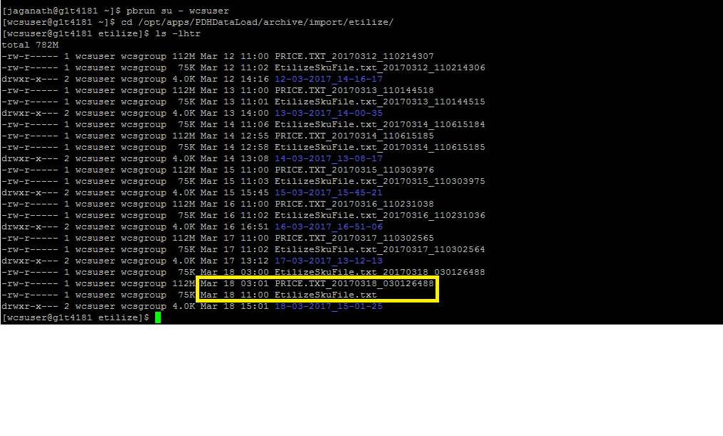

* Once you found the file, copy that file in the below location,

**/home/wcsftp/data/etilize/eligible_skus/**

Using the following command,

Scp EtilizeSkuFile.txt_20170318_030126488 PRICE.TXT_20170318_030126488 [wcsftp@g1t4723c.austin.hpicorp.net:/home/wcsftp/data/etilize/eligible_skus/](mailto:wcsftp@g1t4723c.austin.hpicorp.net:/home/wcsftp/data/etilize/eligible_skus/)

* Once the file is copied, check that file in the copied location for verification and then re-trigger the job.

To login as wcsftp, ssh wcsftp@g1t4723c.austin.hpicorp.net

g1t4723c.austin.hp.cpm