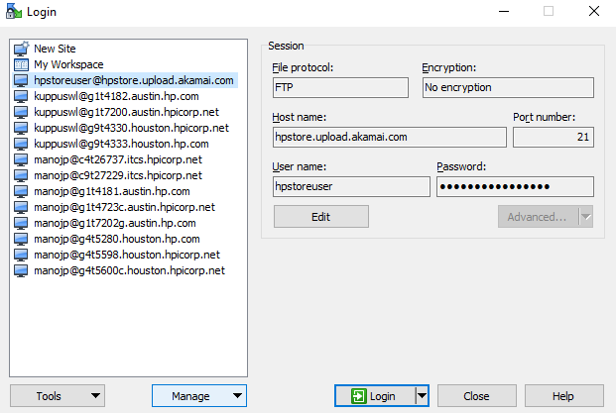

Password: ETR123!

Navigate to /249658/vp/us

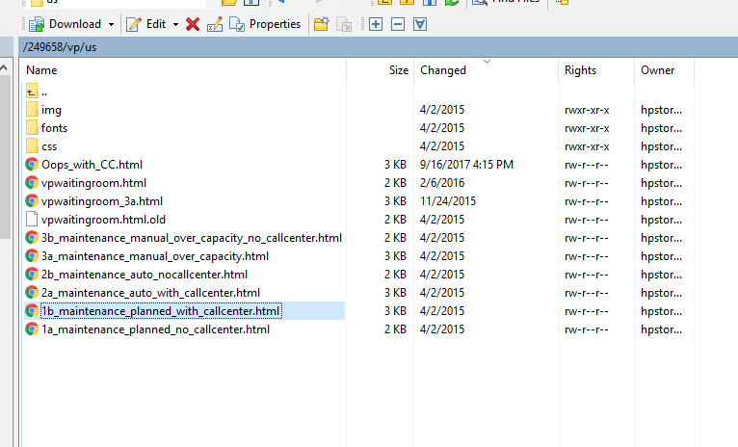

You can find various templates for the maintenance page.

Eg

1a_maintenance_planned_no_callcenter.html – This template will have no call center number, we can use this when we bring the entire site down for any MTP or maintenance.

1b_maintenance_planned_with_callcenter.html – This template will have call center number, we can use this when we need to redirect the traffic to call center.

3a_maintenance_manual_over_capacity.html – when there is more traffic to store, we can use this for redirecting customers to call center.

you download the /249658/vp/us directory to your local and open the html files and you can understand the templates and its purpose when to be used.

**Bringing up the maintenance page:**

vpwaitingroom.html – this is the original file. You must rename the templates which is available under /249658/vp/us as (vpwaitingroom.html)

Eg.

If you need to put the maintenance page with call center (1b_maintenance_planned_with_callcenter.html) – you need to re-name this html as vpwaitingroom.html and bring up the maintenance page from Akamai (normal process).

Before renaming the file, please take the backup.

**Note**- Do not change the file directly in the ftp site. Instead rename the files which you downloaded to your local directory and then push the files.

Change the below files in your local directory

Step1 : vpwaitingroom.html to vpwaitingroom_backup09262017.html

Step2 : 1b_maintenance_planned_with_callcenter.html to vpwaitingroom.html

Open winscp and push the files to /249658/vp/us