**RTAM –Inventory Processing Procedure:**

**OMS:**

1. **STO feed from SAP** -

Note: File will arrive between 3 am to 6 am PST (i.e. Latest by 7:30 PM IST).

**Pre-Validation :( Apps Team)**

Select count(*) from ssfs_admin.yfs_inventory_supply_temp where inventory_supply_temp_key>'**yyyymmdd**'

*Take count before load*

Select count(1) from ssfs_admin.yfs_inventory_alerts where modifyuserid='HPRTAMOP3'and modifyts>sysdate - **30**/1440;

**30** -in minutes

Select count(1) from ssfs_admin.yfs_inventory_alerts where modifyuserid='HPRTAMOP3' and createts>sysdate - 30/1440;

**Process: (Ops Team)**

Login- OMS agent server-g1t4182.austin.hp.com

* + - 1. Check todays file (eg: InventorySyncSTO_20141211.xml.done) inside /opt/apps/invSync/file/comp folder
      2. Take a copy of InventorySyncSTO_20141211.xml.done file to /tmp directory,
      3. mv InventorySyncSTO_20141211.xml.done InventorySyncSTO_20141211.xml
      4. vi InventorySyncSTO_20141211.xml
      5. Search for the pattern Quantity="NaN" and replace it with Quantity="0" (value zero)

*Search term -* “Quantity="NaN"” *Edit it server itself*

* + - 1. save the file
      2. Move the file from /tmp to /opt/apps/invSync/file/in
      3. The file will then automatically move to cd opt/apps/invSync/file/ comp folder if it has no errors.

**Post -Validation (Apps Team)**

**After STO Load**

1. The data in xml should be reflecting in the **yfs_inventory_supply_temp** table after load gets completed

Select count(*) from ssfs_admin.yfs_inventory_supply_temp where inventory_supply_temp_key>'**yyyymmdd**'

*The difference in count before and after load give you the count of data in xml*

Select count(1) from ssfs_admin.yfs_inventory_alerts where modifyuserid='HPRTAMOP3'and modifyts>sysdate - **30**/1440;

*We get the count updated after load and we should be getting more count after load*

**30** -in minutes

Select count(1) from ssfs_admin.yfs_inventory_alerts where modifyuserid='HPRTAMOP3' and createts>sysdate - 30/1440;

*Ideally it would be zero, if we get any new products it will get updated with the entries*

1. Take any five items from the STO file (InventorySyncSTO_20141211.xml) and check it in **yfs_inventory_Supply_Temp**

Eg: Select * from ssfs_admin.yfs_inventory_supply_temp where item_id in ('RY8949','NZ5447','Y94529','CN4723','VM2998','LC6028','QM4336');

1. Compare the quantity obtained from the result of the query to the SAP feed which is in file (InventorySyncSTO_20141211.xml). **The quantities should match**
2. After some time the inventory from **yfs_inventory_supply_temp** table should move to **yfs_inventory_Supply** table.
3. Take the **inventory_item_key** of the items corresponding to the above selected partnumber (which we used in fetching records of yfs_inventory_Supply_Temp table step 1) and compare it in **yfs_inventory_supply** using the below query.

Eg: SELECT * FROM ssfs_admin.yfs_inventory_supply where inventory_item_key in ('2014100115220125211529', '2014091617170415802574', '2014111812391562690134');

1. **3PP FULL Feed from INGRAM**

***Note: Time gap for the STO and 3PP full Load should be minimum 0f 20 mins***

**Pre-Validation: (Apps Team)**

Select count(*) from ssfs_admin.yfs_inventory_supply_temp where inventory_supply_temp_key>'**yyyymmdd**'

*Take count before load*

Select count(1) from ssfs_admin.yfs_inventory_alerts where modifyuserid='HPRTAMOP3'and modifyts>sysdate - **30**/1440;

**30** -in minutes

Select count(1) from ssfs_admin.yfs_inventory_alerts where modifyuserid='HPRTAMOP3' and createts>sysdate - 30/1440;

**Process: (Ops Team)**

**Please follow the above same steps for 3PP HP_Inventory_Full (3PP file)**

eg: HP_Inventory_Full_12112014-00.xml

In addition to that, have to check the duplicate entries in the file. If found, have to remove those records. (**Edit only with notepad or notepad++ not with Excel)**

**Very Critical Step:**

**Replace YantraMessageGroupID="USDC01-" to YantraMessageGroupID="USDC01-timestamp"**

Eg:

**<Inventory ApplyDifferences="Y" CompleteInventoryFlag="N" ReasonCode="" ReasonText="" ShipNode="USDC01" ValidateItems="Y" YantraMessageGroupID="USDC01-20141214">**

We need to copy HP_Inventory_Full_12112014-00.xml to local computer, remove duplicate entries if any and copy back to server

*Note: mode of transfer of file should be* ***binary*** *through* ***WINSCP***

**Post -Validation (Apps Team)**

**After Full Load**

1. The data in xml should be reflecting in the **yfs_inventory_supply_temp** table after load gets completed

Select count(*) from ssfs_admin.yfs_inventory_supply_temp where inventory_supply_temp_key>'**yyyymmdd**'

*The difference in count before and after load give you the count of data in xml*

Select count(1) from ssfs_admin.yfs_inventory_alerts where modifyuserid='HPRTAMOP3'and modifyts>sysdate - **30**/1440;

*We get the count updated after load and we should be getting more count after load*

**30** -in minutes

Select count(1) from ssfs_admin.yfs_inventory_alerts where modifyuserid='HPRTAMOP3' and createts>sysdate - 30/1440;

*Ideally it would be zero, if we get any products it will get updated with the entries*

1. Take any five items from the Full file (HP_Inventory_Full_12112014-00.xml) and check it in **yfs_inventory_Supply_Temp**

Select * from ssfs_admin.yfs_inventory_supply_temp where item_id in ('RY8949','NZ5447','Y94529','CN4723','VM2998','LC6028','QM4336');

1. Compare the quantity obtained from the result of the query to the SAP feed which is in file (InventorySyncSTO_20141211.xml). **The quantities should match**
2. After some time the inventory from yfs_inventory_supply_temp table should move to yfs_inventory_Supply table.
3. Take the **inventory_item_key** of the items corresponding to the above selected partnumber (which we used in fetching records of yfs_inventory_Supply_Temp table step 1) and compare it in **yfs_inventory_supply** using the below query.

SELECT * FROM ssfs_admin.yfs_inventory_supply where inventory_item_key in ('2014100115220125211529', '2014091617170415802574', '2014111812391562690134');

**API Tester (Ops Team)**

If records not get updated in yfs_inventory_supply or CSV is not generated in latest time stamp in WESB server, then go to the starting of the file (eg: InventorySyncSTO_20141208.xml) and **take** the below lines (First line of the screenshot) and paste it in the API tester.

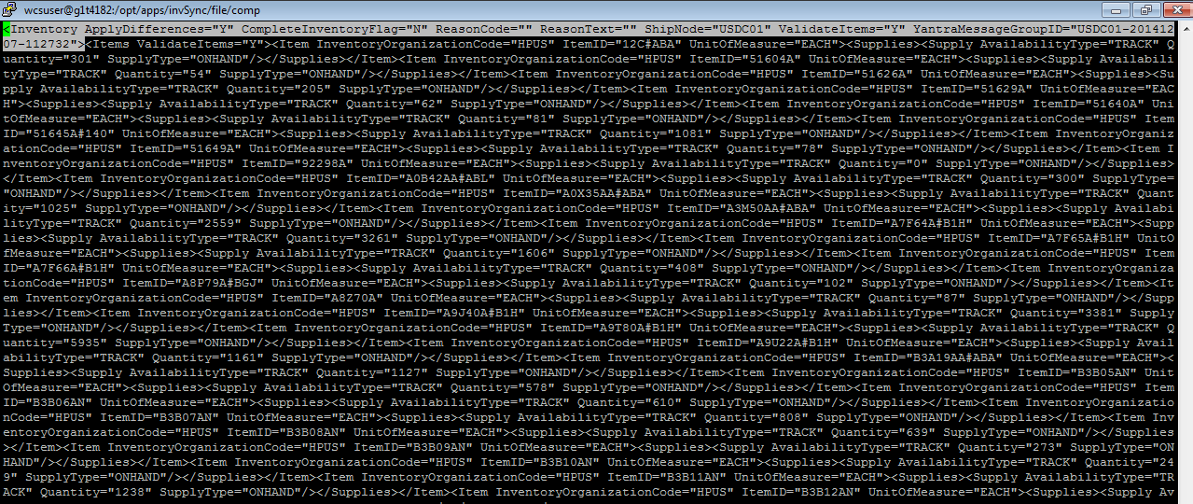

**<Inventory ApplyDifferences="Y" CompleteInventoryFlag="N" ReasonCode="" ReasonText="" ShipNode="USDC01" ValidateItems="Y" YantraMessageGroupID="USDC01-20141210-121230"/>**

Add **“/”** at the end of the above xml when we putting it under message box in API Tester

**Open API tester in Chrome (for easy usability)**

**API tester: ------API name: syncLoadedInventory**

1. URL- [**http://glbecomtran-sterling.austin.hp.com/smcfs/yfshttpapi/yantrahttpapitester.jsp**](http://glbecomtran-sterling.austin.hp.com/smcfs/yfshttpapi/yantrahttpapitester.jsp)

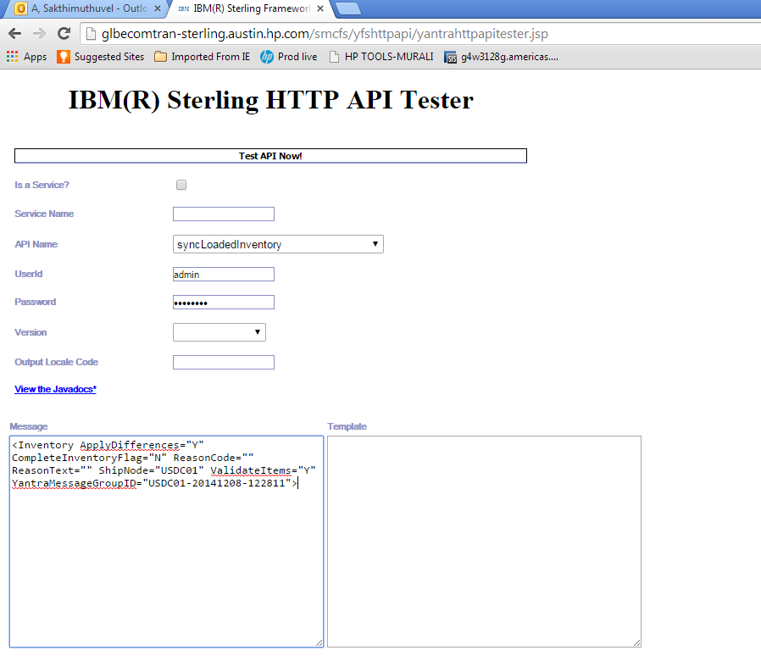

After this please check yfs_inventory_Supply table the values will get updated. And check if CSV gets generated (WESB).

Negative Scenario:

If the .CSV is not generated, please follow the below steps to get the file…

Log into the IBM Application console. http://glbecomtran-sterling.austin.hp.com/smcfs/console/order.list

Credentials: admin/password

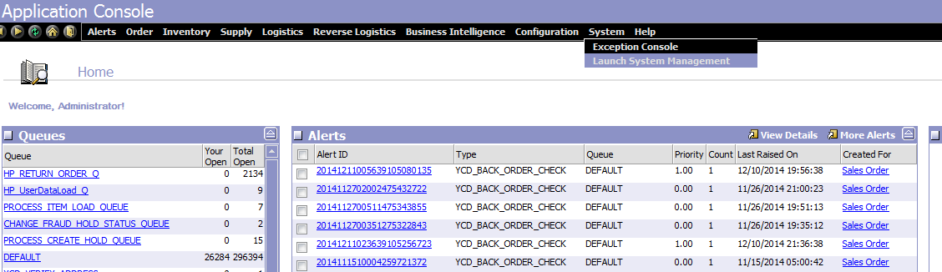

If you do not find valid numbers after running the queries then go to System Management, goto “View Live Agents Server”, choose all threads of the inventory related agents like HPInvMismatch, HPLoadInvMismatchFileServer and HPRTAMOP3 and then “suspend” and “resume” them.

Note:Please ignore if HPRemorseAgentServer is suspended, which is not related…

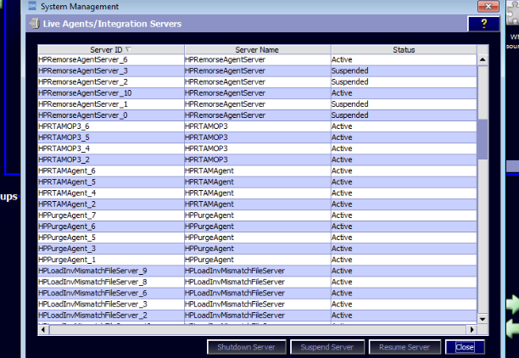

API Tester URL: <http://glbecomtran-sterling.austin.hp.com/smcfs/yfshttpapi/yantrahttpapitester.jsp>

Then use this input xml :

<TriggerAgent BaseTransactionId="" CommitOnParent="" CriteriaId="REALTIME_ATP_MONITOR_OP3" ProcessType="GENERAL" /> and fire triggerAgent API explicitly .

NOTE: API Name: trigger Agent

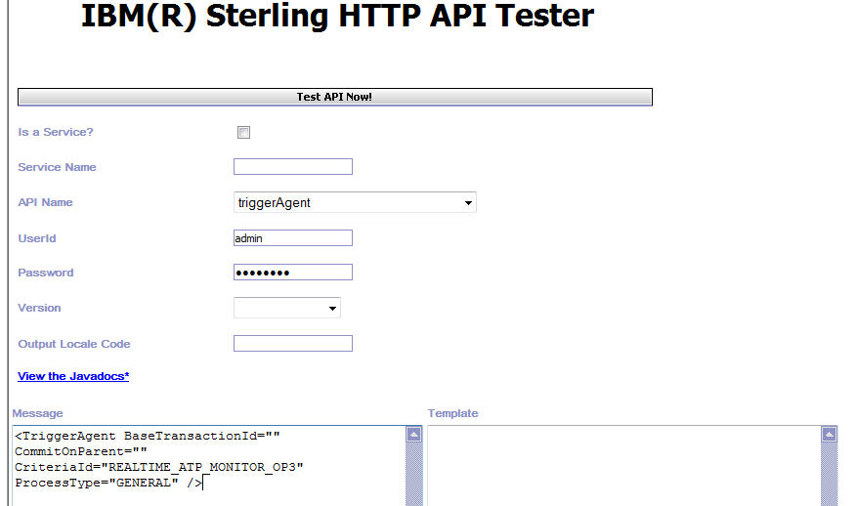

Please check .CSV file will be generated.

Again run the queries after sometime. Valid numbers should come in output.

**WESB: (Ops team)**

Operation Time: 7:30 AM PST (9 PM IST)

**Servers**

g1t4190.austin.hp.com

g2t3071.austin.hp.com

**InventoryAvailability.csv will come either in 4190/ 3071 or both.**

We need to merge, (if you find repetition of records in both file, **NEED NOT** remove the duplicate records). WCS will automatically read the last update of the repeated catentry and update.

For that, first Copy the file which we got in 4190 under /opt/apps/RTAM to /tmp (InventoryAvailability.csv)

Copy the file which we got in 3071 to 4190 /tmp and rename accordingly (InventoryAvailability_3071_yyyymmdd.csv)

scp InventoryAvailability_3071_yyyymmdd.csv username@g1t4190.austin.hp.com:/tmp

From 4190,

Append the data in InventoryAvailability_3071_yyyymmdd.csv to InventoryAvailability.csv

**Cat InventoryAvailability_3071_yyyymmdd.csv >> InventoryAvailability.csv**

Output file name should be **InventoryAvailability.csv**

1. Place the InventoryAvailability.csv in 4190 (/opt/apps/RTAM)
2. scp InventoryAvailability.csv from wesb to wcs (4187- /opt/apps/RTAM/Inbox)
3. Go to <https://glbecomtran-int.austin.hp.com:8002/adminconsole>

Run the scheduler (InventoryAvailabilityAutoLoadFromFiles) in LIVE

1. Change the scheduler date and time to approximately 2 to 3 minutes, when you moved the file to (4187- /opt/apps/RTAM/Inbox)
2. Once the scheduler gets executed, then InventoryAvailability.csv file from Inbox will move to /opt/apps/RTAM/Outbox (automatically)
3. A log file will be generated in /opt/apps/RTAM/Outbox (e.g. AutoDataLoad_InventoryAvailability_2014.12.11_21.45.00.28.log)

Once the file moved to outbox, validate in DB using the below query.

**Trouble shooting steps for Monitor Option 3 and Monitor Option 1:**

If the .csv file is not generated on the WESB host or when Monitor Option1 is not working, please follow the below steps.

1. Check the queue depth of WCSInventory_JMS_RECEIVE_D queue under Buses 🡪 JMSBus 🡪 Destinations 🡪 WCSInventory_JMS_RECEIVE_D 🡪Queue Points. If the queue depth is greater than 0 then the WESB application might be down.
2. Check the queue depth of Exception queue under Buses 🡪 JMSBus 🡪 Destinations 🡪 System Exception 🡪 Queue Points. If there is any data issue / transaction rollback then the queue points of Exception queue will be updated.

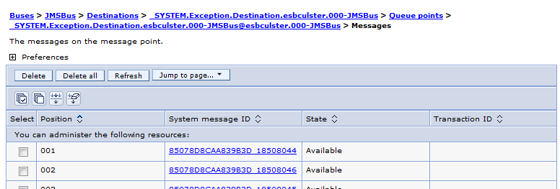

1. Check the Failed Event Manager under Integration Applications 🡪 Failed Event Manager. It will be updated when the WCS application is down or when the outbound service invocation credentials are invalid.

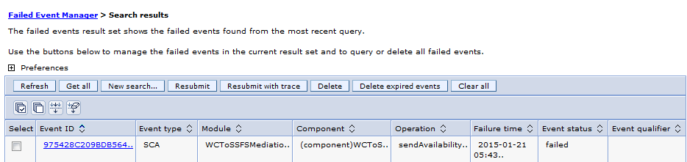

**Checking ffdc logs in WESB Host:**

1. The detailed exceptions can be checked in the putty.
2. Login into the WESB host in putty.
3. Enter the following command to open the ffdc file.

cd /opt/apps/IBM/WebSphere/AppServer/profiles/ESBCustom/logs/ffdc.

1. The ffdc file contains the detailed list of exceptions.

**Final Validation: (Apps Team)**

**For STO**

Select cat.partnumber partnumber,atval.value value from catentryattr cttr,catentry cat,attr att,attrvaldesc atval

WHERE cttr.catentry_id = cat.catentry_id

AND PARTNUMBER in ('partnumber1','partnumber2')

AND cttr.attr_id = att.attr_id

AND att.identifier = 'product_class'

AND cttr.attrval_id = atval.attrval_id

AND atval.value in ('STO')

AND atval.language_id = -1;

Take partnumber from csv file (InventoryAvailability.csv) from Outbox (/opt/apps/RTAM/Outbox) of WESB server

**For 3PP**

Select cat.partnumber partnumber,atval.value value from catentryattr cttr,catentry cat,attr att,attrvaldesc atval WHERE cttr.catentry_id = cat.catentry_id

AND PARTNUMBER in ('partnumber1','partnumber2')

AND cttr.attr_id = att.attr_id

AND att.identifier = 'product_class'

AND cttr.attrval_id = atval.attrval_id

AND atval.value in ('3PP')

AND atval.language_id = -1;

Take partnumber from csv file (InventoryAvailability.csv) from Outbox (/opt/apps/RTAM/Outbox) of WESB server

*The item count should be matching in both the above scenarios*

**Inventory Addition to Sprout:**

After all the process is completed, please add a fake inventory of **500** in **both WCS and OMS** for the Sprout SKU J4W72AA#ABA.

**Final Step: (Ops Team)**

Once the file got processed in WCS, opt/apps/RTAM/Inbox should be empty and there should not be any Error Logs generated with that date.

Once it is done, please manually move the InventoryAvailability.csv from /opt/apps/RTAM/ to /opt/apps/Outbox in **both** **WESB** Servers with the current time stamp to prevent overriding of the existing files.

**----------------------------------------------------EOD--------------------------------------------------**