***TIBCO KT DOCUMENT***

**TIBCO PROD ADMINISTRATOR URL:**

Please click the below TIBCO Production Administrator link and login with the HP credential.

<https://tibco-admin-prd04-gslb1-aa-8443.glb.itcs.hpicorp.net:8443/>

Username: [xxxx@hp.com](mailto:xxxx@hp.com)

assword: HP NT Password

**TIBCO Production server details:**

|  |
| --- |
| c1t26908.itcs.hpicorp.net |
| c1t26910.itcs.hpicorp.net |
| c2t26915.itcs.hpicorp.net |
| c2t26916.itcs.hpicorp.net |

**Note: If any UNIX Patching Related to TIBCO Production Servers, then please raise an IM ticket to TIBCO Platform Team and restart all the service instances.**

After login into TIBCO admin Console, we can able to see ECOM folder and expand it. PFS.

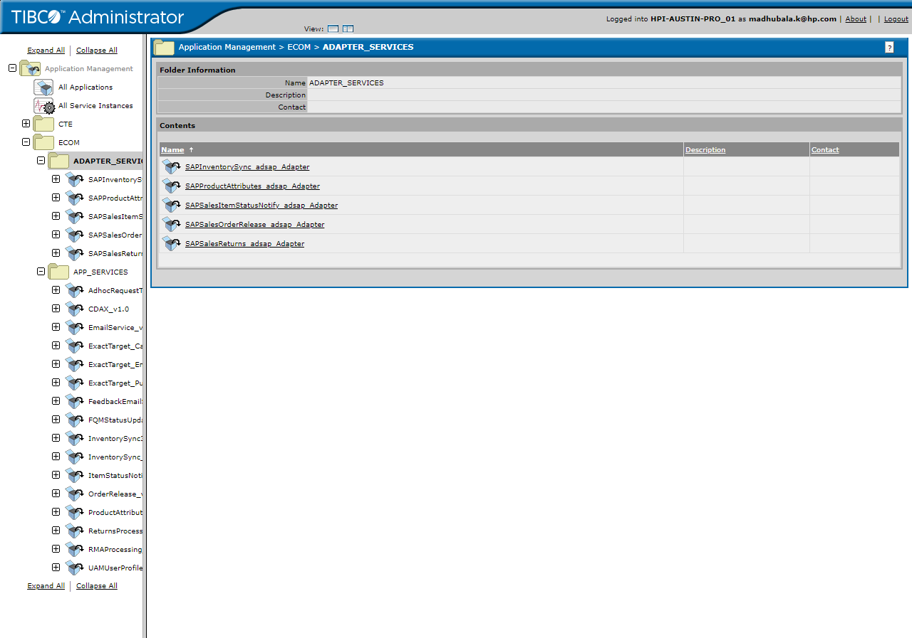

In ECOM, there are two types of services like adapter services and application services.

Adapter Services is for **TIBCO to SAP** & **SAP to TIBCO** Stream

Application Services is for **TIBCO > OMS > WESB > WCS** & **WCS > WESB > OMS >TIBCO** Stream.

**Queues in GEMS TOOL:**

**Screenshot from Gems tool (**will share Installation document**)**

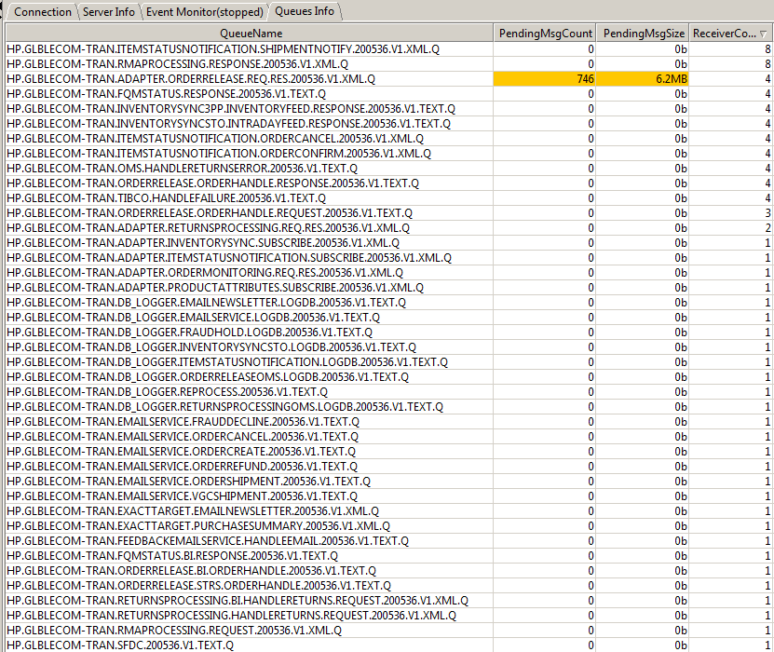

**Queue from each service were configured over in gems tool.**

**ReceiverCount** indicates no of services instances available for each service. If any error in service instances , ReceiverCount will reduced. Receiver details were explained below.

**PendingMsgCount** indicates the accumulated messages in each queue (requests) . If messages exceed 50 to 100, raise IM/SD ticket to platform for restart those errored instance.

**PendingMsgSize** indicates size of messages accumulated in a queue.

**Application Path for all the Services in TIBCO: Application Management > ECOM > ADAPTER_SERVICES**

## **SAP Adapter:**

SAP adapter it helps to communicate with SAP and TIBCO System.

1. TIBCO will transform the input XML and converted into IDOC format. IDOC was the format that is understood by SAP System.
2. SAP will send the IDOC and TIBCO will convert it to XML format.

|  |  |
| --- | --- |
| **ADAPTERS --> Connectivity with SAP System** |  |
| **Queue Names** | **Receiver Count** |
| HP.GLBLECOM-TRAN.ADAPTER.INVENTORYSYNC.SUBSCRIBE.200536.V1.XML.Q | 1 |
| HP.GLBLECOM-TRAN.ADAPTER.ITEMSTATUSNOTIFICATION.SUBSCRIBE.200536.V1.XML.Q | 3 |
| HP.GLBLECOM-TRAN.ADAPTER.ORDERRELEASE.REQ.RES.200536.V1.XML.Q | 4 |
| HP.GLBLECOM-TRAN.ADAPTER.PRODUCTATTRIBUTES.SUBSCRIBE.200536.V1.XML.Q | 1 |
| HP.GLBLECOM-TRAN.ADAPTER.RETURNSPROCESSING.REQ.RES.200536.V1.XML.Q | 2 |

If we receive any hawk alert in the above-mentioned queue. We will have to check three possible way to identify the status of the adapters.

1. Please check the receiver counts are available for the above-mentioned queues (Gems Tools helps to shows the receivers count details).
2. If the Receiver count is available and please check whether the receivers is consuming the messages or not.
3. We will have to check the status of the service instances in the TIBCO Administrator Console.

### **Order Release Adapter:** SAPOrderReleaseLB_Adapter

This adapter will help to send the orders to SAP for fulfillment process.

**Application Path:** Application Management > ECOM > AdapterServices > SAPOrderReleaseLB_Adapter > **Service Instances**

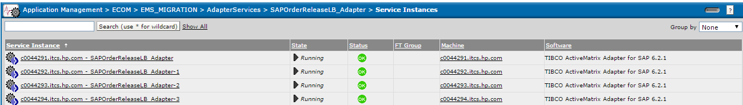

**Note:** Please click each and every Service Instances (SAPOrderReleaseLB_Adapter) 🡪 Tracing 🡪 Search for the log. If any exception occurs in the logs, check with Dev team or raise an IM ticket to restart the SAPOrderReleaseLB_Adapter.

**Order Release Adapter Queue:** HP.GLBLECOM-TRAN.ADAPTER.ORDERRELEASE.REQ.RES.200536.V1.XML.Q

### **Item Status Notification:** SAPSalesItemStatusNotify_adsap_Adapter

ThisAdapter will help to receive the Shipment/Cancellation/Confirmation Notification from SAP to TIBCO System.

**Application Path:**  Application Management > ECOM > AdapterServices > SAPSalesItemStatusNotify_adsap_Adapter > **Service Instances**

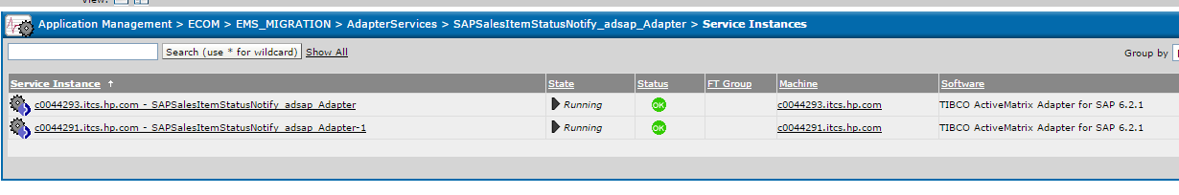

**Note:** Please click each and every Service Instances (SAPSalesItemStatusNotify_adsap_Adapter) 🡪 Tracing 🡪 Search for the log. If any exception occurs in the logs, check with Dev team or raise an IM ticket to restart the SAPSalesItemStatusNotify_adsap_Adapter.

**Item Notification Adapter Queue:** HP.GLBLECOM-TRAN.ADAPTER.ITEMSTATUSNOTIFICATION.SUBSCRIBE.200536.V1.XML.Q

### **Sales Return Adapter:** SAPSalesReturns_adsap_Adapter

This Adapter will help to send the Return Orders and Misc. Credit Orders (R and M orders) to SAP System.

**Application Path:** Application Management > ECOM > AdapterServices > SAPSalesReturns_adsap_Adapter > **Service Instances**

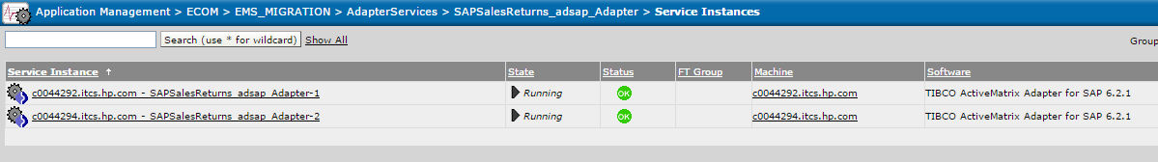

**Note:** Please click each and every Service Instances (SAPSalesReturns_adsap_Adapter) 🡪 Tracing 🡪 Search for the log. If any exception occurs in the logs, check with Dev team or raise an IM ticket to restart the SAPSalesReturns_adsap_Adapter.

**Sales Return Adapter Queue:** HP.GLBLECOM-TRAN.ADAPTER.RETURNSPROCESSING.REQ.RES.200536.V1.XML.Q

### **Inventory Sync Adapter:** SAPInventorySync_adsap_Adapter

This Adapter will help to receive the Inventory load (Full Feed and Delta Feed) from SAP System.

**Application Path:** Application Management > ECOM > AdapterServices > SAPInventorySync_adsap_Adapter > **Service Instances**

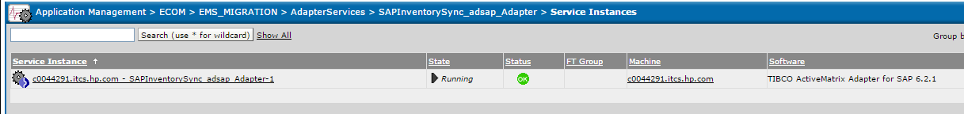

**Note:** Please click each and every Service Instances (SAPInventorySync_adsap_Adapter) 🡪 Tracing 🡪 Search for the log. If any exception occurs in the logs, check with Dev team or raise an IM ticket to restart the SAPInventorySync_adsap_Adapter.

**Inventory Sync Adapter Queue**: HP.GLBLECOM-TRAN.ADAPTER.INVENTORYSYNC.SUBSCRIBE.200536.V1.XML.Q

**-------------------------------------------------------------------------------------------------------------------------------------**

**Application Path for all the Services in TIBCO: Application Management > ECOM > APP_SERVICES >**

# **TIBCO APPLICATION SERVICES**

## **Email Service:** EmailService_v1.0 (OMS🡪TIBCO🡪 WLI)

It helps to send the emails (Order Creation, Fraud Decline, Shipment, Refund, VGC Shipment, and Cancellation) to customer. WLI is the end system help to trigger emails to customers.

**Application Path**: Application Management > ECOM > APP_SERVICES > EmailService_v1.0 > Service Instances

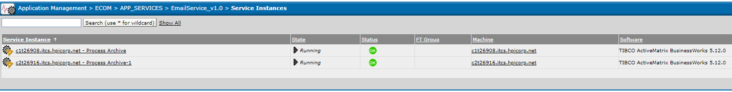

* **Queue’s Related to Email Service:**

|  |  |
| --- | --- |
| **Queue Name** | **Receiver Count** |
| HP.GLBLECOM-TRAN.EMAILSERVICE.ORDERCREATE.200536.V1.TEXT.Q | 2 |
| HP.GLBLECOM-TRAN.EMAILSERVICE.ORDERREFUND.200536.V1.TEXT.Q | 2 |
| HP.GLBLECOM-TRAN.EMAILSERVICE.ORDERSHIPMENT.200536.V1.TEXT.Q | 2 |
| HP.GLBLECOM-TRAN.EMAILSERVICE.VGCSHIPMENT.200536.V1.TEXT.Q | 2 |
| HP.GLBLECOM-TRAN.EMAILSERVICE.ORDERCANCEL.200536.V1.TEXT.Q | 2 |
| HP.GLBLECOM-TRAN.EMAILSERVICE.FRAUDDECLINE.200536.V1.TEXT.Q | 2 |

If we receive any hawk alert in the above-mentioned Service/queues. We will have to check three possible way to identify the status of the service instances.

* 1. Please check the receiver counts are available for the above-mentioned queues (Gems Tools helps to view the receivers count details).
  2. If the Receiver count is available and please check whether the receivers is consuming the messages or not.
  3. We will have to check the status of the service instances and logs in the TIBCO Administrator Console.

**Note**: (Check the logs in Admin Console) Click the Service Instances (EmailService_v1.0)🡪 Primary/Secondary Process Archive (Status-Running) 🡪 Tracing 🡪 Search for the log. Please check whether any exception has been throwing in the logs.

* If any exceptions/errors have been thrown in the logs, check with the Dev Team or raise an IM ticket to TIBCO platform Team.

## **Order Release Service:** OrderRelease_v1.0 (WCS🡪OMS🡪TIBCO🡪SAP)

Order Release service will help to transmit the order details (Order Information details) to SAP for fulfillment process.

**Application Path**:  Application Management > ECOM > APP_SERVICES > OrderRelease_v1.0 > Service Instances

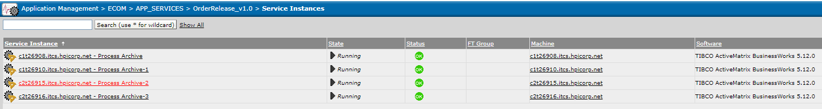

|  |  |  |
| --- | --- | --- |
| **Queue's Related to Order Release Service** | **Receiver Count** | **Details** |
| HP.GLBLECOM-TRAN.ORDERRELEASE.ORDERHANDLE.REQUEST.200536.V1.TEXT.Q | 4 | This queue is the entry point of OMS to TIBCO. It will consume the Order Release XML from OMS to TIBCO. |
| HP.GLBLECOM-TRAN.ORDERRELEASE.ORDERHANDLE.RESPONSE.200536.V1.TEXT.Q | 4 | It will send the SAP Customer ID Details from SAP to OMS |
| HP.GLBLECOM-TRAN.ORDERRELEASE.BI.ORDERHANDLE.200536.V1.TEXT.Q | 1 | It will send the Order Release XML to BI System. |

If we receive any hawk alert in the above-mentioned services/queues. We will have to check three possible way to identify the status of the service instances.

1. Please check the receiver counts are available for the above-mentioned queues (Gems Tools helps to view the receivers count details).
2. If the Receiver count is available and please check whether the receivers is consuming the messages or not.
3. We will have to check the status of the service instances and logs in the TIBCO Administrator Console.

**Note:** (Check the logs in Admin Console) Click the Service Instances (OrderRelease_v1.0)🡪(Status-Running) 🡪Tracing 🡪 Search for the log. Please check whether any exception has been throwing in the logs.

* If any exceptions/errors have been thrown in the logs, check with the Dev Team or raise an IM ticket to TIBCO platform Team.

## **Item Status Notification Service:** ItemStatusNotification_v1.0 (SAP🡪TIBCO🡪 OMS)

Item status notification service will help to send the Shipment/Cancellation/Confirmation Notification from SAP🡪TIBCO🡪 OMS System.

**Application Path**: Application Management > ECOM > APP_SERVICES > ItemStatusNotification_v1.0 > **Service Instances**

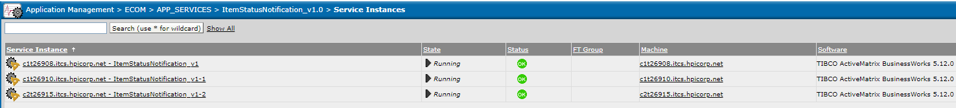

|  |  |  |
| --- | --- | --- |
| **Queue's Related to Item Status Notification Service** | **Receiver Count** | **Details** |
| HP.GLBLECOM-TRAN.ITEMSTATUSNOTIFICATION.**ORDERCONFIRM**.200536.V1.XML.Q | 4 | It will help to send the order confirmation from SAP to OMS System |
| HP.GLBLECOM-TRAN.ITEMSTATUSNOTIFICATION.**SHIPMENTNOTIFY**.200536.V1.XML.Q | 8 | It will help to send the Shipment Notification from SAP to OMS System |
| HP.GLBLECOM-TRAN.ITEMSTATUSNOTIFICATION.**ORDERCANCEL**.200536.V1.XML.Q | 4 | It will help to send the order Cancellation Notification from SAP to OMS System |

If we receive any hawk alert in the above-mentioned services/queues. All the queue related to OMS System, please check any Agent server was down in OMS end.

We will have to check three possible way to identify the status of the service instances in TIBCO.

1. Please check the receiver counts are available for the above-mentioned queues (Gems Tools helps to view the receivers count details).
2. If the Receiver count is available and please check whether the receivers is consuming the messages or not.
3. We will have to check the status of the service instances and logs in the TIBCO Administrator Console.

## **Return Processing Service:** ReturnsProcessing_v1.0 (OMS🡪TIBCO🡪 SAP)

Return Processing Service will help to send the Invoice details of Return Order and Misc. Credit Order (R and M Order) from OMS to SAP system.

**Application Path**: Application Management > ECOM > APP_SERVICES > ReturnsProcessing_v1.0 > Service Instances

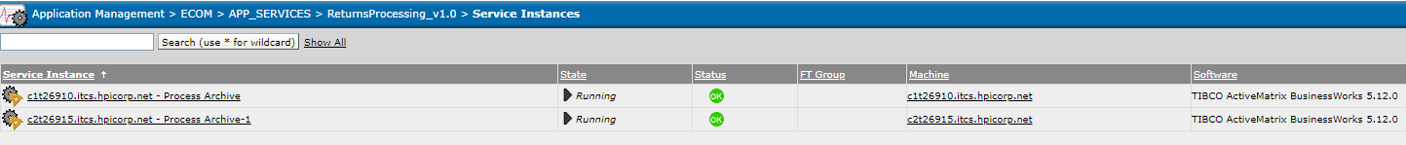

|  |  |  |
| --- | --- | --- |
| **Queue's Related to Return Processing Service** | **Receiver Count** | **Details** |
| HP.GLBLECOM-TRAN.RETURNSPROCESSING.HANDLERETURNS.REQUEST.200536.V1.XML.Q | 2 | It will send the R and M order invoice details to SAP from OMS. |
| HP.GLBLECOM-TRAN.RETURNSPROCESSING.BI.HANDLERETURNS.REQUEST.200536.V1.XML.Q | 1 | It will send the R and M order invoice details to BI System. |

If we receive any hawk alert in the above-mentioned services/queues. We will have to check three possible way to identify the status of the service instances.

1. Please check the receiver counts are available for the above-mentioned queues (Gems Tools helps to view the receivers count details).
2. If the Receiver count is available and please check whether the receivers is consuming the messages or not.
3. We will have to check the status of the service instances and logs in the TIBCO Administrator Console.

**Note:** (Check the logs in Admin Console) Click the Service Instances (ReturnsProcessing_v1.0)🡪(Status-Running) 🡪Tracing 🡪 Search for the log. Please check whether any exception has been throwing in the logs.

* If any exceptions/errors have been thrown in the logs, check with the Dev Team or raise an IM ticket to TIBCO platform Team.

## **Inventory Sync and Inventory 3PP Service:**

Inventory Service will help to receive the Full Feed/Intraday Feed from the source system and will send to OMS system for maintaining the inventory for each and every product.

**For 3PP Product**- Source System was **Ingram**. (INGRAM🡪TIBCO🡪OMS)

Ingram Server location: mercury.ingrammicro.com (TIBCO will keep on check the Full Feed/ Intraday Feed file in Ingram Server location for every 15 mins. If the files are available, TIBCO will process it and send the inventory count to OMS.)

**For STO Products**- Source System was **SAP System**. (SAP🡪TIBCO🡪OMS)

***Inventory Sync (InventorySync_v1.0)***

**Application Path:** Application Management > ECOM > APP_SERVICES > InventorySync_v1.0 > **Service Instances**

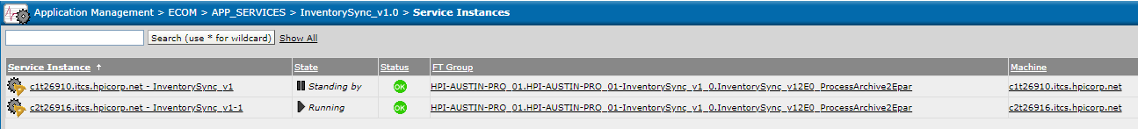

|  |  |  |
| --- | --- | --- |
| **Queue's Related to Inventory Sync Service** | **Receiver Count** | **Details** |
| HP.GLBLECOM-TRAN.INVENTORYSYNCSTO.INTRADAYFEED.RESPONSE.200536.V1.TEXT.Q | 4 | TIBCO will send the STO Intraday Inventory file to OMS. |

If we receive any hawk alert in the above-mentioned queue. This queue related to OMS System, please check any Agent server was down in OMS end.

### ***Inventory Sync 3PP (InventorySync3PP_v1.0)***

**Application Path:** Application Management > ECOM > APP_SERVICES > InventorySync3PP_v1.0 > Service Instances

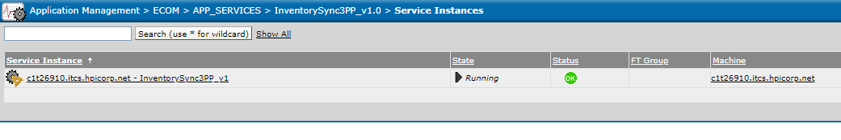

|  |  |  |
| --- | --- | --- |
| **Queue's Related to Inventory Sync 3PP Service** | **Receiver Count** | **Details** |
| HP.GLBLECOM-TRAN.INVENTORYSYNC3PP.INVENTORYFEED.RESPONSE.200536.V1.TEXT.Q | 4 | TIBCO will send the 3PP file Inventory file to OMS. |

If we receive any hawk alert in the above-mentioned queue. This queue related to OMS System, please check any Agent server was down in OMS end.

## ***INVENTORY FILE Check Steps:***

* Please find Inventory Flow for both 3PP and STO file below:

**Ingram >> SeeBurger >> HPSB >> XI >> HHOSAP >> ETR**

* From SAP, TIBCO will receive inventory files in any one of the below server,

**c1t26910.itcs.hpicorp.net**

**c2t26916.itcs.hpicorp.net**

* Path to check inventory file in above TIBCO Servers:

**STO :** /opt/tibco/ecom/inventorySTO

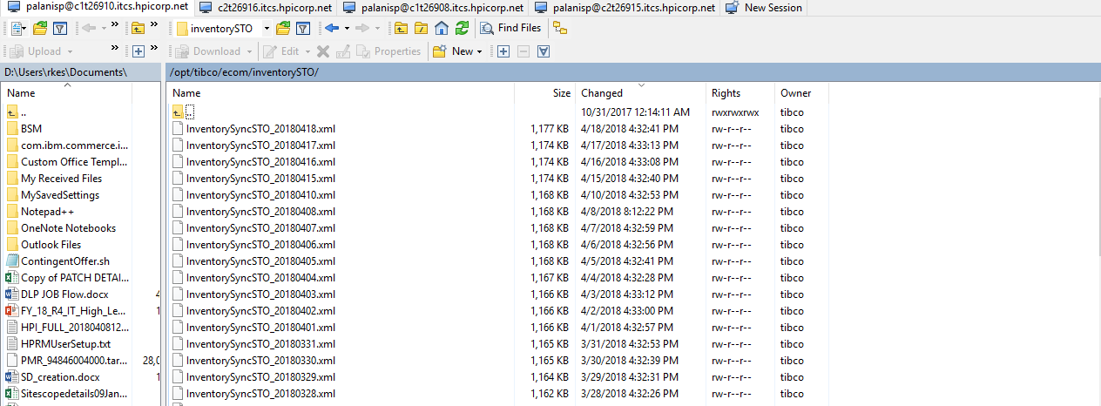

**3PP:** /opt/tibco/ecom/inventorySync/inventory3PP/archive

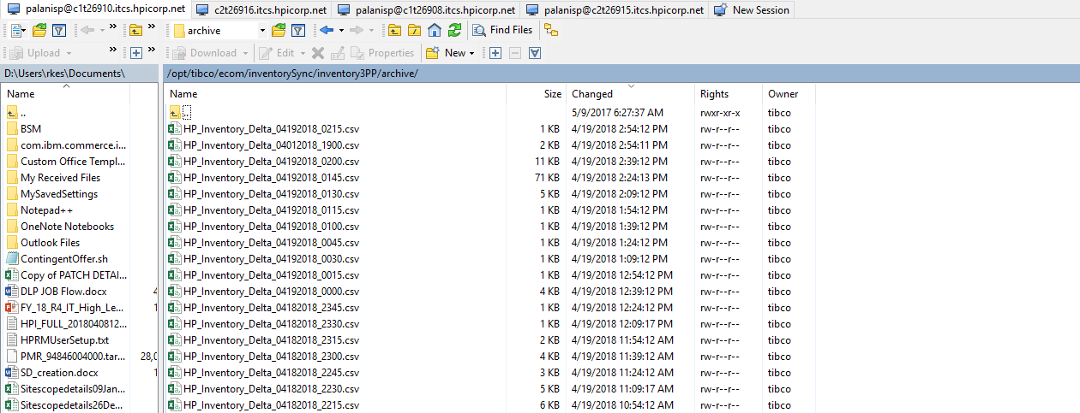

**Check 1:**

We have received files from SAP and found it in above TIBCO location. But xml files didn’t found in OMS.

Then we need to check below inventory sync application services under APP_SERVICES tab in TIBCO admin Console

InventorySync_v1.0



InventorySync3PP_v1.0



Check the state of services instances and raise ticket to platform for restart if it is in down status. After restart, check file sync up in OMS

**Check 2:**

Suppose, Inventory files were not found in TIBCO location. Then we need to check in below SAP Adapter Services under ADAPTER_SERVICES in TIBCO admin console.

SAPInventorySync_adsap_Adapter



Check the state of services instances and raise ticket to platform for restart if it is in down status. After restart, check for file sync up in TIBCO and OMS location.

**Check 3:**

Both Adapter Services and Application Services for Inventory were running fine in TIBCO. But we didn’t get inventory files. Then raise ticket to SAP Team and go for MI if needed.

**NOTE**: If state of service Instances were unknown, it means Hawk agent were down in TIBCO. Then we need to raise ticket to TIBCO Platform Team for restart of those agents.

---------------------------------------------------------------------------------------------------------------------------------------

***TRACING:***

We can able to see error/info messages in every service instances by following as below

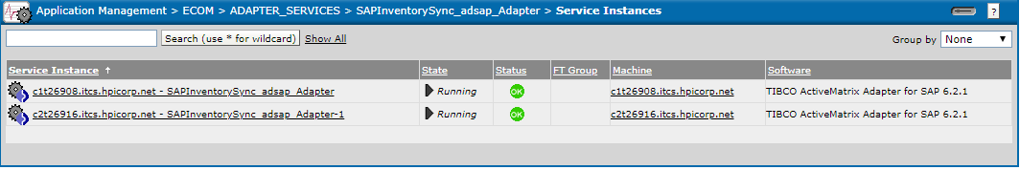

By clicking any one of services, we can see view like below screenshot.

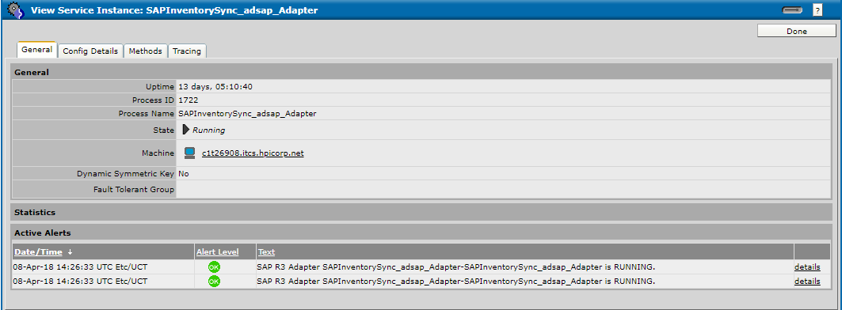

Then Click on Tracing tab and click search. We will able to see Role and message code. PFB

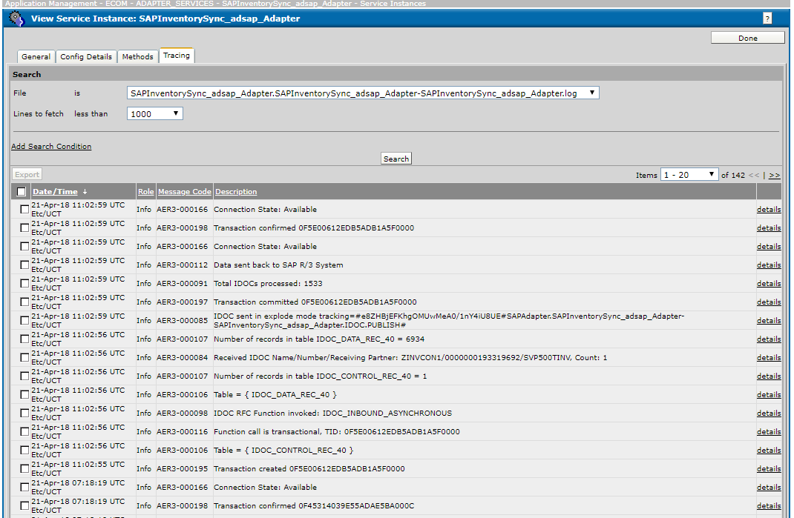

***GIS.EMS.CLE.log Queue* (Common Logging and Exception Handling)**

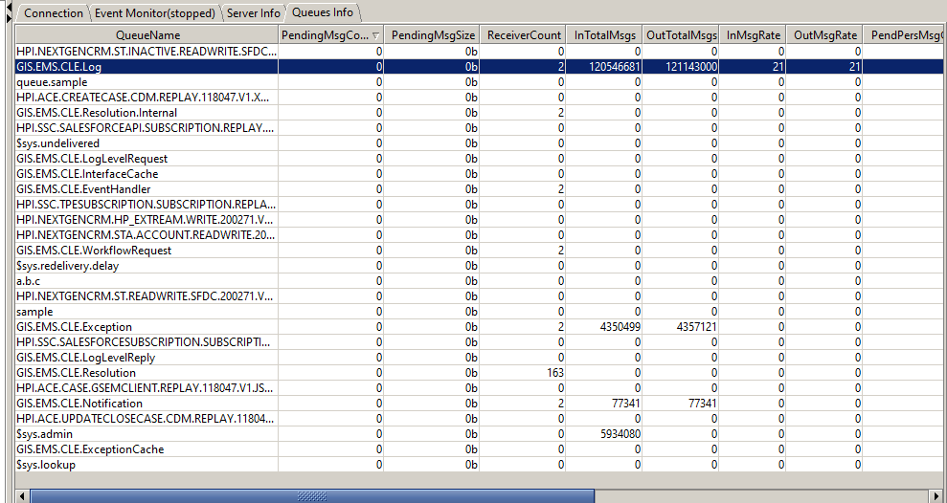

Suppose, pending messages count increases in CLE queue, we need to check all services were up or not.

If not, kindly raise SD ticket to Tibco platform team.

From TIBCO Community(CLE):

 In the enterprise level, application failures might occurs during runtime and leads to several risks or impacts to business down situation if they are not handled properly. ♣ Intelligent Common Logging Error framework (iCLE) addresses these issues by providing a common solution framework for logging and exception handling as enterprise services with a common standard structure format Exceptional Handling & Logging

**---------------------------------------------------------------------------------------------------------------------------------------**

**Guidelines to Create or Search SD tickets to TIBCO team**

For all TIBCO related requests or Incidents please raise an SD ticket from ESS

AG : W-HPI-INCLV3-EA-TCS-TIBCO

EPR ID:202330

ESS Link : <https://itsm-support.corp.hp.com/sm-ess/ess.do>

**How to create and search SD Tickets:**

* Log into ESS portal <https://itsm-support.corp.hp.com/sm-ess/ess.do>

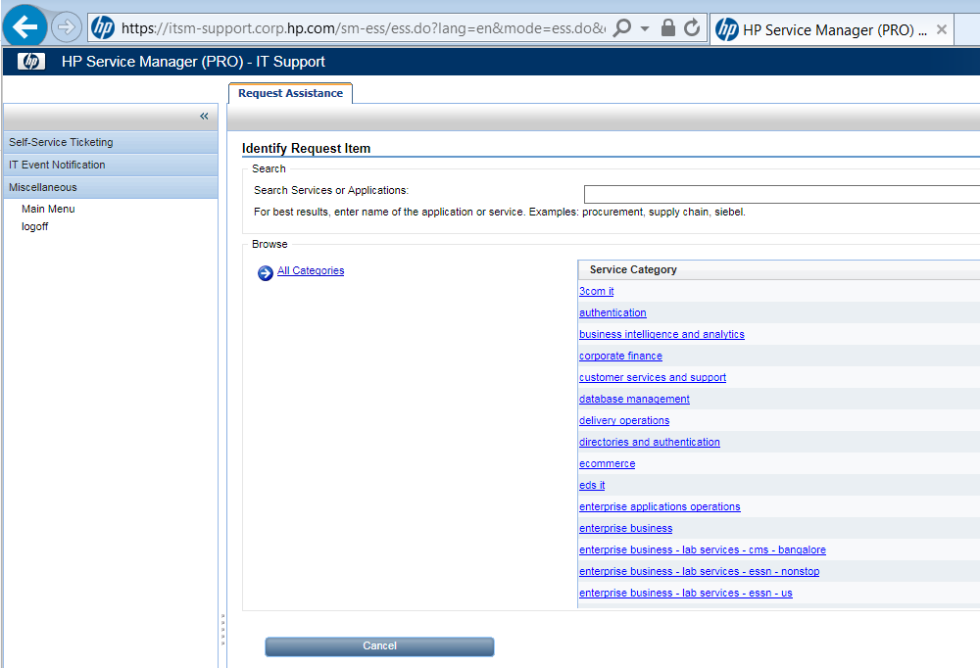

* Search for TIBCO EprID 202330

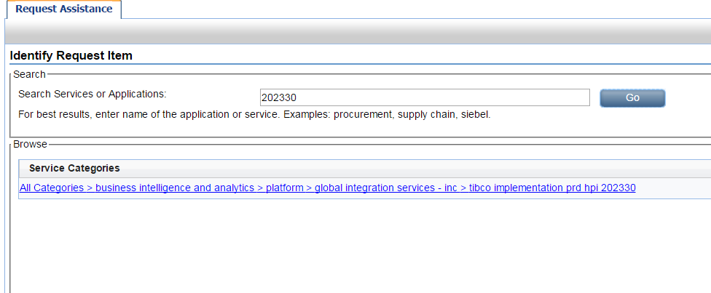

* ***Select the category to submit the request***

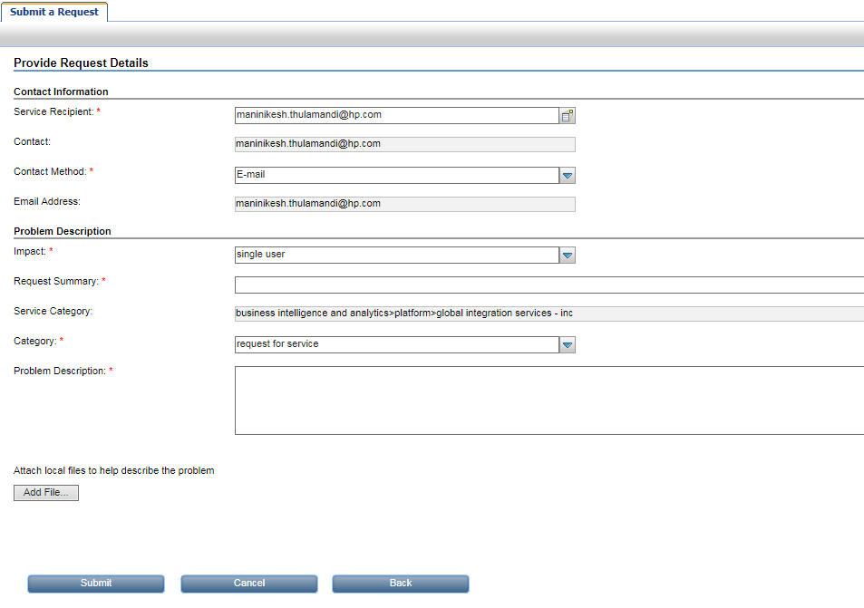

* ***Fill required fields and submit the request.***

## **TIBCO Wiki**

TIBCO Wiki will helps to understand the overall architecture in ETR and it contains queue configuration and server details of all TIBCO Environment.

**TIBCO WIKI:** <https://c1t11995.itcs.hpicorp.net/wiki/TIBCO_Platform_HPECOM>