**TLSv1.2 Changes**

**IBM console changes:**

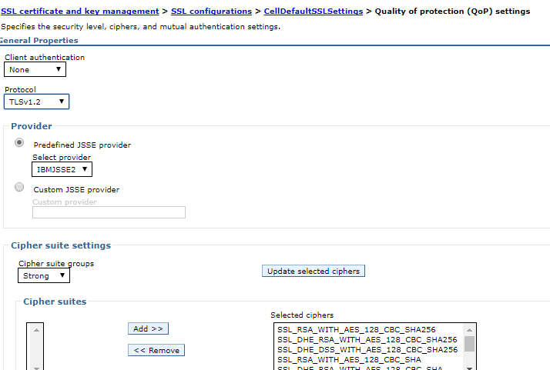

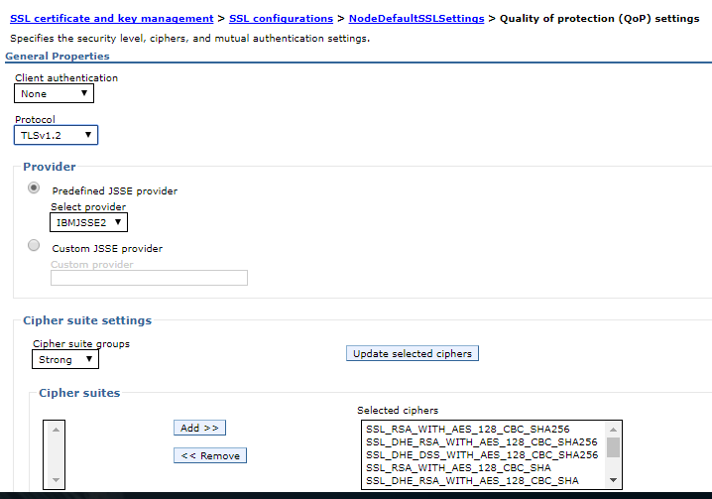

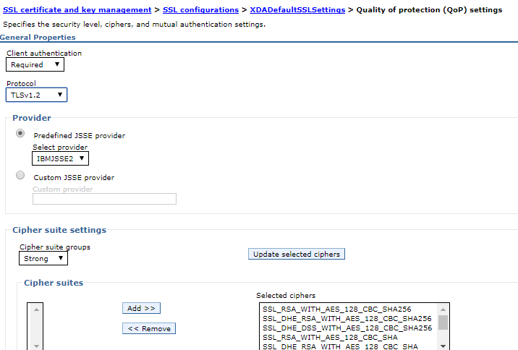

Apply🡪 ok

**Appserver settings:**

/opt/apps/IBM/WebSphere/AppServer/profiles/Dmgr01/properties





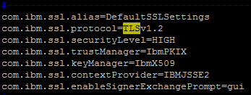

/opt/apps/IBM/WebSphere/AppServer/profiles/ETRLIVE/properties



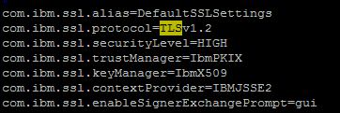

**Solr Appserver settings:**

/opt/apps/IBM/WebSphere/AppServer/profiles/ETRLIVE_solr/properties



vi ssl.client.props

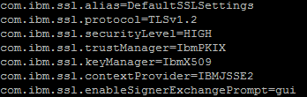

**Webserver Changes:**



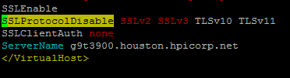

**Agent Server settings:**

1. Add this property in **-Dhttps.protocols=TLSv1.2** in file /opt/apps/IBM/Sterling93/bin/agentserver.sh

**WESB Appserver**

**/opt/apps/IBM/WebSphere/AppServer/profiles/ETRLIVE/properties/ssl.client.props**

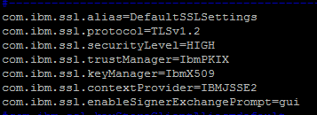

Restart the dmgr using stopmanger and startmanager

Stop the node: WAS_install\profiles\AppSrv01\bin\stopNode.bat -username -password

Stop all Application Servers running on this node using stopserver command

Synchronize the node using syncnode command in each app servers & solr servers

./syncNode.sh g9t3902.houston.hpicorp.net 8879 -username configadmin -password ****

**From WAS_install\profiles\AppSrv01\bin\syncNode.bat dmgrhostname dmgrsoapport -username consoleadminuser -password consoleuserpassword**

Start the node: From WAS_install\profiles\AppSrv01\bin\startNode.bat

Check the Sync status of node from console.. and then start the application server from console.

**Changes in Job server:**

**/opt/apps/IBM/WebSphere/AppServer/profiles/ETRLIVE/properties/ssl.client.props**

